
Student Name: Shohag Hossain
Student ID: 2522419
MBA International Business
University Of Wales Trinity Saint David

Module Name: Marketing Management

Module Code: LCMB7024

Lecturer’s Name: Dr Tola Odugbsesan

Word Count: 2719

Term 1

Table of Contents
ELEMENT 2: STDP ANALYSIS FOR SPOTIFY LEARN 3
ELEMENT 3: 7Ps of Marketing Mix 9
ELEMENT 4: REFLECTION 13
Reference: 15
ELEMENT 1: THE POSTER (APPENDIX) 17

ELEMENT 2: STDP ANALYSIS FOR SPOTIFY LEARN
Market Segmentation:
Spotify Learn will create content for different types of learners, and to meet the needs of each, they will divide the market into four categories:
1. Geographic Segmentation
Tier 1 — Developed Countries
- Location: UK, US, and other Western countries
- Focus plan: Premium plan
Tier 2 — Emerging Markets
- Location: Asia Pacific, Latin America, or African countries
- Focus plan: Free plan
2. Demographic Segmentation
Age | Gen Z+Millennials (Primary)  45+ lifelong learners (secondary)
Income | High disposable income (Premium plan)  Price-sensitive learners (free plan)
Education | Higher education students and working professionals
Occupation | Busy working people, educators, and small business owners

3. Psychographic Segmentation
Lifestyle | Those who grew up with smartphones, and working people who cannot find time to study separately.
Values | Places importance on practical application and wants to learn flexibly.
Interests | Not just rote knowledge, but to combine education and entertainment.

4. Behavioural Segmentation
Usage Rate | Consumes short-duration content every day.
Benefits Sought | They don't have to search for content; AI will analyse their behaviour and surface relevant content.
Occasion | They can set aside 10 minutes during their commute or at work to listen to the episodes.

Targeting:
Primary Targeting Segment
In developed countries such as the UK and the US, the emphasis will be primarily on premium pricing because consumers here are accustomed to purchasing digital products with money. Here, digital certificates are accepted, meaning that if someone earns a digital certificate from a reliable platform outside traditional universities, it has equal value to employers. That’s why everyone here wants to enrol in high-quality courses and pay for them on EdTech platforms (Team, 2026).

Secondary Targeting Segment
In India, Nigeria, and other developing countries, Spotify will focus on the free plan. There is a large population in these regions, but they are not financially well-off. Spotify will provide them with the basic education through the free plan, with which they can start freelancing. While working, they will identify their skill gaps. In the future, they will be the ones who will buy Spotify Learn's premium subscription. In this way, Spotify Learn will achieve two important goals of the UN SDGs:
SDG 4: Ensure quality education for all.
SDG 10: Eliminate the gap between the rich and the poor (Pedersen, 2018).
Differentiation:
Differentiation is about appearing differently to the target customers than competitors (Datta, 2010). Spotify Learn can be differentiated in four ways, namely:
1. Audio-First Platform: Coursera or MasterClass classes are primarily video-based. Students have to set aside time to attend each session. But Spotify Learn's audio content can be listened to by anyone while doing their household tasks.
2. Zero Switching Cost: LinkedIn currently has over 1.2 billion users, but only 130+ million are active daily (Shepherd, 2025). To learn something, these 130 million people must join LinkedIn Learning, which causes friction. But Spotify Learn doesn't have this hassle. Just clicking on a new tab "Learn" will open up hundreds of course contents.
3. True Free Tier: MasterClass costs $120-$240 per year. There is a one-month return policy, but no free plan. Students can’t afford to spend that much at once. MasterClass is a very expensive platform where celebrity teachers impart knowledge on various subjects. It looks glamorous, but not everyone may benefit for practical approach. In Spotify Learn, students can get a basic education for free by watching ads. This will give low-income people an opportunity to gain knowledge.
4. Emotional Connection: Spotify has become a well-known brand by serving its listeners for 16 years. The sincere relationship that has been built with its listeners over this long period of time will take years for any new EdTech business to achieve. So, Spotify Learn is able to differentiate itself from potential newcomers, too.

Positioning:
High Accessibility
Low Accessibility
Low Personalization
High Personalization
Spotify Learn
Linkedin Learning
Coursera
MasterClass
Figure 1: Perceptual Positioning Map — EdTech Competitive Landscape (Accessibility vs. Personalisation)

Philip Kotler is the father of modern marketing. He said positioning is the core message of a brand that creates a specific position in the minds of customers (Ries et al., 2011). It is not related to the product; it is the perception of customers. Where will customers go to search for something? Of course, on the Google search engine. This is how Google has positioned its search engine to customers.
Spotify Learn will establish itself as the best EdTech platform. Their goal is that listeners can listen to the courses at any time. They will not only guide the listeners as teachers but also as mentors. Spotify's AI personalisation will play a special role here. It will suggest courses to them according to their listening habits. To learn on Spotify Learn, customers don't have to take out a separate time. Instead of wasting 1 hour of commuting or 10 minutes of work break scrolling through social media, listeners can spend this time learning. Besides, learning something new will not stop while cleaning the house or cooking. Most of the courses on Spotify Learn will be released in audio episodes. So, no one will have to change their habits to listen to Spotify Learn. Spotify Learn will automatically blend into people's habits. People will perceive Spotify Learn in the fastest and most affordable way.

ELEMENT 3: 7Ps of Marketing Mix

Product:
Philip Kotler mentions three layers of a product. Core Product is what people actually want, which is fulfilled by Actual Product, and Augmented Product is something extra that they get (Kotler, 2012).
- Core Product: Consumers want professional and personal development, but without changing their daily habits.
- Actual Product: A separate tab inside the app that contains micro-courses. Offline download and a valid certificate at the end of the course.
- Augmented Product: Open discussion in the community forum and the opportunity to add certificates directly to LinkedIn with one click.
Spotify has already gained trust as a reliable organisation. So, no one will question the quality of Spotify's courses. However, there is a limitation in the case of audio-first content. Health care or business-related content can be heard in audio format. However, video content is more effective in mathematics or engineering subjects.
Price:
Spotify Learn will be priced in three tiers, namely:
Tier | Offerig | Strategy
Basic | A few basic courses with ads. | Helping low-income students and contributing to social welfare.
Learn Plus | A Spotify Premium offering that bundles music and education | Income from individual buyers
Learn for Teams | A subscription for organisational training | Higher revenue through bulk subscription sales

Spotify Learn will shape its entire pricing strategy with Penetration Pricing Theory (Sije and Oloko, 2013). They will enter the market with a free basic offering and try to pull in Coursera or MasterClass. Then they will gradually increase prices as customers get stuck in Spotify's ecosystem. One risk is that if the conversion rate from freemium is low in developing countries, it will become difficult for the platform to bear the costs of serving free users.
Place:
Spotify Learn will use a zero-level distribution channel. Content will go directly to Spotify’s “Learn” tab. This means that customers will not have to go to a new app, meaning the product will reach them with zero friction.
According to Kotler’s Distribution Channel Theory, an ideal distribution channel will take advantage of place and time; wherever the customer is, the product will be there (Segetlija et al., 2013). Spotify Learn fits this formula perfectly. Their 675 million user base is already listening to music in their ecosystem, where they will tap and explore out of curiosity when they see the Learn tab in the new update. Moreover, without a separate mobile app, Spotify will be able to keep full control of the e-servicescape, meaning customers will get Spotify’s own logo, fonts, and all other unique experiences.
Despite these benefits, consumers in developing countries where internet service is not reliable will not be able to enjoy the full benefits of Spotify Learn. While offline downloads are available, these regions tend to use low-budget mobile phones with limited storage, which can hinder downloads and listening.
Promotion:
Spotify Learn will use an Integrated Marketing Communications (IMC) approach to promote a unified marketing message across multiple channels—"learning while commuting” (Kliatchko, 2005). Their main promotional channel will be within the Spotify app. Attractive banners and AI-generated notifications will attract the attention of customers. Storytelling-based ads will be broadcast on TikTok and Instagram, as housewives have learned new skills while doing other household chores. In addition, influencer marketing will be done by partnering with Gen Z YouTubers who make videos about education and career tips. In this way, Spotify will be positioned to customers through multiple channels. However, the opposite side needs to be considered. In the midst of so many ads, it is necessary to ensure that Spotify's core music experience is not disrupted.
People:
How well Spotify Learn's service will be liked by customers depends on three types of people. First, they are the content creators. Spotify is a renowned platform. But if the content here is not good, then the customers will soon be disappointed. Then there is the internal team, who look after the entire system. If one day their work is disrupted, the entire customer experience can be ruined. In addition, there is the student community where students build a social connection through cooperation.
SERVQUAL is a criterion for measuring the expectations of customers towards a service and what they get (Buttle, 2016). Spotify Learn can easily fulfil two elements of this criterion, Assurance and Responsiveness. Spotify already has an established customer base who trust the organisation. If an experienced instructor like Steven Bartlett is available here, then customers will feel free to join the course. In addition, the learner community ensures the Responsiveness of the service. However, not everyone's teaching style is the same, and it is not realistic to expect Steven Bartlett to teach all subjects. If students do not find an instructor as engaging as Bartlett in a course, they will become discouraged, and the "Gap 5" discrepancy will appear.
In this case, Spotify Learn must use the Reliability dimension of the theory. Instructors who consistently receive low ratings should be removed from the platform. This way, Spotify Learn can maintain customer trust.
Process:
The process in the marketing mix is ​​how a product reaches the customer from start to finish. In the case of Spotify Learn, the process is like this: the customer will open the app, go to the Learn tab, get a course recommendation by AI, listen to 2-3 lessons for free before purchasing the course, join the course, get a digital certificate at the end of the course, and; lastly, share the certificate on LinkedIn.
In Customer Journey Mapping (CJM), each of these steps is called a touchpoint. If there is friction at any of these touchpoints, most customers do not continue (Rosenbaum et al., 2017). At each touchpoint of Spotify, the customer will move forward without any obstacles. However, one limitation must be mentioned here. AI recommendations are certainly effective, but this way, customers are stuck in a filter bubble. As a result, nothing beyond the topic of choice is explored.
A special feature can be added to protect students from the filter double—Discover Courses. In this, AI will intentionally suggest courses that are outside his/her personalized data but are quite popular on the platform and are important as contemporary skills.
Physical Evidence:
Although it is a digital service, Spotify Learn will become credible to customers by providing multiple tangible pieces of evidence. For this, they will control the entire environment with the help of e-servicescape (Lee and Jeong, 2012). A progress bar will be provided where the learning progress can be monitored in the form of percentages. Spotify's brand value will be the validity of its digital certificate. Although the weight of the certificate obtained from the university is much higher than this, Spotify will have to continue its regular partnership with the BBC to increase the weight of its certificate.

ELEMENT 4: REFLECTION

STAGE 1 — Concrete Experience:
As a marketing consultant, I proposed a brand extension for Spotify. I analysed who the Spotify Learn extension was for using the STDP framework (Cloud, 2023). Then I discussed the detailed market entry strategy using the 7Ps marketing mix. Here, I explained with theory why my strategy was appropriate and also mentioned some potential limitations. My goal was to build a new brand extension within Spotify’s established infrastructure. Finally, I created a poster to show how safe it is for investors, with verified data and facts.
STAGE 2 — Reflective Observation:
What went well: Segmenting Spotify’s 675 million users was a fairly easy task for me. I also felt very satisfied explaining how Spotify can fulfil UN SDG 4 and 10 with the free tier.
Challenges: It was difficult for me to rationally demonstrate how audio-first Spotify Learn would stack up against video-based platforms like MasterClass and Coursera. Also, while describing the 7Ps, I found the word count to be very low. It is quite difficult to explain everything convincingly in these limited words.
While answering, I realised that while audio-first Spotify has the benefit of differentiation, I did not have a strong argument for how complex subjects would be presented through audio.
STAGE 3 — Abstract Conceptualisation:
I mentioned multiple theories throughout the proposal, the main three of which are:
1. Brand Extension Theory: The success of any extension depends on how compatible it is with the parent company (Keller and Aaker, 2012). Spotify already serves audio content to a large customer base. So, adding a learn tab here is not at all inconsistent. This theory has taught me that to establish a brand extension, you must first understand the needs of your core customer base. I cannot suggest a Spotify extension that targets luxury shoe customers such as Nike.
2. STDP Framework: This framework helped me segment two different groups, so I was able to make the right decision for the right group. This allows me to identify the best target and positioning for organizations operating in any complex market.
3. Services Marketing Mix (7Ps): EdTech is a digital service, and here it is not possible to explain the entire strategy with only 4Ps. People, Process, and Physical Evidence are, of course, very important to demonstrate the credibility of a service-oriented digital product (Yelkur, 2020). Because service-based products are far more sensitive to consumer satisfaction, focusing solely on promotion will be ineffective; instead, use the seven Ps to improve service quality. This expertise will help me become a more effective marketing manager in the future.
STAGE 4 — Active Experimentation:
In future projects, I will follow the following steps:
1. Primary Research: This time, I have mainly done research based on secondary data. In the future, I will interview students and evaluate their real-world experience to see how effective the AI ​​algorithm is.
2. Balanced Analysis: I will be more critical. I will present a more balanced argument by mentioning the limitations of the free tier. My main goal will be to clearly explain the financial feasibility of any brand extension in the future assignments, as well as in real world practise.

Reference:
Buttle, F., 2016. SERVQUAL: review, critique, research agenda. European Journal of Marketing, 30(1), pp.8-32.
Cloud, E. (2023). A guide to the STP marketing model. [online] Adobe.com. Available at: https://business.adobe.com/blog/basics/stp-marketing-model [Accessed 12 Mar. 2026].
Datta, Y., 2010. A critique of Porter's cost leadership and differentiation strategies. Chinese Business Review, 9(4), p.37.
Keller, K.L. and Aaker, D.A., 2012. The effects of the sequential introduction of brand extensions. Journal of Marketing Research, 29(1), pp.35-50.
Kliatchko, J., 2005. Towards a new definition of integrated marketing communications (IMC). International Journal of Advertising, 24(1), pp.7-34.
Kotler, P., 2012. Kotler on marketing. Simon and Schuster.
Lee, S. and Jeong, M., 2012. Effects of e‐servicescape on consumers' flow experiences. Journal of Hospitality and Tourism Technology, 3(1), pp.47-59.
Patel, P. (2025). How Microlearning Is Changing The Way We Learn In 2025: All You Need To Know. [online] eLearning Industry. Available at: https://elearningindustry.com/how-microlearning-is-changing-the-way-we-learn-all-you-need-to-know [Accessed 11 Mar. 2026].
Pedersen, C.S., 2018. The UN Sustainable Development Goals (SDGs) are a great gift to business!. Procedia Cirp, 69, pp.21-24.
Pierre, K.-K. and Pierre, K.-K. (2025). Spotify’s Rise in Brand Value: Pricing, Product, Profit in 2025 - Kayla-Kaishel. [online] Kayla-Kaishel - Personal blog. Available at: https://kaylakaishel.com/spotifys-rise-in-brand-value-pricing-product-profit-in-2025/ [Accessed 11 Mar. 2026].
Ries, A., Trout, J. and Kotler, P., 2011. Positioning: The battle for your mind (Vol. 2). New York: McGraw-Hill.
Rosenbaum, M.S., Otalora, M.L. y Ramírez, G.C., 2017. How to create a realistic customer journey map. Business horizons, 60(1), pp.143-150.
Segetlija, Z., Mesarić, J. and Dujak, D., 2011. Importance of distribution channels-marketing channels-for national economy. In 22nd CROMAR Congress (pp. 785-809).
Shepherd, J. (2025). 40 Essential LinkedIn Statistics You Need to Know in 2022. [online] The Social Shepherd. Available at: https://thesocialshepherd.com/blog/linkedin-statistics [Accessed 4 Apr. 2026].
Sije, A. and Oloko, M., 2013. Penetration pricing strategy and performance of small and medium enterprises in Kenya. European Journal of Business and Social Sciences, 2(9), pp.114-123.
Team, P. (2026). What is Customer Demographics and Target Market of Spotify Technology Company? [online] Porter’s Five Forces. Available at: https://portersfiveforce.com/blogs/target-market/spotify [Accessed 11 Mar. 2026].
Welter, L. (2026). Spotify Market Share 2026: A Statistical Breakdown of How Spotify Still Dominates the Music Streaming Industry – PianoDreamers.com. [online] Piano Dreamers. Available at: https://www.pianodreamers.com/spotify-market-share/ [Accessed 11 Mar. 2026].
Yelkur, R., 2020. Customer satisfaction and the services marketing mix. Journal of professional services marketing, 21(1), pp.105-115.

ELEMENT 1: THE POSTER (APPENDIX)
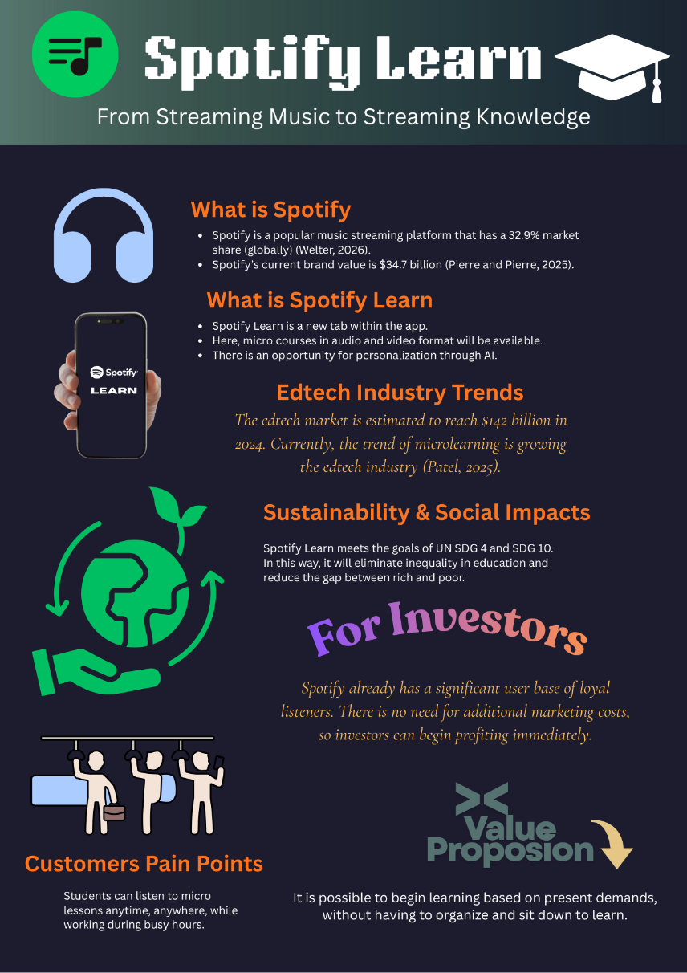
Figure 2: Spotify Learn Brand Extension Proposal for Investors

