Using one of the establishments visited, how easy is it to gain a sense of what constitutes Welsh culture?

Saskia judd
1900292
2021
Contents:
- Location….2
- Brief History….2
- Presentation of Welsh culture….3
- Whose culture?....4
- Relocation and authenticity….5
- Tourism….6
- Conclusion….7
- Bibliography….8
- Image Bibliography….9

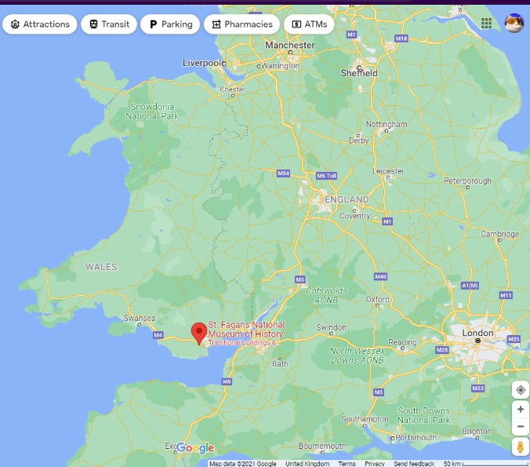
Location:
St. Fagans National Museum of History is an open air museum with reconstructed historic houses which was first opened in 1948 (St. Fagans, 2021). It is situated on the grounds of Cathays Park (Latitude - 51.48704, Longitude - -3.27251 (UK City Map, 2021)) which were donated by the Earl of Plymouth, to the nation (St. Fagans, 2021). The site lies in the South of Wales, six miles west of Cardiff and under 40 miles southeast of Swansea (Google maps, 2021).

Figure 1 Map showing location of St. Fagans in Wales (Google maps, 2021)

Brief History:
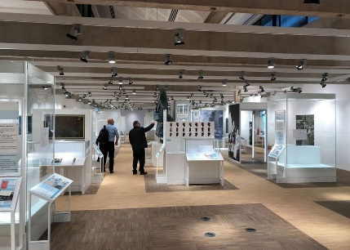
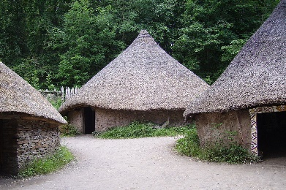
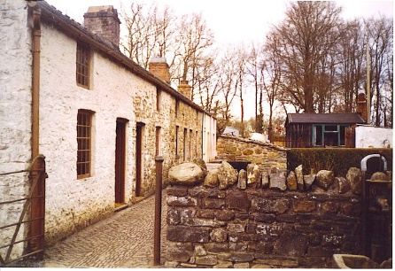
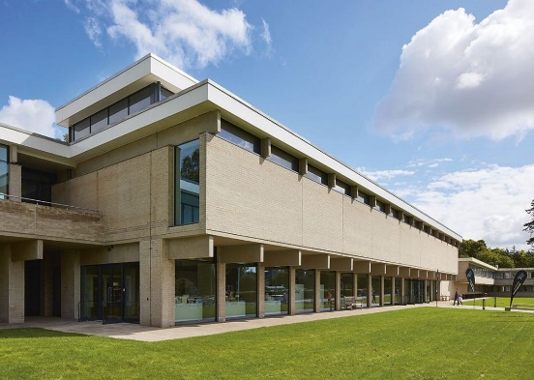
St. Fagans National Museum of History was first opened in 1948 (St. Fagans, 2021). It is situated on the grounds of Cathays Park (Latitude - 51.48704, Longitude - -3.27251 (UK City Map, 2021)) which were donated by the Earl of Plymouth, to the nation (St. Fagans, 2021). During the 1950s the site was cleared of its woodland to make space for the re-erection of the historic buildings that we see today (St. Fagans, 2021). In 1951 the main funding for the museum was raised by the people of Wales which made it more of a community endeavour. In the 1980s there was a shift in focus due to the threat to the Welsh industrial communities under Thatcher, which resulted in the relocation of the Rhyd-y-car ironworkers’ cottages to St. Fagans (St. Fagans, 2021). Throughout this decade there was nearly one building erected a year, one of the most notable being the bakery. Also, during the 80s the Maestir school was opened to allow children to learn about the past in a hands-on way (St. fagans, 2021). In 1992 the museum opened the Celtic village which was the first instance of archaeology being employed to create a building rather than just relocating them. Also, in the 90s the first cottage showing what life would have looked like for the rural poor was erected. In 1995 the museum’s English name was changed to the museum of Welsh life. When the new century arrived the museum realised that Wales was a very different place than it was in the 1950s so created Oriel 1 gallery which allowed the curators to explore more ways to highlight Welsh culture. During this time the museum also worked with community groups to expand the focus with temporary exhibitions. In the following decade the museum underwent the largest refurbishment ever, leading to showcasing 240,000 years of Welsh history (St. Fagans, 2021).
Figure 5 Oriel 1 (Ribaj, 2021)
Figure 4 Celtic Village at St. Fagans (Wikimedia Commons, 2021)
Figure 2 Rhyd-y-car ironworkers’ cottages (Wikimedia Commons, 2021)
Figure 2 Image of front of St. Fagans (Ribaj, 2019)

Presentation of Welsh culture:
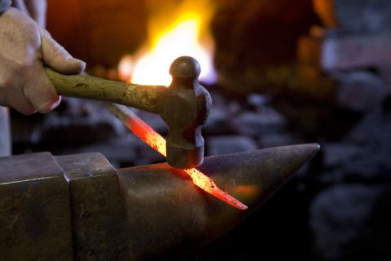
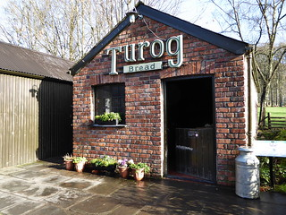
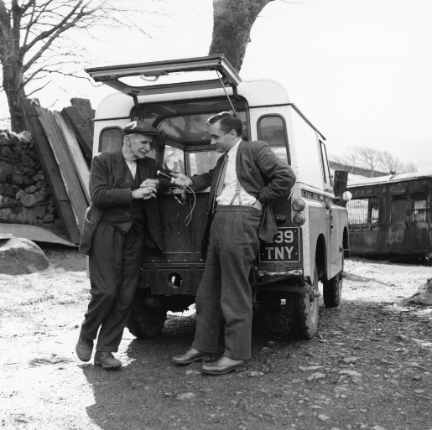
In St. Fagans it is easy to gain a sense of what constitutes Welsh Culture. Every aspect shown in the museum has deep set roots to the Welsh past. One of the exhibits is even a ‘Welsh life’ exhibit. Furthermore, the use of past technologies and crafts even more so gives a sense of Welsh culture. Being able to see and almost ‘live’ the life of past Welsh peoples gives the visitor a better idea of what it was to be Welsh at different points in time. In 1958, due to the decline of Welsh speakers after the war, the museum started recording the oral dialects and traditions throughout Wales (St. Fagans, 2021). This is a contemporary way of showing the culture of Wales. This form of heritage moves away from the traditional museum idea of using objects to show the past and culture and uses multimedia instead to document and keep the past traditions of Wales alive. This makes it very easy to get a sense of Welsh culture due to language and speech being such an important and often forgotten part of heritage. In the 70s another intangible part of Welsh heritage started to get recorded, food (St. fagans, 2021). The traditions throughout Wales were recorded and can be seen still today at the site especially using re-enactment. One of the buildings on the site is a bakery which sells Welsh bread which is made in traditional styles. Furthermore, the museum has put a focus into the maintenance of traditional crafts. A gallery and workshops throughout the year showcase crafts. Moreover, they also offer courses so the public can learn traditional crafts such as spoon carving (St. Fagans, 2021).
Figure 7 Bakery at St. Fagans (Flickr, 2021)
Figure 6 Man interviewing a local (St. Fagans, 2021)

Figure 8 Blacksmithing (National Museum Wales, 2021)

Intangible heritage is a key aspect of heritage as it includes some of the most important parts of cultural identity such as language, practices and music. UNESCO has played a role in making sure that past traditions are being kept in cultural heritage by expanding on what is thought of as ‘cultural heritage’ (UNESCO, 2021). Even though Intangible cultural heritage is fragile it is ‘an important factor in maintaining cultural diversity in the face of growing globalization’ (UNESCO, 2021). With the face of Wales ever changing, St. Fagans highlights the intangible heritage of Wales gives the museum further grounding and offers visitors a fuller experience of what constitutes Welsh culture.

Who’s culture?
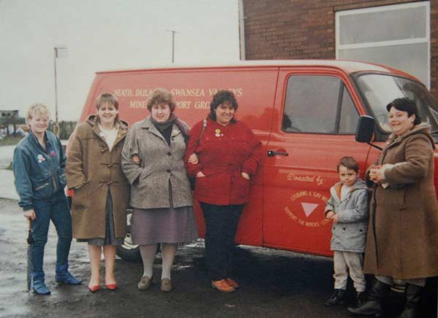
One major issue at St. Fagan’s is the lack of diversity in what is presented as the ‘Welsh identity’. There is no reference to coastal towns which comes across as odd as a large part of Wales is a coastal nation. Being from the coast offers a whole different understanding to your identity. There is also a lack of any other history than that of white and straight individuals. The Black history of Wales is rich as can be highlighted through the ‘Pitch Black’ event which was run by the National Museum of Wales in May 2021. The same goes for LGBT+ history of Wales. Some of the loudest voices in Lesbians and Gays Support the Miners, were from Wales (Power, 2016) yet this is also omitted from the history at St. Fagan’s. What is interesting is that the St. Fagans website declares the site as a reflection of everyday lives of ordinary people (St. Fagans, 2021). The first director of the museum defined ‘folk’ as the ‘whole community or nation, and not merely part of it’ (McAleavey, 2009). If this was true then there would be a larger inclusion of sexualities, races, etc. Maybe in the 1940s this statement felt truer to people due to the attitudes of period. Nowadays people must realise this is only a very select image of what Welsh culture is and has been and that the wishes and definition of Peate (the first director) need to be re-evaluated. Another issue lies with the language. Granted, Welsh is spoken nowadays but there is not as much focus on other languages which are part of the melting pot which is modern day Wales. It is understandable that the Welsh language is the key focus of the museum, but this does limit the view of Welsh culture. In the 1951 census, there was 21,000 Muslims in Wales and England, whereas in the 2001 census there were 1.6 million (Peach, 2006). This indicated that there has been a large intake of Muslims since the opening of the museum but very little has been done to fully represent them as part of Welsh culture. Many of the Muslims in the 2001 census may be 3rd or 4th generation and identify as Welsh but this is not seen in the museum besides a temporary exhibit (McAleavey, 2009).
Figure 3 Wives of the miners (Field, 2013)

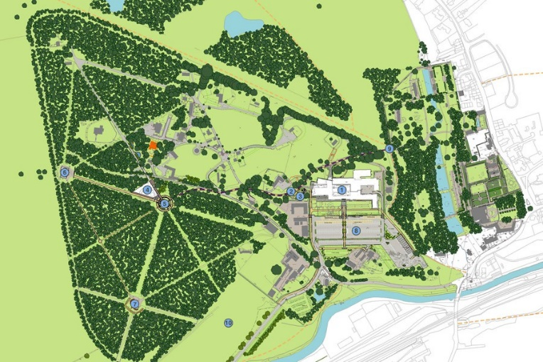
Relocation and authenticity:
Figure 4 Map of St. Fagans (TEP, 2021)
To get an insight to what Welsh Culture is, St. Fagans has removed multiple buildings from multiple locations and recreated them on the land of a country estate in the South of Wales (Figure 10). This can be problematic because these buildings are now out of context and the question must be asked if they still offer as much insight to the past as they were in their previous location? When in their former locations the buildings interacted with the landscape and the people in that specific area. Many of these buildings possibly had a strong sense of agency. Even though they may still be impressive at the museum, the agency and meaning is altered, it loses authenticity. Curtis states that ‘When a historic building has been moved, it loses its integrity of setting and its ‘sense of place and time’ (Curtis, 1979). Exiting a round house onto a newly made path which continues to a modern 21st century building does not exactly offer an ‘authentic’ experience but rather a staged one which can seem confusing. Much Welsh culture is tied up with its landscape. The relations to place are intrinsic to people and their traditions.

The issue of relocation and lack of context does not lie with only the buildings. The items on display in Oriel 1 have been branded by McAleavey as having ‘no contextualisation’ and ‘being hard to read’ (McAleavey, 2009). Furthermore, having multiple time periods makes the experience even more disorientating. It cannot offer a sense of what Welsh culture is because all the ‘best’ parts of the history have been forced together and highlights the fact that these buildings are not in situ so the image offered of Welsh culture is actually inauthentic.

This issue is not unique to St. Fagans. Many living history museums and museums in general can only showcase so much so have to select what the curators and governments think is most appropriate and will draw in most people. Other museums, such as The Aboriginal Heritage Museum and Keeping Place in WHERE!!! , have a similar issue as they tell a very specific narrative from a specific point of view. In the case of the Aboriginal Heritage Museum what they choose to show, the effects of colonialism (Aboriginal Heritage, 2021), is the dark side of their heritage and should be highlighted but people could argue that it is too focused and does not cover enough areas outside of colonialism.

Tourism:
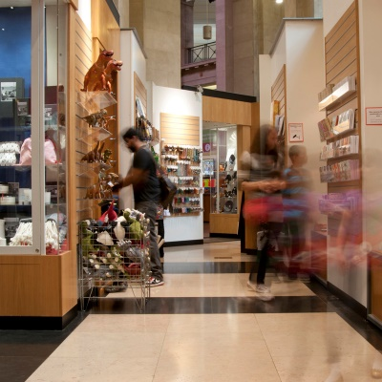
Nowadays heritage is often a matter of tourism. To maintain sites and in St. Fagan’s case, to remove and rebuild buildings, it is a princely endeavour which needs funds. In October 2018 St. Fagan’s underwent a £30 million pound redevelopment and even though it went on to win £100,000 for the best museum award the costs are still higher than revenue (Freize, 2019). The expenditure for Welsh museums in 2016/17 and 2017/18 were £31,155,000 and £30,072,000 respectively (Amgueddfa Cymru Financial Report, 2018). The need for money at heritage sites plays into the hands of tourism as it is the main income. Even though St. Fagan’s offers free entry, the influx of tourists brings in money through various other ways. Between fresh bread being made on site in historically accurate ways to the gift shop which you must walk past on your way in and out. One trip advisor reviewer had this to say about the museum:
Figure 5 Gift shop at St. Fagans (St. Fagans, 2021)
‘It seems only a matter of time before the museum aspect of St Fagans is dropped and lost forever in favour of a theme park for children where they can enjoy themselves but learn absolutely nothing about Welsh heritage’ (Couzensclan, 2019).
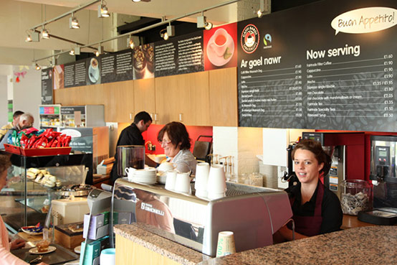
The history and education of the site, to some people, is becoming secondary to the ‘attractions’ and ‘theme park’ that the museum is becoming. The activities offered, include the CoedLan, High Ropes which is charged at £12 per person (St. Fagans, 2021). Parking also brings revenue. The museum charges £6 a day for parking or 30 pounds per year if purchased in advance (St. Fagans, 2021). This form of income is nearly pure profit as car parks are relatively low maintenance. Many psychological tactics are used to make visitors spend money. This is often based on visitor data (Planning solutions consulting, 2021). This makes it more difficult for the visitors to get a real feel for what Welsh culture is when they are constantly being led to the eateries and shops which sell a watered-down version of Welsh heritage and in some cases have nothing to do with it. With this constant need to draw in visitors and make money the curators must make decisions by working out what will draw the largest crowds. This leads to a skewed view of what Welsh Heritage is.
Figure 6 Cafe at St. Fagans (Octopus Creative, 2021)

Conclusion:
Overall, St. Fagans does offer a sense of what Welsh culture is. So, technically the answer to the question is yes, yes, it is easy to gain a sense of what Welsh culture is, but it is only a sense. A fuller picture is simply not present and needs to be explored further outside of the walls of St. Fagans to understand what it truly means to be Welsh. But the reason one may only get a sense of what Welsh culture is, is due to systematic choices perpetrated by the government and legislating bodies. At the same time no one really knows what it means to be Welsh and what Welsh culture is. Welsh culture is different for everyone and is something very personal.

Bibliography:
Aboriginal Heritage (2021) The Aboriginal Heritage Museum and Keeping Place. Available at: https://www.aboriginalheritage.org/museum/ (Accessed on: 26th September 2021)
Amgueddfa Cymru Financial Report (2018)
Couzenclan (2019) Tripadvisor. Available at: https://www.tripadvisor.co.uk/Attraction_Review-g186460-d187984-Reviews-or10-St_Fagans_National_Museum_of_History-Cardiff_South_Wales_Wales.html (Accessed on: 20th September 2021)
Curtis, J,O. (1979) Moving Historic Buildings. Washington D.C.: Sage Publications
Farmakis, A. (2013) ‘Dark tourism revisited: a supply/demand conceptualisation’, International Journal of Culture, Tourism and Hospitality Research , 7(3).
Frieze (2019)
‘Exceptional Imagination, Innovation and Achievement’: St Fagans Named Museum of the Year. Available at: https://www.frieze.com/article/exceptional-imagination-innovation-and-achievement-st-fagans-named-museum-year (Accessed on: 20th September 2021)
McAleavey, M,W. (2009) ‘Renewal or Betrayal? An Experiment in Reflecting Welsh Identity at St Fagans: National History Museum’, folk life: journal of ethnological studies, 47, pp. 58-65
Morris, S (2018) ‘'Story of Wales': history museum's six-year revamp completed’, The Guardian, 18th October. Available at: https://www.theguardian.com/uk-news/2018/oct/18/st-fagans-welsh-history-museum-revamp-completed (Accessed on: 22nd September 2021)
Peach, C. (2006) ‘Muslims in the 2001 Census of England and Wales: Gender and economic disadvantage’, Ethnic and Racial Studies, (29)4, pp. 629 - 655.
Peoples Collection Wales (2021) Leaving Capel Celyn. Available at: https://www.peoplescollection.wales/collections/376981 (Accessed on: 26th September 2021)
Planning Solutions Consulting (2021) Marketing tips for museums and visitor attractions. Available at: https://www.pslplan.co.uk/marketing-tips-for-museums-and-visitor-attractions/ (Accessed on: 26th September 2021)
Power, L. (2016). It’s time to unearth the real history of LGBT people in Wales. Available at: https://www.heritagefund.org.uk/blogs/its-time-unearth-real-history-lgbt-people-wales (Accessed on: 22nd September 2021)
St. Fagans (2021) A Brief History of St Fagans. Available at: https://museum.wales/stfagans/stfagans-history/ (Accessed on: 22nd September 2021)
St. Fagans (2021) Plan your visit. Available at: https://museum.wales/stfagans/visit/ (Accessed on: 22nd September 2021)
UK City Map (2021) Location informations of St Fagans Castle. Available at: https://www.ukcitymap.com/st-fagans-castle-glamorgan-gps-location-coordinates.html
https://ich.unesco.org/en/what-is-intangible-heritage-00003 (Accessed on: 22nd September 2021)
UNESCO (2021) What is Intangible Cultural Heritage? Available at: https://ich.unesco.org/en/what-is-intangible-heritage-00003 (Accessed on: 26th September 2021)

Image Bibliography:
Field, N. (2013) Veteran activists remember LGBT solidarity with miners. Available at: https://socialistworker.co.uk/art/36951/Veteran+activists+remember+LGBT+solidarity+with+miners (Accessed on: 26th September 2021)
Flickr (2021) Still Making Bread In The Old Bakery At St Fagans. Available at: https://www.flickr.com/photos/72191066@N00/32758991112/in/pool-cymru/ (Accessed on: 26th September 2021)
Google maps (2021) Available at: https://www.google.co.uk/maps/place/St.+Fagans+National+Museum+of+History/@52.2319995,-4.7233582,7.67z/data=!4m5!3m4!1s0x486e1abf1bc08b2b:0x654ff013c875edb9!8m2!3d51.487203!4d-3.2723611 (Accessed on: 26th September 2021)
National museum Wales (2021) Creative and Craft Courses https://museum.wales/creative-courses/ (Accessed on: 26th September 2021)
RIBAJ (2019) St Fagans Museum Main Building, Cardiff https://www.ribaj.com/buildings/wales-regional-awards-2019-st-fagans-museum-main-building-cardiff (Accessed on: 26th September 2021)
St. Fagans (2021) A Brief History of St Fagans. Available at: https://museum.wales/stfagans/stfagans-history/ (Accessed on: 22nd September 2021)
St. Fagans (2021) Shopping. Available at: https://museum.wales/cardiff/visit/shopping/ (Accessed on: 26th September 2021)
TEP (2021) ST FAGANS NATIONAL HISTORY MUSEUM. Available at: https://www.tep.uk.com/project/st-fagans-national-history-museum/ (Accessed on: 26th September 2021)
Wiki commons (2021) Category:Rhyd-y-car Ironworkers' Cottages Available at: https://commons.wikimedia.org/wiki/Category:Rhyd-y-car_Ironworkers'_Cottages (Accessed on: 26th September 2021)
Wiki commons (2021) File:Celtic Village St Fagans 01.JPG https://commons.wikimedia.org/wiki/File:Celtic_Village_St_Fagans_01.JPG (Accessed on: 26th September 2021)

