Overview/ground rules
This document will guide you through the use and setup of System Center Virtual Machine Manager. SCVMM is a cloud-based technology sitting on top of Microsoft’s Hyper-V platform. We will be using this platform to deploy our network service architecture throughout the module.
You will be split into groups of 2-3, and work together on labs which will culminate in a working enterprise network.
There are some limitations and rules which you must obey when using this software. SCVMM is extremely powerful, and you will be given a high level of access to the network in order to be able to use it. Some simple rules/guidelines:
- Your cloud of virtual machines is segregated both from the other groups’ clouds and SOAC’s mission-critical architecture. While you should be restricted to your own cloud, do not under any circumstances attempt to gain access to any other student’s cloud, or any virtual machine you yourself did not create. Again, while it is almost certain you won’t be able to access anything other than your own cloud and virtual machines, do not under any circumstance attempt to gain access to anyone else’s. If you find a way to do so, report it to Tim immediately. Penalties for disregarding this rule will be university-level and severe.
- You have a limited set of resources to work with. You will have 6144mb of RAM and 50gb of hard disk space with a maximum of 4 virtual machines. These are tight limits, partly due to the realities of the failover cluster you’re working on, but also partly to give you experience of working in a real-world environment where resources are invariably at a premium. Hard disk space in particular is at a premium; take steps to reduce your disk sizes where possible.
- Avoid doing anything to degrade performance unnecessarily. I have placed no hard restriction on the amount of network traffic you can generate, but suffice it to say, ensure you do not do anything to excessively degrade network performance.
- Please power down your virtual machines when you won’t be using them for a while (e.g. between classes). Feel free to power them up at any point to continue working outside of class, but power them off again when finished. The boot-up time for SCVMM machines is extremely fast (a few seconds).
- If you’re unsure, ask Tim. Again, you’re working on very powerful hardware, in a production-level environment. While I’ve tucked away most of the things you could use to do harm, if you’re in any way unsure, be it what a particular function does, or whether doing something will have undesirable side-effects, ask first. Be sensible, and use judgement.
- This is a group work-heavy module for the practical work, but each worksheet must be completed independently. You may use the screenshots generated while working on the labs, but all other work must be independent. I will be asking each group member to assess one another’s contributions to the labs throughout, and will adjust marks accordingly if necessary.
- Very fast groups may complete 4 of the 5 worksheets in class, however this is not expected. Assume you will likely have to spend some time working on them outside of class in addition – remember that you can only do this from inside the university network due to access issues.
- This will be a very enjoyable module, but do not take lightly the level of privilege you’re being given. This is an excellent learning opportunity for production-level cloud computing software; an extremely desirable skill in industry. Be sensible, treat the environment with respect, and enjoy yourself.
Aims of this session
Here, we’ll generate the structure required to support the rest of the module. Some of these activities (such as mounting an ISO and installing an image) are a little time consuming, especially when many students are working on them at once. We’ll aim to get all of these activities complete in this session, which will be the setup for the remainder of the module.
Our goal is to create three virtual machines:
Name | Operating System | IP Address
Cardiff | Windows 2012 Server R2 | 192.168.0.1
Swansea | Windows 2012 Server R2 | 192.168.0.2
Lab-01-01 | Windows 7 | (Assigned later)

In essence, your task for this tutorial is to:
- Create all three virtual machines.
  - Install the operating systems.
- Name both server machines.
- Utilise the virtual network (isolated) to network “Cardiff” and “Swansea”.
- Test this by pinging between the two hosts.
  - Will require modification of firewall rules.

We will use this structure for the remainder of the module.
This worksheet is not assessed and does not need to be handed in with the others.

Connecting to the System Center Virtual Machine Manager (SCVMM):
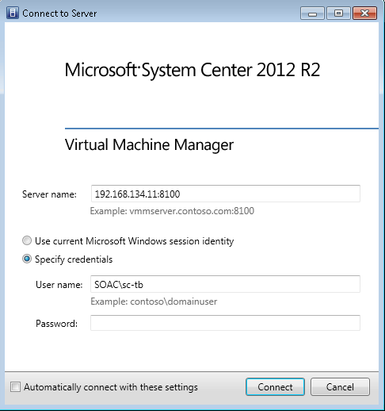
Note that tesla.soac.smu.ac.uk is an alias for this IP, so tesla:8100 will work within SOAC.

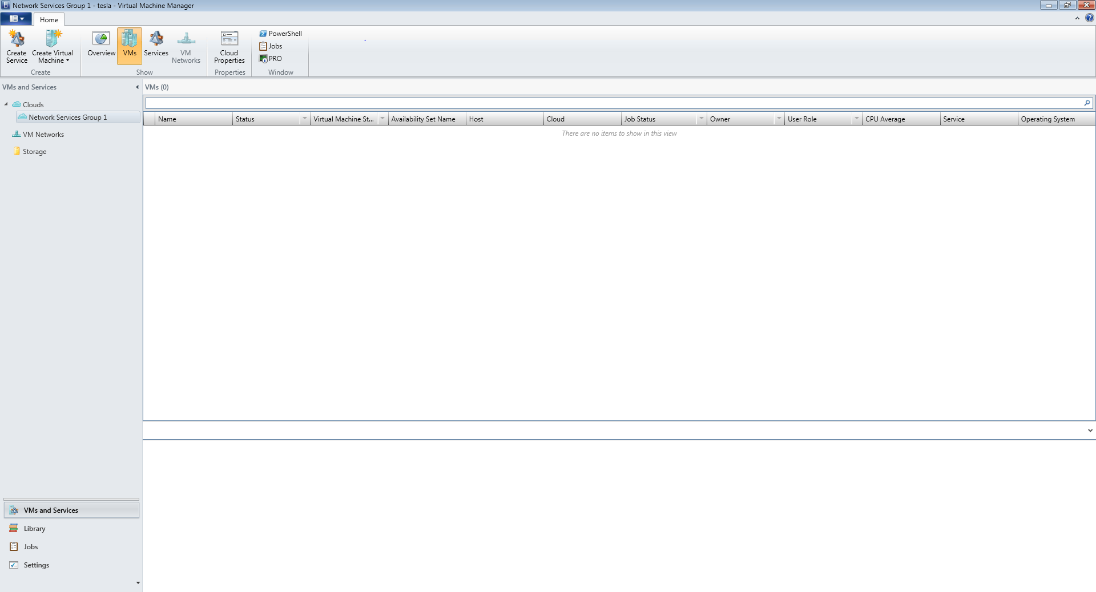
This is the main VMM window – get familiar with some of the controls. From this screen, you can control your virtual machines – from creating, to provisioning, viewing and deleting.
We’re going to start by creating a new VM using the Create Virtual Machine Wizard.
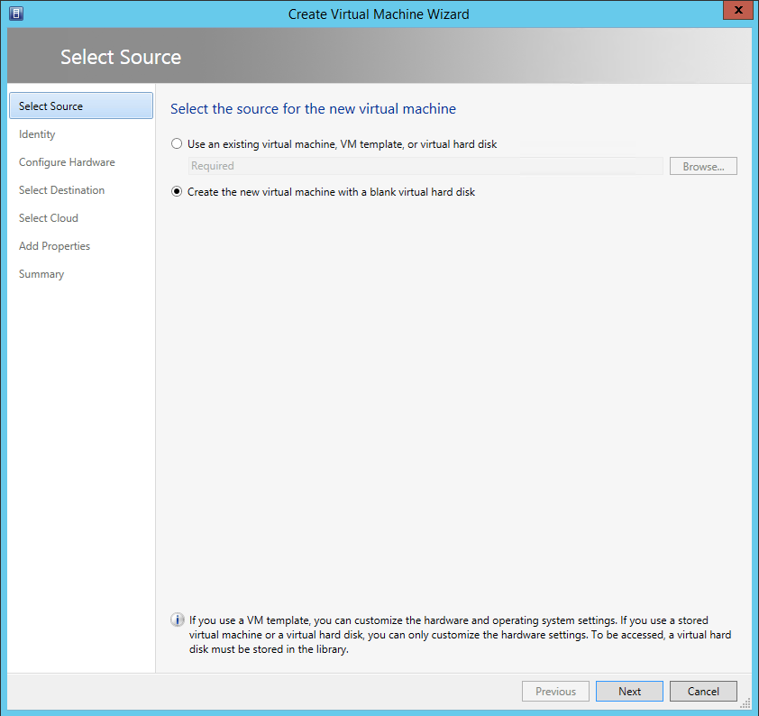
Create a new VM with a blank hard disk.

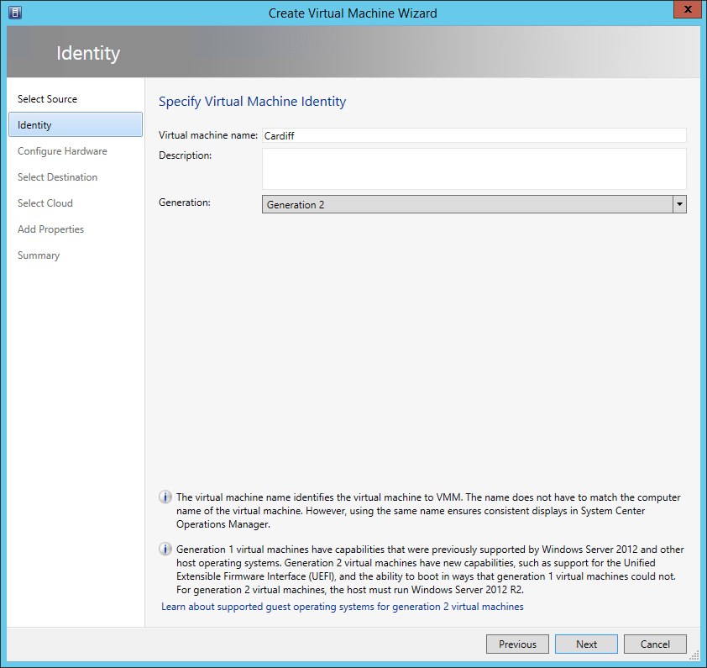
Name it “Cardiff” – this is going to be the first server.
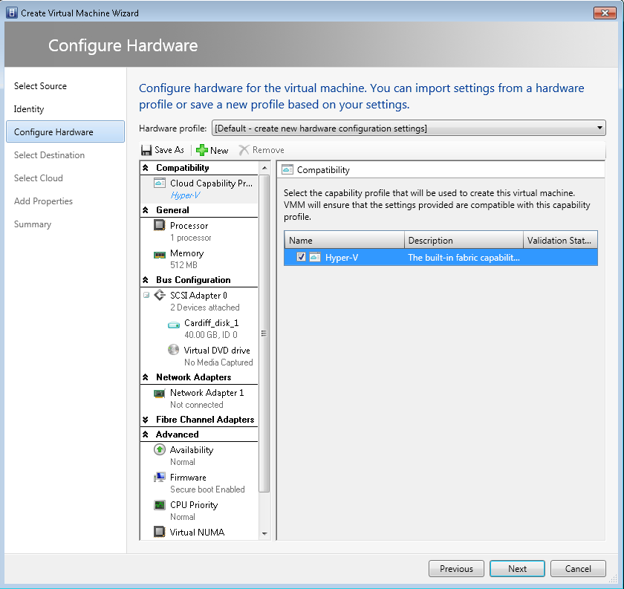
Be sure to do this first – if you miss this step, the VM is likely to fail to provision.
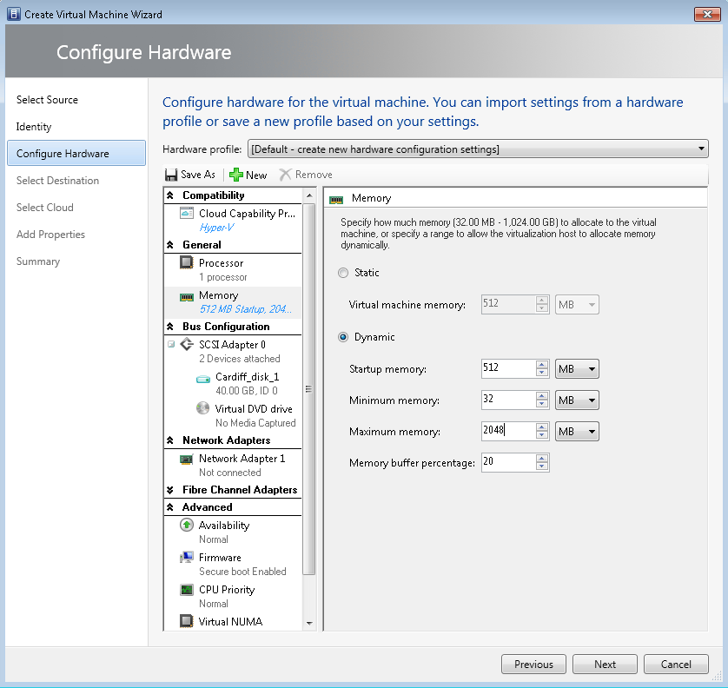
Set a dynamic memory limit. Remember that you have a maximum of 6144mb to use – if you exceed this, your virtual machines will be shut down, so be judicious.

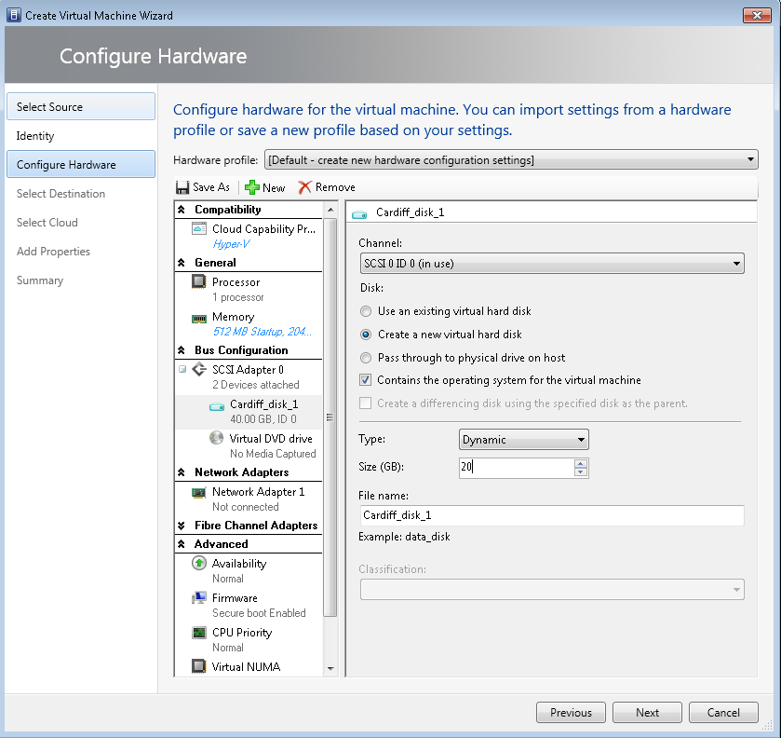
Reduce the size of your hard disk drive. At minimum 15gb.

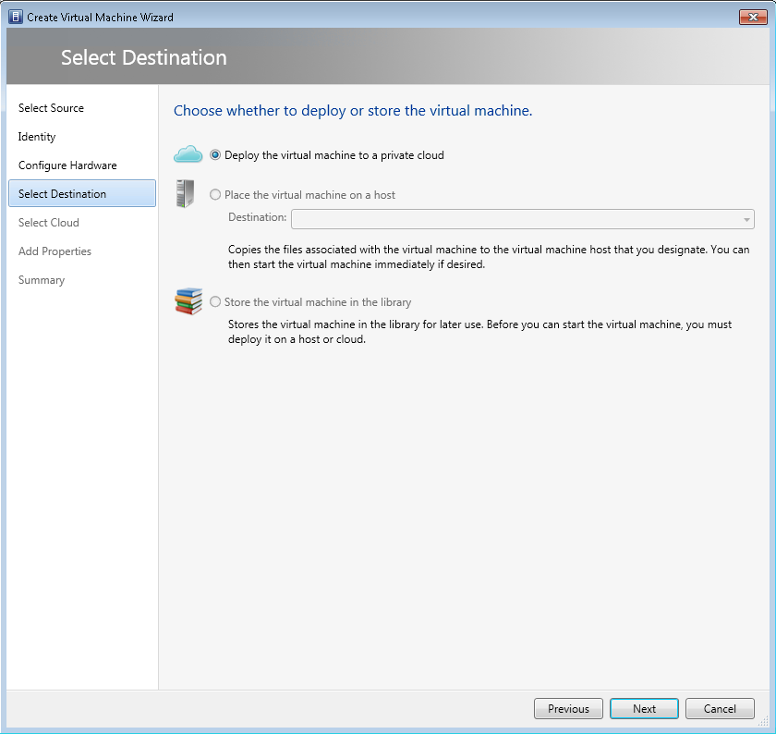

If you see an error at this screen, it’s almost certainly because you forgot to set the Hyper-V capability profile. Go back and do this – you may have to re-create the virtual machine. Remember to do this first.
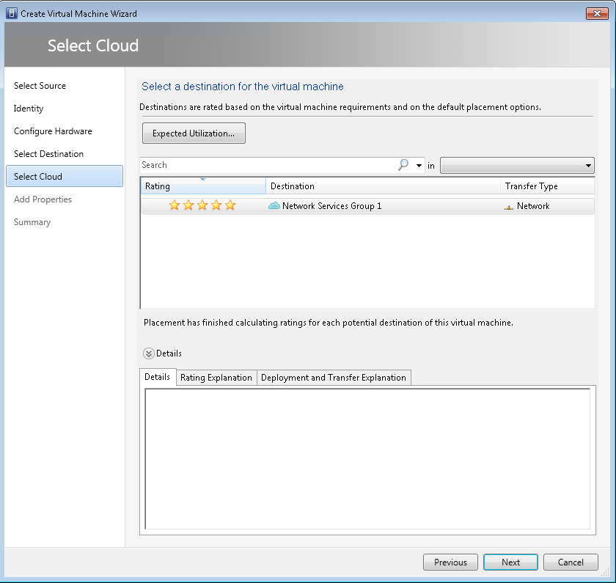
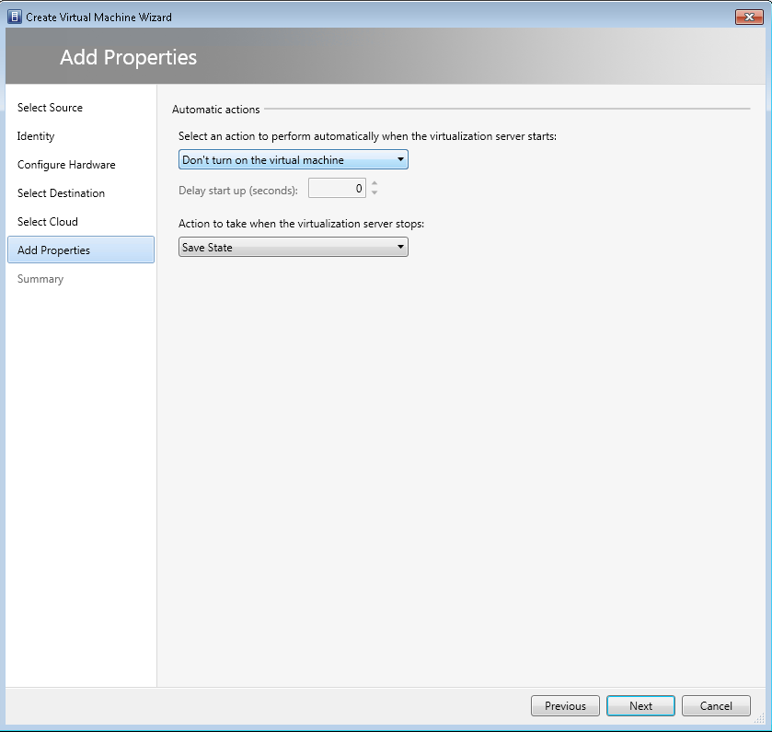
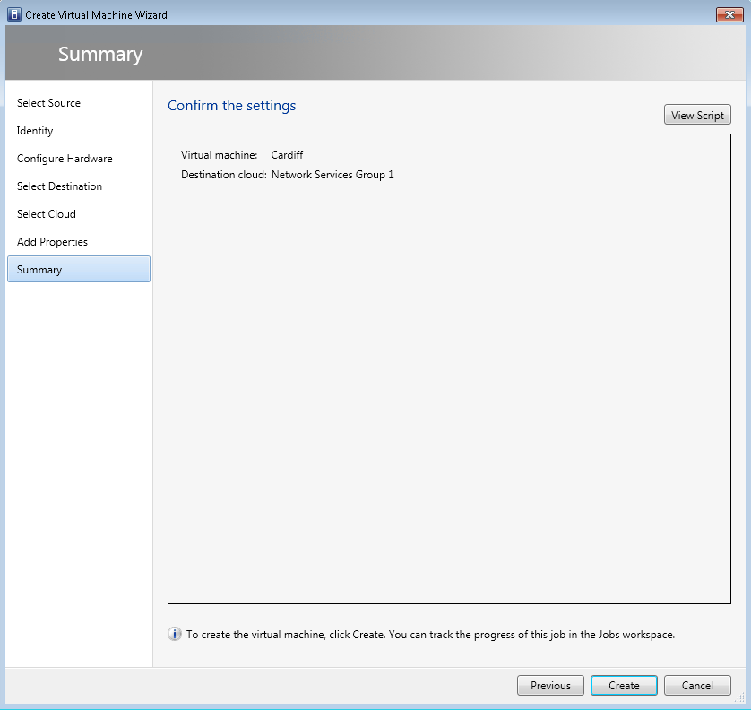
Hit create. You may see this error, but don’t worry, it can be ignored.
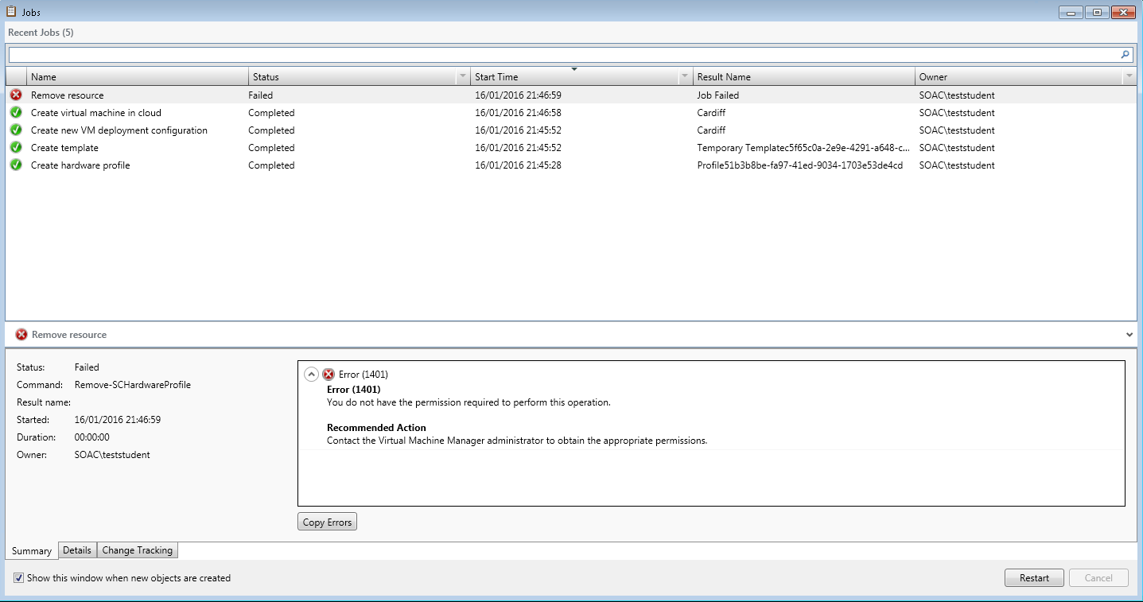
Now navigate to the properties of the virtual machine.
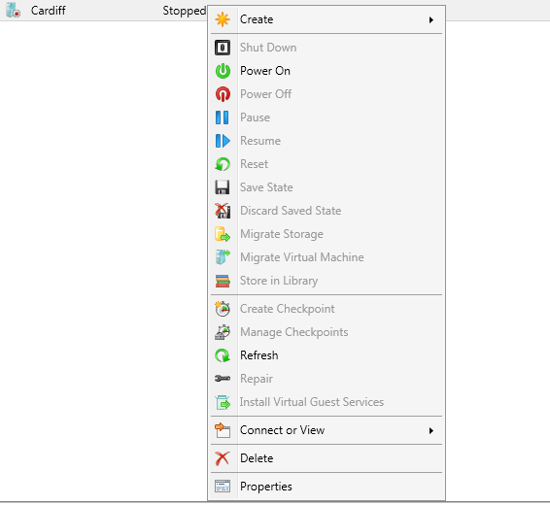

Navigate to “hardware configuration” and the Virtual DVD drive.
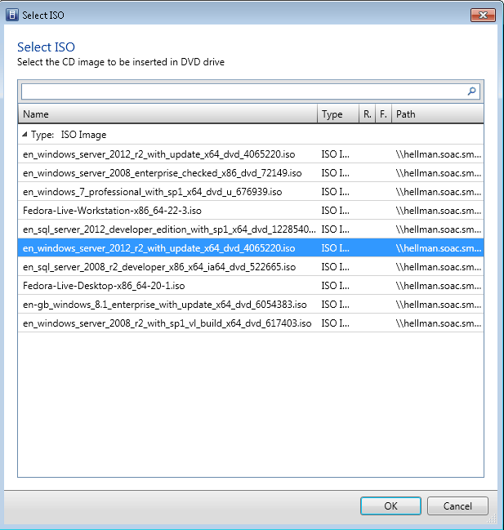
Select the Windows 2012 server 64 bit virtual machine image.
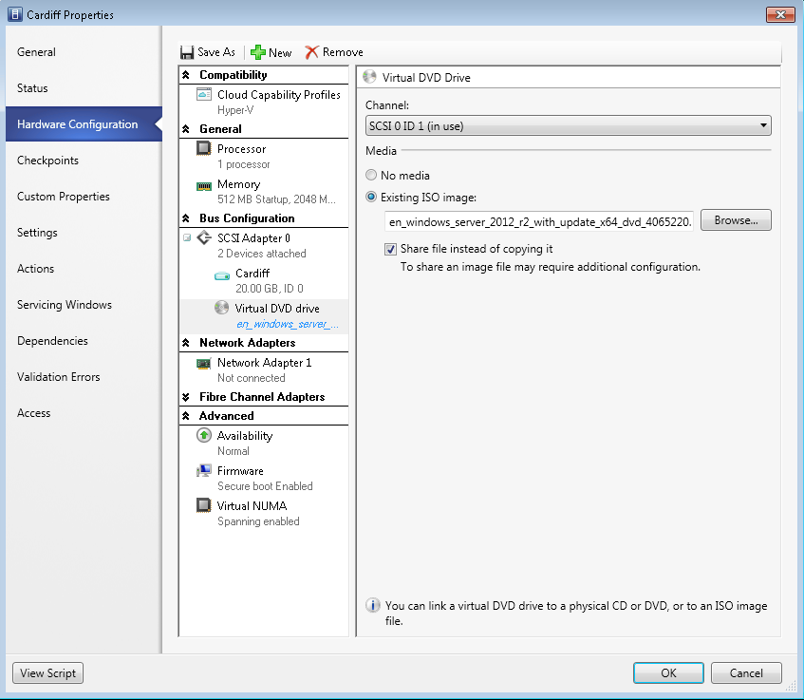

This will take around 5-10 minutes to complete.

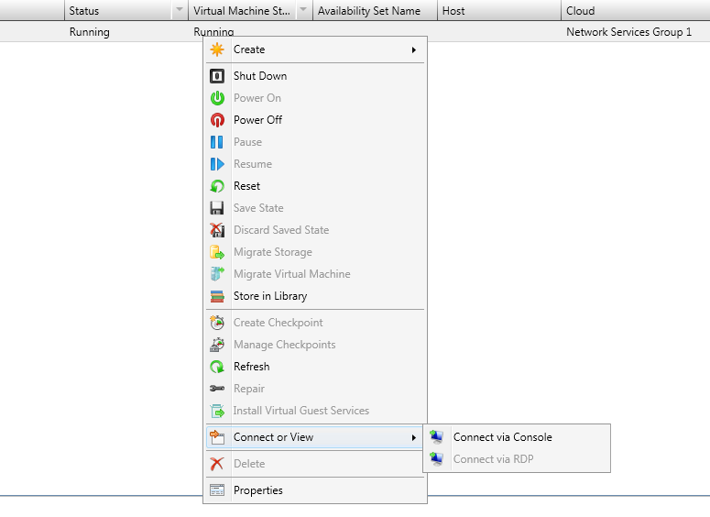
Connect to the virtual machine through “Connect via Console” and install the OS.

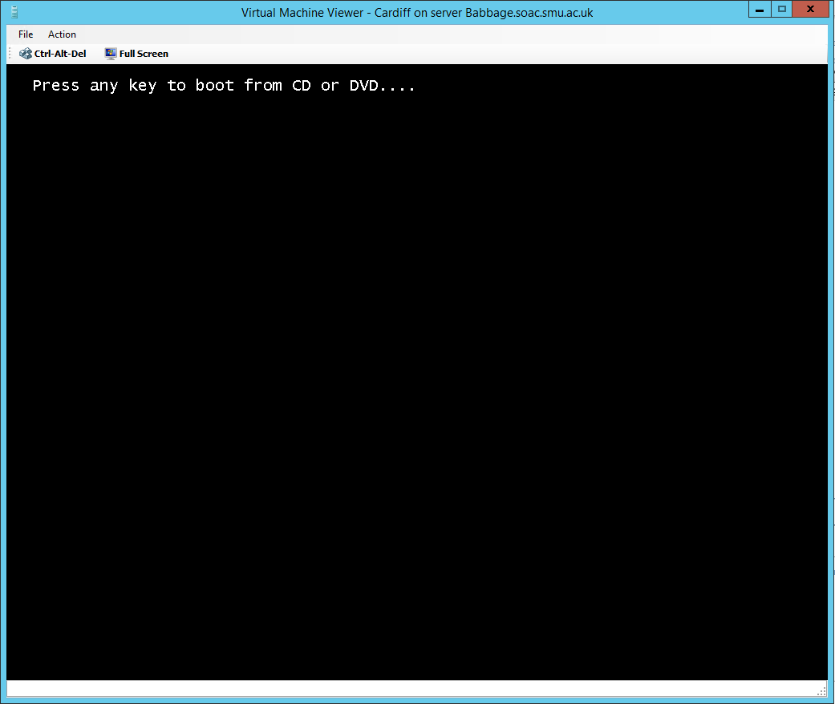

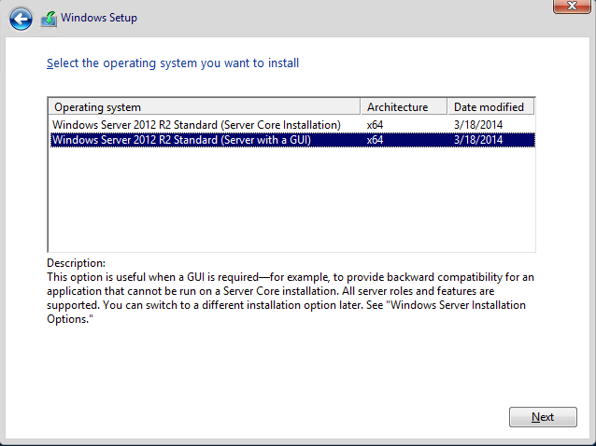
Select “Server with a GUI” (otherwise you’ll end up with a PowerShell server only).
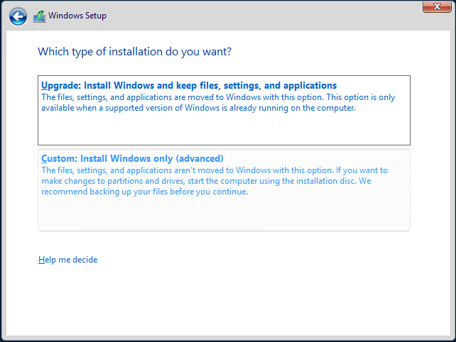
Hit custom.
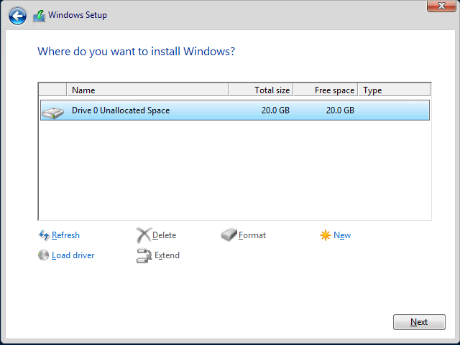
New -> Apply.
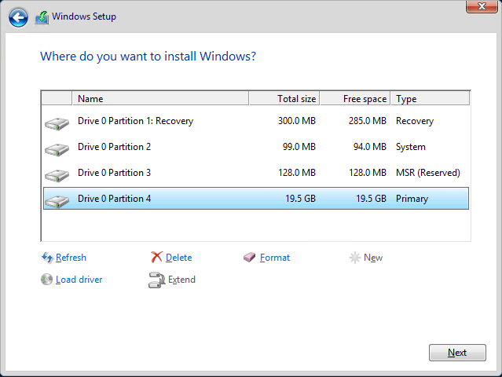

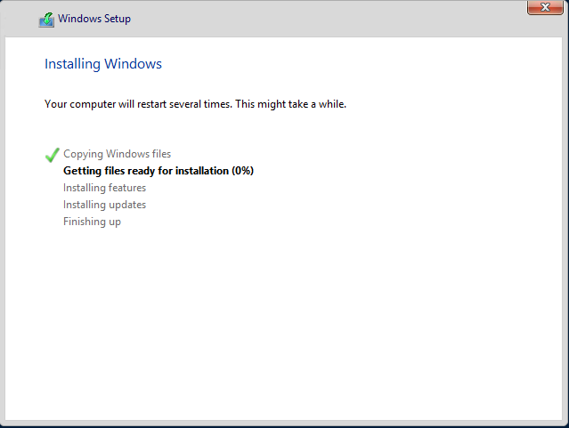
This should take around 5-15 minutes.

Once finished, select an administrator password. Make sure everyone in your group knows it. It doesn’t have to be anything secure; the virtual machines are (deliberately) on an isolated virtual network, so can’t be accessed outside SCVMM, and will require your SOAC domain credentials to view. I would recommend “P@ssw0rd” as it meets every requirement, and is easily remembered.

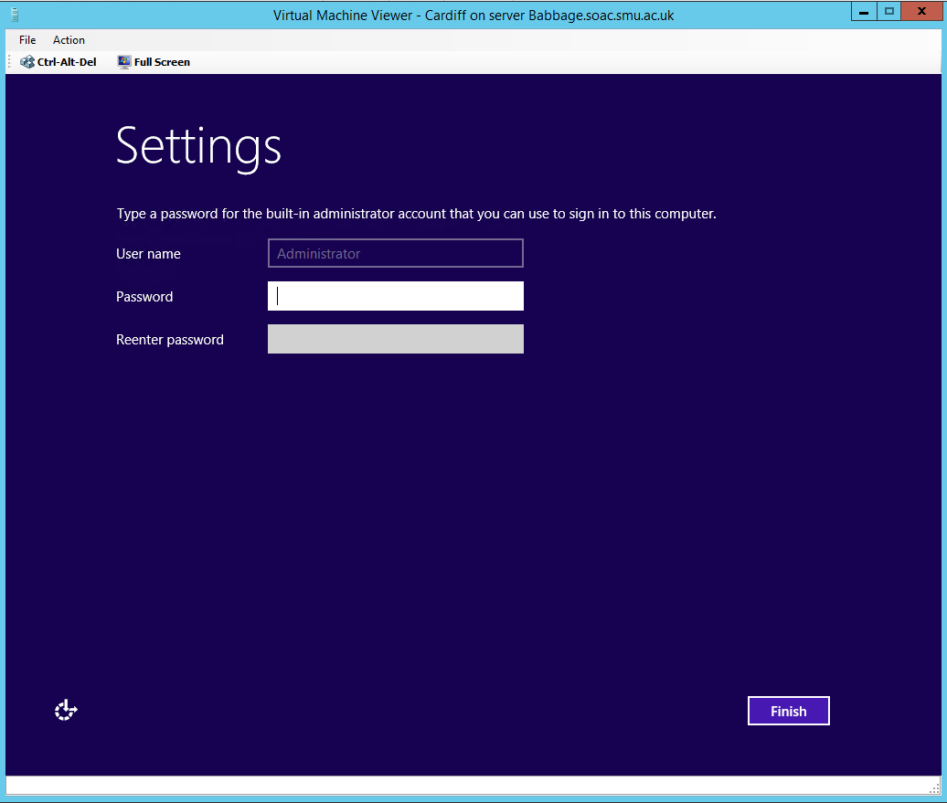

Task
- Create a second Windows 2012 Server installation, with a server called “Swansea”. You may wish to clone “Cardiff” – the VM being cloned will need to be powered down to do this.
- Create a Windows 7 client. Install the OS. We won’t be using this any further today, so it may be powered down. This will run fine with a 15gb hard drive.

Next: networking. First we need to understand networking in SVCMM. I have created 3 networks for you – these are completely isolated; they can neither reach the outside world, nor each other. Today we’ll work only with a single network card for testing purposes, however we’ll ultimately use all 3 networks in some capacity.
Power off both of your servers – to make any changes to virtual machines the VM will need to be powered down.
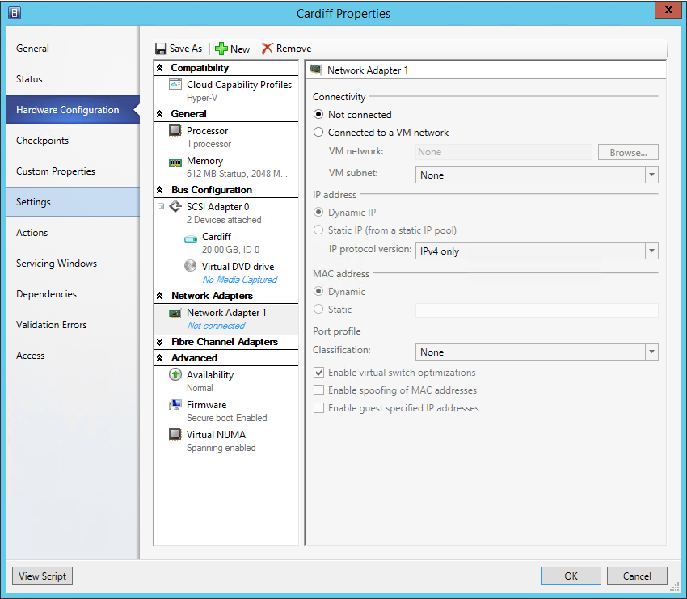

Select “Connected to a VM network” and hit “Browse…” – you should see 3 networks here, named Network Services Group x Network 1/2/3. If you don’t have 3 networks, let Tim know!
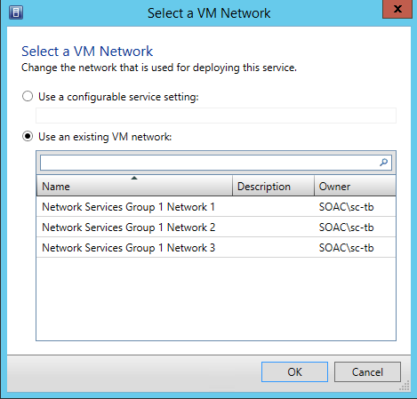

Select Network 1, and check “Enable Virtual Switch optimizations” (note: American spelling of optimisation).
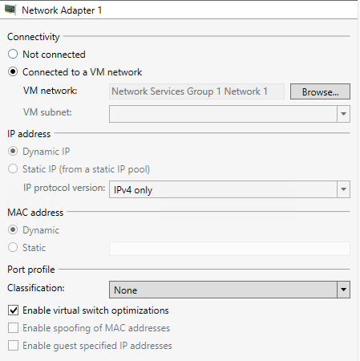
Repeat for the second virtual machine and power both of them on.

We’ll now statically assign IP addresses to the single Network Interface Card (NIC). Assign 192.168.0.1 to Cardiff, and 192.168.0.2 to Swansea, with the subnet mask 255.255.255.0.
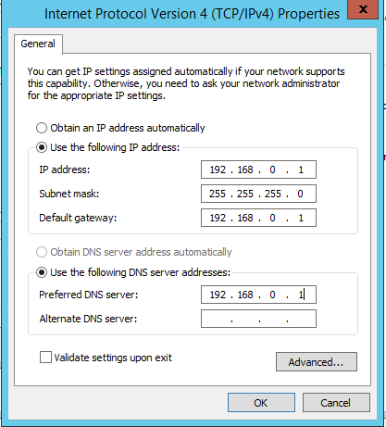
We’ll also set the default gateway and DNS servers to the local address – the DNS server in particular will be required later.
We’ll now test this by attempting to ping each host from the other. Note that to do this you’ll need to create a firewall rule allowing ICMP traffic.

Open the “Windows Firewall with Advanced Security” application and create a new inbound rule.
Select “Custom”, “All Programs”.
Set the protocol type to ICMPv4:
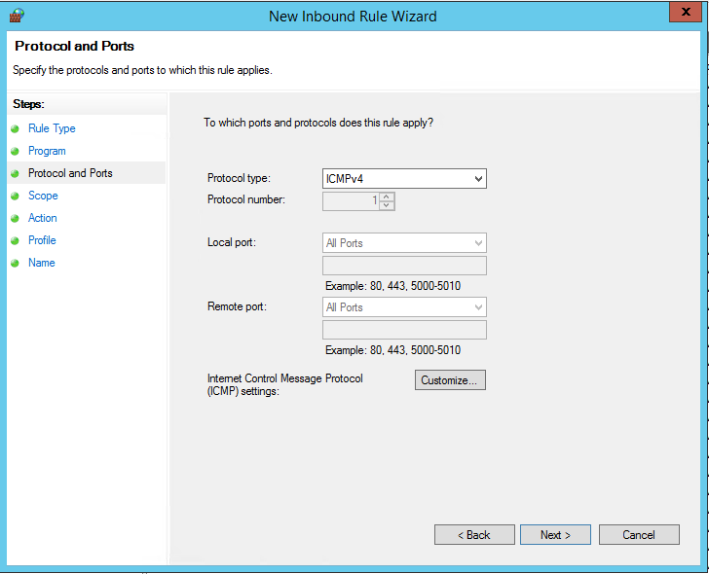
Leave the scope for “any IP addresses”.
Allow the connection.
Leave all 3 network profiles enabled.
Give the rule an appropriate name, such as “ICMPv4 Ping”.

We can now try to ping each remote host. Open command prompt, and attempt to ping 192.168.0.1 from “Swansea”, and 192.168.0.2 from “Cardiff”.
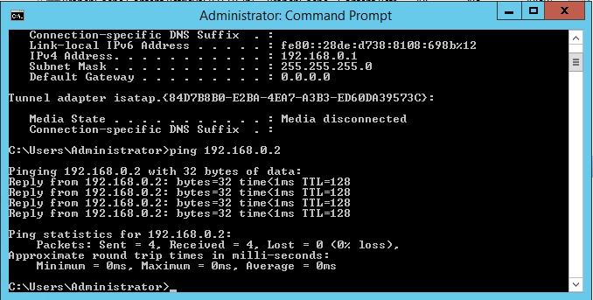

Finally, we’ll name each PC, resulting in a NETBIOS broadcast. Name the “Swansea” and “Cardiff” servers “Swansea” and “Cardiff” respectively, but leave them on WORKGROUP for now – we’ll create a domain later in this module. Both machines will need to be restarted.
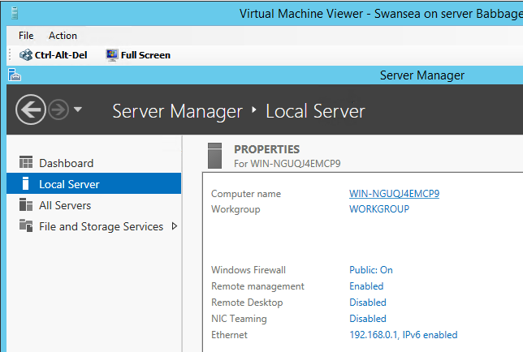

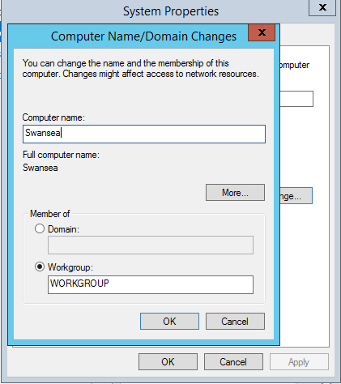
You must restart when prompted. 99% of the time you can ignore a request to restart; this is one of the few times you can’t.
Once both machines are named and restarted, test netbios broadcast by entering the command “nbtstat -n” at console:
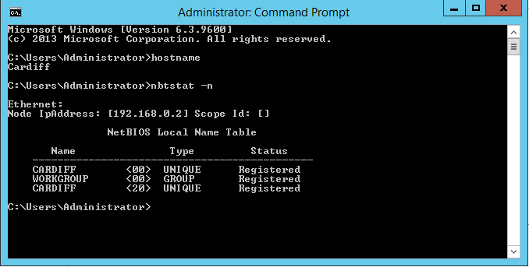
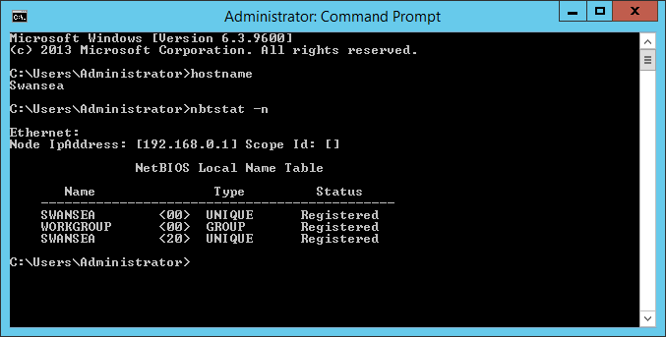
Once these commands are successful, you can consider this tutorial finished. Please power down your virtual machines until they are needed again.

