Skinner Versus Vygotsky

Skinner’s theory
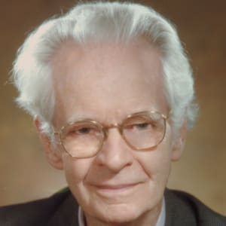
(Bigography.com, April 2014)

When you were younger, we all used to play nicely on the playground and made sure everyone was included. I remember when I was in junior school playing hopscotch, double dutch with my friends. But looking on my experiences within school now, most children are not able to play together nicely like we used to. This could affect their wellbeing and mental state, so therefore we need to praise children more for their good behaviour on the playground with others. This allows us then to look at the origin of the digital platforms that we see today.

Burrhus Fredric Skinner (1938) was one of the first American psychologists to begin work on the human behaviors, to which through his work we can now adapt the way we deal with the behaviours of those around us albeit in or out of education.

Have you ever thought about how it is children are able to regulate their behaviours?

From Skinners (1938) research throughout the year, he decided to develop a tool called ’The Skinner Box’, this helped him develop the skills to examine the different behaviours of animals before putting this to the test on humans. Psychologists these days have been evolving the work that (Skinner 1938) started to match this to individual families that they are helping at the certain points in time. A small clip of how this works is below:
B.F. Skinner Operant Conditioning (Full video) - YouTube

Have you seen a child’s behaviour change in seconds?

Throughout the time I have spent in school, I have noticed some teaching that can develop the young people today into great citizens today. This is put into prospective when you see a child that is hurting or looking for some attention off an adult in a position of trust. In my educational setting we work with the children with behavioural issues to help them regain their confidence and emotional support to get back into mainstream school.

I was sat at one of the tables in school the other day and noticed that one of the pupils was not having a good time, his head was on the table, and he was ready to just let himself shutdown. So, I chose to move closer to this child, so that I was there for a shoulder of support for them, to which after this he brightened up a little bit more and got on with the task in hand. Who knew by just moving closer to this certain pupil he would feel a bit more comfortable and confident to get the work done?

If I had not got close to the pupil, it could have turned into a different scenario, to which the pupil in question could have lost it altogether and carried on in the bad mood for the rest of the day. By doing this you are changing the way the child thinks, due to if you had your back to them and let them carry on as they were they would become defeated and continue to not do the work.

“A failure is not always a mistake; it may simply be the best one can do under the circumstances. The real mistake is to stop trying” – (Skinner, 1938)

This quote sums up all of the feelings of those children that I work with. when they have tried something once and did not get it right, they immediately put their barriers up and go into defeatist mode. This not only goes for the time that they are in school, but they could also be feeling like this when they are at home. We have found that many children come into school craving the attention that they do not get when they are home.
Many schools now use different digital platforms in order to keep in contact with parents but to also praise their students for the work they are doing. These vary from Seesaw, Dojo, Remind and Class tag. These are very useful tools because teachers are able to update these on the go.

Vygotsky – Theory

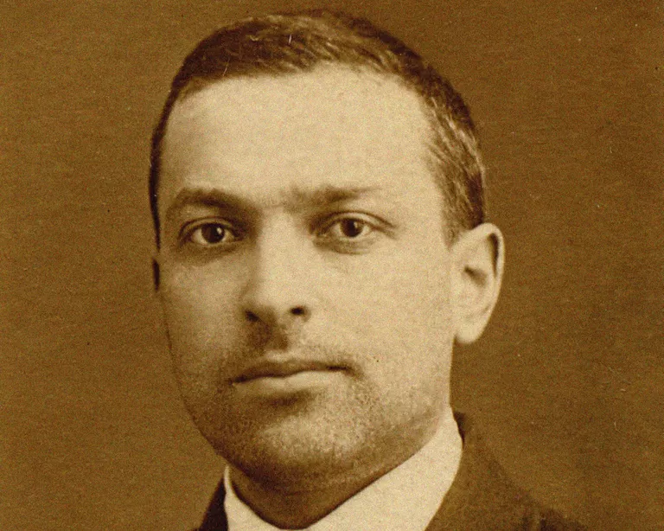
(Verywellmind.com, 2020)
Whilst listening to the Heart radio the other day, they were talking about how we have learnt from different experiences that we have had from years ago whilst we were younger. This could be anything from learning how to crawl, walk or even playing with toys.
Who was the first person in your social surroundings to help you learn something new?
Lev Vygotsky was the Soviet Psychologists, who looked at the social cognitive development and the Zone of Proximal Development. This is the framework that he developed was to show that within the social interaction through children’s play they are able to gain more knowledge of the world around us. Here below is a quick clip of Vygotsky’s (1978) theory:
Vygotsky's Theory of Cognitive Development in Social Relationships - YouTube
From this clip we can see how (Vygotsky 1978) came to find that through play base learning we can achieve a foundation of the world around us. Whilst looking at (Vygotsky 1978)’s zone of proximal development he quoted that “The "zone" is the gap between what a child knows and what they do not yet know.”.
Do you remember playing a new game and not knowing the rules?
I remember that when I was in junior school there were new games being created by my friends and I wanted to get involved. So, throughout time and observation of the game I finally got to know the rules, to which then I eventually joined in. But if it was not for the help of my friends and me looking in on the game then I would not have known what to do. As we have seen in the YouTube clip above, if one child gets the most attention and help to develop then they are getting the knowledge they need to make sure their zone of proximal development is fulfilled.
Vygotsky (1978) whilst going through his theories he concluded that everyone in their lives has somehow been a more knowledgeable other, this could be either towards a family member, a friend or even someone in the public eye. Most of these “more knowledgeable other’s” have already been through the processes of gaining this information already in their lives.
Whilst a child goes through the stages of problem solving, there is only so much of this that is possible on their own. For example, “a child could not solve a jigsaw puzzle by itself and would have taken a long time to do so (if at all) but was able to solve it following interaction with the father and has developed competence at this skill that will be applied to future jigsaws.” (Syafiza. S, 2017)

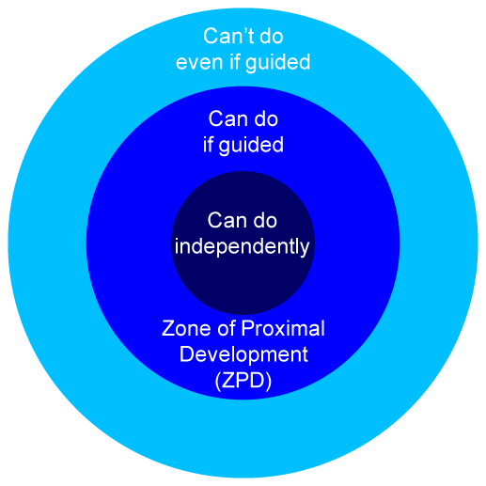

(sites.google.com 2017)
As Vygotsky (1978) states through his research children develop more knowledge through their surroundings and play. This can come to any of us at any stage of life. More schools around the country are developing their staff to help promote what we call “play therapy”. This is for some of the young people we work with that have missed out on the basics of life and also for those who have had to be young carers for family members or wider connections. Unfortunately, whilst all of this research has gone on the world has evolved so much and with technology evolving too, we are seeing more young people staying indoors and not getting the childhood that most of us had when we were their age.
In the link below, you will find an interview that Lev Vygotsky was involved with and hear about his views on technology: Virtual interview: In Conversation with Lev Vygotsky (firstdiscoverers.co.uk)
Element 3 and 4
Within education these days we see a lot more interventions for those who need them. This is what helps some of the young people we have come through education gain the knowledge and practices, that they need to get to the next stage of problem solving. The interventions that we carry out in our provision are Lego Therapy (Construction Crew), ELSA and Accelerated literacy. Through these we help the young people we work with gain the problem solving skills that they need for certain aspects of their lives.
Whilst we go through the eight-week programme of ELSA this is where we help them gain more knowledge on how to cope with their feelings physically and mentally. Many of the children that have come through the provision I work in have gone through this due to being unable to cope with their feelings or express them in the way they should. This can be used to help them with their behaviour within the classes and also within their home lives. We once had a child that came through our provision that when he first started with us, he was unable to put across his feelings and would get frustrated when he could not.
With a little bit of help and some resources which we found online and from other schools, he was able to portray to us what he was feeling. This links into both of the theories that the psychologists have found because, by learning how to tell us about his feelings he was able to gain the core knowledge that he needed to help him gain his full-time placement back into mainstream school. This shows that once these skills have been learned from gaining the information or problem solving, they are able to put this into practice without realising.
Did you ever play with Lego when you were younger?
Lego Therapy or Construction Crew as some schools call it at the moment, has become another intervention for the young people we work with. This is a great little way to get them using their fine motor skills and also their sharing skills. Whilst in Construction Crew they work as a team of three to build a Lego model of choosing. They have then got to choose which role they would like to do; this can be either the Engineer, Supplier, or the Builder. Once they have chosen which role, they would like to have this is when they start sharing the time, they have to make the model.
This gives them skills to learn off their peers and have a bit of fun whilst learning. Once they have completed each role once they then take it in turns to mark each other on how well they have been within the session.
These link to the psychologists and the learning approaches because both Skinner (1938) and Vygotsky (1978) have linked their research to the behaviours and retainment of information. Both of these practices look at the positive reinforcement to which within the ELSA and Lego Therapy if they have a positive session then they are able to earn what we call ‘Dojo’s’. This then helps then move towards their goal and onto trips. Whilst putting these positive reinforcements in place, we are able to change the way the children that our children think about their behaviours.
This helped with one of our children to keep them on track whilst they were with us. When he started with us, he was unable to control his behaviour and also would not open up to any member of staff. We put him onto the ELSA and Lego therapy schemes to help him with this, most of this started out on a one-to-one basis with him to introduce the child in question to the schemes, but then as time went on, we introduced someone that he was unable to grow a bond within our provision.
He enjoyed this as he was able to start making a friendship with another pupil and have someone other than the staff to talk to or to help him through the day. After the six weeks session had finished, we could not believe the difference in the young person. He was able to confide in the staff not just using the correct emotional feeling but also, he was able to calm himself down if he got wound up by another situation going on.
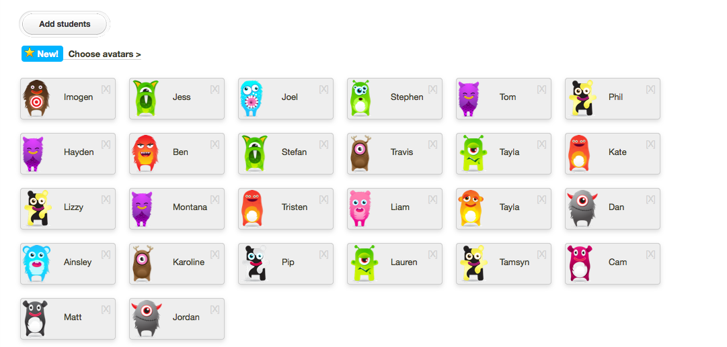
This Photo by Unknown Author is licensed under CC BY-SA-NC

In the above picture this is the face of class dojo, as you can see you are able to create your own little character from any of the ones chosen. In our provision and a couple of the mainstream schools that I have visited, they reward their students by letting them change the appearance of their dojo characters after they collect a certain amount of dojo points. This platform is one of the well used digital platforms, this is a great way for not only the students to have a visual take on how they are getting on in class but also their parents.
On the class dojo application our students’ parents are able to get a link sent to them and they can view all of the work that their child has done throughout the week, but they are also able to message the headteacher or class teacher about anything going on. Below is a picture of the parental view of the class dojo.

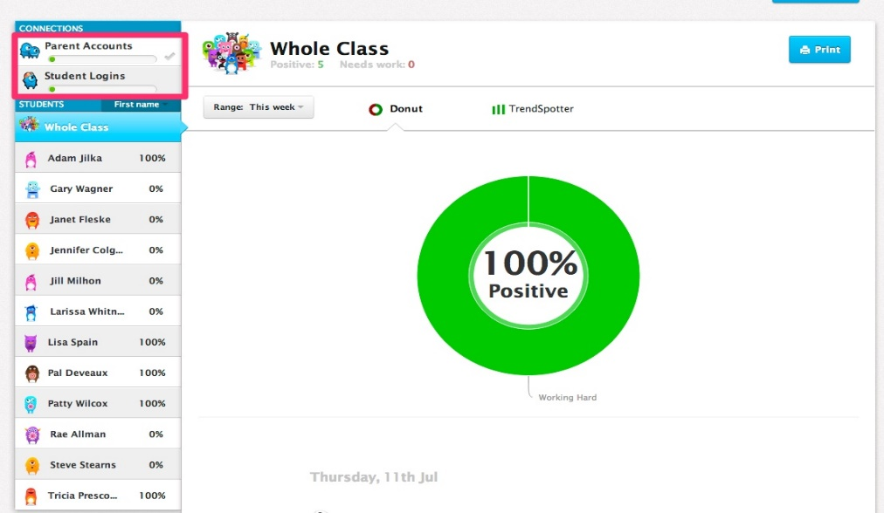
This Photo by Unknown Author is licensed under CC BY-NC-ND

There are many different ways that we are able to input positive and negative reinforcement to the pupils that we teach but it is finding that little niche that we are able to help them with. This is the same for the zone of proximal development for those we look after because without the teaching and help with problem solving that they are getting in the provisions or mainstream school they would struggle to get anywhere.
Why not have a look at some more psychologists and theories to help you?

References

Biography.com Editors, (January 2021), ‘The biography.com Website’, Available at: B.F. Skinner - Theory, Psychology & Facts - Biography , Accessed on: October 23rd 2021.
B.F Skinner Quote – Brainy Quote, (No date), ‘Brainy Quote’ , Available at: B. F. Skinner - A failure is not always a mistake, it may... (brainyquote.com) , Accessed on: October 23rd 2021.
B.F. Skinner Operant Conditioning Video – Escudero. O, (November 2018), ‘Youtube.com’, Available at: B.F. Skinner Operant Conditioning (Full video) - YouTube , Accessed on: October 23rd 2021.
Lev Vygotsky image – Swaim. E, (April 2020), A Biography of Lev Vygotsky, one of the most influential Psychologists’, Available at: Biography of Psychologist Lev Vygotsky (verywellmind.com), Accessed on: October 26th 2021.
Lev Vygotsky Quote - Swaim. E, (April 2020), A Biography of Lev Vygotsky, one of the most influential Psychologists’, Available at: Biography of Psychologist Lev Vygotsky (verywellmind.com), Accessed on: October 28th 2021.
Vygotsky’s Social Development Video – Sprouts, (February 2020), ‘Youtube.com’, Available at: Vygotsky's Theory of Cognitive Development in Social Relationships - YouTube, Accessed on: October 28th 2021.
Zone of Proximal Development example – Syafiza. S, (December 2017), ‘Social Development Theory By Vygotsky’, Available at: Zone Of Proximal Development (ZPD) - SOCIAL DEVELOPMENT THEORY BY VYGOTSKY - GROUP: MOCKINGJAY (google.com), Accessed on: November 4th 2021.
Virtual Interview with Lev Vygotsky – First Discoverers, No date, ‘Virtual interview: In conversation with Lev Vygotsky’, Available at: Virtual interview: In Conversation with Lev Vygotsky (firstdiscoverers.co.uk), Accessed on: November 6th 2021.

