Burberry
submitted by Rahul Kumar

STUDENT NAME: RAHUL KUMAR
STUDENT ID NUMBER: 2126814
MODULE: MARKETING MANAGMNET
LECTURER: Tushara Balendran
COURSE: MASTERS OF BUSSINESS ADMINSTRATION (GENERAL)
SUBMISSION DATE: 09TH SEP 2022
PAGES: 15

INDEX
1. Introduction…………………………………………………………………………………….1
2. Company’s Background………………………………………………………………….…….1
Communication:………………………………………………………………..……………..1
* Definition of communication……………………………………………………………………………...…….1
* Communication Model……………………………………………………………….………...2
3. Integrated Marketing Communication………………………………………………….….…..3
4. New Promotion Strategies ………………………………………………………………. ……4
• Sources of promotion………………………………………………………………………...….4
5. Brand and brand Equity………………………………………………………………….…..5
* Definition Of Brand Equity …………………………………………………………………….5
* Model and diagram……………………………………………………………………….……..6
6 Advantages and disadvantage of Equity ( KELLER’s brand Equity Model)………..………7-8
7. Customer Touchpoints…………………………………………………………………….9-10
* Pre-purchase……………………………………………………………………………….…...11
* Purchase………………………………………………………………………………………..11
* After Purchase………………………………………………………………………………….10
8. Customer Journey MAP diagram with the help of example of table………………………11
9. Total Engagement model: …………………………………………………………………12
10. Conclusion…………………………………………………………………………….…….13
11 References……………………………………………………………………………..……..14
Introduction
“Burberry, which was made in 1856, is an unmistakable worldwide brand for all kinds of people. The reason for this exploration is to decide Burberry's advertising position to give ideas. I directed essential exploration in which I made a poll on the web and requested that my Facebook companions finish it up to realize what individuals of any age thought about the brand Burberry.”
Background
The Burberry brand's primary objective is to investigate, secure, and rouse. These three standards are critical to the organization's image, conduct, and culture. Crafted by the Burberry Foundation and proceeded with headway in corporate obligation, it epitomizes these standards in real life (Burberry, 2003).
“Burberry was established in 1856 in Basingstoke, England, by Thomas Burberry, who began a business selling men's jackets. Burberry's standing was improved by disclosing "coat," a tearing-safe, waterproof, yet breathable material (Burberry, 2002). This new texture was appropriate to military necessities, provoking Burberry to foster a military official's parka, which became a critical part of the standard help uniform for British officials in the mid-1900s. Throughout World War I, Burberry kept assembling the official's parka by adding commonsense components like lashes, epaulettes, and D-rings, presently known as the "Raincoat." As an outcome of its tactical ties, the organization made its example: the dark, tan, and red example known as the Haymarket check or the Burberry exemplary check, which was initially utilized as a covering for the Burberry overcoat in 1924. By 1967, the Burberry Check, presently a perceived brand name, had been widely used all alone for things like scarves, sacks, umbrellas, and different embellishments (Burberry IPO Prospectus, 2002).”
Communication
Communication is the transmission and getting of data, which might occur one-on-one or in gatherings, and can happen up close and personal or by means of communication advancements. Communication requires the transmission of thoughts or the encoding of a message by the source, the person who starts communication. This message is shipped off the beneficiary, an individual who gets the communication, and the beneficiary must then disentangle or figure out the message. This is by all accounts simple, however it isn't (endlessly bet, 2013).
“Model of communication”
As found in the chart beneath, commotion might upset the communication cycle anytime. Chiefs should perceive that a conversation in the following office, a fax machine out of paper, and the collector's interests may all prevent the supervisor's earnest attempts to convey (Al-fedaghi, 2012).
Sender - The organization that sends the communication.
Message - What is sent from the shipper to the beneficiary.
Encoding is the interpretation of a message into its reasonable significance. This is the technique through which the message is addressed.
The medium by means of which the communication is sent is alluded to as the channel.
Unraveling is the method involved with interpreting a message and delivering importance from it.
Receiver - The organization that gets the communication.
Relational communication is worried about communication among colleagues. Both oral and composed methods of relational communication have unmistakable advantages and disadvantages. While choosing a communication medium, the administration ought to evaluate the advantages and disadvantages of every (Al-fedaghi, 2012).
Associations likewise have a great deal of casual communication. Communication networks are customary communication designs among individuals from a gathering. The grapevine is a casual communication network among representatives in an organization. The executives through walking around is another normal casual communication procedure. Looks, substantial developments, actual touch, motions, enunciation, and tone are instances of nonverbal communication (Al-fedaghi, 2012).

Fig 1

“Source: Communication Theory.com”
Hierarchical communication might take a few structures. Vertical communication among pioneers and subordinates might go one way or the other. Flat communication incorporates friends and associates at a similar hierarchical level. Data frameworks are likewise utilized by associations to deal with communication. Before very long, electronic communication is projected to essentially affect the board and authoritative communication (Al-fedaghi, 2012).
Integrated Communication Model
Incorporated showcasing interchanges (Also known as IMC) is a method for satisfying the objectives of a promoting effort by planning the utilization of a few special strategies that are intended to help each other simultaneously. We can perceive the worth of a far reaching plan that assesses the essential jobs of an assortment of correspondence trains like publicizing, advertising, individual selling, and deals advancement and consolidates them to give lucidity, consistency, and most extreme correspondence influence through IMC.
Burberry, as a significant number of us know, is a very good quality British design business best perceived for its notable plaid example and raincoats. As per my examination, Burberry has recognized a misfortune in income faster than some other extravagance products business when looked at over the most recent few years. As of now, Burberry CEO Angela Ahrendts has proposed what I accept is a brief answer for this issue.

Promotion
Associations likewise have a great deal of casual communication. Communication networks are customary communication designs among individuals from a gathering. The grapevine is a casual communication network among representatives in an organization. The board by means of walking around is another normal casual communication procedure. Looks, substantial developments, actual touch, signals, emphasis, and tone are instances of nonverbal communication (Al-fedaghi, 2012).
Fig 2
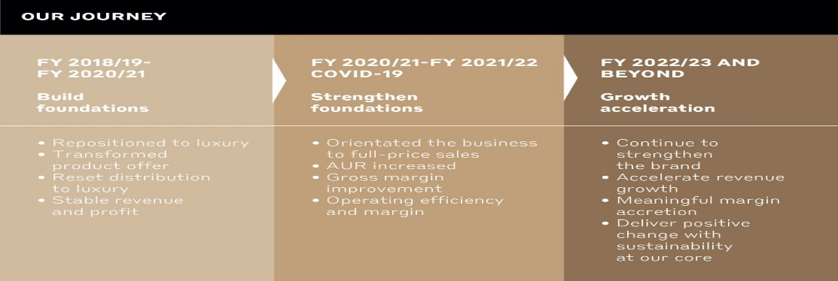
“Source: Burberryplc.com”
Burberry perceives the need of dynamic showcasing correspondences in the formation of a way of life and a picture fit for bringing issues to light among discount purchasers, retail clients, and the media (Matlock and Edmondson, 2002).
Offline
It advertises its products and brand utilizing both old and imaginative methodologies. With regards to traditional promoting,
- Television: It is one of the most effective tools for offline promotion. Products and services of the organisation are generally telecasted on television which helps them to reach out to a large number of people.
- Radio: Radio advertising is another part of the offline promotion in which an organisation can connect its products and services to so many listeners. The message that an organisation wants to convey to the consumers can be sent with the proper voice acting, design and sound.
- Magazines: It is another effective part of the offline promotion in which organisations reach to the customers by advertising their products and services on the magazine page. It includes a detailed explanation of the particular products in services of the organisation.
- Newspapers: It is one of the most effective ways of offline promotion in which advertisements can be done to specific democracy areas. It allows organisations to reach effectively to the targeted customers. This type of promotion organisation generally helps in giving ads in the newspaper regarding their products and services.

Online
- In return for giving the organization's application admittance to their Facebook information, the Facebook lobby guarantees allies of the brand a free example of the smell, which will be shipped off their street number.
- Burberry is likewise setting up its most memorable TV promotion mission to correspond with the presentation of the aroma. The TV ad will debut not long from now in the United States, Europe, and Asia.
- As a feature of a takeover of the internet based video sharing organization, the business will make a big appearance first on Burberry's YouTube page,Instagram,whatsaap.

Brand
A brand is characterized as "a name, term, image, picture, or plan, or a blend of them, intended to recognize the things and organizations of one vendor or gathering of sellers from those of contenders" (Kotler 1991, pp unendingly. 442). Recently recognized, the Burberry brand name was a crucial monetary benefit for the organization; thusly, the supervisory group comprehended the need of an effective and efficient brand the board plan. The underlying idea was to modernize the brand's picture by first changing the name from one Burberry's to another. This change was helped by the reception of another brand logo and beautiful bundling.

Brand Value
Brand value is a promoting expression that addresses the value of a brand. Buyer discernment and encounters with the brand decide its worth. Positive brand value exists when individuals consider decidedly a brand. Negative brand value happens when a brand consistently under-conveys and frustrates to the direct that shoppers exhort others toward stay away from it (Statista, 2021).Kellers rand equity model
Fig 3
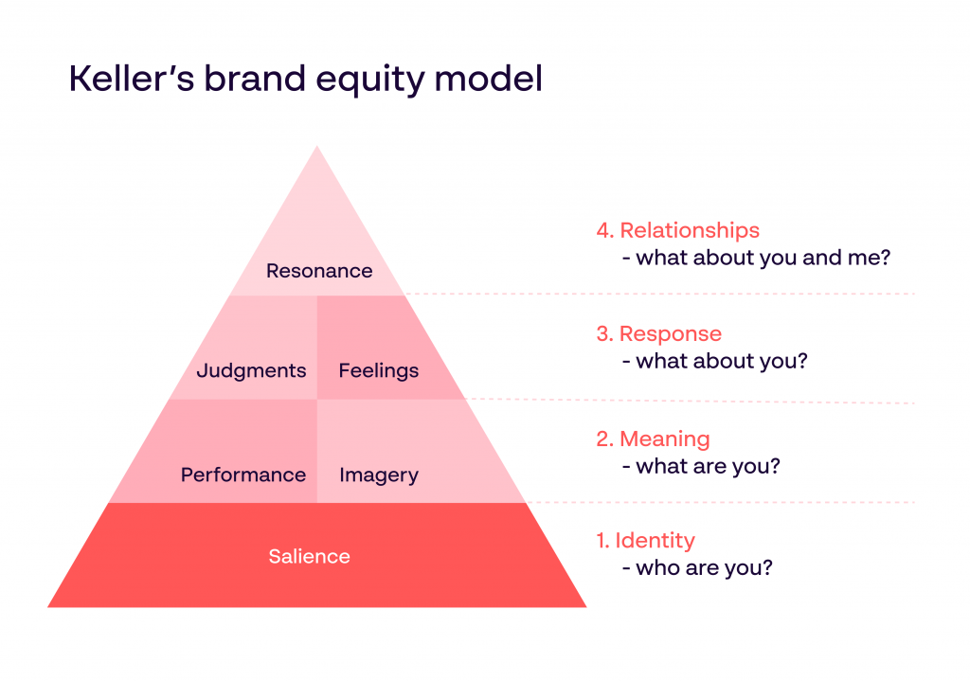
“Source:www.papirfly.com”
Path, Kevin Keller's Customer-Based Brand Equity Model shows how viable brands foster pictures in the personalities of clients (Keller, 1993), with brand picture and notoriety helping differentiation and potentially helpfully affecting buying conduct. The groundwork of this model battles that the strength of the brand comes in what clients or shoppers have learnt, felt, seen, and found out about the brand through time. As indicated by Keller (2001), the genuine test is the sort of encounters that clients will have that will evoke helpful thoughts, feelings, pictures, convictions, and discernments about the brand.
The prestigious checker design is obviously the wellspring of brand esteem in the Burberry clothing line. The Burberry check design was presented during the 1920s as a covering for the organization's renowned raincoat, and it immediately turned into an enrolled brand name. During World War I, Burberry's overcoat was picked as the authority layer of the British armed force (UKEssay, 2018). VIPs, socialites, famous actors, government officials, and voyagers have all followed the checker print consistently. Accordingly, the brand developed to address both extravagance and greatness (UKEssay, 2018).
“Advantage and disadvantage”

Merits
1) It accommodates prompt admittance to a human and drawing in two-manner contact, the two of which help consumer loyalty.
2) The Customer Support delegate might hear something other than words and acquire additional data to address circumstances quick.
Demerits
- The capability of a huge time responsibility: Some clients might proceed to talk and you will not be able to stop them.
The Customer's Journey
Burberry's noteworthy transformation has been completely chronicled in a few meetings, contextual analyses, and comparative distributions, including HBR's "Burberry's CEO on Turning an Aging British Icon into a Global Luxury Brand." In a word, Burberry moved from a failing to meet expectations, underestimated, over-authorized, decentralized business to one of the world's most cherished and esteemed extravagance brands in seven years, multiplying incomes in five.
Fig 4
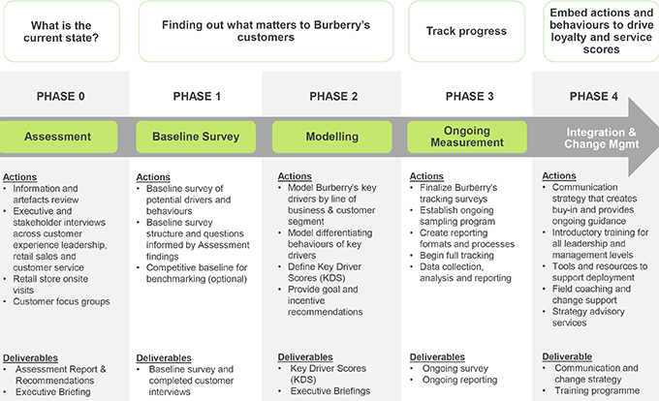

“Source: www.burberry.gallup.com”

The client experience is a basic part of the program. Gallup gives an exceptional encounter to Burberry purchasers around the world, permitting them to voice their thoughts on the web and doing "white glove"* interviews with specific clients when proper.

The client excursion's five stages

Mindfulness (pre-deal)

This step is accomplished by different showcasing systems, information assortment, research, straightforwardness, clear data, and fundamental decisive reasoning.

Your promoting or showcasing will typically demonstrate anything that section point your purchaser showed up to, whether or not adventure or individual - the data ought to mirror the stage they're in (Gulberman et al., 1999).

Thought (pre-deal) (pre-deal)

The buyer starts to look at choices, perhaps yours versus another contribution. They contemplate ascertaining the ideal course of action, gauging parts, and weighing benefits.

Memorability might have a major impact in this present circumstance. Brand comparability, known history, noticed quality, and administration may all effect whether brand is more recognizable or liked (Gulberman et al., 1999).

Buy (post-deal)

The choice has been taken, and the buy has been finished. A shopper makes a fast move; it is possible that they buy or they happen to the opposition. Do whatever it takes not to leave a hole between this stage and introductory contact (Gulberman et al., 1999).

Retention

Holding a client is troublesome; here is when many will tumble off the cycle on the off chance that they are not very much upheld.

Advocacy

Assuming that the various advances are taken care of accurately, your clients will turn into your devoted fans, and they will give the best advertising you can get. Their impact on others' buying choices ought to bring about additional deals. Moreover, limits and grants are an incredible method for expanding buys (Gulberman et al., 1999).Fig 5
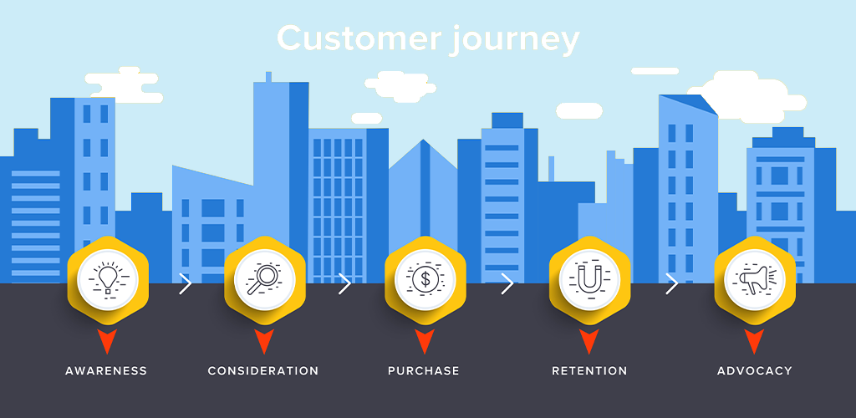
“Source: www.shopivo.com”
Customer touch point
Any immediate or roundabout experience a shopper makes with a brand is viewed as a client contact point. Client contact focuses may happen previously, during, or after the acquisition of a brand's item or administration and can happen both inside and beyond a brand's control.

Fig 6
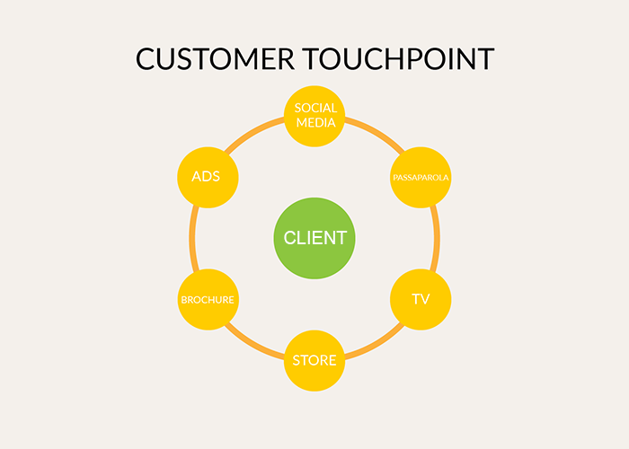
“Source: MagentoBlog.com”

Pre-purchase
The buyer begins to consider options, such as your gift vs another. They consider determining the best course of action, evaluating components, and assessing advantages. In Burberry case, the customer of Burberry gather the information from social media channels, online adds, peer groups etc.
Purchase
In Burberry case, the when customer want to purchase the product the details keep in mind during purchase: Confirm from the company, product catalogues, product online reviews, officials sites, and unit sale.
Post-Purchase
The decision has been made, and the purchase has been completed. A consumer makes a quick decision; they may buy or they may encounter the opposition. Do all it takes to avoid a gap between this stages and initial contact (Gulberman et al., 1999). If the customer satisfied from product he/she will do the work, thank you letters, product feedback, renewal of subscription
Fig 7
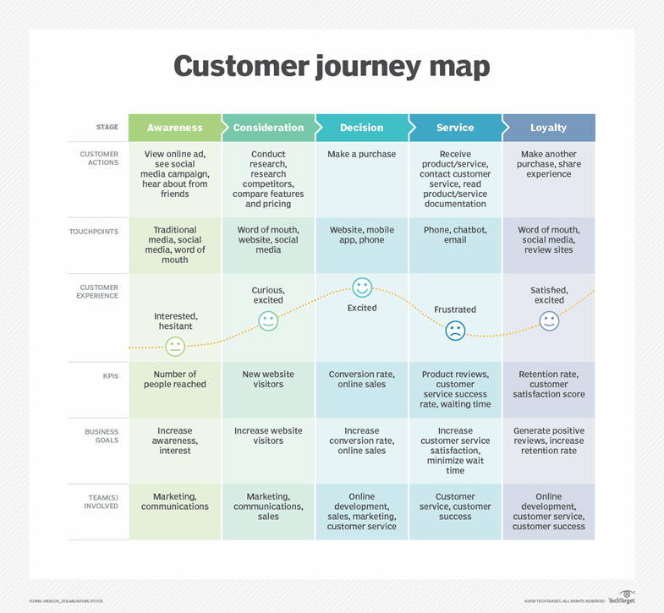
“Source: www.optimizely.com”

"The Engagment technique"
The responsibility model is an assessment apparatus intended to help schools in helping understudies who are not working at the level imagined by the public instructive arrangement. At the point when it turned into a lawful necessity in September 2021, it supplanted the P-levels (one to four) that were utilized in the past system (Watson, 2004).
Brand Discovery
In the event that you work for another firm or haven't done any showcasing before, odds are your client hasn't known about your image. If so, you may now focus your endeavors on advertising exercises, for example, virtual entertainment adverts. Burberry has areas of strength for an exhibition. Burberry keeps up with its British substance, ensuring clients good 'ol fashioned English style by means of spotless and sharp plans, with checkered designs filling in as a notable organization brand name. (Watson, 2004).
Brand awareness
Clients have known about your association yet are just finding out about it as of now. Consider making material that is focused on likely clients to address any questions they might have or to offer responses to any challenges they might insight. You might connect straightforwardly with them by means of your site or web-based entertainment profiles, or you can figure out how these clients’ access data and elevate to them there. Burberry has a positive brand insight among the overall population. Burberry is viewed as one of the most established and most lofty British style houses. (Watson, 2004).
Client Conversation
Regardless of whether you have convinced a client that you are the best fit for their necessities, there are dependably potential chances to get to the next level. To help develop the association, convey correspondence that enhances their life or different kinds of effort, like a welcome box, at this stage. The Burberry brand inspires more private and persevering through sensations of social endorsement and dignity. Customers feel an incredible feeling of social endorsement since they feel tip top, popular and appealing when individuals see them wearing the Burberry brand. (Watson, 2004).
Value creation
Whenever you've changed over your lead into a paying client, consider new strategies to keep them locked in. This might be achieved by offering considerably more benefit by means of exceptional limits, supplementing things, and shared showcasing endeavors. You ought to likewise consider involving this area as a platform for some other pertinent items or administrations you give that might help your clients. Burberry has a committed fan base that takes have a great time communicating their singular styles by means of the brand. Thus, the brand has areas of strength for a purchase rate from this segment. (Watson, 2004).
Conclusion
The limitations that I accept are set up are as per the following:
1. The market and latest things change consistently.
2. Others with big league salaries purchase all over, while individuals with unassuming wages can't manage the cost of Burberry.
3. Burberry's standing should be dealt with in a way that lays the basis for long haul improvement.
4. Burberry's image faces a few opponents.
5. The Burberry actually look at represents most of the brand's deals. The promoting group should devise a procedure for dealing with the importance behind the really look at to create a reliable brand picture.
These limitations may be tended to by, most importantly, reclassifying the brand. The objective of this decision is to interest a more youthful segment while likewise engaging present clients. Another chance is to refresh the product offering. This may be achieved by eliminating the brand's out of date things and supplanting it with a new scope of items. I accept that fostering a cheaper line for kids and youngsters that gives them a nostalgic sense would be the best. Staying aware of patterns and interesting to people, everything being equal, may be the best methodology to inundate the brand completely. With this establishment, the business doesn't have to estrange steadfast shoppers since their line will remain predictable with what they have responded decidedly to from the start. There is satisfactory limit in this business not exclusively to expand the product offering yet additionally to fabricate various different lines inside a brand, for example, Burberry's Prorsum line. Burberry will find success on the off chance that they lay out a method for engaging a different client base.

Reference
Abraham, M (2008). The Off-Line Impact of Online Ads: Harvard Business Review
Al-Fedaghi, S., 2012. A conceptual foundation for the Shannon-Weaver model of communication. International journal of soft computing, 7(1), pp.12-19.
Fitzpatric, K.R. (2005).The legal Challenges of Integrated Marketing Communication: Journal of Advertising, Vol. 34, No. 4.
Gamble, T.K. and Gamble, M., 2013. Communication works.
Gelberman, R.H., Boyer, M.I., Brodt, M.D., Winters, S.C. and Silva, M.J., 1999. The effect of gap formation at the repair site on the strength and excursion of intrasynovial flexor tendons. An experimental study on the early stages of tendon-healing in dogs. JBJS, 81(7), pp.975-82.
https://blog.magestore.com/omnichannel-touchpoints/
https://www.qaizenx.com/blog/what-are-customer-journey-stages-and-can-you-truly-measure-them/
https://www.shopivo.com/blog/marketing/understanding-the-5-phases-of-the-customer-journey/
Keller, K. L. (1993). Conceptualizing, measuring and managing customer-based brand equity Journal of marketing, 57, 1-22.
Keller, K. L. (2001). Building customer-based brand equity: A blueprint for creating strong brands. Marketing Science Institute, report No 10-107, pp.23.
Kitchen, P J & Schultz, D E. 1999. A multi-country comparison of the drive for IMC: Journal of Advertising Research January/February.
Kitchen, P.J., Bringell, J., Li, J. Jones, G.S. (2004). The Emergence of Integrated Marketing Communication: A theoretical Perspective: Journal of Advertising Research, Vol. 44.
Kotler, P. H. (1991),“Marketing Management: Analysis, Planning and Control”, 8th ed.Englewood cliffs, NJ. Prentice-Hall Inc
Panda, T.K. (2003). Marketing Management: Excel Books, New Delhi.
UKEssays. November 2018. Burberry Market analysis. [online]. Available from: https://www.ukessays.com/essays/marketing/market-analysis-and-business-overview-of-burberry-marketing-essay.php?vref=1 [Accessed 24 August 2022].

