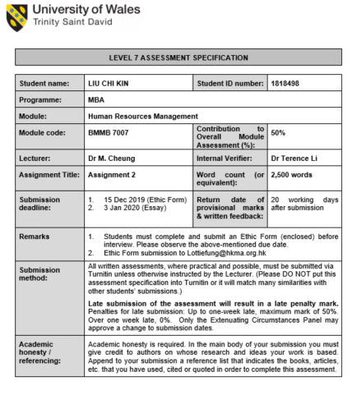

Executive Summary
Performance appraisal is a process to evaluate the staff performance, and through proper communication, the message should send back to the staff to enhance the performance. This study is based on the interview of two Human Resources Managers, which they have a similar company background and function, and to investigate the industrial challenge in performance appraisal.
The company culture and management mentality are critical in performance appraisal. Interestingly, both companies identified that engagement from the staff is the biggest challenge; the action taken to address the engagement rate is very different. Company A is actively engaged with the staff and provide sufficient resource to support the appraisal work. Company B is not actively engaging with the appraisal, as the management does not see the value of the performance appraisal, which in turn, the result is also very different in these companies. At the same time, as the web-based and paper-based performance appraisal were used respectively from these two companies, it can review the difference and effectiveness of the different approaches.
The perception of fairness is another challenge in performance appraisal. Appraisee does not agree with the comments, and it is most commonly found due to a lack of communication, transparency, and without previous alignment. By using the Performance Appraisal model, it can review the underlying issues in these companies and the importance of utilizing the model.
Due to the fundamental difference between these two companies, the short term recommendation is not the same. However, for the long-term recommendation, both companies should look into the implementation of the 360 evaluation, as the technology is already ready, it can address the perspective of fairness by drawing a broader audience in the evaluation.
Performance appraisal must not be only for bonus purposes. Performance appraisal should act as part of the performance management system. By understanding the staff performance, Human Resources should consider the impact for the organization and promote and improve the effectiveness, including employee selection, motivation, retention, training and risk management.

Table of Contents

Executive Summary i
Table of Contents iii
List of Tables iv
List of Figures v
1. Background of the companies 1
2. Challenges 3
3. Scope 4
4. Analysis 7
5. Recommendation for solutions 8
6. Conclusion 12
Bibliography 13
Appendix 1 – Consent forms 15
Appendix 2 – Company A Appraisal Form 17
Appendix 3 – Company B Appraisal Form 18

List of Tables
Table 1.1 | Company background comparison …………………………………......... | 1

List of Figures
Figure 4.1 | Performance appraisal model …………………………………………... | 7
Figure 5.1 | Performance model ……..……………………………………………… | 9

1. Background of the companies
The companies used in the study share a degree of similarity; both of them are manufacturing company with a regional office in Hong Kong, which the Human Resource Department is located. At the same time, they both have a production site located in China. Both interviewees are the regional Human Resource Manager, and they are responsible for Hong Kong and China HR functions, including the planning and execution of the performance appraisal.
Performance appraisal is a process to evaluate the staff performance, and through proper communication, the message should send back to the staff to enhance the performance (Manoharan and Muralidharm, 2012). For the company, it is also the time for the management to reflect and allocate resources for staff development and align with the company goal and expectation (Daoanis, 2012). Interestingly, the approach and mentality of performance appraisal are very different between these companies. Company A is active and values the performance appraisal, versus Company B, is passive and treat performance appraisal as an annual task to complete.

It is understood for both companies; the performance appraisal rating is tied with the bonus. According to the interviews, there is a sharp contrast to the evaluation criteria between these two companies. Top management in Company A would set the goal and vision at the objective alignment stage. The message is than cascade down to each manager first to ensure all the managers understood the message with active dialogs between the top management and the managers. The message will further cascade down to each staff and embedded into the objectives. The targets and achievable is based on the company goal and vision, which will align and signed off by both appraiser and appraisee.
In Company B, however, the criteria predominantly focusing on the key performance indicator, each department is setting the KPI with the best knowledge and intention. Since top management did not share the future development plan with their managers, there is no integration with the company strategy or vision into the performance criteria.

2. Challenges
Both Human Resource managers agreed the staff engagement in the performance appraisal is a challenge. Company B, in particular, the appraiser and appraisee do not share the values of the performance appraisal, which turns out treating it as a “task” that required from the company.
Another challenge is the fairness of the appraisal. It is learned from the Company A HR manager would receive one to two complaints regarding the rating of the appraisal every year. Company B, on the other hand, since the feedback is not given to the staff if they are not in a managerial grade. Therefore, the staff does not know the result of performance appraisal. Although managers can receive feedbacks from top management, the conversation is often one-directional due to the culture; the appraisee has no choice but to accept the grading from the manager.

3. Scope
Employees are the key stakeholders of the company, and their effectiveness affects the whole company (Sundaray, 2011). Although both companies shared the same challenges, engagement and fairness, on the performance appraisal, however, the action that taken is very much different.
Company A changed to the Web-based appraisal system five years ago. Before the implementation, the paper system was complicated in terms of keep tracking and to analyze the results according to the HR manager. After the implementation of the web-based system, HR often acts as a facilitator to get the performance appraisal completed efficiently.
To enhance the engagement rate, in Company A HR provided support to the team. Including a guideline in how to complete the performance appraisal, training sections for managers on enhancing their coaching and communication skills, and how to construct and what is the focal point during the performance appraisal.
Company B is fundamentally different compared to Company A in terms of performance appraisal. According to the HR Manager, not all appraisee received feedback from their manager; the reason is just not required from the top management. The performance appraisal is needed to sign off by the human resource department and the General Manager office according to the process, however, both departments do not have sufficient information to evaluate each performance. Thus, they will sign off and agree on the appraiser's comment. It is not hard to understand why the staff in Company B does not agree with the performance appraisal.
This phenomenon in Company B is aligned with the study stated that only 26% of staff strongly agree the feedback that received from their performance review is accurate, at the same time, the results do not provide a platform for performance improvement. Besides, it is believed the performance appraisal is fundamentally broken and unproductive for the nowadays working environment. It is believed he purpose of the performance appraisal is to hold people accountable for what they have been done in the pass, and improving current performance, preparing capacity for the future (Cappelli and Tavis, 2016).
A large portion of employees does not agree with the performance appraisal due to perceived fairness and effectiveness (Shrivastava and Purang, 2011). Appraisee frequently disagrees with the performance feedback is because of the appraiser based on inaccurate information when conducting the assessment (Campbell and Lee, 1988). Also, without previous alignment on goals and objectives between the staff and management (Campbell, Campbell, and Chia, 1998).
During the study, it is learned that Company A took action to address these issues, but Company B they did not. To enhance the fairness of the performance appraisal, after the completion of the appraisal, each rating is reviewed and discussed with the appraisee manager, which can be revised in both directions. After the review, the HR manager will then conduct a calibration exercise with the top management to normalize the rating. As the staff knows the rating will be normalized, the perception of fairness is improved (Tziner and Rabenu, 2018).
It has been discussed with both Managers the possibility on having a different assessor other than the direct report supervisor to enhance the fairness, the responses were not convinced due to the nature of the business, supervisor has a responsibility on reporting the staff performance.
It is also worth mentioning that the performance appraisal in Company B is heavily weighted on the KPI. The problem is, individual or team, may too focus on the KPI itself, without consideration of other factors, such as team morale, staff retention rate, integrity. These actions may damage the company as a whole, at the right time and performance, the KPI achieved, and the company award the individual or team a bonus.
There is another team however, concerning the team morale, staff retention rate, and doing the right thing for the company. Still, they have missed the target; even though the trend is promising that the team will achieve the target maybe in two months, the company will not granted a bonus to this team just because they have missed the target. In the long run, as this team created a good momentum, this should be the team the company hoping to establish and awarding their performance (Sinek, 2019).
Both companies stated there is a linkage between the performance appraisal result and the bonus; it has to be handled very carefully as it is easy to create unintended consequences (Marr, 2019). One of the purposes of the performance appraisal is helping the staff within the organization knowing the abilities and area of development. However, once the performance review linked with incentives, it stopped being a steering tool and becomes an only focus point for an individual to achieve. Once it happens, staff will become very creative and manipulate the information or their behavior to ensure to achieve the target. This phenomenon is exactly what happened in Company B according to the HR manager.

4. Analysis
Performance Appraisal Model is a critical element of the performance management process. According to the model, the performance appraisal should consist of 5 steps in a loop. Clarity role, agree with SMART objectives, monitor and support, review evaluation, and appraisal interview.
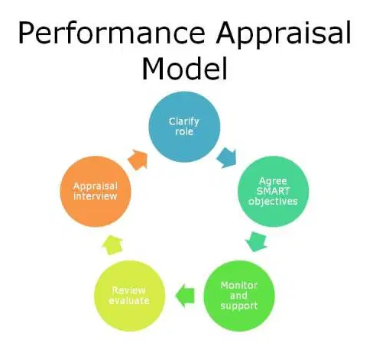
Figure 4.1 Performance Appraisal Model
Source: Learning Models, 2011

Company A follows the steps in this model. The goal and vision from the company can be cascaded down to each individual, versus Company B, it is a classic example in performance appraisal error which leads to low engagement (Jafei 2017). Company B only using a part of the model to execute the performance appraisal. Therefore, the loop is incomplete, which in turn unable to benefit from the output of the performance appraisal.

5. Recommendation for solutions
Due to the fundamental difference between the two companies, there is no urgency for Company A to change its existing program. On the other hand, the current performance appraisal for Company B is incomplete, and Company B should follow the five steps performance appraisal model as their short term action plan.
Further into the performance appraisal model, Clarity role is important for both appraiser and appraisee to define and communicate (Iqbal et al., 2019). SMART objectives provide a platform and clear guidance for staff to move forward. KPI is a widely used tool for staff performance, and there is no question about the effectiveness of KPI. However, it should not serve as the ultimate tool for one’s performance.
Once the platform has established, it is recommended to enhance the content of the performance appraisal. Zhang et al. (2017) stated that Performance could be categorized into four areas: Quantity, Quality, Reliability, and Cooperation. It provided a comprehensive and yet simple platform for both management and employee to set out the targets. Within these parameters, quantity is just the amount of work produces which is easy to quantify and most of the existing company can use the exiting measure to cope with this model. Cooperation further elaborated into Courtesy, Participation, and Work Together. Noticeably, teamwork is as important as individual performance in business and often neglected by both employers and employees (Sanyal and Hisam, 2018).

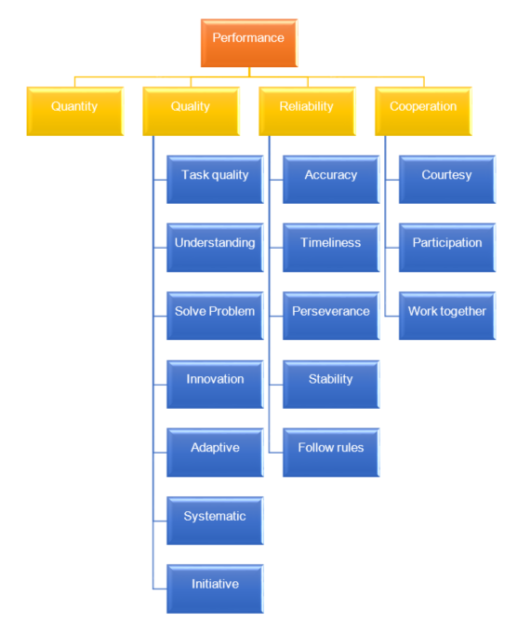
Figure 5.1 Performance Model
Source: Zhang et al. 2017

As both HR managers agreed, they would like to see the increase in the engagement rate towards performance appraisal. From the interview from Company A HR Manager, switching from the paper-based on web-based performance review had increased the engagement rate significantly, this phenomenon is supported by the study that web-based system can create a fundamental change towards engagement (Payne et al. 2009). Therefore, if the resource permit, Company B should be using a web-based platform for their performance appraisal.
Company A Human Resource department demonstrated a high involvement in setting the template for the evaluation, which created ultimate guidance for the manager and staff to perform (Briscoe and Claus, 2008). Although it is understand that it is hard to have a different assessor to enhance the fairness, the company did provide guidance for the same level of staff a benchmarking what the expectation are. It is also recommended them not having a fix time for mid-year performance review, thus to increase the randomness of the performance appraisal.
In contrast, HR in Company B provides only a generic template without any additional coaching or guideline for the appraisal, therefore, appraiser only able to fill the form very subjectively, and provide the grading to their best judgement.
It is recommended the management of Company B to allocate additional resource to enhance the performance appraisal program, therefore, the Human Resource department is able to provide support to each team, understanding the need from the supervisors and the staff, and translate the needs to measureable criteria. Having this mutual understanding between the supervisor and staff increase the transparency which can increase the perception of fairness in the performance appraisal. This should be taken as consideration for Company B, even with the transformation to the web-based platform.
Understanding the importance of an ongoing assessment is important, annually review is often to be often too little too late (Longenecker and Goff, 1992). From the Company A comments, although ongoing assessments required additional resources to complete, it does help the team to revise the objective, and minor adjust the achievable due to unavoidable factors.
For a long term action plan, it is recommended the implantation of 360 evaluation for both companies. It is understood that the web-based software has already included the function of 360 evaluation, to the best of knowledge of the Company A HR manager, none of the colleagues used this function before.
The nature of 360 evaluation is to receive comments from a broader audience, including subordinates, peers, managers, or even top management. Collecting feedback from a more extensive audience base can significantly reduce the bias of the appraiser (Rubin and Edwards, 2018). As the input received from the participant is confidential, which allows the participant more openly to provide the feedback, it helps the viewer to understand the accurate perception from colleagues (Campion, Campion, and Campion, 2015). 360 evaluation helps the organization sustaining the performance appraisal system and promotion a fairness culture (Karkoulin, Assaker, and Hallak 2016).
Implementation of 360 evaluation requires resources such as the web-based program and time. It is also crucial for those who will be participating in the 360 evaluation, as the appraisee initiates it. Human Resource Manager should provide guidance on selecting who and how many of participant in order to get the unbiased, constructive, and effective results (Lee et al., 2015).
Lastly, the results of the performance appraisal should not only tide with the bonus, but it can also serve as a staff development purpose, improve the employees' strengthen, and understanding weaknesses for fitting the future (Brown 2019).

6. Conclusion
The company culture and management mentality play an essential part in performance appraisal; it is critical for the company to accept and trust the performance appraisal in order to work (Sharma and Sharma, 2017). Despite the output of the performance review including both positive and negative feedback, both will help to improve the appraisee performance (Mohrman and Lawler, 2017).
Although both HR Managers shared the same function, which including planning and execution of the performance appraisal, as the approach of performance appraisal is very different between these companies, the outcome is also very different.
It is evidentiary that Company A followed the performance appraisal model much more closely, which in turn to have complete and constructive results. Company B is a classic example in performance appraisal error, which leads to low engagement and unable to benefit from the output of the performance appraisal.
Besides, Company A demonstrated the benefit of using a web-based performance appraisal platform and understood the importance of ongoing assessment, which is something the company should be aware of. Also, 360 evaluation help the organization sustaining the performance appraisal system and promote a fairness culture. As both HR managers agreed they would like to see the increase of transparency in the performance appraisal, Human resources should take this as a long-term action plan.
(Word Count: 2,475)

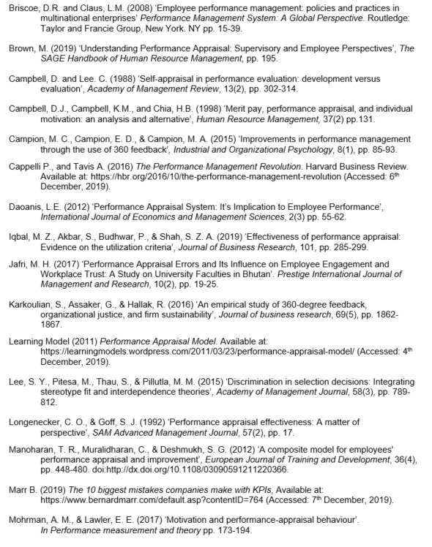
Bibliography
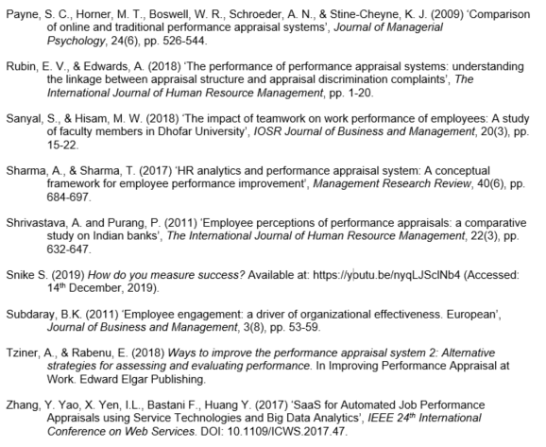

Appendix 1 – Consent forms
Company A
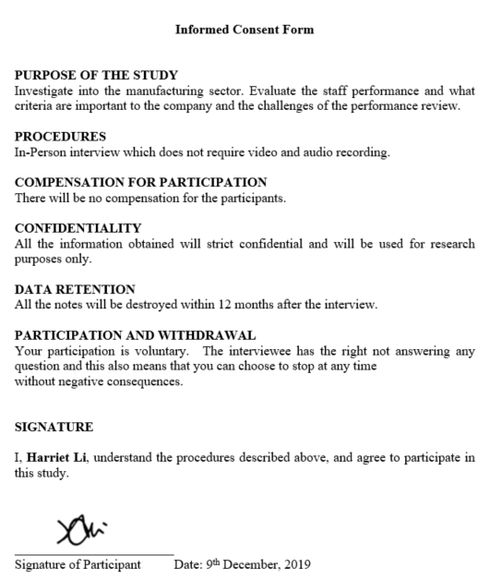

Company B
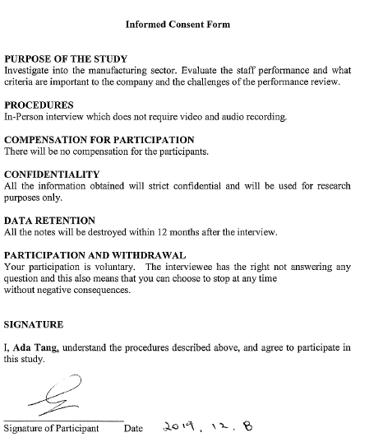

Appendix 2 – Company A Appraisal Form
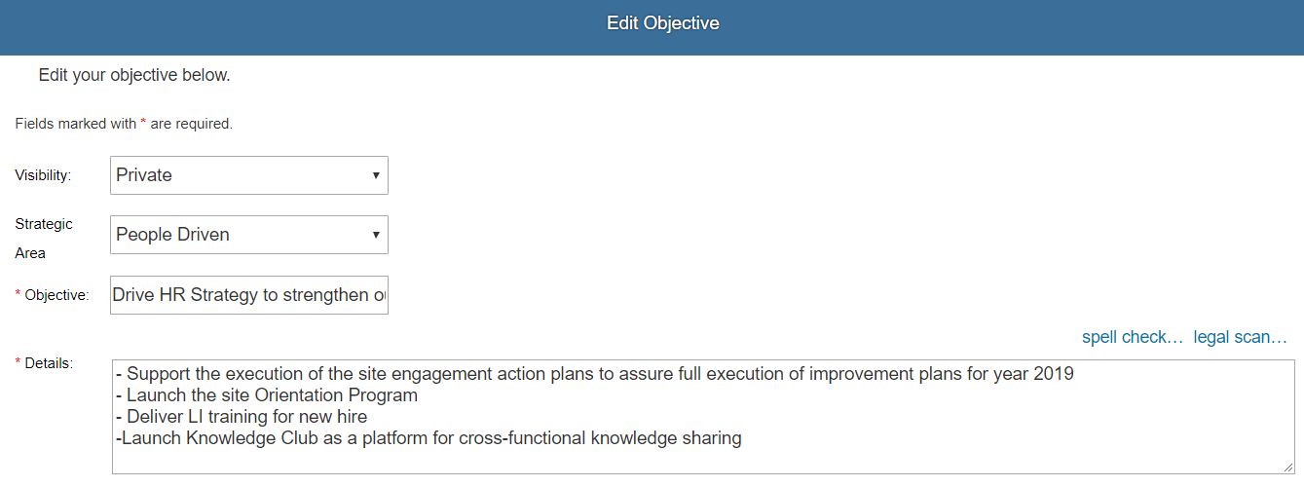
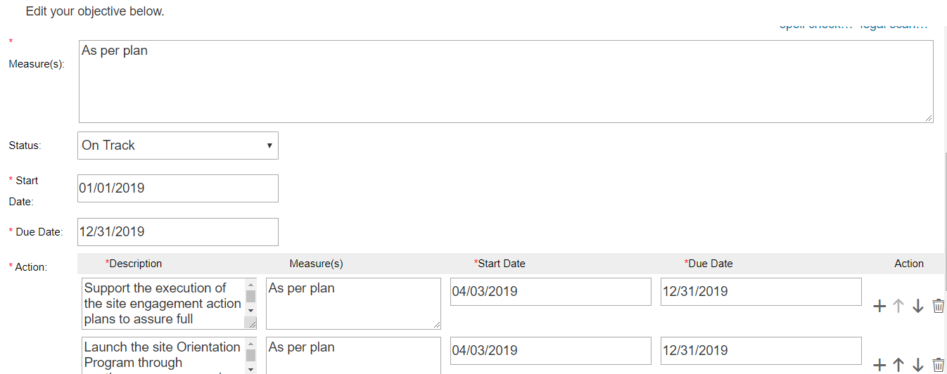

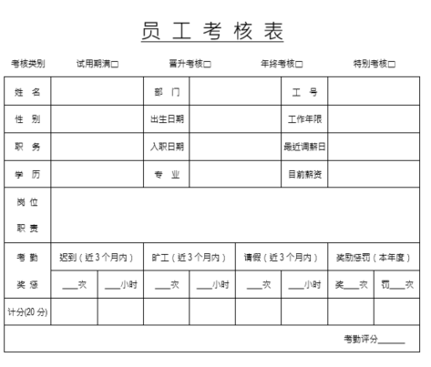
Appendix 3 – Company B Appraisal Form



