Mock Test

Scenario

Create a computer version of a simple game of Dice.

When the computer game runs, it will prompt for two numbers, which represent the values of two dice throws (numbers between 1 and 6).

The program will then check to see if the two given dice numbers total is over 10.

A player wins if the total of the two numbers is greater than 10. If the player gets the same number on both throws but the total is not greater than 10 the player gets another chance.

Then, a suitable message will show win or lose.

- Fill out the IPO Table for the dice game program. (20 marks)
Input | Processes | Output
Throw1  Throw2 | Calculate Throw total  Calculate Win/Lose/Draw | Win  Lose  Draw

- Create Variable Names (20 marks)
List the variable names needed for the simple dice game system. Make sure that they are consistent and meaningful.

Variable | Data type
Throw1 | integer
Throw2 | integer
Repeat | Boolean
Total | integer

- Pseudocode (20 marks)
Write pseudocode for the program.

Program Output
Remember to write the keywords in Block capital.
- Flowchart (20 marks)
Complete the flowchart for the above part of the system. You may use the Visio or Word templates files that are provided on Moodle.

Pseudocode

Throw1 = INPUT “Enter Throw 1 result (1-6)”
Throw2 = INPUT “Enter Throw 2 result (1-6)”

Repeat = True

Total = Throw1 + Throw2
WHILE Repeat = True
IF Total > 10 THEN
OUTPUT “Congrats! You won”
Repeat = False
ELSE IF Throw1 = Throw2 THEN
OUTPUT “Draw! Try again”
ELSE
OUTPUT “Sorry, you lost”
Repeat = False
ENDIF
ENDWHILE

- Trace Table (20 marks)
- Create a trace table for the following values given: 5 and 4. Add more rows and columns as needed.
- Create a trace table for the following values given: 2 and 2. Add more rows and columns as needed.
- Create a trace table for the following values given: 6 and 6. Add more rows and columns as needed.

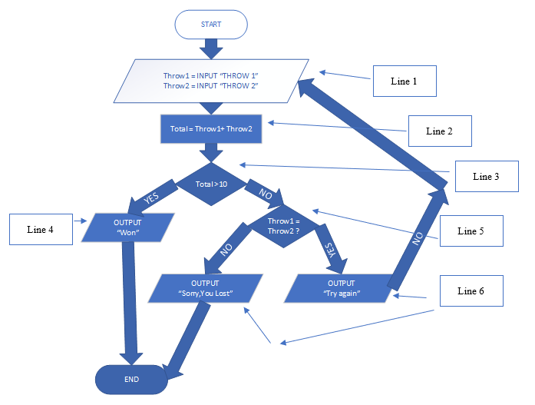
Line | Throw1 | Throw 2 | Total | Total>10 | Thr1 = Thr2 ? | OUTPUT
1 | 5 | 4
2 |  |  | 9
3 |  |  |  | No
5 |  |  |  |  | No
6 |  |  |  |  |  | You Lost

