Designing of Joint Point webpage.

Group business name: Joint Point Café.
Group members: Laura Barrow, Nikola Sugarova and Salman Malak.
Website link: https://www.weebly.com/editor/main.php#/
Email address: laura1806407@gmail.com
Password: Uwtsd2019

We are planning on opening a coffee shop/café situated on Station Terrace, Cardiff, right next to Queen Street train station which is Cardiff’s second largest train station. Our business will be a coffee shop that caters to all with a range of high-quality food and beverages such as a range of coffees, teas, smoothies, salads, baguettes and paninis, with a variety of vegan and vegetarian options as well, we will be offering something for everyone. We do not have one specific target market in mind as such a varied business our aim is to attract a wide range of clients from all walks of life. With such an extensive range of high-quality produce, a relaxed, chilled, friendly atmosphere and a high level of customer service, Joint Point will certainly be the place to be!

When designing our website, we decided as a group who would be creating what page, I was assigned products and services. When designing my webpage, I decided I wanted it to be quirky but clear- giving customers enough insight on what products we offer to encourage them to come and pay us a visit. As you can see the layout of my webpage is pretty simple with bold sub headings and in my opinion just enough text and images to encourage the viewer to carry on looking at my page.

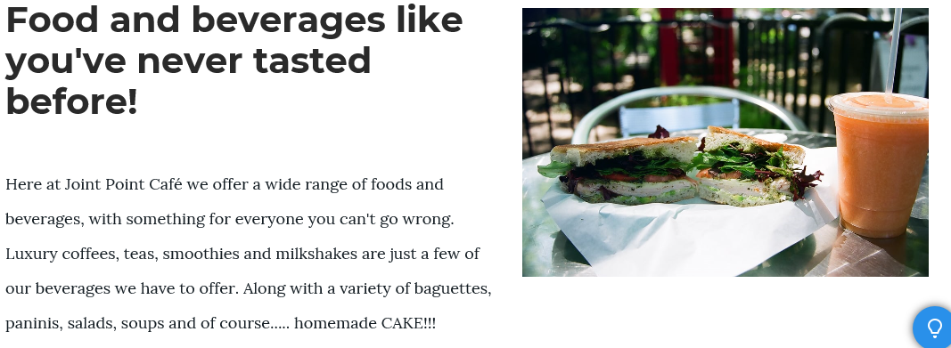

Rather than stating the products we sold in the formation of text I gave a brief description of what we offered and a slideshow of images so viewers could see the presentation of some of our food available.
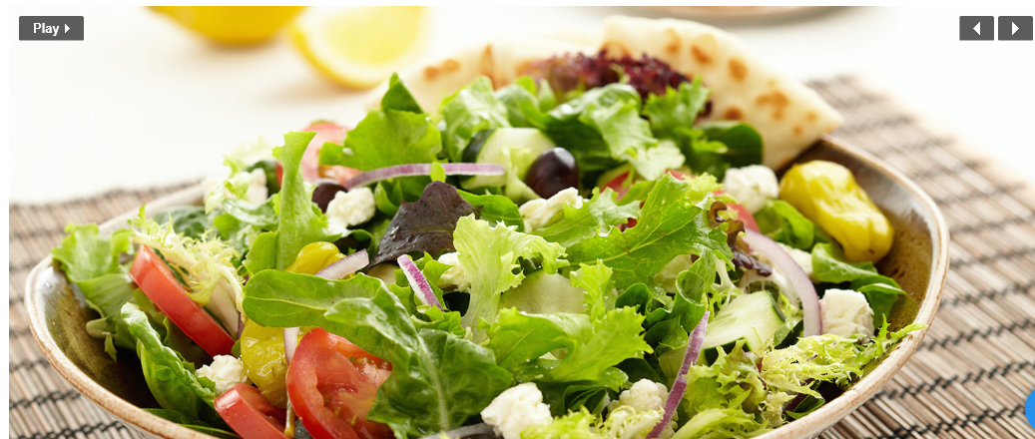

With summer here and temperatures rocketing what better way to promote our freshly made smoothies than to have a special offer and advertise it on the website. Again, a short but bold subheading, getting straight to the point to catch the eye of the viewer and ensure the viewer does not get bored. £1.50 for a smoothie is a good price for a smoothie and by including images makes the product more enticing to the viewer.

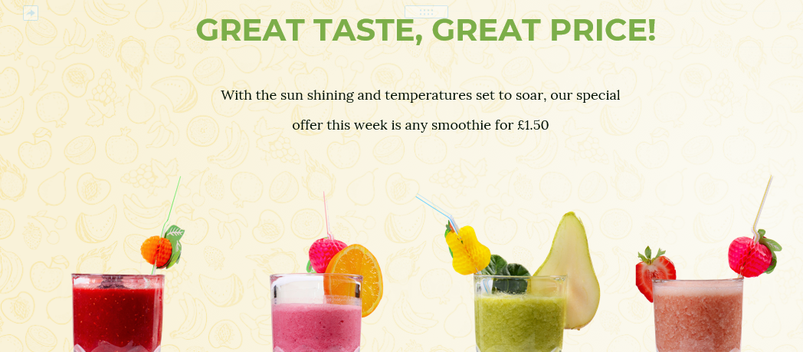

Lastly our special offers section, again not too much text, briefly stating our other offers we have instore and pointing out that we also do childrens meal deals which we imagine will be a great seller with the summer holidays coming up. This section also states that we offer a student, NHS and emergency services discount too. Telling vieweerrs that we have a loyalty scheme available via card or app is another great incentive for them to visit our business especially when our free beverages are far more achievable than competitors such as Costa, Starbucks and Caffe Nero.



