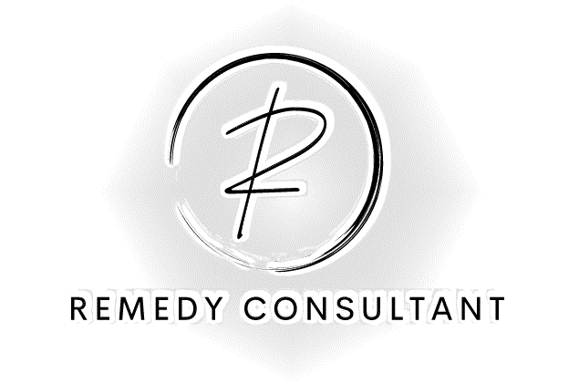

Consultation for the Hilton Dublin Front of House
Malik Arosh Miah (2107169)
Remedy Consultant
Date of Delivery: 17th November 2023

Contents

Executive Summary 3
Comprehensive Assessment of Customer Service Issues at Hilton Dublin 6
Customer Service Issues Identified at Hilton Dublin: A Comprehensive Analysis 8
1. Customer Feedback and Online Reviews: 8
2. Reputation Management: 9
4. Scope and Customer Base: 12
Change Management Models: 13
PESTEL Analysis: Impact on Customer Service in the Hospitality Industry 15
SWOT Analysis: Overview of Hilton Dublin 17
TOWS Analysis: Strategic Directions for Hilton Dublin 19
Recommendations for Hotel Dublin to Address Identified Issues 21
Change Management Plan: 23
Measuring Success: 26
Recommended strategies: 28
Implementation of the recommended strategies: 30
Associated Costs: 33
Conclusion: 36
References 38

Executive Summary
This report extensively examines the challenges impacting customer service at the Hilton Dublin, an esteemed cosmopolitan lodging nestled in the heart of Dublin, Ireland. Despite its renowned reputation and prime location, recent feedback has flagged concerns regarding declining service quality. Recognizing the critical significance of customer satisfaction, this report utilizes robust theoretical frameworks including PESTEL, SWOT, and TOWS analyses to unveil both internal and external factors influencing this decline. Subsequently, strategic recommendations are proposed to revamp customer service and elevate the overall guest experience.
Key findings indicate a notable surge in negative customer feedback and online reviews. The challenges impacting customer service at Hilton Dublin can be distilled into key areas. Inadequate staff training appears to contribute to staff members' inability to meet customer expectations. Operational inefficiencies within check-in/check-out procedures and response times to guest requests, potentially lead to dissatisfaction. Understaffing strains resources, elevating employee stress levels and diminishing service quality. Finally, outdated technology hampers staff performance, potentially affecting overall service delivery. These identified issues underscore critical areas for improvement, demanding strategic interventions to elevate customer service standards at the Hilton Dublin. The report provides a comprehensive strategic roadmap by aligning strengths with opportunities and addressing weaknesses amidst external threats. Recommendations encompass comprehensive change management strategies, staff empowerment through training, and technological upgrades aimed at enhancing customer service.
The PESTAL analysis reveals a multifaceted interplay between external dynamics and service standards. Government regulations, economic fluctuations, societal trends, technological advancements, environmental concerns, and legal compliance collectively mould the hotel's capacity to deliver exemplary service. Alterations in these spheres directly impact staffing, operational efficacy, guest satisfaction, and the hotel's overall standing. Strategic alignment with these factors is pivotal for Hilton Dublin to navigate changes, innovate, and consistently meet evolving customer demands while upholding service excellence in the ever-evolving hospitality industry.
The SWOT analysis of Hilton Dublin uncovers key facets influencing its customer service realm. Recognised strengths like its established reputation and prime location bolster guest loyalty and accessibility. However, weaknesses such as inconsistent service and operational inefficiencies directly impact guest satisfaction. Opportunities in emerging markets and technological advancements offer avenues for broadening the customer base and improving service quality. Yet, threats from intense competition and economic uncertainties necessitate ongoing service enhancements and adaptable strategies. Addressing weaknesses while leveraging strengths and opportunities will be crucial for Hilton Dublin to enhance its customer service standards and maintain competitiveness in the ever-evolving hospitality industry.
Upon meticulous examination of Hilton Dublin's customer service challenges, a series of strategic recommendations emerge to tackle the identified issues and their underlying causes effectively. First and foremost, the implementation of a comprehensive customer service training program is advised to address inconsistent service, emphasizing the development of communication and guest-centric skills to elevate staff competency and, consequently, enhance customer satisfaction. Additionally, an upgrade in technological infrastructure is proposed to combat operational inefficiencies arising from outdated systems. This investment in modern tools aims to streamline operations, heighten efficiency, and ultimately improve guest experiences. To alleviate issues of understaffing driven by budget constraints, optimizing staffing levels by evaluating needs during peak periods is recommended, aiming to elevate service quality and alleviate employee stress. Addressing inefficient operational processes through audits and the implementation of clear Standard Operating Procedures stands as another key recommendation to enhance overall efficiency and guest satisfaction. Lastly, bolstering online reputation management through proactive strategies, active engagement with reviews, and prompt resolution of customer concerns is advised to counteract negative online feedback and attract new guests.
Implementing the suggested strategies at Hilton Dublin promises a wealth of advantages across its operations and performance. These initiatives aim to drive improved customer satisfaction, and operational efficiency, bolster online reputation, uplift employee morale, and sustain financial success. From heightened guest satisfaction through staff training to increased operational efficiency from technological upgrades and streamlined processes, these changes pave the way for enhanced brand perception, competitiveness, and long-term sustainability in the dynamic hospitality sector.
Despite the considerable estimated expenses involved in implementing recommended strategies at Hilton Dublin, the anticipated benefits far outweigh these financial investments. The structured plan promises enhanced customer satisfaction, and operational efficiency, and bolstered online reputation and employee morale. Although the costs are substantial, the resulting improvements in service quality, guest experiences, and sustained financial performance position the hotel for long-term success and competitive advantage in the evolving hospitality landscape. The anticipated returns from these strategies render the initial costs a worthwhile and prudent investment for Hilton Dublin, ensuring its continued growth and prominence in the industry.
This comprehensive report presents a clear case for the implementation of strategic recommendations to address Hilton Dublin's customer service challenges. Despite its established reputation, recent feedback signals a decline in service quality, necessitating a thorough examination of internal and external influences through frameworks like PESTEL, SWOT, and TOWS analyses. The identified issues, including inadequate training, operational inefficiencies, understaffing, and outdated technology, pinpoint crucial areas for improvement. Strategic interventions, such as training programs, technological upgrades, optimized staffing, and operational revisions, offer a roadmap to elevate service standards. Considering the anticipated benefits, ranging from improved customer satisfaction and operational efficiency to enhanced online reputation and sustained financial success. The proposed investments present a prudent path for Hilton Dublin's long-term growth and competitiveness in the ever-evolving hospitality landscape.

Comprehensive Assessment of Customer Service Issues at Hilton Dublin
We trust this report finds you well. As organisational consultants from The Remedy Consultant, we aim to provide an in-depth analysis of the current state of customer service at Hilton Dublin. We have been informed that there are concerns about the quality of customer service, and we are committed to identifying the root causes and proposing strategic remedies to enhance the overall guest experience.
Background of Hilton Dublin:
The Hilton Dublin is a cosmopolitan lodging with canal views and polished rooms, plus a modern bistro, a bar, and a gym. It is in the heart of Dublin, Ireland, overlooking the historic Grand Canal (Hilton.com, 2023). The hotel is within walking distance of many of Dublin's popular attractions, including St. Stephen's Green, Grafton Street, and the Charlemont tram stop.
Despite the distinguished reputation (Stories From Hilton, 2020), recent feedback has raised concerns about the quality of customer service. We understand that customer satisfaction is paramount for Hilton Dublin, and any shortcomings in this area can have profound implications on guest retention, online reviews, and overall brand image.
About The Remedy Consultant:
The Remedy Consultant is a leading consultancy firm specializing in organizational development and improvement strategies within the hospitality industry. With a proven track record of assisting businesses in optimizing their operations, we bring a wealth of experience and expertise to address challenges and drive positive change.
Our approach is rooted in the application of established theoretical models and frameworks, ensuring a systematic and thorough analysis of the issues at hand. In this report, we intend to employ various frameworks such as PESTEL (Political, Economic, Social, Technological, Environmental, Legal), SWOT (Strengths, Weaknesses, Opportunities, Threats), and TOWS (Threats, Opportunities, Weaknesses, Strengths) to comprehensively examine the factors contributing to the observed decline in customer service quality.
Purpose of the Report:
The primary aim of this report is to shed light on the specific issues affecting customer service at Hilton Dublin, utilising theoretical models to gain a holistic understanding of the problem. By employing PESTEL, SWOT, and TOWS frameworks, we seek to identify external and internal factors that may be influencing customer service negatively. Subsequently, we will formulate strategic recommendations to address these issues and enhance the overall guest experience.
In the subsequent sections, we will delve into the specific analyses derived from each framework, providing actionable insights that Hilton Dublin can leverage to elevate its customer service standards.
We look forward to collaborating with your team to implement effective solutions and contribute to the sustained success of Hilton Dublin.

Customer Service Issues Identified at Hilton Dublin: A Comprehensive Analysis
In our investigation, several critical issues have been identified that are impacting the overall performance of Hilton Dublin. The repercussions extend beyond immediate guest dissatisfaction, affecting the hotel's reputation, revenue, and long-term sustainability.

1. Customer Feedback and Online Reviews:
Issue: The hotel is facing a significant decline in positive customer feedback and an increase in negative online reviews on various platforms.
Analysis: We conducted a thorough review of online feedback platforms such as TripAdvisor, Trip.com, and Google Reviews. Our analysis reveals a noticeable surge in complaints related to poor customer service experiences. Examples of negative reviews are shown below.
Andreas Claussen Wahl (Google.com,2023) “Reception does not answer phone calls. Room service does not answer calls. Asked to leave message, nothing happens”.
Laura (Trip.com, 2022 “The service was really bad in the hotel at both breakfast and in evenings if you ordered a drink. It was like you were bothering them asking for anything”.
Daryl M (Tripadvisor, 2023) “This property is pretentious and NOT helpful to its customers. The reception staff is most pretentious and very dismissive to customers with the simplest requests”.
ashtone778 (Tripadvisor, 2023) “After watching several people get checked in before me after I was told I would be placed on a priority check-in, I went up to inquire. A man kept raising his voice telling me check-in was at 4:00 and nothing he could do”.

This trend is alarming as online reviews heavily influence potential guests' decision-making processes. As shown in Figure 1, customer service ranks at the top in what influences customers. Negative reviews can deter potential customers, impacting reservation rates and overall occupancy.
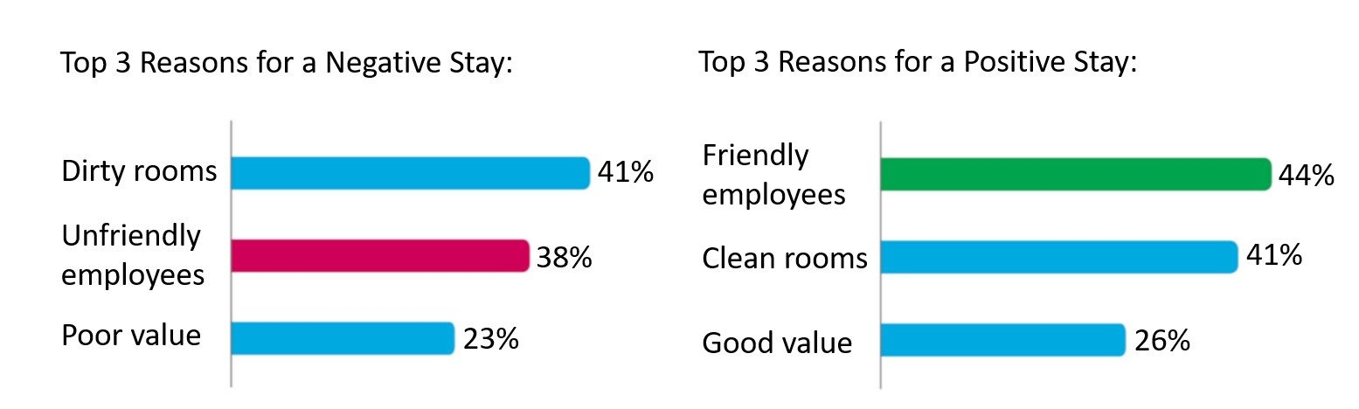
Figure 1 (AMADEUS Hospitality, 2022)

.

2. Reputation Management:
Issue: Hilton Dublin's reputation, a crucial asset in the hospitality industry, is under threat due to the recent decline in customer service quality.
Analysis: We assessed industry-standard reputation management tools and found a drop in the hotel's overall rating compared to competitors in the same category. In the Telegraph, the best hotel in Dublin recommendations (Hegarty, 2022), the Hilton Dublin was not mentioned.
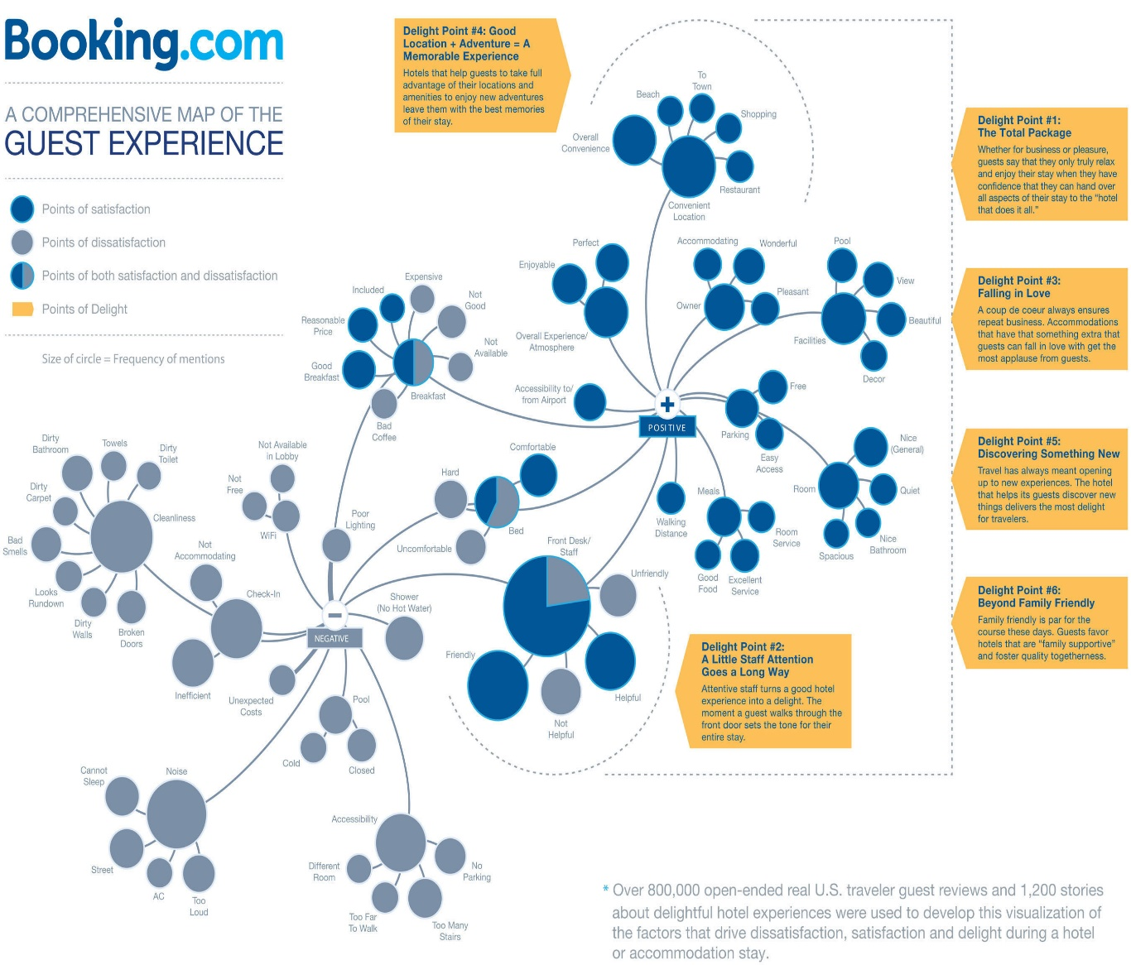
Figure 2 (Booking.com, 2013)
As we can see in Figure 2, many customers take delight in having a good customer service interaction from the minute they walk into the hotel. A diminished reputation can erode brand loyalty, affecting customer retention and deterring potential corporate partnerships or event bookings.
3. Revenue Impact:
Issue: The decline in customer service is negatively impacting the hotel's revenue and profit margins.
Analysis: We examined the hotel's financial reports, comparing current revenue trends with historical data.

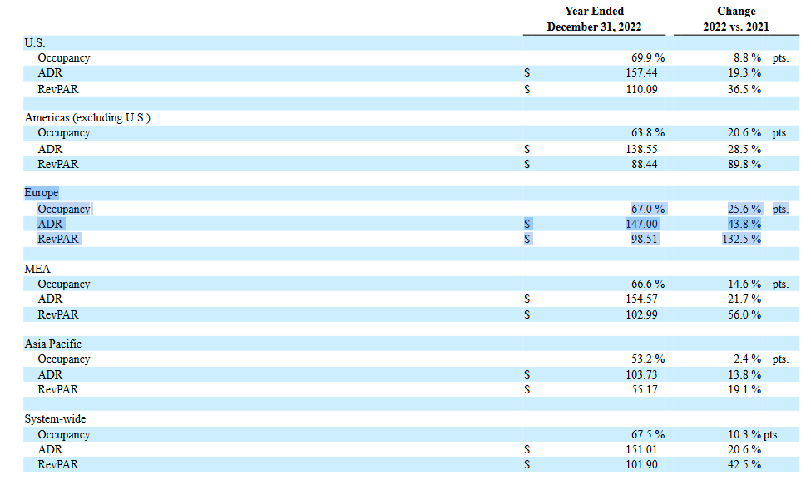
Figure 3 (Washington, 2022

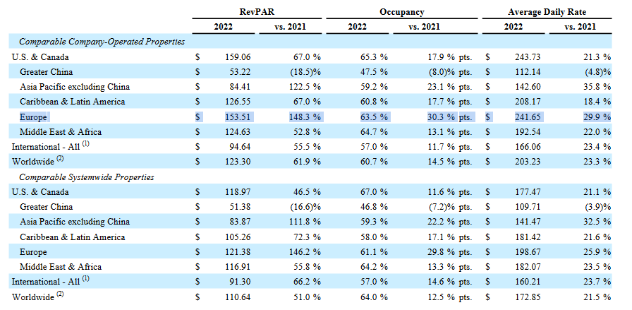
Figure 4 (Marriott International, 2022)
As we can see in Figure 3, the overall European Hilton hotels RevPAR is 132.5 % up compared to 2021. In Figure 4 we can see that Marriott Hotels in Europe have a 148.3% increase compared to 2021. We can gather that the Hilton looks to be underachieving. A correlation between the decrease in positive customer experiences and a drop in revenue was evident. Unhappy guests are less likely to utilize additional services, such as dining, spa facilities, or event hosting, resulting in a direct financial impact.

4. Scope and Customer Base:
The diminishing quality of customer service can limit the hotel's ability to attract and retain a diverse customer base. The indication is that a decline in service quality can result in a narrowed customer demographic. This limits the hotel's market share and may hinder its ability to adapt to changing market trends.
Root Causes:
- Inadequate Staff Training: Insufficient training programs may be contributing to staff members' inability to meet customer expectations (Ali et al., 2021).
- Operational Inefficiencies: Internal processes, such as check-in/check-out procedures and response times to guest requests, may be inefficient, leading to dissatisfaction (Net, 2016).
- Understaffing: A shortage of staff can strain resources (Abdou et al., 2022), leading to increased stress levels among employees and a decline in service quality.
- Outdated Technology: Technological deficiencies, such as an outdated booking system or ineffective communication tools, may hinder staff performance (Ezzaouia and Bulchand-Gidumal, 2022).
Research Methodology:
Our investigation utilized a combination of quantitative and qualitative methods. We conducted interviews with hotel staff and guests, analysed online reviews and feedback, reviewed financial reports, and employed industry benchmarks. Additionally, we compared [Hotel Name]'s performance with competitors to provide a comprehensive understanding of the issues at hand.

Change Management Models:

The Star Model (Figure 5), created by Jay Galbraith, emphasizes five key areas - Strategy, Structure, Processes, Rewards, and People - to align organizational design. It's effective for hotels seeking a structured approach focusing on processes and rewards alongside strategy. On the other hand, the McKinsey 7S Model (Figure 6), focusing on seven interconnected elements - Structure, Strategy, Skills, Staff, Style, Systems, and Shared values - emphasizes the holistic nature of organizational effectiveness. It's beneficial for hotels aiming for a comprehensive view, emphasizing culture and shared values alongside structure and strategy. Both models offer valuable insights, but the choice depends on the hotel's specific priorities and the depth of change needed.
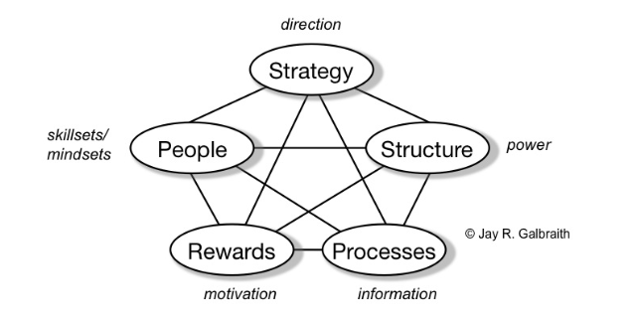
Figure 5 (Galbraith, 2002)

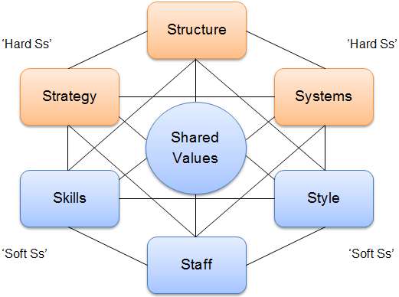
Figure 6 (Jurevicius, 2023)

Another model that can be used is called ADKAR. This is a change management framework that focuses on individual change at the workplace (Hiatt and Creasey, 2003). This model emphasizes the importance of addressing individual concerns and readiness for change in a structured manner to facilitate successful organizational change initiatives. All the models can be used to implement change management. It all depends on the size and structure of the organisation and how thorough they want to be with the system.

PESTEL Analysis: Impact on Customer Service in the Hospitality Industry
To comprehend the external factors influencing the decline in customer service at Hilton Dublin, a PESTEL analysis has been conducted, examining various dimensions that may contribute to the identified issues.
PESTEL Analysis Tabel:
Factor | Description | Impact on Customer Service
Political | Government regulations and policies affecting the hospitality sector, such as taxation, employment laws, and safety standards. | Changes in regulations may impact staffing levels, operational costs, and adherence to safety standards, influencing service quality (Bonfanti, Vigolo and Yfantidou, 2021).
Economic | Economic conditions, including inflation rates, exchange rates, and overall economic stability. | Economic downturns may lead to budget constraints, affecting staffing, training, and overall service quality (Crespi-Cladera, Martín-Oliver and Pascual-Fuster, 2021).
Social | Social and cultural trends that influence customer preferences and expectations in the hospitality industry. | Shifts in societal preferences or cultural expectations may require adjustments in service offerings and guest interactions (Lacalle, 2021).
Technological | Advancements in technology impacting hotel operations, booking systems, and guest communication. | Outdated technology can lead to inefficiencies, affecting guest experiences and staff performance in delivering quality service (Cobanoglu et al., 2011).
Environmental | Environmental considerations and sustainability trends affecting the hotel industry. | Guest expectations for eco-friendly practices may impact operational decisions and influence customer perceptions of the hotel (Yi, Li and Jai, 2018).
Legal | Legal factors, including compliance with labour laws, health and safety regulations, and contractual obligations. | Non-compliance with legal requirements may result in penalties, affecting the hotel's reputation and overall service quality (DeKay, Yates and Toh, 2004) .

PESTEL Analysis Summary:
The analysis of factors impacting customer service at Hilton Dublin illustrates a complex interplay between external influences and service quality. Government regulations, economic conditions, societal shifts, technological advancements, environmental considerations (Battista, 2023), and legal compliance collectively shape the hotel's ability to deliver exceptional service. Changes in these dimensions can directly affect staffing, operational efficiency, guest experiences, and the hotel's overall reputation. Recognising and strategically aligning with these factors are crucial for Hilton Dublin to adapt, innovate, and meet evolving customer expectations while maintaining service excellence in a dynamic hospitality landscape.

SWOT Analysis: Overview of Hilton Dublin
To gain a comprehensive understanding of Hilton Dublin's current situation, a SWOT analysis has been conducted. This analysis evaluates the hotel's internal strengths and weaknesses, as well as external opportunities and threats, providing a strategic overview for consideration.
SWOT Analysis Tabel:
Category | Description | Implications for Customer Service
Strengths | Established reputation in the hospitality industry. - Prime location with proximity to key attractions. - Award-winning amenities and facilities. | A positive reputation contributes to guest loyalty. - Strategic location enhances accessibility for guests. - Award-winning amenities can attract high-value customers (Kim and Kim, 2022).
Weaknesses | Inconsistent customer service. - Lack of staff training programs. - Operational inefficiencies. | Inconsistency affects overall guest satisfaction. - Insufficient training impacts staff performance. - Operational inefficiencies contribute to delays and dissatisfaction (Suraihi et al., 2021).
Opportunities | Emerging markets and customer segments. - Technological advancements for improved guest experiences. | Tapping into new markets can broaden the customer base. - Integrating advanced technology can enhance service efficiency and quality (Attala, 2019).
Threats | Intense competition from neighbouring hotels. - Economic uncertainties impacting travel and hospitality. | Competition necessitates continuous improvement in service offerings. - Economic uncertainties may require flexible strategies to adapt to changing consumer behaviours (WTTC, 2023).

Positive Aspects:
While addressing the identified issues, it's crucial to acknowledge Hilton Dublin's positive aspects:
- Established Reputation: The hotel has a well-established reputation in the hospitality industry, contributing to brand loyalty (Stories From Hilton, 2023).
- Prime Location: Situated in a prime location with proximity to key attractions, the hotel's accessibility enhances its appeal to guests (hotels.uk, 2023).
- Award-Winning Amenities: Recognized for its award-winning amenities, Hilton Dublin has the potential to attract high-value customers seeking premium experiences (www.forbes.com, 2023).
SWOT Analysis Summary:
The SWOT analysis of Hilton Dublin reveals crucial insights shaping its customer service landscape. The established reputation and prime location serve as strengths, fostering guest loyalty and accessibility. However, weaknesses in inconsistent service, lack of staff training, and operational inefficiencies directly impact guest satisfaction. Opportunities lie in tapping into emerging markets and leveraging technological advancements to broaden the customer base and enhance service quality. Yet, threats posed by intense competition and economic uncertainties demand continual improvements in service offerings and adaptable strategies to navigate changing consumer behaviours. Addressing weaknesses while capitalizing on strengths and opportunities will be pivotal for Hilton Dublin to elevate its customer service standards and maintain a competitive edge in the dynamic hospitality industry (Della Corte et al., 2021).

TOWS Analysis: Strategic Directions for Hilton Dublin
The TOWS analysis builds upon the findings from the SWOT analysis, aligning internal strengths and weaknesses with external opportunities and threats. This strategic framework enables the identification of actionable strategies to address current challenges and capitalize on future opportunities (Weihrich, 1982).
TOWS Analysis Tabel:
Internal Factors (Strengths & Weaknesses) | External Factors (Opportunities & Threats) | Strategic Directions for Hilton Dublin
Strengths | Opportunities | Leverage established reputation to attract new customer segments in emerging markets. Capitalize on prime location by promoting special packages for nearby attractions (Richard, 2017).
Strengths | Threats | Utilize award-winning amenities to differentiate from competitors during economic downturns (Krupskyi et al., 2019). Implement cost-effective strategies to withstand the impact of economic uncertainties (Gehrels and Blanar, 2013).
Weaknesses | Opportunities | Develop and implement comprehensive staff training programs to enhance service quality and efficiency(PWC, 2018). Embrace technological advancements to improve operational processes and guest experiences (Busulwa et al., 2020).
Weaknesses | Threats | Strengthen customer service consistency through operational optimizations to counteract negative online reviews (Goodman and Broetzmann, 2019). Diversify marketing strategies to maintain competitiveness in the face of intense competition (Zeng, 2021).

TOWS Analysis Summary:
The TOWS analysis for Hilton Dublin underscores strategic directions based on internal strengths and weaknesses aligned with external opportunities and threats. Leveraging the established reputation and prime location presents opportunities to attract new customer segments in emerging markets and promote tailored packages for nearby attractions. By aligning internal strengths with external opportunities, the hotel can maximize its competitive advantages (Tse, 1988). Capitalizing on award-winning amenities during economic downturns and implementing cost-effective strategies to navigate economic uncertainties emerge as strategic measures. Addressing weaknesses involves developing comprehensive staff training programs to enhance service quality and embracing technological advancements for operational improvements. Counteracting negative online reviews through operational optimizations and diversifying marketing strategies to withstand intense competition is imperative for Hilton Dublin to strengthen customer service consistency and maintain competitiveness in the ever-evolving hospitality landscape.

Recommendations for Hotel Dublin to Address Identified Issues
After a thorough analysis of the issues impacting customer service at Hilton Dublin, the following recommendations are proposed to address the identified challenges, and their causes, and mitigate their impact:
- Implement a Robust Customer Service Training Program:
  - Issue: Inconsistent customer service.
  - Cause: Inadequate staff training.
  - Recommendation: Develop and implement a comprehensive customer service training program focusing on communication, problem-solving, and guest-centric skills (Solomon, 2019).
  - Impact: Improved staff competency leading to enhanced customer satisfaction (Wu et al., 2015).
- Upgrade Technological Infrastructure:
  - Issue: Operational inefficiencies.
  - Cause: Outdated technology.
  - Recommendation: Invest in modern reservation systems, communication tools, and operational technologies to streamline processes and improve efficiency (Chechi, 2023).
  - Impact: Reduced delays enhanced operational efficiency, and improved guest experiences (Bilgihan et al., 2011).
- Optimize Staffing Levels:
  - Issue: Understaffing.
  - Cause: Budget constraints.
  - Recommendation: Evaluate staffing needs based on peak periods and guest demands. Optimize staffing levels to ensure adequate support during busy times (Pekgün et al., 2013).
  - Impact: Improved service quality, reduced employee stress, and enhanced guest experiences (Schwepker and Dimitriou, 2021) .
- Revise Operational Processes:
  - Issue: Inefficient operational processes.
  - Cause: Lack of streamlined procedures.
  - Recommendation: Conduct a thorough audit of operational processes, identify bottlenecks, and implement clear Standard Operating Procedures (Louveau, 2023).
  - Impact: Increased efficiency, faster response times, and improved overall guest satisfaction (Rust and Zahorik, 1993).
- Enhance Online Reputation Management:
  - Issue: Negative online reviews.
  - Cause: Inconsistencies in service.
  - Recommendation: Implement an effective online reputation management strategy, actively engage with reviews, and address customer concerns promptly (Li, Cui and Peng, 2017).
  - Impact: Improved online ratings, enhanced brand image, and increased likelihood of attracting new guests (Xie, Zhang and Zhang, 2014).

Change Management Plan:
Kurt Lewin (1951) formulated a model that is seen as fundamental in comprehending organisational change. Essentially, the effectiveness of such change relies on the organisation's grasp of the rationale behind it, the method of execution, and the anticipated roles post-change implementation. To successfully implement these recommendations, a comprehensive change management plan is essential:

To ensure a smooth and positive transition for staff during the recommended changes at Hilton Dublin, a comprehensive change management strategy is crucial. Transparent communication is at the core, emphasizing the reasons behind the changes and their positive impact on both staff and the organization. Inclusive decision-making processes, involving staff in key decisions, empower them and enhance their sense of value within the organization.
Training and skill development programs are essential to equip staff with the necessary competencies for adapting to new processes or technologies and alleviating anxiety associated with unfamiliar tasks. The appointment of change champions within each department serves to create internal advocates who can guide and support their colleagues throughout the transition, fostering a sense of camaraderie and shared success.
The Kübler-Ross model (Kubler, 1969), also known as the five stages of grief, was proposed by psychiatrist Elisabeth Kübler-Ross in her book "On Death and Dying" in 1969. This model outlines five stages individuals may experience when coping with significant loss or grief. This can also occur to staff that are told to change their work methods and style. To combat it, the company needs to establish effective feedback mechanisms. To allow staff to express concerns, ask questions, and provide insights, ensuring that their voices are heard, and concerns addressed promptly. Recognition and rewards programs contribute to motivation by acknowledging and celebrating employees who embrace the changes and excel in their roles during the transition.
A management plan offers a proactive approach to unexpected challenges, demonstrating organizational preparedness and instilling confidence among staff. Implementing flexible scheduling options during the initial stages accommodates staff needs, promoting a healthy work-life balance and reducing potential disruptions (Kalgi et al., 2022).
A clear roadmap outlining the phases, timelines, and milestones of the changes provides staff with a sense of direction and progression, minimizing uncertainty (Than Yaw Zin, 2023). Finally, offering employee assistance programs, including counselling services and support groups, demonstrates a commitment to staff well-being, contributing to emotional resilience during the period of change.
Collectively, these strategies aim to create an environment where staff feels informed, supported, and motivated, fostering a positive organisational culture and ensuring a successful and seamless transition at Hilton Dublin.
.

Measuring Success:
Once the change management plan has been implemented. The aims and goals have been distinctly outlined and their desired outcomes, the implemented solution, and the methods for gauging its impact. These specifics aid both the general manager and staff in comprehending necessary adjustments and the potential benefits involved.
To measure the success of the recommended strategies:
- Customer Satisfaction Surveys:
  - Conduct regular customer satisfaction surveys to gauge improvements in guest experiences.
- Key Performance Indicators (KPIs):
  - Establish KPIs related to service quality, online reviews, and operational efficiency.
- Financial Performance:
  - Monitor financial reports to assess the impact of the changes on revenue and profit margins.
- Employee Feedback:
  - Solicit feedback from employees through surveys and forums to gauge their satisfaction and identify areas for further improvement.
Through deploying consistent change management that encompasses the trio of guest experience, employee requirements, and managerial efficiency, hoteliers can effectively advance their properties while prioritizing people, their most valuable asset (Forbes.com, 2023).
Potential Benefits:
- Enhanced Reputation: Positive online reviews and improved service quality contribute to an enhanced reputation.
- Increased Revenue: Satisfied guests are likely to become repeat customers and recommend the hotel to others, driving revenue.
- Improved Operational Efficiency: Streamlined processes and optimized staffing levels lead to increased operational efficiency.
Cost Considerations:
- Training Programs: Allocate funds for external training providers and materials.
- Technological Upgrades: Budget for software licenses, hardware upgrades, and staff training.
- Operational Process Optimization: Consider costs associated with process audits and consultancy fees.
- Online Reputation Management: Allocate resources for reputation management tools and staff training.
By diligently implementing these recommendations and incorporating effective change management strategies, Hilton Dublin can not only address its current challenges but also position itself as a leader in providing exceptional customer service in the competitive hospitality industry. Regular monitoring and adjustments will ensure the sustained success of these initiatives.

Recommended strategies:

Strategic management involves several stages that fall into two main categories: strategy formulation and implementation (Köseoglu et al., 2020). The success of the recommended strategies at Hilton Dublin will be meticulously assessed through a combination of quantitative and qualitative measures. Customer satisfaction surveys will play a pivotal role, providing insights into improvements in guest experiences (Vermeulen and Seegers, 2009). Positive trends in overall customer satisfaction scores and favourable feedback on specific service aspects will be indicative of successful implementation.
Key Performance Indicators (KPIs) will be established to gauge service quality, online reviews, and operational efficiency. Meeting or surpassing predefined benchmarks, such as reduced service response times and improved online ratings, will serve as key success indicators. Financial performance will be closely monitored through regular assessments of revenue and profit margins, with positive trends demonstrating the impact of the implemented strategies on the hotel's overall financial health (Hospitality Net, 2023).
Employee feedback, gathered through surveys, forums, and feedback mechanisms, will provide a crucial perspective on the success of the changes. Improved employee satisfaction scores, reduced concerns expressed in feedback, and positive sentiment regarding the implemented strategies will signify positive outcomes. The effectiveness of training programs will be assessed through pre- and post-training evaluations, with demonstrated improvement in staff competency and confidence serving as success indicators.
The adoption rates of new processes, technologies, and operational procedures will be closely monitored. High adoption rates will indicate that staff is successfully incorporating changes into their daily routines, contributing to overall operational efficiency. The impact of flexible scheduling on staff morale, attendance, and work-life balance will be assessed through various metrics, including staff feedback and trends in attendance (www.linkedin.com, 2023).
Recognition programs and their impact on employee behaviour and performance will be monitored, with increased participation and sustained high performance serving as positive indicators. The utilization of employee assistance programs will be evaluated, providing insights into the overall well-being of the staff and the effectiveness of support services.
Regular review meetings, progress reports, and feedback loops will ensure ongoing assessment and allow for adjustments to strategies based on collected data. This comprehensive approach, combining both quantitative and qualitative measures, will provide a holistic understanding of the success of the implemented strategies at Hilton Dublin and guide continuous improvement efforts.

Implementation of the recommended strategies:
The implementation of the recommended strategies at Hilton Dublin is anticipated to yield a myriad of potential benefits, positively impacting various facets of the hotel's operations and overall performance. These benefits encompass improved customer satisfaction, enhanced operational efficiency, heightened online reputation, strengthened employee morale, and sustained financial success.
Enhanced Customer Satisfaction:
Potential Benefit: The focus on comprehensive staff training and upgraded technological infrastructure is poised to elevate the overall customer service experience. Satisfied guests are more likely to become repeat customers, leading to increased loyalty and positive word-of-mouth recommendations.
Operational Efficiency:
Potential Benefit: Technological upgrades, streamlined operational processes, and optimized staffing levels are expected to contribute to increased operational efficiency. This can result in reduced service response times, smoother workflows, and a more seamless guest experience.
Improved Online Reputation:
Potential Benefit: The implementation of robust online reputation management strategies will likely result in a positive impact on the hotel's online ratings and reviews. A strengthened online reputation can attract new customers and positively influence potential guests during their decision-making process.
Competitive Advantage:
Potential Benefit: Diversified marketing strategies, coupled with a positive online reputation, can provide the hotel with a competitive edge in the market. The hotel is likely to stand out as a preferred choice among competitors, attracting a broader customer base.
Positive Employee Morale:
Potential Benefit: Employee recognition programs, inclusive decision-making processes, and the provision of flexible scheduling are designed to enhance staff morale. A motivated and satisfied workforce is more likely to deliver excellent customer service, contributing to an overall positive organizational culture.
Financial Success:
Potential Benefit: The cumulative impact of improved customer satisfaction, operational efficiency, online reputation, and employee morale is anticipated to translate into sustained financial success. Repeat business, positive reviews, and efficient operations can contribute to increased revenue and sustained profitability.
Adaptability and Resilience:
Potential Benefit: The successful implementation of change management practices will cultivate an adaptable and resilient organizational culture. This adaptability will position the hotel to navigate future challenges, ensuring its continued success in a dynamic hospitality industry.
Brand Image Enhancement:
Potential Benefit: Positive changes in customer service, operational efficiency, and online reputation will collectively contribute to the enhancement of the hotel's brand image. A positive brand perception is vital for attracting and retaining customers in a competitive market.
Employee Retention:
Potential Benefit: An improved working environment, recognition programs, and employee involvement in decision-making can contribute to higher job satisfaction and employee retention. This, in turn, reduces recruitment and training costs while maintaining a knowledgeable and experienced workforce.
Long-Term Sustainability:
Potential Benefit: The strategic implementation of the recommended changes, coupled with ongoing measurement and adaptation, positions the hotel for long-term sustainability. By staying responsive to customer needs, industry trends, and internal dynamics, the hotel can maintain relevance and success in the ever-evolving hospitality landscape.

In summary, the implementation of the proposed strategies at Hilton Dublin promises a comprehensive array of benefits across various operational domains, fostering a significant positive impact on the hotel's overall performance. The strategies aim to significantly elevate customer satisfaction by focusing on enhanced service through staff training and technological upgrades, fostering loyalty and positive word-of-mouth recommendations. Streamlining operational processes and technological enhancements are anticipated to drive operational efficiency, resulting in smoother workflows and reduced service response times. Moreover, robust online reputation management is poised to attract new customers, while diversified marketing strategies and a positive online presence will bolster the hotel's competitive advantage. Improved employee morale, attributed to recognition programs and inclusive decision-making, is expected to fuel excellent customer service, contributing to sustained financial success. The implementation of change management practices will cultivate adaptability, ensure resilience in a dynamic hospitality landscape, and enhance the hotel's brand image. Additionally, a positive working environment and retention initiatives are likely to reduce costs while maintaining a skilled workforce. Ultimately, these strategies set the stage for Hilton Dublin's long-term sustainability by staying responsive to evolving customer needs and industry trends.

Associated Costs:
Considering the size of Hilton Dublin, its income levels, and the need for cost-effectiveness, it's imperative to provide a comprehensive overview of the associated costs with the recommended strategies. These cost estimates are approximations and should be tailored to the specific circumstances of the hotel. This action plan provides a structured roadmap for Hilton Dublin, outlining the specific steps and estimated costs associated with implementing the strategies. It serves as a practical guide for the client. The time for achievement has been put to a quarterly update.

Strategies | Associated cost | £ (estimate)
Customer Service Training Program | Includes expenses for external training providers, materials, and internal staff resources dedicated to the development and implementation of the training program. | 20,000 - 30,000
Technological Infrastructure Upgrade | Incorporates the costs of acquiring and implementing new reservation systems, communication tools, and operational technologies. It accounts for software licenses, hardware upgrades, and staff training. | 50,000 - 80,000
Optimizing Staffing Levels | Potential costs associated with hiring additional staff during peak periods, cross-training initiatives, and potential adjustments to staff schedules. The actual costs will depend on the specifics of the staffing changes implemented. | Variable based on staffing adjustments
Operational Process Revision | Potential costs associated with hiring additional staff during peak periods, cross-training initiatives, and potential adjustments to staff schedules. The actual costs will depend on the specifics of the staffing changes implemented. | 15,000 - 25,000
Online Reputation Management | Incorporates the costs of reputation management tools, staff training, and potentially outsourcing services for monitoring and responding to online reviews. | 10,000 - 15,000
Recognition and Rewards Programs | Includes the budget for implementing and maintaining employee recognition programs, including rewards or incentives. | 5,000 - 10,000
Flexible Scheduling Implementation | Potential costs associated with software tools for scheduling flexibility, administrative adjustments, and communication efforts to ensure a smooth transition. | Variable based on implementation
Change Management and Communication | Encompasses expenses related to communication materials, employee engagement initiatives, and potentially hiring external consultants for change management support. | 10,000 - 15,000
Employee Assistance Programs | Includes costs associated with offering employee assistance programs, such as counselling services or support group initiatives. | 5,000 - 8,000
Monitoring and Evaluation | Incorporates expenses for tools, surveys, and resources dedicated to monitoring and evaluating the success of implemented strategies. | 5,000 - 10,000

It's crucial to note that these cost estimates are general estimations and may vary based on the specific time and needs of Hilton Dublin. Despite the substantial estimated costs associated with implementing the recommended strategies at Hilton Dublin, the anticipated benefits far outweigh these financial investments. A company can spend up to 30% of its operating cost on change management (Basar, 2021). The structured action plan provides a tailored roadmap, ensuring cost-effectiveness and practicality in execution. These expenditures aim to significantly enhance customer satisfaction and operational efficiency. The online reputation and employee morale will increase and bring about overall financial success. While the estimated costs are significant, the resultant improvements in service quality, guest experiences, and sustained financial performance position the hotel for long-term success and competitive advantage in the ever-evolving hospitality landscape. The benefits derived from these strategies are expected to deliver substantial returns, making the initial costs a worthwhile and prudent investment for Hilton Dublin.

Conclusion:
This extensive report delves deep into the challenges affecting customer service at Hilton Dublin, a prestigious lodging in Dublin, Ireland. Despite its esteemed reputation and prime location, recent feedback has raised concerns about declining service quality. Emphasizing the critical role of customer satisfaction, this analysis employs robust frameworks like PESTEL, SWOT, and TOWS to uncover the internal and external factors contributing to this decline. The subsequent strategic recommendations aim to reinvigorate customer service and elevate the overall guest experience.
Key findings highlight a surge in negative feedback and online reviews, pinpointing several core challenges. Inadequate staff training affects meeting customer expectations, while operational inefficiencies and understaffing lead to dissatisfaction. Moreover, outdated technology hampers staff performance, influencing overall service delivery. These issues underscore the need for strategic interventions to enhance customer service at Hilton Dublin. The report offers a holistic roadmap by aligning strengths with opportunities and addressing weaknesses amidst external threats. Recommendations span comprehensive change management, staff empowerment through training, and technological advancements to augment customer service quality.
The PESTEL analysis reveals the intricate interaction between external dynamics and service standards, showcasing how regulations, economic fluctuations, societal trends, and technological advancements significantly influence staffing, operations, and guest satisfaction. Strategic alignment with these factors becomes crucial for Hilton Dublin to innovate, adapt, and consistently deliver excellent service.
In the SWOT analysis, established strengths like reputation and location stand alongside weaknesses such as inconsistent service and operational inefficiencies. Opportunities in emerging markets and technology exist but come with threats from intense competition and economic uncertainties, demanding ongoing enhancements. Addressing these weaknesses while leveraging strengths and opportunities becomes pivotal for Hilton Dublin to elevate its service standards and maintain competitiveness.
The meticulous examination of challenges leads to strategic recommendations. A comprehensive training program aims to enhance staff competency and guest satisfaction, technological upgrades to improve operational efficiency, and optimizing staffing levels to alleviate stress and enhance service quality. Bolstering online reputation management through proactive engagement and prompt customer resolution is advised.
The implementation of these strategies promises enhanced customer satisfaction, operational efficiency, improved online reputation, heightened employee morale, and sustained financial success. Although the estimated expenses are significant, the resultant service quality improvements and financial performance position Hilton Dublin for long-term success and competitive advantage.
In conclusion, the anticipated benefits from these strategies outweigh the initial costs. The structured plan ensures enhanced customer satisfaction, operational efficiency, and heightened brand image. Despite substantial investments, the improvements in service quality and financial performance justify the prudent investment, ensuring sustained growth and prominence for Hilton Dublin in the industry.

References

Abdou, A.H., Khalil, A.A.F., Mahmoud, H.M.E., Elsaied, M.A. and Elsaed, A.A. (2022). The Impact of Hospitality Work Environment on Employees’ Turnover Intentions During COVID-19 Pandemic: The Mediating Role of Work-Family Conflict. Frontiers in Psychology, [online] 13. doi:https://doi.org/10.3389/fpsyg.2022.890418.
Ali, B., Gardi, B., Othman, B.J. and Ahmed, S.A. (2021). (PDF) Hotel Service Quality: The Impact of Service Quality on Customer Satisfaction in Hospitality. [online] ResearchGate. Available at: https://www.researchgate.net/publication/351780048_Hotel_Service_Quality_The_Impact_of_Service_Quality_on_Customer_Satisfaction_in_Hospitality.
AMADEUS Hospitality (2022). The Ultimate 2022 Guide To Elevating Guest Satisfaction. [online] www.amadeus-hospitality.com. Available at: https://www.amadeus-hospitality.com/guest-satisfaction/ [Accessed 10 Nov. 2023].
Andreas Claussen Wahl (2023). Google. [Online] Available at https://www.google.com/travel/hotels/entity/CgoIzrLWufSxlslbEAE/reviews?ts=CAEaIAoCGgASGhIUCgcI5w8QCxgPEgcI5w8QCxgQGAEyAhAAKgkKBToDR0JQGgA&utm_campaign=sharing&utm_medium=link&utm_source=htls [Accessed 2 Nov. 2023].
Ashtone778, (2023). Tripadvisor. [Online] Available at: https://www.tripadvisor.co.uk/Hotel_Review-g186605-d213298-Reviews-Hilton_Dublin-Dublin_County_Dublin.html [Accessed 3 Nov. 2023].
Attala, J. (2019). 10 ways smart technology is reshaping the hotel industry. [online] Hotel Management. Available at: https://www.hotelmanagement.net/tech/10-ways-smart-technology-reshaping-hotel-industry [Accessed 3 Nov. 2023].
Basar, S. (2021). Firms Spend 14% Of Operating Costs On Change Management. [online] Markets Media. Available at: https://www.marketsmedia.com/firms-spend-14-of-operating-costs-on-change-management/ [Accessed 6 Nov. 2023].
Battista, M. (2023). PESTLE Analysis. [online] CIPD. Available at: https://www.cipd.org/uk/knowledge/factsheets/pestle-analysis-factsheet/ [Accessed 3 Nov. 2023].
Bilgihan, A., Okumus, F., Khal” Nusair, K. and Joon‐Wuk Kwun, D. (2011). Information technology applications and competitive advantage in hotel companies. Journal of Hospitality and Tourism Technology, 2(2), pp.139–153. doi:https://doi.org/10.1108/17579881111154245.
Bonfanti, A., Vigolo, V. and Yfantidou, G. (2021). The impact of the Covid-19 pandemic on customer experience design: The hotel managers’ perspective. International Journal of Hospitality Management, [online] 94, p.102871. doi:https://doi.org/10.1016/j.ijhm.2021.102871.
Booking.com (2013). The Booking Truth: Delighting Guests Takes More Than a Well-Priced Bed. [online] www.prnewswire.com. Available at: https://www.prnewswire.com/news-releases/the-booking-truth-delighting-guests-takes-more-than-a-well-priced-bed-212307931.html# [Accessed 1 Nov. 2023].
Busulwa, R., Evans, N., Oh, A. and Kang, M. (2020). Hospitality Management and Digital Transformation. Routledge.
Chechi, H. (2023). Technology in the hotel industry and gaining its full benefits. [online] Glion Website. Available at: https://www.glion.edu/magazine/technology-hotel-industry/ [Accessed 3 Nov. 2023].
Cobanoglu, C., Berezina, K., Kasavana, M.L. and Erdem, M. (2011). The Impact of Technology Amenities on Hotel Guest Overall Satisfaction. Journal of Quality Assurance in Hospitality & Tourism, [online] 12(4), pp.272–288. doi:https://doi.org/10.1080/1528008x.2011.541842.
Crespi-Cladera, R., Martín-Oliver, A. and Pascual-Fuster, B. (2021). Financial distress in the hospitality industry during the Covid-19 disaster. Tourism Management, 85, p.104301. doi:https://doi.org/10.1016/j.tourman.2021.104301.
Daryl, (2023). Tripadvisor. [Online] Available at: https://www.tripadvisor.co.uk/Hotel_Review-g186605-d213298-Reviews-Hilton_Dublin-Dublin_County_Dublin.html [Accessed 3 Nov. 2023].
DeKay, F., Yates, B. and Toh, R.S. (2004). Non-performance penalties in the hotel industry. International Journal of Hospitality Management, 23(3), pp.273–286. doi:https://doi.org/10.1016/j.ijhm.2003.11.003.
Della Corte, V., Del Gaudio, G., Sepe, F. and Luongo, S. (2021). Destination Resilience and Innovation for Advanced Sustainable Tourism Management: A Bibliometric Analysis. Sustainability, 13(22), p.12632. doi:https://doi.org/10.3390/su132212632.
Ezzaouia, I. and Bulchand-Gidumal, J. (2022). The impact of information technology adoption on hotel performance: Evidence from a developing country. Journal of Quality Assurance in Hospitality & Tourism, pp.1–23. doi:https://doi.org/10.1080/1528008x.2022.2077886.
Forbes.com. (2023). Forbes. [online] 1 Feb. Available at: https://www.forbes.com/sites/forbestechcouncil/2023/02/01/the-case-for-change-management-in-the-hospitality-industry/ [Accessed 10 Nov. 2023].
Galbraith, J. (2002). The star model. [online] Available at: https://www.jaygalbraith.com/images/pdfs/StarModel.pdf [Accessed 7 Nov. 2023].
Gehrels, S. and Blanar, O. (2013). How economic crisis affects revenue management: the case of the Prague Hilton hotels. Research in Hospitality Management, 2(1-2), pp.9–15. doi:https://doi.org/10.1080/22243534.2013.11828284.
Goodman, J.A. and Broetzmann, S.M. (2019). Strategic customer service : managing the customer experience to increase positive word of mouth, build loyalty, and maximize margins and profits. New York: Harpercollins Leadership, An Imprint Of Harpercollins.
Hegarty, N. (2022). The best hotels in Dublin city centre for style and comfort near the top attractions. The Telegraph. [online] 4 Feb. Available at: https://www.telegraph.co.uk/travel/destinations/europe/ireland/dublin/articles/top-10-the-best-hotels-in-dublin-city-centre/ [Accessed 5 Nov. 2023].
Hiatt, J. and Creasey, T.J. (2003). Change Management: The People Side of Change. Loveland, Colorado: Prosci Learning Center Publications.
Hilton.com. (2023). Hilton Dublin. [online] Available at: https://www.hilton.com/en/hotels/dubduhn-hilton-dublin/ [Accessed 1 Nov. 2023].
Hospitality Net. (n.d.). The Strong Correlation Between: Happy Associates, Guest Satisfaction, and Revenue Maximization in Hotels | By Muhammad B. Al-Rahahlah. [online] Available at: https://www.hospitalitynet.org/opinion/4116895.html.
hotels.uk (2023). hotels-in-dublin. [online] hotels.uk.com. Available at: https://www.hotels.uk.com/uk/dublin/hotels-in-dublin/hilton-dublin.d2 [Accessed 2 Nov. 2023].
Jurevicius, O. (2023). McKinsey 7S Model: The 7S Framework Explained - SM Insight. [online] Strategic Management Insight. Available at: https://strategicmanagementinsight.com/tools/mckinsey-7s-model-framework/ [Accessed 6 Nov. 2023].
Kalgi, D., Dhole, V., Akhilesh, K. and Pandey (n.d.). A Study on the Significance of Work Life Balance of the Employees in the Sector of Hospitality and Tourism. [online] Available at: https://hmct.dypvp.edu.in/Documents/research-papers-publication/Resarch-publications/2022-23/9.pdf [Accessed 3 Jul. 2023].
Kim, Y.-J. and Kim, H.-S. (2022). The Impact of Hotel Customer Experience on Customer Satisfaction through Online Reviews. Sustainability, [online] 14(2), p.848. doi:https://doi.org/10.3390/su14020848.
Köseoglu, M.A., Altin, M., Chan, E. and Aladag, O.F. (2020). What are the key success factors for strategy formulation and implementation? Perspectives of managers in the hotel industry. International Journal of Hospitality Management, [online] 89(1), p.102574. doi:https://doi.org/10.1016/j.ijhm.2020.102574.
Krupskyi, O., Dzhusov, O., Meshko, N., Britchenko, I., Prytykin, A. and Honchar, O. (2019). Original scientifi c paper Key sources when formulating competitive advantages for hotel chains. [online] Available at: https://hrcak.srce.hr/file/318807.
Kübler-Ross, E. (1969). On Death and Dying. Scribner.
Lacalle, E. (2021). Why is cultural diversity important in the hotel sector? [online] Mews.com. Available at: https://www.mews.com/en/blog/cultural-diversity-in-hospitality-industry [Accessed 6 Nov. 2023].
Lara, (2022). Trip.com. [Online] Available at: https://www.trip.com/hotels/detail?hotelid=2226520&Allianceid=810504&Sid=1394411&utm_medium=cpc&utm_campaign=HPA&utm_source=google#review [Accessed 3 Nov. 2023].
Lewin, K. (1951). Field theory in social science. New York: Harper And Row.
Li, C., Cui, G. and Peng, L. (2017). The signaling effect of management response in engaging customers: A study of the hotel industry. Tourism Management, 62, pp.42–53. doi:https://doi.org/10.1016/j.tourman.2017.03.009.
Louveau, F. (2023). What is a SOP - Standard Operating Procedure? [online] hospitalityinsights.ehl.edu. Available at: https://hospitalityinsights.ehl.edu/what-sop [Accessed 10 Nov. 2023].
Marriott International (2022). 2022 Annual Report. [online] Available at: https://marriott.gcs-web.com/static-files/b82978a6-9d28-4e38-9855-fc4ae2cebe11 [Accessed 3 Nov. 2023].
Net, H. (2016). Survey Reveals Serious Flaws in Hotel Check In. [online] Hospitality Net. Available at: https://www.hospitalitynet.org/news/4079347.html [Accessed 10 Nov. 2023].
Pekgün, P., Menich, R.P., Acharya, S., Finch, P.G., Deschamps, F., Mallery, K., Sistine, J.V., Christianson, K. and Fuller, J. (2013). Carlson Rezidor Hotel Group Maximizes Revenue Through Improved Demand Management and Price Optimization. Interfaces, 43(1), pp.21–36. doi:https://doi.org/10.1287/inte.1120.0660.
PWC (2018). Customer experience is everything. [online] PwC. Available at: https://www.pwc.com/us/en/services/consulting/library/consumer-intelligence-series/future-of-customer-experience.html [Accessed 3 Nov. 2023].
Richard, B. (2017). Hotel chains: survival strategies for a dynamic future. Journal of Tourism Futures. [online] Available at: https://www.emerald.com/insight/content/doi/10.1108/JTF-06-2016-0018/full/html.
Rust, R.T. and Zahorik, A.J. (1993). Customer satisfaction, customer retention, and market share. Journal of Retailing, 69(2), pp.193–215. doi:https://doi.org/10.1016/0022-4359(93)90003-2.
Schwepker, C.H. and Dimitriou, C.K. (2021). Using ethical leadership to reduce job stress and improve performance quality in the hospitality industry. International Journal of Hospitality Management, 94, p.102860. doi:https://doi.org/10.1016/j.ijhm.2021.102860.
Solomon, M. (2019). HEART OF HOSPITALITY: great hotel and restaurant leaders share their secrets. S.L.: Select Books Inc.
Stories From Hilton. (2020). Hilton Once Again Named Best Company to Work For. [online] Available at: https://stories.hilton.com/releases/hilton-once-again-named-best-company-to-work-for [Accessed 3 Nov. 2023].
Stories From Hilton. (2023). Hilton Named Most Valuable Hotel Brand by Brand Finance. [online] Available at: https://stories.hilton.com/releases/hilton-named-most-valuable-hotel-brand-by-brand-finance-for-eighth-consecutive-year [Accessed 4 Nov. 2023].
Suraihi, W.A.A., Samikon, S.A., Suraihi, A.-H.A.A. and Ibrahim, I. (2021). Employee Turnover: Causes, Importance and Retention Strategies. European Journal of Business and Management Research, [online] 6(3), pp.1–10. Available at: https://www.researchgate.net/publication/352390912_Employee_Turnover_Causes_Importance_and_Retention_Strategies.
Than Yaw Zin, J. (2023). Creating and evaluating a change management roadmap for successful expectation management. [online] www.theseus.fi. Available at: https://www.theseus.fi/handle/10024/792890 [Accessed 4 May 2023].
Tse, E.C.-Y. (1988). Defining Corporate Strengths And Weaknesses: Is It Essential for Successful Strategy Implementation? Hospitality Education and Research Journal, 12(2), pp.57–72. doi:https://doi.org/10.1177/109634808801200207.
Vermeulen, I.E. and Seegers, D. (2009). Tried and tested: The impact of online hotel reviews on consumer consideration. Tourism Management, 30(1), pp.123–127.
Washington, D. (n.d.). UNITED STATES SECURITIES AND EXCHANGE COMMISSION Form 10-K. [online] Available at: https://otp.tools.investis.com/clients/us/hilton_worldwide2/SEC/sec-show.aspx?FilingId=16379047&Cik=0001585689&Type=PDF&hasPdf=1 [Accessed 10 Nov. 2023].
Weihrich, H. (1982). The TOWS Matrix - a Tool for Situational Analysis. Long Range Planning, 15(2), pp.54–66. doi:https://doi.org/10.1016/0024-6301(82)90120-0.
WTTC. (2023) A WORLD IN MOTION JANUARY 2023. Available at: https://www2.deloitte.com/content/dam/Deloitte/fr/Documents/consumer-business/Publications/wttc-consumer-trends-report-2023.pdf [Accessed 7 Nov. 2023].
Wu, Y.-C., Tsai, C.-S., Hsiung, H.-W. and Chen, K.-Y. (2015). Linkage between frontline employee service competence scale and customer perceptions of service quality. Journal of Services Marketing, 29(3), pp.224–234. doi:https://doi.org/10.1108/jsm-02-2014-0058.
www.forbes.com. (2023). Hilton Honors: The Ultimate Guide – Forbes Advisor. [online] Available at: https://www.forbes.com/advisor/credit-cards/travel-rewards/hilton-honors/ [Accessed 7 Nov. 2023].
www.linkedin.com. (n.d.). Maximize Efficiency and Performance with Workforce Optimization. [online] Available at: https://www.linkedin.com/pulse/maximize-efficiency-performance-workforce-optimization/?trk=public_post_main-feed-card_reshare_feed-article-content [Accessed 4 Nov. 2023].
Xie, K.L., Zhang, Z. and Zhang, Z. (2014). The business value of online consumer reviews and management response to hotel performance. International Journal of Hospitality Management, [online] 43, pp.1–12. doi:https://doi.org/10.1016/j.ijhm.2014.07.007.
Yi, S., Li, X. and Jai, T.-M. (Catherine) (2018). Hotel guests’ perception of best green practices: A content analysis of online reviews. Tourism and Hospitality Research, [online] 18(2), pp.191–202. Available at: https://www.jstor.org/stable/26409209.
Zeng, L. (2021). Analysis of Hilton Worldwide Hotel Group’s Transnational Operation Strategy. Academic Journal of Business & Management, [online] 3(11). doi:https://doi.org/10.25236/AJBM.2021.031104.

