

“Module Title: Digital Skills and Research Method”
“Module Number: BMSK4003”
Submitted By
Tahera Begum
ID
1812947
Submitted To
Paul Wallin

Table of Content
Title | Page Number
Introduction | 03
Part: One
Communication Methods at Workplace | 04
Technologies at workplace | 04
Compare and Contrast web based e-mail and Smartphone communication process | 05
Discuss how Smartphone and Tablet & Web Based Email could help to improve efficiency in the workplace - giving some practical examples. | 05
Explain how Smartphone and Tablet & Web Based Email might increase employability | 06
Part: Two
Social Network | 07
Use of Social Media t Workplace | 07
Advantages and disadvantages at workplace for using social media webpages | 08
Security of the individuals and professionals | 08
Preferred Network | 09
Conclusion | 09
References | 10

“Introduction”
The development of digital technology has speed up the operational activities of the organization and employees able to share real time information with the other employees of the organization. The use of digital technology also find effective for the development of team members performance and organizational overall performance development. Smartphone and web based e-mail and the regulation digital communication tools that applied by the employees ate health and care organization for information sharing with one another. The social media platform is also an effective source for the employees for developing their employability skill and also enhance organizational overall performance.

Part: A
“Communication Methods at Workplace”
Smartphone and Tablet: According to Maund, Schriek and Tinkler (2017), the use of Smartphone and Tablets are dominating the workplace for communicating with different stakeholders of the organization. The numbers of Smartphone users is increasing very rapidly which also increases its use at workplace of the organization. The numbers of Smartphone users will cross the mark of 5 million in the years of 2019. The tablet is a small device that use instead of personal computer and laptop performing different activities. Both Smartphone and Tablet has effective use at workplace
Web Based Email: According to Cottrell (2011), web based communication is an electronic communication platform where two or more individuals sharing information and content with one another. The numbers of e-mail users is increasing very rapidly due to its easy and inexpensive use of communication. It is a widely used method of communication at workplace as it is easy for the employees to communicate.
“Technologies at workplace”
Smartphone and Tablet: The use of Smartphone has developed an effective communication platform among the employees of the organization so that everyone get able to hare instant information with one another and the service performance ability of the employees get improved. I found that employees use Smartphone to communicate with other employees using different free apps. I got instant support from the other employees of the organization over Smartphone which enhanced my overall performance and minimized chances of error at the time of care service delivery.
Web Based Email: The use of e-mail communication at workplace is very cheap and employees at workplace able to share large volume of information with one another. I found at my workplace employees communicate with the upper level manager using e-mail and the manager also send important information to the employees using e-mail. Nurses at care organization also communicate with different other agencies like, GP, therapist, etc. using the web based e-mail communication method. The service care assistants also communicate with the family members of the service users using e-mail to make them acknowledged about important information and also receive information from them.
“Compare and Contrast web based e-mail and Smartphone communication process”
Smartphone and Tablet: Samsung Galaxy S9 is one of the popular devices of Smartphone manufactured by Samsung Electronics and Samsung Galaxy Tab a 7.0 a tablet introduced by Samsung Electronics. There are some seminaries and differences in both devices and applied for information sharing. Samsung Galaxy S9 as developed with some specific features like, 1.7 GHz Octa-core processor with 4 B of RAM. It has 12 Megapixel front camera and 8 Megapixel rear camera. The internal memory size of the device is 64 GB and it extended with 400 GB. With the use of micro SD card. On other hand Samsung Galaxy Tab a 7 has developed some specific features like, 1.5 GHz quad core processor with 1.5 GB RAM. It provides 5 Megapixel front camera and 2 Megapixel rear camera. The internal memory of the device is 8 GB and it could be extended to 200 GB (Samsung, 2019).
Web Based Email: There are different service providers are available for web based e-mail communication these are: Outlook and Gmail. Two different service provider companies are Microsoft and Google. There are some differences between services offered from two companies like, outlook provides 100 MB free space and Gmail provides 25 MB free space. The e-mail filtering system of Google is better than the Microsoft. Google is also linked with the individual’s personal mobile phone devices to ensure high security for the users.
“Discuss how Smartphone and Tablet & Web Based Email could help to improve efficiency in the workplace - giving some practical examples.”
Smartphone and Tablet: The use of internet could enhance the efficiency of the Smartphone at workplace as it makes all employees join together in one single communication platform (Barrick, 2009). I found at my workplace employees using Smartphone get easily engaged with the other employees of the organization and sharing information over social media network and free apps. There are several free communication tools that used for the communication of the employees with other employees at workplace. Employees could seek support from the skilled and experience employees so that the overall performance of the employees enhanced.
Web Based Email: The web based e-mail technology has speed up the operational activities of the organization. The employees of the organization less need to work with paper document as they could print materials directly from the e-mail and keep it for future references. Using e-mail the management could instantly send working orders to the employees and also able to provide guideline to them. I found the web based e-mail communication very effective as I was able to access previous information very easily and used those information when it is necessary. I used to receive my care planning schedule every week from manage over e-mail. It make me and other employees able to find out the time duration of the working hours so that all activities performed smoothly.
“Explain how Smartphone and Tablet & Web Based Email might increase employability”
According to Madhow (2008), employability skill is very important for the individuals as the labor marketing is getting highly competitive and employers wants to employee has transferable skills for the development of the organizational overall performance. The application of digital technology is very effective for developing employability, like,
Smartphone and Tablet: The use of Smartphone find very effective for the improvement of employability skill among the employees what the employer want in them. It helps to develop team working in organization. The employees able to get instant information from the senior management of the organization which find effective in organizational problem solving process (Gallager,, 2008). Employees also get able to take proper decision and enhance the organizational performance ability.
Web Based Email: The web based e-mail is very significant for the development of employability as it makes the employees to get specific information and learn new skills. The employees get enough important information from the management and other agencies over e-mail which find very important planning and organization the work to rightly perform all activities. It is a good communication process of learning and employees get able to find relevant information over email and the overall performance of the employees get enhanced.

Part: Two
“Social Network"
According to Poynter (2010), networking is an effective process of communication for the employees as all employees able to get engage in a common communication platform and share information with the people who are highly skilled with their profession. The key advantage of networking is it make all employees to participate in a common platform where one can ask question to the people who has more knowledge and able to find proper feedback on their queries. Employees at health and care organization able to receive quick reply on their queries. The team members also could communicate over social media website and keep some other experts within their group so they will able to find right feedback if they find any problem
Different types of social network are as below:
LinkedIn: the same professional get engaged in this social media platform and it considered as one of the best networking site for the employees. It has more than 500 million users and 227 million active users which at least visited social media site at least in a month. The companies also has webpages over LinkedIn social media sites. The companies share their vacancies and employees able to find proper information of vacancies and get chance for recruited.
Twitter: The twitter is one of the most commonly used communication platform in which people could share information with others in text format. People could share information and their feelings with others. There are several health care organization which has company profile over twitter and it share information about the company and also latest vacancies. Again service care assistant could find out the service users twitter profile and they could find out the likings and disliking’s of the users and develop care strategies accordingly so that the users will able to get high quality service.
Facebook: Facebook is the world’s largest social media platform which has large numbers of active members and it is around 2 billion active users visit at least once in a month. According to Servellen (2009), employees of health and care organization could form a group over this social media platform and share important information with each other and the different other professional and bodies which find supportive for the knowledge improvement of all employees. Service care assistant could also find service users over Facebook and able to find out important information which could develop the care service strategies.
“Use of Social Media t Workplace”
According to Parker and Thorson (2008), the talent development budget of the organization is increasing in recent days and the businesses greatly rely on online sources for the employee’s skill and knowledge development. The companies allow employees to use social media webpages in organization so that they employees get benefited from it. Different social media platform are as below:
LinkedIn: This is an effective networking website which could make the employees to get a flow of new information which might minimize the service gap among the employees and their performance ability could enhance. The health care assistant could engaged in conversation with the skilled nurses and find innovative strategies for the care service delivery and able to enhance their level of performance
Twitter: employees a workplace could share text messages in a group over Twitter which make them find out the current organizational situation and able to deliver high quality service to the users. The team working ability of the employees improved and one employee support other within the team so that the overall team effectiveness get enhanced. Employees at workplace communicate about group discussion time with the other employees of the organization to perform all activities appropriately.
Facebook: The engagement of the employees over social media group promote openness, diversity and feedback in them which drive positive cultural change at workplace. It make all employees of the organization to get friendly working environment and decrease the stress level of the employees. Recognize group members over social media site would find effective to motivate them. Team members could regularly share videos and important articles which would find effective for the knowledge and skill development of all team members at workplace.
“Advantages and disadvantages at workplace for using social media webpages”
Using the social media communication platform at workplace associates with both advantages and disadvantages like,
LinkedIn: The advantage of using LinkedIn communication platform as it makes the employees get receive information from the outside of the organization but the drawback of this communication platform is some time the privacy of the company might face trouble
Twitter: The positive response of the employees find effective for the overall performance development of the employees but the negative response might create problem within the team and it also could cause the team break
Facebook: The videos and content sharing find effective for the positively influencing the behavior of the employees and enhancing their level of knowledge. The drawback of using Facebook social media communication is employees might engaged in communicating with their families and friendly and make wrong use of working hours
“Security of the individuals and professionals”
According to West and Miller (2009), security is one of the important concern for using social media websites in organization for the safety of the individuals and the organization. The social media websites also provide various options for the protection of the information and also protect unauthorized access. The team members could hide the confidential information of the organization and only share with the other employees of the care organization.
“Preferred Network”
The use of Facebook is very effective for the organizational working environment as employees of the health care organization could promote openness, diversity and feedback in them which drive positive cultural change at workplace. It make all employees of the organization to get friendly working environment and decrease the stress level of the employees. Again proper information sharing will also find effective for the employees knowledge and skill development
“Conclusion”
The application of digital transformation has speed up the organizational operational activities and make all employees engaged in same platform. The networking skill find very significant at workplace as employees at care organization get able to receive quick information and also find support for the other employees of the group. Although there are some limitations but proper networking is find very effective for enhancing employees motivational level.
“Evidence of my Online Presence”
Here I have attached my online profile which I use to communicate with others at workplace

Facebook
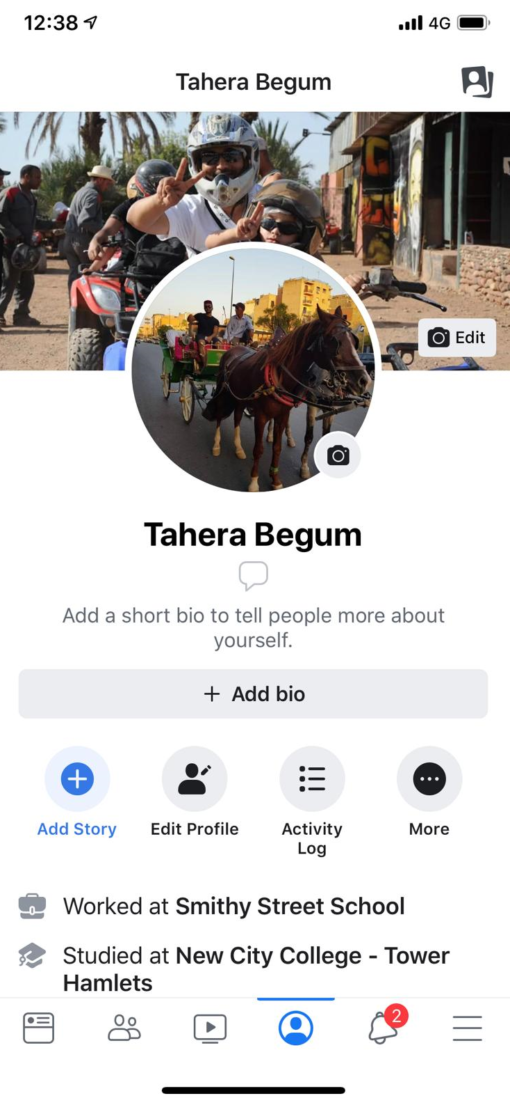

Twitter
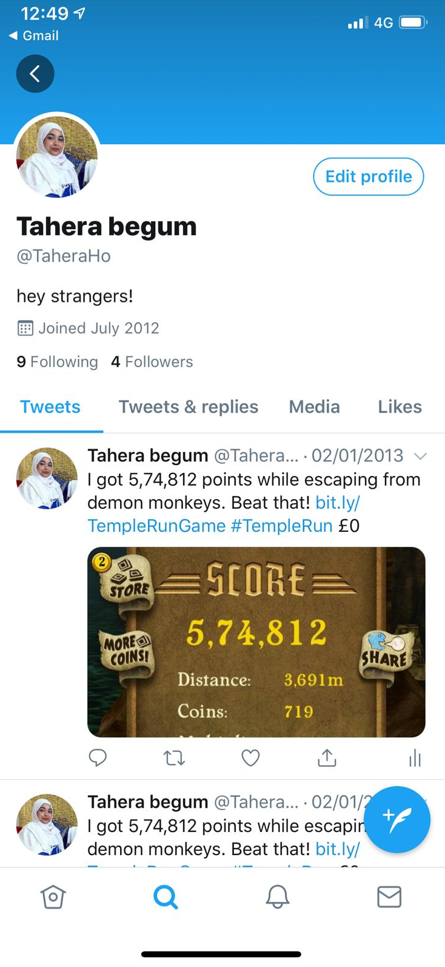

References
Barrick, I. J. (2009) Transforming Health Care Management: Integrating Technology Strategies, USA: Jones & Bartlett Publishers
Cottrell, S. (2011) Critical thinking skills: Developing effective analysis and argument (Palgrave study skills). 2nd edn. Basingstoke: Palgrave Macmillan.
Gallager, R. G., (2008). Principles of Digital Communication, UK: Cambridge University Press
Parker, J. C., Thorson, E., (2008). Health Communication in the New Media Landscape, UK: Springer Publishing Company
Madhow, U., (2008). Fundamentals of Digital Communication, UK: Cambridge University Press
Maund, A. Schriek, M. and Tinkler, P. (2017). Certificate in Higher Education: Skills for the Workplace Student Yearbook. Sage Publications
Poynter, R. (2010) the handbook of online and social media research: Tools and techniques for market researchers. United Kingdom: Wiley.
Servellen, G. M. V., (2009). Communication Skills for the Health Care Professional: Concepts, Practice, and Evidence, USA: Jones & Bartlett Publishers
Thomas, R. K., (2006). Health Communication, UK: Springer Science & Business Media
West, D. M., Miller, E. A., (2009). Digital Medicine: Health Care in the Internet Era, UK: Brookings Institution Press

