
BMIH4003 Hospitality and Guest Services
International Hotel Management
Assignment 2: Report

Student ID : 2207347
Lecturer’s Name : Muhammad Cassamo

Executive Summary
Companies in the hotel sector need to stay abreast of emerging trends or risk falling behind in a highly competitive market (Campbell, 2022). One of the best ways to guarantee that any company provides the kind of client experience that consumers want and demand is to stay abreast of general industry trends. The quality of the hotel, the management of its reputation, and the loyalty of its guests will all be topics covered in this study.

Contents
Executive Summary 2
Introduction 4
The purpose of brand consistency standards 5
Guests Review Management 6
Customer Loyalty 7
Recommendations for hotel industry 8
Conclusion 10
References 11

Introduction
A subset of the service sector, the hotel industry provides accommodations and other types of housing for travellers (Szende and Dalton, 2021). Most interpretations of the "hotel industry" include not just hotels, but also motels, lodgings, homestays, and other similar establishments that provide overnight lodging. One of the best ways to guarantee that any company provides the kind of client experience that consumers want and demand is to stay abreast of general industry trends (Chakravarti, 2018). The quality of the hotel, the management of its reputation, and the loyalty of its guests will all be topics covered in this study.

The purpose of brand consistency standards
Brand standards are what allow hotels to maintain uniformity and provide customers with constant, high-quality service (Chaney and Martin, 2017).
Independent eateries as well as those belonging to networks with more than 400 locations can benefit from adhering to brand guidelines since doing so helps establish continuous success for the business, which in turn can improve its image and win over more regulars (Kang, 2021). However, only 5% of word-of-mouth occurs online, whereas 82% occurs in person, as reported by Google Local Business. A strong brand is the only method to control the content of company guests' interactions in person.
Keeping oneself engaged while at home can be difficult, and this is something that they are well aware of (Gee, 2014). The vast majority of individuals in the world are stumped when it comes to using their free time on rainy or snowy days. Using the hashtag #AtHomeWithSLH, Small Luxury Hotels has suggested several indoor activities that their guests can enjoy while staying in the comfort of their own homes. Small Luxury Hotels can help them with everything from taking up a pencil and realizing their artistic potential to finding ideas for do-it-the self chores around the house. Building a loyal fan base requires consistently producing and distributing high-quality material, and never more so than now (Hall and Schulz, 2021).
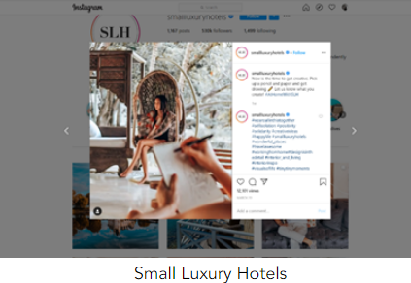
Figure-1: Small Luxury Hotels (Maier and Chon, 2019).
Ovolo Hotels, which is already known for its abundance of surprises and unique personality, have decided to take things to the next level by introducing a digital Easter egg search. Ovolo kicked off a digital Easter egg search for their website users just in time for the holiday weekend leading up to Easter. Ovolo is mailing guests on an enjoyable egg-hunting pursuit, satisfactorily interacting with them while simultaneously adding the greater opportunity to book a reservation in the coming years. The mission features a virtual reality (VR) perception of their Rockstar Suite and an enticing prize for discovering the strange silver egg, which is a discount code for thirty per cent off the room rate. The functionality of the game can also be utilized in an effective manner to collect email accounts for use in subsequent promotional activities (Jackson, 2018).
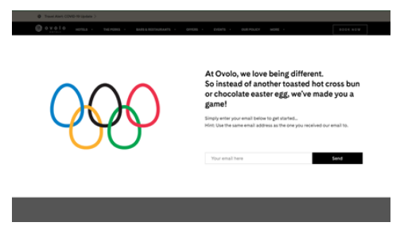
Figure- 2: Ovolo Hotels Game (Slattery, 2016).

Guests Review Management
It's a lovely amenity to have, but most hotels can't afford to provide it. And, to be perfectly honest, it's essential. They should be capable of managing the hotel's reputation on their own without having to hire an expensive team of specialists (Maier and Chon, 2019).
Two primary phases may be identified in the process of managing one's reputation:
- Knowledge of what is being said about them on the internet;
- Taking measures to enhance the hotel's image.
Managing reviews involves keeping tabs on comments and ratings users have left for the company online and on social media (Lashley and Morrison, 2016). Management of reviews is essential, as 82% of buyers consult them before making purchases at brick-and-mortar stores. In this way, they can monitor internet conversations about the company and respond to customer complaints as they arise (O’fallon and Rutherford, 2020). Both the hotel's potential customers and the hotel itself benefit greatly from positive ratings. Potential guests can benefit greatly from this information while they look for a place to stay for the night. There is a win-win situation for both the hotel and its customers when the hotelier is able to boost their profile and interact more closely with their clientele (Slattery, 2016).
In order to make an informed decision about where to stay, prospective guests frequently peruse internet evaluations written by previous guests of the hotel in question (Poustie, 2022). As a hotelier, it is their responsibility to ensure that each guest is completely content and has a fantastic time while staying at the establishment. Guests will have a pleasant stay and spread the word on their social networks, which will raise demand for rooms.
citizenM has been innovative in the ways that it operates, brands itself, and uses social media, earning it a reputation for shaking up the standard hotel model. Due to the global problems plaguing the industry, citizenM realized they needed to reach out to their customers more than ever and this hotel gave importance to their customer reviews. citizenM keeps adding to its content, allowing its lively brand values to flourish via expressions of empathy and reassurance for its customers.
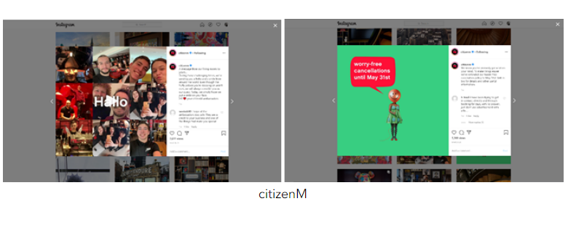
Figure-3: citizenM’s platform
The reputation, reliability, and integrity of any company could be harmed by unfavorable customer feedback (Szende and Dalton, 2021). Customers are often wary about making purchases from companies with either few or unfavorable evaluations. Over eighty-six percent of consumers will not buy from a business that has received low ratings online. Two-and-a-half times as many customers (59%) can be lost with only three bad reviews as with just one bad review.

Customer Loyalty
Loyal customers are those who keep coming back to buy from the same brand over and over again (Teare and Brown, 2018). That is to say, customers that remain faithful despite having access to other products or services are considered loyal. Because they understand they will get what they want every time they book with a reliable brand because of the high quality of service they receive (Yu and Sung Chon, 2017). If a hotel wants to retain more of its guests and attract new ones, it should work on enhancing the quality of service it provides its visitors. There are numerous strategies hotels can use to increase client loyalty, such as:
- Going above and beyond for guests;
- Delivering outstanding service to customers;
- Engaging with guests' opinions and feedback in a positive way;
- Making regular pledges to improvement;
- Establishing rapport with regular flyers;
- Recognizing the needs of hotel visitors;
- Offering unique service for each visitor.
Hotels like Leonardo Royal London provide an exceptional loyalty program by focusing on the guest's complete stay and the perks that will keep them coming back. The Hotel brand is always ahead of the competition because of one crucial aspect that they have mastered. This is just one example of how the company is always adapting to the needs of its clientele, which are constantly shifting (Hall and Schulz, 2021). That'll definitely keep their interest from dwindling.
One instance of a loyalty program that does a good job of making repeat guests feel appreciated is the one offered by the Yotel London Shoreditch. Participants pay bonus points on their birthdays, whenever they suggest a friend to the hotel, and whenever they visit the hotel's social media accounts. Customers are quick to recognize the benefits of becoming members of the program, making it not just an efficient method of client retention for a hotel brand but also an attractive proposition in its own right. Simply registering will earn them a hundred points for the player. And what this amounts to for them is some savings on their subsequent buy (Campbell, 2022).

Recommendations for hotel industry
In order to succeed, a hospitality enterprise needs to generate a constant flow of customers and money (O’fallon and Rutherford, 2020). Marketing a product or service requires original thinking, just like any other kind of business. Getting the word out about the services that are available and the location is essential, and this may be accomplished through strategic advertising (Lashley and Morrison, 2016). The hospitality industry has a wide variety of potential approaches to advertising which are discussed below:
- Use social media
When it comes to incorporating social networking features, the hospitality industry is undoubtedly ahead of the curve. Millions of meaningful connections can be made using social media. But the chances of accomplishment on social media platforms like Facebook, Twitter, and LinkedIn rely on how they use their capabilities (Maier and Chon, 2019). Hotels like Park Grand London Kensington follow this process to get more customers.
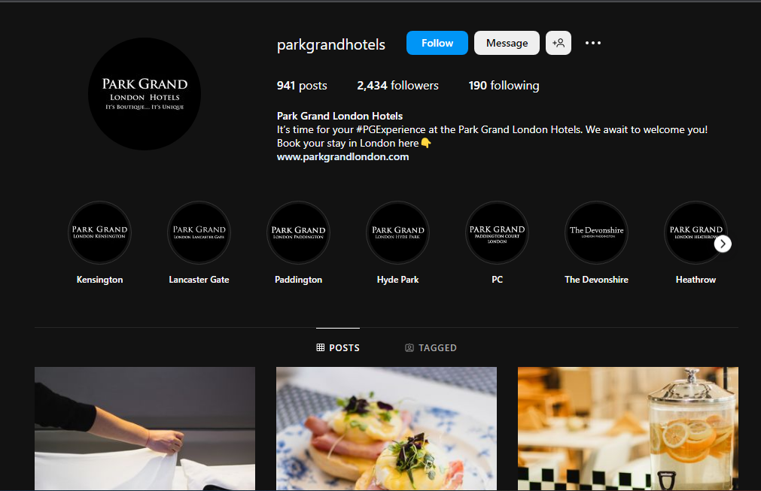
Figure-4: Park Grand London Kensington’s Instagram
- Streamline buying and booking process
Having an online booking and purchasing system is essential for any hospitality industry (Chaney and Martin, 2017). According to a study of almost 4,000 millennials in the United States, Australia, and the United Kingdom, the overwhelming majority (80%) prefer making reservations online1. The hotel is sacrificing a significant amount of potential revenue growth by not allowing guests to book their stays online (Kang, 2021).
- Invest in training
By spending money on training, employees can learn everything from how to properly wash dishes to how to effectively manage critical departments in the hospitality industry (Slattery, 2016). The UK hospitality business takes the training of its employees very seriously such as Milestone Hotel Kensington. By training them in the RSA refresher program, this hotel help business staff better recruit and retain clients.
- Network widely
For successful advertising in the hospitality sector, networking is crucial (Lashley and Morrison, 2016). It needs to be a major focus of any hospitality company's strategic plan. One's ability to communicate positive experiences with the brand and to solicit introductions from other network participants both improve with time spent on the social web (Teare and Brown, 2018). Raising the odds of success, make sure they visit hospitality industry trade fairs and seminars.

Conclusion
Helping and satisfying consumers who have purchased and used a company's goods or services is the focus of customer service (Yu and Sung Chon, 2017). It's useful in making a positive impression on guests and encouraging them to return. Keeping customers happy and bringing in more money requires a commitment to delivering excellent customer service. Recommendations on how to keep clients happy and an analysis of the effects of both positive and negative evaluations on the hospitality sector are included in this research. A thorough understanding of these topics is required for anybody seeking employment in the field.

References
Campbell, K. (2022). 7 Hotel Marketing Trends for 2021 | Cvent Blog. [online] www.cvent.com. Available at: https://www.cvent.com/en/blog/hospitality/hotel-marketing-trends.
Chakravarti, B.K. (2018). Hotel management. New Delhi: A.P.H. Pub. Corp.
Chaney, L.H. and Martin, J.S. (2017). The essential guide to business etiquette. Westport, Conn.: Praeger.
Gee, C.Y. (2014). International hotel management. East Lansing, Michigan: Educational Institute Of The American Hotel & Motel Association.
Hall, K. and Schulz, C. (2021). Hospitality. New York: Ferguson ; London.
Jackson, E. (2018). Hotel management. New York, Ny: Larsen & Keller.
Kang, D. (2021). The Importance of Customer Service in the Hotel Industry - cue media. [online] CUE. Available at: https://onstarplus.com/archives/1691.
Lashley, C. and Morrison, A.J. (2016). Franchising hospitality services. London And New York: Routledge.
Maier, T.A. and Chon, K. (Kye-Sung) (2019). Welcome to Hospitality: An Introduction. Cengage Learning.
O’fallon, M.J. and Rutherford, D.G. (2020). Hotel management and operations. Hoboken, N.J.: Wiley.
Poustie, M. (2022). Hospitality and tourism law. London: Thomson Learning.
Slattery, P. (2016). The economic ascent of the hotel business. Oxford: Goodfellow Publishing.
Szende, P. and Dalton, A.N. (2021). Operations Management in the Hospitality Industry. Emerald Group Publishing.
Teare, R. and Brown, G. (2018). Global directions : new strategies for hospitality and tourism. London ; Herndon, Va: Cassell.
Yu, L. and Sung Chon, K. (2017). The International Hospitality Business. Routledge.

