

Cyber Threat intelligence and critical national infrastructure: effective cyber THREAT INTELLIGENCE and its impact on reducing security risk
Carys Newing
Nitheesh Kaliyamurthy
Project submitted as part of the requirements for the award of Bachelor of Science: Computing (Computer Networks & Cybersecurity)
Oct 2025
Declaration of Originality

I, Carys Rebeca Newing declare that I am the sole author of this Project; that all references cited have been consulted; that I have conducted all work of which this is a record, and that the finished work lies within the prescribed word limits.
This work has not previously been accepted as part of any other degree submission.

Signed : C.R.Newing
Date : 30/1/2026

FORM OF CONSENT
I, Carys Rebeca Newing hereby consent that my Project, submitted in candidature for the Bachelor of Science: Computing (Computer Networks & Cybersecurity, if successful, may be made available for inter-library loan or photocopying (subject to the law of copyright), and that the title and abstract may be made available to outside organisations.

Signed : C.R.Newing.
Date : ...............................................

Copyright Acknowledgement

I acknowledge that the copyright of this project report, and any product developed as part of the project, belong to University of Wales Trinity Saint David, Swansea.

ABSTRACT/SYNPOSIS

Critical National infrastructure is being increasingly exposed to the ever persistent and evolving cyber threat landscape and thus require timely, accurate and actionable cyber threat intelligence to support effective security risk management and minimising the risks wherever possible. This project evaluates the effectiveness of an automated cyber threat intelligence aggregation application programming interface in reducing cyber security risk within critical national infrastructure environments through providing continuous cyber intelligence and analysis.
The implemented system ingests real-time data from multiple open-source intelligence sources and consolidates vulnerability disclosures, threat activity reports as well as patching notifications for systems into a unified intelligence feed. A cleansed dataset collected between 5 August, and 14 December 2025 was analysed to assess intelligence quality, temporal accuracy, sector relevance, and operational usefulness. Testing and evaluation were conducted using empirical output analysis, focusing on classification correctness, temporal consistency, and alignment with technologies and sectors commonly associated with critical national infrastructure.
The results demonstrated that when running the system delivered relevant and timely cyber threat intelligence of which a significant proportion was directly applicable to critical national infrastructure. The aggregated intelligence supports cyber risk reduction by enabling early awareness of newly disclosed vulnerabilities, providing contextual insight into threat activity, and informing the prioritisation of remediation actions based on the threat relevance and patch availability.
The project concludes that effective and automated cyber threat intelligence serves as a practical mechanism for reducing cyber security risk within critical national infrastructure environments by enhancing informed decision-making and defensive preparedness. While intelligence alone does not eliminate risk, the findings confirm its value as a foundational component of an intelligence-led defence strategy when appropriately contextualised and operationalised.

Table of Content

Abstract/Synopsis
Table of Content
List of Figures
List of Tables
Acknowledgements

Copyright Acknowledgement ii
Introduction
1.1 Introduction 9
1.2 Aim 12
1.3 Objectives 12
1.4 Structure Of The Project 13
Chapter 2 - RESEARCH & REVIEW OF LITERATURE 15
2.1 Introduction 15
2.2 Literature Review 15
2.3 Methodology 18
2.4 Critical Appraisals 22
2.5 Conclusion 36
Chapter 3 - RESEARCH METHODOLOGY 38
3.1 Research Overview 38
3.1.1 Research Process 41
3.1.2 Research Philosophy 41
3.1.3 Philosophies 42
3.1.4 Research Methodologies 43
3.1.5 Approach 44
3.1.6 Time Horizons 46
3.1.7 Risks and Limitations 46
3.2 Validity, Reliability and Generalisability 48
3.2.1 Ethical Issues 49
3.2.2 Reliability 50
3.2.3 Generalisability 50
3.3 Development Methodology and Design Planning 51
3.3.1 Primary Design 51
3.3.2 Validation and Refinement 51
3.3.3 Resource and Planning 51
3.3.3.1 Hardware Resources 52
3.3.3.2 Software Resources 52
3.3.3.3 Information Resources 52
3.3.3.4 Human Resources 52
3.4 Contingency Planning 53
3.4.1 Contingency Design 53
3.4.2 Contingency Validation and Refinement 53
3.4.3 Resource and Planning 53
3.4.3.1 Hardware Resources 54
3.4.3.2 Software Resources 54
3.4.3.3 Information Resources 54
3.4.3.4 Human Resources 54
3.5 Conclusion 55
Chapter 4 - DESIGN & IMPLEMENTATION 56
4.1 Introduction 56
4.2 problem formulation 56
4.3 Design 57
4.4 Implementation 59
4.5 Conclusion 66
4.6 Summarised the key aspect of the chapter 66
Chapter 5 – Testing and Evaluation 67
Chapter 6 – Conclusions and recommendations 77
6.1 Summary 77
6.2 Conclusion 77
6.3 Recomendations FOR FURTHER Research 78
Chapter 7 – Reflections 80
Chapter 8 - REFERENCES 83
Bibliography 83
APPENDICES 85
A. PROJECT MANAGEMENT 86
B. Ethics form 91
Outline any anticipated risks that may adversely affect any of the participants, the researchers and/or the University, and the steps that will be taken to address them. 99
C. Logbook 109
D. Narrow Literature review results 119
GLOSSARY 126
E. PROJECT Development – API Code 129

LIST OF FIGURES
Figure 1: Research Overview 40
Figure 2 - Process Flow for API 58
Figure 3 - API Version Control 61
Figure 4 - Visual Studio API Running 62
Figure 5 - .env Variables 63
Figure 6 - Teams Alert Post 65
Figure 7 - Email Alert Display 66
Figure 8 - Alert Volume: CNI-related vs General IT (Monthly) 68
Figure 9 - Alerts by Classification 69
Figure 10 - Alert Volume by Category 70

LIST OF TABLES
No table of figures entries found.

ACKNOWLEDGEMENTS

Dwr Cymru Welsh Water Cyber team for their support and guidance with the project and for the additional feedback following the completion of the project.

Additional acknowledgement to Ryan Draper for assistance with getting Github version control working.

Chat GPT was utilised for the troubleshooting aspects once standard troubleshooting routes had been exhausted.

Introduction

Introduction

Cyber Threat Intelligence (CTI) refers to the systematic process of gathering, analysing, and utilising data about current and potential threats to an organisation's digital security. This process involves understanding the TTPs used by cyber attackers, identifying vulnerabilities, and pinpointing potential targets. CTI empowers organisations to make informed decisions on security strategies and enables proactive measures to safeguard sensitive information and systems.

CTI helps businesses defend against the many forms of cyber threats that are both in the wild as well as vulnerabilities with no current patches or exploits available.
By staying ahead of cyber threats through a well-managed CTI strategy, organisations can protect their digital assets, maintain business continuity, and reduce the risk of data breaches and other costly cyber incidents. As the cyber threat landscape continuously evolves, a proactive approach to CTI is vital for any organisation committed to security and resilience

Cyber Risk Assessment (CRA) are utilised by organisations to identify, evaluate, and prioritise risks to their digital assets. The CRA provide insight into potential security threats, critical vulnerability exploits (CVE) that could be exploited along with the impact of a cyber incident on business operations. For DCWW this extends into both Operational Technology (OT) and the (IT) environments. By involving CRA with CTI this enables DCWW to make informed decisions to reduce risk, enhance security controls and ensure regulatory compliance

Critical National Infrastructure (CNI) has always been classified as at risk due to the impact that it can have on social, health and transport. If a CNI industry such as a water and sewage company is targeted there is the possibility of not only making people ill, but there is the risk of fatalities especially if the chemical dosing is altered. This paper will examine the criticality and effects of having CTI with a closer focus on CNI. As CNI has always been a target, from Stuxnet which targeted nuclear reactors to the Wannacry ransomware that affected the NHS. Both examples convey the impact and importance of cyber security within the CNI sectors.

Dwr Cymru Welsh Water (DCWW) are a water company; they are classed as CNI as they handle drinking water as well as the sewage wastewater. Without water companies working to process water to a potable level there would be disarray within the country as it would have a detrimental effect on society as additional infrastructures would be affected such as the NHS, and whilst this would likely to cause illness there is also a potential for risk to human life should there be a attack on the drinking water processes or the sewage processes. Due to the importance of CNI, alerting systems to aid in the protection of such organisations are highly beneficial. Therefore, this project is to provide an alerting tool to be trialled, improved, and used within the organisation before being shared with other water industries within the UK.

Previously Tweetdeck was used to monitor threat sources however since Twitter was bought out by Elon Musk and renamed X, tweetdeck was no longer able to operate as a development account is required to enable the application programming interface (API) to search X. When this occurred, it resulted in a gap in our monitoring technologies and whilst there are other platforms available the costings associated with them mean that they are not a viable option. The majority of water and sewage companies are in the same predicament as they work in 5-year periods and get awarded set funding depending on the pitches provided by the companies. Unfortunately, most of the monies awarded goes towards the clean and wastewater treatment and getting dedicated monies for cyber security spending is difficult. This means that there is a gap for low costing CNI alerting that can be directly fed into platforms such as Microsoft although it will require human interaction to ensure that the alerts and vulnerability patching are responded to, this will free up team resourcing from manually searching for these to ensuring that they are implemented in a timely fashion.

For this project Azure Logic Apps (ALA) will be the main application used to provide the interactions using API’s to X which it will provide alerting to a dedicated Microsoft teams channel based on a static list of the software and devices that we have on the estate. This list will be generated using the Centrally Managed Database of hardware and software assets that exist on the estate.

Aim

The aim of this project is to implement an effective alerting system to improve Critical National Infrastructure response to Cyber Threat Intelligence alerting and vulnerability patches.

Objectives

The four objectives for this report are:
- Conduct comprehensive research and a literature review to identify existing gaps in current alerting systems and define the functional and technical requirements for the proposed alerting platform.
- Design and develop the alerting system based on the defined requirements, exploring and evaluating suitable design approaches, technologies, and implementation strategies to establish a functional foundation for the final product.
- Produce detailed high-level design documentation outlining the system architecture, key components, data flows, and implementation plan to demonstrate how the alerting system will be constructed and integrated.
- Conduct comprehensive testing to ensure the developed solution meets the minimum and functional requirements. Analyse the outcomes of the testing phase to identify issues, document alterations, and provide justification for any modifications made to improve system performance and reliability.

These objectives have been chosen to enable the creation of a suitable CTI alerting platform that will build into our systems to increase CNI awareness and responsiveness to Vulnerabilities or Threats through ALA using API. The Cyber Security Analyst will be responsible for the creation of this alerting tool. The Cyber Threat Analysts and our IT Network Team will be responsible for handling the output from this tooling.

Structure Of The Project

The project is in three parts. Firstly, the theoretical work already established which underpins the project. The theoretical work relates to the reviewing of literature and former studies of CTI alerting platforms that will expand the knowledge base and will be fundamental to the outcome of the project. The second part details the design and implementation in this case it will outline the problem formulation and the design implementation that will be used to create the alerting platform for CTI and vulnerability patch releases. The software requirements, CMDB lists and KQL requirements and implementation to complete this project will also be covered.
Finally, the third part detailing the findings. This will be reviewing previous CTI responses from tickets in our current platform against the data generated from the CTI and vulnerability patching data as they should also result in tickets being raised on our platform. This will also contain a conclusion summary of the previous chapters, a final conclusion and outlines of any future work or development.

Chapter one delivers a background summary of the report, specifying the aim and emphasising the objectives necessary for a successful outcome.

Chapter two concentrates on the research and review of any relevant literature required to highlight the gaps and the requirement including the benefit for having CTI alerting.

Chapter three details the research approach and design that will ultimately formulate the final product.

Chapter four outlines the high-level design documents to show where it will sit within our architecture and how it will communicate.

Chapter five examines the product testing including any issues met and any alterations to the final product.

Chapter six focuses upon the conclusions and recommendations following the analysis of the data produced against the existing data. This will include any additional features that could be included in future improvements.

Chapter 2 - RESEARCH & REVIEW OF LITERATURE

Introduction

This chapter will evoke how relevant literature was identified, as well as comparing and critically reviewing them. The main literature used will be books and journals.

Literature Review

Whilst the majority of CNI have a segregation between their and their IT estates, this segregation can also leave organisations open to attack if not properly configured or managed. Some OT sites are at a greater risk as the SCADA software, application and architecture are utilising older operating systems as they are often not upgraded after implementation due to the cost and architecture that exists and relies on them. Due to this the Cyber Security Risk Management (CSRM) for CNI is even more challenging.
CTI can be gathered from both open-sourced intelligence (OSINT) and from threat intelligence platforms (TIPs). Whilst TIP’s utilise OSINT sources they also can provide dark web monitoring as well as additional analysis however this is not always affordable for businesses. There are CTI and TIPs but none that specifically are targeted for CNI usage therefore my solution will consider the OT threats that DCWW may be affected by as well as the IT threats. This can be done by creating a tailored list that could be applied to any water industry to provide alerting that enables the reactive response timeframe to be minimised.
The SANS cyber threat survey response [5] indicates that “the leading use was for threat detection (89%), followed by threat prevention (77%), threat response (72%) and threat mitigation (59%).” It also implies that any organization that are focusing too heavily on threat prevention often struggle with detection and response elements that occur in an incident. Whilst [6] CTI is predominantly seen as a primary data driver for the detection of threats found in their estate however the most beneficial CTI is the indicators of compromise (IoC) especially when used with the TTPs.
[1] Emphasises that there is necessity for industries to share CTI however there is a “lack of focus on how CTI information can support the CSRM activities” this is also due to attacks being more sophisticated and multi-vectored. Which is also backed up by the attacks seen against the Ukraine power grid [4] targeting CNI SCADA along with the 2013 Rye dam attack [3] which specifically targeted the floodgate of the Bowman Avenue Dam.
As CNI are not only vulnerable from OT and SCADA attacks as well as IT attacks such as the recent 2023 MoveIT automated attack from Clop [7], but this also emphasises the need for a tailored CNI alerting tool that can be utilised within the water industries. As SCADA are ICS that provide a supervisory-level control over a machine or industrial process [8] their versatility means that they can be found in numerous CNI settings as well as in manufacturing processes – this means that they are likely to have vulnerabilities. Loshin’s [9] SCADA system architecture as shown in figure 1, below, conveys the depth at which SCADA operates and from such it enables the visualisation of how a threat can impact a SCADA system as well as the impacts that it can have on CNI sites.

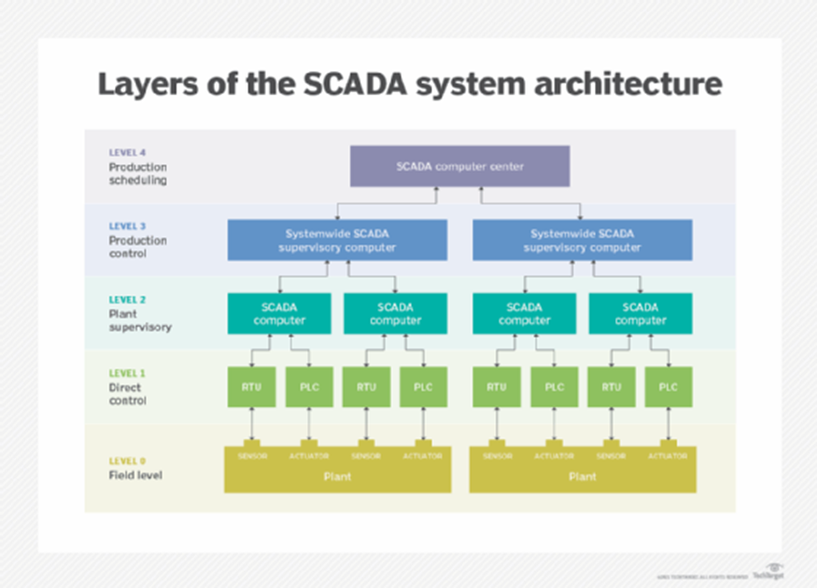
Figure 1 - SCADA System Architecture
Trend Micro’s zero-day initiative [8] indicates that vulnerabilities are known in SCADA and they are likely to be present for some time. Whilst this does not indicate whether mitigations are possible for these vulnerabilities alerting and monitoring systems would be required to ensure that the SCADA and ICS systems are not being exploited. With technological advancements cyber threats against SCADA are becoming more prevalent by exploiting elements such as weak IT and OT segregation [9] along with a lack of maintenance and weak protocols. Depending on the SCADA system it is likely that there are elements that are exposed to the internet that sites such as Shodan may show vulnerabilities [9]. These known vulnerabilities can be mitigated via hardening and the appropriate monitoring of the devices however attacks that might circumvent the security controls are often not monitored as it would require a dedicated cyber threat analyst or an automated reporting system that is specifically looking for these exploits in the wild to enable an organisation to monitor and alert on the specific IoC’s.
With the constantly changing landscape in the field of Cyber Security means that organisations are regularly at risk of cyber threats and whilst this can vary depending on the services, data and applications that they use. This means that businesses must be on constant alert to be able to respond reactively when such incidents are identified. Whilst this is not always feasible for many organisations to respond promptly resulting in delays responding to incidents involving cyber threats especially if they don’t have a security operation centre (SOC) or a hybrid SOC.
CNI’s need for a dedicated and tuneable alerting system is highlighted from the sources reviewed in this document and if it is sharable amongst water industries it would strengthen the security postures and reactive response times in relation to the alert notifications. Having a shared tool that would allow for alerts to be received, reviewed, and added to reports whilst it would have some deviance in the initial response to such an alert would allow and organisation to assess the applicability as not all CNI especially in the water industry use the same systems or SCADA. Ensuring the input from customisable lists would allow organisations to tailor the alerts that they see which would grant flexibility as to the alerts received.

Methodology

For this project a Narrow Literature Review will be performed using the IEEE Xplore platform to identify relevant books and journals as key word searches can be used to aid in the identification of suitable sources.
To identify relevant literature the following keywords were identified:
- CNI
- Critical National Infrastructure
- Water Industry
- CTI
- Cyber Threat Intelligence
- Enterprise Networks
- Cyber Security
- Cybersecurity
- Critical Infrastructure
- Security Controls
- Cyber Security Risk Management
- Regulations
- Tactics Techniques and Procedures
- TTP
- Operational Technology
- OT

With the keywords identified above, the following filters have been used to identify literature to review.

(("All Metadata":Critical National Infrastructure) OR ("All Metadata":CNI) AND ("All Metadata":Water Industry) AND ("All Metadata":Operational Technology) OR ("All Metadata":OT) AND ("All Metadata":Cyber Security) AND ("All Metadata":cybersecurity) AND ("All Metadata":TTP) OR ("All Metadata":Tactics Techniques and Procedures) AND ("All Metadata":CTI) OR ("All Metadata":Cyber Threat Intelligence)AND("All Metadata":Enterprise Network) AND ("All Metadata":Security Controls) AND ("All Metadata":Security Controls)AND ("All Metadata":Regulations) AND ("All Metadata":Regulations))
The above filters generated 193 Journals with restricting the publication year to 2024. for the Inclusion criteria, it contains anything that pertains to relevant Standards, Models and frameworks. Furthermore, it is also including any that include the use of Artificial Intelligence and Machine Learning as part of the CTI monitoring as whilst this may not be currently a viable option for DCWW it should be considered as it is still relevant.
For the Exclusion requirements, anything that did not fit with the keywords has been discarded along with anything pertaining to computerised or automated transportation. Lastly anything pertaining to cables and sub-marine technologies has also been removed.
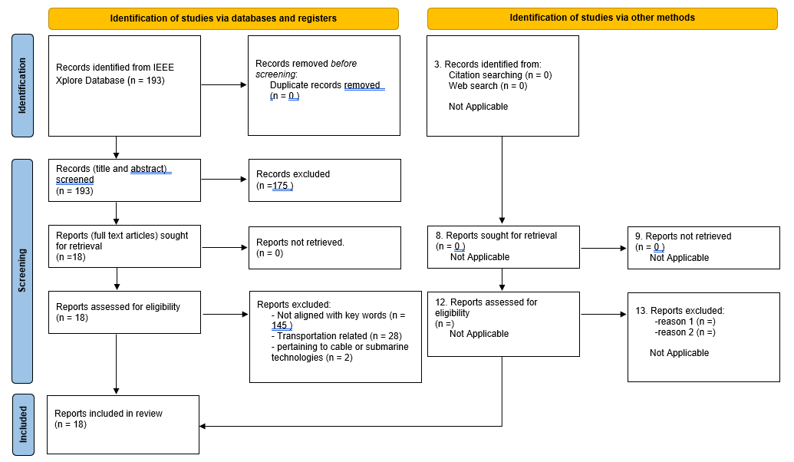
Figure 2 - PRISMA Flow Diagram
By restricting the criteria a total of 18 suitable literatures have been identified, compared to the 193 that was in the restricted keyword search.

The journals identified from IEEExplore platform along with the sources identified as part of the Industrial research project.
Compared to other companies, CNI have both information technology (IT) and operational technology (OT). Whilst they are typically segregated within a business they often use older technology in the OT side and due to it’s operational nature along with the costing involved results in legacy equipment with potential vulnerabilities remaining in the OT environment.

Critical Appraisals

Falowo and Abdo (2024) conducted an extensive analysis of global Distributed Denial of Service (DDoS) incidents from 2019 to 2023, employing ARIMA and Exponential Smoothing State Space (ETS) models to forecast future attack trends. Their research highlights the growing freq decentralized graph federated learning uency and sophistication of DDoS attacks and their direct impact on CNI, emphasizing the economic and operational risks these pose. The study’s use of predictive modelling demonstrates the value of data-driven CTI in anticipating and mitigating emerging threats. Furthermore, the authors identify a strong correlation between DDoS activity and geopolitical tensions, positioning cyberattacks as tools of modern statecraft. This link underscores the need for adaptive, intelligence-led defence mechanisms to enhance CNI resilience. Overall, their findings support the integration of proactive CTI capabilities into national cybersecurity strategies to reduce risk and strengthen critical systems against evolving global threats.

Mejdi et al. (2024) present a comprehensive survey on the application of game theory and machine learning in securing cyber-physical systems (CPS), which form the backbone of modern CNI. The study systematically analyses over 800 research papers to identify key attack models—such as denial of service, false data injection, replay, and jamming—and examines how game-theoretic frameworks can model attacker–defender interactions. By integrating machine learning classification with strategic modelling, the research demonstrates how predictive and adaptive defence mechanisms can enhance cyber resilience. This aligns closely with CTI principles, as it emphasizes anticipating adversarial behaviour, automating threat analysis, and informing proactive mitigation strategies. The paper’s focus on smart grids, healthcare, and industrial control systems underscores its practical relevance to CNI protection, reinforcing the importance of intelligence-led, data-driven approaches in reducing cyber risk.

Ramachandran et al. (2024) present a simulation-based control co-design framework that enhances the resilience of cyber–physical systems (CPS), with a specific focus on microgrid applications. The framework concurrently optimizes system and control parameters to meet operational and resilience objectives under various cyber and physical threat scenarios. By integrating active and passive resilience metrics with Bayesian optimization and high-fidelity simulations, the study enables predictive modelling of adversarial conditions such as false data injection, communication loss, and generation disruption. This approach aligns closely with CTI principles by using adversarial scenario analysis to inform proactive defence strategies. Moreover, its application to microgrids underscores its importance to CNI resilience, providing a data-driven foundation for designing systems that can adapt, recover, and sustain critical operations during cyber incidents.

Moussa et al. (2023) provide a comprehensive survey of digital forensics and compliance auditing as integral components of critical infrastructure protection. The paper emphasizes that forensic investigations not only support post-incident analysis but also contribute to the generation of actionable CTI through evidence correlation and attack attribution. By integrating compliance auditing frameworks such as ISO 27001 and NIST 800-53, the study demonstrates how governance mechanisms can facilitate continuous threat monitoring and risk assessment. The authors further highlight the role of forensic readiness and cross-sector collaboration in enhancing resilience, ensuring that CNI can effectively detect, respond to, and recover from cyber incidents. This alignment of forensic intelligence and compliance practices with CTI principles strengthens the foundation for adaptive, intelligence-led protection of essential services.

Sadeghi et al. (2024) present an in-depth study of security threats in open-source software supply chains, with a particular focus on vulnerabilities within Continuous Integration and Continuous Deployment (CI/CD) pipelines. The paper categorizes major attack vectors such as dependency poisoning, credential theft, and build process compromise, and examines how these can be mitigated through intelligence-led DevSecOps practices. By analysing real-world incidents like the SolarWinds and CodeCov breaches, the authors highlight the systemic risks such vulnerabilities pose to CNI, where compromised software can lead to widespread operational disruption. The integration of CTI into CI/CD workflows — through automated threat feeds, code integrity checks, and zero-trust architectures — is proposed as a means of strengthening software assurance and national cyber resilience. This study reinforces the importance of CTI in proactively identifying and mitigating software supply chain risks that threaten critical systems.

He et al. (2024) proposes an immune-knowledge-driven virus propagation model (SELBR) for Supervisory Control and Data Acquisition (SCADA) systems, which are central to CNI. Their research identifies that traditional industrial virus models fail to consider information exchange between network nodes, a gap that limits the accuracy of current CTI efforts. By emulating biological immune responses, the SELBR model enables SCADA nodes to “communicate danger signals” and reinforce system-wide defence, significantly reducing infection spread in simulations. This approach exemplifies how intelligence-led modelling can predict and contain cyber-physical threats, aligning with the broader CTI objective of proactive defence through behavioural and predictive analytics. The study underscores that enhancing situational awareness within interconnected industrial systems—especially with the rise of 5G and IoT connectivity—is critical for protecting CNI from cascading cyberattacks. Its findings support the need for adaptive, intelligence-driven monitoring frameworks within modern alerting platforms to pre-empt industrial malware propagation.

Khan et al. (2024) proposed an innovative anti-malware architecture integrating Generative Adversarial Networks (GANs) to enhance the detection and mitigation of evolving cyber threats. Their study addresses the limitations of traditional signature-based systems by introducing a GAN-based Malware Classifier Optimizer (MCOGAN) capable of identifying zero-day and polymorphic malware through adaptive learning and data augmentation. The research demonstrates how combining artificial intelligence with conventional detection mechanisms can significantly improve accuracy, reducing false negatives and strengthening system robustness. Importantly, the authors highlight the growing sophistication of malware targeting sensitive digital environments, underscoring the implications for CNI security. By leveraging generative modelling to simulate novel attack patterns, the study contributes to the advancement of CTI practices, enabling more proactive and intelligence-led defence strategies. Overall, Khan et al.’s findings reinforce the importance of AI-driven detection frameworks in reducing cyber risk and enhancing the resilience of national and organizational infrastructures against emerging threats.

Park and Kang (2024) introduced a novel adversarial defence mechanism that integrates detection and mitigation within a unified student–teacher deep learning framework. Their approach addresses the inherent vulnerability of deep neural networks (DNNs) to adversarial perturbations by enabling the model to distinguish between normal and adversarial inputs before applying corrective defences. The study demonstrates how the student network predicts undistorted hidden-layer features of the teacher network, allowing accurate detection of adversarial examples and subsequent recovery of correct classifications through feature restoration. This dual capability significantly enhances robustness against both white-box and black-box attacks, minimizing performance degradation across normal data. The research holds relevance to CTI as it exemplifies the application of adaptive, AI-driven techniques for detecting and mitigating malicious inputs designed to evade traditional defences. Moreover, the framework’s ability to maintain model reliability under adversarial pressure has strong implications for safeguarding CNI, where system integrity and resilience are paramount. Overall, Park and Kang’s findings underscore the importance of integrating intelligent, self-correcting defence mechanisms into cybersecurity systems to strengthen resilience against evolving adversarial threats.

Pauu et al. (2024) proposed an innovative privacy-preserving framework that integrates differential privacy, blockchain, and decentralized graph federated learning (DGFL) for unmanned aerial vehicles (UAVs) in disaster response scenarios. Their Differential Privacy and Blockchain-Empowered Decentralized Graph Federated Learning (DPBE-DGFL) architecture enables UAVs to collaboratively train machine learning models without relying on a central server, thereby enhancing data privacy, security, and system resilience in disrupted communication environments. The framework employs differential privacy to safeguard sensitive information during local model training, while blockchain ensures model integrity and consensus through a Dedicated Proof-of-Stake mechanism. Extensive simulations on EMNIST and real-world disaster datasets demonstrated that the DPBE-DGFL framework achieves strong privacy guarantees, robust model performance, and efficient communication overhead. This research is significant for cybersecurity and critical infrastructure protection as it illustrates how decentralized, privacy-aware intelligence systems can securely coordinate in high-risk environments. Moreover, the integration of blockchain-based authentication into federated learning underscores the potential of distributed trust mechanisms to enhance data integrity and operational continuity in CPS.

Rodrigues et al. (2024) explored the role of edge computing as a key enabler of resilience within interconnected energy and water systems, emphasizing its potential to strengthen the cybersecurity and operational reliability of critical infrastructure. Their study highlights how distributed edge architectures facilitate real-time data processing, anomaly detection, and autonomous control across geographically dispersed assets, thereby reducing latency and dependency on centralized systems. By integrating edge intelligence with advanced monitoring and control mechanisms, the authors demonstrate how critical systems can maintain functionality and stability during cyber incidents or physical disruptions. The research further underscores the importance of embedding cybersecurity measures within edge-based frameworks to mitigate risks associated with data integrity, unauthorized access, and system manipulation. This work is particularly relevant to CTI and CNI as it illustrates how edge-enabled situational awareness can enhance the capacity to detect, respond to, and recover from cyber threats. Overall, Rodrigues et al.’s findings reinforce the value of decentralized intelligence and edge computing in enhancing the resilience and security posture of essential national systems.

Al-Shehari et al. (2024) presented an advanced insider threat detection framework designed to address the challenges of imbalanced cybersecurity datasets using the Density-Based Local Outlier Factor (DBLOF) algorithm. Their research targets one of the most persistent and high-impact risks in modern organizations—malicious activity originating from legitimate users with internal access. Traditional detection systems often struggle to identify these threats due to the rarity and subtlety of insider behaviours, which are typically overshadowed by large volumes of benign user data. By applying DBLOF, the authors demonstrate a method that detects anomalous patterns through local density deviations, effectively distinguishing rare malicious instances without requiring data resampling or duplication. Testing on the CERT r4.2 insider threat dataset achieved an F-score of 98%, highlighting the model’s ability to maintain precision and recall under highly skewed conditions. This work is particularly relevant to CTI and CNI as it underscores the need for intelligent, anomaly-based detection systems that can operate effectively within complex network environments. The study’s focus on early insider threat identification and reduction of false negatives supports proactive risk mitigation strategies essential for safeguarding critical systems. Overall, Al-Shehari et al.’s findings reinforce the importance of adopting data-driven, machine-learning-enhanced CTI frameworks to strengthen organizational resilience against insider-driven cyber risks.

Yu et al. (2024) proposed a novel ransomware defence mechanism titled FREEDOM (Fast Recovery and Detection Mechanism), designed to counter crypto-ransomware attacks by leveraging techniques typically used by malware itself. Their approach utilizes Alternate Data Streams (ADS) within Windows’ NTFS file system to conceal real data while exposing only decoy file “shells” to ransomware. This deception-based architecture allows users to interact with files normally while ensuring malicious encryption attempts target dummy data instead of actual content. The FREEDOM system integrates a kernel-level driver monitor that detects and blocks unauthorized I/O operations in real time, ensuring zero file loss and minimal performance overhead. Experimental evaluations against multiple ransomware variants—including WannaCry, Maze, and Petya—demonstrated complete protection without measurable system slowdown.
This research is highly relevant to CTI and CNI as it embodies an adaptive, intelligence-led defence strategy capable of mitigating evolving ransomware threats that often disrupt essential services and national operations. By adopting a self-protecting and recovery-oriented design, the FREEDOM framework illustrates the potential of autonomous, resilient security architectures that can operate effectively even under sophisticated adversarial conditions. Furthermore, its lightweight deployment model enhances usability across organizational and individual contexts, supporting CTI objectives of minimizing incident impact and improving data survivability. Overall, Yu et al.’s work reinforces the need for proactive, deception-driven protection mechanisms as part of modern cybersecurity strategies aimed at safeguarding critical infrastructure and reducing systemic cyber risk.

Huang et al. (2024) developed MITREtrieval, a deep learning and ontology-fusion framework designed to automatically extract MITRE ATT&CK TTPs from unstructured CTI reports. Their system combines a Sentence-BERT model with the COMAT ontology, enabling accurate identification of adversarial techniques even within complex, sparsely labelled datasets. By integrating semantic analysis with structured knowledge, MITREtrieval overcomes limitations found in prior keyword- or term-frequency-based models, achieving high recall rates and reducing false negatives—a critical requirement for operational threat intelligence. The study demonstrates how automated TTP extraction can significantly enhance CTI analysis efficiency, by reducing manual workload and accelerating response times to emerging threats. This research holds substantial relevance to CNI, as it underpins the need for scalable, intelligence-driven systems that can identify and classify cyberattacks in real time. By translating unstructured reports into structured, actionable intelligence, MITREtrieval contributes to improving situational awareness, supporting proactive defence strategies, and informing incident response across critical sectors. Overall, Huang et al.’s work exemplifies the practical application of AI and ontology fusion in advancing CTI automation and resilience within national cybersecurity frameworks.

Shieh et al. (2024) explored the evolving role of reliability engineering in an era of rapidly converging technologies, emphasizing the need to integrate cyber trust, cybersecurity, and cyber resilience into modern system design and operation. Their research examined emerging domains such as AI-driven autonomous systems, distributed ledger technologies (DLT), 5G and 6G networks, and enterprise cybersecurity, illustrating how convergence increases both interconnectivity and vulnerability. The authors highlighted that reliability engineering must adapt by incorporating proactive risk management, continuous validation, and interdisciplinary collaboration to safeguard the confidentiality, integrity, and availability of critical systems. This is off relevance to CTI and CNI, as the paper underscores that cyber resilience must now be a foundational element of reliability frameworks. By promoting the fusion of reliability engineering and CTI, Shieh et al. advocate for predictive, intelligence-led defence mechanisms capable of anticipating and mitigating systemic risks across essential sectors. Their findings reinforce the necessity of integrating adaptive engineering practices with real-time threat intelligence to protect critical assets from increasingly complex and convergent cyber threats.

Aslam et al. (2024) conducted a comprehensive survey on Industrial Control System (ICS) security, emphasizing architectural vulnerabilities, communication network weaknesses, and real-world attack scenarios across critical sectors like energy, power, and wastewater management. The study classified ICS components—such as SCADA, PLC, DCS, RTU, HMI, and MTU—and detailed their respective vulnerabilities, including weak authentication, poor segmentation, and inadequate update mechanisms. The authors highlighted the risks of OT/IT convergence, which has expanded attack surfaces and increased exposure to advanced persistent threats (APTs), ransomware, and supply chain compromises. They identified new threat actors like CHERNOVITE (developer of PIPEDREAM malware) and BENTONITE, both of which target critical energy infrastructures. Emerging trends include the use of honeypots, AI/ML-based anomaly detection, and zero-trust architectures to strengthen OT defences. For CTI and CNI relevance, the paper underscores the importance of component-specific threat modelling, intelligence sharing, and predictive defence mechanisms. By integrating vulnerability analysis with real-world incident data, Aslam et al. provide a foundational reference for building resilient, intelligence-driven ICS security frameworks that can pre-emptively counter complex, multi-vector cyberattacks on industrial environments.

Zhang et al. (2024) proposed a decentralized framework for securing CPS through collaborative intrusion detection with privacy preservation, addressing the growing need for distributed defence in interconnected industrial and critical infrastructure environments. Their model integrates federated learning (FL) with a blockchain-based consensus mechanism, allowing multiple CPS nodes to collaboratively train intrusion detection models without sharing raw data, thereby maintaining privacy while improving detection accuracy. The framework employs differential privacy and homomorphic encryption to protect sensitive system information during model aggregation, ensuring that learning contributions remain verifiable and tamper-proof. Experimental results demonstrate that this decentralized approach not only enhances detection precision and robustness but also scales effectively across large and heterogeneous CPS networks. The study’s relevance to CTI lies in its ability to facilitate intelligence sharing and cooperative defence without compromising data confidentiality—an essential requirement for modern threat intelligence ecosystems. In the context of CNI, Zhang et al.’s framework provides a blueprint for resilient and secure operational environments, where real-time collaboration between distributed systems is vital to counter sophisticated and coordinated cyberattacks. Overall, the research highlights the transformative potential of privacy-preserving, blockchain-enabled intrusion detection as a foundation for next-generation CTI and CNI protection strategies.

Lachure and Doriya (2024) introduced an advanced cyber-physical security framework for water distribution systems (WDS) that leverages sensor networks and hybrid metaheuristic optimization to detect and mitigate cyber-physical attacks (CPAs). Their proposed CyberNetGuard framework integrates chicken swarm optimization and particle swarm optimization algorithms to enhance feature selection from high-dimensional data, improving detection accuracy and resilience in real time. The system operates within a fog–cloud computing architecture, distributing processing closer to data sources to minimize latency, reduce single points of failure, and support real-time anomaly detection. Using benchmark datasets such as WADI and BATADAL, the framework achieved near-perfect precision and recall, demonstrating its scalability and reliability in identifying complex attack scenarios. This research directly relates to CTI and CNI by addressing the growing need for adaptive, data-driven security models capable of safeguarding essential services like water supply networks. The integration of distributed edge analytics and machine-learning-driven anomaly detection supports the development of intelligence-led monitoring systems, capable of learning from and responding to evolving threats. Furthermore, the study highlights the importance of combining AI, optimization algorithms, and decentralized architectures to enhance the resilience of infrastructure control systems. Overall, Lachure and Doriya’s work exemplifies the convergence of CTI and CNI protection through intelligent automation, offering a scalable model for securing real-time industrial networks against CPA

Abdi et al. (2024) conducted an extensive survey on the application of deep learning (DL) in advancing proactive cybersecurity measures for smart grid (SG) networks, providing one of the most comprehensive taxonomies of DL-driven security techniques to date. Their study distinguishes between reactive and proactive defence strategies, emphasizing the transformative role of DL in predicting, detecting, and mitigating cyber threats before they impact grid operations. The authors detail how models such as Autoencoders, Convolutional Neural Networks, Recurrent Neural Networks, and Graph Neural Networks can enhance anomaly detection, intrusion prevention, and data integrity protection in energy infrastructures. The paper also highlights Moving Target Defence (MTD) and federated learning (FL) as emerging approaches to improve resilience and decentralization within smart grid environments. In the context of CTI and CNI, this research demonstrates how DL-based proactive defence enables intelligence-led situational awareness, automates threat detection, and reduces the time between compromise and response. By advocating for continuous learning systems capable of evolving with emerging threats, Abdi et al. underscore the need for adaptive, data-driven protection architectures within CNI sectors such as energy and utilities. Overall, their work reinforces the strategic importance of integrating DL-based analytics into CTI frameworks to enhance the resilience, confidentiality, and operational continuity of critical infrastructure systems.

Kim et al. (2024) introduced the V2TSA (Vulnerability to Attack Techniques using a Semantic Approach) model, a semantic-based framework designed to automatically map CVE vulnerability descriptions to corresponding MITRE ATT&CK techniques. Their approach addresses key limitations in existing vulnerability management systems—particularly the inability to fully capture contextual meaning in vulnerability data—by leveraging semantic role labelling (SRL) and fine-tuned Sentence-BERT models to extract adversarial TTPs from unstructured text. V2TSA identifies optimal attack paths through probabilistic modelling and establishes a 10% threshold for high-confidence mappings, outperforming manual and keyword-based methods. Experimental evaluation demonstrated the model’s effectiveness in linking vulnerabilities to attack techniques within industrial control system (ICS) environments, offering actionable detection and mitigation strategies. This study is highly relevant to CTI and CNI as it enhances the automation and accuracy of threat mapping, enabling defenders to anticipate potential attack flows and prioritize mitigation based on semantic understanding rather than static classification. By bridging vulnerability descriptions with the MITRE ATT&CK framework, V2TSA provides a structured, intelligence-driven foundation for identifying and responding to threats targeting operational technologies. The research underscores the importance of integrating AI-driven semantic analysis within CTI systems to strengthen situational awareness, improve defensive readiness, and reduce systemic cyber risk across national infrastructure sectors.

Conclusion

The reviewed literature collectively underscores the increasing sophistication, frequency, and diversity of cyber threats facing CNI, particularly within cyber-physical and industrial control environments such as SCADA systems. Across the studies examined, a consistent theme emerges: CTI serves as a vital enabler for proactive and adaptive defence, bridging the gap between detection, prediction, and response. Research by Falowo and Abdo (2024) and Ramachandran et al. (2024) demonstrates the predictive potential of data-driven models for forecasting and mitigating large-scale attacks, while works by Khan et al. (2024), Park and Kang (2024), and Abdi et al. (2024) illustrate how AI-based detection frameworks can enhance resilience against evolving malware, adversarial inputs, and grid-level intrusions. Concurrently, studies such as Aslam et al. (2024) and He et al. (2024) highlight persistent vulnerabilities within industrial and SCADA systems, reinforcing the need for continuous monitoring, threat modelling, and intelligence-led adaptation. The literature also emphasizes the growing importance of decentralization and privacy-preserving collaboration (Zhang et al., 2024; Pauu et al., 2024) in securely sharing intelligence across distributed systems, while Shieh et al. (2024) and Rodrigues et al. (2024) stress embedding reliability and resilience into system design at the engineering level.

Taken together, these findings reveal a clear research and operational gap: although CTI and related analytical frameworks are advancing rapidly, there remains a lack of specialized, industry-tailored alerting platforms capable of integrating OT and IT threat intelligence for sectors such as water infrastructure. This reinforces the justification for developing a customisable CNI-focused alerting system, as proposed in this project, to enhance situational awareness, reduce response latency, and strengthen collective cyber resilience across the water industry. By consolidating intelligence from both open-source and targeted data feeds, such a system would operationalize the principles identified in the literature—transforming CTI from a largely analytical tool into a practical, proactive defence capability for safeguarding essential services.

Chapter 3 - RESEARCH METHODOLOGY

This chapter describes the research methodologies used and the research design along with how it relates to the objectives of the research.

Research Overview

This chapter aims to put forth the view of the entire research process proposed for the achievement of the aim and objectives stated in the previous chapter. According to Saunders, Lewis and Thornhill (2007) research design provides an overall view of the method selected and the reason for that choice. In essence it details an action plan to aid in the execution of the research from its inception to its conclusion.
Figure 3 below provides a top-down view of the four phases of the Research Process. The four-phase segregation: Research Process; Research Philosophy; Methodologies and Data Collection, collectively this helps to provide a better understanding of the research design.
Mono Method
Multi Method
Archival Records
Observations
Documentation
Interviews
Time horizons
Data Collection
Experiment
Survey
Ethnography
Case Study
Action Research
Grounded Theory
Cross sectional
Longitudinal
Research Process
Deductive
Inductive
Research Philosophy
Qualitative Research
Quantitative Research
Research Methodologies

Figure 1: Research Overview
The research overview indicates that my research process is inductive as it is based on a hypothesis and current observations. It will also use quantitative data as part of the research along with longitudinal time horizons as part of the Action research and experiment.

Research Process

The Research onion in Figure 3 highlights the research process and philosophies that will be being using as part of this paper.
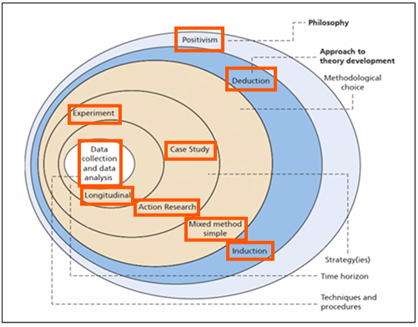
Figure 3: Research Process

Research Philosophy

The Positivism philosophy emphasizes empirical observation and measurable phenomena. It relies heavily on quantitative data and aims to establish causal relationships between variables. The phenomenology philosophy focuses on understanding subjective experiences and the meanings individuals assign to them. It involves qualitative research methods such as interviews, observations, and textual analysis to explore human perceptions and interpretations.

The approach for this project would be mainly an inductive approach; this is because the inductive reasoning involves moving from specific observations to broader generalizations and theories.

Philosophies

The Positivism philosophy emphasizes empirical observation and measurable phenomena. It relies heavily on quantitative data and aims to establish causal relationships between variables. Therefore, in this project, a positivist approach could be useful for aspects such as generating reports based on quantitative metrics like CVE scores, frequency of alerts, and SLA adherence. Quantitative data analysis can provide clear, objective insights into the severity of vulnerabilities and the effectiveness of response measures. Thus, positivism would be particularly relevant when analysing statistical trends in threat data, assessing the impact of security measures, and measuring the efficiency of the system in processing and responding to alerts.
On the other hand, the phenomenology philosophy focuses on understanding subjective experiences and the meanings individuals assign to them. It involves qualitative research methods such as interviews, observations, and textual analysis to explore human perceptions and interpretations. Whilst the primary focus of the project is on processing and analysing quantitative security data, there may also be value in understanding the qualitative aspects of security incidents and threat actors. For example, investigating the motivations and tactics of threat actors, or understanding the human factors influencing response to security alerts. A phenomenological approach could be beneficial for generating reports on threat actors based on qualitative insights gathered from analysing threat intelligence sources, security blogs, and social media. It could help uncover patterns in adversary behaviour and provide context for understanding their actions beyond just numerical metrics.

Research Methodologies

Due to this it is beneficial to pursue a mixed method approach as it combines elements of both positivist and phenomenological philosophies, allowing for the leverage the strengths of both quantitative and qualitative methods.
In the context of this project, a mixed method approach would enable a comprehensive understanding of the security landscape. It would allow for the quantitative analysis of security metrics and trends, while also exploring the qualitative aspects of threat intelligence and human factors influencing security outcomes. By combining quantitative data analysis with qualitative insights, the project can provide a more holistic understanding of security risks, enhance the accuracy of risk assessments, and inform more effective response strategies.
In summary, while the project primarily deals with processing and analysing quantitative security data, incorporating qualitative insights through a mixed method approach can enhance the depth and comprehensiveness of the analysis, leading to more informed decision-making in cybersecurity operations.

Approach
The approach for this project would be mainly an inductive approach; this is because the inductive reasoning involves moving from specific observations to broader generalizations and theories. It begins with collecting and analysing data, identifying patterns or trends, and then formulating hypotheses or theories based on those observations.
In the project, an inductive approach would involve collecting and analysing security data from various sources such as security blogs, Twitter, and threat intelligence feeds. Through this process, patterns and trends in security threats, vulnerabilities, and attacker tactics could be identified. The inductive approach aligns well with the project's objectives of parsing and processing information from diverse sources, assessing vulnerability via application assets lists, and generating reports on threat actors. It allows for the discovery of emerging threats and trends that may not be immediately apparent. By starting with specific data and observations, the project can develop a nuanced understanding of the security landscape, enabling more targeted responses to emerging threats.
The advantages of using an inductive approach are flexibility, the use of real-world data and discovery of insights. Inductive reasoning allows for flexibility in exploring various sources of data and adapting to evolving threat landscapes. This flexibility is crucial in cybersecurity, where new threats emerge rapidly. By starting with real-world data and observations, the inductive approach ensures that conclusions are grounded in empirical evidence, enhancing the credibility and relevance of the findings. Inductive reasoning can lead to the discovery of novel insights and patterns that may not have been anticipated at the outset of the project, enriching the understanding of security threats and vulnerabilities.
There are disadvantages that can come with using the Inductive approach and they are a bias as well as generalisation. To mitigate bias in the analysis, it's important to ensure that data collection methods are rigorous and transparent. Employing multiple sources of data and diverse analytical techniques can help in cross-validating findings and reducing the influence of bias. While inductive reasoning allows for the generation of hypotheses and theories based on specific observations, care must be taken not to overgeneralize findings. It's important to contextualize conclusions within the scope of the data and acknowledge any limitations or uncertainties.
This project can incorporate elements of both deductive and inductive reasoning, depending on the specific objectives and stages of analysis. Whilst the majority to be used in this project is going to be inductive the use of deductive reasoning may be employed when generating reports based on predefined criteria such as CVE scores and SLA suggestions. The inductive reasoning would be utilized in analysing diverse sources of security data to identify emerging threats, assess vulnerability trends, and understand threat actor behaviours. By combining these approaches, the project can leverage the strengths of each method to provide a comprehensive and nuanced understanding of the security landscape, while mitigating the limitations inherent in any single approach.

Time Horizons
A longitudinal approach was taken for this project as it is utilising OSINT and will rely on the data gathered from external sources. The inspection of information at crucial points throughout a given timeframe was required.

Risks and Limitations

Several external factors could potentially prevent the success of the project, including:
- Technological limitations or rapid advancements in cybersecurity threats and technologies may outpace the capabilities of the project's parsing, processing, and analysis systems. To prevent this, I will also continuously monitor technological developments, stay informed about emerging threats and vulnerabilities, and regularly update and enhance the project's systems and algorithms to adapt to evolving security landscapes.
- Data availability and quality can also impact the success of the project relies on the availability and quality of data from various sources such as security blogs, Twitter, and threat intelligence feeds. To address this, I should look to establish partnerships with reputable data providers, implement data validation and quality assurance processes, and explore alternative data sources if necessary.
- Regulatory and Compliance Requirements: Legal and regulatory constraints, such as data privacy laws and industry standards, may impose limitations on the collection, processing, and sharing of security-related data. I will look to ensure compliance with relevant regulations and standards, implement robust data governance policies and procedures, and seek legal guidance if needed to navigate complex regulatory environments.
- Resource Constraints: Limited budget, time, and human resources may hinder the project's ability to achieve its objectives within the desired timeframe and scope. To mitigate resource constraints, I will aim to prioritise tasks and allocate resources efficiently, seek funding opportunities or additional support from stakeholders, and leverage open-source tools and collaboration to maximise productivity.
If things do go wrong, several strategies can be employed to work around potential obstacles; The use of Contingency Planning and developing contingency plans and alternative strategies to address unforeseen challenges or setbacks, such as technical failures, data breaches, or regulatory issues can be used to maintain open communication and collaboration among team members to quickly identify and respond to issues as they arise. The use of Iterative Development can be used to embrace an iterative development approach that allows for incremental improvements and adjustments based on feedback and lessons learned from previous iterations. This will utilise regular review sand reassessments of the project objectives, priorities, and resource allocations to ensure alignment with evolving needs and circumstances. The stakeholder engagement including engaging with the relevant parties and stakeholders such as the end-users and industry partners, to solicit feedback, gather insights, and foster collaboration in addressing challenges and identifying solutions. The use of risk management and utilising robust risk management practices to identify, assess, and mitigate potential risks throughout the project lifecycle. This enables DCWW to maintain a proactive stance towards risk mitigation by regularly monitoring and updating risk registers, developing mitigation strategies, and allocating resources to address high-priority risks.

As with any projects there are limitations which may include:
- Scope Limitations: The project may be limited in scope to specific types of security threats, vulnerabilities, or data sources, potentially excluding certain categories of threats or sources of information. To address this limitation, I will clearly define the scope and objectives of the project, prioritise key areas of focus, and remain open to expanding or refining the scope based on evolving requirements and feedback.
- Technical Limitations: Technical constraints, such as limitations in computing power, data storage capacity, or software capabilities, may impact the project's ability to process and analyse large volumes of data efficiently. To overcome technical limitations, I should leverage scalable and adaptable technologies, optimise algorithms and data processing workflows, and explore cloud-based solutions or distributed computing architectures to enhance scalability and performance.

Validity, Reliability and Generalisability

Ethical Issues
There are several ethical considerations and potential risks associated with conducting research in the field of cybersecurity, particularly when dealing with sensitive data and information related to threats, vulnerabilities, and attack tactics.
The main ethical issue would be regarding the leaking of business information which could impact DCWW as an industry. Whilst the majority of information being used is open sourced there are some static lists that are going to be used to focus the alerts on more relevant or affected applications. The handling of such lists would require an NDA or suitable redacting. The handling of sensitive data related to security incidents, vulnerabilities, and threat intelligence requires strict adherence to data privacy and security protocols to prevent unauthorised access or misuse of information. Therefore, I must ensure that appropriate measures are in place to safeguard the confidentiality and integrity of data.
There is the possibility of retaliation from threat actors as such engaging in cybersecurity research, particularly investigations into threat actors and their tactics, may inadvertently increase the likelihood of retaliation from malicious actors or criminal organisations as we are strengthening our security posture against their attacks.
There is the repetitional risk to DCWW as conducting research in cybersecurity carries the risk of reputational harm if findings are misinterpreted, misrepresented, or leaked to the public or media. Therefore, any products of this project must be closely controlled and monitored to limit and mitigate the risk of reputational damage.
To mitigate these ethical issues and risks, researchers should adhere to established ethical guidelines and best practices, such as obtaining ethical approval from institutional review boards, maintaining transparency and integrity in their research methods and reporting, and prioritising the safety and security of themselves and the business involved in the research process. Additionally, collaboration with industry partners and stakeholders can help address ethical concerns and ensure responsible conduct throughout the research lifecycle.
Based on how DCWW and our cyber team operates there was a gap noted when a member of our team left as he frequently checked and had alerts for relevant CTI sources. By approaching this problem and investigating it through a similar means as to how it was manually performed, this could be considered a good way to investigate this problem and to build the solution from.

Reliability
It is unlikely that a different researcher from our team would come up with a different result however we now have more confirmation tools at hand so can confirm the validity of such alerts generated by the potential solution.

Generalisability
The situations that the results will apply to are narrow and specific. This is because the solution is an alerting system which will generate, and parse information based on the sources it reviews. Due to its specificness, it means that there is the potential for this to be shared with other CTI and specifically water industries in the UK as part of an initiative to encourage CTI sharing amongst the industry.

Development Methodology and Design Planning

Primary Design
The primary designs utilises ALA with the API to call out to X using a dedicated API key generated through the X development platform.

Validation and Refinement
The validation will be based on the generation of email and teams alerts along with any error messages generated within ALA.

Resource and Planning

Tools and structure:
- Actual layout of tools and structure
- Explain/discuss types of tools (hardware & software) and structure (example, gateway/access point); it is about how the communication is going to flow between devices based on your actual design diagram created from your blueprint/problem formulation diagram above.
- It is about how the network experiment is going to set-up or be functional that is what connects to what (the layout).

Hardware Resources
Cloud resources will be used as part of this project to explore the integration and constructing this tooling in ALA.

Software Resources

ALA and the use of the Kusto Query language (KQL) will be used to create the basis of the monitoring tool and to create the templates for the reports to be created as part of the reporting elements.

Information Resources

The external data required will be from open-sourced intelligence, this will take the form of several reputable cyber security sites and extending to X (Twitter) and Threads. This list of sites is already being confirmed with the relevant team to ensure that all relevant sources are monitored.

Human Resources

The DCWW SOC team will be used during parts of the testing phases to ensure that the product of this project is suitable and meets their needs to enable an enhanced response time to threat and vulnerabilities. Their feedback and experience of this tooling will be invaluable to the development of it as they will be the primary recipients to the alerts and report that are generated.

Contingency Planning

Contingency Design

Bluesky (BS) will be used as a contingency plan if Twitter is not a viable option for development. BS is an open-source, decentralised social media platform. It’s free API access means that it would be a suitable cost alternative should the project be unable to be implemented via twitter and ALA.
Whilst BS should be able to be implemented within ALA, there is the potential that it will have to be developed outside of the environment. There would be no changes to the data flow, the only change would be the platform that the data is sourced from.

Contingency Validation and Refinement

There will be no changes to the validation and refinement elements of the development.

Resource and Planning

The alternative data source would be using BS however the data flow would not be impacted.
ALA will be used in the primary instance however if there is additional issues then Visual Studio Code may be required to construct and deliver the CTI tool.

Hardware Resources

The contingency planning would be manually building this in Visual Studio with python as this can still be utilised and integrated into ALA. GitHub will then be used to appropriately manage the versions of the development within visual to ensure issues are tracked and resolved with testing.

Software Resources

Should Azure no longer be a viable option then Visual Studio Code will be used with the Python coding language along with GitHub for version control.

Information Resources

The external data required will be from open-sourced intelligence, this will take the form of several reputable cyber security sites and extending to BS.

Human Resources

The DCWW SOC team will still be utilised during the testing phases to ensure that the product of this project is suitable and meets their needs therefore there will be no change to the human resources required as part of the contingency plans.

Conclusion
Given the everchanging and dynamic nature of CTI the ability to have options for how to best continue with the implementation of the project is paramount especially given that there is the potential for technological restrictions that would sit outside the remit of control for this implementation.
Overall, the logical scoping has been extensively planned and included the ethical and technical risks associated with this implementation. As the project will be implemented outside of DCWW, the SOC team’s feedback will be an integral part of the final implementation.

The following chapter covers the design and implementation based on the research proposals and the discussed designs.

Chapter 4 - DESIGN & IMPLEMENTATION

Introduction
This chapter explores the design and implementation of the project, it also will expand upon the problem formulation and any issues that are encountered as part of the implementation.

problem formulation

This project focuses on creating an appropriate alerting system that can be tuned to our software and hardware requirements to enable us as a business to have greater visibility and awareness of threats that are being use and vulnerabilities that are being exploited.
By enabling greater visibility and awareness we can in turn increase the monitoring, detection, and remediation timeframes by utilising the CTI gathered. Whilst initially there is likely to be a lot of noise from ingesting data from multiple sources over time this will be tuneable either by removing unnecessary sources or by applying additional tuning.
Therefore, this project will have an increased start-up impact both financially and employee-time required however once it is out of its development phase and into a live environment there will be many benefits that can be reaped. As this project will belong to DCWW there is the potential for us to work with other water companies to enable them to build out a similar platform based on the findings.
The development of this alerting tooling will utilise applications that we have at DCWW as well as the OSINT that is freely available. The development of this project will occur over 3 main workflows with the fourth being the evidence gathering and formal presentation of the proposed solution.
As mentioned, this project will have 4 main workflows. Flows one, two and three are using a waterfall development life cycle and will use the waterfall method. Whilst workflow 4 will be present throughout the project as creating the final document will require evidence generated from each of the workflows and will also require a working demonstration of the CNI Alerting system.
In the first workflow it will be focused on getting a single OSINT data source to pull and be analysed correctly. Once this is completed the analysis and testing of the workflow can begin prior to building upon it as part of workflow 2 which will incorporate multiple sources of OSINT. Workflow 3 will focus upon the analysis output and creating reports for the organisation which are aimed at three main areas, our SOC team, the wider cyber security team and finally for the board members of DCWW.

Design
This project is using an agile development lifecycle however when displayed on the Gantt chart it also has a waterfall life cycle especially as there are quality gateway reviews in place to ensure that any issues that are encountered as part of the project are either recorded, mitigated, or resolved prior to entering the next stage of development. By ensuring there is a testing period in each workflow, it ensures that the produced product works well prior to moving into the next phase where additional functionality will be added into the project.

Figure 2 - Process Flow for API
Once an alert has been ingested there are three types of alerts that will be monitored for which consists of;
- Threat Alerts
- Vulnerability Alerts
- Patch Releases
Threat alerts look at the threat actors that are targeting water industries including the monitoring of attacks on other water treatment organisations anywhere in the world.
The Vulnerability Alerts will look at new vulnerabilities which will then be compared to the software and hardware lists to identify and aid in managing DCWW’s vulnerability landscape.
Lastly the Patch releases will be an alert system to allow us to respond appropriately when a patch to a vulnerability is released. This will enable us to implement the vulnerability in our non-production environment prior to implementing it in the production environment. This will be the main factor in reducing the response time to threats and vulnerabilities.
The logging element will need to be agreed with our Security Operations Centre (SOC) to ensure that there is a record that can be referred to prevent the same alert from triggering multiple times.
The alerting when coming through to the SOC will be via the Teams Channel designated. This will receive all copies of the alerts to ensure that the messages are received. There will also be a set criterion for when this is sent to the appropriate teams.

Implementation

There are many requirements that this project needs to enable a successful implementation and integration into DCWW systems.
The primary requirement to start the implementation is the Twitter Developer Account, this point is currently being confirmed within our team to ensure that it is assigned to the appropriate account so that we can start the access to the Developer API and start pulling alerts from a reputable source.
The secondary requirement consists of the data sources. These are mainly going to be twitter sources and reputable blog sources. And the Testing Teams channel that will be used during this project to ensure separation and suitable management of the throughput of the alerts.
The third requirement is the Hardware and Software source lists. Due to the nature of such information this is business confidential and cannot be shown to UWTSD.
Lastly the fourth requirement will consist of the Data gathering and adjustments. These alerts will be tracked and marked suitable or not suitable for out threat intelligence consumption. Any adjustments that are required will also be tracked to show the development of the alerting tool.

The student application of ALA whilst it was easily created did formulate several issues during the design and implementation process. Chat GPT was utilised to aid in the resolution of the issues with the ALA and with X, and the BS troubleshooting. Basic troubleshooting was used in conjunction with ChatGPT to identify potential issues and resolutions in order to create a suitable API.

Whilst X did have the range of users that we could have generated the required alerts off there was an issue with the free version which whilst it could have been resolved by paying for a more premium licence this would have been too costly for the project therefore unattainable.

Due to these two issues, it was deemed appropriate to proceed with the contingency planning option, primarily with building in python into the logic app, then if there are issues the manual creation of a python API.

Upon the creation of the API, whilst there were some developmental issues with the API, the version tracking (Figure 3) through GitHub aided in the detection and resolution of issues. This included building in breakpoints to identify where issues were encountered during the development as seen in Figure 4.
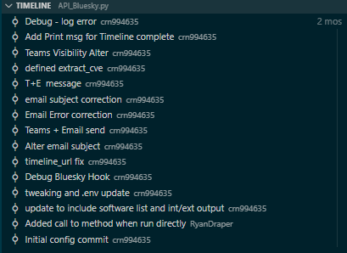
Figure 3 - API Version Control

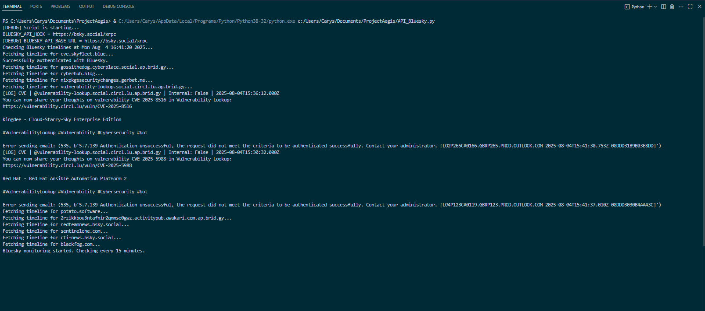
Figure 4 - Visual Studio API Running
During the construction of the python API, an issue became apparent with the holding of the required keys within Azure Key Vault as this was not available on the student licencing. This means that any credentials will have to be hardcoded which is a breach of security therefore to combat this, the project will be constructed outside of Azure with the keys held external to the API to reduce this risk.

The Variables have been configured in an .env file and will be encrypted to secure the logon credentials, the email logon credentials and the email recipients. The .env file was configured to hold the following information, Figure 5 shows the configuration of the .env file that is in use by the API with any passwords and personal information redacted.

#Environment Variables - Handle in Azure Key Vault in live
#BLUESKY_HANDLE=your_handle
#BLUESKY_PASSWORD=your_password
#TEAMS_WEBHOOK_URL=https://...
#SMTP_SERVER=smtp.example.com
#SMTP_PORT=587
#EMAIL_USERNAME=your@email.com
#EMAIL_PASSWORD=your_password
#RECIPIENTS=email1@example.com,email2@example.com
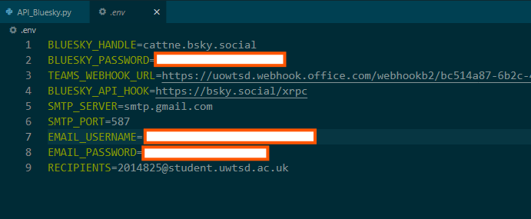
Figure 5 - .env Variables
The API python code that interacts with the variables shown in Figure 5 can be found in Appendix F.

One of the main issues was the polling of the BlueSky accounts however upon additional troubleshooting it was identified that the wrong URL was being used to poll against, this was resolved as a build error
Upon testing the email and teams alerting, there was an issue setting this up with the UWTSD email address with no apparent errors generated. To resolve this issue, it was moved across to a private email address which works as the source for the emails. Initially the emails were being received in the UWTSD email box however after a short period of time they stopped being received given that no further errors were received either in the API nor in the email system, it is possible that they have been deemed spam and automatically blocked as during testing multiple emails were being generated depending on the alert type. The alerts are still present in Teams when the API is running

One of the main parts that required multiple versions was the email and teams alerts as there were display and content issues which required additional time to resolve. Another element that was implemented was the debugging which was kept inline throughout the development of the API. Whilst this is not ideal it was beneficial when making improvements to the code as it enabled the prompt identification of issues upon launch and running of the API. Whilst the API has been left at a higher level to prevent business confidentiality from being breached, this can easily be amended for full implementation. Figure 4 portrays how issues were navigated and resolved by utilising version control within Visual studio which enabled issues to be resolved or reverted if anything went awry.

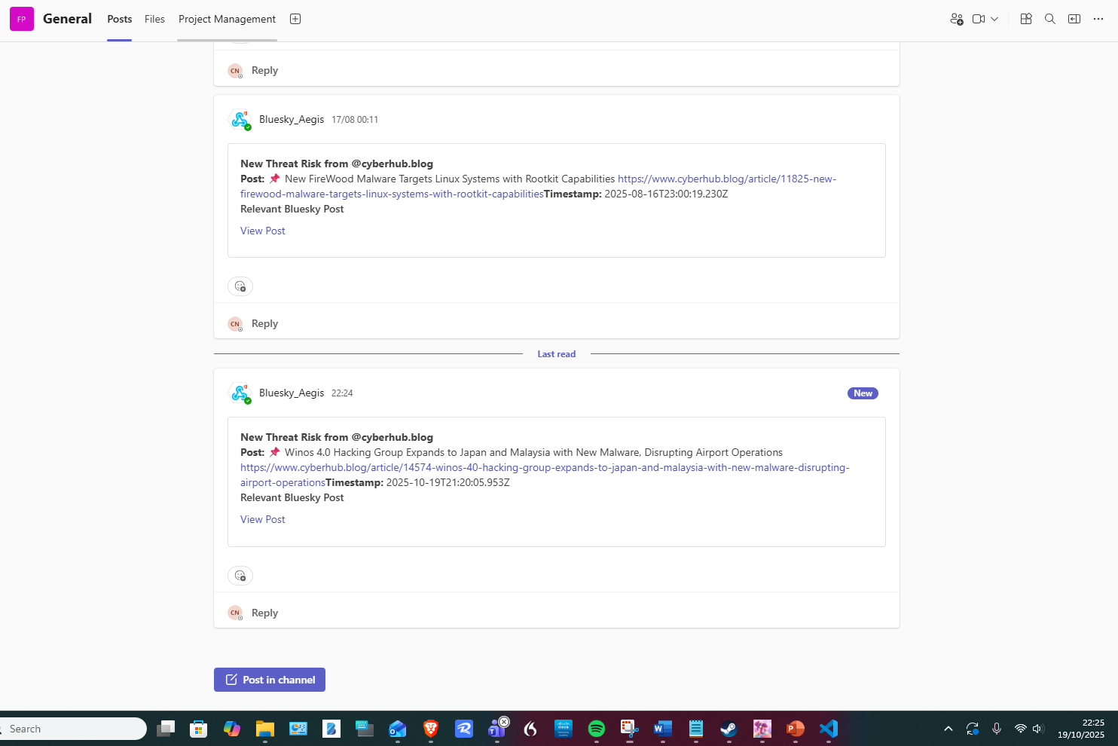
Figure 6 - Teams Alert Post
Figure 6 conveys how the teams posts are displayed within the Microsoft Teams channel as the alert is pushed into teams via a webhook which enables teams to display them within the required channel.

The email alerts provide the same information however the tags are not as clear within the alert as shown in Figure 7. Whilst these alerts are the most robust, they encountered additional issues which were outside of the scope of control such as spam and phishing block filters as well as restrictions on the student Microsoft email address with the generation of the email alerts.

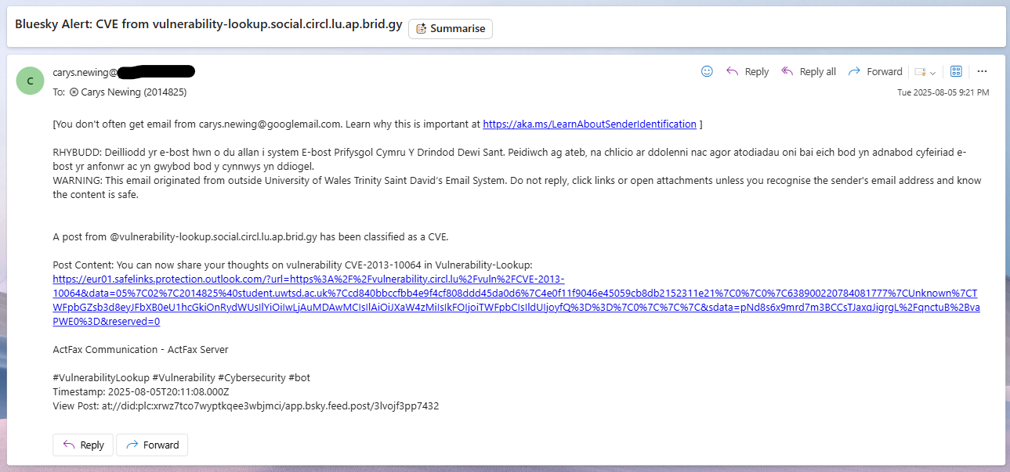
Figure 7 - Email Alert Display

Conclusion
Despite the issues encountered the overall product has met all of the criteria and objectives set out in the design. The contingency plan, whilst it did also have it’s own issues such as the Azure Key management, is now functional and producing alerts when the API is running. ChatGPT was utilised in the troubleshooting of the code also and also provided streamlining when it came to functional issues alongside additional research around the issues encountered thus being used as a research tool.

Summarised the key aspect of the chapter
The design and implementation of the API and the final product are discussed along with any issues that were encountered including issues within development such as the secure key management and env file for containing variables.

Chapter 5 – Testing and Evaluation

The observation window for the testing of the API alerts is the 5th of August 2025 to the 14th of December 2025, which is approximately 131 days in which 176 CTI events were generated. This extended timeframe allows analysis of persistent threat activity, rather than short-term anomaly-driven behaviour using a real-world dataset. As it was possible to generate alerts based off the real-world dataset, this can be used to ascertain and evaluate the API’s correctness, relevance and usefulness of the intelligence alerts produced.

The use of real-world intelligence rather than synthetic test data allows for meaningful assessment of the correctness, relevance, and operational usefulness of the alerts produced. However, reliance on live data also introduces inherent variability in alert volume and timing, which is reflective of real-world threat environments rather than a limitation of the system itself.

Over the period that the alerts have been generating Figure 8 conveys the alerts that were generated and whether they are relevant to CNI along with segmented them by relevance to CNI versus General Information Technology topics. While alert volumes during October and November are lower than those observed in August, this reduction is attributed primarily to operational factors during development, as the system was not running continuously during later stages. This highlights a key operational dependency: the effectiveness of continuous intelligence collection is directly linked to system availability.
Despite this, the dataset demonstrates that when operational, the API does not exhibit extended periods of intelligence silence. This supports the conclusion that continuous deployment would provide sustained situational awareness, aligning with the continuous monitoring principles outlined in the NIST Cybersecurity Framework.
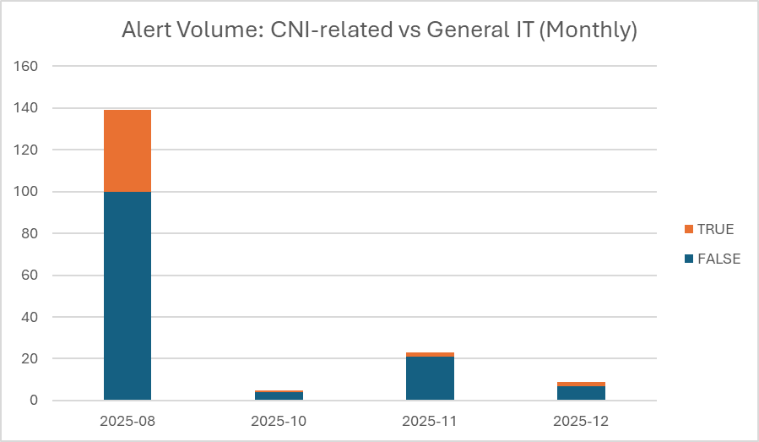
Figure 8 - Alert Volume: CNI-related vs General IT (Monthly)

Given that our Threat hunting occurs mainly within core business operating hours having this operational around the clock enables for a wider capture of alerts that would be of relevance and of interest to DCWW however it is a discretional decision to determine as the alerts have had to be kept at a higher level with less granularity to prevent business confidential information from being leaked.

The developed API classifies alerts into three predefined categories: vulnerability disclosures, threat risks, and patch releases, as defined during the system design phase. Figure 9 demonstrates consistent classification across these categories throughout the observation window.

This classification approach supports operational use by enabling rapid differentiation between emerging vulnerabilities, active threats, and remediation opportunities. The use of a 15-minute polling interval provides near-continuous coverage without reliance on a third-party threat intelligence platform, offering flexibility to focus on specific technologies or vendors where required.

Feedback from DCWW’s Cyber Threat Analyst confirmed that this classification model aligns with existing analytical workflows, indicating that the intelligence produced is not only technically accurate but also operationally relevant.

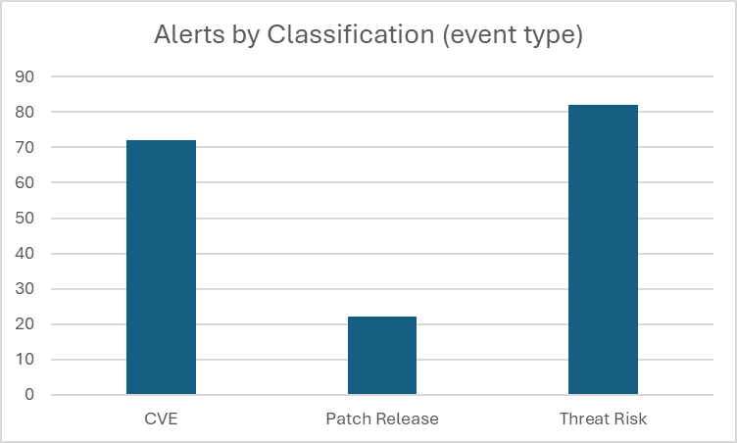
Figure 9 - Alerts by Classification

Figure 9 indicates the tags that were used to identify what category the alert would belong to which conveys that the API is correctly identifying intelligence pertaining to CNI. Whilst only a small number of the alerts were specific to OT/ICS systems, this does not mean that the other alerts generated were not of interest or benefit to DCWW.

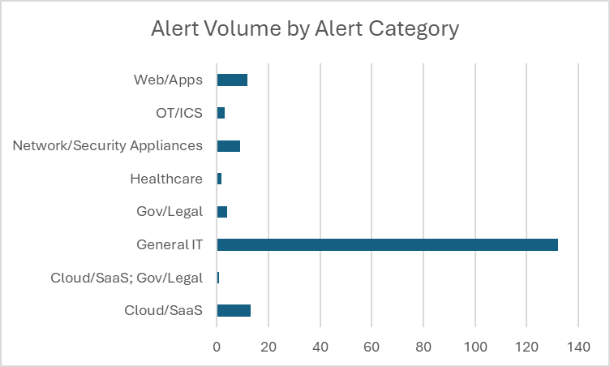
Figure 10 - Alert Volume by Category
Figure 10 highlights the distribution of alerts across identified categories, including those directly associated with CNI environments. While the number of alerts explicitly related to operational technology or industrial control systems is relatively low, this does not imply limited value to the organisation.

Many alerts classified under general enterprise technologies remain relevant to CNI due to the convergence of information technology and operational technology within modern critical infrastructure environments. This reinforces the importance of contextual analysis when interpreting intelligence rather than relying solely on sector labels.

However, the system currently lacks direct asset correlation, meaning relevance must still be determined by analysts. This represents a limitation when evaluated against the NIST Identify function, particularly asset management and contextual risk assessment.

Operating the API outside core business hours enables the capture of intelligence that may otherwise be missed during manual threat hunting activities. However, alert granularity was intentionally limited to prevent the disclosure of sensitive organisational information, representing a trade-off between intelligence detail and operational security.

Additionally, while the system supports risk identification and situational awareness, it does not automate response actions. This reinforces its role as an enabling capability rather than a standalone security control, consistent with the intended function of cyber threat intelligence within a defence-in-depth strategy.

A live demonstration session with relevant DCWW staff validated that alerts were generated in a clear and digestible format. Feedback was positive, and further integration into organisational systems was discussed, supporting the system’s practical applicability.

Overall, testing and evaluation indicate that the API effectively supports early risk identification, improved situational awareness, and informed remediation prioritisation. When mapped to the NIST Cybersecurity Framework, the system demonstrates strong alignment with the Identify and Detect functions, with partial support for Respond through decision enablement.

The limitations identified during testing primarily relate to asset contextualisation and response automation rather than deficiencies in intelligence quality. These findings suggest clear opportunities for enhancement while confirming that the system meets its core objective of supporting cyber security risk reduction for Critical National Infrastructure.

To demonstrate compliance alignment and structured evaluation, the results of this project were mapped to recognised cyber security frameworks and control families. This mapping provides assurance that the observed outcomes contribute to established cyber security risk management practices rather than ad hoc or informal processes.
The outputs of the cyber threat intelligence aggregation API were evaluated against the NIST Cybersecurity Framework (CSF) to assess the extent to which the system supports recognised cyber security risk management functions. The CSF provides a widely adopted, sector-agnostic framework that is particularly relevant to Critical National Infrastructure environments.

The evaluation indicates that the system demonstrates strongest alignment with the Identify (ID), Detect (DE), and Respond (RS) functions of the CSF.

The system supports the Risk Assessment (ID.RA) category by enabling early identification of potential cyber risks through continuous ingestion of vulnerability disclosures and threat intelligence. This reduces the time between public disclosure and organisational awareness, supporting informed risk identification activities.

Partial alignment is observed with Asset Management (ID.AM). While the system identifies vulnerabilities affecting commonly used technologies, it does not directly correlate intelligence to organisational assets. As a result, contextual risk assessment remains dependent on analyst interpretation.

Strong alignment is demonstrated with Security Continuous Monitoring (DE.CM). The API operates on a frequent polling interval and provides a sustained flow of intelligence, enhancing situational awareness of emerging threats and active campaigns relevant to critical infrastructure environments.

The system indirectly supports Anomalies and Events (DE.AE) by informing detection priorities. However, it does not independently detect anomalous activity within internal networks, reinforcing its role as an intelligence-enabling capability rather than a detection control.

The system supports the Mitigation (RS.MI) category by providing timely vulnerability and patch intelligence, enabling security teams to prioritise remediation actions based on current threat conditions. Additionally, delivery of alerts via Microsoft Teams contributes to Response Communications (RS.CO) by ensuring intelligence is disseminated efficiently to relevant stakeholders.

Direct execution of response actions remains outside the scope of the system, consistent with the CSF principle that cyber threat intelligence informs but does not replace operational response processes.

Given the Critical National Infrastructure context of this project, the system was also evaluated against the UK National Cyber Security Centre’s Cyber Assessment Framework (CAF), which is designed specifically to assess cyber resilience within essential services.

The results demonstrate strongest alignment with Objective A: Managing Security Risk, particularly:

A3 – Understanding Security Risks
The system enhances organisational understanding of cyber threats by providing continuous intelligence on vulnerabilities, active threats, and emerging attack techniques. This supports informed risk assessment and prioritisation activities.

Indirect support is also provided to Objective B: Protecting Against Cyber Attack, specifically:

B1 – Service Protection Policies and Processes
By informing patching and remediation decisions, the system contributes to protective decision-making processes, although it does not directly enforce controls.

The system does not directly align with Objective C (Detecting Cyber Security Events) or Objective D (Minimising the Impact of Cyber Security Incidents), as it does not perform internal monitoring or incident recovery functions. This reflects a deliberate design choice rather than a functional deficiency and is consistent with the intended role of cyber threat intelligence within a layered security architecture.

Overall, the mapping to both the NIST Cybersecurity Framework and the UK NCSC Cyber Assessment Framework confirms that the system provides measurable support to recognised cyber security functions related to risk identification, situational awareness, and response prioritisation. The evaluation also highlights clear boundaries of capability, reinforcing that the system functions as an enabling component within a broader cyber security programme rather than a standalone defensive solution.

This framework-based evaluation provides assurance that the system contributes to established cyber security best practices and supports the reduction of security risk within Critical National Infrastructure environments.

Chapter 6 – Conclusions and recommendations

Summary

This project identified the gaps, requirements and importance of CNI and CTI, the critical reviews convey this also. Classifying the reduction in the security risk for DCWW due to this implementation

Whilst a primary and contingency design was created, the API design flow was the same throughout both however the implementation software differed. There were several issues during the implementation which resulted in the contingency design being developed in Visual Studio.

Once the product was viable and generating alerts into both email and a dedicated Microsoft Teams channel, a live demo was delivered to DCWWs SOC and any improvements were noted for future development.

Conclusion

The evaluation demonstrates that the API output supports all core project objectives. By providing timely, relevant, and actionable intelligence, the system enables informed decision-making that directly contributes to reducing security risk to CNI.

The API created as part of this research project has shown that prompt reporting in OSINT can enable a cyber security team to respond and act on intelligence in an increased capacity thus reducing the risk of attack and where appropriate the attack surface area with the notifications for vulnerability and patches being included rather than just focusing on the CTI for threat actors.

This API not only allows for early risk identification, but situational awareness along with support remediation and CNI relevance. Whilst this will be taken narrower when fully implemented into DCWW infrastructure it is the responsibility of the Cyber Threat Analyst to review and ascertain the threats and the risks that they pose to DCWW in both vulnerabilities on our estates and threat actors as some have recently pivoted to target more sensitive organisations which may not necessarily be deemed as CNI.

As this was undertaken on behalf of DCWW there was a business requirement to deliver a working demonstration at DCWW to demonstrate the application to which the feedback was positive and whilst they have provided comments for additional research and improvements, they also stated that the current API met the requirements stated by DCWW.

Recomendations FOR FURTHER Research

Testing identified that not all vulnerability disclosures represent active exploitation and that asset-specific relevance must be determined by the consuming organisation. This reinforces the necessity of contextual prioritisation when deploying CTI in operational environments. Therefore, additional research and alerting around exploits being actively used in the wild and including this into the API would be beneficial. It would also be beneficial to explore modularising the alerts for example, the primary source is currently BS however RSS feeds on relevant cyber sites prove just as useful with CVE’s and Threat Actors therefore it would be highly beneficial to look to include this within the API with further research as it would ensure that the API is flexible and reduce the likelihood of incorrect pieces of code being removed.

Chapter 7 – Reflections

The aim of this research was to produce a low-cost OSINT application to identify if increasing the visibility of CVE’s, patches and threat actors would reduce the cyber security risk for CNI with specific focus on the water industry.

The four objectives for this report were:
1. Conduct comprehensive research and a literature review to identify existing gaps in current alerting systems and define the functional and technical requirements for the proposed alerting platform.
2. Design and develop the alerting system based on the defined requirements, exploring and evaluating suitable design approaches, technologies, and implementation strategies to establish a functional foundation for the final product.
3. Produce detailed high-level design documentation outlining the system architecture, key components, data flows, and implementation plan to demonstrate how the alerting system will be constructed and integrated.
4. Conduct comprehensive testing to ensure the developed solution meets the minimum and functional requirements. Analyse the outcomes of the testing phase to identify issues, document alterations, and provide justification for any modifications made to improve system performance and reliability.

Given the outcome of the overall research was the creation of an API, objective 1 was satisfied by the reading and analysis of related papers and journals. Whilst this did not directly feed into the creation of the API it did highlight the importance of CTI and OSINT especially on CNI, this aided in identifying the factors that needed to be reported on and included within the design. Objective 2 was met by the identification of the software and hardware that would be required to implement the application. Whilst this was met, the contingency option was used on the final implementation. Objective 3 involved the high-level design and documentation including the data flows and the identification of keywords that would be included in the monitoring. Whilst this had to be sanitised for the purposes of this project to prevent business confidential information from being revealed, setting them at a higher level ensured that a functional final product was produced that would still be of benefit to DCWW. Objective 4 encompassed the build and testing phase; this objective was met by the creation of the API and its functionality.

Time management within this project was well handled despite the interruption of the surgery and the recovery time required as it was anticipated that it would be possible to continue the work during the recovery time however it was not possible to be seated or standing at a computer to complete the required work.

This project despite the expanded timescales from the surgery that occurred has developed my python programming

Providing a live demonstration to enabled me to work on my soft skills around giving a presentation and how to handle things when they didn’t go to plan as with any live demonstration. This was overcome by being prepared, having images of it working at each stage and clear visuals of the email and Teams messages that are generated from the API.

Chapter 8 - REFERENCES

Bibliography
[1]
H. Kure and S. Islam, “Cyber Threat Intelligence for Improving Cybersecurity and Risk Management in Critical Infrastructure,” Journal of Universal Computer Science, vol. 25, no. 11, pp. 1478–1502, Nov. 2019, Available: https://repository.uel.ac.uk/item/877y3
[2]
L. Maglaras, M. Ferrag, A. Derhab, M. Mukherjee, H. Janicke, and S. Rallis, “Threats, Countermeasures and Attribution of Cyber Attacks on Critical Infrastructures,” ICST Transactions on Security and Safety, vol. 5, no. 16, p. 155856, Dec. 2018, doi: https://doi.org/10.4108/eai.15-10-2018.155856.
[3]
R. Reich, “Newsweek,” Newsweek, 2013. https://www.newsweek.com/
[4]
A. Greenberg, “Crash Override Malware Took Down Ukraine’s Power Grid Last December,” Wired, Jun. 12, 2017. https://www.wired.com/story/crash-override-malware/
[5]
R. M. Lee, “2020 SANS Cyber Threat Intelligence (CTI) Survey,” SANS Institute, 2020. https://www.sans.org/white-papers/39395/ (accessed Dec. 14, 2025).
[6]
J. Matkowsky, “Threat Intelligence-Driven Attack Surface Management | SANS Institute,” www.sans.org, Aug. 09, 2022. https://www.sans.org/white-papers/threat-intelligence-driven-attack-surface-management/
[7]
M. Kapko, “MOVEit mass exploit timeline: How the file-transfer service attacks entangled victims,” Cybersecurity Dive, Jul. 14, 2023. https://www.cybersecuritydive.com/news/moveit-breach-timeline/687417/
[8]
“One Flaw too Many: Vulnerabilities in SCADA Systems - Security News - Trend Micro USA,” www.trendmicro.com, Dec. 16, 2019. https://www.trendmicro.com/vinfo/us/security/news/vulnerabilities-and-exploits/one-flaw-too-many-vulnerabilities-in-scada-systems
[9]
A. Devasia, “Securing SCADA Systems from Cyber Attacks - Technical Articles,” control.com, Jul. 01, 2020. https://control.com/technical-articles/securing-scada-systems-from-cyber-attacks/
[10]
P. Loshin, “What is SCADA (supervisory control and data acquisition)?,” WhatIs.com, Dec. 2021. https://www.techtarget.com/whatis/definition/SCADA-supervisory-control-and-data-acquisition
[11]
NIST, “The NIST cybersecurity framework (CSF) 2.0,” The NIST Cybersecurity Framework (CSF) 2.0, vol. 2.0, no. 29, Feb. 2024, doi: https://doi.org/10.6028/nist.cswp.29.
[12]
NCSC, “Cyber Assessment Framework,” www.ncsc.gov.uk, Apr. 18, 2024. https://www.ncsc.gov.uk/collection/cyber-assessment-framework

APPENDICES

PROJECT MANAGEMENT

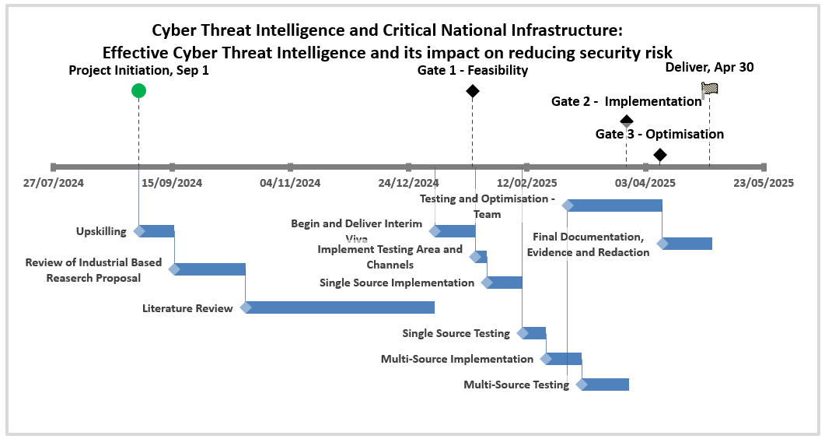
This Project has the projected Gantt chart and the actual Gantt chart. This has been impacted due to medical conditions and surgery. Below is the Actual Gantt Chart for the Project however it does not show the delivery of the Final Viva and Poster that is required for the project. The surgery was expected however the impact and recovery time were longer than originally anticipated.
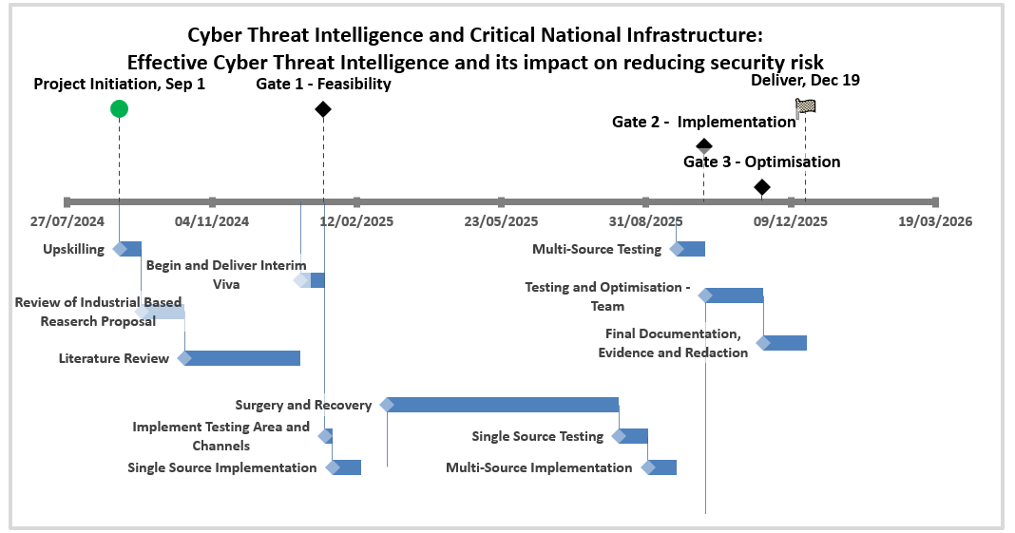

Ethics form

APPLICATION FOR ETHICAL APPROVAL

In order for research to result in benefit and minimise risk of harm, it must be conducted ethically.

The University follows the OECD Frascati manual definition of research activity: “creative work undertaken on a systematic basis in order to increase the stock of knowledge, including knowledge of man, culture and society, and the use of this stock of knowledge to devise new applications”. As such this covers activities undertaken by members of staff, postgraduate research students, and both taught postgraduate and undergraduate students working on dissertations/projects.

The individual undertaking the research activity is known as the “principal researcher”.

This form must be completed and approved prior to undertaking any research activity.

SECTION A: About You (Principal Researcher)
1 | Full Name: | Carys Rebeca Newing
2 | Student Number: | 2014825
3 | Email address: | 2014825@student.uwtsd.ac.uk
4 | Programme of Study: | Cyber Security and Networks
5 | Industrial Partner/Employer: | Dwr Cymru Welsh Water

SECTION B: Internal and External Ethical Guidance Materials
 | Please list the core ethical guidance documents that have been referred to during the completion of this form (including any discipline-specific codes of research ethics, location-specific codes of research ethics, and also any specific ethical guidance relating to the proposed methodology). Please tick to confirm that your research proposal adheres to these codes and guidelines. You may add rows to this table if needed.
1 | UWTSD Research Ethics & Integrity Code of Practice | ☒
2 | UWTSD Research Data Management Policy | ☒
3 |  | ☐

SECTION C: Details of Research Activity
1 | Indicative title: | CTI and the Water Industry as CNI - How good CTI can minimise the risks to Threats to the Water Industry
2 | Proposed start date: | Jan 2024 | Proposed end date: | July 2024
Introduction to the Research (maximum 300 words in each section)
Ensure that you write for a Non-Specialist Audience when outlining your response to the points below:
- Purpose of Research Activity
- Proposed Research Question or Hypothesis
- Aim of Research Activity
- Objectives of Research Activity
- How the research activity will be of use to your industrial partner/employer.
3 | Purpose of Research Activity  The purpose of this research activity is to identify the risks associated with Cyber Threat Intelligence (CTI) and the critical national infrastructure (CNI). As the water industry is classified as CNI, ensuring that there is an appropriate alerting and reporting tool available
4 | Research Question or Hypothesis  The research hypothesis is whether effective Cyber Threat Intelligence has an impact on reducing security risk when focusing on critical national infrastructure.
5 | Aim of Research Activity  This research activity aims to create a solution that enables organisations to automatically generate alerts for threats which can either be reviewed manually or automatically with the goal of minimizing the risk threats posed. The solution will also be and be able to produce reports based on the type and Threat score along with some details regarding the threat actor and be able generate reports suitable for board members.
6 | Objectives of Research Activity  The objectives to achieve this aim in the research activity:  - Generate alerts based off Security sources not limited to X (nee twitter) and security blogs which will include the critical vulnerability score.  - To produce reports suitable for weekly team updates and monthly for board members  - To produce information regarding relevant Threat actors based on activity seen in the week
Proposed data collection methods

The data collection will be from online sources not limited to X nee twitter, security blogs and other reputable cyber threat intelligence using Azure Logic Apps.

Once gathered it will then gather secondary data relating to the information it has gathered by querying the threat name to capture the critical vulnerability score, the threat level and the threat actor from reputable threat and vulnerability sites that are used in the industry.

7 | No personal data will be gathered as part of this research project.  The data will be collected from security blogs as well as sources such as twitter and threads. Then information will be gathered based on the CVE score and the threat actors name.  (this box should expand as you type)

SECTION D: Scope of Research Activity
 | Will the research activity include: | YES | NO
1 | Use of a questionnaire or similar research instrument? | ☐ | ☒
2 | Use of interviews? | ☐ | ☒
3 | Use of focus groups? | ☐ | ☒
4 | Use of participant diaries? | ☐ | ☒
5 | Use of video or audio recording? | ☐ | ☒
6 | Use of computer-generated log files? | ☒ | ☐
7 | Participant observation with their knowledge? | ☐ | ☒
8 | Participant observation without their knowledge? | ☐ | ☒
9 | Access to personal or confidential information without the participants’ specific consent? | ☐ | ☒
10 | Administration of any questions, test stimuli, presentation that may be experienced as physically, mentally or emotionally harmful / offensive? | ☐ | ☒
11 | Performance of any acts which may cause embarrassment or affect self-esteem? | ☐ | ☒
12 | Investigation of participants involved in illegal activities? | ☐ | ☒
13 | Use of procedures that involve deception? | ☐ | ☒
14 | Administration of any substance, agent or placebo? | ☐ | ☒
15 | Working with live vertebrate animals? | ☐ | ☒
16 | Procedures that may have a negative impact on the environment? | ☐ | ☒
17 | Other primary data collection methods. Please indicate the type of data collection method(s) below. | ☒ | ☐
 | Details of any other primary data collection method:  Publicly available cyber threat intelligence will be gathered and collated from various sources previously named and not limited to twitter and cyber security blogs  (this box should expand as you type) | ☒ | ☐

If you have ticked NO to every question then the research activity is (ethically) low risk and you may skip section E and continue to section F.

If YES to any question, then no research activity should be undertaken until full ethical approval has been obtained.

SECTION E: Intended Participants
 | Who are the intended participants: | YES | NO
1 | Students or staff at the University? | ☐ | ☒
2 | Adults (over the age of 18 and competent to give consent)? | ☐ | ☒
3 | Vulnerable adults? | ☐ | ☒
4 | Children and Young People under the age of 18? (Consent from Parent, Carer or Guardian will be required) | ☐ | ☒
5 | Prisoners? | ☐ | ☒
6 | Young offenders? | ☐ | ☒
7 | Those who could be considered to have a particularly dependent relationship with the investigator or a gatekeeper? | ☐ | ☒
8 | People engaged in illegal activities? | ☐ | ☒
9 | Others. Please indicate the participants below, and specifically any group who may be unable to give consent. | ☐ | ☒
 | Details of any other participant groups: | ☐ | ☒

Participant numbers and source
Provide an estimate of the expected number of participants. How will you identify participants and how will they be recruited?
10 | How many participants are expected? | None are required for this research activity
11 | Who will the participants be? | None are required for this research activity
12 | How will you identify the participants? | None are required for this research activity

 | Information for participants: | YES | NO | N/A
13 | Will you describe the main research procedures to participants in advance, so that they are informed about what to expect? | ☐ | ☐ | ☒
14 | Will you tell participants that their participation is voluntary? | ☐ | ☐ | ☒
15 | Will you obtain written consent for participation? | ☐ | ☐ | ☒
16 | Will you explain to participants that refusal to participate in the research will not affect their treatment or education (if relevant)? | ☐ | ☐ | ☒
17 | If the research is observational, will you ask participants for their consent to being observed? | ☐ | ☐ | ☒
18 | Will you tell participants that they may withdraw from the research at any time and for any reason? | ☐ | ☐ | ☒
19 | With questionnaires, will you give participants the option of omitting questions they do not want to answer? | ☐ | ☐ | ☒
20 | Will you tell participants that their data will be treated with full confidentiality and that, if published, it will not be identifiable as theirs? | ☐ | ☐ | ☒
21 | Will you debrief participants at the end of their participation, in a way appropriate to the type of research undertaken? | ☐ | ☐ | ☒
22 | If NO to any of above questions, please give an explanation

 | Information for participants: | YES | NO | N/A
24 | Will participants be paid? | ☐ | ☐ | ☒
25 | Is specialist electrical or other equipment to be used with participants? | ☐ | ☐ | ☒
26 | Are there any financial or other interests to the investigator or University arising from this study? | ☐ | ☐ | ☒
27 | Will the research activity involve deliberately misleading participants in any way, or the partial or full concealment of the specific study aims? | ☐ | ☐ | ☒
28 | If YES to any question, please provide full details

SECTION F: Anticipated Risks

 | Outline any anticipated risks that may adversely affect any of the participants, the researchers and/or the University, and the steps that will be taken to address them.
1 | Risks to participants  For example: sector-specific health & safety, emotional distress, financial disclosure, physical harm, transfer of personal data, sensitive organisational information. If you have identified in section D that there are no participants then enter N/A and go skip to question 3.
 | Risk to participants:  N/A no participants are required in this research project | How you will mitigate the risk to participants:  (this box should expand as you type)
2 | If research activity may include sensitive, embarrassing or upsetting topics (e.g. sexual activity, drug use) or issues likely to disclose information requiring further action (e.g. criminal activity), give details of the procedures to deal with these issues, including any support/advice (e.g. helpline numbers) to be offered to participants. Note that where applicable, consent procedures should make it clear that if something potentially or actually illegal is discovered in the course of a project, it may need to be disclosed to the proper authorities
 | Publicly available information is being gathered and reviewed as part of the primary data gathering. There is the potential for hardware and software lists to be generated as part of the project however this is not included in the primary goals but is listed as something the project will be able to do. This information will be gathered then only used in the research project and the access will be limited to our cyber security team.
3 | Risks to the investigator  For example: personal health & safety, physical harm, emotional distress, risk of accusation of harm/impropriety, conflict of interest
 | Risk to the investigator:  The main risk to the investigator is personal health and well being due to ongoing long-term medical conditions and a varying workload | How you will mitigate the risk to the investigator:  Ensure that I communicate and ask for support when and where required to ensure that the project stays on track
4 | University/Employer risks  For example: adverse publicity, financial loss, data protection
 | Risk to the University or your Employer:  Employer risk is that the non-prod domain is not available to test in and end up developing and testing in the live systems | How you will mitigate the risk to the University or your Employer:  Ensuring that appropriate measures are taken to either allow for developing and testing is available in a non-production environment or to allow for testing areas to be created to ensure that live systems are not flooded with data and alerts
5 | Environmental risks  For example: accidental spillage of pollutants, damage to local ecosystems
 | Risk to the environment:  No risk to the environment | How you will mitigate the risk to environment:

SECTION G: Feedback, Consent and Confidentiality

If you have identified in section D that there are no participants then enter skip this section and continue to section H.

1 | Feedback  What de-briefing and feedback will be provided to participants, how will this be done and when?
 | No physical participants as data is being gathered from digital data sources.
2 | Informed consent  Describe the arrangements to inform potential participants, before providing consent, of what is involved in participating. Describe the arrangements for participants to provide full consent before data collection begins. If gaining consent in this way is inappropriate, explain how consent will be obtained and recorded in accordance with prevailing data protection legislation.
 | No physical participants as data is being gathered from digital data sources.
3 | Confidentiality / Anonymity  Set out how anonymity of participants and confidentiality will be ensured in any outputs. If anonymity is not being offered, explain why this is the case.
 | No physical participants as data is being gathered from digital data sources.

SECTION H: Data Protection and Storage

 | Does the research activity involve personal data (as defined by the General Data Protection Regulation 2016 “GDPR” and the Data Protection Act 2018 “DPA”)? | YES | NO
1 | “Personal data” means any information relating to an identified or identifiable natural person (‘data subject’). An identifiable natural person is one who can be identified, directly or indirectly, in particular by reference to an identifier such as a name, an identification number, location data, an online identifier or to one or more factors specific to the physical, physiological, genetic, mental, economic, cultural or social identity of that natural person. Any video or audio recordings of participants is considered to be personal data. | ☐ | ☒
 | If YES, provide a description of the data and explain why this data needs to be collected:
2
 | Does it involve special category data (as defined by the GDPR)? | YES | NO
3 | “Special category data” means sensitive personal data consisting of information as to the data subjects’ –  (a) racial or ethnic origin,  (b) political opinions,  (c ) religious beliefs or other beliefs of a similar nature,  (d) membership of a trade union (within the meaning of the Trade Union and Labour Relations (Consolidation) Act 1992),  (e) physical or mental health or condition,  (f) sexual life,  (g) genetics,  (h) biometric data (as used for ID purposes), | ☐ | ☒
 | If YES, provide a description of the special category data and explain why this data needs to be collected:
4

 | Will data from the research activity (collected data, drafts of the thesis, or materials for publication) be stored in any of the following ways? | YES | NO
5 | Manual files (i.e. in paper form)? | ☐ | ☒
6 | University computers? | ☐ | ☒
7 | Private company computers? | ☒ | ☐
8 | Home or other personal computers? | ☐ | ☒
9 | Laptop computers/ CDs/ Portable disk-drives/ memory sticks? | ☐ | ☒
10 | “Cloud” storage or websites? | ☒ | ☐
11 | Other – specify: | ☐ | ☒
12 | For all stored data, explain the measures in place to ensure the security of the data collected, data confidentiality, including details of backup procedures, password protection, encryption, anonymisation and pseudonymisation:
 | All data will be kept in restricted access cloud storage on works devices. Only reports designated for university will be stored on university systems.

 | Data Protection
 | Will the research activity involve any of the following activities: | YES | NO
13 | Electronic transfer of data in any form? | ☒ | ☐
14 | Sharing of data with others at the University outside of the immediate research team? | ☐ | ☒
15 | Sharing of data with other organisations beyond your employer? | ☐ | ☒
16 | Export of data outside the UK or importing of data from outside the UK? | ☐ | ☒
17 | Use of personal addresses, postcodes, faxes, emails or telephone numbers? | ☐ | ☒
18 | Publication of data that might allow identification of individuals? | ☐ | ☒
19 | If YES to any question, please provide full details, explaining how this will be conducted in accordance with the GDPR and Data Protection Act (2018) (and/or any international equivalent):
All data will be kept in restricted access cloud storage on works devices. Only reports designated for university will be stored on university systems.

As this will be used as a research project then used as a live system for improving out security posture and response time the data will be held in a restricted access area with only the cyber security team in Welsh Water permitted to access the data.

20 | List all who will have access to the data generated by the research activity:
 | data will be held in a restricted access area with only the cyber security team in Welsh Water permitted to access the data. The main people who will be accessing the data is myself, the SOC manager, the Lead SOC Analyst, the Threat Intelligence Analyst as well as the Lead Security Engineer but the data will be read only to the rest of the Cyber Security Analysts and those on the on-call rota.
21 | List who will have control of, and act as custodian(s) for, data generated by the research activity:
I will be the primary custodian of the data generated by the research activity.

(this box should expand as you type)
22 | Give details of data storage arrangements, including security measures in place to protect the data, where data will be stored, how long for, and in what form.
All data will be kept in restricted access cloud storage on works devices. Only reports designated for university will be stored on university systems.

As this will be used as a research project then used as a live system for improving out security posture and response time the data will be held in a restricted access area with only the cyber security team in Welsh Water permitted to access the data.

22 | Confirm that you have read the UWTSD guidance on data management (see https://www.uwtsd.ac.uk/library/research-data-management/) | ☒
23 | Confirm that you are aware that you need to keep all data until after your research has completed or the end of your funding | ☒

SECTION I: Declaration
The information which I have provided is correct and complete to the best of my knowledge. I have attempted to identify any risks and issues related to the research activity and acknowledge my obligations and the rights of the participants.

In submitting this application I hereby confirm that I undertake to ensure that the above named research activity will meet the University’s Research Ethics and Integrity Code of Practice which is published on the University’s website: https://www.uwtsd.ac.uk/media/uwtsd-website/content-assets/documents/research/REICoP-July-2022.pdf
1 | Signature of applicant: | Carys R Newing | Date:  06/09/2023

FOR INTERNAL USE ONLY:
 | Ethical approval given
1 | Signature of assessor: |  | Date:
2 | Name:
3 | Role: | Module Leader, ACCA6029 Industrial-Based Research

Logbook
Date Range | Gantt Phase / Task | Key Activities | Purpose / Objectives | Reflection / Rationale | Issues / Risks | Actions Taken | Evidence / Outputs | Next Steps
01/09/2024 -15/09/2024 | Upskilling | Python Programming | Improving skills for API creation | Skill will be required to complete contingency design | None | CodeAcademy Python Courses | Code Academy Logs | Review Research proposal
16/09/2024 -15/10/2024 | Review of Industrial Based Research Proposal | Ensuring Project feasibility | Confirm with employer the project is required | To enable time for aligning to a new project if required | None | DCWW confirmed project still required | Verbal agreement from SOC Lead | Review original proposal
16/09/2024 -15/10/2024 | Review of Industrial Based Research Proposal | Reviewing document produced in Industrial Research Module | To prepare for use within final project document |  | None | Proposal reviewed | Proposal was located and stored in a suitable place for easy access with final project | Continue identifying additional sources
16/09/2024 -15/10/2024 | Review of Industrial Based Research Proposal | Review Sources | To identify additional suitable sourced | Additional sources outside of scientific journals for final project | None | Confirmed SANS as an additional source with their annual threat reports | Gathering of additional reading and non-journal sites and papers | Begin Literature Review
16/10/2024 -03/01/2025 | Literature Review | Identification of key words and suitable journals | To identify gaps and evidence of suitability of the project | This was frustrating but enabled personal development | Terms also brought back irrelevant papers | IEEE Xplore platform search | See Narrow Literature Review Results | Identify relevant journals
16/10/2024 -03/01/2025 | Literature Review | Assessing Suitability | To assess the suitability of the journals identified | This was frustrating but enabled personal development | Terms also brought back irrelevant papers | Due to the nature and length of the papers additional time was required to complete this activity. | See Narrow Literature Review Results | Review and write a short applicability paragraph for each journal deemed suitable
16/10/2024 -03/01/2025 | Literature Review | Reviewing papers | To improve knowledge and to show technical understanding including the gap in OSINT and CTI | I found this activity difficult due to additional demands from DCWW | Additional work demands due to DCWW projects | This took longer than the Gannt chart timescales allocated. | See literature review in final paper | Deliver and apply proposal and lit review in interim viva
04/01/2025 -20/01/2025 | Begin and deliver interim viva | Creation of Presentation | To create a suitable presentation to deliver a project proposal and interim viva to markers | Reasonably happy although some elements do not feel like they display enough technical knowledge | Slide recommendations provided felt restrictive with demonstrating the knowledge and technical requirements | Presentation created | Interim Viva Presentation | Rehearse Presentation
04/01/2025 -20/01/2025 | Begin and deliver interim viva | Rehearsal |  | Creation of a script to ensure the correct information would be provided and that the timing of the whole presentation was under 20 minutes | Ensuring conciseness without having a script was difficult so a script was written into the notes of each slide including pronunciation of words like phenomenological | The creation of the presentation overran into the rehearsal as I had to shuffle some of the information | Interim Viva Presentation | Deliver Interim Viva
04/01/2025 -20/01/2025 | Begin and deliver interim viva | Delivery of Interim viva |  | Delivered the interim viva presentation on the 20th of January | Felt overly anxious and felt like this was evident in my delivery | Interim Viva Presentation Delivered | Interim Viva Presentation Delivered | Begin Implementation
21/01/2025 -25/01/2025 | Implement Testing Area and Channels | The creation of a Teams area that the posts can be delivered | Creating a Teams channel | This action was successful | No issues | Teams channel was created successfully | Teams Channel | Implement single source
26/01/2025 -14/02/2025 | Single Source Implementation | Single Source implemented in Azure Logic Apps with Twitter | Create API in Azure Logic Apps and implement single source to Twitter | Azure Logic app was successful | Issues with Twitter connecting to a single source identified | Issue identified with Key management system and the twitter source was unable to be contactable due to the free tier for twitters’ API. | Logged issues for Twitter and troubleshooting | Resolve issues and move across to alternative design using Python API.
05/03/2025 -11/08/2025 | Spinal cord stimulator implantation surgery | Recovery following surgery for Complex Regional Pain Syndrome | To have a pain management tool implanted | This action was successful | Recovery was longer than anticipated and sitting and standing was painful | Mandated rest and recovery | Drs notes and hospital notes | Finalise API with single source
12/08/2025 -31/08/2025 | Single Source Testing | Testing with a single known working source | To identify and fix any issues with the single source testing | The API was created with Python and a single source implemented | Same issues with Twitter sources so using contingency and switching to BlueSky for sources | Changed sources to BlueSky and single source testing was successful | Logged issues and troubleshooting logs within ChatGPT as it was felt that options from manual troubleshooting was exhausted. Single source with BlueSky API connection was successful | Continue with implementing multiple sources
01/09/2025 -20/09/2025 | Multi-Source Implementation | Implement with other identified sources for BlueSky | To expand from the single source to multiple sources | Successful expansion and identification of additional sources to use on BlueSky | No Issues | Implemented multiple sources |  | Continue with testing and tweaking the email and teams channel messages
21/09/2025 -10/10/2025 | Multi-Source Testing | Testing sources | To test the multiple sources are working | Successful | No Issues | Sources showing as successful connections with no debug errors | Permanent Debug implemented | Teams messaging optimisation
21/09/2025 -10/10/2025 | Teams Message | Optimising Teams Channel Messages | To ensure outputs are tagged and easy to read | Successful – no major issues | Some display issues but rectified | Once deemed appropriate moved to testing emails | Github Version Tracking | Email messaging optimisation
21/09/2025 -10/10/2025 | Email | Optimising Email Alerts | To ensure outputs are tagged and easy to read | Successful – no major issues | Some display issues but rectified | Amended code to ensure better information display | Github Version Tracking | Prep for demo session in DCWW
11/10/2025 -19/11/2025 | Testing and Optimisation - DCWW | Optimising and delivering demo of API | Deliver Demo to DCWW to confirm meeting objectives | Successful – no major issues | Issues with DCWW guest wifi and product demo | Demoed to SOC | Email response following | Complete final project, final viva and project poster

Narrow Literature review results

Document Title | Authors | Author Keywords
2019â€“2023 in Review: Projecting DDoS Threats With ARIMA and ETS Forecasting Techniques | O. I. Falowo; J. B. Abdo | DoS attacks;DDoS attacks;major cybersecurity incidents;incident response strategies;geo-politics
A Comprehensive Survey on Game Theory Applications in Cyber-Physical System Security: Attack Models, Security Analyses, and Machine Learning Classifications | H. Mejdi; S. Elmadssia; M. KoubÃ£a; T. Ezzedine | Cyber-physical systems;game theory;security;attack model;machine learning;classification
A Computational Framework for Control Co-Design of Resilient Cyberâ€“Physical Systems With Applications to Microgrids | T. Ramachandran; S. Vasisht; A. Rahman; A. Bhattacharya; V. Adetola | Control design;design optimization;hyperparameter optimization;microgrids;resilience
A Survey on Forensics and Compliance Auditing for Critical Infrastructure Protection | J. Henriques; F. Caldeira; T. Cruz; P. SimÃµes | Critical infrastructure protection;industrial automation and control systems;cybersecurity;forensics;compliance auditing
Ambush From All Sides: Understanding Security Threats in Open-Source Software CI/CD Pipelines | Z. Pan; W. Shen; X. Wang; Y. Yang; R. Chang; Y. Liu; C. Liu; Y. Liu; K. Ren | Attack surface;CI/CD script;GitHub actions;pipeline
An Immune-Knowledge-Driven SCADA-Based Industrial Virus Propagation Model | J. He; Y. Li; J. Tang; H. Wang; G. Yang; T. Li; X. Lan | Industrial virus;nonlinear immunodynamics;supervisory control and data acquisition (SCADA) system;sensitivity analysis;stability analysis
Design and Performance Analysis of an Anti-Malware System Based on Generative Adversarial Network Framework | F. B. Khan; M. H. Durad; A. Khan; F. A. Khan; M. Rizwan; A. Ali | Anti-malware system;generative adversarial networks;malware sandboxes;malware;unpacker;performance
Detection and Defense: Student-Teacher Network for Adversarial Robustness | K. Park; P. Kang | Adversarial attack;adversarial detection;adversarial defense;student-teacher network
Edge Computing as an Enabler of Energy and Water System Resilience | L. Fiondella; L. Hogewood; A. Ligo; I. Linkov | Edge computing;energy system;resilience;water system
Enhancing Insider Threat Detection in Imbalanced Cybersecurity Settings Using the Density-Based Local Outlier Factor Algorithm | T. A. Al-Shehari; D. Rosaci; M. Al-Razgan; T. Alfakih; M. Kadrie; H. Afzal; R. Nawaz | Machine learning;insider threat detection;local outlier factor algorithm;data imbalance addressing
Fight Malware Like Malware: A New Defense Method Against Crypto Ransomware | A. Yu; J. Kang; J. Morris; E. Bertino; D. Lin | ADS (Alternate Data Streams);ransomware;file encryption
MITREtrieval: Retrieving MITRE Techniques From Unstructured Threat Reports by Fusion of Deep Learning and Ontology | Y. -T. Huang; R. Vaitheeshwari; M. -C. Chen; Y. -D. Lin; R. -H. Hwang; P. -C. Lin; Y. -C. Lai; E. H. -K. Wu; C. -H. Chen; Z. -J. Liao; C. -K. Chen | Cybersecurity;deep learning;MITRE ATT&CK;natural language processing;ontology;threat intelligence
Reliability Engineering in a Time of Rapidly Converging Technologies | S. W. Shieh; J. Voas; P. Laplante; J. Rupe; C. Hansen; Y. -S. Wu; Y. -T. Chen; C. -Y. Li; K. -C. Wu | Artificial intelligence (AI);autonomous driving;blockchain;cyber resilience;cyber security;cyber threats;deep learning;distributed ledger technology (DLT);enterprise cybersecurity;prognostics and health management (PHM);threat hunting;trusted computing
Scrutinizing Security in Industrial Control Systems: An Architectural Vulnerabilities and Communication Network Perspective | M. M. Aslam; A. Tufail; R. A. A. H. M. Apong; L. C. De Silva; M. T. Raza | Industrial control system;ICS security;IoT;IIoT;cyber security;ICS architecture;vulnerabilities;real cases
Securing Cyber-Physical Systems: A Decentralized Framework for Collaborative Intrusion Detection With Privacy Preservation | Z. U. I. Nasir; A. Iqbal; H. K. Qureshi | Collaborative detection;cyber-physical systems;differential privacy;distributed IDS;federated learning;threat intelligence
Securing Water Distribution Systems: Leveraging Sensor Networks Against Cyber-Physical Attacks Using Advanced Chicken Swarm Optimization | J. Lachure; R. Doriya | Chicken swarm optimization (CSO);critical infrastructure security;cyber-physical attacks (CPAs);particle swarm optimization (PSO);resilience enhancement;voting classifier;water distribution systems (WDS)
The Role of Deep Learning in Advancing Proactive Cybersecurity Measures for Smart Grid Networks: A Survey | N. Abdi; A. Albaseer; M. Abdallah | Deep learning (DL);early detection;moving target defense (MTD);proactive security;smart grid (SG)
V2TSA: Analysis of Vulnerability to Attack Techniques Using a Semantic Approach | D. -Y. Kim; S. -S. Yoon; I. -C. Euom | Vulnerability analysis;MITRE ATT&CK;operational technology;adversary-centric;attack detection;attack mitigation

GLOSSARY
ADS Alternate Data Streams
AE Autoencoders
ALA Azure Logic Apps
API Application Programming Interface
APTs Advanced Persistent Threats
BS BlueSky
CMDB Centrally Managed Database
CNI Critical National Infrastructure
CPAs cyber-physical attacks
CPS Cyber-Physical Systems
CRA Cyber Risk Assessment
CSRM Cyber Security Risk Management
CTI Cyber Threat Intelligence
CVE Critical Vulnerability Exploit
DBLOF Density-Based Local Outlier Factor algorithm
DCWW Dwr Cymru Welsh Water
DDoS Distributed Denial of Service
DGFL decentralized graph federated learning
DL deep learning
DLT distributed ledger technologies
DNNs deep neural networks
DPBE-DGFL Differential Privacy and Blockchain-Empowered Decentralized Graph Federated Learning
ETS Exponential Smoothing State Space
FL federated learning
GANs Generative Adversarial Networks
GNNs Graph Neural Networks
HMI Human Machine Interface
ICS Industrial Control Systems
IoC Indicators of Compromise
IT Information Technology
KQL Kusto Query Language
MCOGAN GAN-based Malware Classifier Optimizer
MTD Moving Target Defence
MTU Master Terminal Unit
NDA Non Disclosure Agreement
NHS National Health Service
NTFS NT File System
OSINT Open Source Intelligence
OT Operational Technology
PLC Programmable Logic Controller
RNNs Recurrent Neural Networks
RTU Remote Terminal Unit
SCADA Supervisory Control and Data Acquisition
SG Smart Grid
SLA Service Level Agreements
SOC Security Operations Centre
SRL semantic role labelling
TIPs Threat Intelligence Platforms
TTPs Tools Tactics and Procedures
UAVs unmanned aerial vehicles
UWTSD University of Wales Trinity St David
V2TSA Vulnerability to Attack Techniques using a semantic approach
VS Visual Studio
VSC Visual Studio Code
WDS water distribution systems

PROJECT Development – API Code

#Configuration
DEBUG_MODE = True # True = full post dumps, False = compact logging
import os
import re
import smtplib
import time
import json
from email.mime.text import MIMEText
from atproto import Client
from apscheduler.schedulers.blocking import BlockingScheduler
from datetime import datetime, timezone
from dotenv import load_dotenv
import requests

#Body
print("[DEBUG] Script is starting...")

load_dotenv('/Users/Carys/Documents/ProjectAegis/.env')
print("BLUESKY_API_HOOK =", os.getenv("BLUESKY_API_HOOK"))

EMAIL_FROM = os.getenv("EMAIL_USERNAME")
BLUESKY_USERNAME = os.getenv("BLUESKY_HANDLE")
BLUESKY_PASSWORD = os.getenv("BLUESKY_PASSWORD")
TEAMS_WEBHOOK_URL = os.getenv("TEAMS_WEBHOOK_URL")
EMAIL_USERNAME = os.getenv("EMAIL_USERNAME")
SMTP_SERVER = os.getenv("SMTP_SERVER")
SMTP_PORT = os.getenv("SMTP_PORT")
SMTP_PASSWORD = os.getenv("EMAIL_PASSWORD")
RECIPIENTS_STR = os.getenv("RECIPIENTS")
EMAIL_RECIPIENTS = [email.strip() for email in RECIPIENTS_STR.split(',')] if RECIPIENTS_STR else []
BLUESKY_API_BASE_URL = os.getenv("BLUESKY_API_HOOK")
print("[DEBUG] BLUESKY_API_BASE_URL =", BLUESKY_API_BASE_URL)

# Keyword patterns
THREAT_RISK_KEYWORDS = re.compile(r"threat|risk|vulnerability|exploit|malware|attack|breach", re.IGNORECASE)
CVE_KEYWORDS = re.compile(r"CVE-\d{4}-\d{4,7}|common vulnerabilities and exposures", re.IGNORECASE)
PATCH_RELEASE_KEYWORDS = re.compile(r"patch|update|fix|release|security update", re.IGNORECASE)

def extract_cve(text):
match = re.search(r"(CVE-\d{4}-\d{4,7})", text, re.IGNORECASE)
return match.group(1) if match else None

# Internal software check list
INTERNAL_SOFTWARE_LIST = ["windows", "exchange", "fortinet", "apache", "microsoft", "linux"]

# Bluesky accounts to monitor
BLUESKY_USERS_TO_MONITOR = [
"cve.skyfleet.blue",# CVE Alerts,
"gossithedog.cyberplace.social.ap.brid.gy", #Kevin Beaumont,
"cyberhub.blog",#CyberHub
"nixpkgssecuritychanges.gerbet.me", # Nixpkgs Security
"vulnerability-lookup.social.circl.lu.ap.brid.gy", #Vulnerablity-Lookup
"potato.software",
"2rzikkbou3ntafnir2qmmse0gwz.activitypub.awakari.com.ap.brid.gy",
"redteamnews.bsky.social",
"sentinelone.com",
"cti-news.bsky.social",
"blackfog.com"
]

# Bluesky API client
class BlueskyClient:
def __init__(self, base_url, username, password):

self.base_url = base_url
self.username = username
self.password = password
self.session = requests.Session()
self.jwt = None

def _authenticate(self):
# This is a simplified example. Refer to Bluesky API docs for actual auth.
auth_url = f"{self.base_url}/com.atproto.server.createSession"
try:
response = self.session.post(auth_url, json={"identifier": self.username, "password": self.password})
response.raise_for_status()
self.jwt = response.json().get("accessJwt")
self.session.headers.update({"Authorization": f"Bearer {self.jwt}"})
print("Successfully authenticated with Bluesky.")
except requests.exceptions.RequestException as e:
print(f"Bluesky authentication failed: {e}")
self.jwt = None

def get_user_timeline(self, user_handle, limit=10):
if not self.jwt:
self._authenticate()
if not self.jwt:
return [] # Authentication failed

timeline_url = f"{self.base_url}/app.bsky.feed.getAuthorFeed"
params = {
"actor": user_handle, # Or 'actor': did if DID is required
"limit": limit
}
try:
response = self.session.get(timeline_url, params=params)
response.raise_for_status()
posts = response.json().get("feed", [])
# Extract relevant information (e.g., text, timestamp)
parsed_posts = []
for item in posts:
post = item.get('post', {})
text = post.get('record', {}).get('text', '')
created_at = post.get('record', {}).get('createdAt', '') # ISO 8601 timestamp
uri = post.get('uri', '') # URI to link back to the post
parsed_posts.append({"text": text, "timestamp": created_at, "uri": uri})
return parsed_posts
except requests.exceptions.RequestException as e:
print(f"Error fetching timeline for {user_handle}: {e}")
return []

# --- Post Classification ---
def classify_post(post_text):
if CVE_KEYWORDS.search(post_text):
return "CVE"
elif THREAT_RISK_KEYWORDS.search(post_text):
return "Threat Risk"
elif PATCH_RELEASE_KEYWORDS.search(post_text):
return "Patch Release"
else:
return None

def is_internal(post_text):
return any(software.lower() in post_text.lower() for software in INTERNAL_SOFTWARE_LIST)

def log_event(classification, user_handle, post_text, timestamp, internal):
print(f"[LOG] {classification} | @{user_handle} | Internal: {internal} | {timestamp}\n{post_text}\n")

# --- Notification Functions ---
def send_teams_message(message_content, post_uri=None):
headers = {"Content-Type": "application/json"}
payload = {
"text": message_content
}
if post_uri:
payload["sections"] = [{
"activityTitle": "Relevant Bluesky Post",
"activitySubtitle": f"[View Post]({post_uri})"
}]

try:
response = requests.post(TEAMS_WEBHOOK_URL, headers=headers, data=json.dumps(payload))
response.raise_for_status()
print("Teams message sent successfully.")
except requests.exceptions.RequestException as e:
print(f"Error sending Teams message: {e}")

def send_email(subject, body):
msg = MIMEText(body)
msg["Subject"] = subject
msg["From"] = EMAIL_FROM
msg["To"] = ", ".join(EMAIL_RECIPIENTS)

try:
with smtplib.SMTP(SMTP_SERVER, SMTP_PORT) as server:
server.starttls()
server.login(EMAIL_USERNAME, SMTP_PASSWORD)
server.send_message(msg)
print("Email sent successfully.")
except Exception as e:
print(f"Error sending email: {e}")

def notify_team(post_text, user_handle, classification, timestamp, post_uri, internal):
cve_id = extract_cve(post_text)

title_line = f"**New {classification} Alert**"

if cve_id:
title_line += f" — {cve_id}"
message = (
f"**New {classification} from @{user_handle}**\n\n"
f"**Post:** {post_text}\n"
f"**Timestamp:** {timestamp}\n"
)

email_body = (
f"Bluesky Alert: {classification} from {user_handle}",
f"A new {classification} was detected on Bluesky.\n\n"
f"Post Content: {post_text}\n"
f"Timestamp: {timestamp}\n"
f"View Post: {post_uri}"
)

subject = f"Bluesky Alert: {extract_cve(post_text) or classification}"

send_teams_message(message, post_uri)
send_email(subject, email_body)

print("[DEBUG] Sending to BOTH Teams and Email")

# --- Main Monitoring Logic ---
def normalize_post_text(text):
"""Ensure post text is always returned as a string."""
if isinstance(text, tuple):
# Join tuple elements into a string
return " ".join(str(part) for part in text)
if text is None:
return ""
return str(text)

def check_bluesky_timelines():
print(f"Checking Bluesky timelines at {time.ctime()}...")
bluesky_client = BlueskyClient(BLUESKY_API_BASE_URL, BLUESKY_USERNAME, BLUESKY_PASSWORD)

for user_handle in BLUESKY_USERS_TO_MONITOR:
print(f"Fetching timeline for {user_handle}...")
posts = bluesky_client.get_user_timeline(user_handle, limit=5) # Get a few recent posts

for post in posts:
raw_text = post.get("text", "")
post_text = normalize_post_text(raw_text)
post_timestamp_str = post.get("timestamp", "")
post_uri = post.get("uri", "")

if not post_text or not post_timestamp_str:
continue

# Parse timestamp and check if it's recent (e.g., within the last 15 minutes)
try:
# Bluesky timestamps are typically ISO 8601 (e.g., "2023-10-27T10:00:00.000Z")
post_datetime = datetime.fromisoformat(post_timestamp_str.replace('Z', '+00:00'))
current_time = datetime.now(timezone.utc) # Ensure timezone awareness
time_difference = current_time - post_datetime

if time_difference.total_seconds() <= (15 * 60):
classification = classify_post(post_text)
if classification:
internal = is_internal(post_text)
log_event(classification, user_handle, post_text, post_timestamp_str, internal)
notify_team(post_text, user_handle, classification, post_timestamp_str, post_uri, internal)

except ValueError as e:
print(f"Could not parse timestamp '{post_timestamp_str}': {e}")
except Exception as e:
if DEBUG_MODE:
print(f"[DEBUG] Full post data for {user_handle} due to error: {e}")
print(json.dumps(post, indent=2))
else:
post_id = post.get('uri', 'Unknown ID')
print(f"[⚠️ WARNING] Error processing post ID: {post_id}, Author: {user_handle}")
print(f"Error: {e}")
print("User Timeline Checks Complete")

if __name__ == '__main__':
check_bluesky_timelines() # First immediate run
scheduler = BlockingScheduler()
scheduler.add_job(check_bluesky_timelines, 'interval', minutes=15)
print("Bluesky monitoring started. Checking every 15 minutes.")
try:
scheduler.start()
except (KeyboardInterrupt, SystemExit):
print("Scheduler stopped.")

