How Students Feel Confident in Using Technology to Collaborate

Student Name: Rukhsana Bi
Student ID: 2228763
Lecturers name: Neil Haddon
Module Code: LCHS4002
Module title: Research Report

Table of Contents
How Students Feel Confident in Using Technology to Collaborate 1
How Students Feel Confident in Using Technology to Collaborate 3
1. Introduction 3
2. Research Design 4
2.1 Research Question 4
2.2 Method 5
2.3 Ethical consideration 6
3 Results 7
4 Discussion 8
5 Conclusion 13
Reference 14
Appendix 16

How Students Feel Confident in Using Technology to Collaborate

Introduction
In today's society, teamwork is a vital skill made achievable by modern inventions. It is now possible for people to work together regardless of their location, thanks to digital devices, which have become an integral part of everyday life, including Education. Learners nowadays rely heavily on various digital devices to collaborate on group tasks and projects. This article will explore learners' confidence when utilizing modern inventions to facilitate their teamwork.
For teachers to ensure they provide students with the necessary digital skills for success in the modern world, it is crucial to comprehend how students perceive and utilize digital tools. While platforms such as Microsoft Teams and OneDrive have gained popularity for collaboration among college students, some may be unfamiliar with these tools or prefer alternative digital instruments. (Çankaya and Durak, 2020).
Studying requires teamwork because it allows students to work together, exchange ideas, and benefit from one another. Working together is essential in today's fast-paced culture because it will enable people to operate more productively and efficiently (Tiwari, 2022). Understanding how students feel about using digital tools to collaborate to enhance their learning experience is critical.
Studies have highlighted the importance of technological skills in the modern job. Employers are increasingly looking for people who can use engineering to collaborate with their colleagues (Hodder, 2020). Consequently, mastering digital tools is crucial for students to succeed in the long run.

Research Design

Research Question
RQ1: do students feel more confident in using technology to collaborate?
RQ2: do students use one digital tool more than the other?
RQ3: do students use Ms team more than the others?
RQ4: how do students rank digital application tools?
RQ5: do students use digital tools to collaborate?

HO1: There is a demonstrable connection between student assurance and the utilization of technology. Evidence suggests that the two variables have a meaningful correlation.
HO2: There is a statistically significant relationship between students' use of digital tools and the other.
HO3: There is no evidence to suggest any correlation between a student's performance on the Ms team and that of other students.
HO4: A statistically significant relationship exists between student rank and digital application tools.
HO5: There is no statistically significant relationship between student collaboration and the use of digital tools.

Method
A survey was used to gather data on how confident students felt about utilizing engineering to collaborate. There were six questions in the poll, and participation was optional. Before completing the survey, participants were informed of the study's objectives, and their informed consent was obtained.
Participants were chosen randomly from one university's campus. 13 undergraduates participated, and all were in different fields of Education. Social media sites and email were used to recruit participants (Sharabi and DeVette, 2019). The sample size was modest. As a result, the results may not apply to a larger population.
Six questions were asked at the inquiry. Members were asked if they would voluntarily engage in the analysis in the initial investigation. The second investigation sought to ascertain whether participants used any particular electronic device more frequently than others (Amhag, Hellström, and Stigmar, 2019). The final question asked users if they used M.S. Teams more regularly than other electronic tools. The fourth question asked participants to arrange their electronic devices according to how frequently they would use them. The sixth question looked into whether participants collaborated using different electronic tools. The sixth question also asked participants if they used Microsoft Teams and OneDrive similarly while working with others.
The small sample sizes used in this research are one notable limitation since they might not accurately represent the student population (Hennink and Kaiser, 2022). Additionally, the example used was drawn from a single college campus, limiting the findings' generalizability to other academic contexts. Finally, because the questionnaire utilized in this analysis was limited to six issues, it might not provide a comprehensive understanding of student's confidence in using technology to collaborate.

Ethical consideration
To ensure that people were treated with respect and that their privacy was protected, this study considered moral problems. People were informed of the study's objectives before the research started, and their conscious consent was obtained. They were told that participating in the survey was voluntary and that leaving early would have no negative effects.
The information obtained from the questionnaire was kept private and solely used for research purposes to protect the subjects' privacy (Nayak and Narayan, 2019). The participants' identities were kept anonymous throughout the analysis, and their data was coded and maintained securely. No personally identifiable information, such as their names, was recorded during the assessment.
A further moral consideration ensured the protection of the people from harm or suffering. No sensitive or private questions that would upset respondents were asked in the survey. The investigation did not involve physical or mental dangers (Sipes, Roberts, and Mullan, 2022).

Results
The study's findings showed that the majority of participants used a variety of electronic collaborative tools. Only one person mentioned using one electronic instrument more than the others, whereas the majority said using several. The results of the questionnaire did not demonstrate any duplication.
Only one person responded "sure" when asked if they use M.S. Teams more than various electronic instruments, while the others either said "no" or showed no response (El Firdoussi et al., 2020). This suggests that M.S. Teams may not be the most popular electronic tool for encouraging user teamwork.
No survey participants responded to the question about ranking electronic resources according to how frequently they are used. It is, therefore, difficult to determine which electronic tools are most commonly used by participants for collaborating.
Most participants reported using various electronic devices for cooperation, indicating they feel comfortable using several electronic gadgets for social interaction (Nyarko, Agyei, and Armah, 2020). Most participants said "no" when asked if they commonly use M.S. Teams and OneDrive in the same way while working with others, indicating that they utilize one technology more frequently. However, one person said "yes," suggesting they used both tools simultaneously.
Overall, the findings imply that participants easily utilize digital technologies for cooperation but have no clear favorite. The participants may not clearly understand how frequently they use various digital tools for collaboration if they did not respond to the question about rating them according to the frequency of use (Wang et al., 2019). The small sample size and the few questions severely constrain the generalizability of the results.

Discussion
This section of the study report provides a detailed analysis and comprehension of the questionnaire results. The chapter explains the findings, their significance, and their relevance to the material examined in the introduction (Hanelt et al., 2021). The section also discusses the theory and whether or not the findings supported it. The relevance of the research findings and their anticipated impact on teaching and the use of digital tools for teamwork are made clear to the reader in this section of the report, which is crucial.
The original issue raised in part is that the results suggest that people are simple with using various advanced collaboration tools and do not strongly prefer a particular device. This result aligns with research emphasizing the value of using multiple digital tools to foster student collaboration and communication (Tohara, 2021). This analysis demonstrates how the study successfully answered its research question and offered data to bolster the body of current literature.
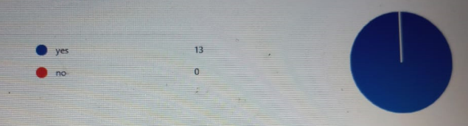
Figure 1confident in technology
The discussion also makes it obvious that the participants may not understand how frequently they use various digital platforms for collaboration if they didn't respond to the question about rating them according to the frequency of usage. This study emphasizes the need for additional research to examine the variables that affect students' choice of digital tools for collaboration and how usage frequency varies depending on the type of collaboration activity (Cotos, Huffman, and Link, 2020). This aspect is crucial because it sheds light on the current study's limitations and how future research can expand on it.
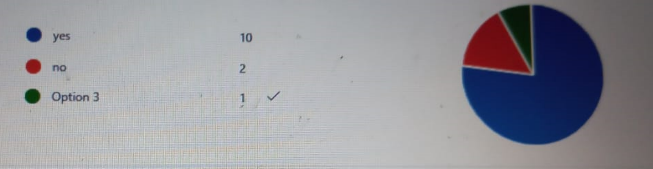
Figure 2usage of digital tools
Most participants use various digital tools to collaborate, which brings us to the next topic covered in this section. This result aligns with the literature's emphasis on utilizing multiple tools to promote different aspects of collaboration. As this argument underlines, educators must expose students to and teach them various digital devices to encourage their ability to collaborate. The explanation of this finding is essential because it shows how instructors can more effectively promote their students' collaborative skills.
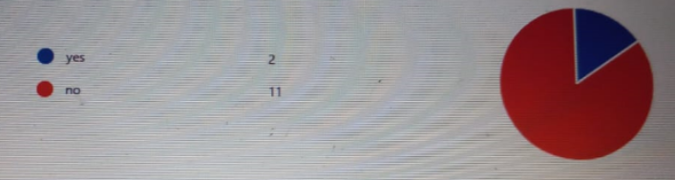
Figure 3usage of Ms and other tools
The discussion also points out that, given the growing popularity of M.S. Teams in educational contexts, the lack of a large demand for M.S. Teams in this analysis is noteworthy. This finding is important because it refutes the notion that M.S. Teams are the preferred electronic medium for student collaboration (Ha and Ngo, 2021). The discussion points out that this discovery might result from the individuals' familiarity with and experience with various electronic tools for collaboration or the fact that they were not assigned specified tasks to complete in M.S. Teams. This emphasizes the necessity for educators to consider the nature of the coordination project when selecting electronic tools and the need for additional research into the factors influencing students' decisions to choose electronic means for cooperation.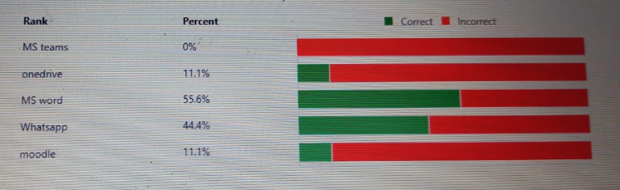
Figure 4ranking of digital application tools
The important findings and consequences of the study are summarized in the commentary's conclusion. The results show that students are comfortable using various digital tools for collaboration and do not desire a precise instrument. This result emphasizes how crucial it is to introduce students to and train them in different digital devices to support their cooperative capacities (Olszewski and Crompton, 2020). The commentary points out that the finding that M.S. Teams was not significantly favored in this survey calls into question the notion that M.S. Teams is the preferred digital tool for student collaboration. The discussion concludes by highlighting the need for additional studies to examine the factors influencing students' choice of digital tools for collaboration.
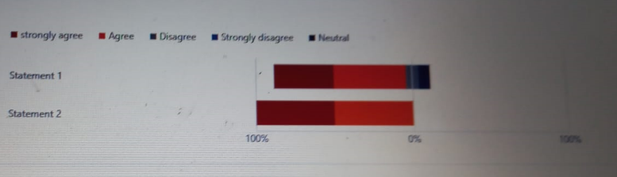
Figure 5digital tools for collaboration
The presentation provides hints about the findings, their implications, and their connections to the literature reviewed in the introduction section. The discussion deftly addresses the conjecture and offers evidence to support the existing literature. The lecture also acknowledges the limitations of the inquiry and suggests additional research. The presentation provides insight into the findings, their ramifications, and how they relate to the literature covered in the first section.
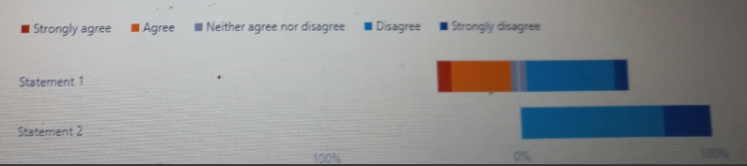
Figure 6Usage of ms team and one drive
Overall, the discussion section is well-written and provides valuable insights into the study results and their potential impact on Education and digital tools for collaboration.

Conclusion
In conclusion, this study examined how students collaborate with self-assurance when using technology. The results suggest that while students easily use digital tools for cooperation, they do not have a favorite tool. Only one participant reported using one digital tool more than others, whereas most said they used multiple digital tools to communicate. Additionally, MS Teams did not become the most popular digital tool for collaboration. These results are consistent with how technology is used and how researchers collaborate. Still, they also highlight the need for future research using a larger, more diverse sample and an inclusive questionnaire. The lack of responses to the question about grouping digital tools according to the frequency of use highlights the need for a more comprehensive survey that includes a larger range of digital instruments. This study lays the groundwork for future research to expand and deepen our understanding of how students feel comfortable interacting with technology.

Reference
Amhag, L., Hellström, L. and Stigmar, M., 2019. Teacher educators' use of digital tools and needs for digital competence in higher Education. Journal of Digital Learning in Teacher Education, 35(4), pp.203-220.
Arthur-Nyarko, E., Agyei, D.D. and Armah, J.K., 2020. Digitizing distance learning materials: Measuring students' readiness and intended challenges. Education and Information Technologies, 25, pp.2987-3002.
Çankaya, S. and Durak, G., 2020. Integrated systems in emergency distance education: The Microsoft Teams.
Cotos, E., Huffman, S. and Link, S., 2020. Understanding graduate writers' interaction with and impact of the Research Writing Tutor during revision. Journal of Writing Research, 12(1), pp.187-232.
El Firdoussi, S., Lachgar, M., Kabaili, H., Rochdi, A., Goujdami, D. and El Firdoussi, L., 2020. Assessing distance learning in higher Education during the COVID-19 pandemic. Education Research International, 2020, pp.1-13.
Ha, G.L. and Ngo, T.C.T., 2021. Challenges in learning listening comprehension via Microsoft Teams among English majors at Van Lang University. International Journal of TESOL & Education, 1(3), pp.142-175.
Hanelt, A., Bohnsack, R., Marz, D. and Antunes Marante, C., 2021. A systematic review of the literature on digital transformation: Insights and implications for strategy and organizational change. Journal of Management Studies, 58(5), pp.1159-1197.
Hennink, M. and Kaiser, B.N., 2022. Sample sizes for saturation in qualitative research: A systematic review of empirical tests. Social Science & Medicine, 292, p.114523.
Hodder, A., 2020. New Technology, Work and Employment in the era of COVID‐19: reflecting on legacies of research. New technology, work and employment, 35(3), pp.262-275.
Nayak, M.S.D.P. and Narayan, K.A., 2019. Strengths and weaknesses of online surveys. Technology, 6(7), pp.0837-2405053138.
Olszewski, B. and Crompton, H., 2020. Educational technology conditions to support the development of digital age skills. Computers & Education, 150, p.103849.
Sharabi, L.L. and Dykstra-DeVette, T.A., 2019. From first email to first date: Strategies for initiating relationships in online dating. Journal of Social and Personal Relationships, 36(11-12), pp.3389-3407.
Sipes, J.B., Roberts, L.D. and Mullan, B., 2022. Voice-only Skype for use in researching sensitive topics: A research note. Qualitative Research in Psychology, 19(1), pp.204-220.
Tiwari, S.P., 2022. Knowledge Enhancement and Mobile Technology: Improving Effectiveness and Efficiency. arXiv preprint arXiv:2208.04706.
Tohara, A.J.T., 2021. Exploring digital literacy strategies for students with special educational needs in the digital age. Turkish Journal of Computer and Mathematics Education (TURCOMAT), 12(9), pp.3345-3358.
Wang, A.Y., Mittal, A., Brooks, C. and Oney, S., 2019. How data scientists use computational notebooks for real-time collaboration. Proceedings of the ACM on Human-Computer Interaction, 3(CSCW), pp.1-30.

Appendix
- Do students feel more confident in using technology to collaborate?
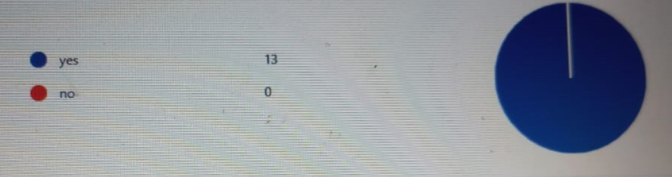
- Do students use one digital tool more than the other?
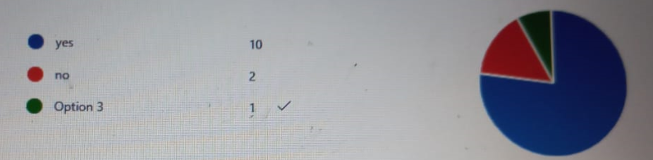
- Do students use Ms team more than the others?
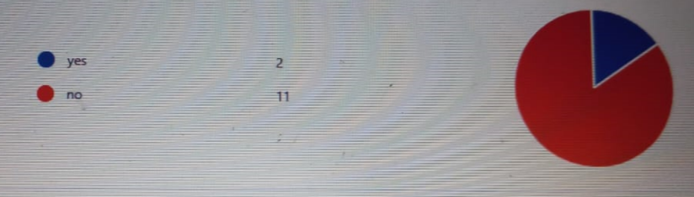
- How do students rank digital application tools?
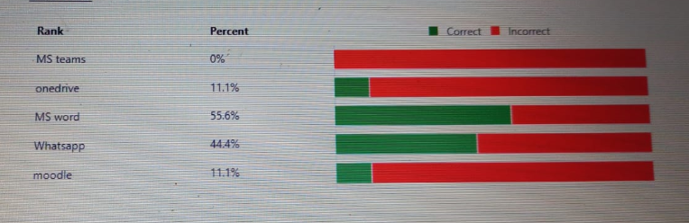
- Do students use digital tools to collaborate?
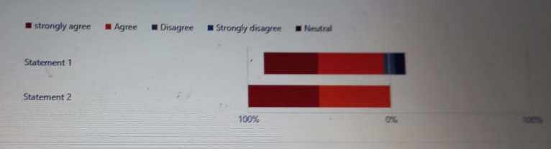
- Do students use M.S. teams and the one drive equally often when working with others?


