Ways of perceiving, Curation exhibition essay
Programme of study: Product and furniture design
Module: ADAD4019
Word count:
Tutor: Julia Lockheart

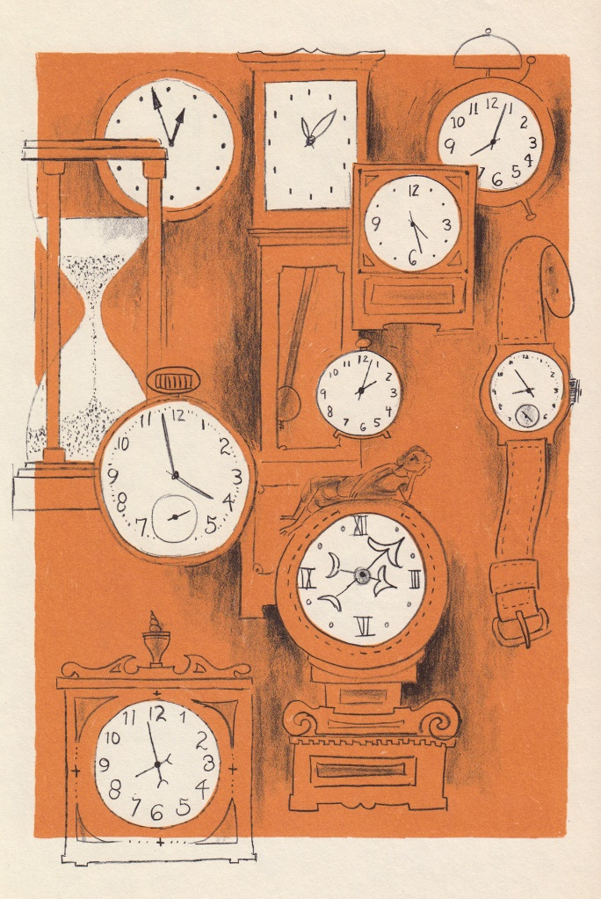
Perception of time

Figure 1- Time is when, Harvey Weiss, 1960

Through the process of curation, this is my Exhibition for people that want to know the truth about time. An opportunity to allow my audience to rethink time as fluid and arbitrary. Presenting artworks from different eras, that engage with the concept of time in various ways, illustrating similarities and differences within the concept. During my artistic studies, I have been fascinated by the perception of time. Quotes such as “There is an old and new consciousness of time” Doesburg, 1918) Manifest of the style, mentioned in my artist manifesto, could suggest that time is far from being a single entity and has different forms in oneself. Similarly, there is a difference in how time is interpreted in different parts of the world.
“One might say that there are as many different kinds of time as human beings on this earth, but we in the Western world view time as a single entity. This is incorrect, but it is the way we see it.” (Hall, 1983, p.17).
What is time?
Time is abstract and can be seen as highly mysterious, studied for centuries as time is associated with many features that shape the way lives are led. The philosophical aspects of time are explored in detail in various artistic disciplines such as visual and literature based. For example, Hymn to time is a short poem that discusses the characteristics of time. “Time is being and being time/ it is all one thing/ the shining/ the seeing, the dark abounding” (Le Guin, 2016, p.25.). This sentiment suggests that time is a singular construct that makes up humanity which can be trusted. Similarly, time can be perceived as an element that is manufactured into the soul and consciousness, “Time is the substance I am made of. Time is a river which sweeps me along, but I am the river; it is a tiger which destroys me, but I am the tiger; it is a fire which consumes me; but I am the fire” (Borges, 1964). This powerful passage from the Argentinian writer, Jorge Luis Borges, could signify that time is included in his identity. The aggressive tone used in the verb ‘destroys’ may be a reference to the inevitability of ageing and death.
In 1905, Albert Einstein assembled the special theory of relativity. In summary, he proposed that time is flexible and will never be absolute; the concept of time simply being an illusion which is made up of our memories. He additionally further suggests that all things can ‘bend’ such as gravity which can alter time perception. (Einstein and penrose,2006). Furthermore, Danish philosopher Soren Kierkegaard investigates the order of events and experiences which challenges the perception of time.
“If time is correctly defined as an infinite succession, it most likely is also defined as the present, the past, and the future. This distinction, however, is incorrect if it is considered to be implicit in time itself, because the distinction appears only through the relation of time to eternity and through the reflection of eternity in time.” (Kierkegaard, Hong et al Hong, 2000, p.149).
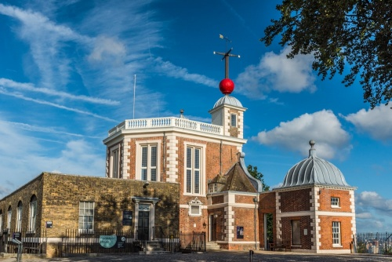
Figure 2- Prime meridian, Royal observatory, Greenwich
Where is time?
My Perception of time exhibition will be in the Royal observatory Greenwich museum. This will be an appropriate location to hold my exhibition as this is where official time zones were created (GMT). Known as the ‘home of time’, many people visit the Royal Observatory museum annually, bringing a variety of people to explore my exhibition. The exhibition would be an effective way of temporarily bringing people away from the educational purposes of their visit to a more philosophical journey. While timekeeping has existed dating back to ancient Egyptian times, the standardisation of time across the world has been a somewhat recent practice. Up until the late eighteenth century precise time schedules were not kept. It was not until the nineteenth century and the industrial revolution with its vast rail and communication networks that synchronising and standardising time across wide regions became necessary for successfully doing business. Davis (2013). 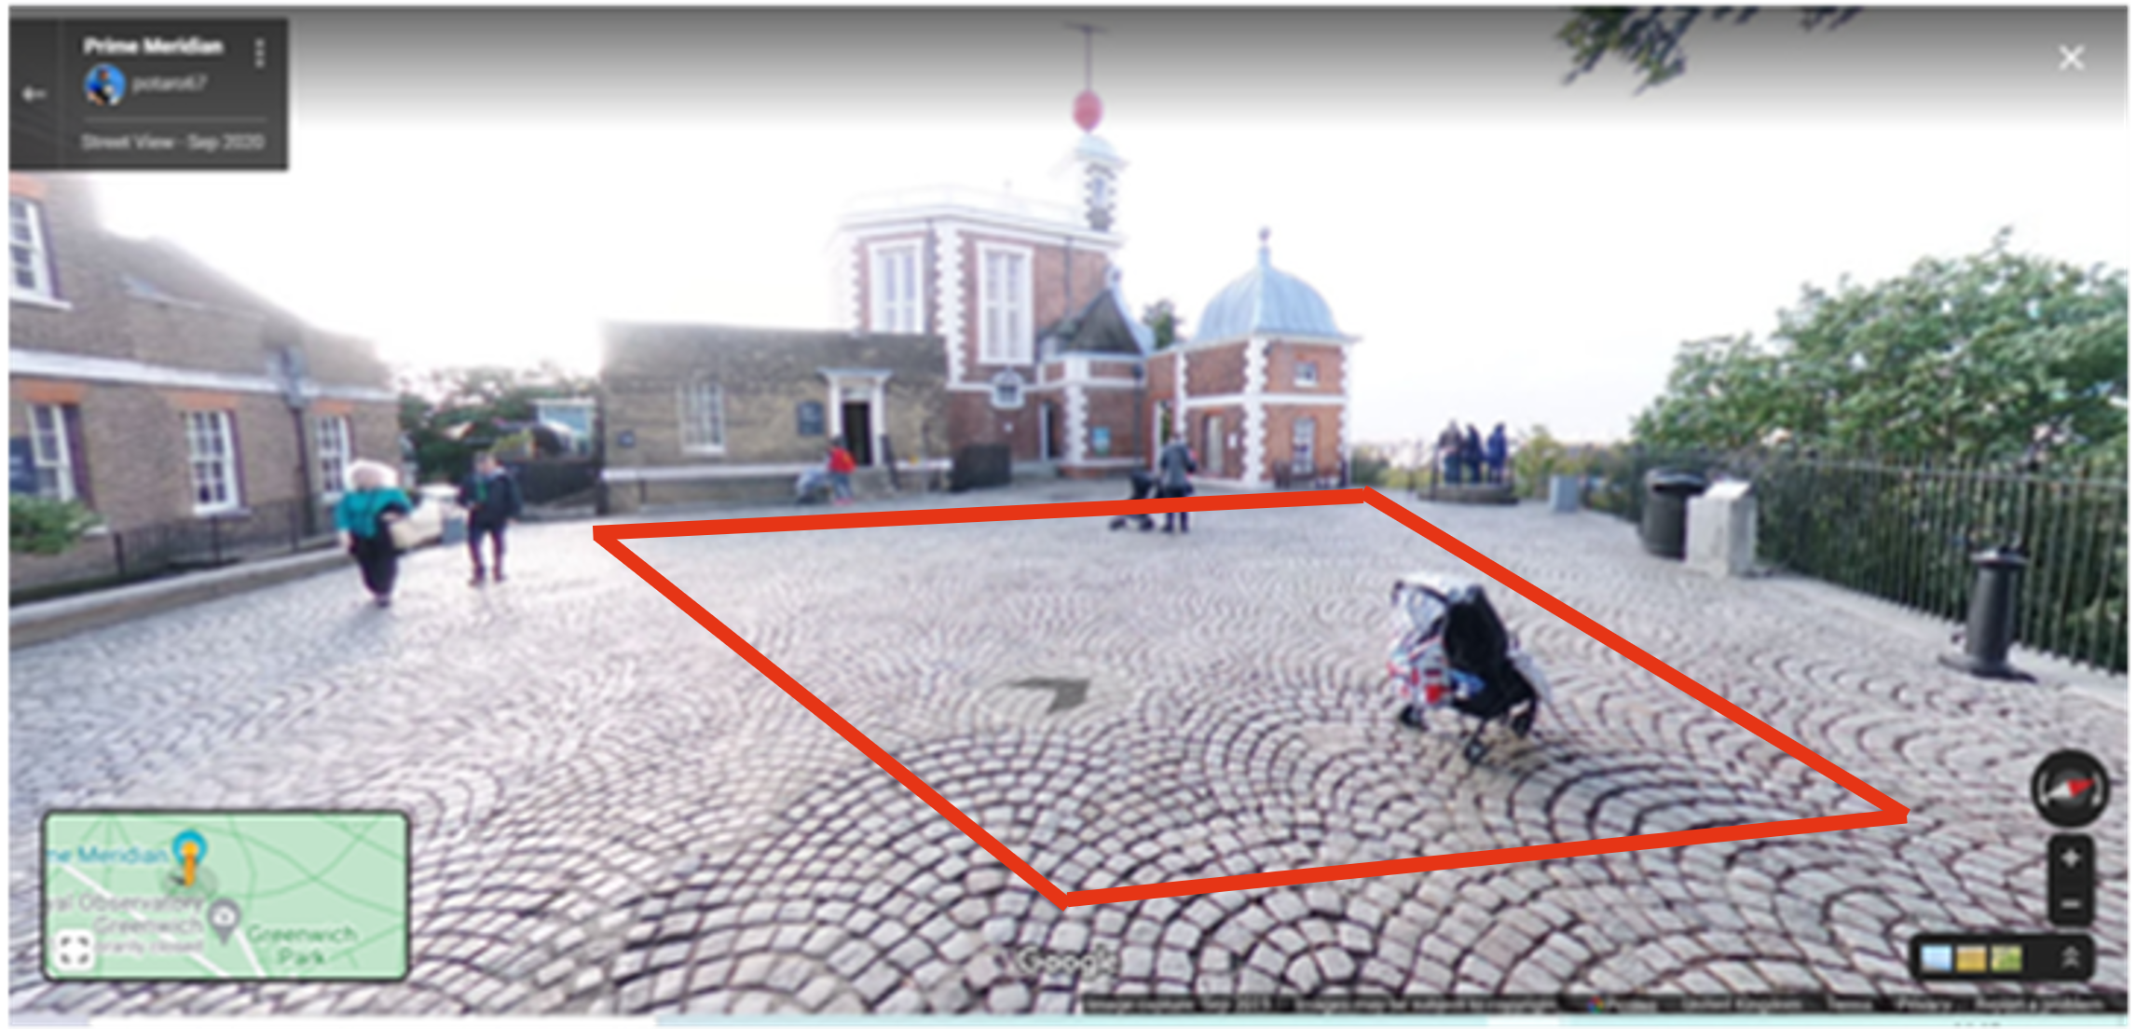
As you can see from the image above, the entrance of the prime meridian has plenty of unused space to utilize for curating an exhibition. However, I plan to build a small (15’ x 15’) construction at the entrance of the museum. My decision to create a smaller exhibition lies behind Edward T. Halls theory of proxemics and the four different types of spatial zones, intimate, personal, social, and public. The exhibition will bear the four proxemic spaces. The small space allows my audience to have a more intimate experience with the pieces presented. The idea of less being more and the few art works displayed having a bigger impact.
The exhibition will consist of a small room containing a clock face on the ground, with the hands pointing to the included art pieces. There are many artists that have explored the concept of time and how it impacts individuals in society. Those of particular relevance to this exhibition are art works such as Salvador Dalí’s persistence of memory, 1931, Felix Gonzalez Torrez’s perfect lovers, 1991, and Antonio de Pereda’s Allegory of vanity, 1632-1636.

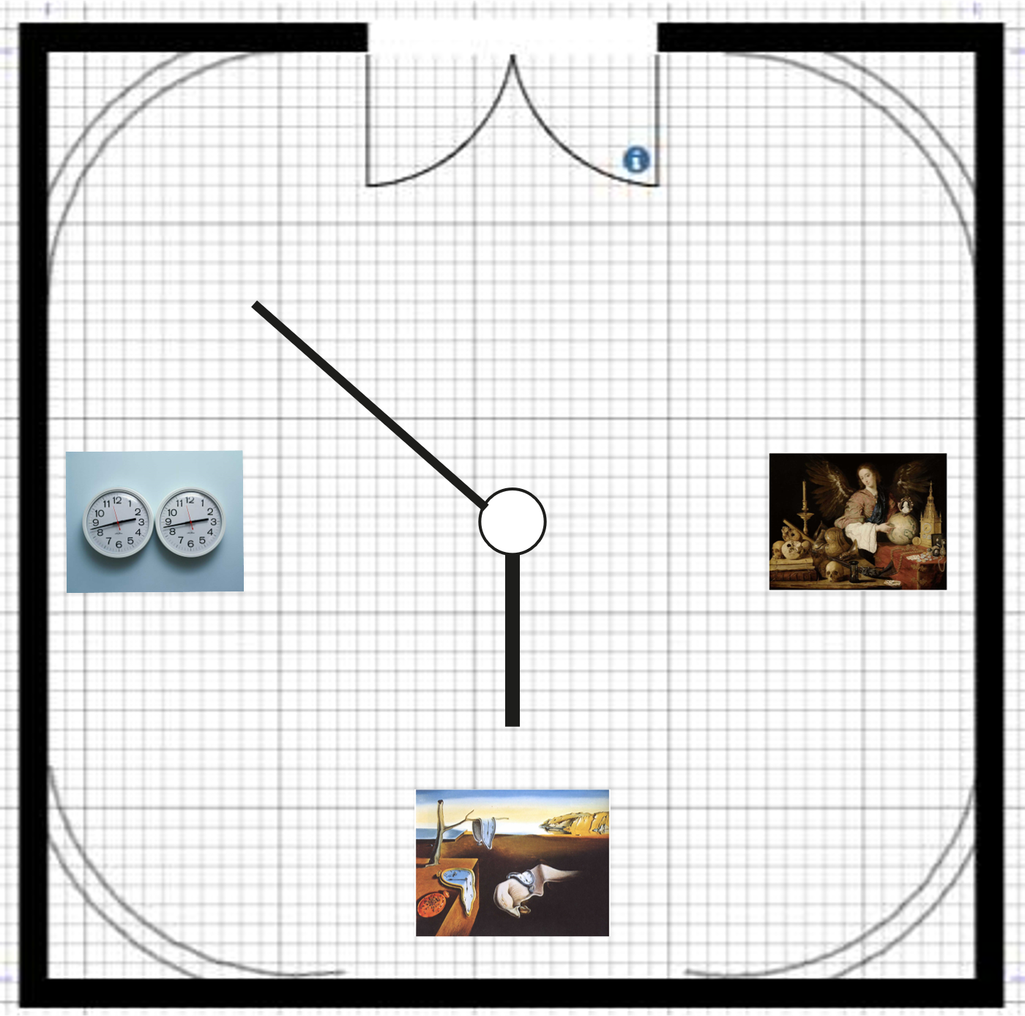

‌

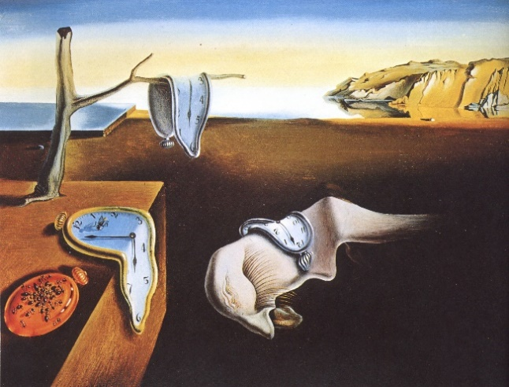

Figure 3- persistence of memory, 1931
By using a semiotic analysis, I can dissect the image, finding connotations of the piece. Salvador Dali’s persistence of memory, 1931, is a painting that will be included in my exhibition, using time as a key concept. Dalí’s persistence of memory is one of the most iconic and recognized paintings of surrealism, painted in 1931, this 24cm by 32cm Oil canvas painting is one of his earlier surrealist works. The painting contains a light blue horizon and the landscapes of Catalonian mountains containing four limp pocket watches. Dalí places a rectangular platform with a lifeless tree with a hollow top. The tree is located on what looks like wooden desk or table. The single branch holds a silver melting pocket watch. The presentation of the dead tree conveys the inevitable concept of mortality. Furthermore, the tree is shown to be sprouting from the wooden box/table, juxtaposing nature by growing on manmade material. Similarly, symbols of decay are indicated using a colony of ants on the bronze pocket watch. Dalí uses ants in many of his work to represent impermanence of human existence, ultimately referring to time running out.

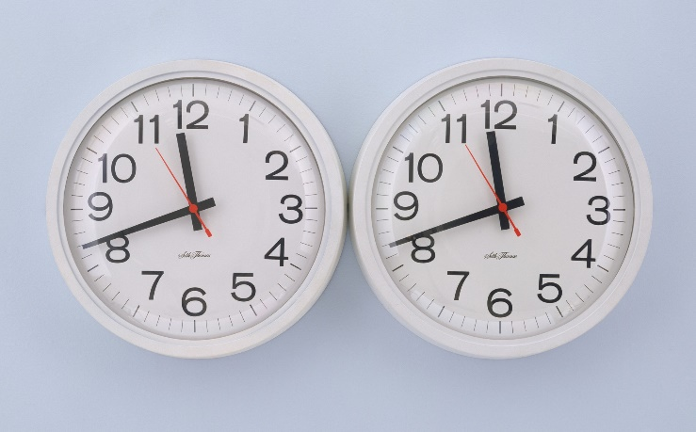

Figure 4- perfect lovers, 1991
Felix Gonzalez- Torres’s perfect lovers is a conceptual art piece consisting of two identical clocks that start in synchronisation. Eventually the two clocks will fall out of synch as the batteries run out. The piece corresponds to the unfortunate decline of his partner dying of HIV. The two clocks represent the two mechanical heartbeats that can both be reset to resume perfect synchrony. The two clocks piece brings the metaphor of unity and partnership.


Figure 5- Allegory of vanity, 1632-1636

Bibliography
‌ Borges, J., 1964. Labyrinths. New York: New Directions.
‌Einstein, A. and Penrose, R. (2006) Relativity: The special and the general theory. Penguin Books.
Hall, E., 1983. The dance of life. New York: Anchor.
Le, U.K. (2016). Late in the day : poems, 2010-2014. Oakland, Ca: Pm Press.
Søren Kierkegaard, Howard Vincent Hong and Edna Hatlestad Hong (2000). The essential Kierkegaard. Princeton, N.J: Princeton University Press, Cop.

Davis, C., 2021. The Fluidity of Time - VAULT OF THOUGHTS. [online] VAULT OF THOUGHTS. Available at: <http://www.vaultofthoughts.com/2013/11/03/the-fluidity-of-time/> [Accessed 24 April 2021].
Popova, M., 2021. Kierkegaard on Time, the Fullness of the Moment, and How to Bridge the Ephemeral with the Eternal. [online] Brain Pickings. Available at: <https://www.brainpickings.org/2017/04/18/kierkegaard-concept-of-anxiety-time/#:~:text=At%20this%20meeting%20point%20of,experience%20of%20time%20plays%20out%3A&text=The%20fullness%20of%20time%20is,the%20future%20and%20the%20past.> [Accessed 30 April 2021].

