

Master of Business Administration

Module Name: Marketing Management

Module Code: LCMB7024

Brand Extension Portfolio – Apple Drone

Student Name: Abdul Ahad Hazary Shanto

Student ID: 2428523

Lecturer’s Name: Dr Jayalakshmi Gopalkrishnan

Work Count: 2630

Submission Date: 28th April

Term 1

Table of Contents
Introduction 3
Brand Extension 5
STP for the New Brand Extension 6
Segmentation 6
Targeting 7
Positioning 8
Customer Personal Profile 9
Demographic Overview: 9
Psychographic Traits: 9
Buying Behaviour: 10
Marketing Mix Strategy 11
Product 11
Price 12
Promotion 12
Place 13
Process 13
People 13
Physical Evidence 13
Conclusion 15
References 16

Introduction
Apple Inc. is a leading global innovator in consumer electronics, personal computers, mobile communications and mobile operating software, as well as the world leader in digital music and form factor design, content services, online advertising, marketing, branding and blockchain technology. Apple is a company headquartered in Cupertino, California, that has created a dedicated global customer base through its products, including the iPhone, iPad, Mac, Apple Watch and services like iCloud, Apple Music and the App Store (Bica, 2021). Simplicity, performance, and user-centric design are engraved in the brand identity of the company, which, time and again, combines technology in a refined and user-friendly manner.
This report introduces Apple’s new product concept, the Apple Drone. This would be a premium consumer drone featuring Apple’s hallmark aesthetics and capability, plus wide application of its smart AI, ultra HD camera systems, and deep integration in the ios ecosystem. It has been designed for both recreational use as well as for professional content creation, and a huge variety of other avenues. It will have biometric security and the ability to be used with Siri voice control, as well as include compatibility with Apple apps and cloud services.
Keeping at its recent practice of innovating and expanding its ecosystem, Apple’s entry into the burgeoning drone market makes sense (Addanki, 2024). With this new funding, an explosive growth of the drone market can be expected as people demand more and more from it in creative, commercial and personal applications. It presents Apple with a unique opportunity to gain from its strong brand equity position by delivering a better user experience and thereby attracting new and existing customers.

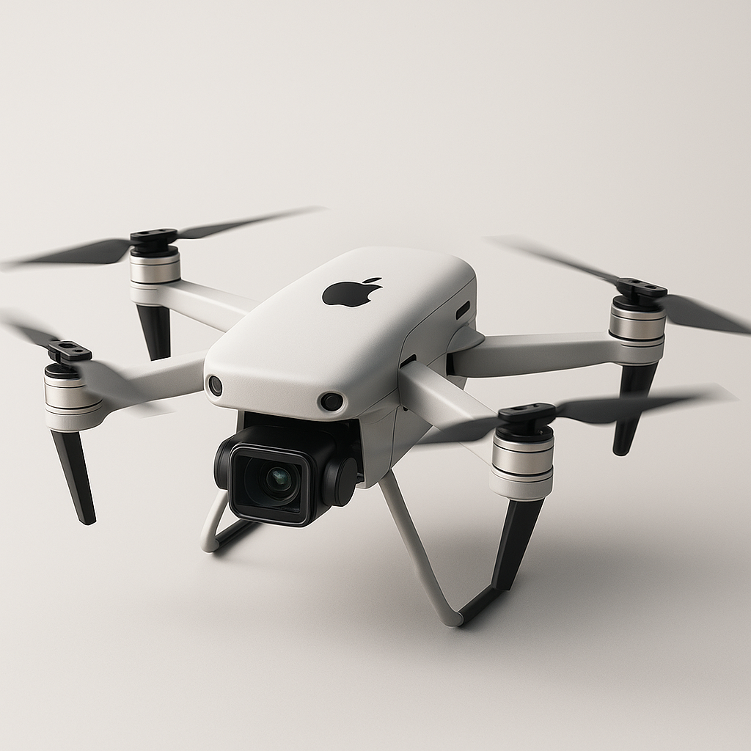
Figure 1: Apple Drone (Self-Prepared)

Brand Extension
The Apple Drone is an AI-powered device aiming to fit perfectly into Apple’s current ecosystem of products and services, as a premium product. The drone, according to Apple’s values of innovation, simplicity and user-focused design, will bring a refined and intuitive user experience, upon which the company’s reputation for excellence in the technology sector is built.
With a 12K cinematic camera, Apple Drone is perfect for professional and amateur photography/videography and creation of creative media, equipped for ultra-high definition aerial content creation. Real-time image stabilisation, object tracking and voice command through Siri will make things more user-friendly and more precise in operation. It will connect to iPhones, iPads, and MacBooks with ease, allowing for instant file transmission via AirDrop and cloud backup using iCloud. A person will be able to design a complete recording workflow with Apple software such as iMovie and Final Cut Pro.
However, this brand extension is a natural progression from Apple’s diversification of products from personal computers and mobile phones to wearables and digital services. Entering the drone market opened the door for Apple to discover new frontiers in consumer technology and the large unmet demand for high-performance smart drones in sectors including vlogging, environmental research, and security, along with entertainment.
The drone will support Apple’s commitment to privacy and sustainability and includes biometric security safety features like fingerprint-allowed access through its connected app and geofence badging to guarantee safe and authorised use (Ghannam, 2025). Instead, the body of the drone will be made from recycled aluminium by Apple’s wider environmental efforts.
There is a very clear market wanting to be met by the Apple Drone: Many current drones don’t have the favourable cross-device compatibility and intuitive interfaces. By being an ecosystem's integration, Apple sets its golden standard in terms of where the connection is seamless and achieved through automation and control (Vermesan and Friess, 2015). Its intelligent flight systems and its user-friendly interface make it beginner-friendly and also a pro-friendly one. The Apple Drone helps to massage the brand’s core values while introducing a new product that opens up the brand to offering something new. It brings something new to the portfolio, providing a more forward-thinking and aesthetic solution with eco tendencies. It allows Apple to cement customer loyalty, bring in more of the creative audience, and rather than continue reshaping the next generation of personal technology.

STP for the New Brand Extension
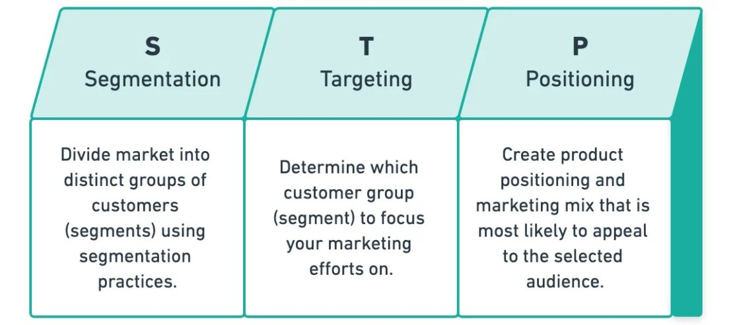
Figure 2: STP Analysis (Wright, 2020)

Segmentation
The demographic, geographic, psychographic, and behavioural parameters are strategically defined in the market segment of Apple Drones (Gajanova, Nadanyiova and Moravcikova, 2019).
- Demographic Segmentation:
The Apple Drone is aimed at someone between 18 to 45 years old, which means they are part of younger millennials and Gen Z people who are highly connected to the technology and digital media scene. Middle to high disposable income groups and working in creative industries such as photography, filmmaking, real estate, media, or marketing are typical target audiences for these consumers (Towse, 2020). Most are freelancers, entrepreneurs or aerospace professionals who depend on excellent visuals and tech for their work.
- Geographic Segmentation:
For North America, Western Europe, and the Asia Pacific areas, the first market focus will be on urban and semi-urban regions where Apple has established a customer base and presence. As a result, drones are being adopted at a higher rate, and these regions also have access to open spaces that are suitable for drone use and are close to both content creators and technology users.
- Psychographic Segmentation:
Its appeal lies to people who enjoy the use of tech, futuristic ideas, and have a status and creative mind that appreciates innovation, convenience and a better lifestyle. They are early adopters, adventurers, influencers, vloggers, and aspirational users, looking for the newest in technology and to complement their modern way of life (Irimiás, 2023). Apple’s premium image helps to associate the product with these consumers’ identity.
- Behavioural Segmentation:
Brand loyal consumers of Apple Drone will show preference for products that offer an easy, premium quality experience and seamless working across all devices. The way they want to get things done connects them with things outstanding performance, smart automation and tasteful style. They are brand ambassadors who are influenced by product reviews, tech trends, and community recommendations, as their decisions to purchase are influenced by those pieces of information. And the fact that so many are already in the Apple ecosystem only makes a drone in step with their existing devices and services more attractive.

Targeting
Apple will implement a differentiated targeting strategy, focusing on two distinct yet complementary customer segments:
- Creative Professionals:
It is also a mix of photographers, filmmakers, vloggers, and drone videographers. The goal of these professionals is to get high-resolution imaging, intelligent flight control, some degree of stability, and access to advanced editing tools (Peksa and Mamchur, 2024). For these users, the Apple Drone’s 12K camera, AI-assisted navigation and integration with Final Cut Pro and iCloud are the perfect tools. Since they do not consider price as the main filter, these customers are performance-driven and willing to invest in quality technology to improve their creative output.
- Tech-Savvy Lifestyle Consumers:
They are loyal to Apple; these users love the premium lifestyle, which includes innovation, aesthetics and connectivity (Htet, 2024). The drone may be hobbyists, travellers, or social media influencers who are using the drone for creating content, documentation or entertainment. Apple’s hallmarks of product offerings (convenience, stylish design with intuitive controls) are what this group cares about. This also strengthens their likelihood of purchase due to their loyalty to the Apple brand.

Positioning
Positioning Statement:
“For tech-savvy creators and adventurers who demand uncompromised quality and intelligence, the Apple Drone is a premium, intuitive flying device that redefines the drone experience through cutting-edge design, AI-powered navigation, and seamless integration within the Apple ecosystem—unlike any other drone on the market.”
The key to Apple Drone’s positioning is exclusive ecosystem compatibility, user experience, and brand trust. The product will be put in place in the high price, high quality segment of the market alongside Apple’s already created portfolio. Apart from its competitors, like DJI, Apple is different by having complete cross-device privacy features and a minimalist design.

Customer Personal Profile
Name: Sarah Chen
Age: 29
Gender: Female
Occupation: Freelance Filmmaker / Travel Vlogger
Income: $80,000 per year
Location: Los Angeles, California
Education: Bachelor’s in Film and Media Studies
Relationship Status: Single

Demographic Overview:
Based in Los Angeles, California, and 29 years old is freelance filmmaker and travel vlogger Sarah Chen. She has created a lucrative career working with brands, creating content and making money via YouTube ads, brand partnerships, and freelance videography. Sarah is a single, independent professional with an annual income of $80,000, and she relishes the option of making travel and inspiration commonplace.

Psychographic Traits:
Sarah is a very creative and motivated person, she likes to innovate, be free, to narrate and tell stories. For her career, there are always new technologies to experiment with the new environments to explore (Nilson, 2016). With so many values in line with her inclinations towards sustainability, privacy and slick design, she is an early adopter when it comes to tech products. She is environmentally conscious and supports brands that have a focus on green and ethical manufacturing. Sarah is a loyal Apple user and owns several Apple devices, which are seamless, aesthetically appealing, and easy to use.

Buying Behaviour:
Sarah researches a product before buying; she reads customer reviews and compares features. She is willing to put her money behind that which contributes to her increased productivity and also aligns with her professional objectives. The key decision factors for her are the quality, user experience, device compatibility and design (Unger and Chandler, 2023). But Sarah is especially attracted to products that help them integrate smoothly into the Apple ecosystem, preserving an object and a high level of performance across devices.

Marketing Mix Strategy
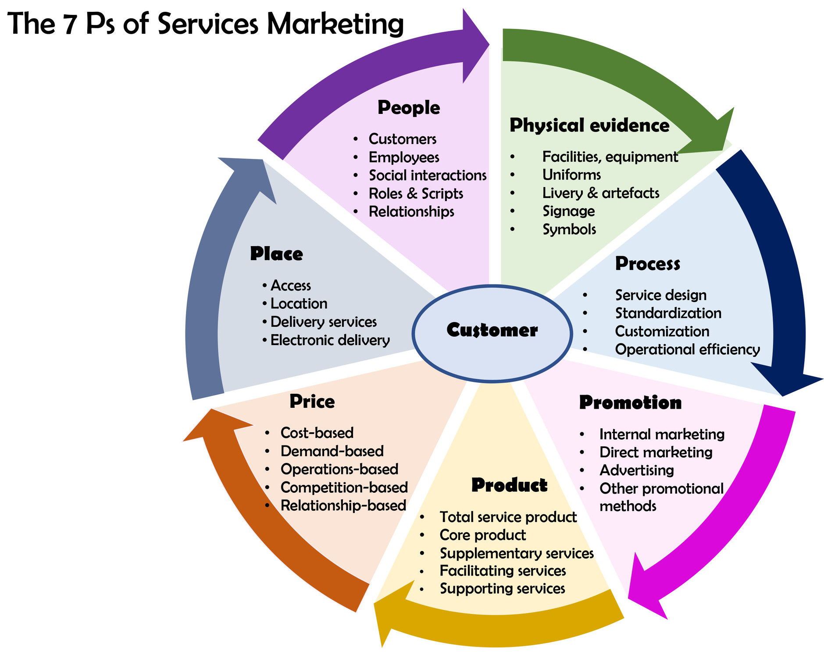
Figure 3: 7Ps of Marketing Mix (Zahedi, 2019)

Product
The Apple Drone is positioned as a high-end consumer drone, offering advanced features to appeal to professionals and tech-savvy users alike. It will be available in two models:
- Apple Drone Standard
- Apple Drone Pro (equipped with a LIDAR scanner and extended battery life)
Key product features include:
- 12K ultra-HD camera with cinematic-grade lenses for professional video quality
- AI-powered obstacle detection and auto-navigation to ensure safe and accurate flights
- Voice and gesture control, integrated with Siri for a hands-free experience
- Foldable, lightweight design, making it highly portable and travel-friendly
- Biometric security features, such as Touch ID access via the Apple Drone app
- Deep integration with the Apple ecosystem, allowing for seamless syncing with iPhones, iPads, MacBooks, iCloud, and Apple’s editing tools like iMovie and Final Cut Pro
The Apple Drone will be designed with sustainability in mind, using recycled aluminium and energy-efficient components, reflecting Apple’s commitment to environmental responsibility.

Price
Apple will adopt a premium pricing strategy, in line with its brand image and market expectations. The prices are set as follows:
- Apple Drone Standard – $1,799
- Apple Drone Pro – $2,499
The drone comes with high-end features, advanced technology and ecosystem compatibility pricing. Just as customers already pay for a superior product experience with Apple’s other offerings, they will pay for a superior experience from AirPort Total Support (Berridge, 2016). To make the product more accessible and to increase perceived value, Apple will also offer financing options through Apple Card as well as monthly instalment plans and bundles with related Apple products or AppleCare+.

Promotion
Building up anticipation and excitement for the Apple Drone, Apple will run a holistic, multi-channel promotional campaign that uses its trademarked minimalist and emotionally charged branding tactics. The campaign will start with a teaser phase of slick visuals and toned-down messaging to generate curiosity, but it will culminate during a major Apple event when the campaign will unveil the product grandly (Bochner, 2016). Useful keynote presentations and a wealth of detailed video demonstrations will accompany this launch, and it will be globally streamed. Apple’s brand tone is aspirational and innovative, which matches the campaign’s aspirational and innovative central tagline, ‘Sky is No Limit’, about the drone.

Place
Apple will adopt a selective and strategic channel model, which distributes the device via partner channels as well as direct channel outlets to promote accessibility, brand consistency and premium brand experience (Ailawadi and Farris, 2020). The Apple Drone will be available for purchase on the official Apple website and the more convenient Apple Store mobile app, bringing a smooth and seamless digital shopping experience to customers. The drones will also be available, in physical Apple Stores worldwide, as primary distribution points where potential buyers can come in, see, test, and interact with the drone before, all before they buy.

Process
The customer journey of Apple Drone will be in line with Apple’s tradition of simplifying, streamlining and improving user experience. The whole process is planned to be intuitive and simplified from product selection to post-sale support (Danh, 2023). Using tools to configure their purchase online, customers will be able to choose accessories and care plans. Based on the customer preference, the free delivery and in-store pickup by Apple is setting a flexible and convenient tone. For users, to receive the product, they will be guided through setup and calibration via the Apple Support app with interactive tutorials and troubleshooting guides to help.

People
As we have already written about before on the blog, the ‘human element’ will be a major aspect of Apple Drone’s customer experience. They will train Apple’s in-store specialists and support staff extensively in drone technology to be able to provide customers up to the level expected. Live demonstrations of the product and answers to technical questions will be provided by dedicated drone experts stationed at a variety of Apple Stores (Kreps, 2016). Customers will be helped by the Genius Bar staff, who will be able to troubleshoot and repair drones.

Physical Evidence
This would prove to be the physical evidence to reinforce the Apple Drone’s premium positioning and overall brand experience. And it will ship in signature Apple packaging to boot, in typical sleek, minimalist and premium ways, carrying Apple's product philosophy in its unboxing experience. It will have a large screen area in Apple Stores that would show demo videos, user-generated content, and customer testimonials and much more in a prominent display in high end to the Apple Store app offering digital product guides, and interactive demos, as well as augmented reality previews so customers can see the drone in action before they buy (Simon, 2016).

Conclusion
The introduction of the Apple Drone is a major and strategic extension of the brand that capitalises on Apple’s strengths of innovation, design excellence and seamless ecosystem integration. As a tech-savvy, creative professional or premium lifestyle consumer, Apple now enters the rapidly growing consumer drone market, it has an opportunity to provide a distinctive and superior user experience.
This report has illustrated how the Apple Drone fits neatly into Apple’s customers and brand image, brings new functionality and experience to address an existing customer need, and fills a market gap by providing a smart, logical, integrated into ecosystem drone can separate itself from the established competitors, addressing in carefully selected segmentation, targeting, setting positioning.
This marketing mix will support product high positioning as it fuses in the combination of advanced features, sustainable design and a customer-oriented distribution, promotion and support. However, the strength in storytelling and experiential marketing that Apple has at its disposal will be essential in capturing consumer interest and building long term brlong-termty.
To ensure a successful launch and long-term growth, Apple should prioritise:
- Prioritising with content creators, influencers, and creative communities
- Framing the drone as a creative companion, not just a piece of hardware
- Advancing innovation in AI navigation, security, and environmentally responsible design
Apple has a longstanding trusted brand image, an established (if not dominated) customer base, and an ecosystem that will greatly assist in the transformation of the drone space. According to the plans, the Apple Drone can go above and beyond personal and professional content creation to create new standards in smart aerial technology in the consumer market.

References
Addanki, S., 2024. Dynamics of Corporate Entrepreneurship in Technology Companies: A Study of Strategic Practices and Governing Frameworks Shaping Entrepreneurial Ecosystems (Doctoral dissertation, Massachusetts Institute of Technology).
Ailawadi, K.L. and Farris, P.W., 2020. Getting multi-channel distribution right. John Wiley & Sons.
Berridge, E., 2016. Customer obsessed: a whole company approach to delivering exceptional customer experiences. John Wiley & Sons.
Bica, J.A.A.S.A., 2021. Apple and the Earbuds Business in 2021 (Master's thesis, Universidade NOVA de Lisboa (Portugal)).
Bochner, A.P., 2016. Coming to narrative: A personal history of paradigm change in the human sciences. Routledge.
Danh, N.D.M., 2023. Post-sales strategy to achieve customer satisfaction for Hiava Oy.
Gajanova, L., Nadanyiova, M. and Moravcikova, D., 2019. The use of demographic and psychographic segmentation to create marketing strategy of brand loyalty. Scientific Annals of Economics and Business, 66(1), pp.65-84.
Ghannam, Y.P., 2025. Ethical Business Tightrope: Privacy vs. National Security in Consumer Products. In Resiliency Strategies for Long-Term Business Success (pp. 79-110). IGI Global.
Htet, Z.L., 2024. Emotional Branding, Customer Satisfaction and Brand Loyalty of Apple Smart Phone (Zaw Lynn Htet, 2024) (Doctoral dissertation, MERAL Portal).
Irimiás, A., 2023. The young tourist and social media. In The youth tourist: Motives, experiences and travel behaviour (pp. 63-81). Emerald Publishing Limited.
Kreps, S.E., 2016. Drones: What everyone needs to know. Oxford University Press.
Nilson, L.B., 2016. Teaching at its best: A research-based resource for college instructors. John Wiley & Sons.
Peksa, J. and Mamchur, D., 2024. A review on the state of the art in copter drones and flight control systems. Sensors, 24(11), p.3349.
Simon, J.P., 2016. User generated content–users, community of users and firms: toward new sources of co-innovation?. info, 18(6), pp.4-25.
Towse, R., 2020. Creative industries. In Handbook of cultural economics, p.137.
Unger, R. and Chandler, C., 2023. A Project Guide to UX Design: For user experience designers in the field or in the making. New Riders.
Vermesan, O. and Friess, P., 2015. Building the hyperconnected society—Internet of Things research and innovation value chains, ecosystems and markets (p. 332). Taylor & Francis.
Wright, M. (2020). The Complete Guide to STP Marketing: Segmentation, Targeting & Positioning. [online] Yieldify. Available at: https://www.yieldify.com/blog/stp-marketing-model/.
Zahedi, Z. (2019). what are the 7ps of marketing mix and how should it be used?? [online] www.linkedin.com. Available at: https://www.linkedin.com/pulse/what-7ps-marketing-mix-how-should-used-zahra-zahedi/.

