HPHI4002
Writing History

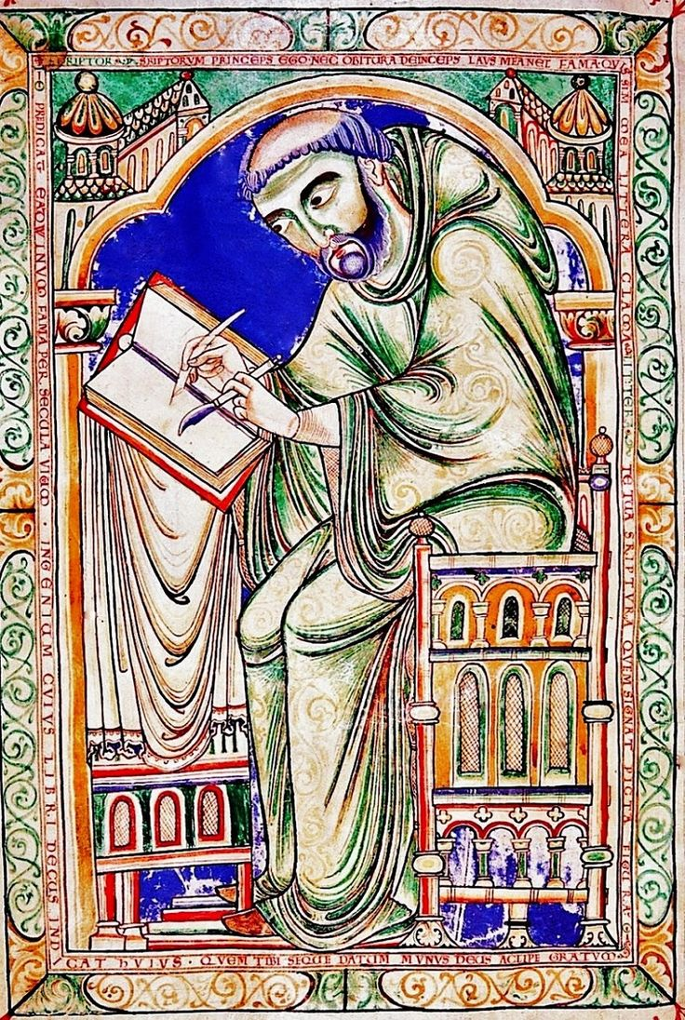

Perspectives on the Past
Module Study Guide, 2017–2018

Lectures:
Thursdays, 4pm–6pm in Cliff Tucker room 1 (Tucker 1)

Module convenor:
Alexander Scott (alexander.scott@uwtsd.ac.uk)

Module convenor’s office hours:
Wednesdays 10am–11am, Fridays 11am–12noon
(alternative appointments can be arranged by email)
MODULE OVERVIEW
MODULE AIM(S)
- To familiarise students with key principles and characteristics of studying history and history-related disciplines at university level history, and to explore how, where, why and when these characteristics developed;
- To equip students with fundamentals of university-level writing as applied to history and history-related disciplines, and with the ability to construct and appraise historical arguments;
- To equip students with the ability to formulate and substantiate historical arguments, and to situate these arguments within existing historiographical debates.

LEARNING OUTCOMES
Upon the successful completion of this module, the student should be able to demonstrate the ability to:
- Understand and apply the principles of academic history-writing;
- Reference (footnote) using the appropriate Modern Humanities Research Association (MHRA) formulae;
- Understand, evaluate and critique different historians’ work and different historical concepts;
- Formulate, sustain and substantiate cohesive historical arguments, both orally and in written form.

LEARNING AND TEACHING STRATEGY
This is a skills-based module oriented towards students taking degrees in history and history-related disciplines (Modern Historical Studies, Medieval Studies, War and Conflict, Ancient History, etc.). The syllabus embeds sessions on generic study skills within a broader syllabus of theme- and topic-based lectures. Lectures cover generic study skills (e.g. referencing; essay writing; constructing an argument) alongside discipline-specific ones (historiographical analysis; MHRA referencing) as part of a broader curriculum which explores the development of history writing techniques. When discussing strategies for reading at university level, for example, teaching sessions will touch upon the history of the printed word; likewise, as an introduction to the principles of using primary sources and footnotes, lectures will explore innovators of such historical methods such as Edward Gibbon and Leopold von Ranke.
Delivery is based on a team-taught model: medieval and modern historians teach topics bespoke to their specialisms. It is intended that teaching will continuously blend ‘traditional’ plenary discussions led by lecturing staff alongside group discussions and group tasks. Throughout, there is an emphasis on student participation, culminating with the final assessment being student-led. Students work collectively on an assigned task that forms the basis of the final assessment, which takes the shape of student presentations that contribute to a broader in-class debate. The latter foregrounds the importance of argumentation and debate as delineators of university-level history study. In the latter respect, while the module places titular emphasis on historical writing techniques, it also aims to hone students’ oral delivery skills.

MODULE ASSESSMENTS
Assessment Component 1 – 5% of module grade
Essay appraisal (200–500 words) – deadline Friday October 20 2017, 11.59pm
Students will be given an example of an undergraduate essay to read and evaluate. Students then write a short appraisal of the essay’s strengths and weaknesses, attaching a suggested numerical grade. The intention is to familiarise students with good (and bad) writing practices and to finesse their understanding of assessment criteria.

Assessment Component 2 – 25% of module grade
Article review (800–1000 words) – deadline Friday December 1 2017, 11.59pm
Students will write a review an academic journal article which discusses a topic or debate covered during lectures. Students should place emphasis on critical analysis and endeavour to situate the article within a historiographical context.

Assessment Component 3 – 35% of module grade
Presentation during in-class debate (equivalent to 1000–1500 words) – to be done in-class during January examination period (date, time, venue TBC)
Individual students will prepare and deliver a ten-minute presentation on one ‘side’ of an historiographical debate. Other students will prepare and deliver presentations from a competing standpoint. With both sides of the debate having been aired, presenters and peers will engage in dialogue with one another. Grading will be based on the quality of students’ presentations, but also their contributions to subsequent debates.

Assessment Component 4 – 35% of module grade
Annotated bibliography (1000–1500 words) – deadline January 19 2018, 11.59pm
Students will compile an annotated bibliography comprising of various source types accessed in the process of doing research for their in-class presentation. Short written analyses of different sources should be provided. Grading will be based on the quality of annotations, but also students’ adherence to correct MHRA referencing formulae.

ASSESSMENT CRITERIA
Coursework will be graded in accordance with the criteria adopted by the Faculty of Humanities and Performing Arts. For written work, these criteria are spelled out below.

Inclusion of source/primary material (S) | The work makes reference to a range source/primary materials relevant to the piece of work.
Inclusion of modern scholarship (MS) | The work demonstrates awareness of appropriate scholarly developments over time and inclusion of up to date material, and takes into account interdisciplinary, theoretical or methodological concerns.
Critical Engagement with source/primary material (CE1) | The work demonstrates critical in-depth discussion of a range of relevant sources and material; is fully aware of the nature of the evidence available; takes into account the original text/objects, where appropriate critically discusses scholarship on the relevant primary material(s).
Critical Engagement with Scholarship (CE2) | The work demonstrates a consistently critical attitude to scholarship; provides an engaged and informed discussion of relevant debates and schools of thought; demonstrates clear and relevant engagement with theoretical approaches and models; provides (a) statement(s) of own position in relation to scholarship.
Argument (Argue) | The work presents a clear and coherent argument/inquiry that is developed on the basis of critical examination of the evidence and that takes into account modern scholarship.
Structure (Struc) | The work has a clear, coherent and appropriate structure which contextualises, supports and demonstrates its argument
Relevance (Rel) | The work clearly and specifically relates throughout to the question attempted or the title of the work, and there are no unjustified digressions and no inclusion of irrelevant or tangential material.
Analytical Approach (AA) | The work has a well thought out and justified analytical approach consistently applied throughout, taking into account the relevant scholarly approaches and evidence. The whole of the work represents an in depth evaluation of the issues and material under discussion.
Referencing (Ref) | There is inclusion of consistent referencing at all relevant points throughout the work. The use of footnotes is supported by automatic footnotes in Microsoft Word (or relevant word processing program).
Readability, Coherence, and Written Style (RCWS) | The work achieves excellent clarity allowing the reader to focus on content; achieves stylistic excellence; there are no proof reading errors; achieves a tone appropriate for the type of communication.
Adherence to guidelines (AG) | The work adheres to: the subject referencing guidelines; the word limit and publication of word count; the individual module guidance on spacing e.g. margin font type spacing.

Level 4 grade guide
 | 1-29 | 30-39 | 40-49 | 50-59 | 60-69 | 70-79 | 80+
Inclusion of source/primary material (S) | Effort At | Very Limited | Limited | Adequate | Good | Very Good | Excellent
Inclusion of modern scholarship (MS) | Effort At | Very Limited | Limited | Adequate | Good | Very Good | Excellent
Critical Engagement with source/primary material (CE1) |  |  | Effort At | Very Limited | Limited | Adequate | Very Good
Critical Engagement with Scholarship (CE2) |  |  | Effort At | Very Limited | Limited | Adequate | Good
Argument (Argue) |  |  | Effort At | Very Limited | Limited | Adequate | Good
Structure (Struc) |  |  | Effort At | Very Limited | Limited | Adequate | Good
Relevance (Rel) |  |  | Effort At | Very Limited | Limited | Adequate | Good
Analytical Approach (AA) |  |  | Effort At | Effort At | Very Limited | Limited | Adequate
Referencing (Ref) |  | Effort At | Effort At | Very Limited | Limited | Good | Very Good
Readability, Coherence, and Written Style (RCWS) | Effort At | Very Limited | Limited | Adequate | Good | Very Good | Very Good
Adherence to guidelines (AG) | Effort At | Very Limited | Limited | Adequate | Good | Very Good | Outstanding

Additional Presentation Marking Criteria
Presentations have a set of criteria additional to that of a normal essay or exam.
Presentations
Engagement with Audience (EA) | The presenter(s) achieve highly effective audience engagement throughout.
Presentational Aids (PA) | The presenter(s) achieve excellent and interactive use of presentational aids.
Time Keeping (TK) | The presentation does not deviate from the specified time limit.

Level 4 Marking Criteria (Presentations) | 1-29 | 30-39 | 40-49 | 50-59 | 60-69 | 70-79 | 80+
Engagement with Audience (EA) | Effort At | Very Limited | Limited | Adequate | Good | Very Good | Excellent
Presentational Aids (PA) | Effort At | Very Limited | Limited | Adequate | Good | Very Good | Excellent
Time Keeping (TK) | Effort At | Very Limited | Limited | Adequate | Good | Very Good | Excellent

LECTURE SCHEDULE

Week 1 (week beginning October 2)
Historiography: What and Why? (Alex Scott)

Week 2 (week beginning October 9)
Reading: What, Why and How? (Alex Scott)

Week 3 (week beginning October 16)
Essay Writing: What, Why and How? (Alex Scott)
Essay appraisal due Friday October 20 2017, 11.59pm

Week 4 (week beginning October 23)
Referencing: What, Why and How? (Alex Scott)

Week 5 (week beginning October 30)
Libraries, Archives and Electronic Resources (Alex Scott)

Week 6 (week beginning November 6)
Reading Week

Weeks 7–8 (weeks beginning November 13, 20)
Key Debates in Medieval History (Harriett Webster followed by Erica O’Brien [or vice versa])

Week 9–10 (weeks beginning November 27, December 4)
Key Debates in Modern History: Empire vs. Postcolonialism (Lester Mason followed by Alex Scott)
Article review due Friday December 1 2017, 11.59pm

Week 11 – (week beginning December 11) Presentation Skills and Preparation for Coursework Debates
Presentations and annotated bibliography to be completed in-class during January examination period – date, time and venue TBC

