Common Assessment Criteria Applied
Common Assessment Criteria Applied | REFER |  | D |  | C | B | A
 | OUTRIGHT FAIL | UNSATISFACTORY | SATISFACTORY | GOOD |  | VERY GOOD | EXCELLENT
1. Subject Knowledge and Understanding (which includes using research-informed literature and knowledge and understanding of the subject)
 |  |  | X
2. Intellectual Skills (Analysis)
2. Intellectual Skills (Analysis) |  |  | X
3. Pedagogic and Professional Applications (Practical Application and Deployment)
 |  |  | X
4. Key Transferable Skills
4. Key Transferable Skills |  |  | X

‘Supporting pupil progress: a detailed analysis of one child’s holistic development, with justification for the next steps in learning.’

Student 1302734

Word count 4849 words in total

Contents page

Introduction Page 4
Data Collection Page 5
Analysis of learner Page 7
Next steps for learning Page 12
Conclusion Page 17
References Page 18
Appendices Page 20

‘Supporting pupil progress: a detailed analysis of one child’s holistic development, with justification for the next steps in learning.’

Introduction
This essay gives a detailed analysis of one child’s holistic development, with next steps for their learning including evidence to support this.

Following ethical guidelines and Article 16 (UNCRC, 1989) the child has been named as Child A and the school has remained anonymous.

Child A is four years old and has been in the Nursery class for four months. Child A has one older brother and lives in a flat with her Mum which is within walking distance to the school. Child A receives free school meals and has 97% attendance, although she is picked up from school every day half an hour early to allow time for her brother to be picked up from a different primary school.
The nursery has 49 pupils who attend on a full-time basis. The school has 272 pupils coming from a variety of backgrounds; ranging from relatively prosperous to economically disadvantaged.
The children receive one adult focused activity per day and have ‘free play’ the rest of the time. There is a large outdoor area which is used when the weather is dry. The children are predominantly indoors, except for the last hour of the day and at playtimes. Although the school has a large outdoor area with two sheltered areas adult focused activities are kept to a minimum.
There are three teaching groups which are based on attainment, Child A is in the middle attainment group. The Nursery class do a Welcomm programme which is undertaken every afternoon for twenty minutes which focuses on children’s language and communication skills. Child A is in the middle group for this too as her communication skills are intermittent depending on the situation.

Data collection
To gather as much information about the focused child as possible enabling an analysis to be given and to look at Child A’s next steps, the Mosaic approach was used. Emilia theories (cited in Clark et al, 2010) have explored using documentation as an integral part of the procedures to foster a child’s learning and for how the teaching relationships should be modified. The Mosaic approach was first developed in England in 1999 to research preschool children. It brings together a range of methods for listening to young people. The Mosaic is widely known as being a child friendly approach of collecting data as the child is the main focus. It ensures that information is not missed or interpreted in a different way and certifies that children are not passive objects (Clark, 2011). Clark’s (2011) research found that by being active in the research children are honest thus eliminating negative views described by Cowie (2014). He argues that when interviewing and collecting information about a child they are likely to say what they think the researcher wants to hear, therefore giving a bias reflection and conclusion.
The Mosaic approach considers gaining qualitative data from different sources including photos, child conferencing, observations, map making, magic carpet and interviews. It is important to listen to the views of the child and to gain their perspective about school life. Katz (1993, cited in Clark et al, 2010) explains how the child’s story must be heard to see what the world is like from their eyes, as what adults perceive is not necessarily what children think and do. There can be limitations as Clark et al (2010) explains, children may not feel natural to expose their feelings and thoughts to other adults. This forms the basis to why adults need to build a good relationship with children for them to feel comfortable in sharing their thoughts and feelings.

Throughout the research study interviews were conducted with the class teacher and Child A’s Mother during a home visit. The school has a strong ethos with family engagement, as Dewey (1933 cited in Higgins et al, 2016) identifies the value of the family should be reflected in the life of the school, and be a part of the childs schooling. It is important for parents to take part in their childs learning and for the school to listen to the needs of the families.

The data collected was collated to analyse the child’s language, mathematics and the child’s personal and social development including her physical, intellectual, linguistic, emotional and social skills to create an overall picture of her. Professor Graham Donaldson’s (2015) recognises that children should be ambitious and capable learners and be creative and confident. The data conducted in this research gave an insight into this.

To analyse the data the Ask model was used, this identifies three key areas of children’s learning which are attitudes, skills and knowledge. The ASK model identifies the child’s attitude to learning, are they curious to learn, do they want to succeed and are they open minded learning. The skills are then identified to enable the practitioner to see if they can carry out actions necessary for gaining understanding and achieving performance. Finally, the familiarity with information and knowledge to enable them to put into practice their skills and attitudes (Nottingham, 2013).
Furthermore, it is important to be open-minded when analysing data, as Dewey (1933, cited in Pollard et al, 2014) points out it is important to listen to more than one side, to listen to facts from whatever source they come from and to give attention to all possibilities. As Clark (2004) emphasises this ensures that the researcher can be fully reflective considering all data.
Within the research BERA (2011) guidelines were followed along with the United Nations Rights of the child (1989). It is essential that children are comfortable at all times when observing them which is why assent was given throughout the observations. Assent was given rather than consent due to the young age of Child A. Following UNCRC article 12 (1989) Child A’s views were considered, respected and taken seriously. The best interest of Child A was considered throughout the process. Child A was never left alone with an adult and was treated equally to eliminate any risks.
It is important to mention that during any time when children share their thoughts it might be a time for children to disclose child protection issues. Which is why at all times information was recorded as accurately as possible and the researcher was aware of the procedure should this occur.
Consent (Appendix A) was also given by the class teacher for observations to be undertaken and for the data collection.

Analysis of the learner

On initial observation (Appendix B) child A spent most of the day sitting by the teacher, touching her shoes and seemed very much in need of the teacher’s attention. On occasions when the teacher was giving attention to another child she would spit at the teacher until she gained the teachers attention. It was evident during the initial observations that were undertaken that Child A thrived with attention. Within a group situation she would sit in front of the teacher bouncing up and down on her knees or spend time trying to sit on the teacher’s knee. She lacked confidence sitting still and listening, waiting her turn to answer the question. If the teacher did not listen to her she would spit in the teacher’s face. The researcher decided to talk to Child A and spend time getting to know her and understand how she could help her overcome these issues. The researcher observed that during the adult focused activities (Appendix C) if the teacher was not speaking directly to her she would be disruptive. Her attitude towards learning was often negative and she didn’t show any persistence when undertaking activities.

The researcher was curious to understand why Child A acted in this way to try and eliminate these feelings and promote a more positive mindset to move her learning on. Child A took the researcher on her magic carpet tour of the school, taking photos (Appendix D) of the areas she enjoyed. She quickly ran to the outside area where she said she felt happy, along with the role play area. Estyn (2016) describes that role play helps children to master social and emotional abilities which in turn provides a foundation for them to live happy, well-adjusted lives, it deepens a child’s understanding of the world and helps them to develop key life skills. Child A enjoyed interacting with her peers and seemed to thrive in that situation. The problem arose when her peer didn’t want to join in with her, observations showed her spitting in their face (Appendix E). Les Vygotsky (cited in Robson, 2006) believed that children learn best when they interact with an adult or peer and that role play is a leading factor of development. Child A could not tell the researcher why she did this or how she felt.

Mathematics

Child A’s best fit outcome for Maths is outcome 2 and she is now working on outcome 3.
Analysing lessons and photos Child A (Appendix F) can count using the one to one principle to 10, she can identify one more and one less using simple addition and subtraction. She uses coins in her play in the role play shop and can make estimates when looking at teddies in a jar.
Her next step within outcome 3 is to write her numbers to ten which she is finding more difficult. The researcher asked child A to write her numbers 1, 2 and 3, firstly, child A wrote a number 3 on the chalkboard, she refused to write a number 1 and 2. (Appendix H) shows that the formation is like a S.
On the second observation with number formation the activity was to draw three snails and write the numbers 1,2 and 3 using a laminated sheet as a scaffold. The number 1 is clear and has good formation, the 2 and 3 are unclear (Appendix G). As Child A showed through her photographs that she enjoyed the outdoors the researcher decided to take the activity outdoors where she would write her numbers in chalk.
Child A seemed happier to write the numbers and more confident (Appendix I), the researcher also observed a change in her behaviour and attitude, in the way she wasn’t as dependent on an adult and shared with her peers. Her number formation in numbers 1,2 and 3 were all clearer showing a good formation. This justifies the impact learning outdoors can give in enhancing children’s knowledge, motivation, social skills and self-confidence identified by Arthur et al (2007).
Child A can repeat a pattern of three orally and by clapping a pattern, she did this as part of a performance for the rest of the class.

Literacy

Based on observations, baseline and speaking to the class teacher Child A is working at Outcome 2 as a best fit.

Reading

Child A can hold a book the correct way and turn pages (Appendix J), she enjoys stories but needs to be reminded to sit quietly to listen. She will talk about what is happening in the pictures and is beginning to relate it to real life contexts. She is beginning to recognise graphemes and relate the phoneme.

Oracy and writing

Child A enjoys songs and rhymes, she also understands and undertakes two-part instructions. Child A is beginning to participate in discussions and contribute her ideas alongside her peers, depending on the context of the activity. Child A took a photograph of the performing area as an area in which she enjoys.

Child A enjoys exploring graphemes (Appendix K) in the different areas and is beginning to understand the phonemes associated with the grapheme.

The researcher observed Child A during a literacy lesson inside the classroom. The children had rice in cups and were asked to describe the rice. Child A refused to listen to the other children and started throwing the rice around the table. The children were in a group of 8 children and Child A did not want to wait for her turn. Following on from this activity the researcher chose to see if Child A would respond better within a smaller group of five children. The researcher decided to undertake the activity on a mat outdoors to further ideas that she felt more comfortable in the outdoor environment. The activity was a Knowledge and Understanding of the World lesson where the teacher had frozen some characters from a book and the children needed to find ways of melting the ice.
As the photograph shows (Appendix L), Child A was engaged in the activity, she shared with another child and came up with a sentence saying, ‘Our hands melted the ice.’ Observations showed that Child A finds it difficult to listen to other children. During this activity she listened better, becoming slightly restless towards the end. She did share the lion and let the other children have a turn with minimal reminders that she needed to let the other children feel it.

The teacher sat down one to one with Child A to do the writing part of the activity, and she produced some beautiful emergent writing (Appendix M). She was able to make marks and orally compose a sentence to a form modelled by an adult. Her attitude to do this was strong and curious. She used her skills to communicate with the researcher, her peers, her fine motor skills and her intellectual capability. She used her knowledge of writing left to right, held the pencil correctly and communicated to the teacher.
A pitstop was undertaken whereby all the children stopped and looked at Child As work, she was very proud (Appendix N), and the teacher highlighted the effect of the pitstop. Child A was proud of her work showing the other children which promoted her self-confidence, which Hattie (2012) describes is one of the benefits of mini plenaries and pitstops.

Personal and social and general information

The best fit outcome would be Outcome 1 as Child A is still very dependent on familiar adults emotionally, she still does get very frustrated and will spit when she does not have her own way. However, she enjoys role play and it was one of the first areas in which she took a photograph of. Child A can do her coat up, go to the toilet independently, wash her hands and brush her teeth independently.

The researcher had the opportunity to attend a home visit at Child A’s house. Vygotsky (1978, cited in Hayes, 2008) emphasised the importance of family engagement as he believed that parents are partners in their child’s education. Grigg (2012) emphasised the challenge on literacy and numeracy when a child comes from a low-income family. Although it is important not to stereotype, in this the researcher knows that Child A does come from a low-income family and following from the home visit the struggles her Mother is having.
While interviewing her Mother (Appendix O) it was evident that she was struggling at home and was interested in working with the class teacher to find strategies to improve Child A’s behaviour. As previously mentioned Child A lives in a flat and her Mother explained that she keeps going out of the house without telling her Mother. Child A was very excited to see the teacher at her house and kept bringing toys out, while there she argued with her brother on numerous occasions over the television. Child A watched whatever her brother wanted to watch on the television.

Creative

The best fit is outcome 1, Child A enjoys manipulating playdoh and mark making, the researcher recently introduced ready steady music to the class which is an initiative from Powys which enhances children’s creative, music and physical skills. Child A has shown her confidence growing each week when she has undertaken this (Appendix P). During Child A’s magic carpet tour she took a photo of the creative area as one of the places she enjoyed (Appendix D).

Physical

Observations show that the best fit outcome for Child A is 2 as she is beginning to snip with scissors (Appendix Q). She can build a tower of ten bricks easily (Appendix R), she can hold a pencil correctly but is unable to draw a body with arms and legs (Appendix S).
ADD IN GROSS MOTOR

Due to time constrictions and only knowing the child for a few weeks to make judgements the researcher found that it limited the data that she was able to gain. The classroom was very busy, and it was difficult to spend as much time with Child A as she wanted to. Critics (Devereaux and Miller, 2003) believe there are limitations with observations as they can be difficult to manage due to time and the way the data is analysed, as unless you are an experienced practitioner it is a difficult process to undertake. This is the in the same way that Meadows et all (1998) believe observing and assessing play can be a difficult task to undertake and interpret. Simpson et al (2003) argues that it as one of the most versatile ways of gathering information and therefore should be used as a routine.
The researcher found by using the mosaic approach it enabled her to gather a range of useful data to show how child A learns best and by asking for her opinion it ensured that it was not biased.

Using the ASK framework (Nottingham, 2013) data revealed that:
Skills

Intellectual – Child A shows that when she enjoys doing an activity she has a positive mindset and she has the ability to undertake activities.
Social – Child A – lacks social skills but on observation is better outside.
Communicative – Child A has good communication skills, she has good language skills and can follow instructions.
Physical – Child A has demonstrated she learns better in a more physical environment.

Attitudes

Curiosity – The melting ice experiment showed Child A’s curiosity.
Desire to succeed – Child A shows that she wants to succeed, this was demonstrated during a mini plenary, the limitation is that Child A struggles with resilience as she has a negative mindset and poor social skills.
Knowledge

Child A demonstrates knowledge and the ability to use the knowledge to aid her learning. This was shown in the ice melting experiment when she had remembered that the caretaker puts salt on the ice to dissolve it.

Next steps

Maths
According to the outcomes for the Foundation phase, Child As three next steps working to gain outcome three are to write and order her numbers to ten, recognise simple 2D and 3D shapes and use comparisons with measuring. As previously observed Child A responds in a more curious and positive way when using the outdoor environment. The activities which Child A would undertake initially would be developing fine motor skills by doing dough disco and finger gym exercises. By doing these activities they will strengthen the muscles to enable Child A’s formation of her numbers. Sian Eckersley (cited in Robertson, 2017) argues that children need to be developmentally ready before they are physically able to undertake any handwriting. There would be a strong emphasis on using the outdoors using practical activities such as swirling a stick in a puddle, sand and mud before moving on to using chalk, paint and pens. This would give child A enjoyment and increase her confidence as she would be in an environment in which she has a desire to succeed in.

To enable Child A to be able to measure accurately it is important to ensure that she can use non-standard measures as a basis to measuring using rulers and measuring tape. As Haylock (2014) argues children should begin measurement in an un-threatening way by using non-standard measure to build their confidence. It would also benefit Child A’s learning to work on estimating as it helps children to get a better feel for measuring units. Measurements can be undertaken well in the outdoor environment, it can be messy and on a large scale. To begin the process of measurement, Child A could go on a scavenger hunt to find different items that she could use to measure an object. This would be fun and with it being another outdoor activity would increase Child A’s confidence.

Child A struggles with sharing with other children and to promote her social interaction with others she could join in with team building exercises, initially in a small group to build up Child As confidence. As a group they could construct 2D and 3D shapes using materials outdoors.

For example:
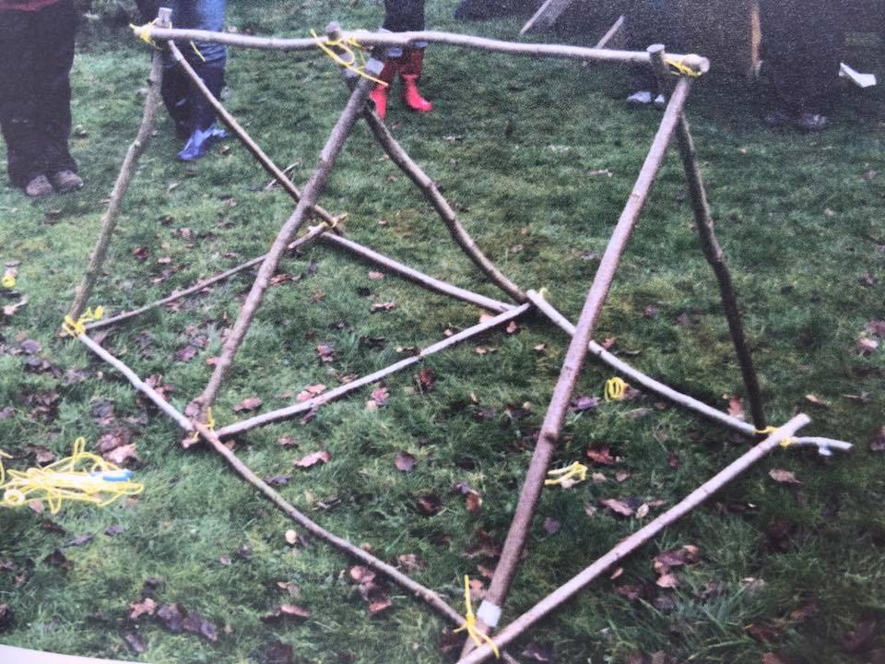

Child A would work with a more able peer, as Vygotsky (1978) researched when children work with a more able peer it pushes their learning at a comfortable level. As Moyles (2010) suggests by playing and undertaking activities outdoors it develops their confidence to take risks and self-belief. Due to Childs A’s nature of spitting it could be helped by using the outdoor environment as Dyments (2018) research has found, learning in the outdoor environment promotes calming characteristics.

Literacy
Child As next steps for literacy based on outcome 3 are:

Reading
Child A needs to recognise that words are constructed from phonemes and these are represented by graphemes. She needs to begin to read some familiar, simple words using strategies with support and show awareness of simple punctuation.
In the Summer term the children begin taking reading books home, this will promote parental involvement, as Child A and her Mother can begin to share her learning together. Flashcards would be taken home and could be used for a phonics hunt.
Games could be played outdoors for Child A to begin to recognise high frequency words (Appendix T).

Oracy
Child As next steps are to demonstrate that she has listened to others and that she can understand three-step instructions and basic concepts. **Partner taking turns beebot DCF
Child A struggles to listen to others as Jalongo (2007, cited in Grigg, 2015) argues listening is the least taught language skill in school but it is the most prevalent in life. Grigg (2015) extends this thinking further by saying that by modelling listening as a teacher and not rushing children it can make a notable difference.

Writing
The next steps for Child A are to begin to form letters and simple words. As previously mentioned it is important that children’s fine motor skills are developed enough to begin handwriting. Words could then be explored by making them out of sticks and writing them in shaving foam.
It is important for mark making opportunities to be available in all of the areas in the classrooms. By mark making it ensures that children’s confidence is built as they can try writing without making mistakes. An idea which was given to Child A’s Mother was when they go shopping together for Child A to write a shopping list by mark making. This encourages engagement between the parent and child (Webster Stratton, 2011).

Personal and social

To begin to work towards outcome 2 Child A needs to begin to share toys and materials and take turns. She also needs to recognise her own feelings and the feelings of other children.
Brown (2006, cited in Moyles, 2010) states that in play children learn to control their feelings and understand themselves. Fabian (2008, cited in Moyles, 2010) affirms this by describing play as a means to engage children with their peers enabling them to develop relationships with them, especially those children who are socially deprived as they can find it more difficult to build those relationships.
Child A has already shown that she enjoys role play. Irrespective of theorists differing views on the contribution to child development, Freud, Piaget and Bruner (Pound, 2009) all stress the importance of socio- dramatic and fantasy play. Role play develops many things including children’s imagination, model’s language and increases vocabulary, supports social collaboration and encourages problem solving (Price, 2007). To begin to show Child A how to be a friend to others, sharing and taking turns activities could be set up within the role play area. Situations could be set up for her to see the feelings other children have when she behaves in an unacceptable way with others. By doing this in the role play area it would be in an un-threatening way (Moyles, 2010).

At present within the classroom children’s feelings are not discussed, as Hoyle (2018) argues children’s emotions impact their readiness and ability to learn, feeling safe is vital within the school environment. A child who does not feel emotionally safe, valued or listened to, may enter the classroom feeling frustrated, angry, distracted or withdrawn, particularly when attempting to learn a new concept. By discussing feelings daily during circle time, it could help Child A to combat those feelings and feel listened to.
Child A’s Mother is willing and interested to play a part in her child’s education and learning, according to the Welsh Government Family and Community Engagement Toolkit (2015), research has shown that at the age of 7 the degree to which families engage with their child’s learning has six times more influence over the child’s educational attainment than the quality of the school. Therefore, it is so important to build the parents confidence and engagement as early as possible. Dr Russell Grigg (2015) explains that one of the challenges in raising literacy and numeracy standards, particularly for pupils from low income families is securing parental engagement. He describes that parental engagement improves school attendance, increases motivation and improves grades.
Furthermore Vygotsky (1978) emphasises the importance of parental involvement saying that parents are partners in their childs life scaffolding them to problem solve which links in with Donaldson (2015).
The school is due to set up family engagement sessions called Faz which focuses on promoting healthy eating and physical activities. This will be beneficial to Child A as she enjoys physical activities and it will help to strengthen a bond between them (Goodhall, 2010).
To ensure a flow between communication between the home and school a home school book is going to be introduced.

Creative
Child A needs to begin to participate in more imaginative activities, she has already indicated that she enjoys role play, so it would be an idea to take imagination from role play and use it in creative dance.

Physical
To move Child A’s learning on she needs to develop her control and co-ordination and fine motor skills. These fine motor skills will help her with her literacy and writing her numbers so they are all interlinked. Child A needs to gain more opportunity to thread as she needed a lot of help when she was threading beads (Appendix U).

The next steps are all based on being in an ideal situation, unfortunately there are limitations. Based on research by the Welsh Government (2015) 79% of families want to be involved in their childs education, unfortunatley 21% do not feel that it is important. At present Child As parent does want to be involved but if she decided not to or if she was unable to attend the parental engagement session on a Friday afternoon then the sessions would not help Child A. Child A has a brother in a different school and therefore goes early every day this could affect her being part of the programme.
Child A thrives in the outdoor environment, at present there is a large outdoor area which is not used routinely and if it is raining the children stay inside. Waterproofs and wellies could be worn to ensure that the children can go outside in all weathers. When Child A moves to the next class there is not an established outdoor area therefore as an alternative solution outdoor natural materials could be brought inside. The class teacher could also ask for more time in the forest area and ask for parent helpers if staff ratios are low. It is important to continue out of class learning as literature points out it promotes children’s independence, confidence, assertiveness and decision making (Hattie et al, 1997 cited in Grigg et al, 2016).

Conclusion

By undertaking this research into a child’ s learning it has helped the reseacger to look in depth at the outcomes for the Foundation phase and how big some of the steps are between them. For example between outcome two and three in Maths children need to be able to write numbers up to ten, which for some children can be very difficult as they are just not ready to begin writing but are advanced in more practical situations.
Looking at what children are interested in has helped mthe researcger to see that children learn best in different areas, how one child learns best is not necessarily how another child learns. Child A learning evidenced a notable difference in her learning outdoors compared to indoors.
The researcher belives if there had been a arger time scsale to complete the study, then more observatioons could have been obtained allowing a positive impact on her future education and behaviour.
Finally in the future the researcher would like to conduct the study again to observe the impact the next steps have made. It is also important to listen to a childs views to build on any observation allowing successful planning.

References
Arthur J, Grainger T, Wray D. (2006). Learning to teach in the primary school. London: Routledge.
British Educational Research Association (2011). Ethical guidelines for educational research. London. BERA
Clark, A. Kjorholt, A. Moss, P. (2010). Beyond listening. Children’s perspectives on Early childhood services. Policy Press: USA.
Clark, A. (2011). Listening to children. Sage: London
Cowie, H. Huser, C. Myers, C. (2014). The use of participatory Methods in researching the experiences of children and young people. [Online] https://hrcak.hr/file/185021 cited on [1st May 2018].
Devereaux, J and Miller, L, (2003). Working with Children in the Early Years. Oxon: David Fulton Publishers.

Donaldson, G. (2015.) Successful futures. Independent Review of the Curriculum and Assessment Arrangements in Wales.

Dyment, J. Chick, H. Walker, C. Macqueen, T. (2018). Pedagogical content knowledge and the teaching of outdoor education [Online] https://doi.org/10.1080/14729679.2018.1451756 [Accessed 3rd May 2018].

Eckersley-Robertson, S. (2017) Measurements of wellbeing. [Online]
https://www.researchgate.net/publication/281976843_The_four_approaches_to_measuring_wellbeing. [Accessed on 30th April 2018].

Estyn (2016). An inspiring learning environment for delivering Foundation Phase education. Cardiff: Estyn.

Goodhall, J, Vorhaus, J. (2010). Review of best practice in parental involvement. Department for Education.

Grigg, R. (2015). 2nd Edition. Becoming an Outstanding Primary School Teacher. Oxon: Routledge Taylor and Frances Group.

Grigg, R and Lewis, H. (2016). a to Z of learning outside of the classroom. London: Bloomsbury

Hattie, J. (2012). Visible learning for teachers, Maximizing impact on learning. Oxon: Routledge.
Hayes, D. (2008). 4th Ed. Foundations of Primary teaching. Routledge; London.

Haylock, D. (2014). 5th Ed. Mathematics explained for primary teachers. Sage: London.

Hoyle, T. (2018). Circle time – create academic environments where academic excellence thrives. [Online] Available at http://theresehoyle.com/circle-time/ . [Accessed on 1st May 2018].

Meadows, S. & Cashdan, A. (1988). Helping children learn: contributions to a cognitive curriculum.

Moyles, J. (2010). The excellence of play. Open University Press: Glasgow.

Nottingham, J. (2013). Encouraging learning. David Fulton: London.

Pound, L. (2009). How children learn: Contemporary thinking and theorists. Luton: Andrews UK Ltd.
Price, H. Nursery World magazine: Role play in the foundation phase. 18th April 2007. pp. 36.
Robson, S. (2006) Developing thinking and understanding n young children: an introduction for students. London: Routledge.

Simpson, M. Tuson, J. (2003). Using observations in small scale research. SRCE: Glasgow.

United Nations Convention on the Rights of the child. (1989) [Online] Available at htps://downloads.unicef.org.uk/wp-content/uploads/2010/05/UNCRC_summary-1.pdf [Accessed on 1st May 2018].

Webster-Stratton, C. Reid, J. (2010). A school partnership: Addressing multiple risk factors to improve school readiness and prevent conduct problems. Seattle: The incredible years.

Welsh government (2015). FaCE the challenge together: Family and community engagement toolkit for schools in Wales.

Appendix A
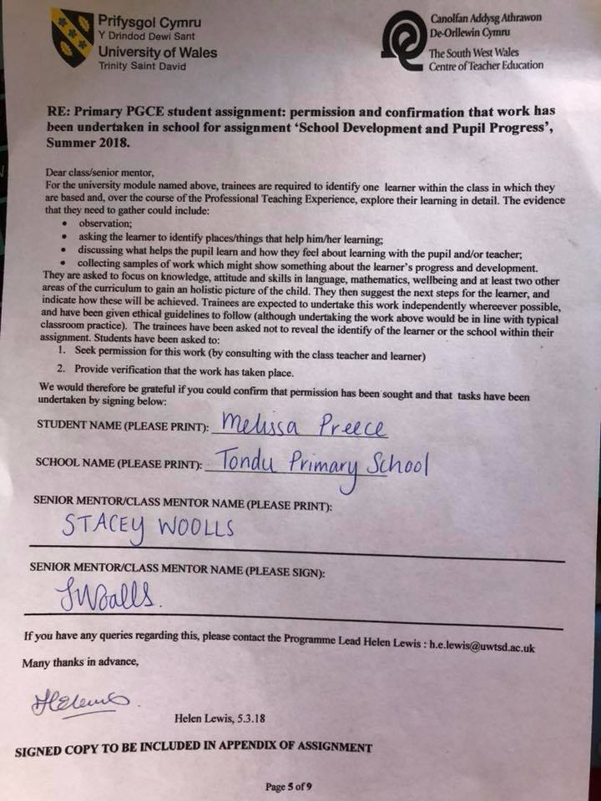

Appendix B
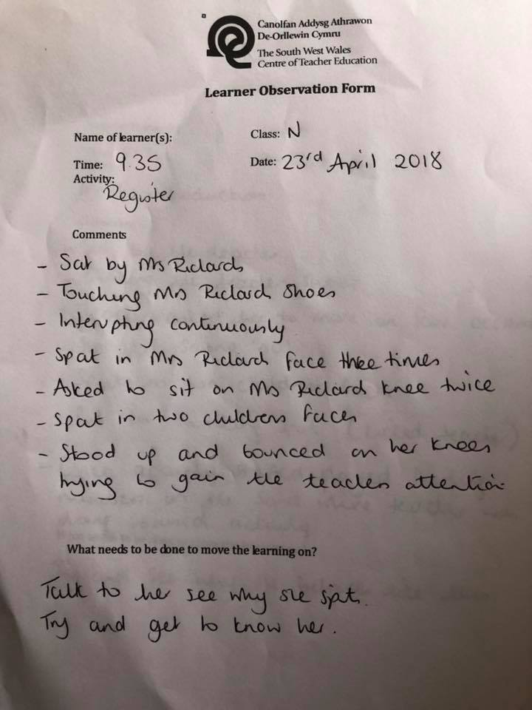

Appendix C
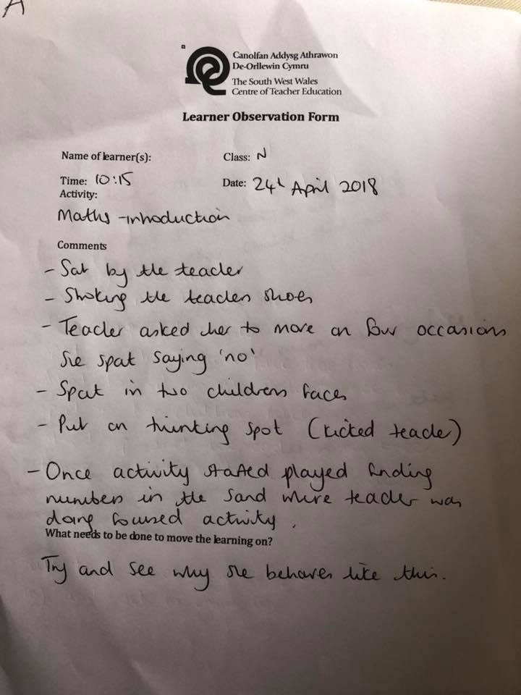

Appendix D

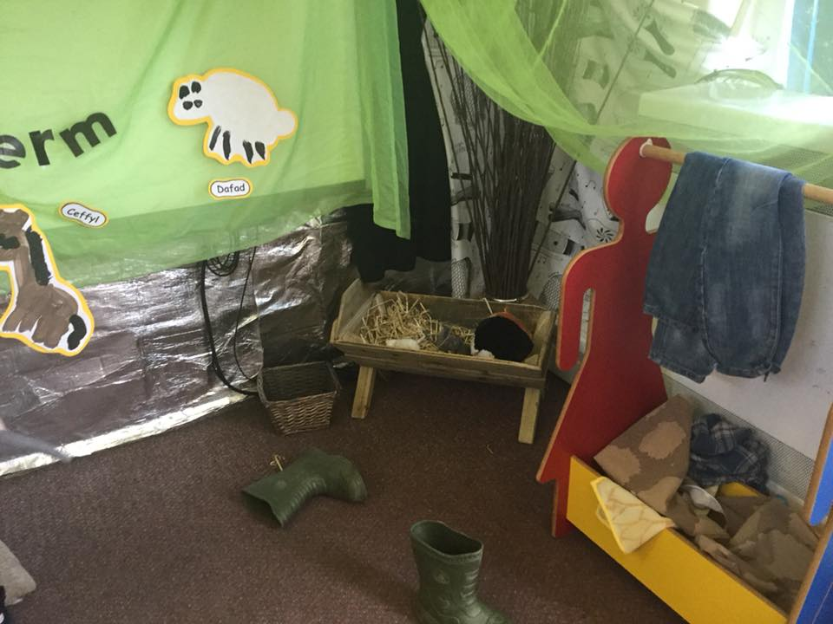

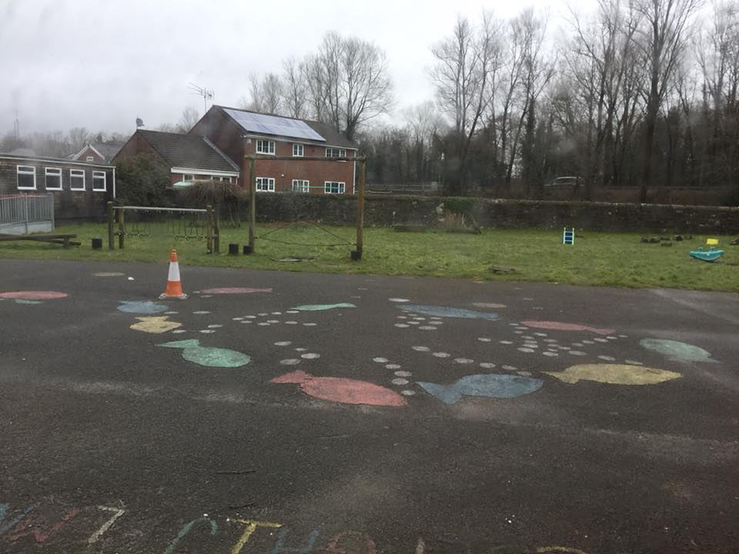
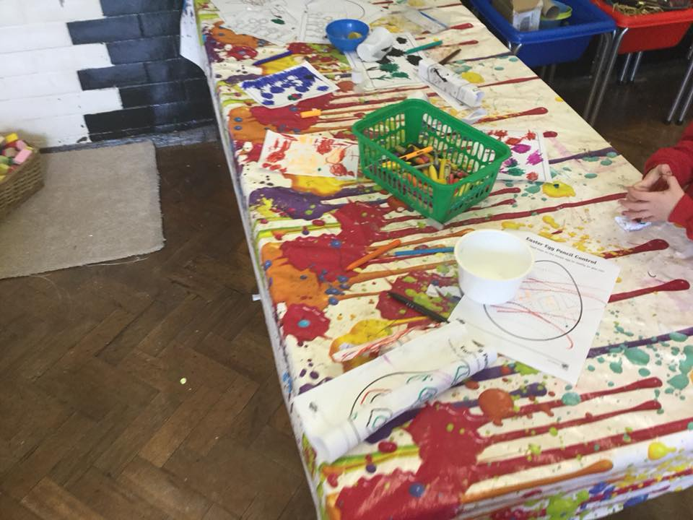

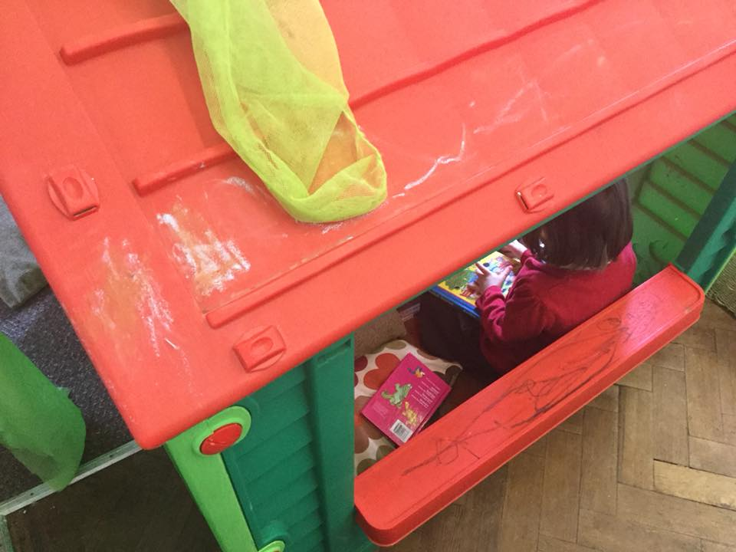

Appendix E
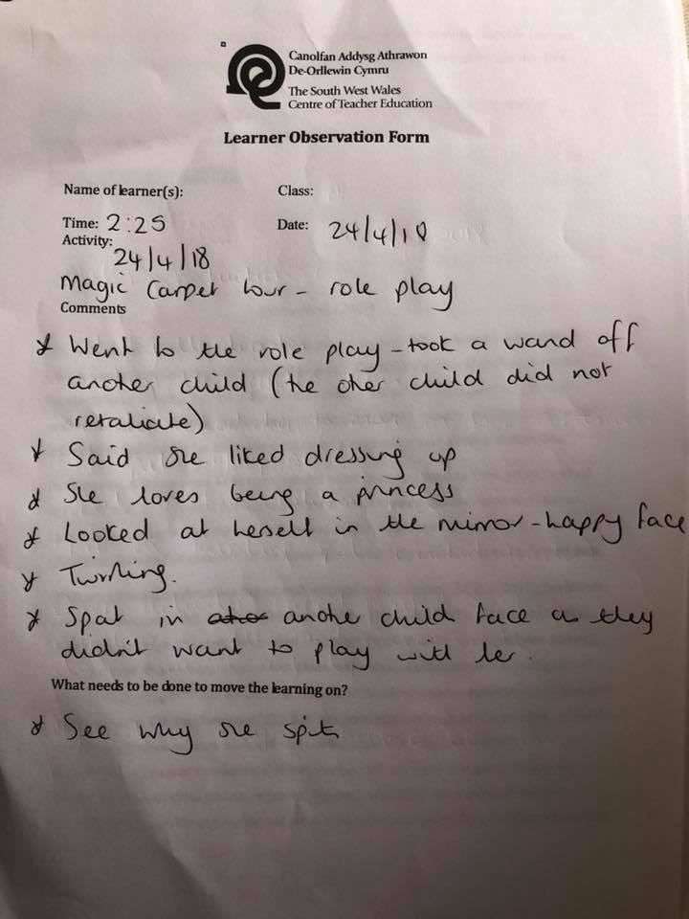

Appendix F
Maths
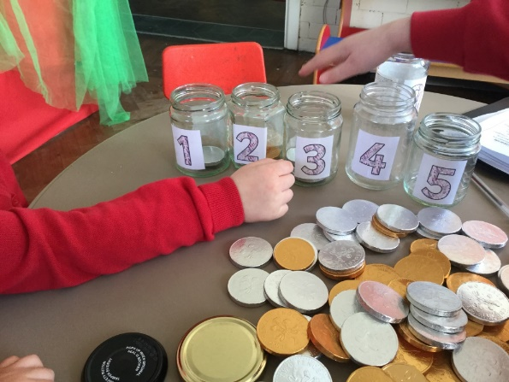
Child A was able to one more and one less.
The jars went to 10 and Child A used 1-1 principle to count out ten gold coins.
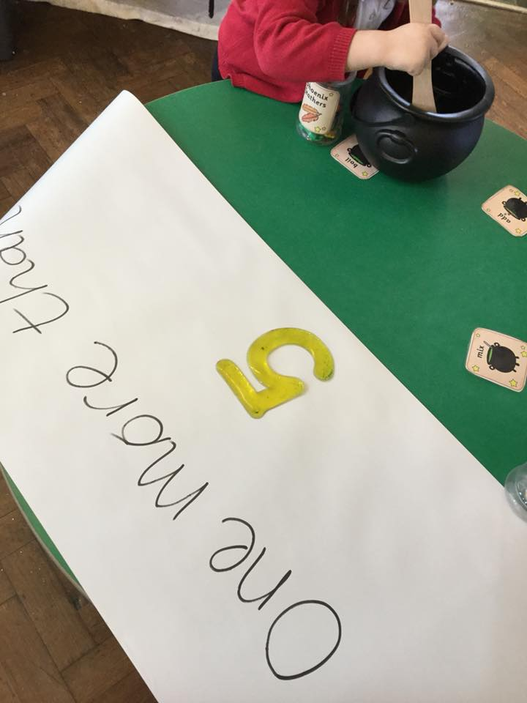
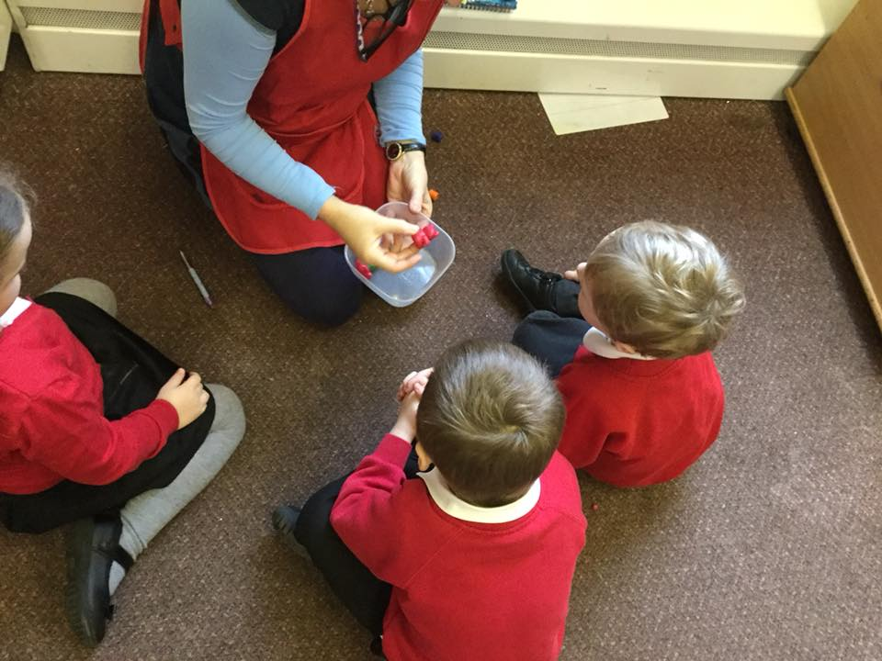
Child A was able to make an estimate of how many teddy bears were in the pot.

Appendix G
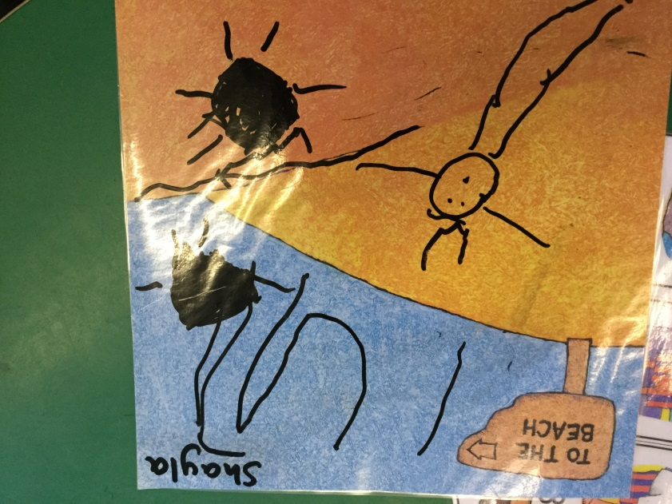
Numbers 1,2,3

Appendix H
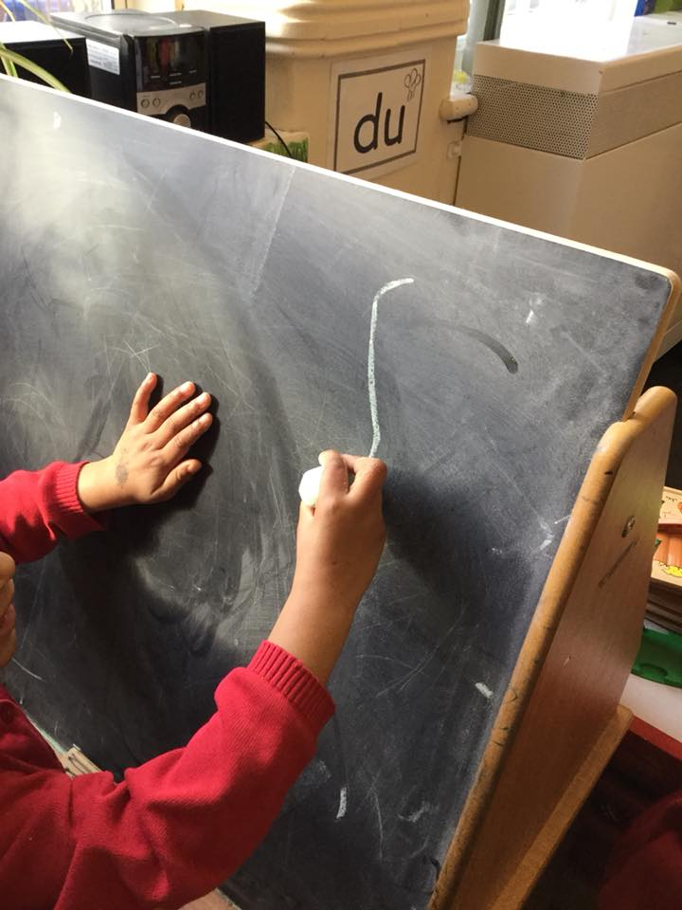
Number 3

Appendix I
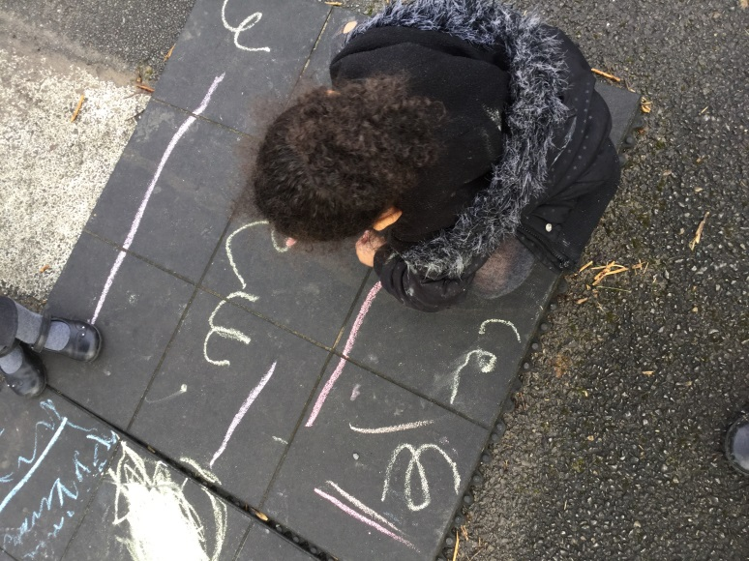
Numbers 1,2,3 – clear formation.

Appendix J
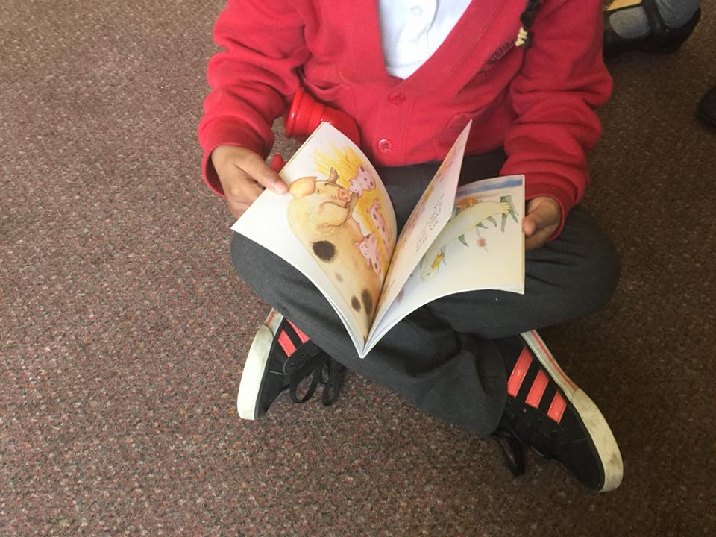

Appendix K

Language, literacy and communication
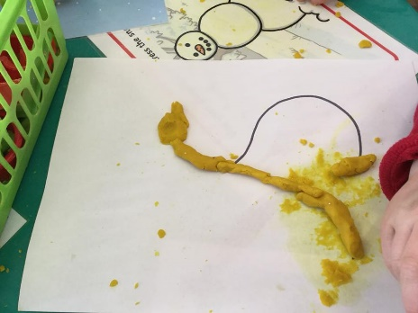
Exploring graphemes

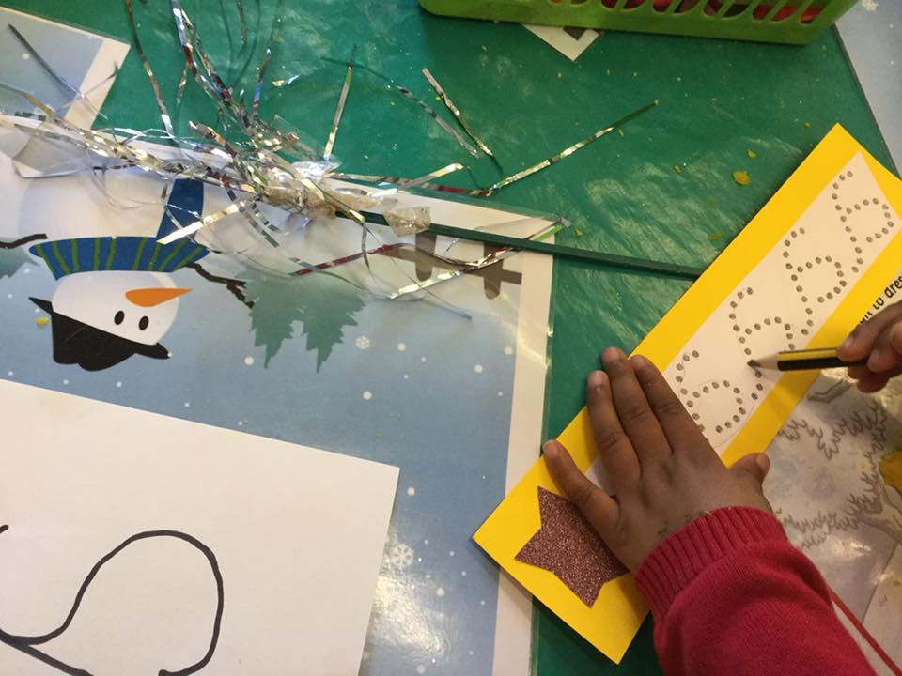
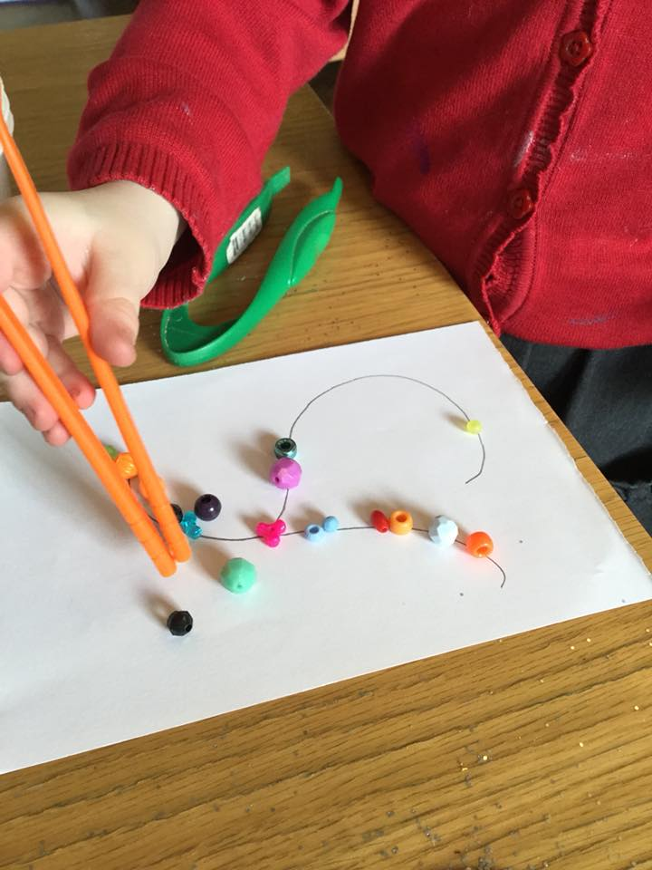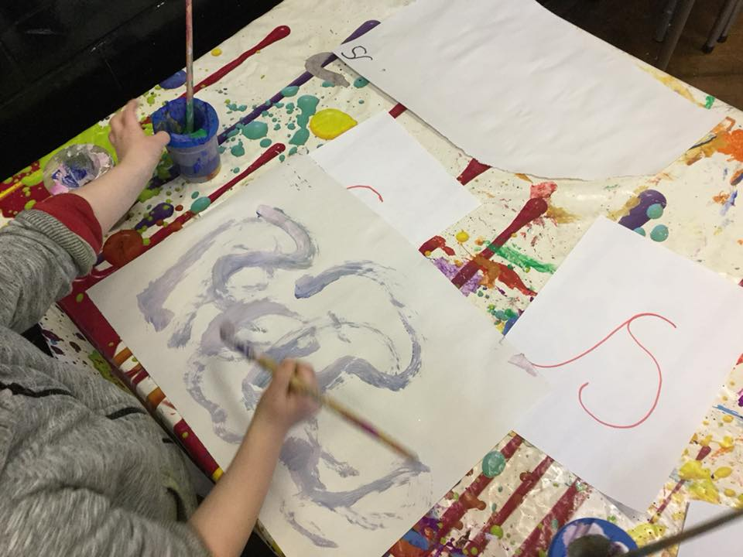
Appendix L

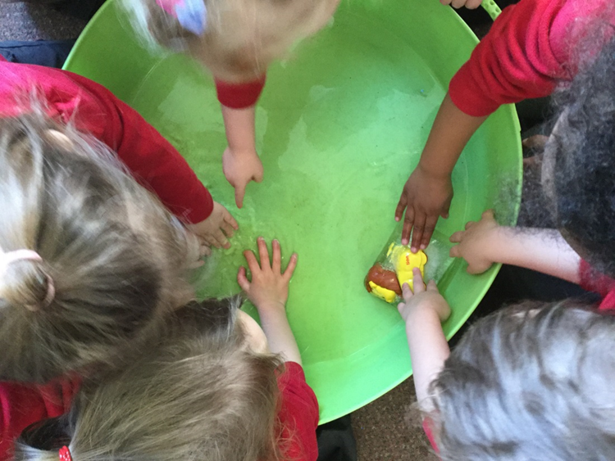
Sharing, exploring, communicating ideas and listening to others.

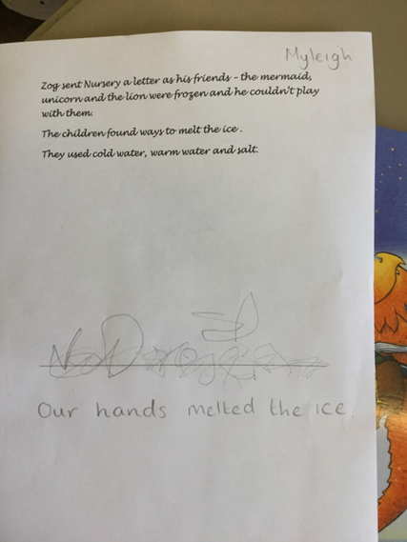
Appendix M
Emergent writing discussed the experiment.

Appendix N

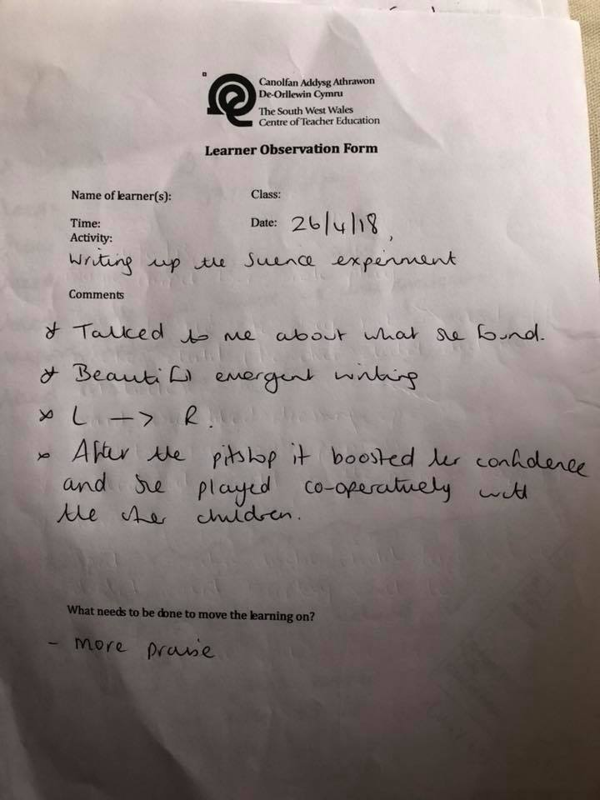

Appendix O

Interview taken on 8th May at 4:15 at Child As house
Mums comment-
- A and her brother argue a lot mainly over the TV.
- A keeps trying to go out of the flat (2nd floor).
- Asked what she was like in school.
- Asked if we can advise on any strategies to improve her behaviour.
- Asked if she has any friends in school.

Observation on A while we are at the house
- Keeps getting toys from behind the sofa and throwing them.
- Argued a lot with her brother over the TV
- Guarded the door so we didn’t leave.
- Showed us photos of her family and her favourite teddy which she had when she was born.

Appendix P

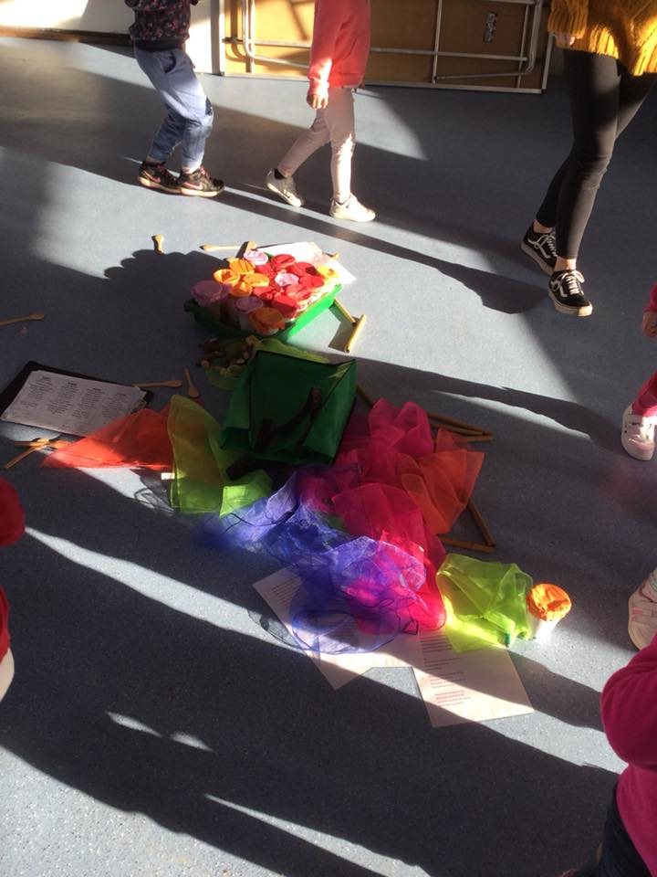
Ready steady music which combines creativity, music and physical activities.

Appendix Q
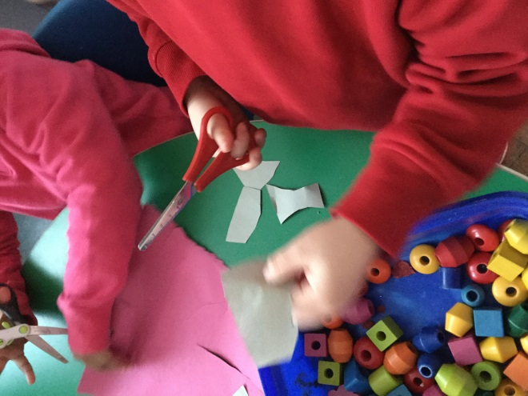

Appendix R

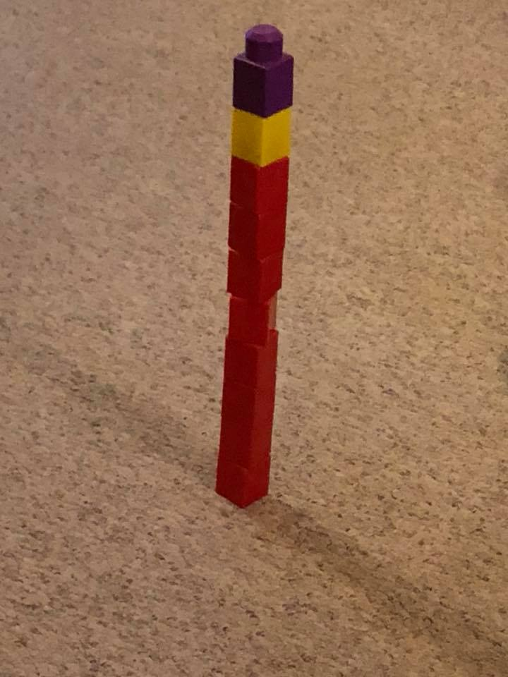
Independently built a tower of ten blocks.

Appendix S
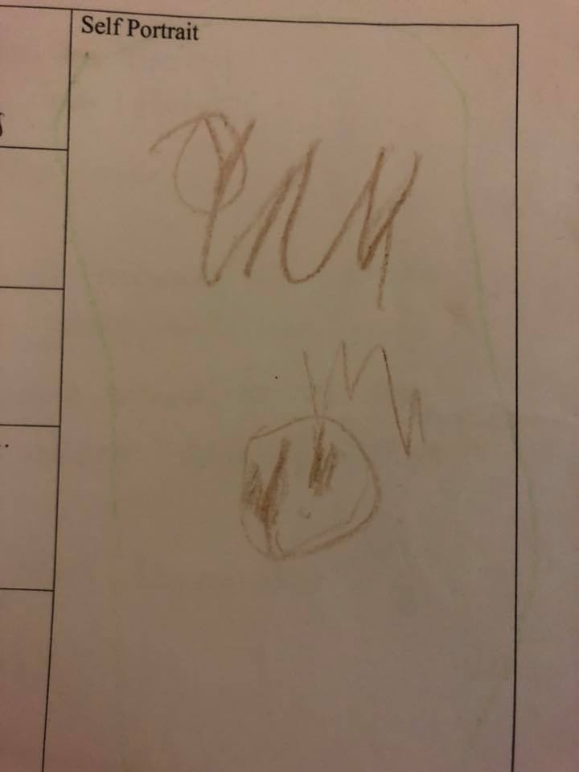

Appendix T
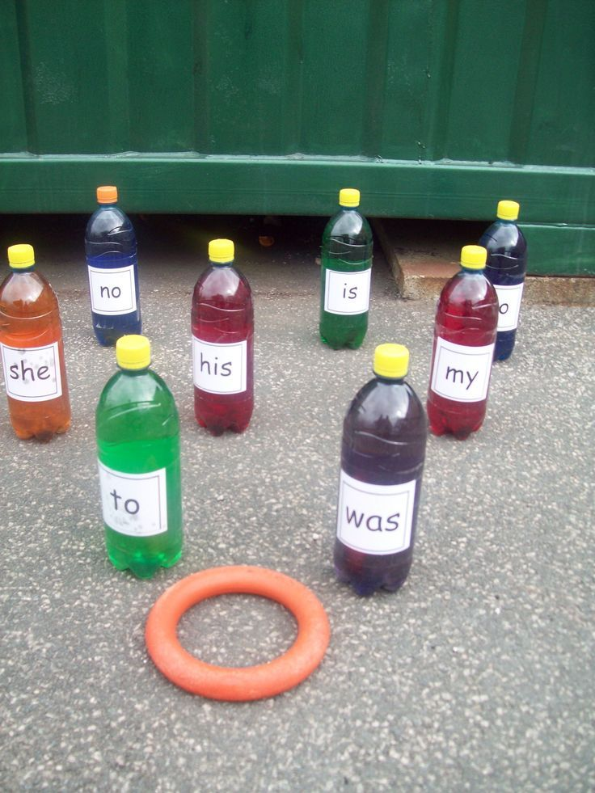

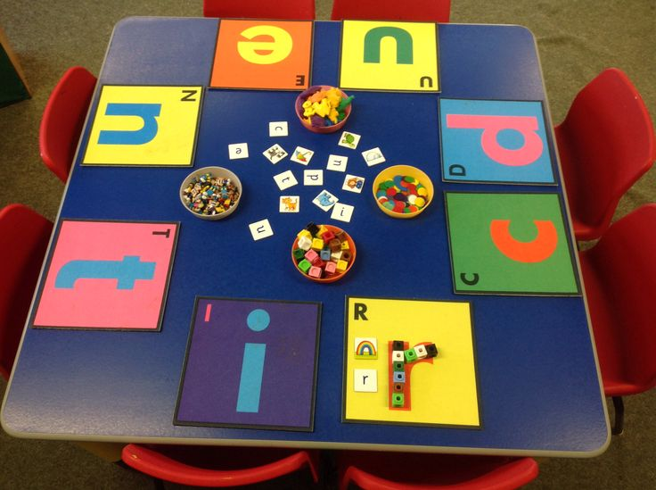
This would also enhance fine motor skills by using the tweezers.
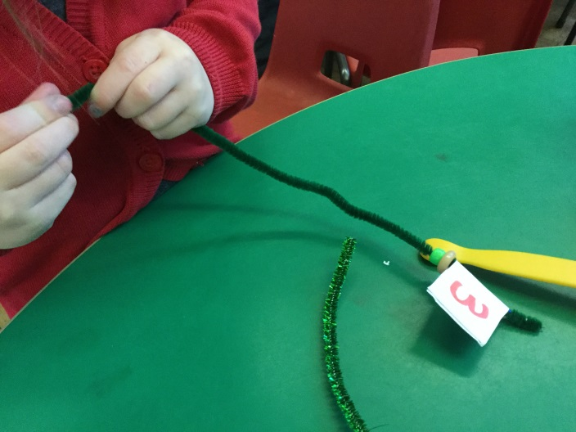
Appendix U
Child A struggled and needed a lot of help to thread the beads on the pipe cleaner.

