Research Methods & Data analysis
Assignment 1: Data Analysis
Module Number: M7X01702
Lecturer: Dr Mabrouka Abuhmida
Author: Simon Thomas P146671

Table of Contents
Table of Figures 1
Introduction 2
University Survey 3
Hypothesis 3
Counter Hypothesis 4
Data Statistics 4
Frequency Distribution 5
Central Tendency and Percentiles 6
The Normal Curve and Standard Deviation 8
t Test 10
Conclusion 11
References 11
Appendices 12
ANOVA 12

Table of Figures
Figure1 ……………………………………………………………………………………………………………………………………………. 3
Figure2 ……………………………………………………………………………………………………………………………………………. 4
Figure3 ……………………………………………………………………………………………………………………………………………. 5
Figure4 ……………………………………………………………………………………………………………………………………………. 6
Figure5 ……………………………………………………………………………………………………………………………………………. 7
Figure6 ……………………………………………………………………………………………………………………………………………. 7
Figure7 ……………………………………………………………………………………………………………………………………………. 8
Figure8 ……………………………………………………………………………………………………………………………………………. 8
Figure9 ……………………………………………………………………………………………………………………………………………. 9
Figure10.………………………………………………………………………………………………………………………………………….. 9
Figure11.………………………………………………………………………………………………………………………………………… 10
Figure12.………………………………………………………………………………………………………………………………………… 10
Figure13.………………………………………………………………………………………………………………………………………… 11
Figure14.………………………………………………………………………………………………………………………………………… 12
Figure15.………………………………………………………………………………………………………………………………………… 12
Figure16.………………………………………………………………………………………………………………………………………… 13

Introduction
Data analysis is a variety of mathematical formulas used to apply a statistical technique to illustrate and evaluate data, this technique is widely used in the fields of business and economics. But these techniques can be used in any field of industry that create or rely on some form of data, based on the data collected the analysis can be used to evaluate hypotheses set by a person or a group of people looking in to said data. Typically, the data that is used in analysis are classified as either Qualitive or Quantitative data.
Qualitative data can be represented in a verbal or narrative format, these representations can be collected through a number of ways. Some ways this data can be collected include interviews, focus groups and any open-ended question or situation that could be seen as a less structured form of collecting data. An example that most people will come across of this are people typically seen on city centre high streets asking questions to random people that walk past them and are willing to spare some time answering the person. Simply putting it Qualitative data is any data collected in the form of words[1].
The other, Quantitative data is basically a form of data that is expressed in numerical terms, these numeric values could be either large or small. Numerical values can and are usually corresponding with a specific category or identifier[1]. As this data is the collection of number values there are several ways to gather numerical information such as survey data, scientific data and corporate data[2].
With the extent of how data is used in all fields of the industry a common terminology or keyword being used is Big Data, this terminology is what should come to the minds of industry personnel when data analysis is mentioned. The definition by Garner can be seen to be that Big Data is data that contains a great variety of data types, at a collation rate that seems too high and increasing volume and finally at a velocity that exceeds the volume[3]. Though this report does not cover Big Data it is being mention as it is the area where data analysis is producing the most benefit. Which is evident by the technology companies such as IBM who create systems specifically for analysing huge collections of data[4].
For this report the author has been asked to look at a survey that was conducted to examine the differences perceived by mature and young students in the terms of their satisfaction experienced during their time at university. For this trial study ten students from each age range, so twenty in total were given a survey to fill out[5]. This data was collected and provided to the author in a simple format, which will be covered in more detail in a following section. With this data it is to be determined if there are any significant differences between the two groups, this will be done by means of statistics and data analysis using a strategy based on a hypothesis seen by the first observation of the data[5]. This report will be completed by looking at the results of the data analysis and concluding with how the results compare to the hypotheses.

University Survey
The information that will be analysis using data statistics is a research study performed on university students, there was a total of twenty students divided in half based on whether they were classed as a mature aged between 45 – 62 or younger student aged between 17 and 20. These students were enrolled to complete a satisfactory test based upon their experience of university, this test was graded between 0 to 60.
High scores indicated a high level of satisfaction experience and low scores meant low level of satisfaction, the output of this survey was provided in a table format with two columns for the mature and young students and each row showing a score given by students[5]. The table can be seen below (Figure1).
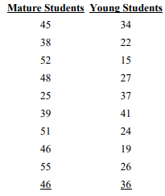
Figure1: University Student Survey Results[5].
From the first look at the information shown by the university survey, it can be taken that the information from the surveys are graded and represented as a numerical value as stated before this can be classified as Quantitative data. Also, from a first understanding of the data it can be viewed that the information has been collected and hasn’t been structured or layout in anyway to provide the reader with any form of understanding or conclusion of what factors the data represents.
Though the author has been asked to identify any significant differences with these two groups of students a number of issues can be seen already, it has already been stated that the data has been presented in a raw form where no data strategy or analysists have been taken prior. Another factor that can be seen is the data group could be considered too small for some data analysis formulas, though the data can still be calculated its outcome could be insignificant too small to want to make any note of it. This problem could have been overcome by adding an additional group for the middle age range or even expanding the existing age ranges and increasing the groups sizes for each the mature and young students. Lastly this comparison is being pursued based on the numbers from the survey being guaranteed honest and truthfully by each student, so going on the hypotheses for this group that factor will be consider as well.

Hypothesis
The hypothesis for this data represents by this survey is that the Mature students show a higher level of satisfaction with the experiences at university, more so than younger students. It is believed at this point that mature students will have increased satisfaction due to having more life experience and at this point have a better understanding on current events.
It is seen that the mature student has a better understanding on how to act and behave at an establishment much like a university. It’s also believed that the mature student has higher motivation to make the most of the experience to achieve this education to ensure healthier living most likely to pursue a better career. This is considered through the author being considered a mature student and the university they are currently studying at.

Counter Hypothesis
A counter hypothesis can be made that both the mature and young group of students were satisfied with their experience in university. This is based on a first glance basis that the number of surveys that score in the lowest third of the satisfaction range in two out of the twenty students. This would make anyone believe that all the students were satisfied, that being the case that all the surveys were fill out honestly and that the reason for these low scores are unknown to us and could be factors outside the university’s control.

Data Statistics
For the data analysis these will be undertaken using a number of statistic formulas, they will range from frequency distributions to inferential statistics. These formulas will be executed on excel, this is seen as the best form of practice due to the lack of experience within this field of study. While there is an understanding of the formulas used for these statistical outcome values, excel has the capability to calculate these formulas with minor understating.
To better view the data for the following analysis the data was organised by numerical value as seen in the figure below lowest to highest for each group. This was done to provide an improved comparison from a first glance, this change shows the lowest values were from the younger students.
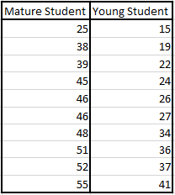
Figure2: Organised University Student Survey Results.
The start of this data analysis will look in to the basics of statistics, this will be done to cover terminology before the provided data is analysed. The factors that will be noted include a brief explanation of variables and scales of measurements.
When data is gathered it can be characterised in numerous ways for example when looking at a person and asked to collect data on their characteristics, it is natural for one person to notice some feature such as height and weight. But others could take notice of all feature including height, weight, hair colour and eye colour, there are also those who would go to different collecting data based on intelligence, personality and interests[6]. Within statistics characteristics that can be perceived as different are called Variables, these Variables can be assigned to be either Discrete which can take on the value of whole numbers or Continuous which are able to take on any value such as height and weight mentioned previously[6]. In fields of research Variables can be categorised into being independent, which is a variable that can be manipulated to determine its effect on other variable and there is dependent which is the concentration of statistical analysis do to variables being measured in response to manipulation to the prior category[7]. So, when it comes to the case of the student groups the variables each of their numeral value, the range of these values and the groups themselves one being made of mature students and the other young students.
To understand the points going forward further measurement need to be understood, not simple the term but how it refers to the assignment of numbers to characteristics on things people views can differ this being variable[6]. The scales of measurement are summarised under four types, Nominal in which the numbers serve as a label over just being a value. Ordinal which is a scaling that is used for terms of values that include greater than or less than without requiring any interval to the values and could be used for defining the mode, median and percentage of variable[6], [8]. Interval which is the scale of measurement using a defined interval or degree of difference and whos’ start point isn’t necessary at the value of zero. This as well as Ordinal will be used through the data analysis of the student survey, the last scale is Ratio which is the opposite in the fact that it measures in equal intervals and has to have an origin point of zero[6], [8].

Frequency Distribution
As shown previously in Figure1 the provided data is in a random sequence there is no order to how they have been presented, frequency distribution is a first step to creating a way the data can be examined. The way this is usually done is that the data is summarized in a table format to show how often a value was obtained, due to the value range of the survey and to provide more detail a grouped frequency distribution will be done using set intervals[9].
As the number value cover a wide range of 15 to 55 Grouped Frequency Disruptions is being used to organise the data for the two groups of students, typically to determine the range of the table the lowest score from the group will be subtracted from the highest and this would give the interval value. For the intervals of the table it is stated that common practise should be to have a width to allow for ten to twenty intervals, due to the low amount of data for this report and to help provide better analysis later on there will be less than ten intervals[6].
For the mature students there are six intervals each equalling a width of six, each value was then matched to a score range and checked off. Once every score was checked they were tallied up to give the frequency for that range. What can be taken from this table (Figure3) is that most of the checks and higher value of frequency is after the range of 43-48, seeing as the maximum value is 60 this supports the hypotheses that mature students had a more satisfied experience.
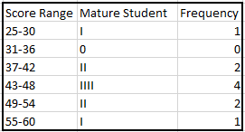
Figure3: Frequency Distribution Table Mature Students.

The younger student table also used a width of six for the intervals but to a smaller range of values, 5 intervals were used to create the grouped frequency. Going by the table below (Figure4) for the younger students, the data that can be observed is that the scores were more spread than the mature students covering both low and high values.
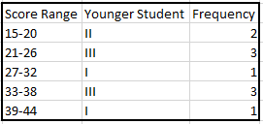
Figure4: Frequency Distribution Table Younger Students.

Central Tendency and Percentiles
Measures of Central Tendency is used to calculate an average or distinctive score that can be used to define the level of a group of numeral values. Measures of central are most likely used when comparing the levels of performance between two or more groups of individual values, this makes it useful to understand the two groups of students. There are three forms of central tendency which include Mean, Mode and Median[10].
The most widely used central tendency is Mean also called average shown in the formula below, this is when all the values in a group are added together and then divided by the number of values in that group.
- $\overline{X}=\frac{\sum{X}}{N}$ Show in this formula X represents the total values, N represents to total number of values and $\overline{X}$ is used to show the mean in an incomplete formula[10], [11].
The median is the value that divides the frequency distribution in half, this is typically just seen as the middle score. This is due to the values of a group being organised from lowest to highest and to then select the middle value, if the group is made of an equal number the two middle numbers are added and then divided by two which then equals the median number. The Mode otherwise named the most common can simply be defined as the most reoccurring individual value within a group[10].
The last two central tendencies are Variance which is most commonly used measure of variability, as it is defined as the mean of the sum of the squares of the deviation values. Which formula looks quite complex as seen below but with the aid of Excel it is converted to a small line of code.
- ${SD}^{2}= \frac{\sum{{\left(X-\overline{X}\right)}^{2}}}{N-1}$ [10]
  - ∑ is the total sum.
  - X refers to obtained score.
  - $\overline{X}$ is the average of previous point.
  - N refers to the total number in a group.
The last is Standard Deviation this too being a common measure of variation used in data analysis which is the formula below, but if the variance has already been calculated then a simpler way to work this out is to take the square root of the variance[10].

- $SD=\sqrt{\overline{\frac{X}{N}} }$ [12]
  - $\overline{X}$ is the Mean.
  - N refers to the total number in a group.
The table below (Figure5) displays the central tendency for the group of mature and young students these calculations were completed on Excel using the formulas from this section, all of the values seen are useful at this time to identify any differences with the exception of standard deviation. As It is used in the calculation of other statistical mathematics including Quartiles, Percentiles and Normal Curve[10].
When observing the table it can be understood that the mature students have greater numbers when it comes to central tendencies though standard deviation isn’t used currently for analysis, mean and median and mode show large differences especially mean which differs by a value of 16.4 as well as median showing a difference of 19.5.
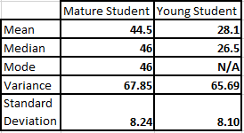
Figure5: Central Tendency Data for Student Survey.
Percentiles are a frequently used type of measurements in statistics, this is used as it is one of the easiest forms of values to comprehend. For example, a value that is at the 75th percentile of a group scored higher than an estimated 75% of the people in the normal groups, same is said for the 50th percentile scored higher than 50% of the group and so on. In the table below (Figure6) it shows the percentiles for the student groups, this has been separated in to particular values of percentiles to best understand the differences[13]. Also, quartiles can be seen in the table, as essentially quintile are worked out the same as percentiles but just in quarters them being 0, 1st equal to 25%, 2nd equal to 50%, 3rd equal to 75% and 4th equal to 100%. From the percentiles comparing the two groups it can be seen that the mature students have a greater percentile value for every score. In the next section of this report it will utilise percentiles to better visually show this outcome in an improved way.
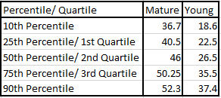
Figure6: Central Tendency Data for Student Survey.

The Normal Curve and Standard Deviation
The normal curve is a mathematical idealisation of symmetrical distribution, how this is worked out isn’t formed naturally. It is just that most objects that can be characterised approximate a normal curve, with the assistance of mathematics it can be used to better show an interpret test results. Seen in the example below (Figure7) a normal curve graph shows the data in the form of a bell curve, utilising the data from the graph and combining it with the formulas of standard deviation it can be used to show proportions or percentiles of values displayed[14], [15].
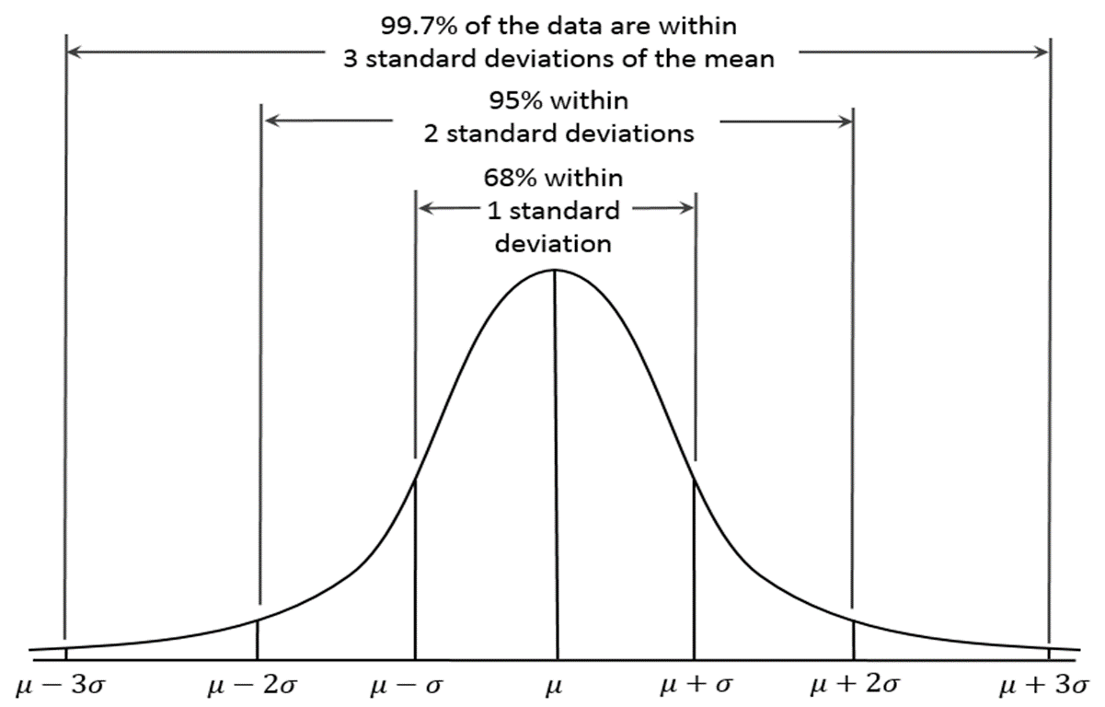
Figure7: Representation of a Normal Curve.
The graph beneath (Figure8) shows the normal curve for the mature students, utilising the frequency data provided by the tally table. Though compared to the example graph the bell curve for this data isn’t perfect but there is a similar shape to it, it does show a unimodal design. This meaning that the data is symmetrical from the highest point this being the point of mean, mode and median.
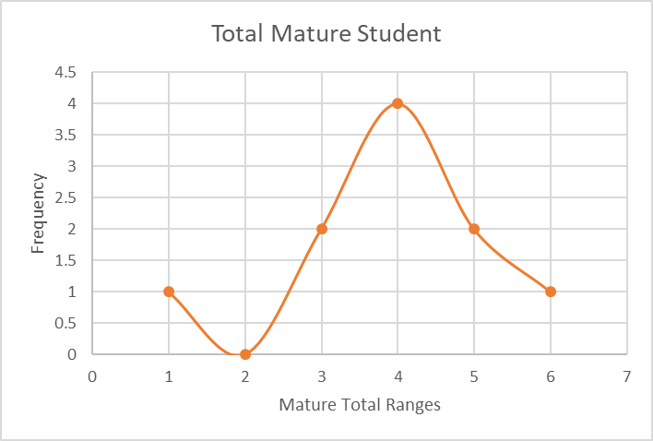
Figure8: Mature Student Normal Curve.

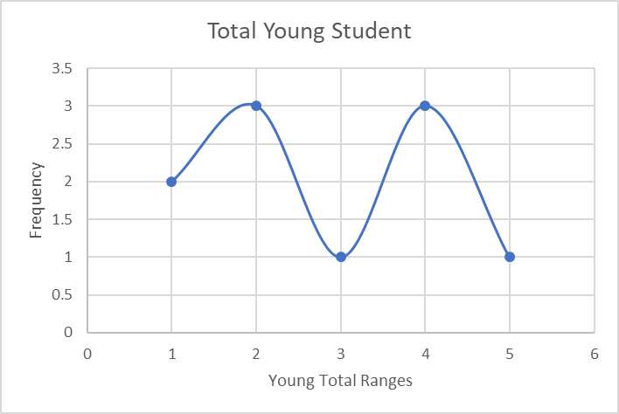
Figure9: Young Student Normal Curve.
The graph above shows its attempt at a normal curve which is doesn’t, the graph represents a more bimodal design. When trying to get a normal curve result for the young students group it proved to be quite impossible. Though it was later revealed that with a larger sample of data the likelihood of getting a normal curve would be greatly increased. Though from this graph it can be used to compare to the mature students and from these two things can be noted. First the scale of the frequency is lower and also that while the scores of the mature students steadily increase over the whole group, the younger groups shows a more variant attitude to the scores.
To give a better understanding of how normal curve and standard deviation are used together to represent proportion of a groups score compared to an individual contended in that group, the table below was created to show the levels of data for each standard of deviation in comparison to a normal curve seen at the beginning of this section. The table show that mature students have scores greater than that of younger students by a range of 10 to 24 points depending on standard deviation.
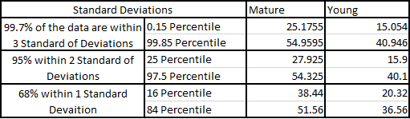
Figure10: Central Tendency Data for Student Survey.

t Test
The t Test is another commonly used statistic form of test, it has the main purpose of being used for two groups of values. This is to determine if the means of the two groups change when entered with scores with degrees of significant difference. Like all the statistics used in the report the t Test utilises mathematical formulas, the difference though is that these are quite complex to where excel is heavily recommended.
When it comes to this the ultimate goal is to show that during an investigation of two groups that their numeral value as well as the mean of the group is obtained not by chance. With this the research has some confidence identifying that the difference is not just a coincidence and there is a more in-depth reasoning as to why one group differs from the other[16].
When completing the t test for the data analysis the formulas used the statistical degree of Alpha(P) 0.01, 0.02 and 0.1. These were used to determine any changes between the tests, the only difference to note took place at the points of t Critical, noting that the lower the alpha the increased value to t Critical. It also shows that the mature students in this case being Variable 1, still contains a higher average.
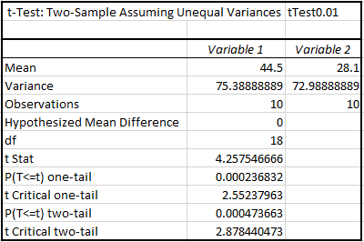
Figure11: t-Test Two Samples P=0.01.
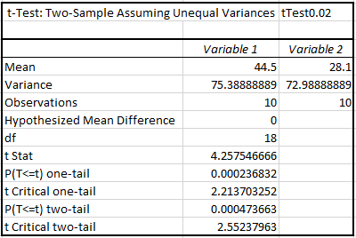
Figure12: t-Test Two Samples P=0.02.
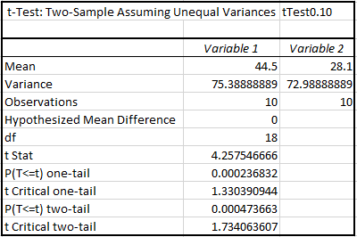
Figure13: t-Test Two Samples P=0.10.

Conclusion
To conclude, it can be seen with supported tests made throughout the report that the hypothesis discussed is true and resulting in no statistical errors, that the mature students have a higher satisfaction level than younger students. This can be evidenced for example the average for mature students was significantly higher than younger by a value of 16.4. Similar statements can be made for the variables in the t Test as well as the Normal Curve graph for mature students. With the fact that there were 10 students in each group a clear outcome for this higher value of statistics that mature students marked more satisfied experience for every student in the group. With the numerus formulas for statistics there were many more ways to show this conclusion, but due to the lack of understanding and limitation of the report they weren’t utilised an example being Analysis of Variance (ANOVA) test shown at the end of this report.

References
[1] M. & S. H. Start and T. A. Center, “Ways of Thinking About Data,” in Introduction to Data Analysis Handbook, 2006, pp. 5–10.
[2] S. Dillard, “What is Data Analysis?,” 2015. [Online]. Available: https://www.quora.com/What-is-data-analysis-1. [Accessed: 05-Jan-2019].
[3] Gartner, “What Is Big Data?,” Gartner IT Glossary. [Online]. Available: https://www.gartner.com/it-glossary/big-data/. [Accessed: 05-Jan-2019].
[4] IBM Analytics, “Big Data Analytics | IBM Analytics,” IBM. [Online]. Available: https://www.ibm.com/analytics/hadoop/big-data-analytics. [Accessed: 05-Jan-2019].
[5] M. Abuhmida, “Research Methods & Data Analysis,” 2018.
[6] J. H. Kranzler, “Frequency Distribution,” in Statistics for the Terrified, Fifth., Pearson, 2010, pp. 31–41.
[7] J. L. Phillips, “More of the Testing Hypotheses,” in How To Think About Statistics, W.H. Freeman and Company, 1999, p. 130.
[8] D. Siegle, “A Summary of Measurement Scales, Thier Characteristics, and Thier Statistical Implications,” Connecticut.
[9] S. Glen, “What is a Frequency Distribution Table?,” in The Practically Cheating Statistics Handbook, .
[10] J. H. Kranzler, “Descriptive Statistics,” in Statistics for the Terrified, Fifth., Pearson, 2010, pp. 42–55.
[11] M. Abuhmida, “Descriptive Statistics,” 2018.
[12] J. L. Phillips, “The Standard Deviation,” in How To Think About Statistics, Sixth., 1999, p. 39.
[13] I. Robertson, “Calculating Percentiles,” 2004.
[14] J. H. Kranzler, “The Normal Curve,” in Statistics for the Terrified, Pearson, 2010, pp. 56–61.
[15] “Definition of Normal Curve | Chegg.com,” Chegg. [Online]. Available: https://www.chegg.com/homework-help/definitions/normal-curve-31. [Accessed: 08-Jan-2019].
[16] D. Siegle, “t Test | Educational Research Basics.”

Appendices

ANOVA
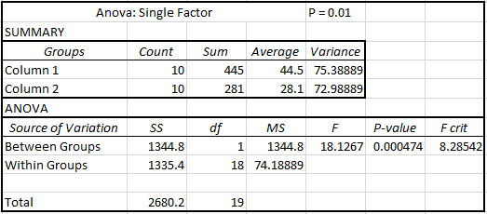
Figure14: Anova Test for Survey groups P= 0.01.
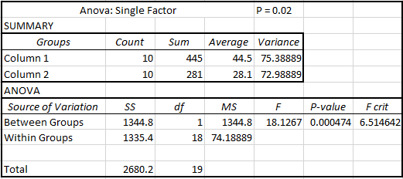
Figure15: Anova Test for Survey groups P= 0.02.
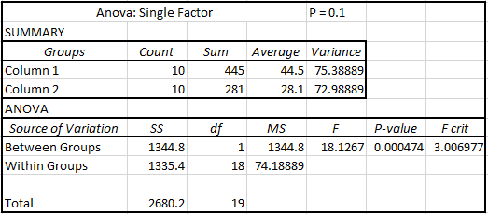
Figure16: Anova Test for Survey groups P= 0.1.

