wi

DIGITAL SKILLS AND RESEARCH METHODS
The Impact of Virtual Learning Environment

Research report
Giorgia Calamida
Student ID:2129212

Lecturer: Suneth Fernando

INTRODUCTION

“Secondary research”

A virtual learning environment “VLE” is a potential method to learn and teach.
Virtual environment can be defined as when students and teacher having a virtual Education but not sharing the same space.

This new habitat it creates new and amazing way to communicate with each other, a new concept for everybody to relate each other.
It is used for different kind of situations that it can be a virtual meeting, a virtual class etc etc.
This particular modern technology was introduced by Morton Heilig in the 1957, which is one of his famous multimedia device calls Sensorama is contemplate as the earliest VR system.

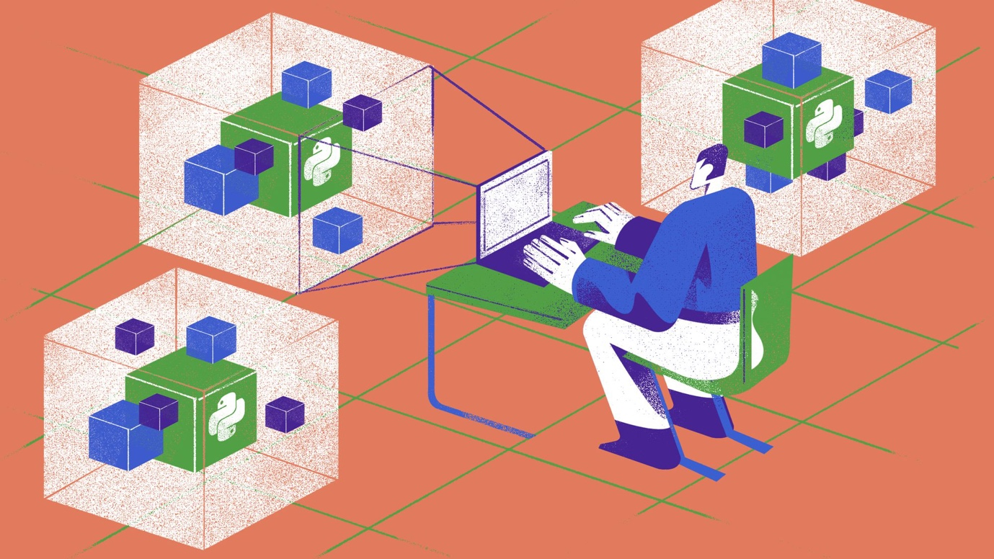

BACKGROUND

“Secondary Research”

At this point, virtual learning environment provides varies type of services. First the virtual education like language learning, musical instrument learning. Second one is the real time communication for instance live video conferencing or audio conferencing. Lastly, content management such as uploading homework’s, taking exams as online.

BENEFITS

People lives in a world which has a limited source. It also means human beings should use the remaining natural resources more carefully. Therefore, the amount of the energy that is used currently, needed to be decreased with new strategies.

Cost Saving
The benefits of virtual learning environment are able to use fewer paper by taking exams as online, saving the expenses of students

- More free time

Instead of wasting time on the public transport, students can spend their times more efficiently. Another point of view, with that way people can prevent the increase of the air pollution.

- Repeated access to course materials

By providing this, students will be able to scan all the literature for what they need, regardless of time and place.
- Flexible scheduling and testing
Teachers can create tests of all kinds and allow students to select their own schedules. Students can opt to take tests once they’re ready.
- Extensive data tracking:
The ability to keep track of learner data allows educators to assess the effectiveness of their courses and the learning ability of their students. Learners can track their grades and take proactive measures if their performance is below par.

CHALLENGES

In 2020 when the world faces this new COVID-19 Pandemic and no one obviously was ready to deal with this new environment, Students from all around the world were forced to stop they’re study in campus and to finish it from home.
This virus has changed many fields in our life, most particularly in the education.

More specifically I want to talk about this survey made in April from the College Reaction ( New York) that declares that 77% of more than 800 students perceived distance learning inferior comparing than in-person classes.

This is a list of the challenges they have undergone:

- Firstly Distraction, which is a reality in virtual classroom lessons, everything became an interference for our studies, and this depends perhaps entirely on self-motivation.
Therefore, Students needs to give a significant role to they’re tuition, especially how to manage they’re time that can became really challenging.
A solution for this obstacle can be really easy, for instance recognize a peaceful place absent from any distraction and set a schedule for any time you necessitate for study.

- Secondly Technical issues, unfortunately in a virtual environment this problem can cause a lot of stress and unfortunately, they are mostly not our fault.
One of these disputes can be the Connection to the WI-FI (too slow) the laptop suddenly shut down or the screen starting to not work anymore and all of this problems can cause really important impact to the lesson we are following.

- The final challenging situation are student left behind. It can be hard to recognize any funny situation during a virtual class. In a live environment teachers can give extra time to students facing difficulties but in the virtual environment in not visible all of this and in the mostly occasion students can just put the camera off or in serious situation leave the virtual class. All of this circumstances can cause frustration or a feeling of not having learned anything from the point of view of the student and obviously on the prospecting of the teacher not having given enough importance or not having realized the spot.

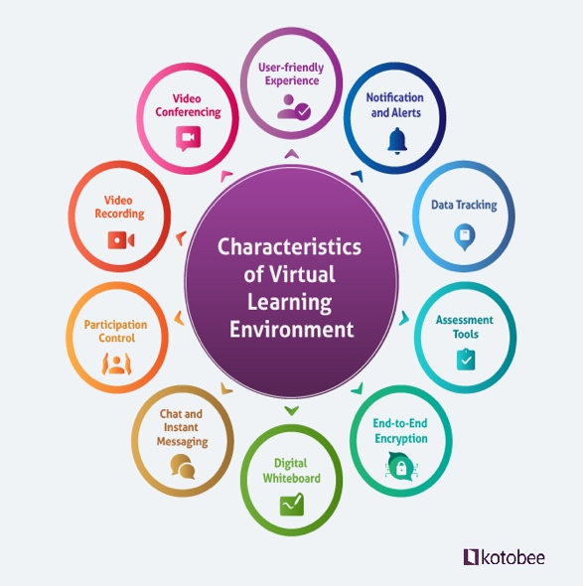
The technologies that are essential for a student to be part of a Virtual learning environment are undoubtedly an efficient laptop with a well connection to the internet, and that can manage a diversity type of different programs. This is not necessarily needed the urge to own the latest model of laptop, but perhaps being comfortable working with it without any slightest trouble.
For working in a VLE is recommended to have install in your laptop Microsoft Office 365 which will give you access to the most used programs in this sector such as Words, Excel, PowerPoint, Outlook, and OneNote.
To improve your listening to a lecture it will be relevant the support of a set of earphones for understand better and clearly our lessons.
The fact we are using computer obviously most of the notes we are taking will be on our laptop, but it is not insignificant to have always items such as pencil, highlighters or a simple notebook close to us, this depends also on the class we are taking.

The risk we can face using all these technologies are a couple, for example,if the laptop turns off or we have not a stronger connection to the Wi-Fi. Those are risk that can be related to the VLE and unfortunately there is nothing we can do apart work on it as I said before, have a good laptop handy and make sure it is everything ready for the class we are going to follow.

There is a list witht some of the opportunities regarding this sector indicated below:
- Flexible learning according to availability and preferences
- The best of both worlds. Learners enjoy an interesting and varied experience, both online and onsite
- Seamless interaction for everyone, with learners are able to participate in the same polls and use the same whiteboard



AIMS AND OBJECTIVES OF THIS RESEARCH

Since the start of the COVID-19 Pandemic all around the world has incorporated Virtual Learning Environment in their degree programmers.
Most of the universities understandably scrambled to be able to offer all their course content online.
Afterward universities and students alike have worked to a way out to enjoy more the virtual learning and to make it more efficient. However, innumerable students have returned to their courses in person this academic year, using the virtual learning only when it necessary.
From this point of view online learning has beyond any doubts left an impact on higher education in the UK. Various studies have understood how exactly the learning environment and outcomes have changed.
In the UK a Survey for National Statistics conducted by the Student Covid Insights Survey has made to help understand how online learning affects students’ experiences are. In 2020, the results of these statistics found out that around 50% of all the UK students had at least six hours of online learning per week.
The majority of students in 2020 reveal no in-person teaching, ironically.
In December of 2020, it was announced that university learning in the UK would be online going forward, a decision that led to 22% of students not returning to their university accommodation for the rest of the academic year.
In terms of satisfaction related to online learning in the UK, the numbers are varied. While almost 50% of undergraduates is being self-satisfied with their academic experience in general, 29% were dissatisfied or not happy at all, mostly on account of the quality and format of the education.
There are different methods for improve our Learning Environment, for instance having more feedback.
Feedback is the great way to connect with learners, facilitate online training and to set learning efforts in the right direction. Feedback is vital for learners as it helps them in tracking their progress and in changing their learning strategy accordingly. It also helps them recognize their weak areas while improving the developed skills.

Another aspect that can be improve is encouraging group activities. Introduction of non-competitive games and activities break down the cliques within a learning environment. This also assists the new and shy students to have a sense of belonging.
These fun activities make learners interested in attending the class and help them learn and progress in a friendlier environment.

METHOD

‘’PRIMARY RESEARCH’’

During my research I settle myself into this report and I analyze many different resources from where I collect all my data.
I did have an intense and close look to all the website, the articles I read, and I obviously got the most important information from it, I understood the meaning first of all, I paraphrased it and tried to rewrite it in my own way.
For every paragraph took me hours to make it how it is now, it was a hard job for me because this was my first time, but it was really interesting and curious how many information we can actually find on internet about a singular subject, and this makes me want to do many more in the future.
In any case, during my primary research, I collect some individual data about a survey I did and from my point of view it was fascinating to see the responses.
This survey was all about Virtual Learning Environment and the meaning of this survey was to understand what the students prefer and how they found themselves with this new environment.
This was my first time doing a survey and I found it really engaging, and it will help me for my future career, for example when I will need to analyze different situation for a various and large number of people.
Below the appendix you will see the survey I talk about and obviously the result at the end:

APPENDIX:
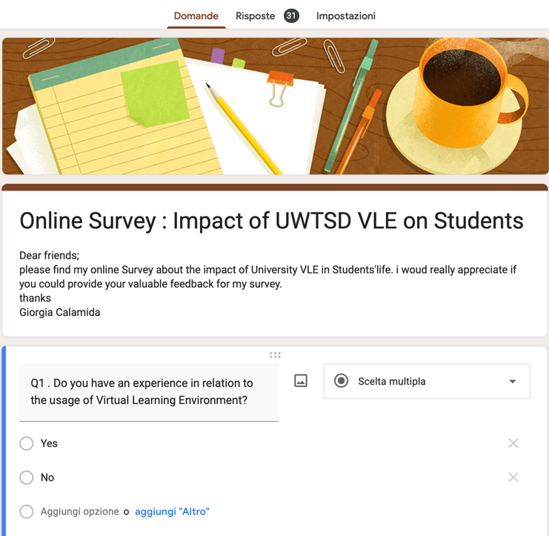

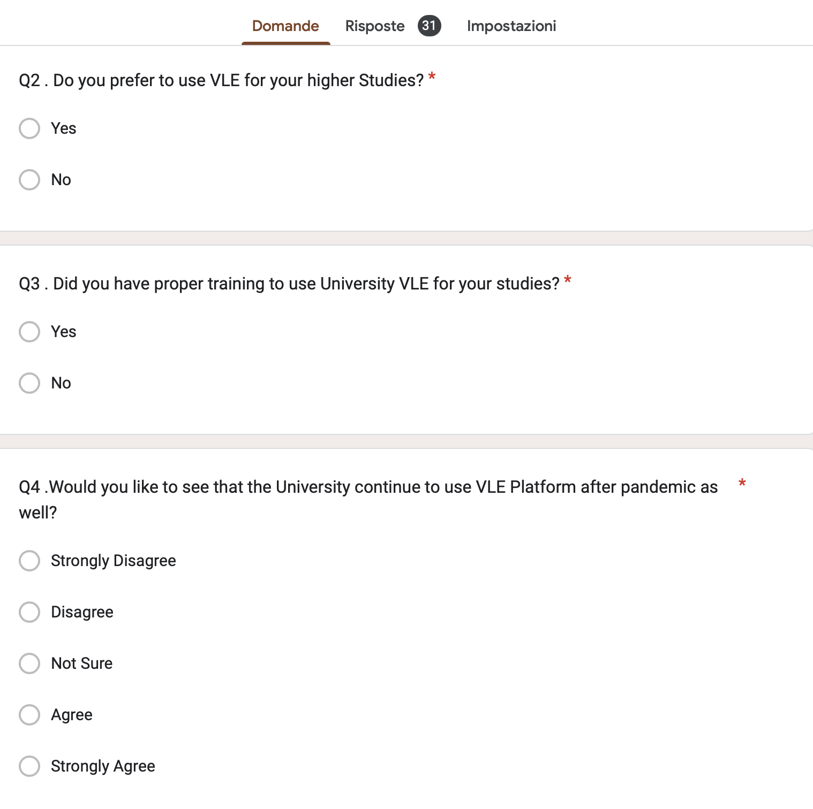

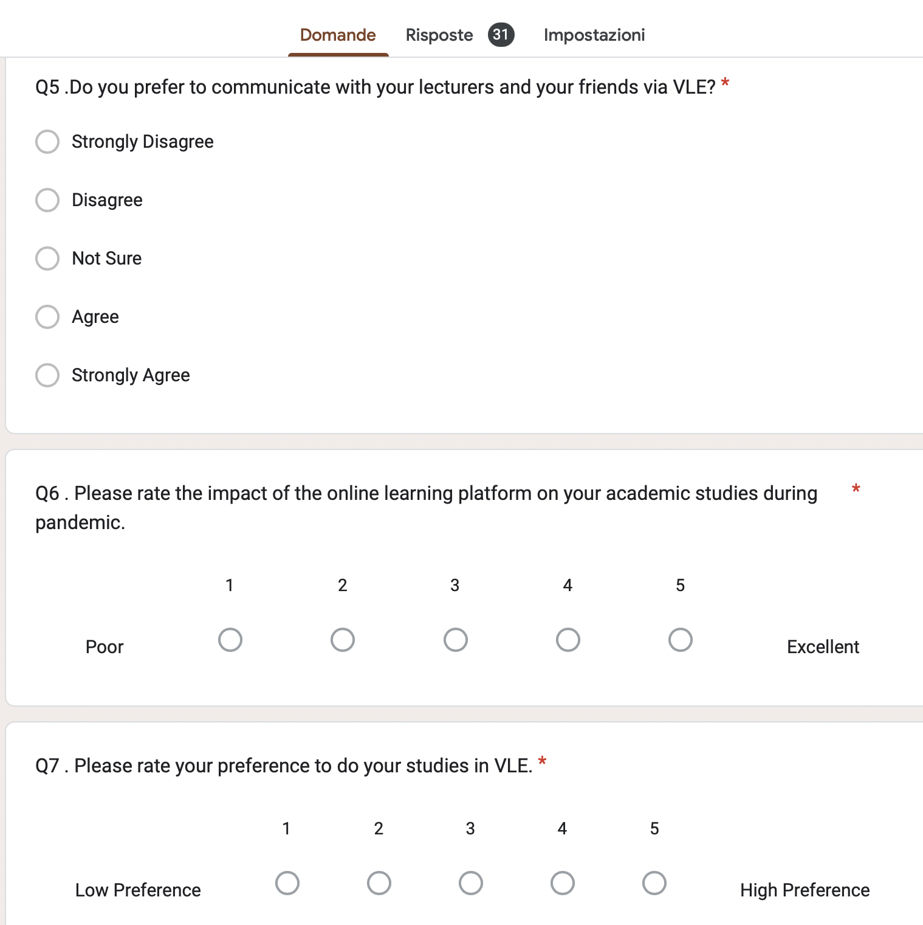

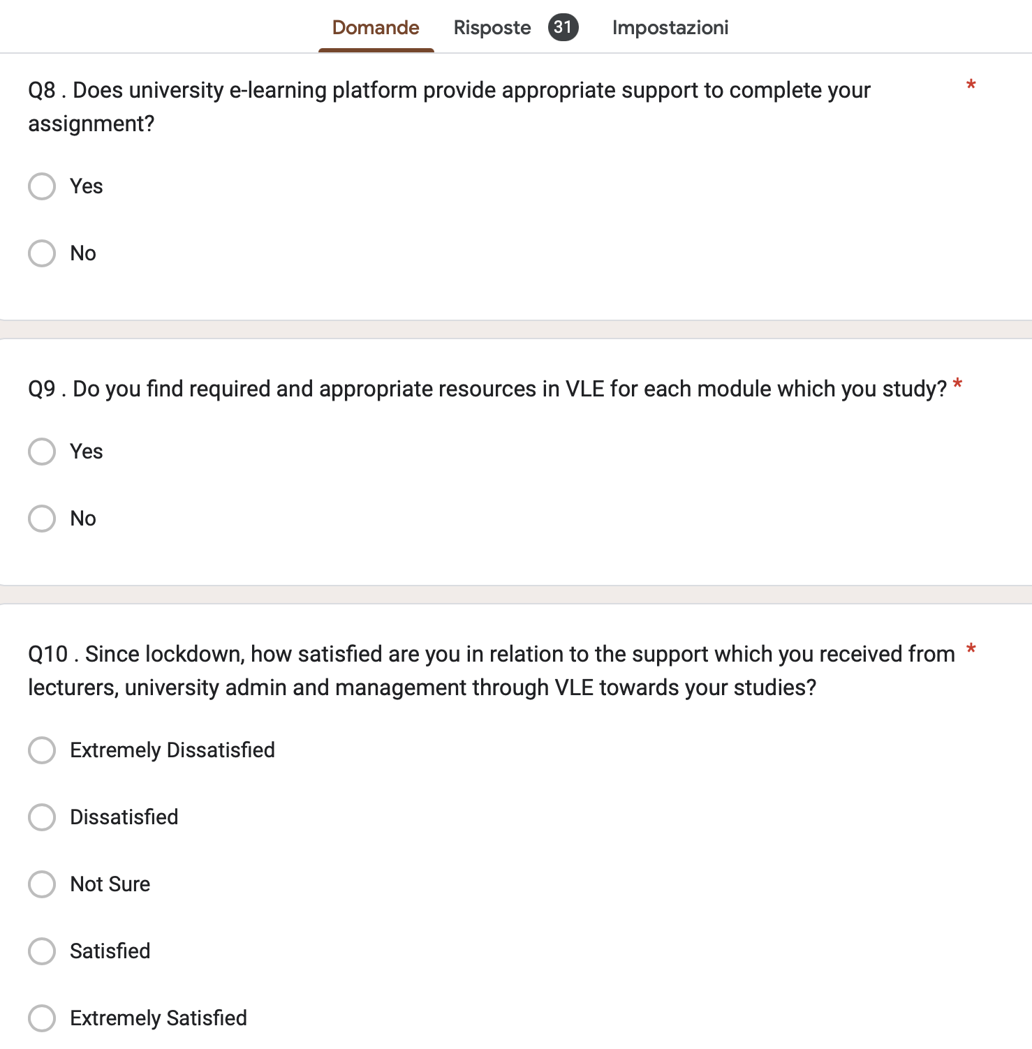

RESULT:

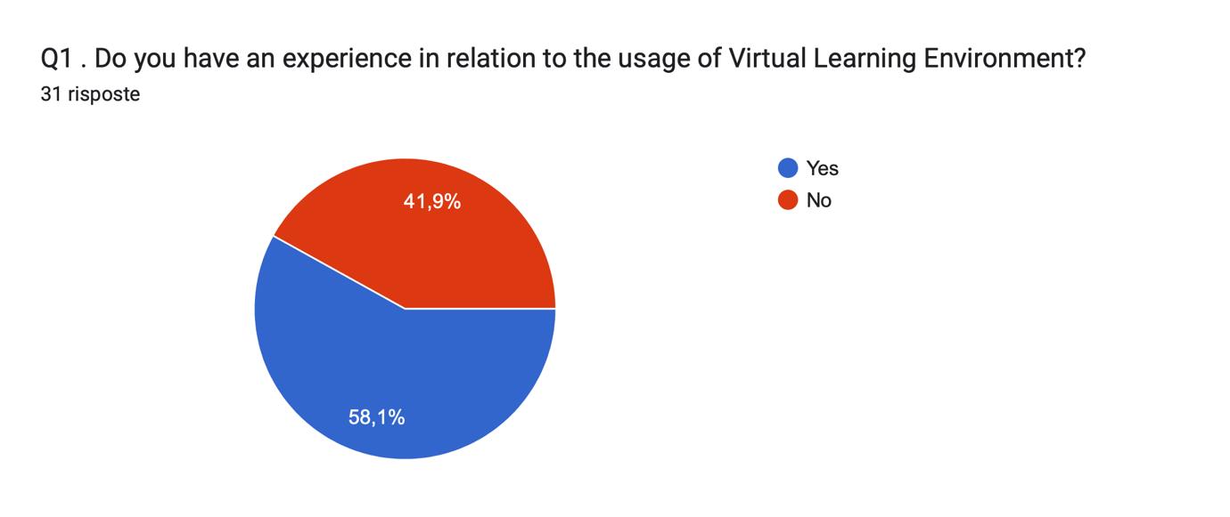

According to this result we can tell most of the students who answer had an experience on VLE

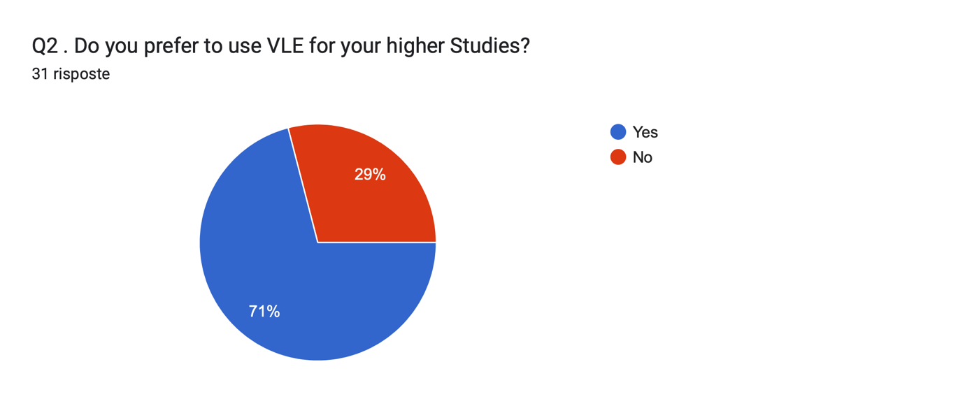

This result is really surprising because the majority answer was yes

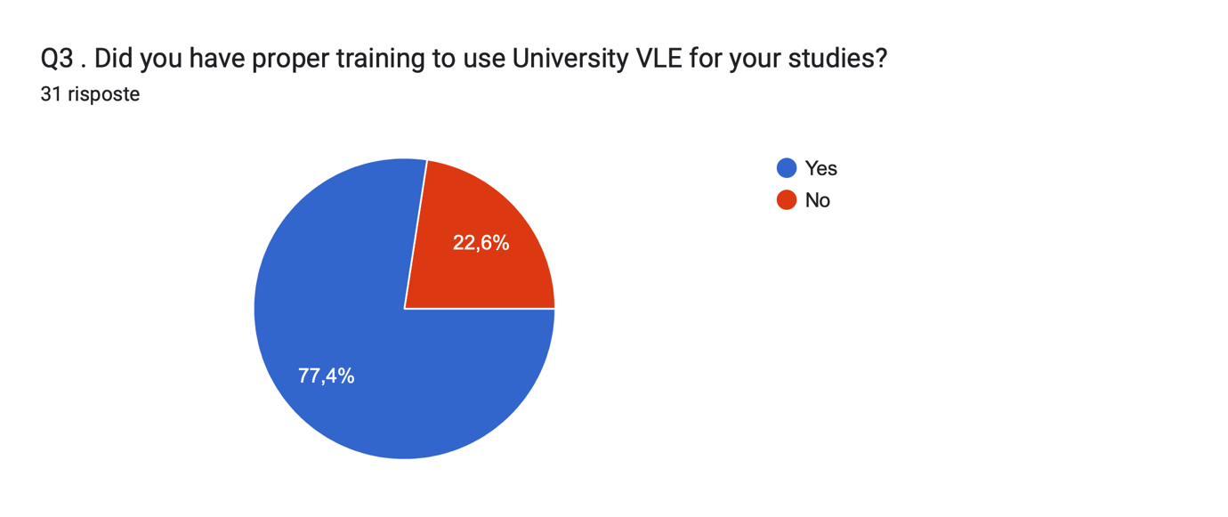

According to this result looks like most of the students who answer had a proper training

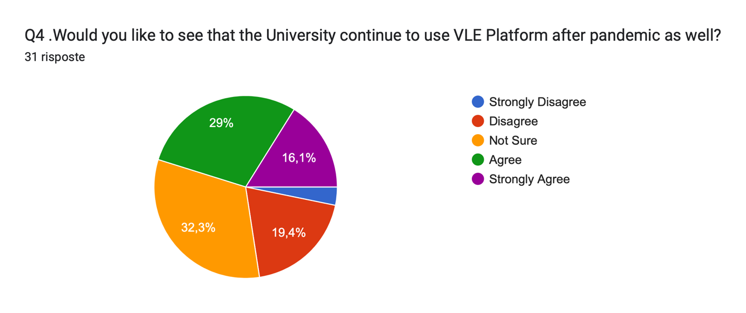

Hereby we can observe most of the students were not sure about the answer

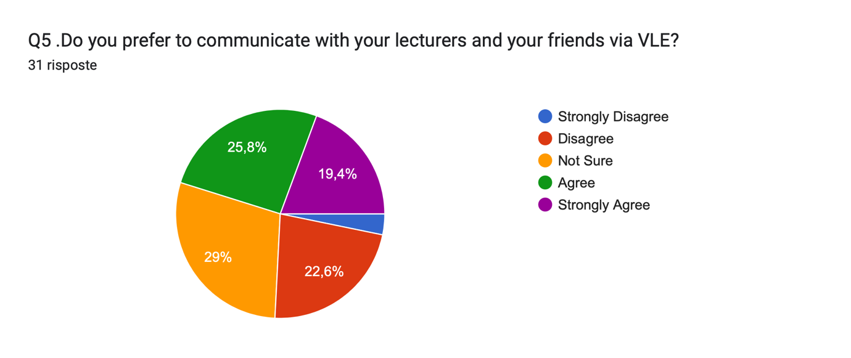

The results here are very close to each other and this makes me think about most of the students do not have a clear idea about it

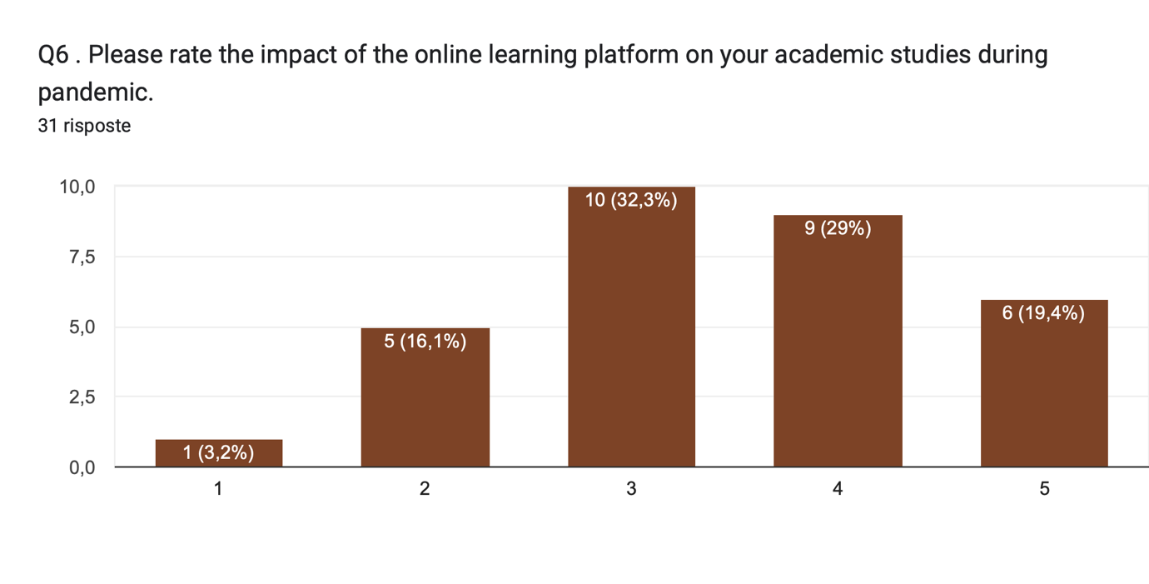

We can see the majority had a really good impact on VLE

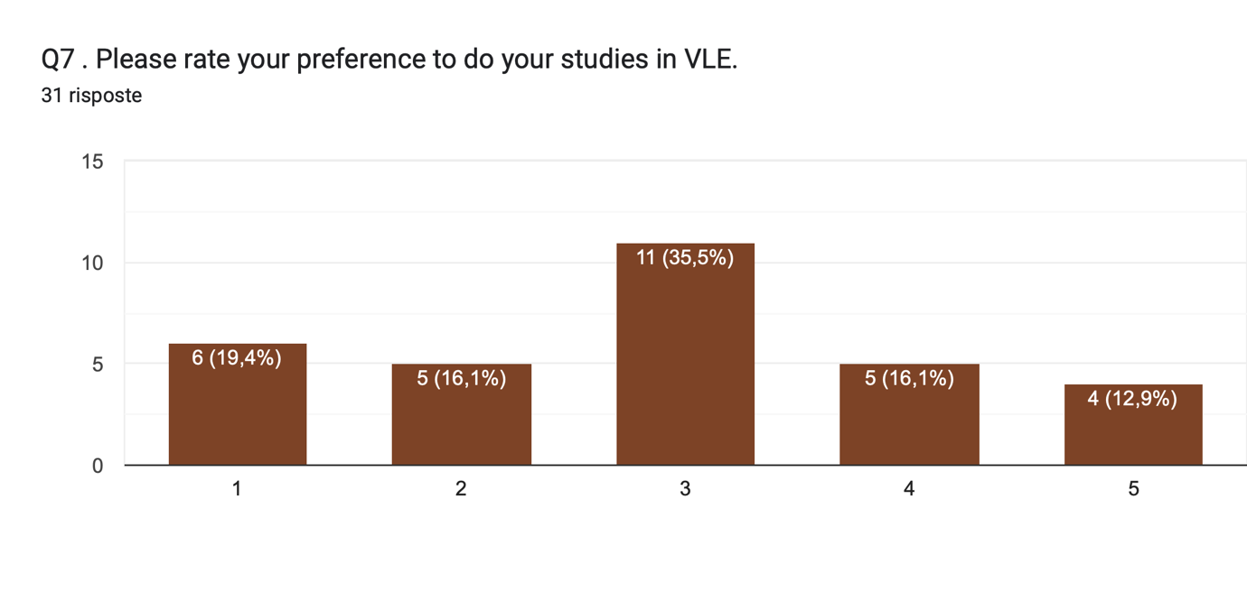

Most of the students prefer to study in VLE

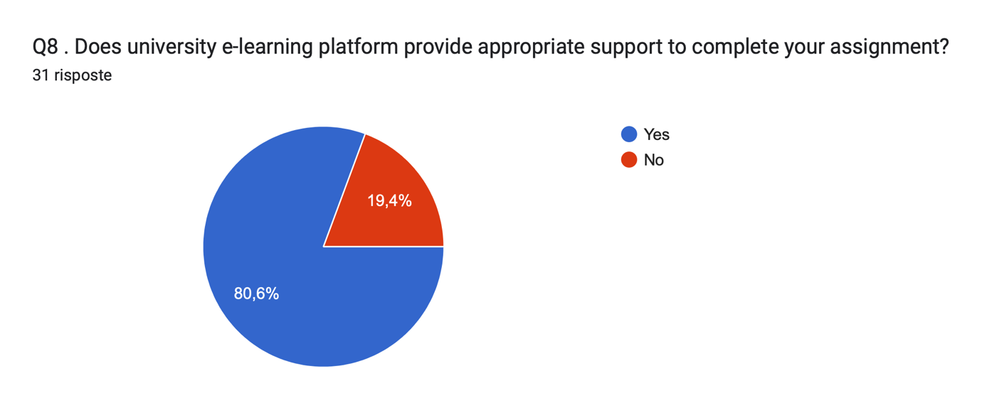

This answer to the survey is a really good prospective for VLE and the support for it

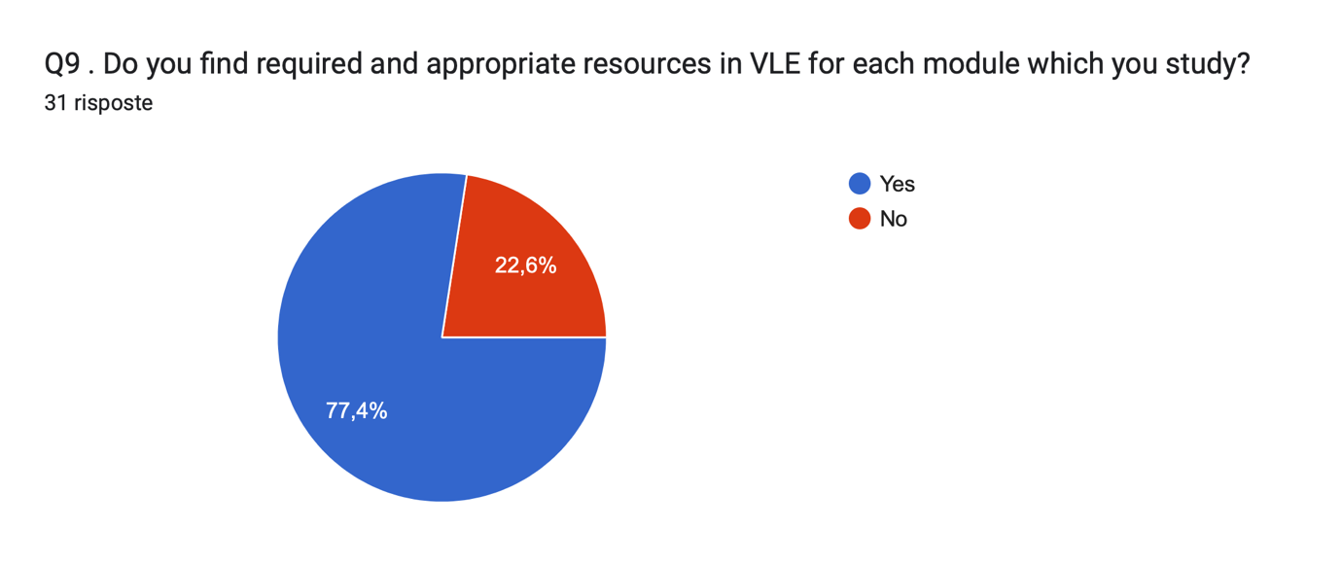
The majority seems happy about the resources they can find for their studies
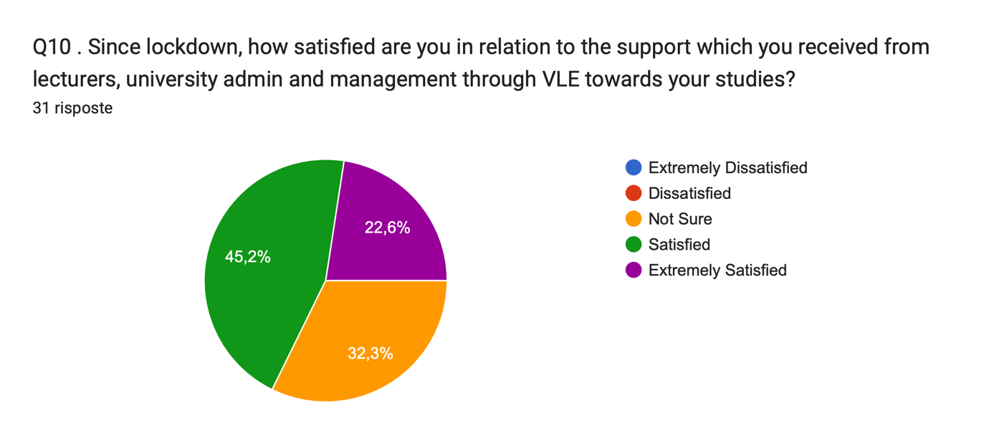

In conclusion most of the students answer satisfied about their satisfaction in VLE

DISCUSSION

As a result of my summary, I can tell students had a really good approach with Virtual Learning Environment.
Most of the students answer in a positive way and it looks like they want to keep use VLE rather than going to campus or doing both at the same time.
For my personal opinion I did use VLE this year and it was my first time, I felt a bit insecure having a virtual class but at the end it was a new experience, and of course I did enjoy it.
Some of the problems I had was absolutely the distraction, I do not focus properly if I am not in a live learning environment for many different reasons such as my phone, I keep looking at my phone instead of following the class which is does not happen in a live environment.
However, from my point of view it is really convenient for students that cannot attend the class in campus for different reason, but following the class opening their laptop anywhere they are.

CONCLUSION

In conclusion I would like to encourage the lectors to have a more carefully idea about VLE. Before doing this report I did not know various things which now I know, and I am really satisfied with the work I done.
I did develop some of my tools and especially my digital skills, without those I would not finish this report and obviously my research skills.
Virtual Learning Environment is a new environment that was always within reach, but we never really needed till we were forced to use it after the COVID-19, and after few years from that situation we are still use it for different situations.

REFERENCES

- Barco. 2022. Barco weConnect. [online] Available at: <https://www.barco.com/en/page/products/weconnect?ccmpgn=T-00000803&gclid=CjwKCAjw6fyXBhBgEiwAhhiZsrJEjlSZsytyRx0m6cnSLKmUzSxwmAzVR2EtSNnhj7pChvam928gKhoC0fkQAvD_BwE> [Accessed 19 August 2022].

- Firefly. 2022. What is a Virtual Learning Environment (VLE)?. [online] Available at: <https://fireflylearning.com/what-is-a-virtual-learning-environment-vle> [Accessed 11 August 2022].

- FunTech Blog. 2022. 8 Benefits of Virtual Learning Environments (Importance of Virtual Classrooms). [online] Available at: <https://funtech.co.uk/latest/benefits-virtual-learning-environments-classrooms> [Accessed 11 August 2022].

- Utep.edu. 2022. The definitive online school supply list for online students. [online] Available at: <https://www.utep.edu/extendeduniversity/utepconnect/blog/may-2017/the-definitive-online-school-supply-list-for-online-students.html> [Accessed 23 August 2022].

- Walleit, S., 2022. The Key Characteristics and Benefits of a Virtual Learning Environment. [online] Parallels Remote Application Server Blog - Application virtualization, mobility and VDI. Available at: <https://www.parallels.com/blogs/ras/virtual-learning-environment/> [Accessed 19 August 2022].

