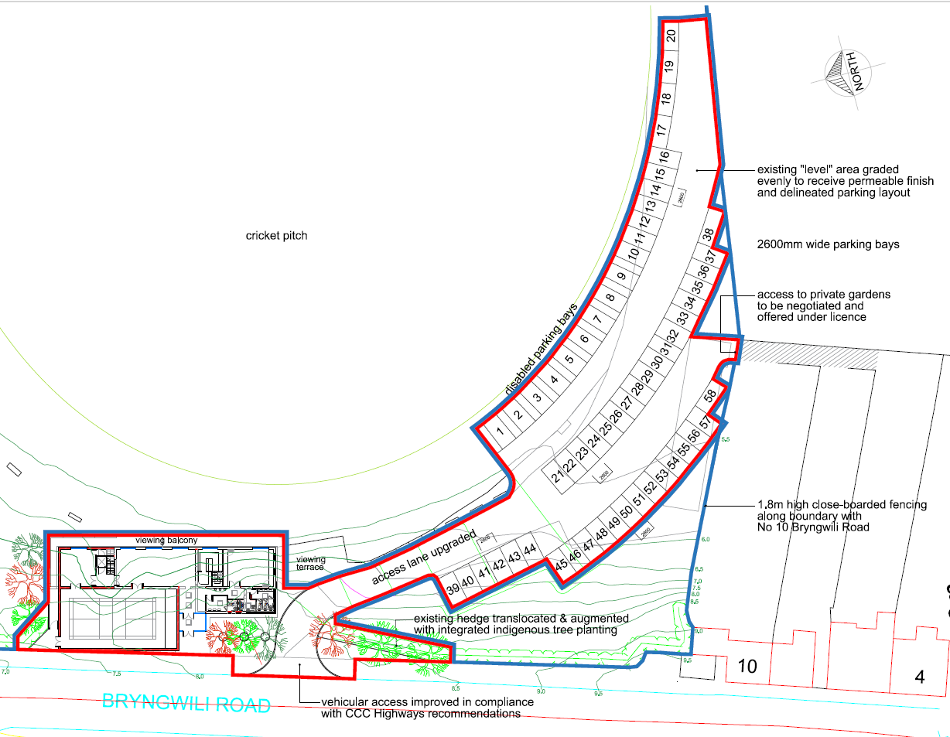
Planning Application: S/36546
Joseph O'DONNELL
2118883@student.uwtsd.ac.uk
Abstract
Report for project timeline, including resources, delay resolution strategies
Canolfan Gwili Centre
2118883 - UWTSD


Contents
Introduction 2
Critical Resources and their roles 2
Personnel Resource 2
Material Resource 2
Equipment Resource 2
Delays and Mitigation Strategy 2
Critical Paths 2
Resource Allocation 3
Fast-Tracking 3
Communication 3
Introduction – Canolfan Gwili Centre 3
Delays in Project 3
1st Delay – Utilities Disconnection 3
2nd Delay – Structural Columns 3
3rd Delay – Roofing Installation 4
Conclusion to Delays 4
Fixation of the Delays 4
Car Park expansion 4
Refurbishment of existing building 4
Conclusion 5
References 7

Introduction
The Canolfan Gwili centre project spans multiple phases starting at the initiation phase, leading to the construction of the extension, additional car parking spaces to the refurbishment work in the existing building. The primary goal of this project is for the work to be finished by 24/10/2025.
This report evaluates the critical resources that were used for this project, examines the delays that occurred during the project timeline and how these were resolved to commit to the commission date expected by the client.
This report also explored the variety of methods that were used or could be used to reduce the amount potential delays to a project with justification on why these methods were used.

Critical Resources and their roles

Personnel Resource
Resource management for this project were the underlined reason as to the project success, with the utilisation of experienced workers that can do various jobs required. The key personnel for the coordination of core activities were the project manager, construction manager and the senior engineer.
The use of subcontractors was key to performing specific tasks when summoned upon such as the HVAC engineers, surveyors and electricians. Although, the use of subcontractors came with a price as they charged an additional fee, this was worth it as it ensured that the project timeline remained in place and had no discrepancy on the commissioning date of the project.

Material Resource
Construction materials such as concrete, steel reinforcement and formwork were vital for the structural task in the foundation works of the building as well as the foundation works for the car park to reduce the amount of cracking and increase stability of the building. With the use of prefabrication offsite for wall construction, steel and columns this provided a reduced amount of storage area requirements for the site.

Equipment Resource
Heavy machinery for the project was used at a limited amount to reduce the amount of noise pollution. Heavy machinery was specifically used for construction work on the extension of the existing building and the use of rollers and dumper trucks when levelling and grading the additional car park. Standard tools were used for the rebar installation and electrical wiring works.

Delays and Mitigation Strategy
Delays to construction project are inevitable due to many different aspects of the jobs that are out of the contractor’s hands such as weather, supply of materials and potential labour shortages. But, it is the contractors responsibility to employ effective strategies to mitigate the impact of potential delays. See different methods below that could resolve potential delays:

Critical Paths
Identifying specific tasks that are on the critical path of the project helps prioritise different activities that could directly affect the projects completion date. For example, if there are delays to the foundation works then this could have significant effects on the completion date as there are future tasks that can only begin once the foundation is completed. (Designingbuildings.co.uk, 2013)

Resource Allocation
Correctly designating resources from tasks that may not be a priority or effecting future jobs and using that resource to be implemented into delayed critical tasks will reduce the amount of delay and accelerate the projects progression. For example, assigning personnel to excavation or adding an additional machinery to recover lost time. (Designingbuildings.co.uk, 2013)

Fast-Tracking
If able to, having different tasks overlap each other instead of having to wait for the previous task to be completed is a way to reduce the amount of time it takes to carry out the tasks. Concerns with this idea are that it has the potential for errors to be made as different trades will be working around each other, so careful communication and organisation by the construction manager is vital. (Designingbuildings.co.uk, 2013)

Communication
Transparent communication between all stakeholders in the construction project can have a significant impact into the reduction of delays. This will ensure that everyone is aware and understand the potential implications of the delays and can improve the collaborative working methods, reducing potential delays in materials and resources required. Communication between trades should always be involving the construction manager so he can arrange and sort jobs in the correct timescale. (Designingbuildings.co.uk, 2013)

Introduction – Canolfan Gwili Centre
For the Canolfan Gwili Centre, we are contracted to provide the construction work for the redevelopment of the building including an extension to the current building, and increased car park allocation and the refurbishment of the existing building following the planning permission set on the Carmarthenshire council website under planning ref no. S/36546 (Site.com, 2025). In this report of the project, I am going to run through the significant findings of the project with what delays were caused and how the project team rectified these delays to mitigate an increase in the timeline of the construction project including mitigation strategies that were previously highlighted.
For this project, the work commenced on the 16/09/2024 and is due to be completed on 09/10/2025.

Delays in Project
Once the construction phase started for the project, different delays occurred that could affect the completion date that was agreed between the contractor and the client. In this section of the report, it will evaluate which tasks were delayed, the reasons and the effects that it caused on the project timeline.

1st Delay – Utilities Disconnection
The first delay occurred during the disconnection of utilities connected to the existing building. While this task was initially planned to be completed within 7 days, it ultimately took 10 days to finish. As a result, the delay prevented the task from being completed before the Christmas break (17th December to 6th January). Consequently, excavation work, which was scheduled to begin earlier, could not commence until 10th December, and was not completed until 8th January in the new year.

2nd Delay – Structural Columns
The second delay for the Canolfan Project occurred on 17th February, when the supplier of structural columns and beams reported a supply shortage, leading to reduced deliveries for the project. This extended the structural framing installation from the planned 15 days to 30 days, shifting the expected completion date from 4th March to 28th March. This delay significantly affected the project as it prevented subsequent tasks from progressing and placed additional pressure on later phases to be completed within a shorter timeframe.

3rd Delay – Roofing Installation
Additional delays occurred during the roofing installation, extending the task's duration from the planned 20 days to 30 days due to a labour shortage. Although the subcontracted roofers were expected to provide a team of 10 workers, only 5 were available to carry out the work, resulting in a 10-day delay. Consequently, the original baseline finish date of 22nd April was pushed back to the new expected completion date of 30th May.

Conclusion to Delays
Overall, these delays demonstrate the necessity of thorough planning, reliable supplier coordination, and ensuring the availability of adequate resources in construction projects. The effects of each delay extended beyond their immediate phases, disrupting the overall timeline and requiring significant adjustments to keep the project on track. This underscores the value of proactive risk assessment and adaptive strategies to handle unexpected challenges and minimise disruptions in future tasks or future construction projects.

Fixation of the Delays
Following the delays, the project team explored strategies to prevent further disruptions to the project timeline and identified measures to ensure the project could still be completed on schedule, maintaining compliance with the client’s contractual requirements. The improvements implemented are outlined below.

Car Park expansion
When originally setting out the time of the car park preparation to take, it has an expected duration of 25 days including site clearance, excavation, levelling, and drainage installation. To reduce the number of days these tasks would take, the project team looked in hiring more resources from labourers to help with the site clearance to hiring more tools such as an additional rollers and dumper trucks to reduce the amount of time it took to prepare the area. By doing this, the duration reduced to 15 days that brought back some time that was lost from previous tasks that took longer than originally anticipated. During the car park expansion work, an unexpected, reduced amount of time in the landscaping around the area took only 3 days to completed instead of one working week expected, meaning that future tasks such as safety barriers and road markings could be completed at an earlier stage.

Refurbishment of existing building
The refurbishment works achieved the most substantial reduction in duration, enabling the Canolfan Gwili Centre project to be completed on time as agreed with the client. Structural repairs, initially estimated to take 8 days, were reduced to 3 days by implementing more efficient solutions than those outlined in the original method statements. For instance, a faster grout curing process was adopted, allowing work to proceed much sooner. Additionally, multiple trades were coordinated to work simultaneously within the refurbishment area, facilitated by fast-tracking and effective communication from the construction manager to avoid conflicts. This approach allowed structural repairs to progress alongside electrical work, while plasterers and plumbers worked adjacent to one another.
Another significant time-saving measure was achieved during the flooring installation. A revised flooring design, agreed upon with the client, reduced the installation duration from 2.5 weeks to just 1 week. These combined efforts brought the project timeline back on track, aligning with the original completion date agreed with the client.

Conclusion
In conclusion, while the project experienced a cumulative delay of 33 days, the strategic reductions achieved across other tasks, amounting to 35 days, successfully offset the impact. This outcome underscores the importance of adaptability, resource management, and proactive decision-making in construction projects. By employing these measures, the Canolfan Gwili Centre project was completed on time, demonstrating the team’s ability to deliver within contractual obligations while maintaining quality and efficiency.
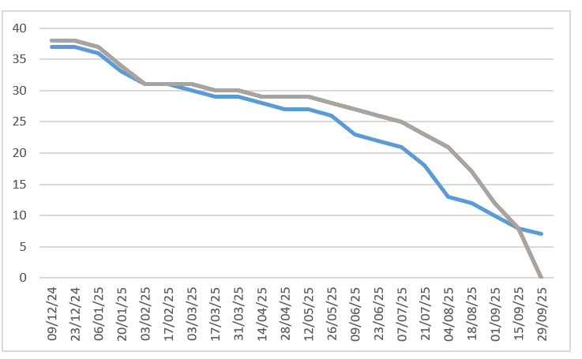
Figure 2: Blue line was originally baseline for the project, with grey line showing how delays were overcome.
This construction project is currently 32% complete, with £59,275.75 spent so far and an estimated £700,459.65 remaining to be utilised. The progress achieved to date includes excavation work, while major tasks such as the installation of structural columns and beams, the car park expansion, and refurbishment work are yet to begin.
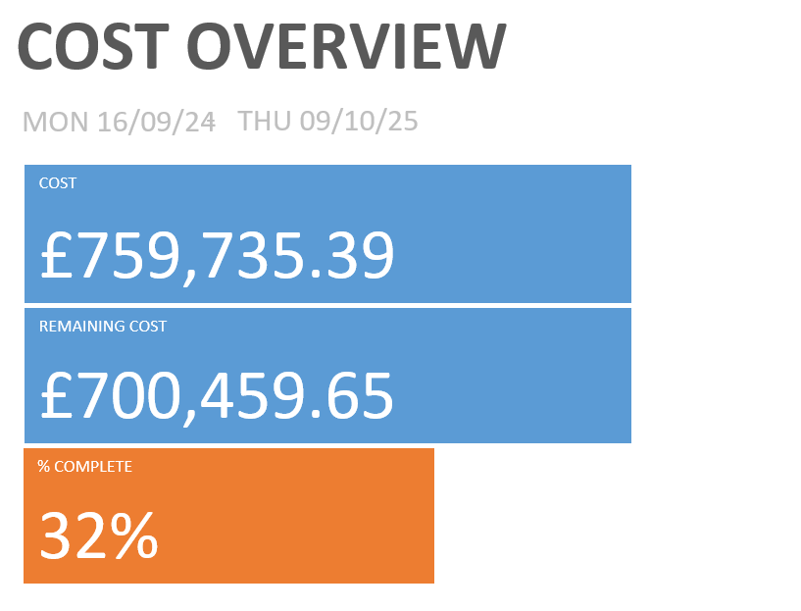
Figure 3: Showing cost review of the project to date.
A review of the project's overall costs reveals that the most expensive task was the installation of the roofing. This was primarily due to delays and a reduced workforce, which extended the duration of the task. Among labour costs, the construction manager accounted for the highest expense as they oversaw the project and were involved in most activities. Regarding materials, the three most costly items were roofing tiles, steel columns, and asphalt for the car park, collectively accounting for more than a third of the total project cost.
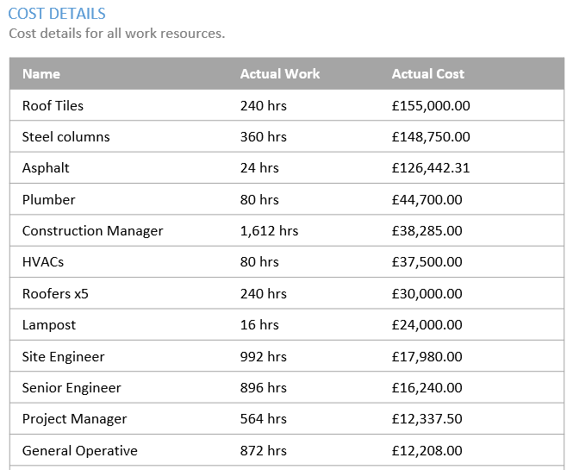
Figure 4: Review of the cost details for resources.

References
Ainscoughmetals.co.uk. (2025). Ainscough Metals. [online] Available at: https://www.ainscoughmetals.co.uk/steel/Columns/254x254x73.000_699/6.000_828 [Accessed 3 Jan. 2025].
Caerphilly skips (2024). Skips. [online] Available at: https://www.caerphillyskips.co.uk/skip-hire-prices-south-wales
Checkatrade. (n.d.). Roof Installation Cost Guide | How Much Will It Cost? [online] Available at: https://www.checkatrade.com/blog/cost-guides/roof-installation-cost/.
Checkatrade (2024). Digger. [online] Available at: https://www.checkatrade.com/blog/cost-guides/mini-digger-cost/
Checkatrade's Professional Estimators (2022). How Much Does an HVAC Cost in 2024? [online] Checkatrade. Available at: https://www.checkatrade.com/blog/cost-guides/hvac-cost/.
Checkatrade's Professional Estimators (2023). Cost to paint house exterior. [online] Checkatrade. Available at: https://www.checkatrade.com/blog/cost-guides/cost-to-paint-exterior-of-house/ [Accessed 3 Jan. 2025].
Checkatrade's Professional Estimators (2024). Plumbing installation costs. [online] Checkatrade. Available at: https://www.checkatrade.com/blog/cost-guides/plumbing-installation-costs/.
Coppard (2024). 10T Dumper truck. [online] Available at: https://www.coppard.co.uk/pages/consumer-price-list/dumpers.php
Designingbuildings.co.uk. (2013). Delays on construction projects - Designing Buildings Wiki. [online] Available at: https://www.designingbuildings.co.uk/wiki/Delays_on_construction_projects.
Fenceuk.co.uk. (2022). Square Top Standard Budget Panel – Minimum order quantity of 10 Number. [online] Available at: https://fenceuk.co.uk/product/square-top-budget-panel/?gad_source=1&gclid=Cj0KCQiAst67BhCEARIsAKKdWOkhVI1fFXktWze8u0lk3TRWQGrnSAzuX8wThtEAibA-CycBD7O4U6IaAqFHEALw_wcB [Accessed 3 Jan. 2025].
Glassdoor (2024). General Operative. [online] Available at: https://www.glassdoor.co.uk/Salaries/blackwood-wales-general-operator-salary-SRCH_IL.0,15_IC3299959_KO16,32.htm
Gov.wales. (2025). Job Information. [online] Available at: https://careerswales.gov.wales/job-information/ground-worker/pay-and-hours [Accessed 3 Jan. 2025].
Indeed (2024). Carpenter. [online] Available at: https://uk.indeed.com/career/carpenter/salaries/Wales
Indeed (2024). Concretors. [online] Available at: https://uk.indeed.com/career/concrete-laborer/salaries/Wales
Indeed (2024). Construction Manager. [online] Available at: https://uk.indeed.com/career/project-manager/salaries/Wales
Indeed (2024). Electrician. [online] Available at: https://uk.indeed.com/career/electrician/salaries/Wales [Accessed 3 Jan. 2025].
Indeed (2024). Project Manager. [online] Available at: https://uk.indeed.com/career/project-manager/salaries/Wales
Indeed (2024). Steel fixer. [online] Available at: https://uk.indeed.com/career/ironworker/salaries/Wales
Indeed (2024). Window fitter salary in Wales. [online] Available at: https://uk.indeed.com/career/window-fitter/salaries/Wales [Accessed 3 Jan. 2025].
Materials Market (2023). Mesh. [online] Available at: https://materialsmarket.com/products/6mm-a142-high-tensile-steel-reinforcement-mesh-sheet-2000mm-x-3600mm
Mileshire (2024). Roller. [online] Available at: https://www.checkatrade.com/blog/cost-guides/mini-digger-cost/
Mylocaltoolbox.co.uk. (2024). Asphalt driveway cost | How much is a new asphalt driveway? [online] Available at: https://mylocaltoolbox.co.uk/cost-guides/asphalt-driveway-cost/ [Accessed 3 Jan. 2025].
Office Removals (2024). Lamppost. [online] Available at: https://office-removals-london.net/how-much-does-it-cost-to-move-a-street-light-uk/
Roofers (2025). Job Information. [online] Available at: https://careerswales.gov.wales/job-information/roofer/pay-and-hours [Accessed 3 Jan. 2025].
Site.com. (2025). Carmarthenshire Public Register. [online] Available at: https://carmarthenshire.my.site.com/en/s/planning-application/a0b5J000000S1WTQA0/s36546 [Accessed 3 Jan. 2025].
SPEnergyNetworks. (n.d.). New Connection: Example Costs & Timescales. [online] Available at: https://www.spenergynetworks.co.uk/pages/new_connection_example_costs_timescales.aspx
Talent.com. (n.d.). Steel Erector Salary in United Kingdom - Average Salary. [online] Available at: https://uk.talent.com/salary?job=steel+erector
Thomas, T. (2019). 10 Ton Dumper Hire Nationwide | Front Tip or Swivel Tip Dumper Hire. [online] Ridgway Rentals. Available at: https://www.ridgwayrentals.com/plant-hire/10-ton-dumper-hire/ [Accessed 6 Dec. 2023].
Totaljobs (2024). Site Engineers. [online] Available at: https://www.totaljobs.com/salary-checker/average-civil-engineering-salary-wales-uk
Totaljobs.com. (2025). Surveyor. [online] Available at: https://www.totaljobs.com/salary-checker/average-surveyor-salary-wales-uk [Accessed 3 Jan. 2025].
White Lining (2023). Road Markings. [online] Available at: https://www.whiteliningcontractors.co.uk/roads/lines/the-vale-of-glamorgan/welsh-st-donats
www.crowdcontrolsolutions.co.uk. (n.d.). Heras Fence Panels - Temporary Mesh Fence Panels. [online] Available at: https://www.crowdcontrolsolutions.co.uk/shop/heras-fence-panels/85.htm [Accessed 6 Dec. 2023].
www.jarvieplant.co.uk. (n.d.). 10t Midi Excavator. [online] Available at: https://www.jarvieplant.co.uk/product-catalogue/171-10t-midi-excavator [Accessed 6 Dec. 2023].

