DS 1 Template

My Screenshots/Photos
- Please add 4–6 screenshots or photos of your digital life.
- You can use your phone or laptop.
- For each screenshot, write one or two sentences explaining what it shows.

Screenshot/Photo 1
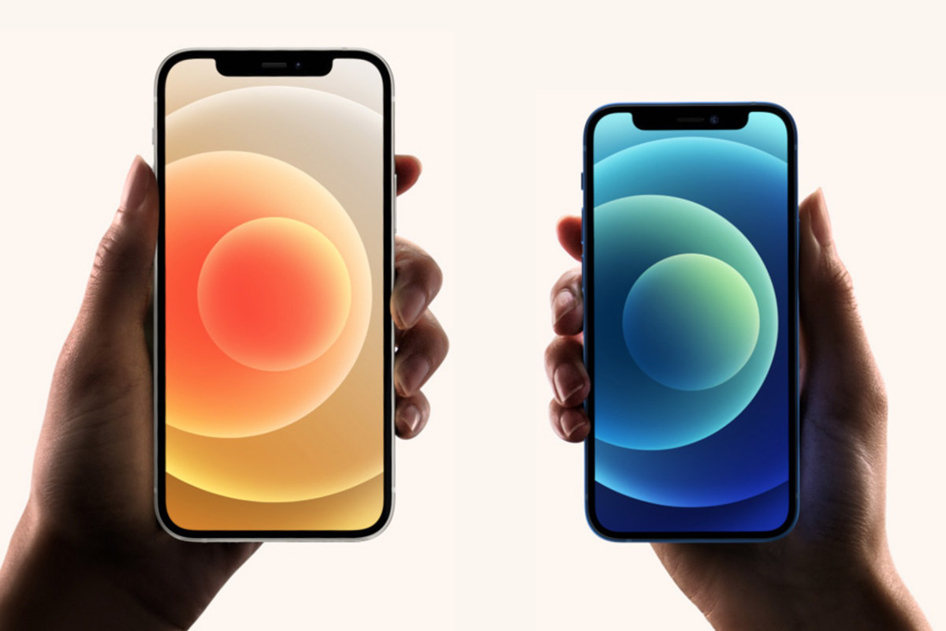
(Iphone)
My phone shows my digital life, I use it everyday to communicate with friends and family also take pictures, play games and upload pictures to my social media. It helps me stay in contact with the online world and stay up to date with news.
Khayretdinova, M. (2022)

Screenshot/Photo 2
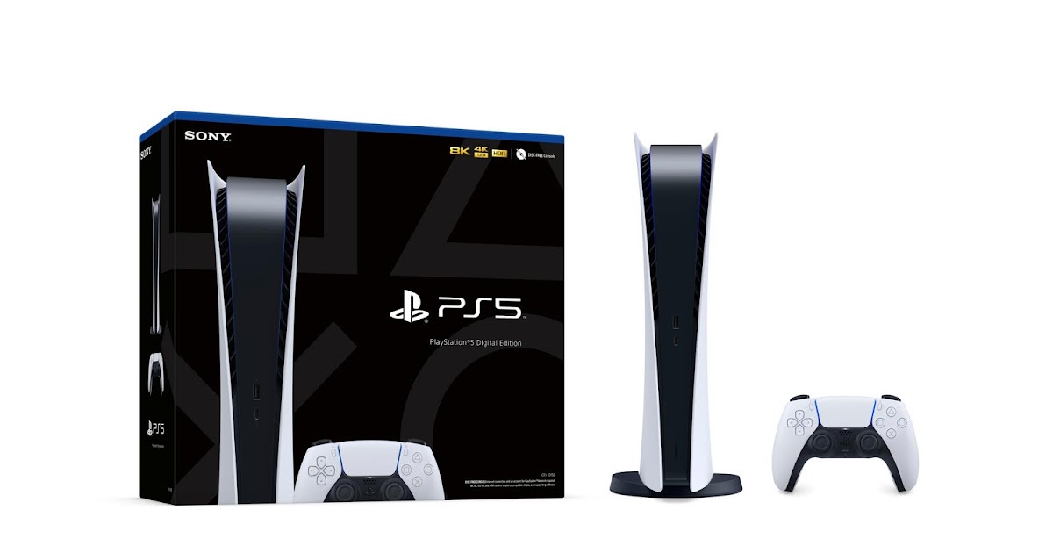
(playstation)
Gaming monitor plays a big part of my life I get to stream games, stay on live and also connect with other game players all around the world. Meet people on game station and have fun playing multiple player games online.

Screenshot/Photo 3
[Insert Photo/Screenshot below]
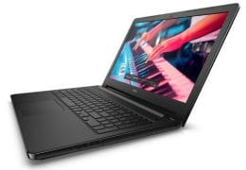 (laptop)
Laptop helps me with majority of things such as keeping up with my class work, I can also access google where you can search for variety of things like weather forecast or even look for jobs.

Screenshot/Photo 4
 social media

I like being on social media it helps me with me socializing skills and make new friend also helped me a lot when I was trying to put myself out there as a mechanic, social media did help me pull some clients in.

Screenshot/Photo 5
[Insert Photo/Screenshot below]

[Write what this shows of your digital life]

Screenshot/Photo 6
[Insert Photo/Screenshot below]
[Write what this shows of your digital life]

My Short Reflection
- Write 5–8 simple sentences about your digital life.
- You can use the sentence starters below if helpful.
I would like to practice more on my digital skills so I can feel more confident when I do my work on word or online. I am going to improve by practicing more on my laptop and submitting more work online then physical. I use digital skills a lot to communicate with others on apps like Instagram, I like posting about my life or what I’ve been up to.

Sentence starters
- I use digital tools to …
- I feel confident when I …
- I want to improve …
- I often use these tools: …
- I sometimes feel nervous about …
- I hope this module will help me …
- Digital skills are important for me because …
You can write more if you want.

Submission Checklist
Before you submit, please check:
​​​ ☐ I added 4–6 screenshots
☐ I wrote short sentences for each screenshot
☐ I wrote my short reflection
☐ My work is my own
☐ My file opens correctly
​​☐ My file opens correctly

Referencing
Khayretdinova, M. (2022) Mind Wandering in a Smartphone World: The Impact of Pervasive Smartphone Usage on Mind Wandering and Attentional Restoration. Harvard University Extension School. Available at: https://dash.harvard.edu/handle/1/37371700 (Accessed: 25 October 2026)

