[Date]
Word count: 1114
Lyudmil Simeonov
University of Wales – Saint Trinity David London
Lecturer: Dr. Anupam Mazumdar

20140311

Data Analysis and Visualization
ACCB4002 DAV Assessment 1 Task 1
Contents
Introduction 3
Main body 3
Task 1 3
CONCLUSION 6
REFERENCES 7
Task 2 8

Introduction
The term data analysis can be understood as a form of approach under which collected information from different sources is cleaned, formatted and arranged in a manner which can be used for better decision making (Wilke, 2019). While data visualization is known as a process of presenting the data in the form of graphs and charts which make data analysis under stable and easier. Under the project report, both aspects are included by analyzing given infographics and excel sheet of given data set.

Main body

Task 1
Analysis of fluctuation of Coronavirus in different countries along with features of infographic.
As above discussed that data visualisation is a form of way in which data is presented in an effective which can be read and understand by each individual. Apart from this, data visualisation becomes effective in the case when there is huge number of data set and data is complex.
The corona virus has affected to different kinds of countries in terms of finance, health and economy. Herein, below an infographic is presented which states information related to corona virus in different kinds of nations:
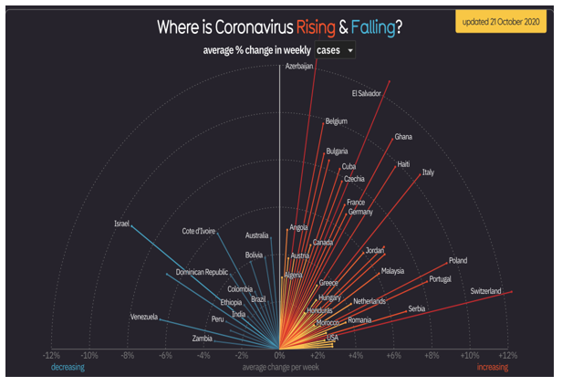
The above mentioned chart states about corona virus in different nations which is fluctuating in a significant manner. From this graph, it can be inferred that there are some regions in which corona virus impact is lower which is because of implementation of effective techniques and approaches. In the context of Azerbaijan country, this can be find out that there is 12% growth in terms of cases that states that there is in such country COVID 19 impact is higher. While in the aspect of Israel this can be stated that cases are decreasing at the rate of 9% which shows that under such nation government might have taken significant steps to overcome the COVID. Apart from this, there are some other nations in which corona virus is increasing and decreasing with significant rates.
Benefits of Infographics:
- They serve as a great way to gather sufficient knowledge in a quick access that seems compelling. This helps make readable and comprehensible. This means the material that is illustrated by the use of infographics would be easy to read (Evergreen, 2019).
- Infographics offer a simple means of recording and interpreting information that further contributes to formulating insight into the style of visualized content.
- In addition to this, infographics is useful for making a form of presentation in which any size of data can be processed and understand by users.
- Apart from such benefits of infographic, this can be stated that it is useful for those data set that is inconsistent in nature and larger in nature.
- This makes easier for users or readers to understand any huge issue or case in very less time and effort. As we can see that in above case, this has been used to present the number of cases in different nations of corona virus in first week of November.

The infographics are mostly used on those data sets which are inconsistent in nature like if there is increasing and decreasing in data than this can be useful to understand the trends (Unwin, 2020). As in the context of above prepared infographic this can be assessed that in Ghana country, there is 11% growth in terms of cases. While in rationale with Venezuela it can be analysed that 7% decreasing in terms of number of cases of COVID.
Herein, this is important to know that infographics not only offers financial data but also it contributes in projection of different kinds of strategies and techniques (Erraissi, Mouad and Belangour, 2019). As per the above done analysis, it can be find out that in Ghana, they might have adopted effective strategies and techniques which helped them to deal with this pandemic. On the other side, in Venezuela they might not be able to deal with complex situation of corona in more effective and comprehensive manner. So these are some key opportunities and advantages of infographics which are adopted by different kinds of companies who adopt such tool for presentation of data set that can be complex and larger in nature.

Limitation of Infographics- Apart from this above mentioned specifications and merits of infographics this can be stated that there are some limitations also which are faced by users (Börner and Ginda, 2019). One of the major limitation of such tool is that it is time specific and presents the data only for a shorter time period. As in the aspect of above presented chart we can assess that the analysis has been done only for one week of November of different nations.
In addition to this, infographic does not help in the aspect of making comparison of two components data series. As we can see in above infographic that there are different kinds of countries in which population is different. Like if a nation’s population is 1 million and other nations’ is of 10 million. In such case, this will be injustice to make comparison of both companies in terms of number of cases related to COVID 19. As well as the infographic states that there is decreased growth in terms of number of cases in various kinds of nations but this is not a correct and exact information. On the grounds of such information government of particular nation cannot take any initiative to make further policies and plans.

CONCLUSION
On the basis of above prepared project report this can be concluded that data visualization is one of the effective method in order to assess trend in a particular data set. The report concludes about limitations and features of infographic with rationale to given information related to COVID 19 patients or cases in different kinds of nations. In accordance of above done overall discussion, it can be articulated that infographic is not successful in the case when there is large number of data set and data is complex to understand.

REFERENCES
Wilke, C.O., 2019. Fundamentals of data visualization: a primer on making informative and compelling figures. O'Reilly Media.
Evergreen, S.D., 2019. Effective data visualization: The right chart for the right data. Sage Publications.
Unwin, A., 2020. Why is data visualization important? What is important in data visualization?. 2.1, 2(1).
Börner, K., Bueckle, A. and Ginda, M., 2019. Data visualization literacy: Definitions, conceptual frameworks, exercises, and assessments. Proceedings of the National Academy of Sciences, 116(6), pp.1857-1864.
Erraissi, A., Mouad, B. and Belangour, A., 2019, April. A Big Data visualization layer meta-model proposition. In 2019 8th International Conference on Modeling Simulation and Applied Optimization (ICMSAO) (pp. 1-5). IEEE.

