Academic and Employability skills

Student name: Lucian Cristinel Hritcu
Module: BMSW4001
Lecture: Joanna Walsh
Student number: 1913389

Contents

Abstract………………………………………………………………………………………………………………………………….3
Definition of Employability…………………………………………………………………………………………………..3
Employability Skills……………………………………………………………………………4
Communication Skills………………………………………………………………………….5
Listening Skills………………………………………………………………………………...5
The function of recruitment agencies …………………………………………………………6
SWOT Analysis………………………………………………………………………………..6
Time Management Tools………………………………………………………………………8
Reflection of Academic Progress……………………………………………………………..10
References…………………………………………………………………………………….11

Abstract
Every fresh graduate completing college is concerned about the future. Students are full of questions about how to make survival in the markets of job, techniques to win and impress recruiters during the Interview, what factors recruiters consider while recruiting and what are the exclusive combination of skills, attributes and values are needed to secure a job as well as developed within the career. Understanding and meeting with the requirement of skills in the corporate world are itself challenging. In the recent economic climate, employers are looking for skills beyond the degree. Today, graduates require not only methodological skills to perform particular tasks but they significantly required to have academic employability skills: ability, communication skills, behavioral skills, problem resolving skills and teamwork, etc. The current study pursues to find employability skills, its importance, and the procedure of recruitment in agencies.
Definition of Employability
The employability skills have been defined by ILO as the skills, information and proficiencies that improves the capability of the worker to secure and retain employment, progress at the workplace and deal with changes. Individuals become employable in case of possessing broad-based education as well as training, basic and transferrable higher level of skills including work with a team, problem resolving skills, information and conversational technology (ICT) and also communication and language skills (Suleman,2016).
Employability can also be explained as “a set of accomplishments, understandings, skills and personal characteristics that create graduates more like to achieve employment and become successful within the chosen career or occupations which provide advantages to themselves, the workplace, community as whole and economy. Employability is the valuation of the economic worth of graduates at the moment of employment. Employability can be explained as improved capacity to secure and preserve employment. It is a set of transferable skills (Smith et al.,2018).

Employability Skills
Employability skills have been usually been mentioned by employers as the skills most complicated to the success of the workplace in the economy of the 21st century. The skills involve but are not only limited to complicated thinking skills, adaptabilitybut also proposed solutions to problems, written and oral communication skills, cooperation, and teamwork, innovative skills, responsibility, ethics of professionalism as well as moderate use of technology.
Whilst Graduates might be observed as a statement of the level of knowledge capabilities, skills and understanding Dany&Torchy, (2017).To develop academic and employability skills it is essential to focus on a group of necessary abilities that engages the development of knowledge base, proficiency level, and mindset that is significantly necessary for the development of the workplace. Employability skills usually considered the necessary qualifications for various job positions. Also, it becomes essential for an individual success of employment at about level within the environment of business (Rodríguez de Céspedes,2017).
It is not as similar to getting a job, rather it implements to the capacity of graduates to survive in the job market and be capable to move among jobs, thus lasting employability throughout the life period. It is the control of skills and competencies to endure in the situation of work. Skills that are essential for self-encouragement and interacting to deal with changing situations. Employs require to be active in the maintenance of constant learning and should show the capability to work within influencing teams.
According to the class activities and published literature, it can be considered that employability skills can be classified on three factors
- Technical skills
- Communication skills
- Essential Employability skills or Personal characteristics
Although the core employability skills are the most essential as it can only be measured in relative terms through the analysis of psychometric capabilities of interviewer Zaroh,(2018) Further, communication and professional skills are also used to measure during the procedure of recruitment.
Communication Skills
In order to make survival in today’s corporative environment engages interaction with customers as well as with managerial staff daily. Communication skills are the basic tool for exchanging information, interests, behaviors, opinions and broad ideas to influence and significantly lead others. Communication skills involve the ability to listen and communicate verbally as well as non-orally to receive understanding both formally as well as informally (Thomas et al.,2016).
The skills usually presented during the conversation of an interview and at the moment of targeting success in the interview as well as the workplace create it as essential to give acceptable importance to good communication. During the interview, the recruiter focuses on howthe candidate used to present dialogues, converse as well as conveys his ideas. The ability of the candidate in written and no written communication, the capability to significantly articulate opinions, thoughts, fluency skills through using appropriate grammar, excellent vocabulary and comprehension skills are essential that are retrieved by the recruiter during the procedure of hire)ng (Jackson,2016).
Strong command over communication capabilities is given adequate importance where the employments require its workers to make presentations regularly and direct engagement with clients and consumers (Zamyadi et al.,2016).
Listening Skills
Employability skills require active listening skills. The employee requires presenting itself as an active listener, the effective listening capability is prominent for interpersonal communication skills. Thus during an interview, providing an accurate response towards each question is possible in case when an individual can listen properly ( Jeswani,2016).
The above mentioned few skills are essential for the employees to have. The employability matter has gained attention across the world. From one edge employers are pointing towards right know-how to meet with ever-challenging responsibility of today’s global economy and this has ultimately become a battle of market. The given details show the Graduate employability. Employability of graduatesis interpersonal skills, skills to manage the job as well as enterprising approach and engages fostering professional chains, interacting employers within the curriculum (JeanPierre&Perrain,2016).
The function of recruitment agencies
Recruitment agencies function on behalf of employers to seek a suitable candidate to fill out vacancies. When employers require to hire fresh graduates or experienced employees, it usually providesthe agency with a description of the job. The agency then performs to find out an appropriate resume for the company in its database to match job seekers towards the vacancy. The employer thus selects desirable candidates and schedules an interview.
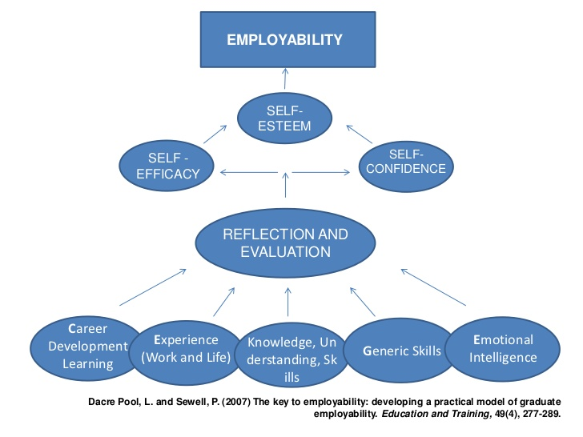
Figure 1 Employability
SWOT Analysis
SWOT stands for strength, weakness, opportunities, and threats. SWOT analysis is beneficial for recognizing the areas of development and an individual can examine strengths and weaknesses they might face (Stewart et al.,2016).
Strengths
To originate with my strengths as far as the organization and skills of planning are the capabilities of presenting good record keeping, the procedure of conveying priorities and the capability of undertaking appropriate research. These skills were received by attending class activities. Some other strengths include that I am pretty good at documentation and delivers attention to detail and at the procedure of setting appropriate goals that can be accomplishable and measurable. Other strengths include strong technical information include hardware, programming languages, and software information.
Weakness
My weakness is I have observed that I am not pretty good at mediating people as I have delicatedevelopment and maintain network skills, I feel that I donot work with confidence as I required to do and I am not being self-assured. By the means of communication skills, my other weakness is that I can never significantly choose kinds of delivery, structure, and language that is appropriate to the audience. Also, I felt that I should be more good in the organization as well as in planning skills as I am lack of skills in planning and managing time effectively. Thus I require the bring improvement in particular areas.
Opportunities
The knowledge of technology recognized as an opportunity in the field of career. Information onthe appropriate use of technology can support my task in the future. An individual can keep knowledge up to date through reading regularly the magazine of “Economist”. Attention towards detail will also support me with better employment opportunities. Also, through treating the employment team with courtesy, any set of tasksis accomplished with accuracy (Gavazza et al.,2018).
Threats
The threats in the field of employability involve strong competition in the field of employment. While applying, employees usually think about other candidates that possess strong credentials as compared to them and this usually categorizes as threat or fear. The other threat includes that I have poor marketing skills and one should be good at marketing skills before seeking employment. My incapability of preserving networks will propose a negative impact on the project of teamwork. Also, a lack of confidence may lead to negative outcomes in teamwork tasks.
Outcomes that Delivered from SWOT Analysis
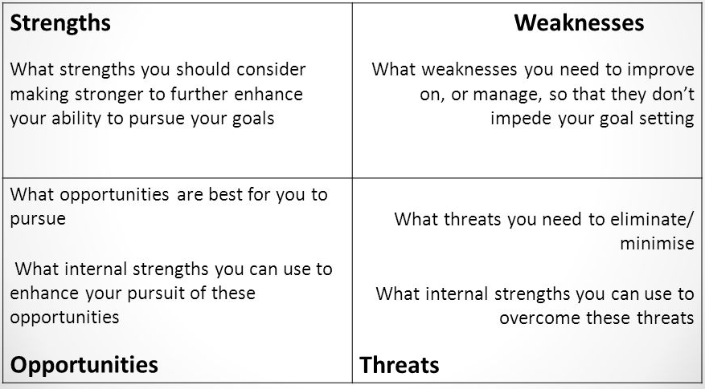
Time Management Tools
Time management indicates a range of skills, techniques, and tools to effectively manage time to achieve particular tasks, goals, and projectsThomas et al.,(2016).The set incorporates a wide scope of activities, and these involve distributing, planning, setting appropriate goals, allocation, the examination of time spent, monitoring, scheduling, organizing as well as prioritizing. The tool of time management begins with the commitment to bring influence. Time management is an easy going process as long as an individual commits to performing. The best step of time management skills includes
Planning
The key to effective time management skills includes proper planning. As being committed to a particular workplace, it is necessary to manage time effectively. When employees plan to manage time in the workplace, they suppose to then stick to that particular plan to accomplish a goal. The time management tool is significantly about conditioning an environment rather than allows the environment to condition itself. Time management has been classified as subsets of diversified concepts such as
Project Management
Time management usually considered as project management subset and is more significantly known as planning for the project as well as the schedule for the project. Time management in previous literature has been identified as a core principle of employability skills (Zamyadi et al.,2016).
Prioritization
Evaluating each responsibility according to priority is key to become a good time manager. Various ways employees can select to prioritize according to the requirement that needs to be accomplished. An employee should be committed to complete the task quickly and should follow simple items.
Accomplishment of Goals
Setting a particular goal is the basic step to become an effective time manager. The setting a particular goal allows an employee to look at the picture exactly as it is required. It also enables to prioritize goal that requires to be accomplished. Through setting both long term and short term goals usually lead to success in the career (Zaroh,2018).
Therefore,a time management tool is significant includes employability skills. The recruiters seek people who can not only manage time effectively and make adjustments towards priorities and deadlinesbut also provide quality within a short period (Stewart et al.,2016).

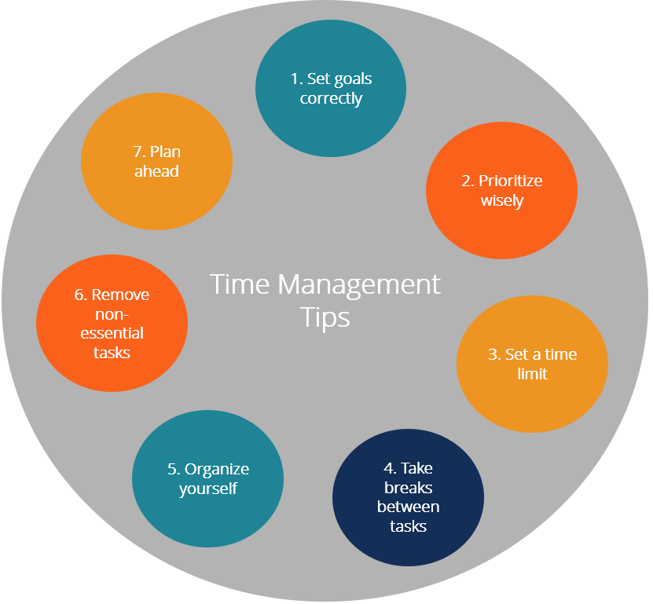
Figure 2 Time management tool
Reflection of Academic Progress
In the beginning, the module of employability seems to me as quite interesting and good within the global higher education. While taking classes and participation in activities gradually my interest develops towards the module topics. The module, in the beginning, taught us about employability skills and further about the tools we learned in class such as SWOT analysis, PDP and time management tools. In comparison to the end of term, I observed that lots of things that I learned such as how to do personal SWOT analysis, major academic and employability skills as well as PDP analysis.

References
Dany, F. and Torchy, V., 2017. Recruitment and selection in Europe Policies, practices and methods 1. In Policy and practice in European human resource management (pp. 68-88). Routledge.
Devi, N.S., 2018. Analysis of Employability Skills of Undergraduate Engineering Students in View of Employers Perspectives. International Journal of Research in IT and Management (IJRIM), 8(12).
Gavazza, A., Mongey, S. and Violante, G.L., 2018. Aggregate recruiting intensity. American Economic Review, 108(8), pp.2088-2127.
Jackson, D., 2016. Re-conceptualising graduate employability: The importance of pre-professional identity. Higher Education Research & Development, 35(5), pp.925-939.
Jean-Pierre, P. and Perrain, D., 2016. Combining Tourism Economic Account and Tourism Employment Module for a best measurement of tourism at a sub-national level. European Journal of Tourism Research.
Jeswani, S., 2016. Assessment of employability skills among fresh engineering graduates: A structural equation modeling approach. IUP Journal of Soft Skills, 10(2), p.7.
Rodríguez de Céspedes, B., 2017. Addressing employability and enterprise responsibilities in the translation curriculum. The Interpreter and Translator Trainer, 11(2-3), pp.107-122.
Smith, M., Bell, K., Bennett, D. and McAlpine, A., 2018. Employability in a global context: Evolving policy and practice in employability, work integrated learning, and career development learning.
Stewart, C., Wall, A. and Marciniec, S., 2016, July. Mixed signals: Do college graduates have the soft skills that employers want?. In Competition Forum (Vol. 14, No. 2, p. 276). American Society for Competitiveness.
Suleman, F., 2016. Employability skills of higher education graduates: Little consensus on a much-discussed subject. Procedia-Social and Behavioral Sciences, 228, pp.169-174.
Thomas, A., Piquette, C. and McMaster, D., 2016. English communication skills for employability: The perspectives of employers in Bahrain. Learning and Teaching in Higher Education: Gulf Perspectives, 13(1).
Zamyadi, A., Choo, F., Newcombe, G., Stuetz, R. and Henderson, R.K., 2016. A review of monitoring technologies for real-time management of cyanobacteria: Recent advances and future direction. TrAC Trends in Analytical Chemistry, 85, pp.83-96.
Zaroh, S., 2018. The Impact of Experimental Learning Techniques in Improving the Capability of Career Planning for Students. Islamic Guidance and Counseling Journal, 1(2), pp.45-52.

