LCBB4004
Marketing Fundamentals
Sameena Hassan
2023264
Lecturer : Umar Saddat

In this report, we will be providing a detailed report on how adaptation strategies helped local food producers from Quebec,Canada and how they had coped with the different initial challenges during the COVID-19 Pandemic.We will be using various marketing frameworks and theories to analyse our process. The covid – 19 pandemic has exhibited the vulnerability of food systems to disturbances and shown how the pliability and redundancy has authorised local farmers to adapt to the challenges during the global pandemic.
To begin with, we will be analysing the local food producers and how they had overcome the challenges using different strategies. I will start by using the SWOT analysis. The swot analysis is combined of strengths, weaknesses, opportunities and threats. It is a very essential tool that helps to analyse what a company is best at, and to devise a successful strategy for the future.
The strengths that courage the local farmers to enable their adaptation strategies to be stronger to overcome the problems during the pandemic was by restructuring their market and sales. This has been segregated into different categories such as replacement, streamlining, collaboration, redistribution, adjusting in the farming industry and last but not least outlet adjustment. As food is an important necessity to keep us alive, the food production industry will always be in demand. However there will just be periods like when the global pandemic of covid-19 occurred, where businesses and sectors will see a change in demand however will always be vital for us as this is a need and must for everyone around the world. Covid-19 pandemic had also bolstered the interest in and awareness for using local farmers for more fresh produce and allowing to give local custom as some people may like to travel out or use trusted or popular names and brands but using local farmers allowed them the opportunity and trust and has been a great response from there onwards.
Opportunities that local producers during the pandemic was to establish marking online and using it as a platform and way of income. For example using different marketing tools to promote online and gain custom and orders. This also gave local farmers the opportunity to increase their knowledge and confident using laptops and social media etc and different online tools just as surveys and websites. By using the different opportunities which has now become available to local farmers as online marketing which has increased their income.

Following onto the weaknesses and threats that local farmers had to overcome were workforce shortages during covid-19, having the capacity to be able to balance the food demand and supply alongside any convert to sales and the marketing channels. This also resulted in consequences to face any functioning and expansion problems and issues. After research, it shows that 40% of farmers had to implement drastic changes to some strategies such as their distribution aspect due to covid-19. There was an online research form which was sent to many farmers who are local food farmers in Quebec via direct marketing, which resulted in some problems in different sectors such as workforce shortages, being able to balance the food demand and supply alongside others. In the research, it was also identified that farmers had concerns of various coping and adaption measures which resulted to the most important impact fields.
We will now provide you with an insight of covering some impact fields and the challenges that were faced and what were the adaption strategies were and how they helped the discussed topic we will look into. To begin with, I would like to introduce the workforce, the challenges that were faced during covid 19 in Quebec were acquisition and the retention of the farm labour. The adaptation strategy that was used by accepting help from volunteers, as during covid – 19 there were lots of members of the public who were laid off work or made redundant which implanted that they had some spare time and in order to keep busy and in touch with the community they volunteered in farm labour. Moving onto the food supply and demand field which faced the challenges of changes in demand for specific materials or products which includes the increases and decreases or even the variability of an produce. The strategy which helped in the adaption was by changing the distribution strategy such as decrease in food production and production on demand.
For example when orders are placed and depending on numbers of the items required. Another impacted field was the distribution strategy and the different marketing channels The challenges that were faced were the measures that took place of some permanent closes of sales outlets and the temporary closures. This resulted in the different health and safety challenges for farm workers, farmers and the customers during covid 19. So the adaptable tool which was used to implement change and a positive forward change would be to really take an interest on, add or pause sales at marketing outlets and implementation of safety measures. Lastly the impacted sector would be another other operational and development issues which resulted in challenging development barriers of businesses which outcome in resources shortages at new expenses. The adaptation strategy which was implemented to overcome this was to introduce virtual meetings and calls with new clients and companies where they provided their goods too following with better planning at higher prices because knowing that consumers needed these goods as they are at essential which would be purchased at any cost.
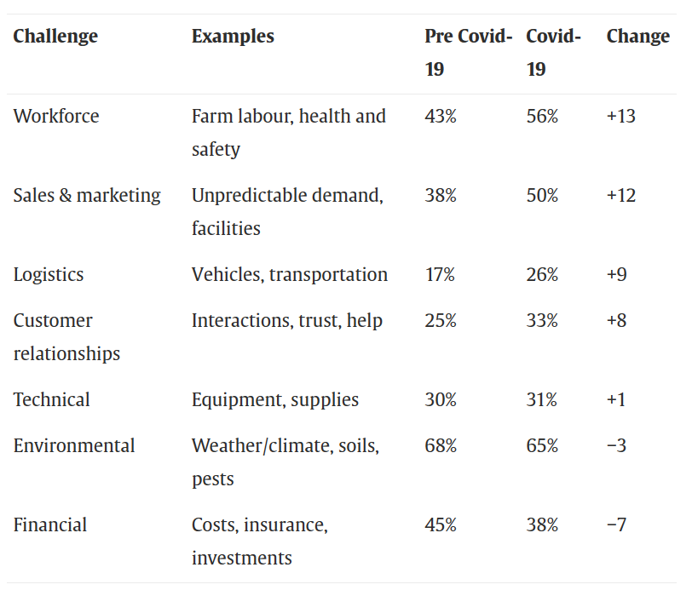
Looking at the pestle analysis tool which includes political, economic, social, technology, environmental and legal. We will now look to use some of these tools to identify how they can be used to overcome and be used to be adaptation challenges and be implemented for positive change for the future in Quebec. Many farmers in Quebec raised their concerns following covid that the pandemic had impacted their capacity to find farm workers, both due to the fact that systemic difficulties and how the local government had responded to the health crisis and how covid could impact a person with high risk illnesses. This would come under political and economic and social as this is being advised by the local government to be protected and isolate where and when possible which resulted in not many people of the local community feeling comfortable as this would put their families at risk if caught something and was at high risk which meant they had to be extra cautious. This also had resulted in shortage of finding farm workers when the travel restrictions had been introduced by the government which was to limit the risk of virus transmission. Local farmers therefore dealt with uncertainty around whether, when, and how temporary foreign workers could enter Canada at a key time permittingly. The Ministry of Agriculture and Fisheries Québec and Immigration, Refugees and Citizenship Canada (IRCC) announced that TFW were considered essential workers and allowed to enter and work in Canada after a 2-week quarantine Even once TFW were in Canada, one farmer explained, rapid turnover led to a workforce shortage during the peak season and a surplus during the lean season. Three farmers compensated temporary workforce gaps by hiring locals, which, as they explained, was often not an adequate replacement due to the lack of training. A local farmer who did not manage to fill the gap sufficiently had made it aware that the loss of several ten thousand pounds of high-value vegetables that could not be harvested which was a huge income loss. Some farmers also had to replace their usual international volunteers, so called “Wwoofers” (from “World Wide Opportunities on Organic Farms”), due to international travel restrictions. This is coming under the legal and political sector of the pestel analysis as this includes the law that was introduced during the pandemic in Quebec.
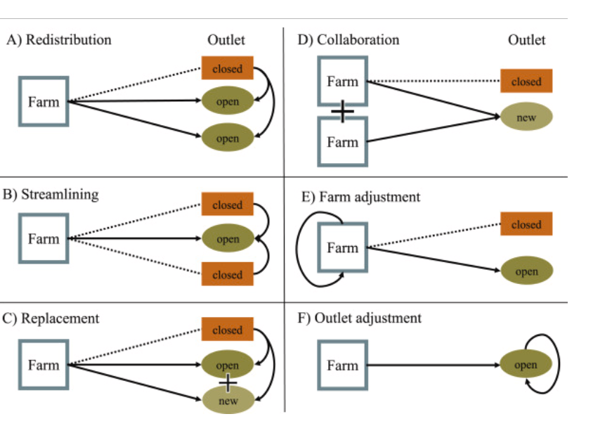

This graph shows the changes in the adaptation challenges that were implanted during covid. planning uncertainties in different ways, for instance, by redistributing food dedicated to restaurants to other outlets. Others decided to abandon outlets that they previously sold to in order to focus on the distribution of subscription vegetable baskets. This is identified in the pestel analysis at how there was social changes due to population growth.
Concluding this report on how Diverse adaptation strategies helped local food producers cope with initial challenges of the Covid-19 pandemic by making small and few changes such as marketing online and meeting and producing by demand which allowed less wastage taking all important details into consideration allowed to intake how the flexibility and redundancy among local farmers had eventually stabilized the local food cycle during covid. sing a mixed-method approach, our findings demonstrate that local farmers in Québec generally managed to address the diverse challenges (e.g., safety protocols, travel restrictions, and other public health measures) that they encountered in the first year of the pandemic (March 2020–March 2021). While many local farmers struggled due to the pandemic, others reported overall positive impacts on their sales and operations. For instance, many farmers benefited from the increased awareness of and demand for local food. Overall the adaptation was very positive for many local farmers as this allowed to explore different avenues such as social media and marketing online which as resulted in returning custom and a lifelong relationship with some consumers.

References :

Béné C. Resilience of local food systems and links to food security – A review of some important concepts in the context of COVID-19 and other shocks. Food Secur. 2020 (accessed 22nd June)

Diverse adaptation strategies helped local food producers cope with initial challenges of the Covid-19 pandemic: Lessons from Québec, Canada - PubMed (nih.gov) accessed 25th June 2023.

Untangling the role of social relationships for overcoming challenges in local food systems: a case study of farmers in Québec, Canada - PubMed (nih.gov) accessed 21st June 2023

CANADA | The Resilience of Farmers in Québec in the Fight Against Climate Change and COVID-19 - The Climakers

Diverse adaptation strategies helped local food producers cope with initial challenges of the Covid-19 pandemic: Lessons from Québec, Canada - ScienceDirect accessed 1st July 2023

