This presentation will cover the definition of organisational culture and the modules in order to analyse the culture and context of Tesco supermarket store such as cultural web and pestle analysis.

Managers of the organisation must put organisational culture into application simply because in the workplace, culture has control of the way how employees behave amongst oneself including with people outside the organisation (Managementstudyguide.com, 2020).

Organisational Culture

According to Buchanan and Huczynski (2017),

“Organisational culture is the shared values, beliefs and norms which influence the way employees think, feel and act towards others inside and outside the organisation”

There are many different models to analyse organisational culture such as cultural web, Handly’s model and Deal and Kennedy model. The researcher will be discussing cultural web as it identifies problems and issues that occur in the organisation.

Cultural Web

The cultural web was created by Gerry Johnson and Kevin Scholes in 1992. It is made up of six elements shown below on the diagram (OPM,2020).

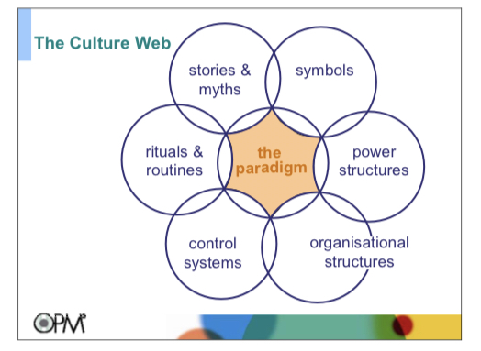

Cultural web provides a method for recognising and changing the organisation’s culture. When one uses it, one can reveal cultural practices and assumptions, and proceed to aligning elements of an organisation with one another and with one’s strategy (Mindtools, 2020).

For example, this is how cultural web is applied to Tesco.
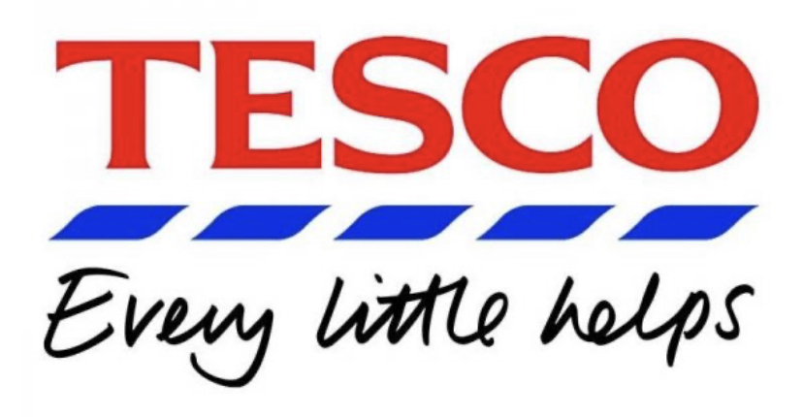

Stories- According to The Grocer article (2018), Tesco is cheaper than its competitors.

Symbols- Tesco’s logo is derived from the British flag – red means prosperity and happiness while blue means trust worthiness and excellence (Birmingham mail, 2020).

Power structures- Store manager, head office (Tesco-careers, 2020).

Organisational structures- Hierarchal structure is present in Tesco. It is mainly a functional structure due to it focusing on different departments in the organisation. It is used because the organisation is large and has multiple layers within it (Hierarchical structure, 2020).

Control systems- Quality products, health and safety (Tesco PLC, 2020).

Rituals and routines- Long service awards, once a year Tesco holds an award ceremony to recognise and celebrate the hard work of the employees (Our Tesco, 2020).

There are many different models to analyse the context of an organisation such as SWOT and Pestle analysis. The researcher will discuss the Pestle analysis.

Pestle analysis

Pestle analysis was created by Francis Aguilar (Mindtools, 2020). Pestle analysis describes a structure of macro-environmental factors that are used in the environmental scanning component of strategic management. Pestle is made up of six factors shown below in the diagram (CIPD,2020).
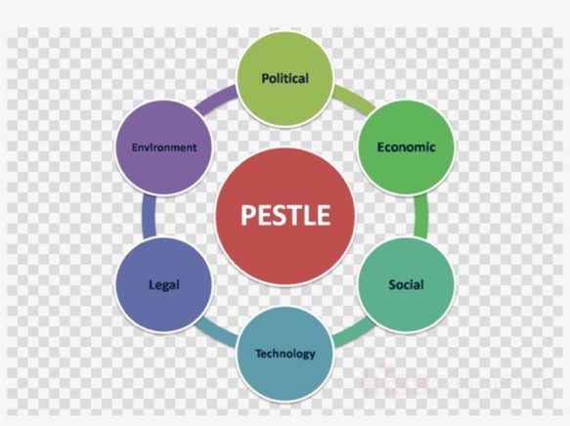

For example, this is how Pestle is applied to Tesco.

Political – Lockdown caused from Covid-19 resulted in Tesco paying employees sick pay to those have been affected and over 70’s of age employees off work for 12 weeks paid leave (CNN, 2020).

Economic – Due to Brexit supermarkets have risen prices of products. Tesco is determined to keep its prices low to ensure customers can afford (The Guardian,2017).

Social – Five generation workforce, 9,000 jobs at risk (The Guardian, 2019).

Technology – According to The Telegraph (2019), Tesco is launching cashier less services in order to compete with competitors Amazon.

Legal – Tesco faced legal action from employees regarding a pay dispute (BBC News, 2016).

Environmental – Tesco selling sustainable product (Tesco PLC, 2016).

To summaries, the researcher has defined what organisation culture is and discussed cultural web, pestle analysis, gave an example how it is applied in order for a manager to understand and apply to one’s organisation.

This is the link of the presentation: https://youtu.be/_duR07eAjuA

Reference:

Amp.theguardian.com (2017) Tesco says price rises are last resort as UK growth hits seven-year high [Online] Available at: https://amp.theguardian.com/business/2017/jun/16/tesco-price-rises-uk-growth-inflation-pound-brexit (Accessed on 30/5/2020)

Amp.theguardian.com (2019) Tesco confirms 9,000 jobs at risk as it axes fresh food counters | Tesco [Online] Available at: https://amp.theguardian.com/business/2019/jan/28/tesco-jobs-fresh-food-counters-supermarket--staff (Accessed on 30/5/2020)

BBC News (2016) Tesco faces legal action from staff in pay dispute [Online] Available at:
https://www.bbc.co.uk/news/amp/business-37671752 (Accessed on 30/5/2020)

Buchanan, David A, and Huczynski, Andrzej (2017) organisational behaviour, 9th edition, Harlow, Pearson, P109.

Birmingham mail (2020) This is why supermarket logos are certain colours [Online] Available at: https://www.birminghammail.co.uk/whats-on/shopping/supermarket-logos-certain-colours-12772238 (Accessed on 28/5/2020)

CIPD (2020) Pestle analysis [Online] Available on YouTube at: https://youtu.be/GFVKKTwkANY (Accessed on 28/5/2020)

CNN (2020) Why the UK’s biggest grocer is unlikely to profit from booming sales [Online] Available at: https://amp.cnn.com/cnn/2020/04/08/business/tesco-coronavirus-sales/index.html (Accessed on 28/5/2020)

Hierarchy Structure (2020) Tesco Management Hierarchy | Tesco Organisational Structure [Online] Available at: https://www.hierarchystructure.com/tesco-management-hierarchy/amp/ (Accessed on 28/5/2020)

Managementstudyguide.com (2020) Importance of Organisation Culture [Online] Available at https://www.managementstudyguide.com/importance-of-organization-culture.htm (Accessed on 28/5/2020)

Mindtools.com (2020) The cultural web: Aligning your organisation’s culture with strategy [Online] Available at https://www.mindtools.com/pages/article/newSTR_90.htm (Accessed on 28/5/2020)
OPM (2020) Understanding culture and change [Online] Available at: https://moodle.uwtsd.ac.uk/pluginfile.php/292615/mod_resource/content/1/Cultural-Web-Questions.pdf (Accessed on 28/5/2020)
Tesco-careers.com Stores – Management | Tesco Careers [Online] Available at: https://www.tesco-careers.com/stores-and-distribution/management-colleagues/stores/ (Accessed on 28/5/2020)

Tesco PLC (2020) Product [Online] Available at: https://www.tescoplc.com/sustainability/product/ (Accessed on 28/5/2020)

The Grocer (2020) Can Tesco convince consumers it’s cheaper than Aldi and Lidl [Online] Available at: https://www.thegrocer.co.uk/prices-and-promotions/can-tesco-convince-consumers-its-cheaper-than-aldi-and-lidl/572624.article (Accessed on 28/5/2020)

Our Tesco (2020) What you can expect from us [Online] Available at: https://www.ourtesco.com/your-benefits/what-you-can-expect-from-us/ (Accessed on 28/5/2020)

Telegraph.co.uk (2019) Tesco turns to cashier less stores as competition with Amazon heats up [Online] Available at: https://www.telegraph.co.uk/technology/2019/06/26/tesco-turns-cashierless-stores-competition-amazon-heats/amp/ (Accessed on 30/5/2020)

Tesco PLC (2020) Five ways we’re reducing our impact on the environment [Online] Available at: https://www.tescoplc.com/blog/reducing-environmental-impact-when-sustainably-sourcing-tesco-products/ (Accessed on 30/5/2020)

