PAGILA Rental Database SELECT Query Exercise

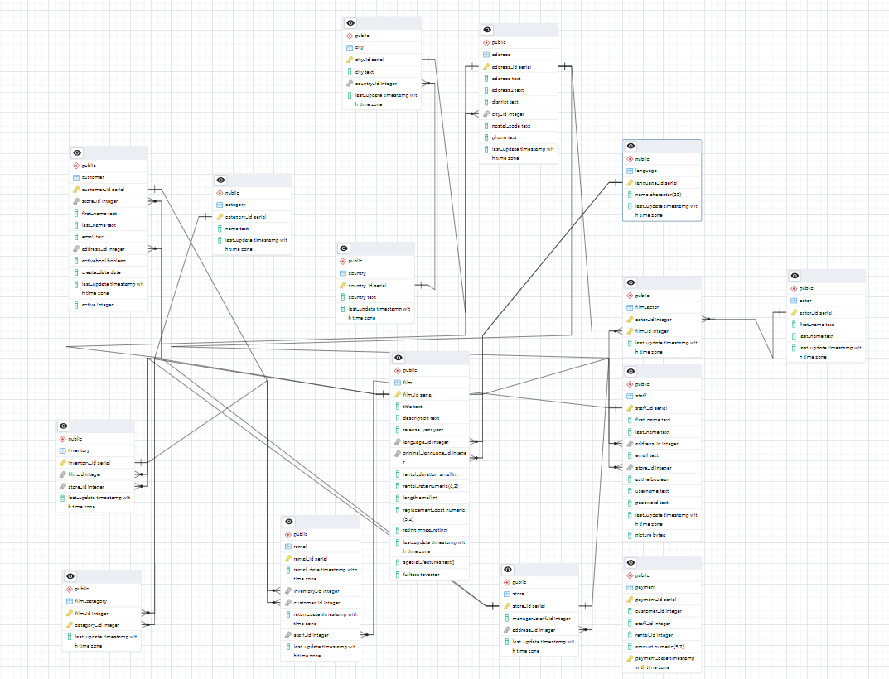

Above is the ERD for the Pagila movie rental database.
This can be installed through PGAdmin using the two SQL files on Moodle named:
- pagila-schema.sql
- pagila-insert-data.sql

Below are 30 SELECT query questions to practice with. The questions, covering a broad spectrum of SQL skills, from basic selection to complex subqueries and joins, get progressively more complex. Answer as many as you can.

Basic SELECT Queries
- Retrieve all customer names (first and last).

- Get the email and address ID of customers who have provided an email.

- Show customers who have an active status (activebool = true).

- Retrieve all distinct store IDs from the customer table.

Conditional Queries
- List customers created after January 1st, 2020.

- Get customers whose first name starts with 'A'.

- Retrieve customers who are inactive (activebool = false).

- Show customers whose last update was within the last month.

Aggregate Functions
- Count how many customers are in the database.

- Find the number of active customers.

- Get the average customer active score.

- Find the maximum customer_id in the customer table.

GROUP BY and HAVING
- Count how many customers there are per store.

- Get the number of customers per store where the count is greater than 50.

JOINs
- List all customers along with their address details (join customer and address tables).

- Get all customer emails and the city they live in (join customer, address, and city).

- Show the store ID and the number of customers per store (using JOIN with store table).

- Find all films rented by customers (join rental, customer, and film).

- List all active customers and the date they last rented a film.

Subqueries
- Find the customer with the highest number of rentals.

- Get a list of customers who rented a specific film (e.g., 'The Godfather').

- Find customers who have not rented any films.

- Get the name of the store with the most active customers.

- Find customers whose last name appears more than once in the database.

Complex Queries
- Retrieve the total number of films rented by active customers.

- List all customers who rented films from store 1 and store 2.

- Get the name of the film rented the most in 2023.

- Find the store with the highest revenue from rentals.

- Get the list of customers who have rented more than 5 films in a month.

- Find the name of customers who have rented every available film.

