

Student Name | Somi Naz
Student ID | 2421930
Programme | BSc Health and Social Care
Module | Changemakers: Creativity and Value Creation
Module Code | BMHP5014
Lecturer | Tomy Adattu Chacko
Assignment Title | Component 2 – Academic Poster & Written Pitch Guidance

Table of Contents
Introduction: The Issue and Proposed Innovation 1
How CareConnect AR Works 1
Target Audience and Expected Impact 1
Implementation Plan and Timeline 2
Policy, Legislation and Professional Standards 2
Value, Feasibility and Future Recommendations 2
Conclusion and Call to Action 3
Reference List 4

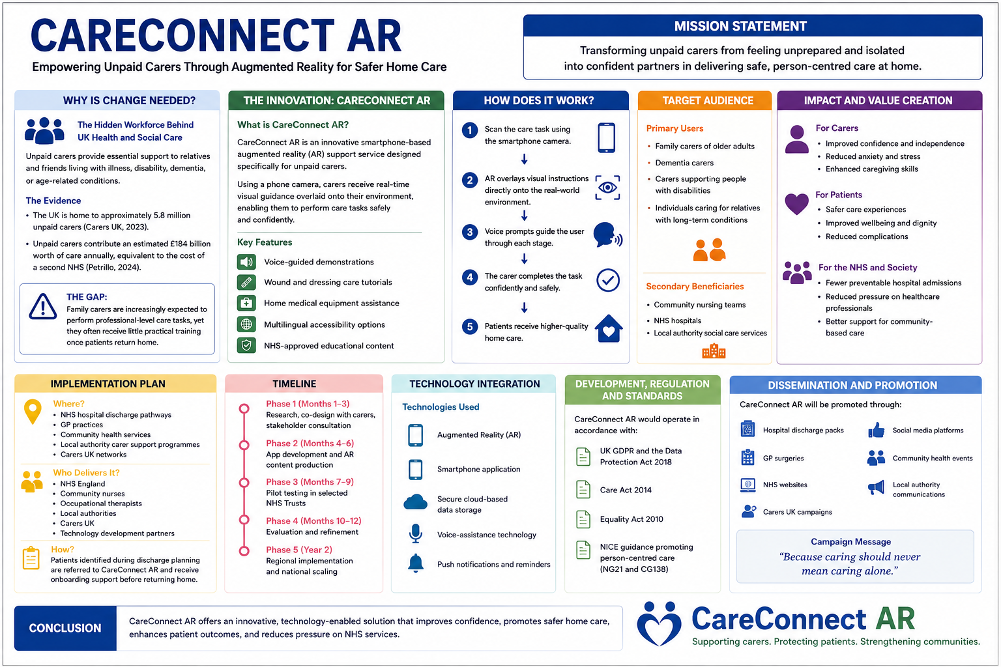

CareConnect AR: Empowering Unpaid Carers Through Augmented Reality for Safer Home Care

Pitch

Introduction: The Issue and Proposed Innovation
This proposal is going to be shared with NHS leaders, NHS policy makers, local authorities, and carers organisations within the UK. Unpaid carers have a vital role within UK’s health and social care framework but are not widely acknowledged (Redican et al., 2024); they support family members and friends who have an illness, disability, dementia or long-term health condition. With more and more care and services moving out of hospital settings, carers are being asked to perform complex care activities with little or no didactic training or support (Bou, 2023). I believe a comprehensive care support service using Augmented Reality would be the solution to address this challenge, namely CareConnect AR, a service framework that would provide real-time guidance for caregiving activities. This pitch aims to show the benefits of CareConnect AR regarding carer confidence, patient safety and community-based care.

How CareConnect AR Works?
CareConnect AR is an Augmented Reality smartphone application that allows care staff to receive interactive, step-by-step support while completing care tasks in the home. Using the phone camera, users can see visual instructions and voice-guided prompts that appear over the background image of care (Kostadimas, Kasapakis and Kotis, 2025). Medication Administration Support, safe moving and handling guidance, wound and dressing care tutorials and assistance with medical equipment are among the key features. CareConnect AR offers practical assistance, e.g., info on the point of need without relying on leaflets or written instructions. The system provides on-the-spot feedback to the carers, enhancing their ability to execute tasks with greater precision, alleviating uncertainty, and building confidence, all while ensuring safer and more effective patient care.

Target Audience and Expected Impact
CareConnect AR is used principally by family carers for older adults, individuals caring for relatives with long-term health conditions, dementia carers and those supporting a person with a disability. One of the things these groups often do without proper training is provide care for others in challenging situations, and there is a higher risk of stress, anxiety and burnout (McAtee et al., 2021). CareConnect AR is an innovation to support carers and augment their knowledge, skills and confidence in the safe provision of their care. With the increased capabilities of carers, patients should have higher levels of safety, wellbeing and continuity of care in their own homes. The innovation has broader health and social care advantages as it contributes to minimising avoidable hospital admissions and alleviating pressure on NHS resources. CareConnect AR helps advance the shared good by investing in the care of unpaid carers, which supports more sustainable, person-centred and community-based care.

Implementation Plan and Timeline
I aim to work closely with NHS England, community nurses, occupational therapists, local authorities, Carers UK and technology development partners to effectively deliver CareConnect AR. The project would start by engaging unpaid carers in a co-design process, with a three-month user-research phase, to ensure that the platform is relevant to the real world. The application and AR training content would be created based on clinical understanding and user feedback in months 4-6. Pilot testing would then be conducted between months seven and nine in selected NHS Trusts to assess usability, safety and effectiveness in selected NHS Trusts. After testing and refinement over the course of the months 10–12, the innovation would be available for broader use. Creatively, CareConnect AR could be deployed at a regional level and expanded nationally by year two. The successful implementation of this would need funding, digital infrastructure and clinical expertise, as well as user-friendly training materials.

Policy, Legislation and Professional Standards
CareConnect AR is purposely aligned to relevant key health and social care policies and professional standards in the UK. The innovation reflects the ambitions of the Care Act 2014 (GOV.UK, 2014) that encourages and promotes wellbeing and helps carers to carry out their caring role. The focus on digital innovation, community-based care, and better patient outcomes with the NHS Long Term Plan (Department of Health and Social Care, 2019) also resonates with this. All personal data will be protected and regulated according to UK GDPR and Data Protection Act (UK Government, 2025) to protect the users. Adhering to the Equality Act 2010 (GOV.UK, 2010), NHS Digital specifications, and NICE (2025) person-centred care guidance, would provide accessibility, patient safety, data security, and equal access services for a range of populations nationally in the UK.

Value, Feasibility and Future Recommendations
For carers, patients and the wider health and social care system, these are significant benefits of CareConnect AR. It offers practical, real-world advice and guidance which enables unpaid carers to provide safer and more confident care at home. This can help to improve patient outcomes, reduce unnecessary complications and potentially reduce hospital admission rates, thus reducing the pressure on NHS resources. Additionally, improving carers’ skills will help to create sustainable care in the community. Challenging factors are different degrees of digital literacy, budget constraints, and technology resistance (Rousaki et al., 2024).
These challenges can be overcome by designing an app simply and openly, offering access to free training from the NHS and pilot testing the application prior to introducing it nationally. Future plans for CareConnect AR include embedding its AI-driven personalised guidance (Singh et al., 2024) directly into NHS App services, expanding the program to more settings, and ultimately rolling out the programme across the UK.

Conclusion and Call to Action
There are significant gaps in support for people providing complex care in the UK health and social care system, despite the critical nature unpaid carers play in this system. CareConnect AR delivers a unique and innovative solution for carers, patients and the NHS that is realistic and scalable. This will inspire NHS leaders, policy makers, and healthcare organisations to fund, pilot, and invest in the future of CareConnect AR as a way to help make care safer, more confident, and more sustainable in our communities.

Reference List
Bou, C. (2023) ‘Factors Associated with the Quality-of-Life of Young Unpaid Carers: A Systematic Review of the Evidence from 2003 to 2019’, International Journal of Environmental Research and Public Health, 20(6), pp. 4807–4807. Available at: https://doi.org/10.3390/ijerph20064807.
Carers UK (2023) Key facts and figures, Carers UK. Available at: https://www.carersuk.org/policy-and-research/key-facts-and-figures/ (Accessed: 12 June 2026).
Department of Health and Social Care (2019) NHS Long Term Plan Launched, GOV.UK. Available at: https://www.gov.uk/government/news/nhs-long-term-plan-launched (Accessed: 12 June 2026).
GOV.UK (2010) Equality Act 2010, Legislation.gov.uk. Gov.uk. Available at: https://www.legislation.gov.uk/ukpga/2010/15/contents (Accessed: 12 June 2026).
GOV.UK (2014) Care Act 2014, Legislation.gov.uk. Available at: https://www.legislation.gov.uk/id/ukpga/2014/23 (Accessed: 12 June 2026).
Kostadimas, D., Kasapakis, V. and Kotis, K. (2025) ‘A Systematic Review on the Combination of VR, IoT and AI Technologies, and Their Integration in Applications’, Future Internet, 17(4), p. 163. Available at: https://doi.org/10.3390/fi17040163.
McAtee, R.E. et al. (2021) ‘Caregiver Burden: Caregiving Workshops Have a Positive Impact on Those Caring for Individuals With Dementia in Arkansas’, Journal of Patient Experience, 8, p. 237437352110180. Available at: https://doi.org/10.1177/23743735211018085.
NICE (2025) Person-centred working | Tools and resources | Home care: delivering personal care and practical support to older people living in their own homes | Guidance | NICE, www.nice.org.uk. Available at: https://www.nice.org.uk/guidance/ng21/resources/tailored-resource-2433814097/chapter/Person-centred-working (Accessed: 12 June 2026).
Petrillo, M. (2024) New Report: Valuing Carers: 2021/22, the value of unpaid carers in the UK, the Centre for Care. Available at: https://centreforcare.ac.uk/updates/2024/11/new-report-valuing-carers-uk/ (Accessed: 12 June 2026).
Redican, E. et al. (2024) ‘The prevalence, characteristics, and psychological wellbeing of unpaid carers in the United Kingdom’, Social Psychiatry and Psychiatric Epidemiology, 60(4). Available at: https://doi.org/10.1007/s00127-024-02745-8.
Rousaki, A. et al. (2024) ‘The digitalisation of social care in England and the implications for older unpaid carers: a constructionist thematic analysis (Preprint)’, Journal of Medical Internet Research, 26, pp. e60056–e60056. Available at: https://doi.org/10.2196/60056.
‌Singh, P. et al. (2024) ‘Patient Guidance and Remote Care With AI and AR’, Advances in healthcare information systems and administration book series, pp. 139–178. Available at: https://doi.org/10.4018/979-8-3693-8552-4.ch005.
UK Government (2025) Data Protection Act, Gov.uk. www.gov.uk. Available at: https://www.gov.uk/data-protection (Accessed: 12 June 2026).

‌

