Urban Aroma Coffee


www.urbanaromacoffee.com

Student: Fatima Galbiade Fernandes
Submission Date: 29-03-2026
Lecturer: Toyin Adisa

Table of Contents
- Executive Summary 3
- Business Concept 4
- Business Description 4
- Production Description 4
- Business Objectives (SMART) 4
- Market Analysis and Marketing Plan 5,6
- PESTEL Analysis 6
- SWOT Analysis 7
- Marketing Mix (4Ps) 8
- Orgarisational Chart 9
- Financial Plan (One Year) 10
- Cash Flow Forecast 11
- Sales Forecast & Production Break down 12
- Break-Even Analysis 13
- Operations and Management Plan 14
- Reference List 15

Executive Summary
Urban Aroma Coffee is a business that offers high-quality coffee in a modern and comfortable place. It is located in a busy urban area with many people. The business serves workers, students, and people who like special coffee. It offers premium products and a different experience.
The initial investment is £80,000. The business expects to return this investment in 24 months. The idea is to combine good coffee, sustainability, and customer experience.

Business Concept
Urban Aroma Coffee focuses on the coffee experience. It offers good quality products, a comfortable place, and friendly service. The business includes eat-in, take-away, and online orders.

Business Description
The company will be a limited business located in London. The shop will be in a busy area, near universities or offices. The mission is to offer excellent coffee with social and environmental responsibility. The vision is to become a popular local coffee shop.

Product Description
- Special coffee (espresso, cappuccino, latte)
- Other drinks (tea and plant-based drinks)
- Bakery products
- Vegan and gluten-free options
The difference is the use of sustainable coffee beans and controlled preparation.

Business Objectives (SMART)
Short Term (less than 1 year):
- Reach break-even in 12 months
- Serve 200 customers per day
- Build strong online presence
Long Term (more than 1 year):
- Open a second shop in 3 years
- Create own coffee brand
- Develop loyalty program

Market Analysis and Marketing Plan
Market Analysis (Competitors, Customers, Target Groups)
Competitors
There are many coffee shops in the market. Big companies like Starbucks and Costa Coffee are very popular. There are also small local cafés.
Big companies have strong brands and lower prices. Small cafés focus on quality and good service. Urban Aroma Coffee will offer good coffee, a nice place, and friendly service.
Customers
The main customers are:
- Office workers
- Students
- People who like coffee
These customers want good coffee, fast service, and a comfortable place.
Target Groups
Market Segmentation
- Age: 18 to 40 years old
- Location: city centre (London)
- Lifestyle: people who like modern and quality products
- Behaviour: people who drink coffee often
Targeting
The main target is young people and workers who buy coffee every day and like good quality.
Positioning
The café will be a modern coffee shop with good quality and fair prices. It will be a good place to relax, study, or meet friends.

Marketing Plan
Reaching Your Audience
- Social media (Instagram, TikTok)
- Google Maps
- Promotions and discounts
Promotion Strategy
- Opening discounts
- Special offers
- Loyalty cards
- Small events
PESTEL Analysis
Factor | Impacts on the Business
Political | The business must follow government rules and health regulations. The café needs licenses to operate legally. Changes in government policies can affect costs and operations.
Economic | Inflation can increase the cost of coffee, milk, and other products. Customer income affects spending. Economic problems can reduce sales.
Social | Coffee culture is growing and more people drink coffee every day. Customers like comfortable places to relax or work. Many people prefer healthy and sustainable products.
Technological | The café can use POS systems to improve service. Delivery apps help increase sales. Social media is important for marketing.
Environmental | Customers prefer eco-friendly businesses. The café should use recyclable materials and reduce waste. Sustainable coffee improves brand image.
Legal | The business must follow food safety and hygiene laws. Employment laws must be respected. Legal problems can cause fines or closure.

SWOT Analysis
Strengths
- High quality coffee products
- Good location in a busy area
- Friendly service and comfortable environment
Weaknesses
- High initial investment
- New brand with low recognition
- Dependence on suppliers
Opportunities
- Growing demand for coffee shops
- Increase in coffee culture
- Opportunity to expand business in the future
Threats
- Strong competition from big brands
- Price changes in raw materials
- Economic problems can reduce customers

Marketing Mix (4Ps)
Product
The café offers high-quality coffee, drinks, bakery products, and healthy options. The focus is on quality and customer experience.
Price
Prices will be competitive but slightly higher than average because of better quality. The café will offer value for money.
Place
The café will be located in a busy area in London. It will also offer take-away and online orders.
Promotion
The café will use social media, promotions, discounts, and loyalty cards to attract customers.
Management Team
- CEO (Owner): Responsible for business decisions, strategy, and management.
- Head Barista: Responsible for coffee preparation and product quality.
- Operations Manager: Responsible for daily operations and staff management.

Organisational Chart
Below is an overview of the planned organisational structure of the business. The number of staff, including baristas, admin, HR, and marketing staff, will increase in line with business growth.
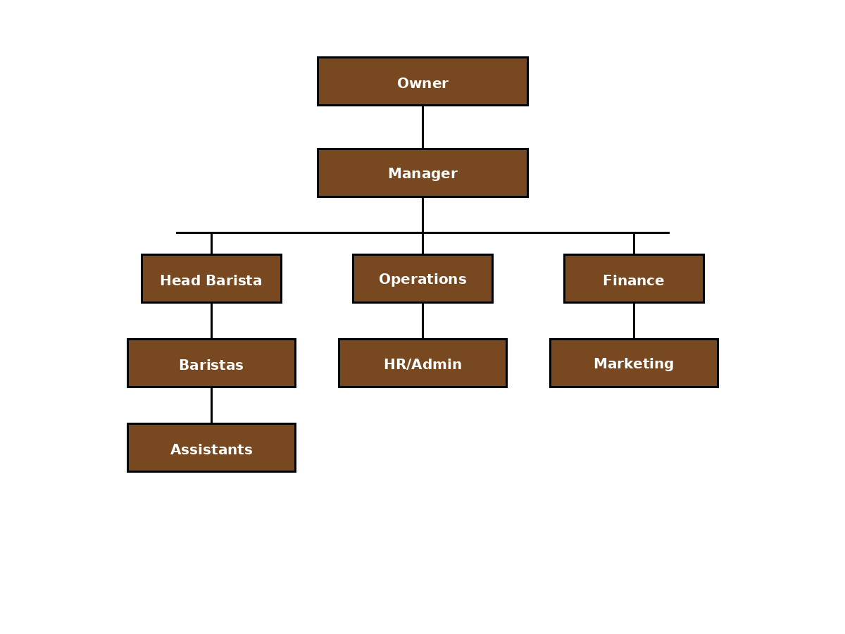

Financial Plan (One Year
Sources of Finance
Funding from a Loan £50.000
Personal Investiment into the Business £35.000
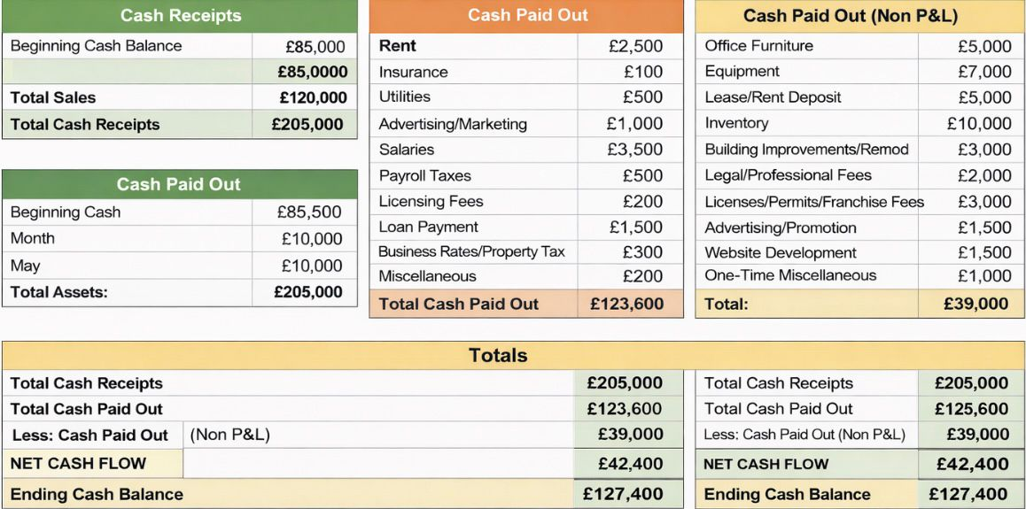

Cash Flow Forecast
Predicted positive cash flow by the end of the firt financial year.

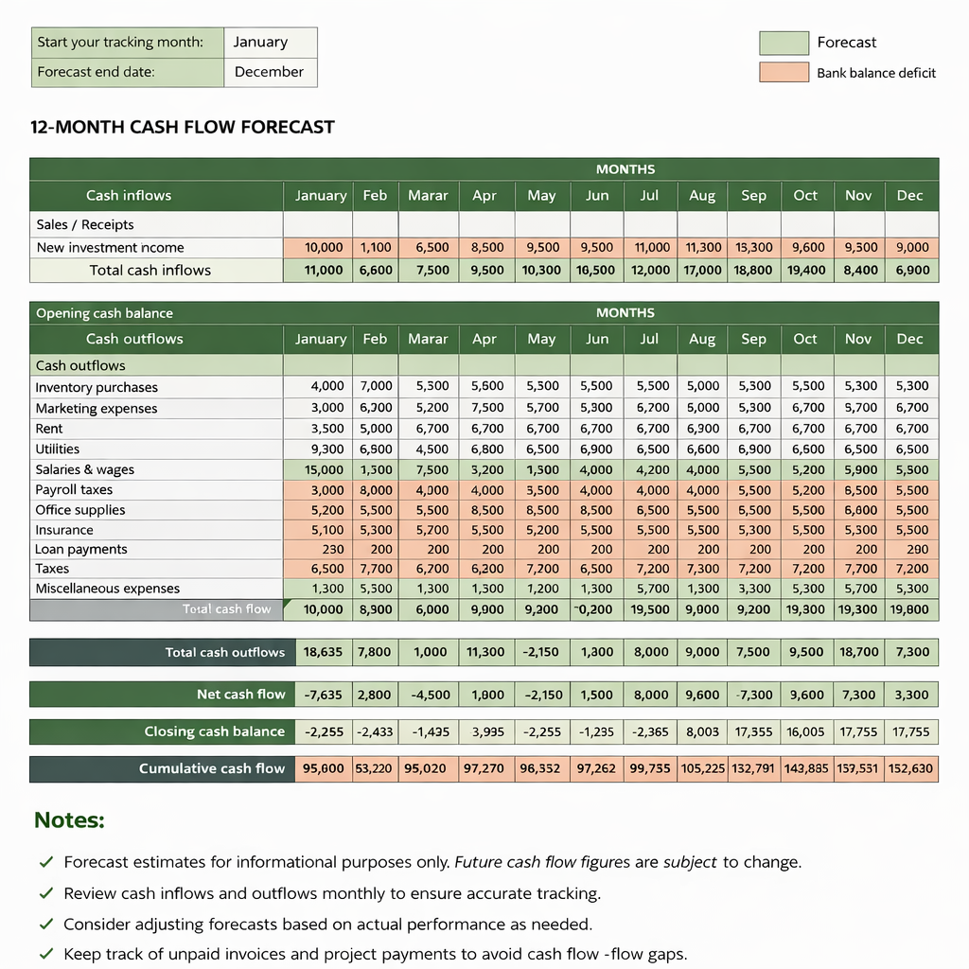

Sales Forecast & Production Breakdown
The below shows the projected sales expectel for the first financial year.

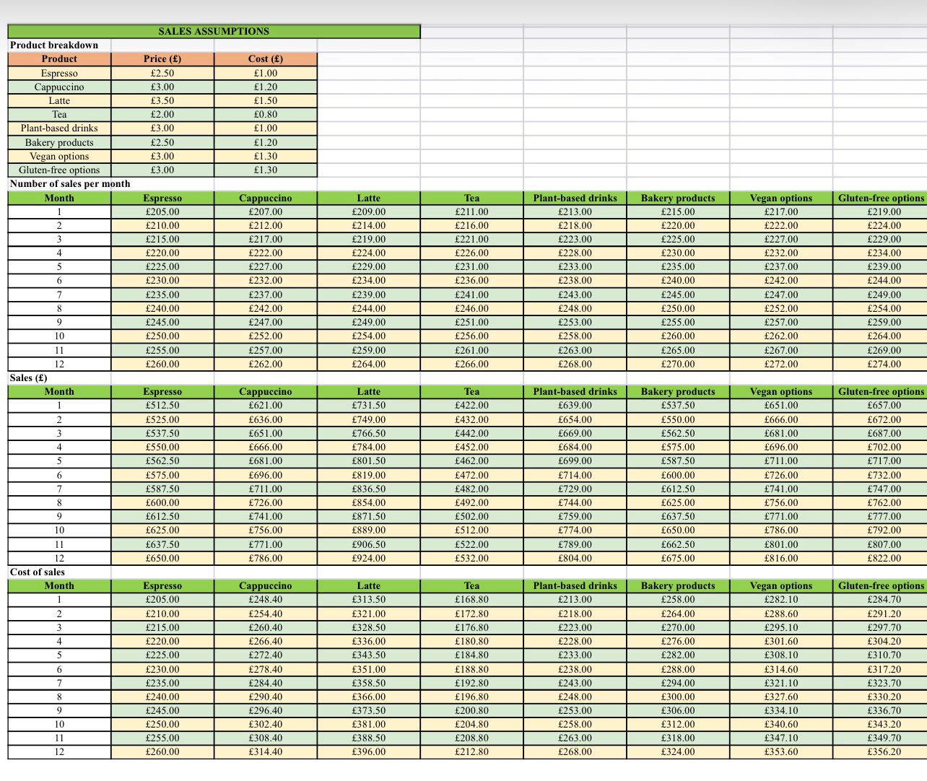

Break-Even Analysis
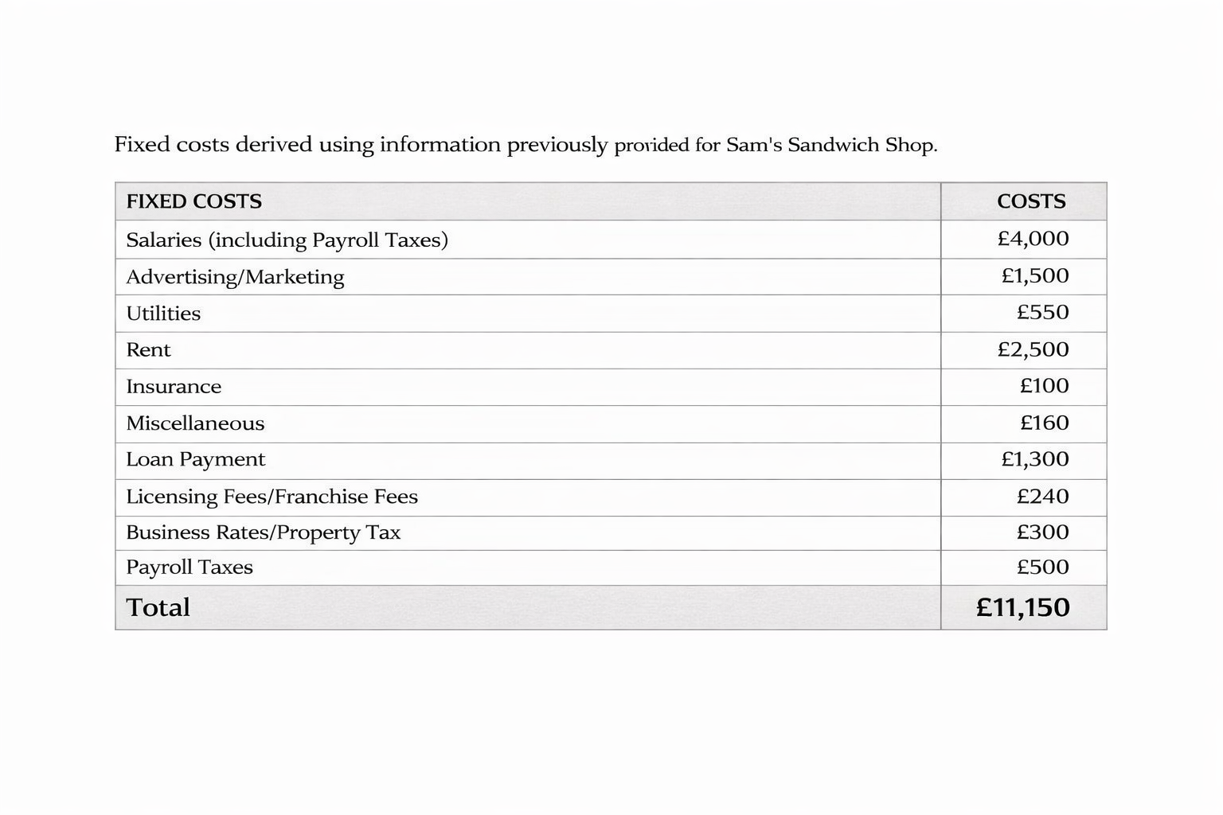

Operations and Management Plan

Production of Goods and Services
Urban Aroma Coffee will serve high-quality coffee, drinks, and baked goods.
• Coffee and drinks are made daily with fresh beans.
• Baked goods are made in-house or by trusted local suppliers.
• Daily quality checks for taste and presentation.
• Weekly inventory control for stock and expiry dates
Technology Plan
Technology will help manage the store and improve customer experience.
• POS system for sales and inventory tracking.
• Accounting software for cash flow and payments.
• Social media and loyalty programs for marketing.
• Data security and automatic backups.
Human Resource Plan
The team is trained to provide good service and manage operations.
• Staff: 4 baristas, 1 operations manager, 1 finance/marketing.
• Training: customer service, food safety, and production.
• Benefits: competitive salaries and bonuses for performance.
Expansion Plan
The café will grow step by step:
• Short-term: keep current store running and increase customers.
• Medium-term: open a second location in 3 years.
• Long-term: expand brand through franchises or licensing.
• Funding: use profits or small loans for expansion.

Reference List

Statistica. (2025) Average price for a cup of coffee in the UK in 2025, by region. Statistica.com. Available at: https://www.statista.com/statistics/coffee-prices-uk (Accessed: 29 March 2026).
Small Business Price Index. (2025) Typical operating costs for a coffee shop UK. SmallBusinessPriceIndex.co.uk. Available at: https://smallbusinesspriceindex.co.uk/costs/coffee-shop (Accessed: 29 March 2026).
Office for National Statistics. (2025) Commercial rental price index, London. ONS.gov.uk. Available at: https://www.ons.gov.uk/businessindustryandtrade/propertyincome/datasets/commercialrentalpriceindex (Accessed: 29 March 2026).
Glassdoor. (2025) Average barista salary in London. Glassdoor.co.uk. Available at: https://www.glassdoor.co.uk/Salaries/barista-salary-London (Accessed: 29 March 2026).

