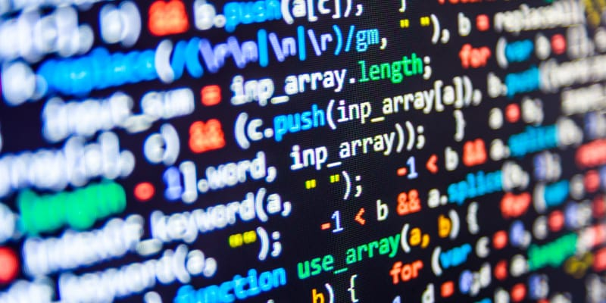
2026
Darina Tsoneva
2423106
6/30/2026

Scripting and Programming Concepts

Contents
1. Analysis 1
1.1 Introduction 1
1.2 Problem Decomposition and Abstraction 1
1.3 Requirements Analysis 2
2. Software Design and Development 3
2.1 Design 3
2.1.1 System Flowchart 3
2.2 Implementation Decisions 6
2.2.1 Data Structures 6
2.2.2 Programming Constructs 7
2.2.3 Python Modules and Libraries 8
2.3 Source Code 8
3. Testing and Debugging Report 8
3.1 Importance of Programme Testing 8
3.2 Types of Programming Errors 9
3.3 Test Cases and Evidence 9
3.4 Debugging Process 11
4. Evaluation 11
4.1 Challenges Faced 11
4.2 Future Improvements 11
4.3 Self-Reflection 12
References 12

1. Analysis

1.1 Introduction
Bright Minds Academy is a small private tutoring centre that has recently begun piloting a smart classroom environment. The aim of this initiative is to improve the efficiency of classroom management through the use of connected smart devices such as projectors, interactive displays, thermostats, smart lighting systems and other Internet of Things (IoT) technologies. These devices are intended to enhance the learning experience while reducing the amount of manual intervention required by tutors and administrative staff. At present, however, the academy manages these devices using informal methods such as paper records, spreadsheets and staff memory. Although this approach may be sufficient when only a small number of devices are deployed, it quickly becomes inefficient as the number of classrooms and connected devices increases. Staff often struggle to determine which devices belong to particular classrooms, whether a device is currently operational, or whether maintenance is required. This can lead to devices being unnecessarily left switched on, equipment remaining unavailable because faults have not been reported promptly, and confusion when multiple members of staff attempt to manage the same resources. The absence of a centralised device management system therefore creates several operational challenges. Firstly, administrative staff spend additional time manually checking equipment before classes begin. Secondly, there is an increased risk of inaccurate records due to human error, particularly when devices are moved between classrooms or their operational status changes during the day. Finally, without a structured method of recording information, management cannot easily obtain an overview of the current condition of all classroom equipment. The objective of this project is to develop a simple Python application that allows staff to maintain an organised record of smart classroom devices. Rather than controlling physical IoT hardware directly, the application simulates a simplified device management system by allowing users to add devices, update their operational status, display all recorded devices and search for individual devices. The system therefore acts as a lightweight management tool that models the information displayed by a commercial device management dashboard while remaining achievable within the scope of this assignment. The assignment brief specifically limits the solution to the use of Python programming constructs together with lists and dictionaries rather than databases or external software frameworks. Consequently, all device information exists only during program execution and is stored in memory. This design decision ensures that the project focuses on demonstrating core programming concepts including abstraction, decomposition, modular programming, iteration, selection, validation and data structures instead of advanced database implementation. The software development process followed a simplified Waterfall Software Development Life Cycle (SDLC). The Waterfall model divides software production into sequential phases including analysis, design, implementation, testing and evaluation. Each phase produces outputs that become the inputs for the next phase, allowing requirements to be clearly understood before programming begins. Since the assignment requirements were fully defined before development commenced and the overall system is relatively small, the Waterfall approach provided an appropriate level of structure. Unlike Agile development, which relies on frequent customer feedback and repeated iterations, this project benefited from careful planning and documentation before coding commenced. Following a structured development methodology also reduced the likelihood of introducing unnecessary functionality that was outside the project scope. By completing the analysis stage before implementation, it became possible to identify the exact functionality required, determine suitable data structures and establish clear relationships between the project requirements and the eventual Python functions.[1][2]

1.2 Problem Decomposition and Abstraction
Problem decomposition is a fundamental computational thinking technique in which a complex problem is divided into smaller, manageable components that can be solved independently before being combined into a complete solution. Rather than attempting to develop an entire software system as a single program, decomposition encourages developers to identify individual tasks and implement each one separately. This improves readability, maintainability and testing while reducing overall program complexity. The overall problem addressed by this project is the management of smart classroom devices. After analysing the assignment brief, this problem was decomposed into four primary functional components. The first component is the ability to add a new device to the system. Staff need to record the device name, its classroom location and its current operational status. This functionality forms the basis of the entire system because every other operation depends upon devices already existing within the collection. The second component involves updating the operational status of an existing device. Smart classroom devices frequently change between online, offline and maintenance states. Rather than deleting and recreating device records, users should simply modify the status field whenever the operational condition changes. The third component allows users to display all devices currently stored within the system. This provides staff with an overview of available classroom equipment and supports routine monitoring activities. Listing all devices also enables users to verify that records have been stored correctly after new entries are added. The fourth component enables users to search for individual devices by name. As the number of stored devices increases, manually scanning the complete list becomes increasingly inefficient. A dedicated search function therefore improves usability by allowing users to retrieve a specific device quickly. Each of these four sub-problems is implemented as an independent Python function. This modular design reflects the principle of separation of concerns, whereby each function performs one clearly defined responsibility. Functions can therefore be tested independently, reused where appropriate and modified without affecting unrelated parts of the program. Abstraction was also an important consideration during system design. Real IoT devices possess many technical characteristics including MAC addresses, IP addresses, firmware versions, battery levels, communication protocols, encryption methods, signal strength and energy consumption. While these characteristics are important in enterprise-level device management systems, they are unnecessary for the requirements of this assignment. Instead, the system models only the information that administrative staff require for day-to-day management. Each device is represented using three attributes:
- Device name
- Classroom location
- Current operational status
By deliberately excluding unnecessary technical information, the program remains easier to understand and significantly simpler to implement. This abstraction allows users to focus on operational management rather than networking or hardware configuration while still demonstrating the principles of data modelling within software engineering. The abstraction also supports future extensibility. Additional fields such as purchase dates, maintenance schedules or device serial numbers could easily be incorporated later without requiring fundamental redesign of the existing software architecture.[4]

1.3 Requirements Analysis
The functional and non-functional requirements for the system were derived directly from the project brief and the intended needs of staff using the application. The requirements define what the system must be able to do and the standards it should meet in terms of usability, reliability, maintainability and portability. These requirements were used to guide the design and implementation of the Python program.

Table 1: Functional Requirements
ID | Requirement | Mapped Function
FR! | Staff can add a new device with a name and a room location. | add_device()
FR2 | Staff can change a device's status to online, offline or maintenance. | update_status()
FR3 | Staff can view a list of all devices with their location and status. | view_devices()
FR4 | Staff can search for a device by name and see its details. | search_device(), find_device()
FR5 | The system must reject invalid input (empty fields, invalid statuses, duplicate names). | Validation blocks in each function

FR1 ensures that staff can maintain an up-to-date list of devices within different rooms. When adding a device, the program validates that the required information has been entered and that the device name is not already in use. FR2 allows staff to reflect changes in device availability by updating its status. Restricting status values to the three defined options prevents inconsistent data from being stored.
FR3 provides a straightforward way for staff to review all devices currently recorded in the system. FR4 provides a more efficient method of locating an individual device when the list becomes larger. The search functionality allows staff to enter a device name and retrieve its relevant details without manually checking every entry. FR5 supports data integrity by preventing invalid information from being added to the system.

Table 2: Non-Functional
ID | Requirement
NFR1 | Usability: the menu-driven interface should be understandable to non-technical staff without training.
NFR2 | Reliability: invalid input must never crash the program.
NFR3 | Maintainability: code should be modular, commented, and use descriptive names.
NFR4 | Portability: the program must run with the standard Python 3 interpreter and no external dependencies or database.

The non-functional requirements ensure that the system is not only functional but also practical to use and maintain. A simple menu-based interface supports NFR1 by allowing staff to select clearly labelled operations. Input validation and controlled error handling support NFR2 by ensuring that mistakes can be corrected without terminating the program. Modular functions support NFR3 because individual parts of the system can be understood, tested and modified independently. Finally, NFR4 keeps the application lightweight and portable by using only standard Python functionality.
The following features are out of scope for this version of the system, as agreed in the project brief: real-time device control, such as physically switching a light on or off; automation or scheduling; multi-user accounts and authentication; and persistent storage using files or a database. Device information therefore exists only for the duration of a single program execution and is stored temporarily in memory using Python lists and dictionaries. This keeps the implementation appropriate to the project scope while providing the core device-management functionality required.

2. Software Design and Development

2.1 Design

2.1.1 System Flowchart
Figure 1 shows the top-level flowchart of the program. The system loads two sample devices for demonstration purposes, then enters a loop that repeatedly displays a menu, reads the user's choice, and dispatches to the relevant sub-process before returning to the menu. The loop terminates only when the user selects option 5 (Exit).
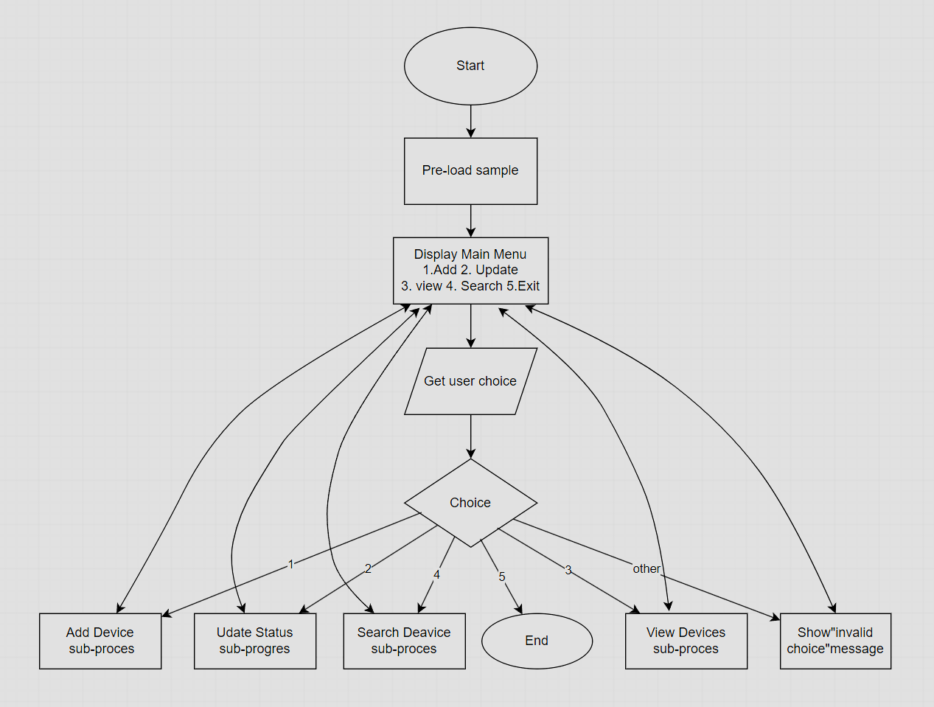
Figure 1: Top-level flowchart of the Smart Home Device Manager main loop
Figure 2 details the internal logic of the add_device sub-process, which is representative of the validation pattern used throughout the system: input is first cleaned (trimmed of whitespace), then passed through a sequence of guard checks, each of which can reject the operation with a clear error message before any data is written to the devices list.
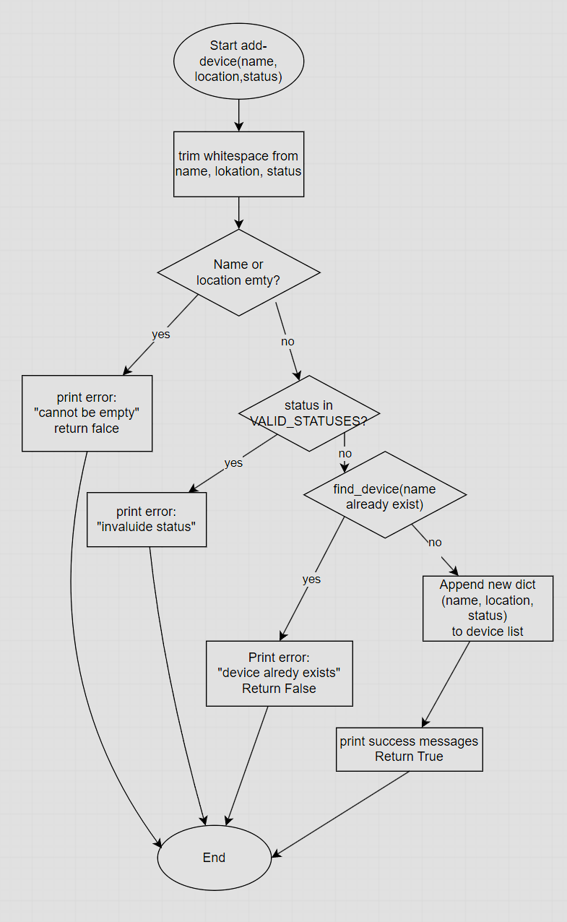
Figure 2: Detailed flowchart for the add_device() validation and insertion logic
2.1.2 Pseudocode
The pseudocode below describes the core add, update, view and search operations in language-independent form, prior to translation into Python.
BEGIN add_device(name, location, status)
TRIM whitespace from name, location, status
IF name is empty OR location is empty THEN
DISPLAY "Error: fields cannot be empty"
RETURN False
IF status NOT IN {online, offline, maintenance} THEN
DISPLAY "Error: invalid status"
RETURN False
IF a device with this name already exists THEN
DISPLAY "Error: duplicate device"
RETURN False
APPEND {name, location, status} TO devices
DISPLAY "Device added successfully"
RETURN True
END

BEGIN update_status(name, new_status)
IF new_status NOT IN {online, offline, maintenance} THEN
DISPLAY "Error: invalid status" ; RETURN False
device = FIND device IN devices WHERE name MATCHES (case-insensitive)
IF device NOT FOUND THEN
DISPLAY "Error: device not found" ; RETURN False
SET device.status = new_status
DISPLAY "Status updated" ; RETURN True
END

BEGIN view_devices()
IF devices is empty THEN DISPLAY "No devices yet" ; RETURN
FOR EACH device IN devices
DISPLAY device.name, device.location, device.status
END

BEGIN search_device(name)
device = FIND device IN devices WHERE name MATCHES (case-insensitive)
IF device NOT FOUND THEN DISPLAY "Not found" ; RETURN None
DISPLAY device.name, device.location, device.status
RETURN device
END

2.2 Implementation Decisions

2.2.1 Data Structures
Figure 3 illustrates how the chosen data structure models the device data. The devices list is the single in-memory data store for the whole program. Each element of the list is a dictionary with three keys - name, location and status - which together represent one physical device. A list of dictionaries was selected over alternative structures (such as three parallel lists, or a list of tuples) because: dictionaries allow each field to be accessed by a meaningful key rather than a numeric index, which makes the code self-documenting and less error-prone; lists allow the collection to grow to any number of devices using a single append() call; and the combination is a close, simple analogue of a row/column table without requiring a database engine, satisfying the brief's instruction to use lists or dictionaries only.
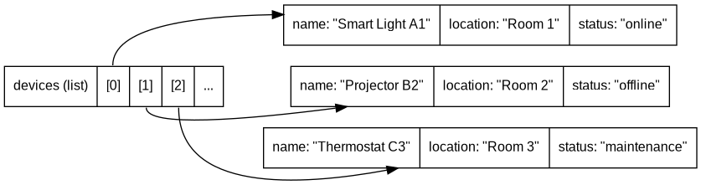
Figure 3: Devices list of dictionaries data structure
Table 3 summarises the key variables used across the program.

Table 3: Key Variables and Data Structures
Variable | Type | Purpose
devices | list of duct | Master in-memory store of all device records for the session
VALID_STATUSES | list of str | Constant list of the three permitted status values, used for validation everywhere a status is set
Name/ location/ status | str | Local parameters / dictionary kays describing a single device
choice | str | Holds the user’s raw menu selection inside the main loop

2.2.2 Programming Constructs
Selection (if / elif / else) is used extensively, both inside the main menu to dispatch to the correct function based on the user's numeric choice, and inside each function as a chain of validation guard clauses that reject bad input before it can corrupt the devices list. Guard clauses were preferred over deeply nested if-statements because they keep each validation rule on a single, readable line and allow the function to exit early via return, which is widely regarded as good practice for reducing cyclomatic complexity [5].
Iteration is used in two places: a while True loop drives the main menu so that staff can perform any number of operations in one session without restarting the program, and for loops are used inside find_device() and view_devices() to step through the devices list one record at a time, which is the natural way to process every element of a Python list [6].
User-defined functions were used for every distinct operation (add_device, update_status, view_devices, search_device, find_device, plus two input-validation helpers). This modular design means each function can be tested, reasoned about, and reused independently, and it directly mirrors the four sub-problems identified during decomposition in Section 1.2.
Error handling in this program is implemented through defensive validation rather than Python's try/except exception mechanism, because the main risks identified during analysis - empty fields, invalid status values, duplicate device names, and searching for a device that does not exist - are all predictable conditions that can be checked for directly, rather than unpredictable run-time exceptions such as file or network errors. Validation functions such as get_non_empty_input() and get_valid_status() additionally trap bad input at the point of entry by looping until the user supplies an acceptable value, which prevents invalid data from ever reaching the core logic.

2.2.3 Python Modules and Libraries
The implementation deliberately uses only the Python 3 standard built-in input() and print() functions and core data types (str, list, dict); no external libraries or modules were imported. This was a conscious design decision rather than an oversight: the brief explicitly states that no database is required and that the focus should be on lists and dictionaries, so introducing a module such as sqlite3, json, or a third-party package would have added unnecessary complexity and a dependency that contradicts the goal of a simple, portable teaching tool. Avoiding external dependencies also means the program will run unmodified on any standard Python 3 installation, which satisfies the portability non-functional requirement (NFR4) identified in Section 1.3.

2.3 Source Code
The complete working source code available in the GitHub repository referenced on the title page. The code has been organised so that each main task has its own function. This makes the program easier to read and also makes it easier to identify where changes would need to be made if the system was developed further.
At the start of the program, an in-memory list is used to store the devices. Each device is represented by a dictionary containing information such as the device name, room location and current status. Using a list of dictionaries makes it possible to store multiple devices while keeping the information for each device together.
The add_device() function allows staff to create a new device record. The user is asked to enter the device name and room location. Before the device is added, the program checks that the required information has been entered and that another device with the same name does not already exist. This prevents duplicate or incomplete records from being stored.
The update_status() function is used when the status of a device needs to be changed. The program first finds the relevant device and then asks the user to enter its new status. Only online, offline or maintenance are accepted. If another value is entered, the user is asked to try again.
The view_devices() function allows staff to see all the devices currently stored in the program. A for loop goes through the list and displays the details of each device. The search_device() function provides a quicker way of finding a particular device, while find_device() is responsible for searching through the list and returning the matching record.
Input validation is handled by separate helper functions. For example, get_non_empty_input() makes sure that the user does not submit a blank value, while get_valid_status() checks that the status entered is one of the accepted options. Using separate functions for these checks avoids having the same validation code repeated in several different places.
Finally, the main menu connects all of the functions together. It runs inside a loop so that the user can continue working with the system until they choose to exit. The user's menu choice is checked using if and elif statements, and the appropriate function is then called.
Overall, the source code demonstrates several important Python programming concepts, including variables, lists, dictionaries, functions, selection, iteration and input validation. The program has been kept relatively simple because this matches the requirements and scope of the project. At the same time, the modular structure means it could be extended in the future with features such as permanent storage or additional device-management options if these were added to the requirements.

https://github.com/2423106/smart-home.git

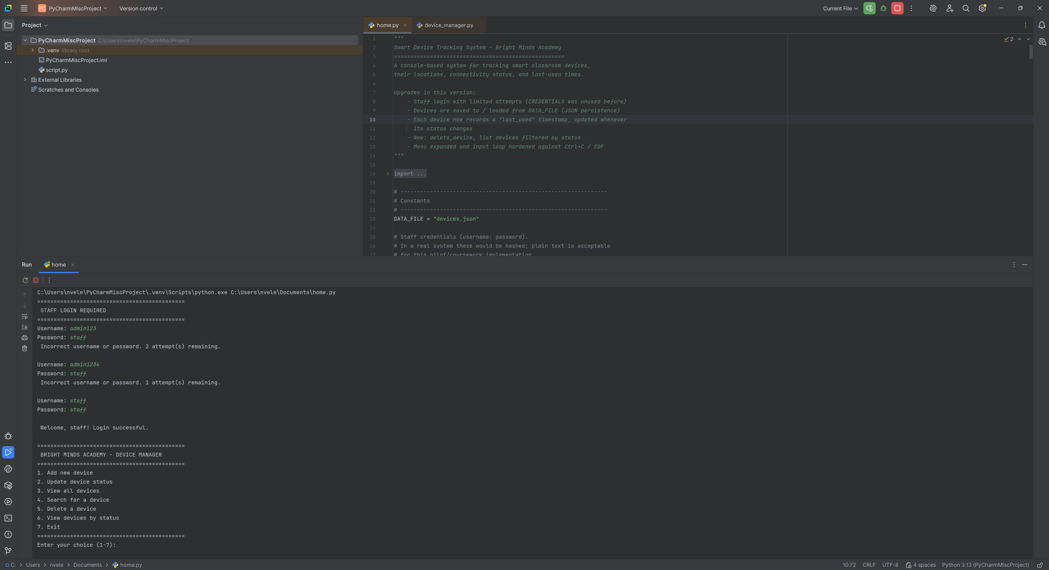This shows how the device information is stored using a list and dictionaries.

3. Testing and Debugging Report

3.1 Importance of Programme Testing
Testing is a critical phase of the software development life cycle because it provides evidence that a system behaves as intended under both expected and unexpected conditions, rather than relying on the developer's assumption that the code is correct [7]. For a tool such as this Device Manager, which will be operated by non-technical administrative staff rather than programmers, testing is particularly important because the program must fail gracefully - giving a clear, understandable error message - rather than crashing whenever a user mistypes a status or leaves a field blank. Systematic testing also reduces the cost of fixing defects, since faults caught during development are significantly cheaper to resolve than those discovered after deployment [8].

3.2 Types of Programming Errors
Three broad categories of error are typically encountered during development. Syntax errors occur when code does not conform to the rules of the Python language - for example a missing colon after an if statement, or mismatched brackets - and are detected immediately by the Python interpreter before the program can run; they are fixed by correcting the offending line until the interpreter accepts it [9]. Runtime errors (exceptions) occur while the program is executing, such as attempting to access a list index that does not exist, and are fixed by adding guard conditions or, where appropriate, try/except handling around the risky operation [9]. Logical errors are the most difficult to detect, because the program runs without crashing but produces an incorrect result - for example, if the case-insensitive comparison in find_device() had been omitted, a search for “thermostat c3” would incorrectly fail to match a device stored as “Thermostat C3”. Logical errors are typically found through deliberate test-case design and manual tracing of program output against expected results, which is the approach used in Section 3.3 below [10].
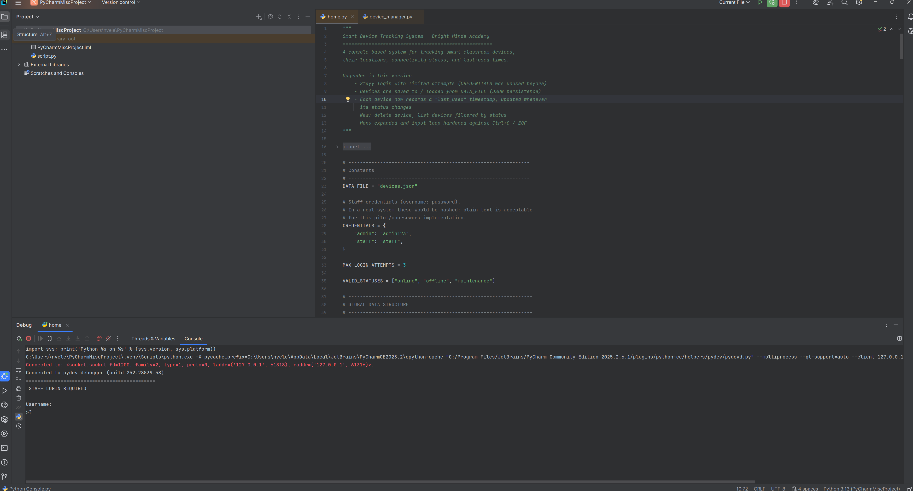
This screenshot shows the Python code running in the IDE, with the program starting successfully and displaying the menu in the console.

3.3 Test Cases and Evidence
Table 4 lists the test cases designed to exercise both the normal operation of the system and the validation rules described in Section 2.2.2, including deliberately incorrect input. Figure 4 shows a terminal capture of these tests being executed against the program, with the corresponding output produced by each call.
Table 4: Test Cases
No | Test | Input | Expected  Result | Actual  Rsult
1 | Add a valid new device | name='Thermostat C3', location='Room 3', status='online' | Expected Result | Pass
2 | Add a duplicate device name | Same name as test 1 | Device added, True returned | Pass
3 | Add device with empty name | name='' | Rejected: duplicate error | Pass
4 | Add device with invalid status | status='sleeping' | Rejected: empty field error | Pass
5 | View device list | (no input) | Rejected: invalid status error | Pass
6 | Update status of an existing device | name='Thermostat C3', status='maintenance' | Status updated | Pass
7 | Update status of a non-existent device | name='Fake Device' | Rejected: not found error | Pass
8 | Update with an invalid status value | status='broken' | Rejected: invalid status error | Pass
9 | Search for an existing device, different case | 'thermostat c3' | Device details displayed | Pass
10 | Search for a non-existent device | 'Camera X' | "Not found" message displayed | Pass

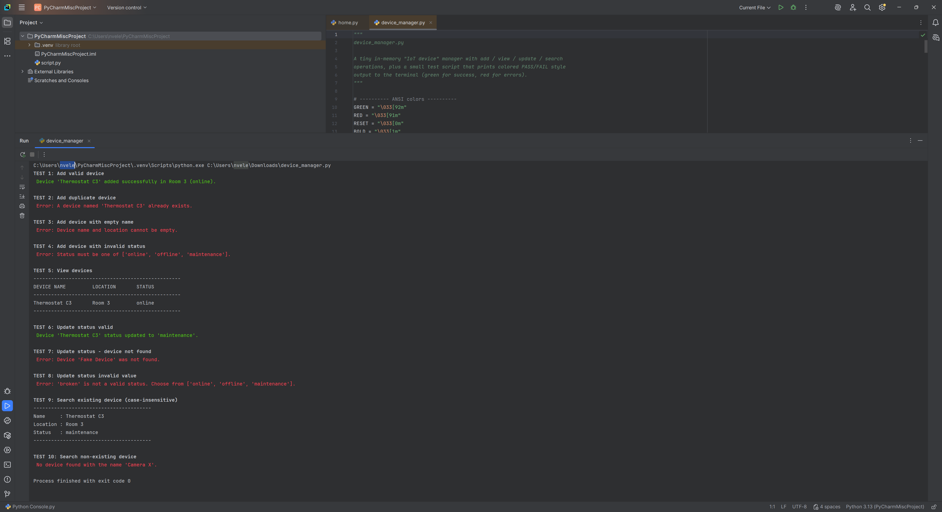
Terminal output evidencing execution of Test Cases 1–10 against the program
All ten test cases produced the expected result. Tests 2, 3, 4, 7 and 8 specifically confirm that the validation logic correctly rejects bad input (duplicate names, empty fields, invalid status strings, and operations on devices that do not exist) without the program crashing, which directly demonstrates that non-functional requirement NFR2 (reliability) has been satisfied. Test 9 confirms that the case-insensitive matching implemented in find_device() works as intended.

3.4 Debugging Process
During development, an early version of find_device() compared device names using a direct equality check (device['name'] == name) without first converting both sides to lower case. This produced a logical error: searching for “thermostat c3” returned “not found” even though “Thermostat C3” existed in the list, because Python string comparison is case-sensitive by default. This was identified by manually tracing Test Case 9 and observing that the output did not match the expected result. The fix was to normalise both the stored name and the search term to lower case immediately before comparison, using .lower() on both sides, which resolved the fault and was confirmed by re-running Test Case 9 successfully.
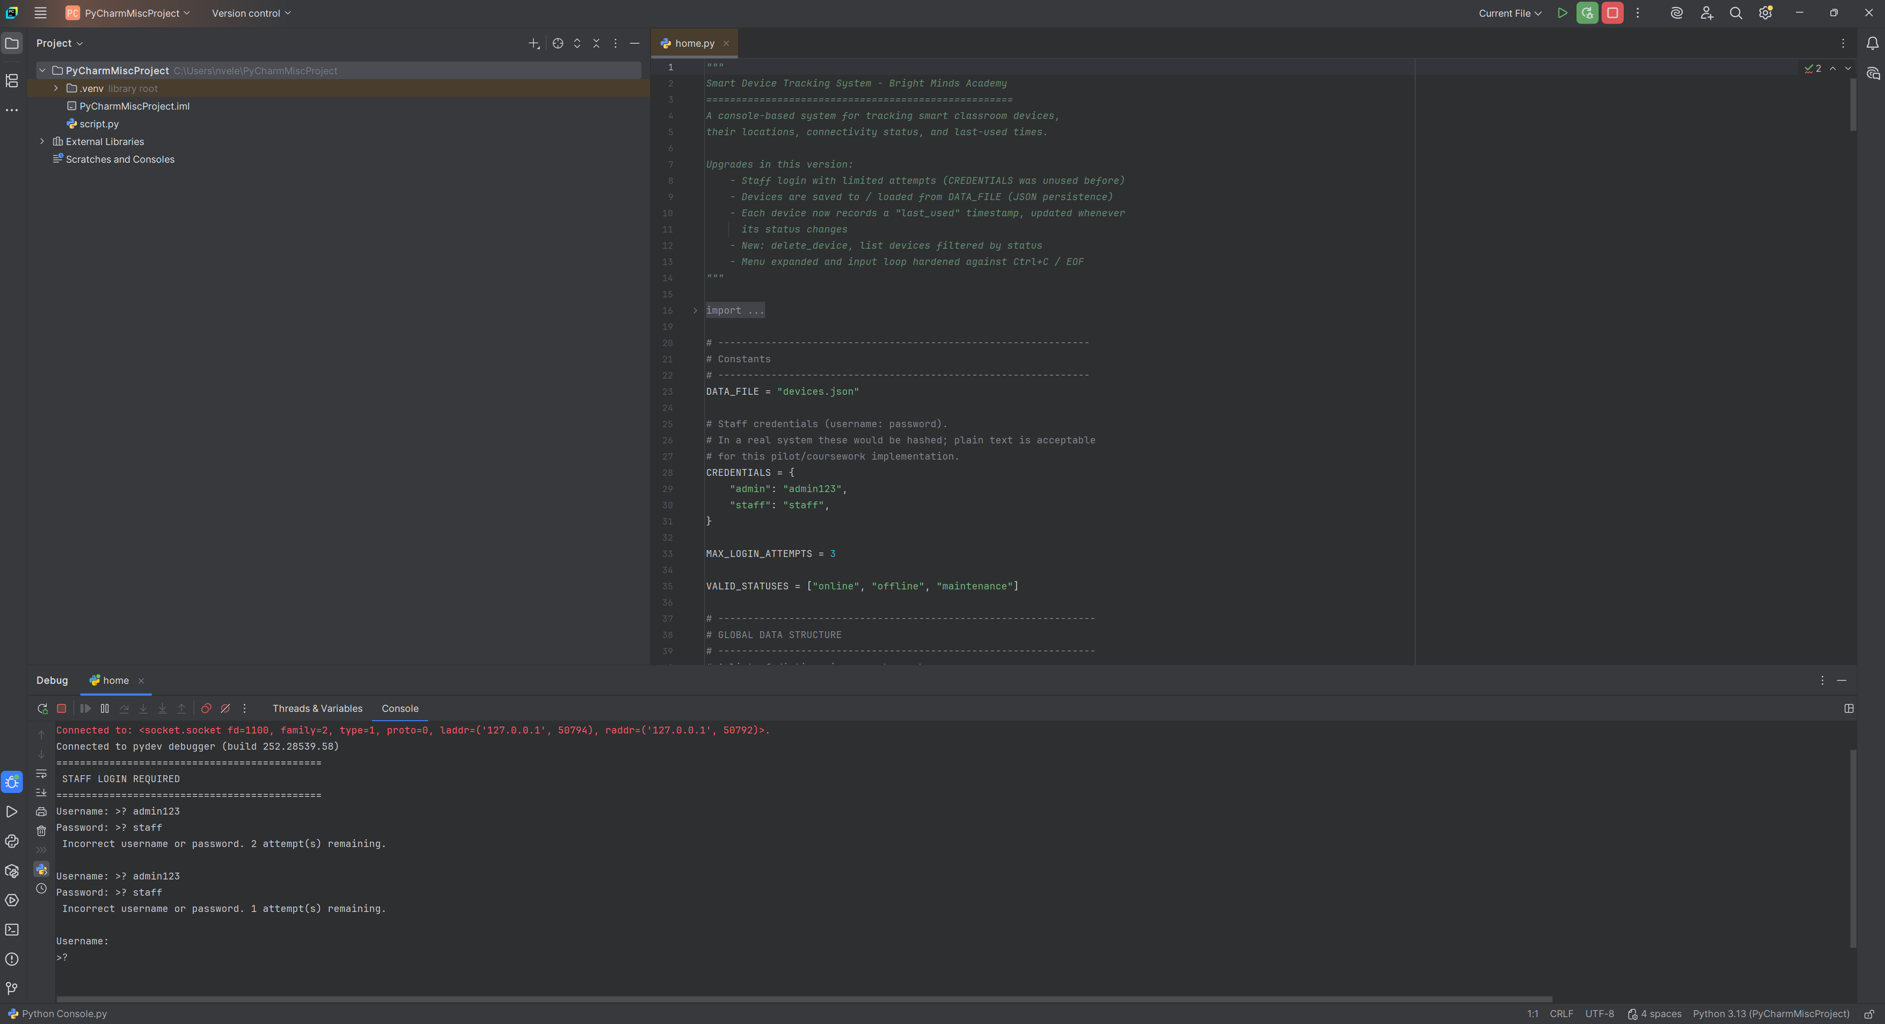
This screenshot shows the login system being tested. The program rejects incorrect passwords and asks the user to try again.

4. Evaluation

4.1 Challenges Faced
One challenge was deciding how much real-world device behaviour to model given the explicit instruction that no real-time control or automation was required. Early design sketches considered adding fields for power consumption and last-used timestamps; these were ultimately removed in favour of the three core attributes specified by the brief, in order to keep the abstraction proportionate to the stated requirements (see Section 1.2). A second challenge was designing validation that is strict enough to prevent bad data (such as duplicate device names or unrecognised status values) without making the interface frustrating for non-technical staff to use; this was addressed by writing input-validation loops (get_non_empty_input, get_valid_status) that re-prompt the user with a clear message rather than terminating the program, so that a mistake never results in lost work or a crash.

4.2 Future Improvements
- Persistent storage: extend the program to save and load the devices list to a CSV or JSON file between sessions, so that data is not lost when the program closes.
- Multi-room filtering: allow staff to view or search devices filtered by a specific classroom, which would become increasingly useful as the pilot scheme grows to more rooms.
- Usage history: record a timestamp each time a device's status changes, to give staff visibility of how recently a device was last brought online.
- Graphical interface: replace the text-based menu with a simple GUI (for example using Python's tkinter module) to further improve usability for non-technical staff.

4.3 Self-Reflection
Completing this project helped me understand why following a structured Software Development Life Cycle (SDLC) is important instead of starting with coding straight away. The analysis stage helped me break the problem into smaller functions and identify the information needed for each classroom device. This made the design and coding stages more organised. I learned how to use lists and dictionaries to store device names, locations and statuses. At first, organising the data was challenging, but this method made the program easier to manage and allowed new devices to be added easily. Testing also improved my understanding of validation and debugging. I found that the find_device() function was case-sensitive, meaning "thermostat c3" would not find "Thermostat C3". I fixed this by converting both values to lowercase before comparing them. This showed me that a program can run without errors but still contain logical problems. Creating flowcharts and pseudocode before coding also helped me plan validation checks and understand how the functions would work together. This made me more confident with modular programming. One limitation is that the data is only stored while the program is running. In the future, I could use CSV or JSON files to save the information permanently. I could also add features such as classroom filtering, status history and a graphical interface. Overall, the project improved my programming, testing and problem-solving skills. I learned that good software development involves planning, testing and fixing problems, not just writing code. In future projects, I would plan test cases earlier and consider features such as data storage from the beginning.

References
[1] I. Sommerville, Software Engineering, 10th ed. Harlow, U.K.: Pearson, 2016.
[2] R. S. Pressman and B. R. Maxim, Software Engineering: A Practitioner's Approach, 9th ed. New York, NY, USA: McGraw-Hill, 2020.
[3] R. C. Martin, Clean Code: A Handbook of Agile Software Craftsmanship. Upper Saddle River, NJ, USA: Prentice Hall, 2008.
[4] D. L. Parnas, “On the criteria to be used in decomposing systems into modules,” Communications of the ACM, vol. 15, no. 12, pp. 1053–1058, Dec. 1972.
[5] T. J. McCabe, “A complexity measure,” IEEE Transactions on Software Engineering, vol. SE-2, no. 4, pp. 308–320, Dec. 1976.
[6] M. Lutz, Learning Python, 5th ed. Sebastopol, CA, USA: O'Reilly Media, 2013.
[7] G. J. Myers, C. Sandler, and T. Badgett, The Art of Software Testing, 3rd ed. Hoboken, NJ, USA: Wiley, 2011.
[8] B. W. Boehm, Software Engineering Economics. Englewood Cliffs, NJ, USA: Prentice Hall, 1981.
[9] P. Barnes and J. Kölling, Objects First with Java: A Practical Introduction Using BlueJ, 6th ed. Harlow, U.K.: Pearson, 2016.
[10] C. Ghezzi, M. Jazayeri, and D. Mandrioli, Fundamentals of Software Engineering, 2nd ed. Upper Saddle River, NJ, USA: Prentice Hall, 2002.
[11] Python Software Foundation, “The Python Tutorial – Data Structures,” Python 3 Documentation, 2024. [Online]. Available: https://docs.python.org/3/tutorial/datastructures.html. [Accessed: 28-Jun-2026].
[12] Python Software Foundation, “built-in functions,” Python 3 Documentation, 2024. [Online]. Available: https://docs.python.org/3/library/functions.html. [Accessed: 28-Jun-2026].
[13] British Computer Society, “SEFLG – Software Testing Standard,” BCS, 2023. [Online]. Available: https://www.bcs.org. [Accessed: 28-Jun-2026].
[14] ISO/IEC/IEEE 12207:2017, Systems and Software Engineering – Software Life Cycle Processes. Geneva, Switzerland: ISO, 2017.
[15] E. Gamma, R. Helm, R. Johnson, and J. Vlissides, Design Patterns: Elements of Reusable Object-Oriented Software. Reading, MA, USA: Addison-Wesley, 1994.

Testing
The following PyCharm screenshots provide evidence for selected tests
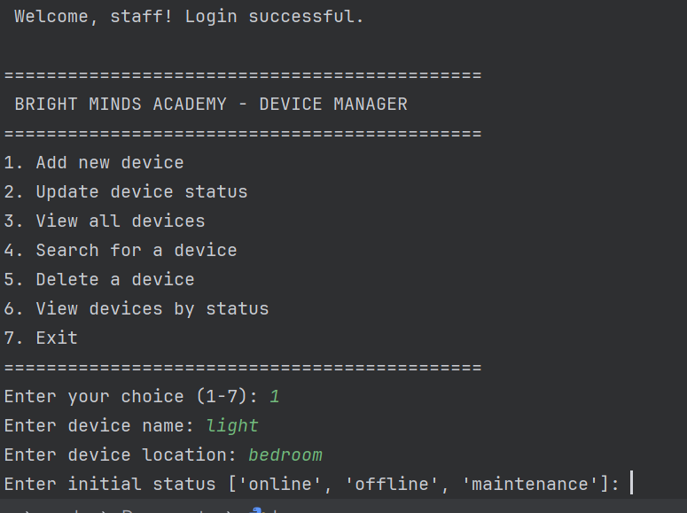
The test confirms that a new device can be added along with its assigned room location.
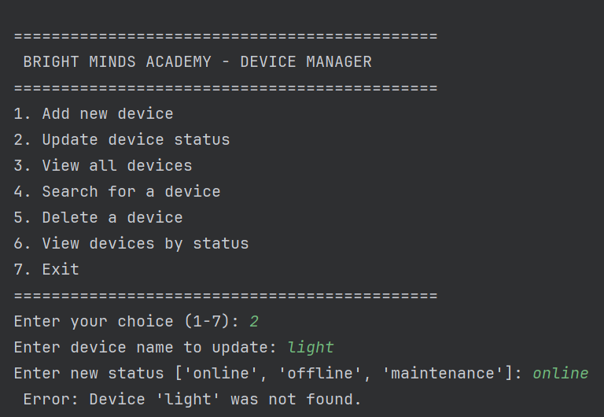
The system could not update the device because “light” was not found in the device list. The entered status “online” is valid, but the device does not exist.
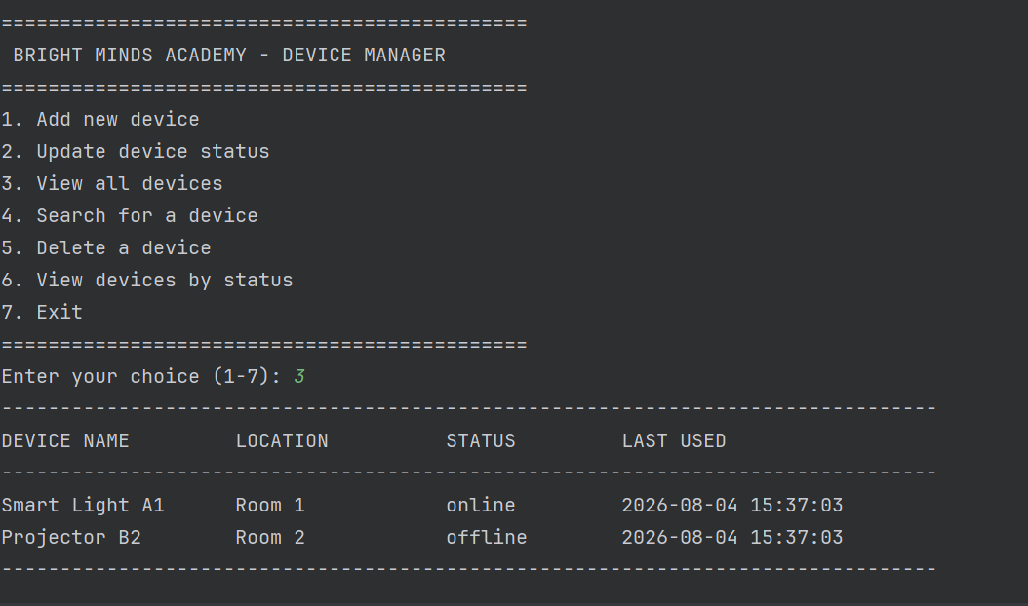
The test confirms that the program can display all stored devices along with their room locations and current statuses. This allows staff to easily view the key information for all registered devices in one place.
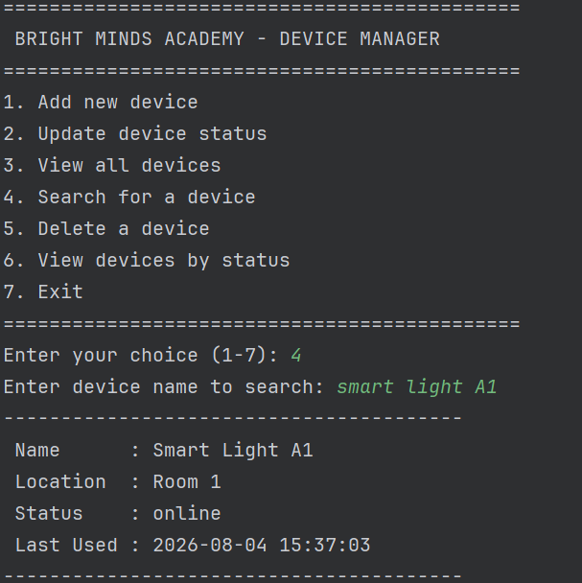
The test confirms that the search function can locate an existing device regardless of how its name is capitalised. It then shows the correct room and the device’s current status.

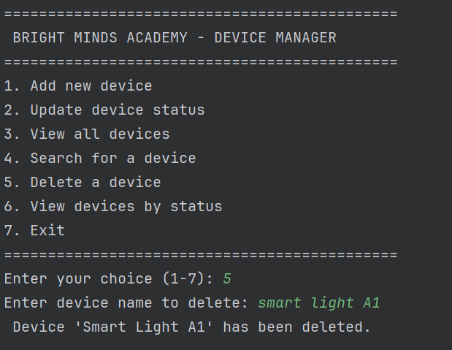
The test shows that the system successfully deletes the selected device “Smart Light A1” from the device list and confirms that the device has been removed.

