
Skills for the Workplace
Module Assignment Submission
Student Name: | Sylwia Wujcikowska
Student Number: | 2005248
Module No: | BMSK4003
Module Title: | Digital Skills and Research Methods

Statement of Confirmation of Authenticity
By the act of making this submission, the student declares that this is the work of the student named above. The work has not, in whole or in part, been knowingly presented elsewhere for assessment, or where assessment has been built on a previous assessment, this has been identified. Where materials have been used from other sources it has been properly acknowledged. If this statement is untrue, the student acknowledges that an assessment offence has been committed.
Attention is drawn to the plagiarism and unfair practice policies of both the University and of ILM.
Permission for ILM to use this script
ILM uses learners’ submissions – on an anonymous basis – for assessment standardisation. By submitting, both the centre and the learner agree that ILM may use this script on condition that identifying information is removed. However, if you are unwilling to allow ILM use this script, please refuse by ticking the box: □

Table of Contents

Introduction..................................................................................................................................................3
What has been the impact of 21st Century Technologies on the modern workplace? 3
Part 1 4
Research for the use of modern technology and the use of social media within the workplace. 4
Part 2......................................................................................................................................................10
Exploring the use of modern technologies and social media in own workplace generally 10
Research LinkedIn and other social media platforms to enhance networking and career prospects. 14
LinkedIn Profile. 14
Conclusion..................................................................................................................................................21
References 22
Appendix.....................................................................................................................................................25

‘‘Remember that the Internet is not anonymous, nor does it forget’’ (Baker Daniels)

Introduction
Technology has been able to reshape the modern workplace and now plays a really significant role within business. During this assignment, research was carried out in order to establish what is the impact of technology on a business in the 21st century and if the effect has been positive or negative. Few digital skills such as the use of social media have been able to enhance career prospects and were implemented by credible sources such as C.R.A.A.P (Currency, Relevance, Authority, Accuracy and Purpose).

What has been the impact of 21st Century Technologies on the modern workplace?

Technology within the modern workplace has been able to evolve into playing a significant role. In the 20th century, there was a major reliance on physical workers which were constricted to offices and buildings. In today's era, technology has been able to allow people to work from any location and at any time that is comfortable for them. With the use of the internet, the modern workplace has been able to explore many new means of communication. As well as bringing many advantages, technology does also come with some disadvantages such as the replacement of physical work with automated machinery which ultimately results in the loss of jobs.
A report from the consultancy firm PwC found that 37% of all jobs in Britain are at a potential risk due to the increase in technological advancements.
In order to explore this further and analyse, a data set compiled by the OECD looked at the details of the tasks that are involved in the jobs of over 200,000 workers across 29 different countries.
Building up on previous research from Frey and Osborne (Oxford University, 2013) and from Arntz, Gregory and Zierahn (OECD, 2016) it was able to estimate the proportion of existing jobs that might be at a potential high risk from the increase of technological advancement by the year 2030.
The report writer believes that this will not be true, as the technology within the modern society has been able to create many more jobs, especially within new and modern workplaces which are able to provide more flexible job opportunities that provide the ability to work from anywhere and within more agreeable work times, which are able to provide more people with opportunities to work. With technology continuously changing and updating it will lead to an increase in IT based jobs.

Part 1

Research for the use of modern technology and the use of social media within the workplace.

A general overview of the workplace in the 21st century.

The expansion of modern technology has had a massive impact on the workplace in general and has influenced the way we work.
Technology in the 21st century is a critical part of businesses' chances for success. Having the access to computers, smartphones and tablets has been able to ease complex tasks within the workplace enabling businesses to run and perform well. However, these devices are not able to be utilised to their full advantage.
Mobile devices or other hand-held computers.
It is very hard to imagine a world without mobile phones, but there was once a time when we didn’t have such luxuries and we still managed. Not even that long ago, pen, paper and ledgers the workplace. The times are now changing and the main focus has been shifted towards a world populated with mobile devices. A mobile device is a small handheld computer or any other form of electronic device that has been designed with portability as a priority. Some of the most common mobile devices that are used daily are:
- Smartphones
- Tablets
- Laptops
- Smart Watches
- E-Readers
- Handheld gaming consoles.
Many such devices can connect to the internet and interconnect with other devices. (ThefreeDictionary.com, 2020).
Tablets, phones and other personal devices are able to provide assistance while being able to provide most of the functionality of a laptop/desktop computer while being more convenient and providing some exclusive features.
Enterprise digital assistants are also able to provide additional functionality within the workplace such as the integrated capture of data via barcode scans and smart card readers.
Handheld devices have become more rugged in order to withstand their use in mobile field management.
As examples of this workers are able to digitise their notes as well as having the ability to send and receive invoices, manage assets, and record digital signatures,
The possibility of using mobile devices in order to carry out trans-border services is available. With this, mobile devices have been able to create a lot of new opportunities for training and educating and have been particularly useful in enabling people to perform their work-related activities from anywhere and at any time.
Mobile phones have become so integral to our lives that they now account for more than half of all devices that are used on a daily basis.

Software
Computer software has been designed in order to perform specific tasks, such as process control, word processing, graphic design, communication and project management, etc. (ThefreeDictionary.com, 2020).
Through the use of an office suite such as Microsoft Office 365, businesses are able to benefit and enhance their productivity within the workplace as well as providing IT control and efficiency.
Downloadable software is also available for other devices such as for smartphones, and small businesses are also able to benefit greatly from the use of these applications such as: online booking systems, data access and storage, organisation applications, accounting software and also the social media can be used in order to promote products and services through advertisements.

Wireless Communication
One of the main advantages of using wireless networks is to provide the ability to increase mobility within the business. A workplace equipped with wireless LAN connectivity, allows employees to move around the office space without any restrictions such as cables, restricting their movement throughout. A wireless network gives access to all applications and documents on the network from anywhere inside the building and within the range of the wireless network signal (Small Business Trends, 2020).

Cloud Computing
Another aspect of modern IT is cloud computing, it is not software but is a system able to provide software as a SaaS. An example of this can be Gmail or Linkedin. Both of them are software applications which are running in the cloud and not on the user’s devices. Therefore, the software is able to be provided as a service and the cloud enables businesses and the employee online storage and access system for resources, making it very easily accessible from various devices. All of this is able to promote flexible working opportunities for the employees as well as giving them the ability to share documents and information via the internet.
Cloud storage can provide live backups of files, which reduces the possible risk of data loss due to computer malfunctions or even human error.
When these are used together, these three pieces of technology are able to equip businesses and their employees with advanced tools that can help them complete and improve workflow.
Other types of cloud storage such as iCloud or Google Drive can be used to store things such as photos or documents while allowing multiple people from the same company the ability to access these as well as editing them whenever it is necessary as well as having the ability to do so from anywhere they want.

Most Important Technologies at Work based on a survey of 535 adult internet users who are employed full-time or part-time. (January 2015).

Supporting Marketing Charts based from the Marketing Charts (2020)

Notes: Email (61%) beats everything including, internet (54%) as well as landline phones (35%) as the most important piece of technology for the working internet users, according to a recently released survey. However, in general email and the internet in general are usually considerably more important to those people with while collar jobs (Office based jobs) in comparison to those with a blue-collar employment (non-office-based jobs) with the latter mostly being dependent on landline and cell/smart phones. Overall, this study is also able to reveal that 46% of employed internet users believe that the internet has made them much more productive at work, with just 7% of them feeling that they’re less productive as a result of the internet.

About the Data: The basis of the survey was carried out including 535 adults which are employed full-time or part-time. The survey was carried out in English by the GfK Group using the Knowledge Panel, which is a nationally representative online research panel. Possible sampling errors for the subsample of the 535 working adults is + / - 4.9% at the 95% level of confidence.
Data from a report from Global Digital 2019 which was prepared by We Are Social and Hootsuite, showing that every single day there are at least a million new internet user.

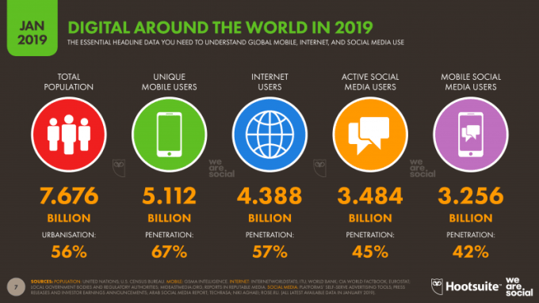
Using the data from the Digital Around the World 2019 graph you are able to see that 4.388 billion people have access to the internet of which 3.484 billion people are active users of social media.

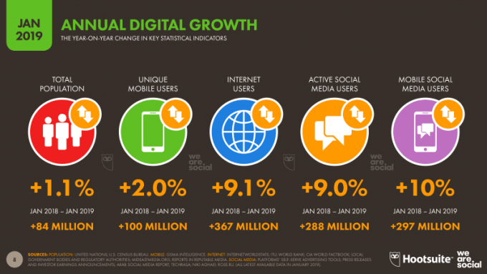
Yearly increase in active internet user is +9.1% which is over 367 million people joining each year and from that the yearly increase in active social media users is +9.0% which is over 288 million new people actively using social media.

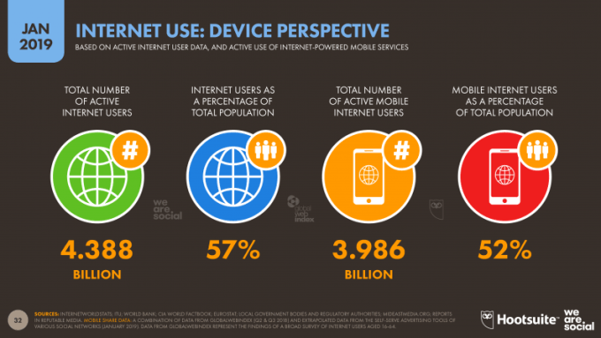

From the population of people with an access to the internet 52% (3.986 billion) people have access to the internet on their mobile phones.

The value within the digital economy is able to create many more economic opportunities. Digital data is able to be used for the development purposes and the purposes of solving societal problems. This can thus help with the improvement of economic and social outcomes and be the force for innovation and the productivity growth. Platforms are able to facilitate transactions as well as networking and other information exchanges. From the business perspective, the transformation of all the sectors and markets through the digitalisation is able to foster the production of much higher quality goods and services at reduced costs.
These technologies are very effectively reshaping the modern workplace. The arrival of smartphones, email and social media have been able to change the way that businesses and people are able to communicate with each other.
The access to wireless communication as well as software have been able to enhance the productivity and ultimately changed the way work gets carried out.
This can very easily be seen through the increase in employees working remotely from home. Employee efficiency has also been able to improve through better use of time management.
Through the help of modern technological tools, the amount of time and effort spent on daily activities has been greatly reduced which has allowed the employees more time to be spent on developing new idea and becoming more creative.
Teleconferencing has also been easier through the use of applications such as Skype which has given businesses the ability to hold conferences and meetings at conveyance, saving money as well as dismissing the time that would have been spent on travelling.
Emails have also provided effective and reliable communication which is delivered instantly in comparison to traditional mail. Dress codes have also been able to become more informal at work which also provides a certain level of comfort for the worker which is able to make them carry out their jobs more effectively.
Additionally, technology within the workplace has also its disadvantages such as the loss of direct communication skills. With other technology such as phones, emails and social media replacing all types of face to face communication, which is able to decrease vital personal interactions and ultimately might lead to an unenthusiastic workplace. The author believes that direct in person communicating is vital for productivity.
With technology being constantly improved, regular upgrades can be quite daunting for some people and with that might require training to be provided to the employees.
There also exists a possible security risk from things such as hacking and the internal threats of information theft for the business, employees or even a client. The impact of the modern technology can change the way the business is conducted and is constantly reshaping the business and the workplace.
Author isn't currently working , but in previous workplace modern technology is highly relied on.
The primary social media used within the workplace was Facebook which was used in order to build the imagine of the company, receiving engagement from the client as well as receiving information from clients in the form of feedback.
The secondary social media used was Linkedin as well as GoldenLine which was used for the purpose of public relations or analysing growth of the company as well being used to look for possible business partners as well as new opportunities.
These social media were used as they can be accessed for free with endless possibilities of use of the social media or well as giving you a fast reaction time for replies.
Through the use of the these social medias, the businesses are able to recruit employees with the necessary qualifications.

Part2

Exploring the use of modern technologies and social media in own workplace generally

Social media, enabled by the powerful and easily accessible as well as user-friendly information technology (IT) apps that have been able to spread across many organisations within all types of industries (Bernoff& Schadler, 2010; Curtis et al., 2010; Stolley, 2009). Social media has been able to spread across many aspects of organising and has been able to generate many new ways of connecting with the customers, collaborating as well as innovating (Cisco, 2010; Dunn, 2010; Wilson, Guinan, Parise, & Weinberg, 2011).In general, social media is an “internet-based application that build on the ideological and the technological foundations of Web 2.0, and that allow the creation and exchange of user-generated content” (Kaplan &Haenlein, 2010).
Some of the common social media includes blogs and microblogs, wikis, social networking sites as well as video and/or content-sharing sites (Piskorki& McCall, 2010; Vaast, Davidson, & Mattson, forth coming). Social media is able to simultaneously present itself with its own challenges as well as opportunities for organisations.
The arrival of social media within the modern workplace has been able to bring new potential increase in brand awareness as well as the ability to connect with the intended audience that you want to target.
Marketing:
Social media marketing is able to deliver many benefits for the business, one of the key ones being advertising.
Advertising is very effective on social media and it is one of the most effective methods for advertising known in the modern world.
With the ability of targeting a select audience of people available to businesses, they are able to share their content directly to their target audience, generating traffic to their websites which ultimately will lead to an increase in sales and a profit being made. Advertising and marketing on social media is also very cost efficient/effective and is possibly one of the cheapest means of digital marketing.
Customer Service:
Through the use of social media businesses are able to provide a high level of customer service. Through the use of direct messaging, which is available on most social networking platforms, businesses are able to offer support and advice to customers when it comes to purchases as well as any possible questions that they might have. This is also able to help businesses through diminishing costs and a general decrease in costs through the need of call centres fading out and through the replacement with online messaging systems to handle customer complaints and any queries. This will allow for faster response time which creates customer satisfaction and builds trust/reliability for the business which will lead to an increase in sales.
Communication:
Social media can be one of the most important channels of communication for businesses, it is able to provide companies with a wide variety of opportunities to stay as close to their customers as possible.
In addition to advertising there is also four other ways in which social media is able to promote communication in order to reach customers, these are as following:
Connections: Being able to connect with the intended audience such as the customers as opposed to just pushing sales of the product is able to promote trustworthy engagement.
Campaigns: Through the use of social media in order to broadcast a marketing campaign is a highly effective advertising strategy. The company is able to quickly interact as well as engage with the customers which allows the businesses to respond quickly in order to promote effective communication.
Image: Brand promotion as well as product promotion is able to be visualised by the customers allowing them to make faster decisions in making purchases.
Availability: Social media is able to provide the business with an easily accessible communication that is readily available. Through this, it enables faster responses at very convenient times to the customer, which ultimately leads to customer satisfaction.
Information gathering:
Social media is able to provide businesses with a very valuable opportunity to gather relevant information as well as data, this data is able to help build the marketing strategies for the business.
The collection of such data would usually include things such as: audience interaction, age range, gender as well as location which is able to provide the business with an opportunity to check for trends as well as measure engagement.
Through the use of social media, employees are able to mobilise resources as well as implement and test out new ideas quickly and efficiently and, in bottom-up fashion (Vaast, 2010). This is able to offer the opportunity to make organisations more agile as well as responsive to any demands from the customers, which today are also equipped with the powerful social media (Gallaugher&Ransbotham, 2010). However, when it comes to management, it faces a number of possible challenges as it stands to lose many of its traditional control over what IT initiatives as well as applications have been implemented as well as used within the organisation. (Kane, Fichman, Gallaugher, & Glaser, 2009; Safko& Brake, 2009; Stolley, 2009). Many of the employees are diversely able to impact on the organisation both internally through something such as the business culture and innovation processes; McAfee, 2006) as well as externally through the organisational image employees might project in public social networking sites; Kane et al., 2009). On the organisations part they might want to seek to encourage certain use of social media as well as limiting others which might justify the need for governance. Therefore, in this regard the organisational policies are constituted as one of the main vehicles for social media governance available to the organisation.
Ultimately, the company’s goal is to make more money, and through the use of social media they might be able to increase revenue as well as sales.
In many cases, more than half (52%) of all social media marketers have said that social media has helped them increase their company’s sales as well as revenue.
Therefore, a company’s ultimate goal is to make more money which is able to increase through the use of social media to generate more sales and revenue.
“I think that’s a huge number for people to be reporting, given the age of social media,” stated Steve Pearson, the CEO of Friendemic, which is a company that provides online reputation as well as social media software and services. “Ten years ago, the question would have hardly made sense to most people. I feel quite confident in saying that number is growing dramatically and will continue to grow. Social media is not going anywhere.” (Clutch, 2020)
The Social Media Platforms Businesses Value

Complied in the support of the Marketing Charts, 2020
The graph shows that out of the people asked, 89% of them use Facebook as a social media platform and only 15% of them use Reddit as a social media platform.

There are also legal considerations which are required when using social media in the workplace, some of the UK laws are:
The Data Protection Act of 1988, which covers how the information about the job applicants as well as the employees can be collected, handled as well as how its used.
The Human Rights Act of 1998,which sets out the fundamental rights as well as freedoms that everyone within the UK is entitled towards. It incorporates the different rights set out within the European Convention on Human Rights (ECHR) into the domestic British law.
The Regulation of Investigatory Powers Act of 2000, which regulates the powers of the public bodies to carry out surveillance as well as investigations that cover the interception of communications

Research LinkedIn and other social media platforms to enhance networking and career prospects.

‘‘Write about what you know. The best way to be interesting is to write about what you know. If you have a deep understanding of something, talk about the challenges and issues around it.’’ (Hill & Knowlton) ‘‘Do not post material that is harassing, obscene, defamatory, libellous, threatening, hateful, or embarrassing to any person or entity. Do not post words, jokes, or comments based on an individual’s gender, sexual orientation, race, ethnicity, age, or religion.’’ (Razorfish) Guidelines that relate to What Not To Post were made more frequent and more specific than those concerning What To Post. This observation is able to again highlight that policies were more concerned with mitigating potential risks associated with the visibility and persistence as opposed to promoting them as a potential source of value for the organization.
As a professional individual the use of social media is vital. Having an active online presence is a great wat to gain clients as well as maintaining current customers. The use of social media platforms is able to provide many ways of self-advertising as well as promotion as an employee. The use of this can be used when applying for a new job that provides the potential employers the with the need-to-know information such as the abilities and the skills needed. Furthermore leading to a much higher change of being recruited that those who might not have a social media profile.

Linkedin Profile.

‘‘Build a Following: Promote yourself by finding and sharing information that will be interesting to your friends and followers and useful for them to share.’’ (AMP3)
A Linkedin profile has to look professionally as it is a business network. Linkedin even has photo guidelines which suggests that the users should upload headshots of themselves with the face taking up over 60% of the photo frame. The photo should also be relatively recent as well as being unedited in order to avoid any misleading to the potential employers when meeting face to face. The summary of the Linkedin profile should also include the abilities/skills as well as a reflection of the person’s personality, as that is one of the first things that people will see when they check your profile. Any previous job position and titles should also be stated along with a job history. Furthermore, connections should be made on the site in order to expand networking and any possible career prospects.
My personal profile on Linkedin was created in order to gain new connections and promote my personal skills while being able to develop any new career prospects.

My profile
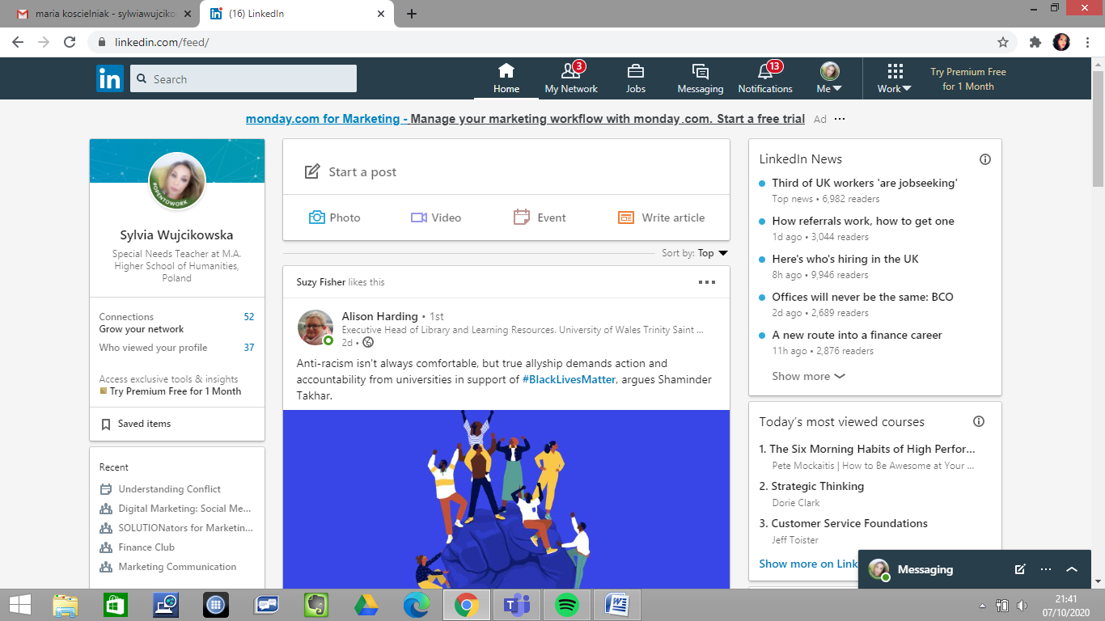

Some of the possible benefits of having an Linkedin profile is to help professional individuals in promoting themselves while trying to get notices by any potential recruiters. It is able to provide the ability to branch out to make connections while establishing a professional presence.
Security on Linkedin:
Linkedin is able to provide a variety of security option ranging from being able to restrict the information you are willing to share as well as being able to restrict the people that are able to view that information.
After carrying out research on a range of other social media platforms that are available to me, I believe that Linkedin is very useful when trying to make a stride towards career prospects.

Social Media within the Workplace Can Benefit a Business:
- Improvement of Workplace Communication and Collaboration.
- Giving Employees an Important Resource.
- Honing of self-Social Media Marketing Strategies.
- Improvement of Job Performance and Efficiency.
- Encouraging Professional Development.
- Giving Everyone a Shot at Leadership.
- Encouraging Creativity.

Conclusion
In conclusion, technology has been extremely beneficial to as well as within the workplace and it will continue to reshape the way in which business is conducted. Social media platforms have been able to help users identify and work towards their career prospects. Technology has also been able to help in changing the definition of a workplace and has aided many people in the adoption of a different lifestyle. When it is used appropriately, businesses will able to achieve huge amounts of progress with technology within the workplace.
The COVID-19 pandemic has been able to show us how much we are able to achieve with the technology that is available to us and how helpless we would be without the use of technology in the form of online communication, video calls or even our online classes.
During the lockdown he have been able to adapt very quickly to new ways of working as well as new methods of engaging with customers, our workforce as well as the community. We are able to see a streamlining of decisions, making the processes and the use of technology and data to increase responsiveness and planning.
Even after the lockdown ends people will be more engaged with the use of technology for the sake of saving time as well as money for the business as well as for the individual, through the use of home offices and giving people the ability to work from home whenever they are available.

References:

Adam B (1995) Timewatch: The Social Analysis of Time. Cambridge: Polity Press.
Achieving performance excellence in organizations. Advances in Developing Human Resources, 11, 349-361.
Google Scholar | SAGE Journals
Akdere, M. (2009). The role of knowledge management in quality management practices: Achieving performance excellence in organizations. Advances in Developing Human Resources, 11, 349-361.
Alberta (2011). IPads: What are we learning? Summary report of provincial data gathering day, ISBN 978-0- 7785-9859-6 (Print) ISBN 978-0-7785-9860-2 (Online), Retrieved March 10, 2016, available at: https://education.alberta.ca/learning-with-technology/overview [Accessed 13/09/20].
Appelbaum S, Marchionni A and Fernandez A (2008) The multi-tasking paradox: perceptions, problems and strategies. Management Decision 46(9): 1313-25 [Accessed 13/09/20].
Arntz, M.T. Gregory and U. Zierahn (2016) "The risk of automation for jobs in OECD countries: a comparative analysis, OECD Social, Employment and Migration Working Papers No 189A.
Bailey, D. and Leonardi, P. Technology choices: why occupations differ in their embrace of technology. Cambridge: MIT Press.
Barley SR, Meyerson DE and Grodal S (2011) E-mail as a Source and Symbol of Stress. Organization Science 22(4): 887–906.
Beamish, A. (2008). Learning from work: Designing organizations for learning and communication. Stanford, CA: Stanford Business Books.
Bennett, E. E. (2009). Virtual HRD: The intersection of knowledge management, culture, and intranets. Advances in Developing Human Resources, 11, 362-374.
Google Scholar | SAGE Journals
Bente, G., Rüggenberg, S., Krämer, N. C., Eschenburg, F. (2008). Avatar-mediated networking: Increasing social presence and interpersonal trust in net-based collaborations. Human Communication Research, 33, 287-318. doi:10.1111/j.1468-2958.2008.00322.x
Google Scholar | Crossref | ISI

Bingham, T. (2009). Learning gets social. T&D, 63(8), 56-63.
Google Scholar
Bingham, T., Conner, M. (2010). The new social learning: A guide to transforming organizations through social media. San Francisco, CA: Berrett-Koehler.
Google Scholar
Bittman M, Brown JE and Wajcman J (2009) The mobile phone, perpetual contact and time pressure. Work, Employment and Society 23(4): 673–691.
Brown, L., Murphy, E., Wade, V. (2006). Corporate elearning: Human resource development implications for large and small organizations. Human Resource Development International, 9, 415-427.
Google Scholar | Crossref
Burden, K., Hopkins, P., Male, T., Dr, Martin, S., Dr, &Trala, C. (2012, October). IPad Scotland Evaluation (Rep.). Retrieved February 06, 2016, from The University of Hull website: http://www.janhylen.se/wpcontent/uploads/2013/01/Skottland.pdf.
Business Queensland (2018) Using twitter to market your business, [online] available at https://www.business.qld.gov.au/running-business/marketing-sales/marketing-promotion/online-marketing/twitter [Accessed 15/09 /20].
Center for the Digital Future (2103) The Digital Future Project 2013 - Surveying the Digital Future Year 11. Los Angeles: University of Southern California.
Chesley N (2005) Blurring boundaries? Linking technology use, spillover, individual distress, and family satisfaction. Journal of Marriage and Family 67(5): 1237– 1248.
Chesley N (2014). Information and communication technology use, work intensification and employee strain and distress. Work, Employment and Society 28(4): 589–610.
Clark, W., &Luckin, R. (n.d.). IPads in the Classroom (Rep.). Retrieved April 06, 2016, from Institute of Education University, London available at: https://digitalteachingandlearning.files.wordpress.com/2013/03/ipadsin-the-classroom-report-lkl.pdf.
Clarke, B., Dr, &Svanaes, S. (2012, December 04). One-to-one Tablets in Secondary Schools: An Evaluation Study (Rep.). Retrieved March 22, 2016, from http://www.elearningfoundation.com/Websites/elearningfoundation/images/PDF. Documents/Honeywood_2012_Barbie_Clark.pdf.
Conley, C. A., Zheng, W. (2009). Factors critical to knowledge management success. Advances in Developing Human Resources, 11, 334-348.
Google Scholar | SAGE Journals

Davies A R, and Frink, B (2014) The Origins of the Ideal Worker: The Separation of Work and Home in the United States From the Market Revolution to 1950. Work and Occupations 41(1): 18-39.
Deeds, D. L. (2003). Alternative strategies for acquiring knowledge. In Jackson, S., Hitt, M., DeNisi, A. (Eds.), Managing knowledge for sustained competitive advantage: Designing strategies for effective human resource management (pp. 37-63). San Francisco, CA: John Wiley.

Digital Economy Report 2019 value creation and capture: Implications for Developing Countries, United Nations, 2019, available at: un.org/publications [Accessed 19/09/20].
Doyle, A. (2017) Learn how to make a better LinkedIn Profile, [online] available at https://www.thebalance.com/tips-to-make-a-better-linkedin-profile-2062332 [ Accessed 16/09/20].
Duxbury L, Higgins C, Smart R and Stevenson M (2014) Mobile Technology and Boundary Permeability. British Journal of Management 25(3): 570-588.
Dwight, V (2013): The apps have it. iPads and tablets are changing the face of special education URL available at: http://www.weareteachers.com/hot-topics/special-reports/assistive-technology-in-theclassroom [Accessed 16/09/20].
Felstead A, Jewson N and Walters S (2005) Changing Places of Work, London: Palgrave.
Frey, C.B. and M.A. Osborne (2013) The future of Employment: How susceptible are Jobs to Computerisation?, University of Oxford.
Garvin, D. (1993). Building a learning organization. In Harvard Business Review on knowledge management (pp. 47-80). Boston, MA: Harvard Business School.
Gershuny, J. (2000) Changing Times: Work and Leisure in Postindustrial Society. Oxford: Oxford University Press.
Giddens A (1991) Modernity and Self-Identity. Cambridge: Polity Press.
Gill, R. (2010). Conceptual framework for using computers to enhance employee engagement in large offices. Human Resource Development Review, 9(2) 115-143. doi:10.1177/1534484309354707
Google Scholar | SAGE Journals

Githens, R. P. (2007). Understanding interpersonal interaction in an online professional development course. Human Resource Development Quarterly, 18, 253-274.
Google Scholar | Crossref
Glucksmann M (1995) Why ‘Work’? Gender and the ‘Total Social Organization of Labour’. Gender, Work & Organization 2(2): 63-75.
Goodwin, K., Dr. (2012). Use of Tablet Technology in the Classroom (pp. 1-16, Rep.). Strathfield, New South Wales: NSW Curriculum and Learning Innovation Centre.
Hassan R (2009) Empires of Speed: Time and the Acceleration of Politics and Society. Leiden: Brill Academic Publishers.
Henderson, G. M., Provo, J. (2006). A new world ahead—Are we ready? Human Resource Development Review, 5, 274-277.
Google Scholar | SAGE Journals
Henneman, T. (2010, April). Companies making friends with social media. Workforce Management. Retrieved from http://www.workforce.com/section/10/feature/27/11/92/index.html
Google Scholar
Hernes, T. (2000). Effects of media of communication and collaboration in structural change: Insights from a computer-mediated research group. Human Resource Development International, 3(1), 69-87.
Google Scholar | Crossref
Huang, J. J. S., Yang, S. J. H., Huang, Y. M., Hsiao, I. Y. T. (2010). Social learning networks: Build mobile learning networks based on collaborative services. Educational Technology & Society, 13(3), 78-92.
Google Scholar | ISI

Hutchison, A. & Reinking, D. (2011). Teachers’ Perceptions of Integrating Information and Communication Technologies into Literacy Instruction: A National Survey in the U.S. Reading Research Quarterly, 46(4).
Hyland, L. (2009, March). Up, up and away. e.learning age, 12-13. doi:1669560561
Google Scholar
Ipe, M. (2003). Knowledge sharing in organizations: A conceptual framework. Human Resource Development Review, 2, 337-359.
Google Scholar | SAGE Journals
Jacobs, R., Park, Y. (2009). A proposed conceptual framework of workplace learning: Implications for theory development and research in human resource development. Human Resource Development Review, 8, 133-150.
Google Scholar | SAGE Journals
Jue, A., Alcade Marr, J., Kassotakis, M. (2009). Social media at work: How networking tools Propel Organizational Performance. San Francisco, CA: John Wiley.
Google Scholar
​
Nations, D. (2017) What is LinkedIn and why should you be on it?, [online] available at: https://www.lifewire.com/what-is-linkedin-3486382 [Accessed 15/09/20].
Kane, K., Robinson-Combre, J., Berge, Z. (2010). Tapping into social networking: Collaborating enhances both knowledge management and e-learning. VINE, 40(1), 62-70. doi:1956399361
Google Scholar | Crossref
Kapp, K. (2006). Embracing informal learning: Understanding the tools of informal learning and their impact on organizations. Retrieved http://www.karlkapp.com/materials/informal%20learning.pdf
Google Scholar

Karsenti, T., &Fievex, A. (2013, December 09). The iPad in education: Uses, benets, and challenges A survey of 6,057 students and 302 teachers in Quebec, Canada (Rep.). Retrieved March 18, 2016, from http://www.karsenti.ca/ipad/pdf/iPad_report_Karsenti-Fievez_EN.pdf.
Kazi, S., Puttonen, J., Sulkusalmi, M., Valikangas, P., Hannus, M. (2002). Knowledge creation and management: The case of Fortum Engineering, Ltd. In Coakes, E., Willis, D., Clarke, S. (Eds.), Knowledge management in the sociotechnical world: The graffiti continues (pp. 153-169). London, UK: Springer.
Google Scholar | Crossref
Kenyon S (2008) Internet Use and Time Use: The importance of multitasking. Time & Society 17(2/3): 283-318.
Kunzler, G. (2011, September 11). Tablets motivate students to learn, improve the education experience. Tablet News. Available at http://www.mactrast.com/2011/11/tablets-motivate-students-to-learn-improvethe- education-experience/ [Accessed 19/09/20].
Lasch C (1977) Haven in a Heartless World. New York: Basic Books.
Lenhart, A., Purcell, K., Smith, A., Zickuhr, K. (2010). Social media & mobile internet use among teens and young adults (A Pew Research Report). Retrieved from http://pewinternet.org/Reports/2010/Social-Media-and-Young-Adults.aspx
Google Scholar
Leslie, S., Landon, B. (2007). Social software for Learning: What is it, why use it? (Report: The Observatory of Borderless Higher Education, London). Retrieved from http://www.obhe.ac.uk/documents/view_details?id=8
Google Scholar
Long, J.S. and Freese, J. Regression Models for Categorical Dependent Variables using Stata (2nd Edition). College Station, Texas: Stata Press.
Mango, O. (2015). iPad use and student engagement in the classroom. The Turkish Online Journal of Educational Technology, 14(1), 53-57. Retrieved March 15, 2016, from http://www.tojet.net/articles/v14i1/1417.pdf.
Marc P. (2001), Digital Natives, Digital Immigrants By From On the Horizon (MCB University Press, Vol. 9 No. 5, October 2001) http://www.marcprensky.com/writing/Prensky%20- %20Digital%20Natives,%20Digital%20Immigrants%20-%20Part1.pdf.
Marsick, V. J., Volpe, M. (1999). The nature and need for informal learning. Advances in developing human resources, 3, 1-9.
Google Scholar | SAGE Journals
Marsick, V. J., Watkins, K. E. (2001). Informal and incidental learning. New directions for adult and continuing education, 89, 25-34.
Google Scholar | Crossref
Mazmanian M (2013) Avoiding the Trap of Constant Connectivity: When Congruent Frames Allow for Heterogeneous Practices. Academy of Management Journal.
Meister, J. (2008, April). Learning for the google generation. Chief Learning Officer. Retrieved from http://www.clomedia.com/in-conclusion/jeanne-c-meister/2008/April/2142/index.php?pt=a&aid=2142&start=0&page=1
Google Scholar
Morrone, A. S., Gosney, J., &Enge, S. (2012, April). Empowering Students and Instructors: Reflections on the Effectiveness of iPads for Teaching and Learning. Retrieved March 18, 2016, from https://net.educause.edu/ir/library/pdf/ELIB1201.pdf.
Mullan, Killian and Wajcman, Judy (2017) Have mobile devices changed working patterns in the 21st century? A time-diary analysis of work extension in the UK Work, Employment and Society Journal ISSN 0950-0170 available at: http://eprints.lse.ac.uk/84051/[Accessed 19/09/20].
Nishizaki, D. M. (2015). The Effects of Tablets on Learning: Does Studying from a Tablet Computer Affect Student Learning Differently Across Educational Levels (Unpublished master's thesis). Claremont McKenna College, United States.
Orlikowski, W. (2007) Scoiomaterial practices: exploring technology at work. Organization Studies 28: 1435-1448.
OxIS (Oxford Internet Surveys). Oxford Internet Institute, Oxford University. Available at: http://oxis.oii.ox.ac.uk/reports/[Accessed 19/09/20].
Palmer, A. (2009). Joining the revolution. Incentive, 183(12), 6-9. doi:1929119501.
Google Scholar
Perlow L (2012) Sleeping with your Smartphone. Boston: Harvard Business Review Press.
PEW Internet & American Life Project (2008) Madden M and Jones S, ‘Networked Workers’.
Piotrowski, C. (2012). Where is the organizational-business research regarding Facebook? Organization Development Journal, 30(2), 79-84.
Google Scholar
PwC "workforce of the future" (2017) available at: https://www.pwc.com/gx/en/services/people-organisation/publications/workforce-of the future.html [Accessed 13/09/20].
Rosa H (2013) Social Acceleration: A New Theory of Modernity. New York: Columbia University Press.
Rose E (2013) Access denied: employee control of personal communications at work. Work, Employment & Society 27(4): 694–710.
Rubery J, Ward K, Grimshaw D and Beynon H (2005) Working Time, Industrial Relations and the Employment Relationship. Time & Society 14(1):89-111.
Sadler-Smith, E., Gardiner, P., Badger, B., Chaston, I., Stubberfield, J. (2000). Using collaborative learning to develop small firms. Human Resource Development International, 3, 285-306.
Google Scholar | Crossref
Saxena, S. (2013, November 14). How Can Technology Enhance Student Creativity? Retrieved March 19, 2016, from http://edtechreview.in/trends-insights/insights/750-how-can-technology-enhance-student-creativity.
Senge, P. (1990). The fifth discipline: The art & practice of the learning organization. New York, NY: Doubleday.
Google Scholar
Shepherd, C. (2008, November 1). The ascent of learning 2.0. e-learning age. Retrieved from http://ayersresources.wikispaces.com/file/view/The+ascent+of+Learning+2.0.pdf
Google Scholar
Shuler, C. (2009, January). Pockets of potential: Using mobile learning technologies to promote children's learning. New York: The Joan Ganz Cooney Center at Sesame Workshop. From: http://joanganzcooneycenter.org/pdf/pockets_of_potential.pdf.
Skiba, D. J. (2008). Nursing education 2.0: Social networking for professionals. Nursing Education Perspectives, 29, 370-371.
Google Scholar | Medline
Smith, D. (2010). Connecting government to improve it. T + D, 64(4), 24. doi:2051575221
Google Scholar
Social media affordances and governance in the workplace: An examination of organizational polices- Vaast- 2013- Journal of Computer- Mediated Communication- Viley Online Library- Google Chrom at:
https://onlinelibrary.wiley.com/doi/pdf/10.1111/jcc4.12032. [Accessed 13/09/20].
Sturges J (2013) A matter of time: young professionals’ experiences of long work hours. Work, Employment & Society 27(2): 343–359.
Szabó, K., Négyesi, A. (2005). The spread of contingent work in the knowledge-based economy. Human Resource Development Review, 4(1), 63-85.
Google Scholar | SAGE Journals
Thomas, K., Akdere, M. (2011). Social media as a means to improve organizational learning: Implications for HRD. In Dirani, K. M., Wang, J., Doshy, P. (Eds.), Refereed Proceedings of the 2011 Academy of Human Resource Development International Research Conference in The Americas (pp. 2203-2230). St. Paul, MN: Academy of Human Resource Development.
Google Scholar
Urry J (2000) Sociology Beyond Societies: Mobilities for the Twenty-First Century. London: Routledge.
Wajcman J (2015) Pressed for Time: The Acceleration of Life in Digital Capitalism. Chicago: Chicago University Press.
Wajcman J, Bittman M and Brown JE (2008) Families without Borders: Mobile Phones, Connectedness and Work-Home Divisions. Sociology 42(4): 635–652.
Wajcman J and Rose E (2011) Constant Connectivity: Rethinking Interruptions at Work. Organization Studies 32(7): 941–961.
Ward, T., Goodman, J. (2009 April 16). Creating a communications culture: Intranet vs. face-to-face—What works best? Presentation at the Intranet Inside World Tour Live, New York, NY. Retrieved from http://www.communitelligence.com/cnt/docs/Online%20vs%20Offline%20Communications%20NYC%20April%202009-2.pdf
Google Scholar
Weinstein, M. G., Shuck, B. (2011). Social ecology and worksite training and development: Introducing the social in instructional system design. Human Resource Development Review, 10, 286-303. doi:10.1177/1534484311411074
Google Scholar | SAGE Journals
Wellman, J. (2009). Organizational learning: How companies and institutions manage and apply knowledge. New York, NY: Palgrave Macmillan.
Google Scholar | Crossref
Appendix

The author decided to carry out personal research as well as preparing a SurveyMonkey a short questionnaire containing 10 questions about social media on the date of 16.09.2020 which asked people on Facebook the use of social media, receiving 100 responders back.

1. Do you use any social media?

From the 100 people that were asked all of them said that they use social media.

2. What social media (beside Facebook) do you use?

From the people asked 30% of them use Snapchat and only 2% of them use Whatsapp.

3. Do you have a smartphone?

From the people that were asked, only 2% said that they don't have a smartphone.

4. How much of your day ( in hours) do you spend on social media?

From the people that were asked 33% of them only spend 1-3 hours on social media.

5. What device do you use to check your social media?

From the people that were asked, 90% of them check their social media on their phones.

6. Would you be capable of switching off your device for 24 hours?

From the people that were asked, 52% of them said that they would be capable of switching off their device for 24 hours.

7. Do you use any form of Cloud Storage?

From the people that were asked, 72% of them have replied that they use some kind of cloud storage.

8. What type of cloud storage are you using?

From the people that were asked, 59% of them are using iCloud as their cloud storage.

9. Do you actively use multiple devices to check social media?

From the people that were asked, 53% of them have said that they don't use multiple devices to actively check social media.

10. Technology makes life easier. Do you agree or disagree?

From the people that were asked, 90% of them have said that technology made their life easier in some way.

When asked, "why does technology make life easier ?", these were some of the most common answers:
- Because you are able to talk to people directly and making it easier to connect to other people.
- It is very convenient
- Technology has made us addicted to itself.
- On the one hand it makes things easier but before all the technology we had better lives, spending more time together outside than using our phones.
- It is dependent of the field.
The results of my survey indicate the growing use and acceptance of modern IT technologies by a large percentage of the population. Not only are people using these technologies but they see and appreciate their use both in the workplace and in their social lives.

