Network Security

Name: Vikaskumar Kantibhai Patel
Student ID: 2105975

Part 1 – Using your laboratory tasks skill set.

- Describe the security threats facing modern network infrastructures:
  - Explain network security.
Data and networks are protected from breaches, intrusions, and other threats with Network Security. In our increasingly digital world, security refers to both hardware and software solutions, as well as processes or rules and configurations that apply to how networks work, how they are accessed, and how they are protected from threats [4]. Today's network architecture is complex and faced with a threat environment that is constantly changing and attackers that are constantly looking for vulnerabilities. "Network security" involves access control, virus removal, antivirus software, network analytics, endpoint security, web security, firewalls, VPN encryption, and more. The vulnerabilities could exist in a variety of areas, including data, applications, users, and locations [4]. Because of this, today there are many tools and applications available to help manage network security, both for addressing individual threats and exploits as well as compliance with regulatory requirements. An organization's bottom line and reputation can suffer massive damage from even just a few minutes of downtime, so protection measures must be in place [5]. Organizations that work with networked data and systems should give high priority to network security. Besides protecting assets and preserving data integrity from external threats, network security allows businesses to efficiently manage traffic, improve network performance, and ensure secure data sharing between employees and data sources. It's possible to secure your networks from attacks and avoid downtime with the use of a wide variety of tools, applications, and utilities [4].
  - Describe various types of threats and attacks.
One of the most common network threats for everyday Internet users is computer viruses. A recent study shows that approximately 33% of household computers are infected with some type of malware, with viruses accounting for more than half of those infections [6]. There are a number of different types of computer viruses, which are pieces of software made to spread across computers. The malicious software known as rogue security software misleads users into believing they have network security issues, most commonly that they have computer viruses installed on their systems or that their security measures need to be updated. They then suggest installing or updating security settings for users. "Trojan horses" are metaphors for tricking someone into inviting an attacker into a secure area. The Trojan horse, or "Trojan" as it's called in computing, is a malicious bit of software which disguises itself behind a legitimate program to trick users into running it [6]. "Adware" is software that tracks your browsing habits and, based on that, displays advertisements or pop-ups based on your browsing history. As you use the software, advertisements will show - which is a legitimate method for companies to earn income by allowing users to try their software for free. Adware clauses are often hidden in User Agreement documents, but they can be found by carefully reading everything you agree to while installing software.
  - Explain tools and procedures to mitigate the effects of malware and common network attacks.
Security begins with access control. Weak access control makes your data and systems vulnerable to unauthorized access. Use a strong password system to enhance access control. You shoulThe mix of uppercase and lowercase letters, numbers, and special characters should be varied. ways reset all default passwords [7]. Lastly, put in place a strong access control policy. Update alerts, no matter how annoying they might be, are vital for the health of your network. Ensure your computer operating system and anti-virus software are updated. A new version of software is usually released with vulnerabilities fixed. Updating software manually is inconvenient. Make sure all programs are automatically updated. Sometimes external threats are successful because of insider threats [7]. Your own employees can be the weakest link in protecting your data. Train your staff to understand how to protect your network. Ensure that they are aware of potential threats. In addition, they need to know what to do in the event of a breach. Be sure to update security training every year. Security risks are constantly changing.
  - Describe the fundamental principles of securing a network.
The company's assets are protected by security controls. One of the major information assets belonging to Company is formulas developed by the organization and data collected through its research and development. With this perspective in mind, security controls include policies and procedures that contribute to mitigating risk. Company’s security plan includes technical controls, including both hardware and software. Security measures will include firewalls, restricted interfaces, and access control lists (ACLs) for the company's system.
  - Explain how to mitigate the effects of common network attack methodologies in a small to medium-sized business.
Study results indicate that approximately 33% of household computers are infected with malware, with viruses accounting for more than half of these infections [6]. Each type of computer virus is a piece of software that spreads from one computer to another. This malicious software causes users to believe they have network security issues, most commonly that they have computer viruses on their systems or that their security measures need to be updated. They then suggest users install or update security settings.
  - Explain how the Cisco Network Foundation Protection (NFP) framework is used to secure a network.
Cisco's Network Foundation Protection (NFP) is a framework that is designed to logically group functions that occur on a network. In order to ensure network availability in the face of attack, the framework combines a number of security techniques. One of the most frequent threats to networks is the presence of computer viruses.
  - Explain how to mitigate the effects of Viruses, Worms, and Trojan Horses in a small to medium business.
The term "Trojan horses" refers to a method of tricking someone into inviting an attacker into a secure area. Trojan horses, or Trojans in computing, are malicious pieces of software that hide behind legitimate applications and trick users into running them [6]. As a result, adware displays advertisements or pop-ups based on your browsing habits. By allowing users to try their software for free, companies earn income by showing advertisements. Adware clauses are often buried within User Agreement documents, but you can find them by carefully reading everything you agree to when installing software
  - Describe endpoint vulnerabilities and protection methods.
Information and organizations are shielded from breaks, interruptions, and different dangers with Network Security. In our undeniably computerized world, security alludes to both equipment and programming arrangements, as well as cycles or decides and setups that apply to how organizations work, how they are gotten to, and how they are shielded from dangers [4]. The present organization engineering is perplexing and confronted with a danger climate that is continually changing and assailants that are continually searching for weaknesses. "Network security" includes access control, infection expulsion, antivirus programming, network examination, endpoint security, web security, firewalls, VPN encryption, and that's just the beginning. The weaknesses could exist in an assortment of regions, including information, applications, clients, and areas [4]. Along these lines, today there are many instruments and applications accessible to assist with overseeing network security, both for tending to individual dangers and exploits as well as consistence with administrative prerequisites. An association's main concern and notoriety can experience the ill effects of even only a couple of moments of margin time, so security estimates should be set up [5]. Associations that work with arranged information and frameworks ought to give high need to organize security. Other than safeguarding resources and protecting information honesty from outer dangers, network security permits organizations to effectively oversee traffic, further develop network execution, and guarantee secure information dividing among representatives and information sources. It's feasible to get your organizations from assaults and keep away from free time with the utilization of a wide assortment of devices, applications, and utilities [4]. Quite possibly the most well-known network dangers for regular Internet client is PC infections. A new report shows that around 33% of family PCs are contaminated with some sort of malware, with infections representing the greater part of those diseases [6]. There are various sorts of PC infections, which are bits of programming made to spread across PCs. The pernicious programming known as maverick security programming deceives clients into accepting they have network security issues, most regularly that they have PC infections introduced on their frameworks or that their safety efforts should be refreshed. They then propose introducing or refreshing security settings for clients. "Deceptions" are similitudes for fooling somebody into welcoming an assailant into a solid region. The Trojan pony, or "Trojan" as it's brought in processing, is a vindictive bit of programming which masks itself behind an authentic program to fool clients into running it [6]. "Adware" is programming that tracks your perusing propensities and, in light of that, shows promotions or pop-ups in view of your perusing history. As you utilize the product, ads will show - which is a genuine strategy for organizations to procure pay by permitting clients to attempt their product free of charge. Adware statements are much of the time concealed in User Agreement archives, however they can be found via cautiously perusing all that you consent to while introducing programming. Security starts with access control. Feeble access control makes your information and frameworks defenseless against unapproved access. Utilize serious areas of strength for a framework to upgrade access control. You shoulThe blend of capitalized and lowercase letters, numbers, and exceptional characters ought to be differed. ways reset all default passwords [7]. Finally, set up major areas of strength for a control strategy. Update alarms, regardless of how irritating they may be, are essential for the soundness of your organization. Guarantee your PC working framework and hostile to infection programming are refreshed. Another rendition of programming is generally delivered with weaknesses fixed. Refreshing programming physically is badly arranged. Ensure all projects are consequently refreshed. Now and again outer dangers are fruitful in light of insider dangers [7]. Your own workers can be the most fragile connection in safeguarding your information. Train your staff to comprehend how to safeguard your organization. Guarantee that they know about possible dangers. Likewise, they need to know what to do in case of a break. Make certain to refresh security preparing consistently. Security gambles are continually evolving.

- Steps 2 – 11
The IP address and Subnet Mask are calculated based on the information given in the network topology. There are total 3 total three routers and each router is connected to switch. Further these switches are connected to 2 PCs. If we only consider switches, then there are three different networks. The IP address assigned to the 1st network is 192.168.10.1/24, it means 24 network bits are already used.

192.168.10.1/ 24
11111111.11111111.11111111.00000000 (Current Subnet Mask)
255.255.255.0

All these networks have 24 bits network part. We need 3 more bits to connect extra 6 PC’s, 2 PCs for each network. For this we use 3 extra bits from host part.
2¹ =2
2²= 4

2³ = 6 (Best Choice)

Step 1: Required Subnet Mask
11111111.11111111.11111111.00000000 (Current Subnet Mask)
11111111.11111111.11111111.11100000 (3 Extra Bits)
255.255.255.224 (Required Subnet Mask)

Step 2: Calculating Subnet 1
For finding the first subnet mask for network 1, we need to calculate Broadcast address and the Network address.
- Finding Broadcast Address
192.168.10.1
11111111.11111111.11111111.11100000 (New subnet Mask)
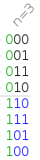
For calculating the broadcast address of 1st subnet we use binary conversion bits. In last octet, 3 extra bits from the host part are changed to 000 and remaining 5bits are converted to 11111
192.168.10.00011111

192.168.10.31

- Finding Network Address
In last octet, 3 extra bits from the host part are changed to 000 and last 5bits remains the same.
192.168.10.0

We can assign any IP to PC’s within this range
192.168.10.0 ----------------------- 192.168.10.31
// Same calculation for other networks.
Table 1. PC’s IP Address
Device | IP Address | Subnet Mask | Default Gateway
PC1 | 192.168.10.2 | 255.255.255.224 | 192.168.10.1
PC2 | 192.168.10.3 | 255.255.255.224 | 192.168.10.1
PC3 | 192.168.20.2 | 255.255.255.224 | 192.168.20.1
PC4 | 192.168.20.3 | 255.255.255.224 | 192.168.20.1
PC5 | 192.168.30.2 | 255.255.255.224 | 192.168.30.1
PC6 | 192.168.30.3 | 255.255.255.224 | 192.168.30.1

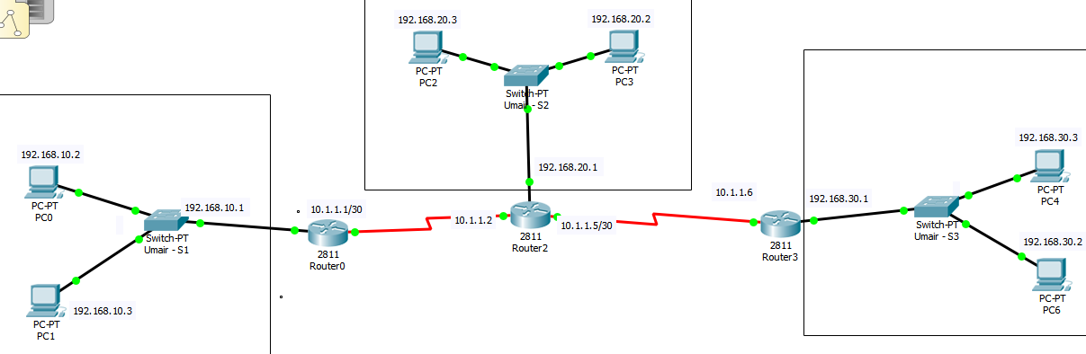

Figure 1. Configuration of IP devices
Table 2. Router’s IP Address
Device | Interface | IP Address | Subnet Mask
Router1 | Fast Ethernet 0/0 | 192.168.10.1 | 255.255.255.224
Router1 | Serial 0/2/0 | 10.1.1.1 | 255.255.255.252
Router2 | Serial 0/2/0 | 10.1.1.2 | 255.255.255.252
Router2 | Fast Ethernet 0/0 | 192.168.20.1 | 255.255.255.224
Router2 | Serial 0/2/1 | 10.1.1.5 | 255.255.255.252
Router3 | Fast Ethernet 0/0 | 192.168.30.1 | 255.255.255.224
Router3 | Serial 0/2/0 | 10.1.1.6 | 255.255.255.252
Router’s Subnet Mask.
10.1.1.1/30 (30 network bits)
11111111.11111111.11111111.11111100
// Routers are already on different subnets
255.255.255.252

Task 2: Choose Devices
Many different models of switches and routers are available in Packet tracer. Different models provide various numbers of ports, different forwarding rates, and unique feature support [3]. Following are some switches model in packet tracer version 7.1.1.0138.
- SWITCHES MODEL
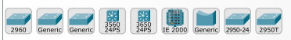
Figure 2. Switches model in Packet Tracer [1]
- 2950-24: This switch comes with 24 Fast Ethernet ports and no Gigabit Ethernet ports [3]. But this switch model is not suitable for our topology as we only need to connect 2 extra PC’s. We need fewer Ethernet ports [1].
- Cisco 2950T-24: This switch is a member of the Catalyst 2590 Intelligent Switch family and has two Gigabit Ethernet ports in addition to the 24 Fast Ethernet ports.
- Cisco 2960-24TT: This is another 24 port switch; the previous switch has Gigabit Interface Converter (GBIC) for Gigabit Ethernet ports, whereas this switch has Small Form-factor Pluggable (SFP) modules for the same [1]. This is a difference only on real switches, it has no impact on Packet Tracer.
- Cisco 3560-24PS: This switch is different from the others because it is a layer 3 (use IP address) switch that can be used to perform routing in addition to switching. The PS suffix implies support for Power over Ethernet (PoE), which can be used to power up IP phones without using power adapters. This is also not suitable for our topology [1].
- Bridge PT: This is a device used to segment a network and it has only two ports. This is also not suitable for our topology.
- Generic Switch PT: This is a Packet-Tracer-designed switch running on Cisco IOS. This is the only customizable switch with 10 slots and several modules. Like the generic router, the switch section also includes a generic switch with 10 slots that can be customized with the required modules. Except for the generic switch, other Cisco model switches cannot be customized and do not have a power switch [1]. This is because that is how real switches of the same models are designed. This switch model is suitable for our topology. It is modular and has fewer Ethernet ports.

- ROUTERS MODEL
The following routers are available in Packet Tracer:
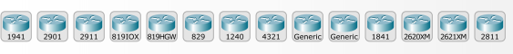
Figure 3. Router’s model in Packet Tracer [2]
- Cisco 1841: This is an Integrated Service Router (ISR) having two Fast Ethernet ports, two slots for High-Speed WAN Interface Cards (HWICs), and one slot for Advanced Integration Module (AIM).
- Cisco 1941: This is similar to the previous model but runs on Cisco IOS Version 15. It has two ports that operate at Gigabit Ethernet speeds [2].
- Cisco 2620XM: This is a multiservice router with one Fast Ethernet port, two slots for WAN Interface cards, and one slot for AIM [2].
- Cisco 2621XM: This is similar to the previous model, except that this router has two Fast Ethernet ports.
- Cisco 2811: This ISR comes with two Fast Ethernet ports, four WIC slots, and a dual-slot for AIM. This router model is suitable for our topology. We need only Ethernet ports to configure LAN interface on Router. (LAN interface to connect with Switch). This router model is modular, we can add serial ports for router WAN interfaces [2]. This model is best because it is commonly used and we don’t need any Gigabit Ethernet ports for our topology. This router series is similar to the previous routers models with some extra features. Rather than using old version, I prefer this latest model, but previous modular models with 2 Ethernet ports can also be used for this topology [3].
- Cisco 2901: This router has two Gigabit Ethernet ports, four WIC slots, and two Digital Signal Processor (s 15. This is suitable for our topology [3]. It has 3 Gigabit Ethernet ports. It is modular, we can easily add the serial interface in this router model.
- Generic Router-PT: This is a custom router running on Cisco IOS. It contains 10 slots and has separate modules with a naming convention beginning with PT [3].

Task 3: Build the Topology
For building the required topology, 3 routers, 3 switches and 6 extra PC’s are required. Straight-through cables were used to connect PCs to switches and switches to routers. The routers were connected to each other using a Serial DTE/DCE cable. DCE cables are connected to Router1 and Router 2 with the serial link speed 64 kbps.
(Straight- Through) (Serial DCE) (Serial DTE)

Straight-through cables were used to connect PCs to switches and switches to routers.
A cross-over cable was used to connect the server to the router.
The routers were connected to each other using a Serial DTE/DCE cable

Figure 3. The connections in Packet Tracer [2]
- To build this topology, we used 6 generic PC’s from End devices.
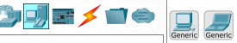
Figure 4. Generic PC [2]
- Three Generic switches are used to connect the PCs’ with Fast Ethernet port. Generic switches have 4 Ethernet ports, 2 are used for PC’s and 1 is used for connecting router with switch.
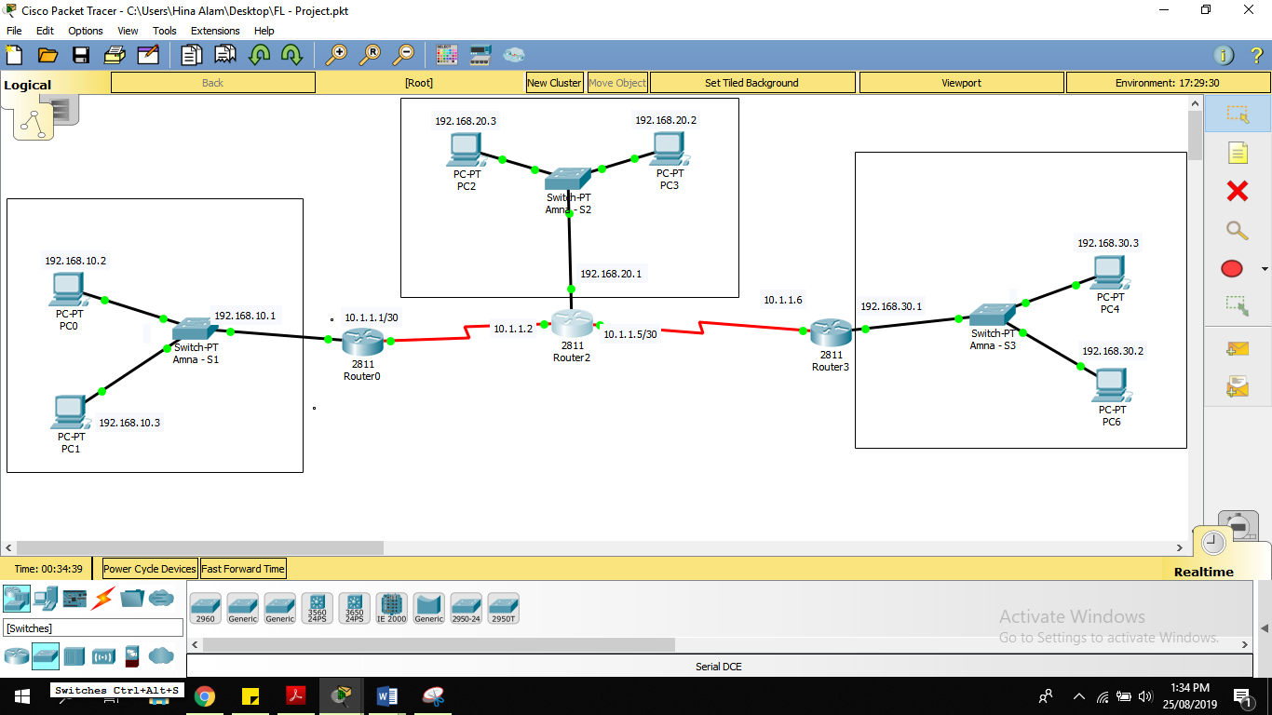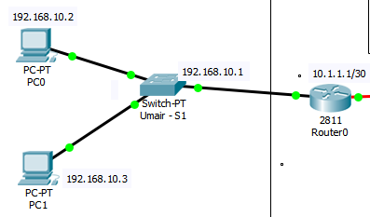
Figure 5. Switches Connection

- Three 2811 router has been used in this topology. This router model consists of 2 Ethernet ports, and we only need 1 Ethernet port for LAN interface between routers and switches. The serial interface has also been added in these routers for serial connection between all three routers. The HWIC-2T is a Cisco 2-Port Serial High-Speed WAN Interface Card, providing 2 serial ports and we need maximum 2 serial ports.

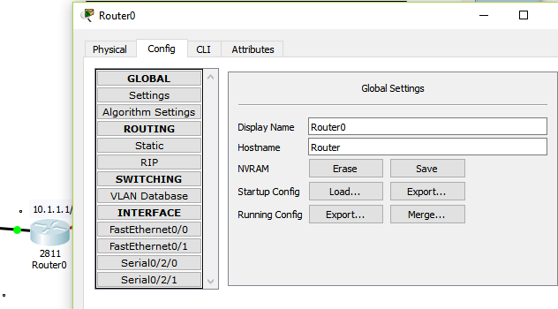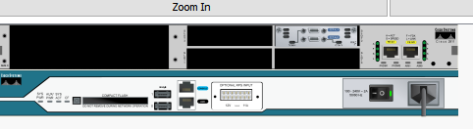
HWIC- 2T
Figure 6. Router’s Configuration

- COMPELETE TOPOLOGY
Figure 7. Complete Topology

Task 4: Prepare Basic Configuration
- Change display names of devices
The device name can easily change by clicking on the devices i.e. switch or router and then click the Config Tab. Change the display name. The following figure exhibits the display name of Switch 1.
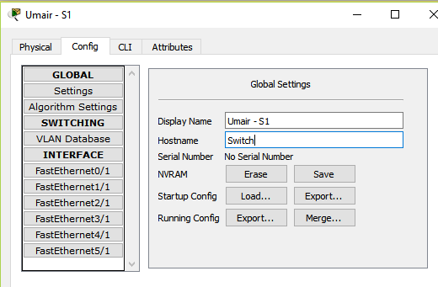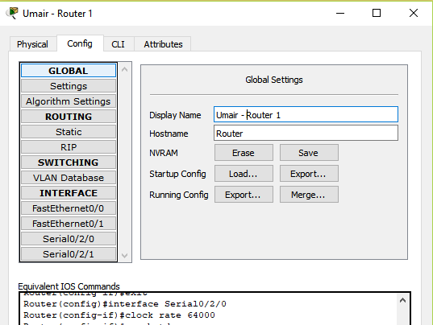
Figure 8. Display name of Switch 1 and Router 1
- Configuring hostname of Router
To change the router’s and switches’ name, CLI is used. Some basic command is used to change the mode. Router name can be set from global configuration mode. Use hostname [desired hostname] command to set name on router. Same configurations for all other routers.
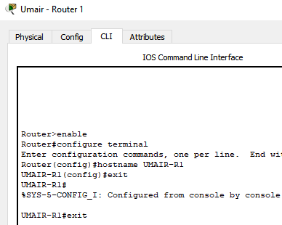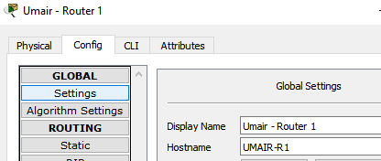
Figure 9. The hostname of Router 1

- Configuring hostname of Switch
Switch name can be set from global configuration mode. Use hostname [desired hostname] command to set name on the switch. Same configurations for all other switches.
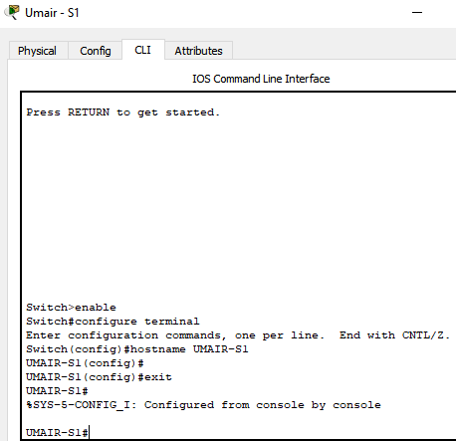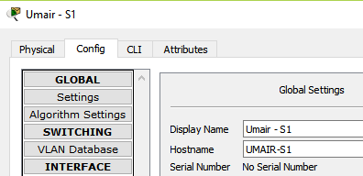
Figure 10. The hostname of Switch 1
- Configuring Banner on Router
A banner is a message that is presented to someone using the router. Router banner can be set from global configuration mode
. 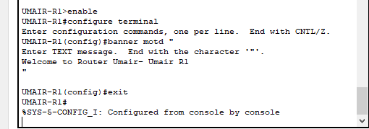
Figure 11. Setting banner on Router 1

Figure 12 exhibits the working of the banner. Following command is used to check the correct working of banner.s
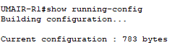

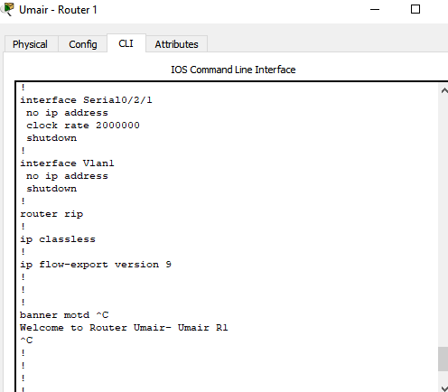
Figure 12. Checking the configured banner

Task 5: Configure WAN Interface on Routers
- Static Configurations of PC’s
In this task, IP addresses are assigned to all PC’s. All the IP address and Subnet mask are computed in Task 1. Using those IP address and Subnet Mask are assigned to all the PC’s in the required network topology. Click on the PC> Desktop> IP configuration. Here the Default gateway is the IP address we assigned to the router for this specific subnet or network. Same steps for all other PC’s
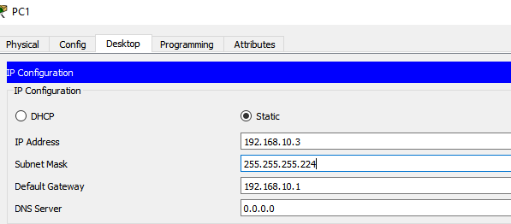
Figure 13. Configuring the IP address on PC1
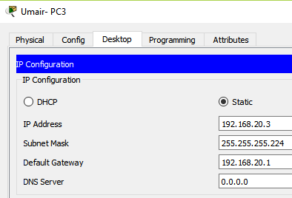
Figure 14. Configuring the IP address on PC3
- WAN Configurations of PC’
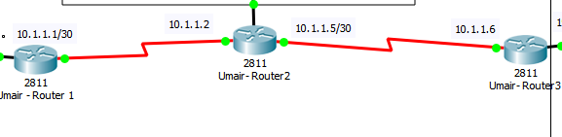
Figure 15. Serial connections between Routers
- Assigning a STATIC IP address to Router 2 Interfaces
This router has 3 interfaces, 2 serial with other routers and 1 Ethernet with the switch. Same steps are required for the other two routers. In this task, we just assigned IP address, subnet mask and gateway address to PCs. For serial connection ports in the config tab must be mark checked. DCE cables are connected to Router1 and Router 2 with the serial link speed 64 kbps.
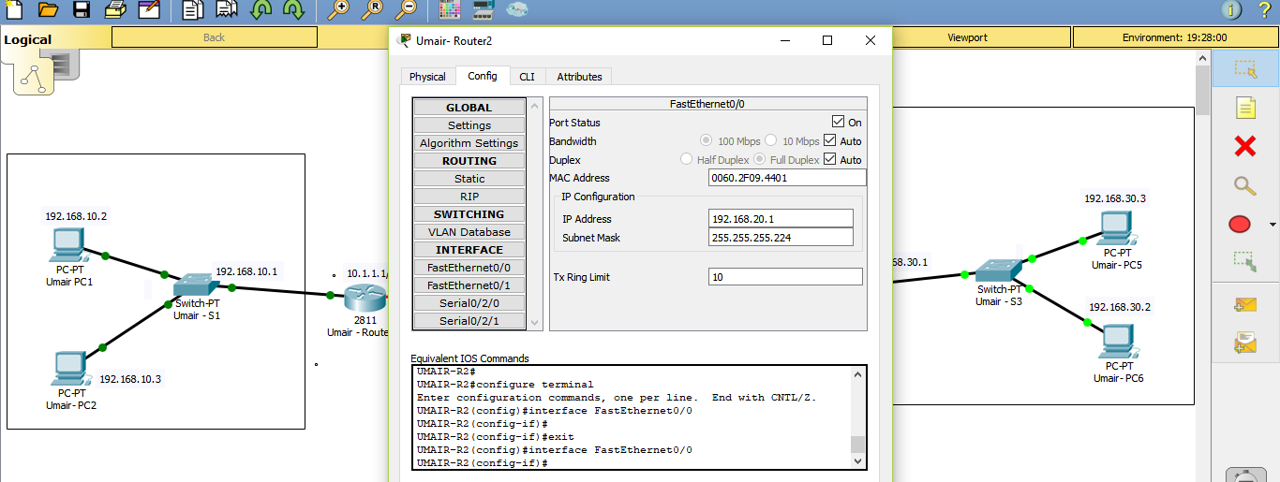
Figure 16. Ethernet Interface of Router 2 with Switch 2
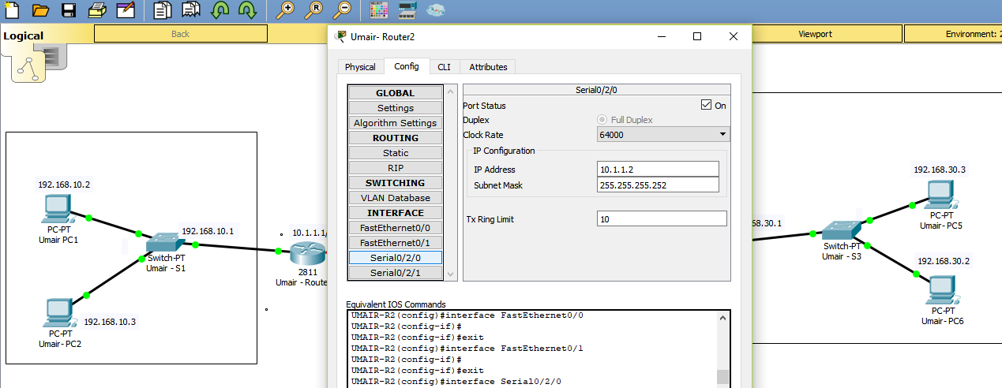
Figure 17. Ethernet Interface of Router 2 with Router 1
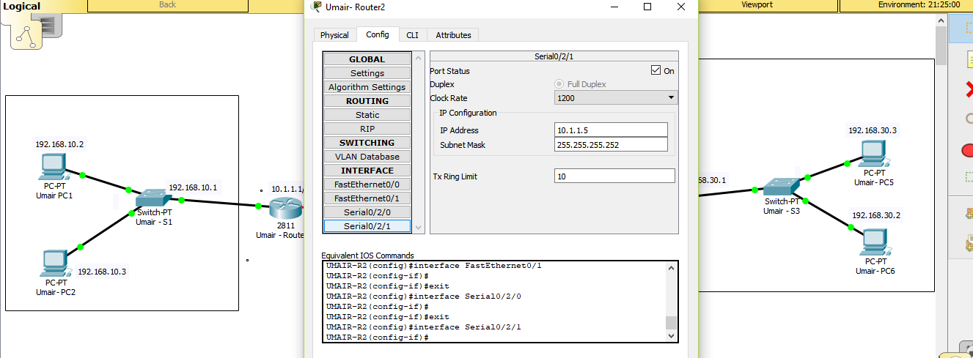
Figure 18. Ethernet Interface of Router 2 with Router 3
- Assigning an IP address to Router’s Using CLI (required Task)

- Router1
- 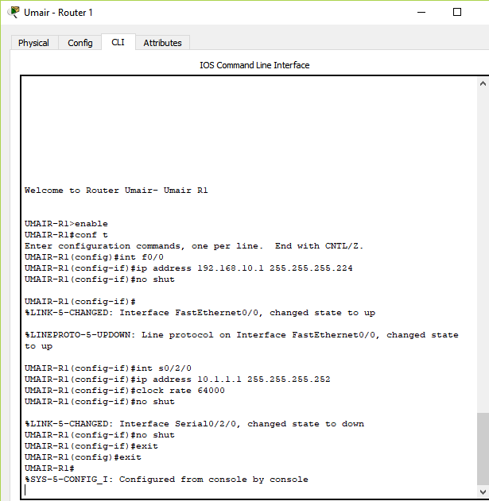
Figure 19. Router 1 configuration using CLI
- Router2

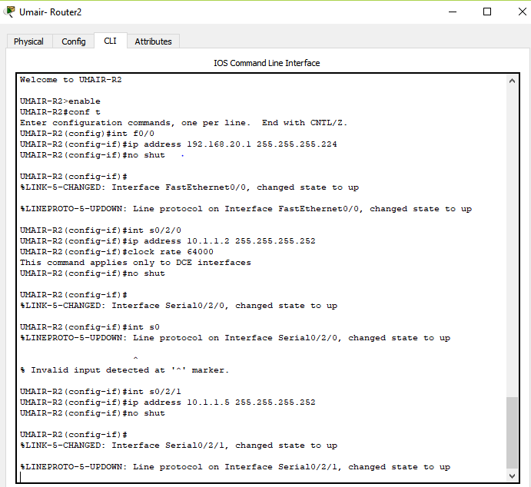
Figure 20. Router 2 configuration using CLI
- Router3

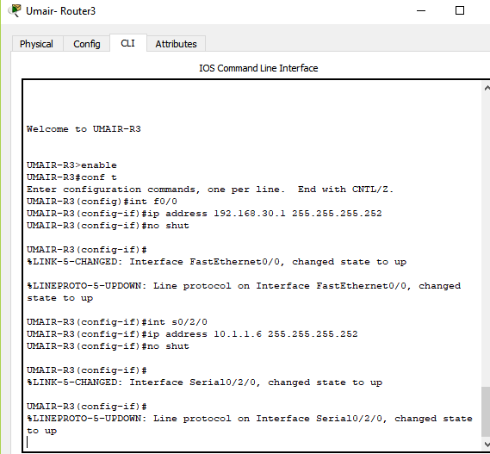
Figure 21. Router 3 configuration using CLI

PINGING ROUTERS
Ping from Router1 to Router2 and Router2 to Router3. Status is successful.

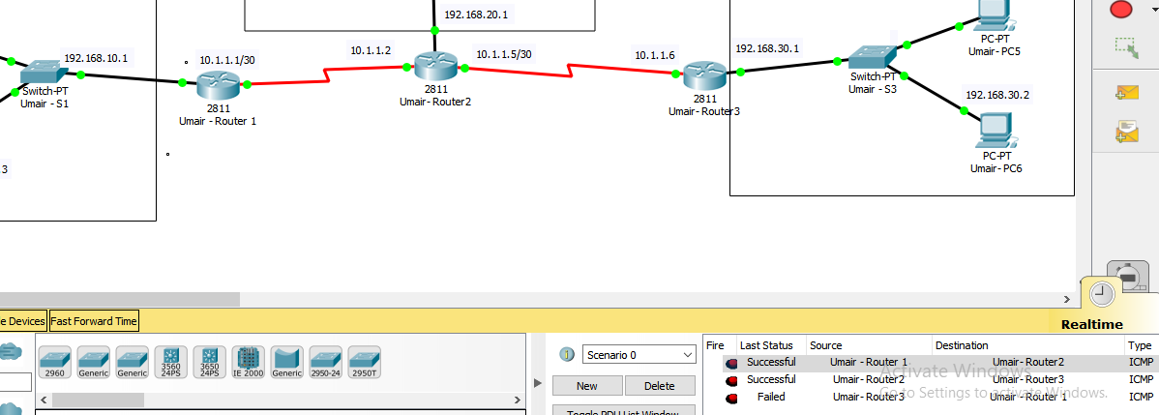
Figure 22. Ping from Router 1 to Router 2

Task 6: Configure LAN Interface on Routers
In this task, we configure the Fast Ethernet interface of the routers and then configure the IP address and default gateway of all PCs. (Same Steps in Task 5). We verify our LAN configuration by issuing ping from Router1 to PC1 & PC2, from Router2 to PC3 & PC4 and Router3 to PC5 & PC6. All pings are successful.
- Router1 to PC1 & PC2
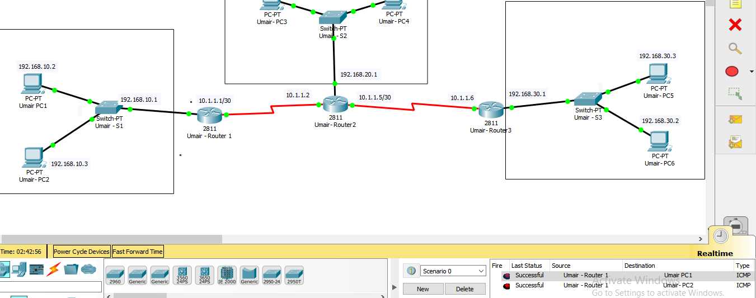
Figure 23. Ping from Router 1 to Pc1 and Pc2

- Router 2 to PC3 & PC4
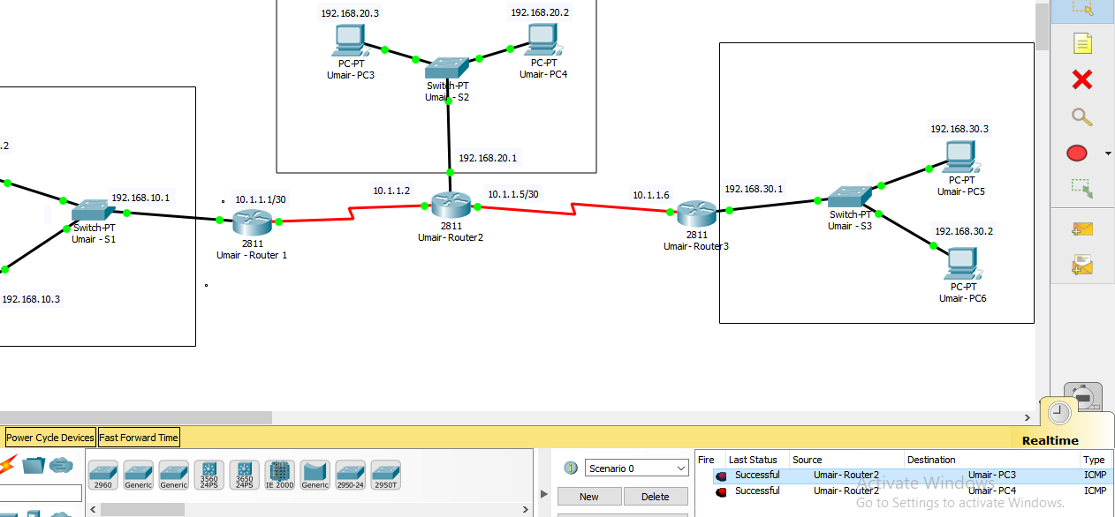
Figure 24. Ping from Router 2 to Pc3 and Pc4

- Router 3 to PC5 & PC6
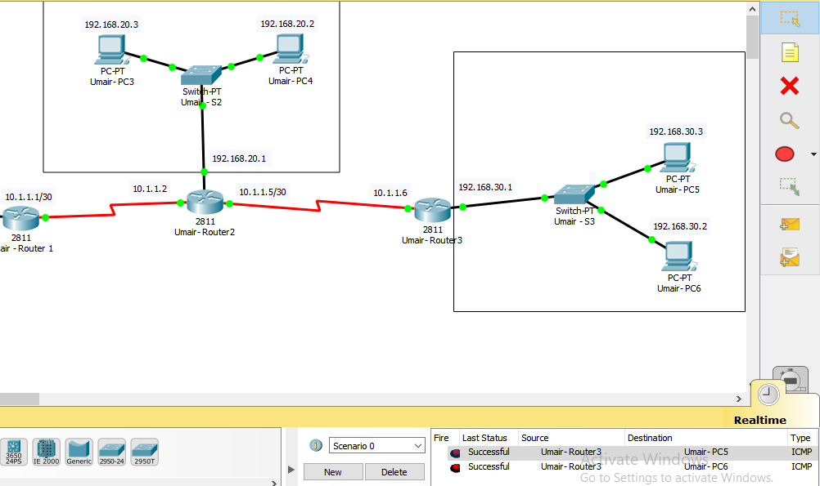
Figure 25. Ping from Router 3 to Pc5 and Pc6

Task 7: Configure the EIGRP Dynamic Routing Protocol on Routers
In this task, EIGRP (Enhanced Interior Gateway Routing Protocol) has been implemented. EIGRP is a dynamic routing protocol by which routers automatically share route information. When we ping from PC1 to PC4 or PC1 to PC6, our ping was unsuccessful; therefore, we need to configure your EIGRP thus all the PC in the topology can connect remotely.

s
- Failed Pings

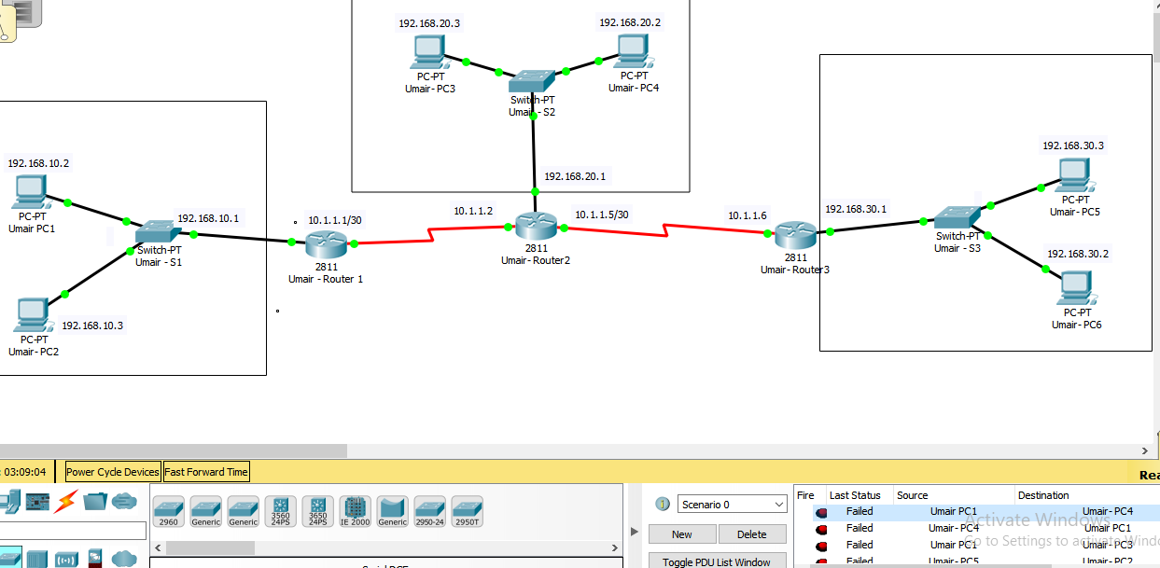
Figure 26. Failed pings from Pc1 to P4
- Configuring EIGRP on Router 1

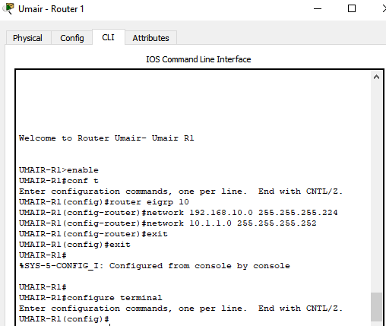
Figure 27. EIGRP on Router 1

- Successful ping from PC1 & PC3

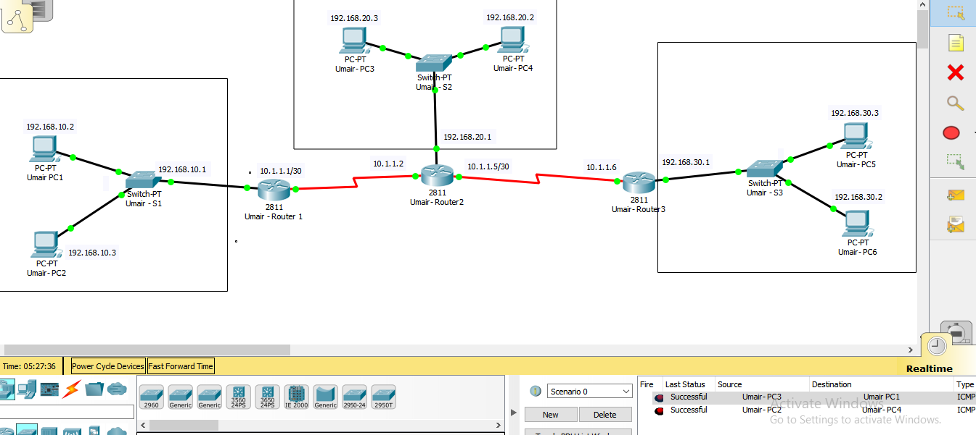 Figure 28. Successful ping from PC1 & PC3

- Configuring EIGRP on Router 2
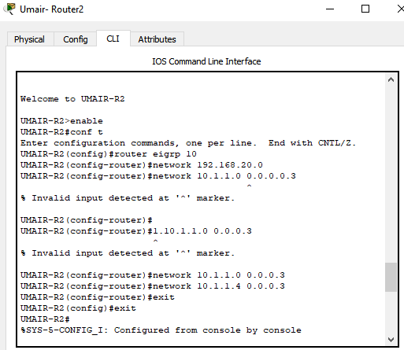
Figure 29. EIGRP on Router 2

- Successful ping from PC3 & PC5
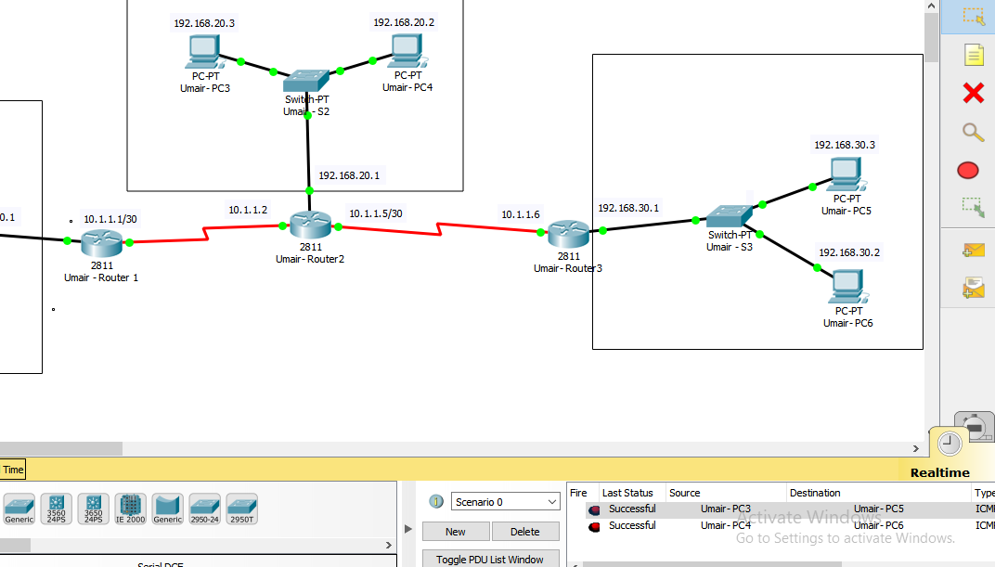
Figure 30. Successful ping from PC3 & PC5s

- Configuring EIGRP on Router 3
- 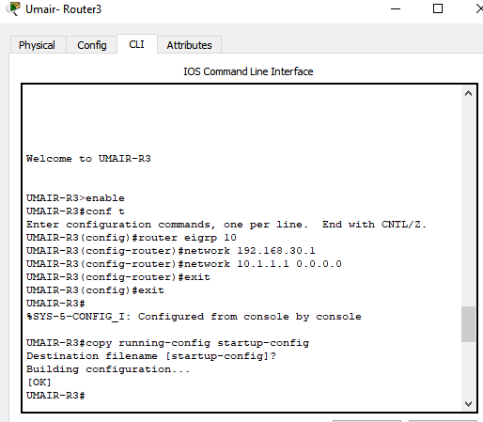
Figure 31. EIGRP on Router 3

- Successful ping from PC1 & PC3
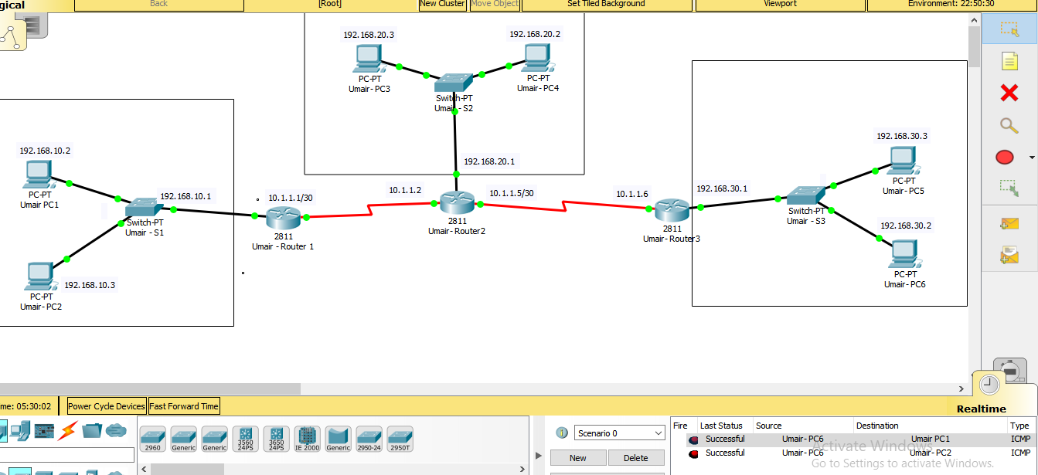
Figure 32. Successful ping from PC6 to PC2 & PC1

Part 2 – Propose a secure network infrastructure based on a given scenario.

The head office consists of the Sales department, HR department, R&D, Finance department, Marketing department and Customer Relations department. There is no department based at the manufacturing plant.

The company want to be proactive to make their network infrastructure cybersecurity resilience owing to the impactful incidents of 2020 cyber-attacks on organisations. Moreover a number of the workers are working from home and accessing the company resources virtually. The company also adopts cloud services and a number of staff are using their personal devices to carry out their day to day duties.

Introduction

Background
A2Z Technologies Ltd is a company that specialises in the design and manufacture of high-tech electronic equipment, which are then sold to retailing companies in the UK and around the world. The company has its head office in Swansea with manufacturing plant based at Cardiff.

Purpose
Based on the security issues faced by A2Z Technologies, a security management plan based upon ISO27001 will be presented for the progress and future prospects of the company.

Readership
This report will be intended for the following readers:
- Employees of A2Z Technologies
- Security officers of the company
- IT department
- Higher Management

Solution Overview

Security control overview
Security controls are a way of reducing risk to the company’s existing assets. As a part of A2Z Technologies Company, two major information assets include the formulas developed by the company and data collected using R&D in the organization. Keeping in view this perspective, security controls include the types of policies and procedures that will help in establishing the goal of risk mitigation. As a part of A2Z Technologies security plan, technical controls will be used that include the utilization of both hardware and software. Technical controls for the company’s system will include utilization of firewalls, constrained interfaces and access control lists (ACLs) along with other encryption measures.

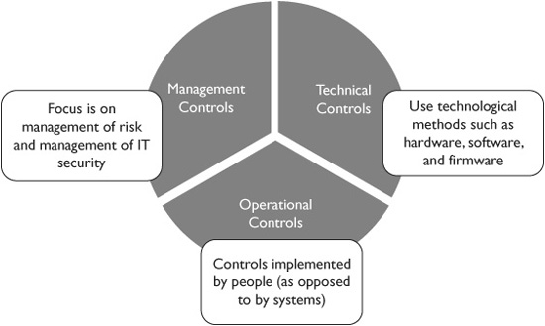
Figure 1: An overview of security controls

Secure architecture scope
The architecture scope of the system security plan will include which controls will be used and what controls can increase the effective implementation of the system. As a part of A2Z Technologies, the system architecture will cover secure control implementation along with a detail about system owners and functional members of the organization. An overview of security strategy flow for the security plan development of A2Z Technologies is presented in the figure below:
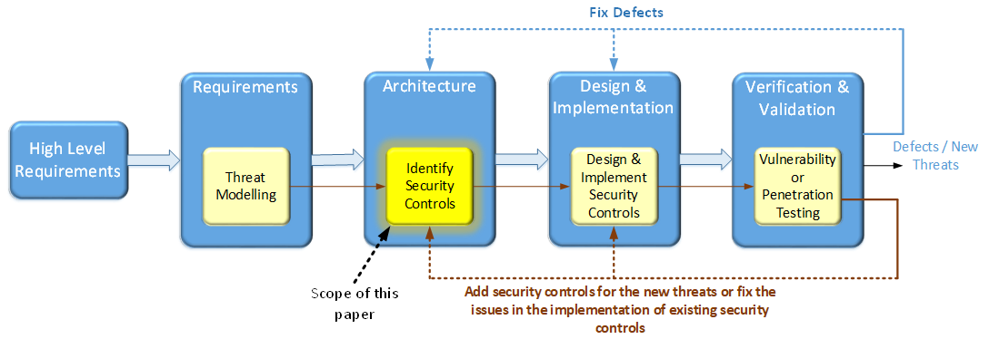
Figure 2: Security strategy flow

Scope

Assurance Approach
Security assurance approach helps in providing guarantee with regard to access control and the enforcement on the users with time as the user interaction with application will be observed in detail. In case of A2Z Technologies, assurance approach will be concerned about increasing awareness about the security requirements of the company among the key members. Moreover, in this approach the consequences of breach will be explained in detail among the necessary people.

Assurance Frameworks
The assurance framework for A2Z Technologies will follow the following approach:
- Helping in developing a consistent and comparable approach for the development of security controls to be used in information system
- Providing a detailed recommendation for security controls to be used in information system which is in accordance with GD 100 and ISO27001 guidelines
- Develop a focused, stable and flexible catalog for security controls that will be used
- Develop a foundation related to assessments methods that increase the efficiency of the security system

Scope of Security Services
Scope of security services will cover the following details:
- Server activation hours will be included 24 hours a day in which 2 hours each day will be allocated for data backup and maintenance
- Managing client infrastructure
- Providing a shared dedicated system that will be shared among the key members of the organization so that information remains save

Security Services Out Of Scope
Security services out of scope will include the following:
- Any information passed through employees personal connection
- Data shared among the non-key members

Information Security Management System

ISO/IEC 27001:2013 control coverage
ISO 27001 2013 has 14 different control coverage’s will be included. As a part of this security plan, 2 controls related to Information security policies will be discussed in detail.

Continual Improvement
Since the risks faced by the company are identified using the below given framework, hence, continual improvement will focus on reassessing risks based on the same framework.
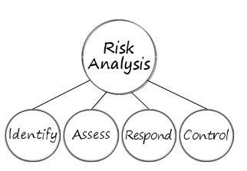
Figure 3: Risk analysis steps

Effectiveness measures
Following measures will be taken to keep the security of the system in check:
- Establish strong passwords.
- Set up a firewall.
- Updating is important.
- Secure every laptop.
- Secure mobile phones.
- Schedule backups.
- Monitor steadily.

Information Security Policies

Information Security policy is structured in accordance with ISO/IEC 27001:2013.
Policies and Standards
ISO/IEC 27001 Control References |  |  |  |  | Control Description
Sec. | Obj. | Control# | A.5.1.1 |  | A set of policies for information security must be defined, approved by management, published and communicated to employees and relevant external parties.

ISO/IEC 27001 Control References |  |  |  |  | Control Description
Sec. | Obj. | Control# | A.5.1.2 |  | The policies for information security need to be reviewed at planned intervals, or if significant changes occur, to ensure their continuing suitability, adequacy and effectiveness. Whenever changes are made to the business, its risks & issues, technology or legislation & regulation or if security weaknesses, events or incidents indicate a need for policy change.

References
[1]J. Shen, Z. Yin and Y. Guo, "Research on Reliability of Knowledge-Updating in A Kind of Network Knowledge System", Intelligent Information Management, vol. 03, no. 06, pp. 215-218, 2011. Available: 10.4236/iim.2011.36026.
[2]H. Yamada, T. Yada and H. Nomura, "Developing network configuration management database system and its application—data federation for network management", Telecommunication Systems, 2011. Available: 10.1007/s11235-011-9607-0.
[3]É. Ngoupé et al., "A Declarative Approach to Network Device Configuration Correctness", Journal of Network and Systems Management, vol. 25, no. 1, pp. 180-209, 2016. Available: 10.1007/s10922-016-9387-7.
[4] Kizza, J.M., Kizza, W. and Wheeler, 2013. Guide to computer network security (Vol. 8). Berlin: Springer.
[5] Kizza, J.M., 2005. Computer network security (pp. 440-455). New York: Springer.
[6] Mavoungou, S., Kaddoum, G., Taha, M. and Matar, G., 2016. Survey on threats and attacks on mobile networks. IEEE Access, 4, pp.4543-4572.
[7] Butt, U.J., Abbod, M., Lors, A., Jahankhani, H., Jamal, A. and Kumar, A., 2019, January. Ransomware Threat and its Impact on SCADA. In 2019 IEEE 12th International Conference on Global Security, Safety and Sustainability (ICGS3) (pp. 205-212). IEEE.

