
Programme: MSc Public Health and Social Care in Practice
Module: Community Care and Management of Longer-term Conditions
Module code: LCHS7003
Assignment Title: Component 1 Information Booklet of Long- term Condition Management

Table of Contents
Definition and Overview 3
Burden and Prevalence 4
Risk Factors and Causes 4
Physical Impact 5
Psychological Impact 6
Social and Family Impact 6
UK model for Chronic Kidney Disease 7
International model for Chronic Kidney Disease 8
Local and national political and care agendas 8
NHS Treatments and Management 8
Self-Management and Person-Centred Care 9
Signposting and Support Organisations 10
Epidemiology 1
Financial Scale 2
Middle: System Pressure 2
Closing: Critical Sustainability Argument 3
Part 1: Diagnostic Gaps in Primary Care 3
Part 2: Consequences of Late Detection 4
Part 3: Sustainability Argument (Forward-Looking Close) 4
Reference list 11



Definition and Overview
Kidneys are two organs, bean-shaped, at the rear of the abdomen (Abbas et al. 2023). They primarily serve the purpose of filtration of waste products and surplus fluid of the blood which are expelled out of the body in the form of urine (Edgman-Levitan, 2025). The kidneys stabilise the blood pressure besides filtering waste substance, maintaining the balance of vital minerals like sodium and potassium, and secretion of hormones that aid in red blood cell production and bone development (Cardol et al. 2025). A healthy functioning kidney is, hence, paramount to the general wellbeing.
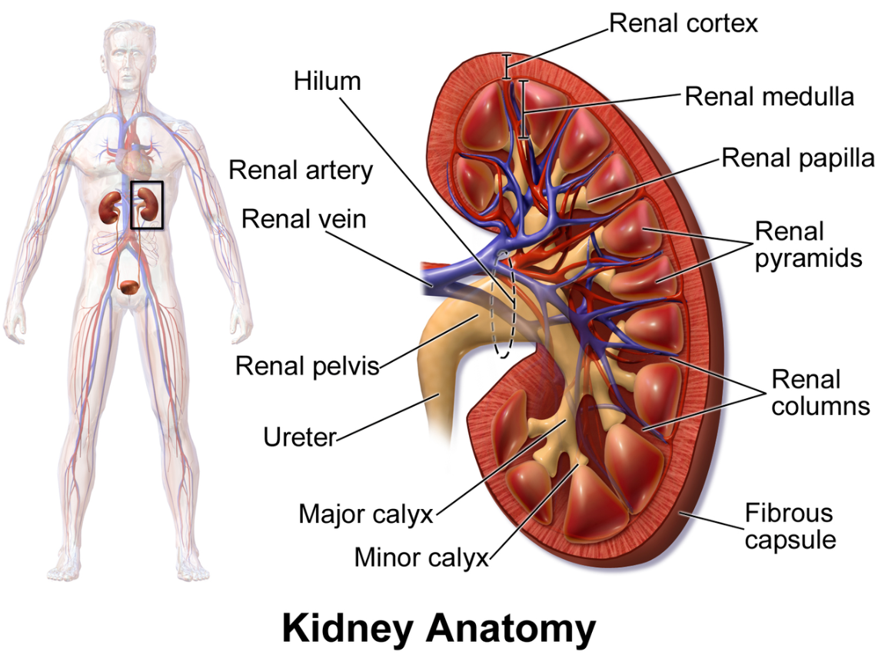
There are five stages of CKD, which are Stage 1 (kidney is mildly damaged with normal or almost normal functioning) to Stage 5 (kidney failure) (Zafer and Baloch, 2023). In comparison to acute kidney injury that can occur abruptly and can be reversed, CKD is progressive and tends to manifest over time and is chronic (Mayoclinic, 2025). Early CKD is not always associated with any apparent signs and this is the reason why it is commonly referred to as a silent condition; people may not even know that they have the disease until it is advanced.

Burden and Prevalence
CKD is seen in approximately 738 per cent of the adult population in the United Kingdom with prevalence going up with age. It is more prevalent in individuals above 60 years old (Kidneyresearchuk, 2025). The condition has a close association with other widespread long-term diseases, especially diabetes and high blood pressure (hypertension) which are the two main causes of kidney damage. Due to a constant increase in obesity rates and other lifestyle-related factors, which contribute to the rise in diabetes rates, the population with CKD is likely to increase as well (Kuma and Kato, 2022).
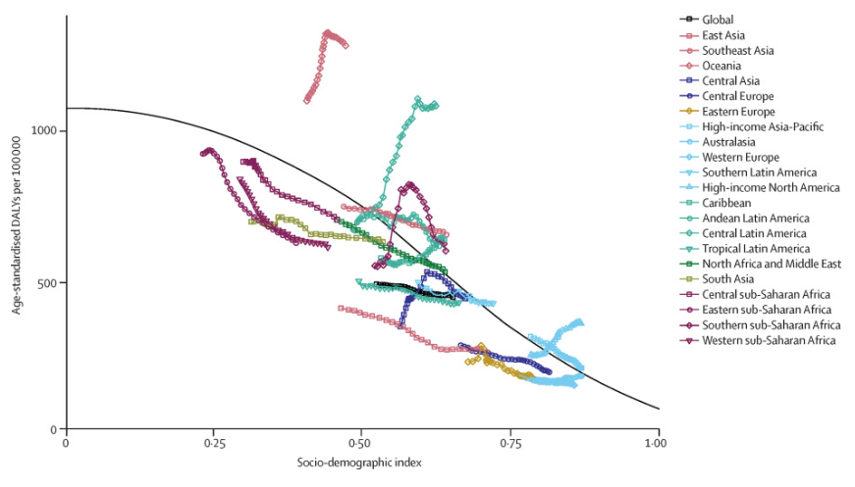
The NHS is also under a lot of financial pressure due to CKD. Dialysis and kidney transplant are highly complicated and expensive treatments both in the short- and long-term requiring specialist care (Español, 2025). Moreover, CKD has significant related health disparities. Individuals of South Asian and Black origin have increased likelihood of getting kidney disease and developing kidney failure (Kidneyresearchuk, 2026). These trends are indicative of broader social and economic dynamics, such as access to healthcare, underlying health conditions and deprivation (Kidneyresearchuk, 2026). With the ageing population in the UK, the total cost of CKD may also continue rising.

Risk Factors and Causes
Chronic Kidney Disease (CKD) may occur due to various reasons, the most prevalent one being due to other long-term illnesses (Elias et al. 2024). Diabetes is the foremost cause of CKD (Frandsen et al. 2024). The high levels of blood sugar taken over an extended duration of time may produce harm to small blood vessels within the kidneys (Kidney, 2025). The role of these blood vessels is to filter the waste in the blood. Continual elevation of glucose in the body causes the vessels to become thick and less functional thus decreasing the ability of the kidneys to filter adequately (Sluiter et al. 2024). In the long run, this damage may be irreversible.
There are a number of risk factors that predispose one to CKD, which include age (above 60), the family history of kidney disease, some ethnic groups, obesity, and smoking (Nature, 2025). Social forces like poverty, inadequate access to good food and poor access to health care services can also augment risk since they determine the levels of diabetes and high blood pressure (Nature, 2025).
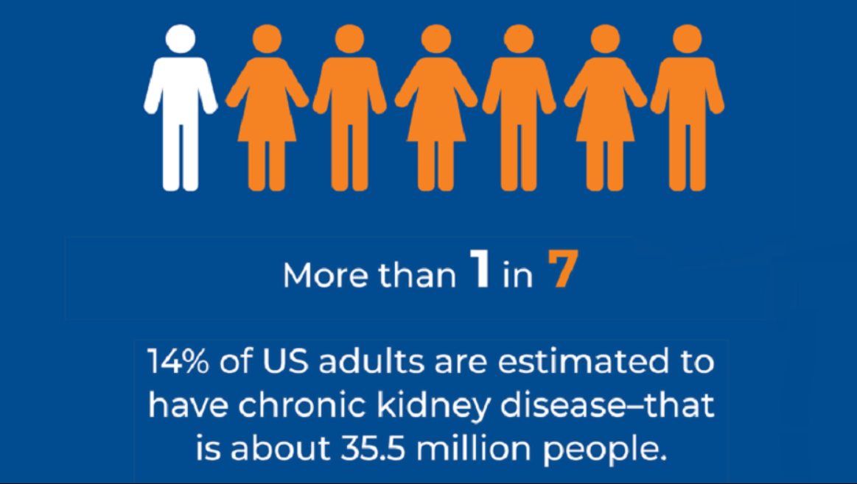

Physical Impact
Chronic Kidney Disease (CKD) can present itself with no apparent symptoms during the initial phases (Kidney, 2026). Nonetheless, with the worsening of kidney functioning, physical symptoms can accumulate. The chronic fatigue is witnessed in many as the kidneys are no longer in a position to sustain normal levels of hormones that promote the production of red blood cells.
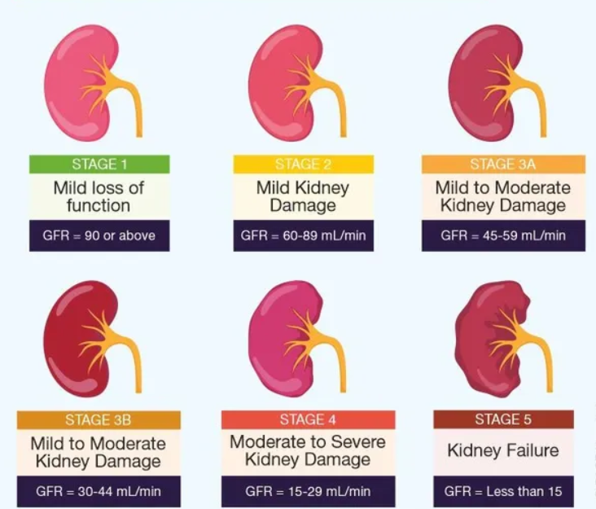

CKD may promote the emergence of severe complications. These are bone diseases, because the kidneys are involved in the regulation of calcium and vitamin D, and an extremely increased risk of heart disease, which is the cause of the greatest death rate in individuals with CKD (Emedicinehealth, 2025). The stage 5 has a very low level of functioning kidney, which is referred to as kidney failure. Kidney transplant or dialysis can be required at this stage. It is necessary to mention though that not all people with CKD will develop (Schoot et al. 2022).
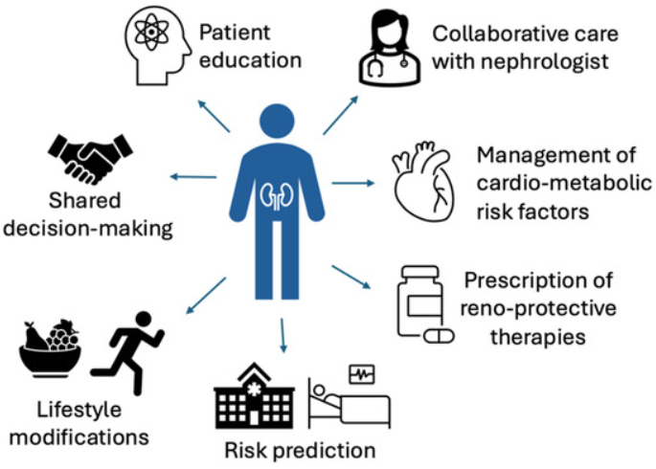

Psychological Impact
Psychological influence of Chronic Kidney Disease is great and it can influence emotional and mental health of patients. The depressive state of many people is explained by the chronicity of the disease and limitations of the way of life (Yun and Yun, 2023). Fear is the next most frequent condition, which is usually associated with the uncertainty in the course of the disease and effects of the treatment. Unrelenting medical attention and nutritional restrictions cause stress and emotional overload (Kumar et al. 2024). The effect of CKD on the quality of life can be fatigue, social isolation, and loss of independence. There are also cognitive problems and insomnia. In general, it is critical to treat mental health in addition to physical treatment to elevate the wellness of patients and their quality of life.

Social and Family Impact
Chronic Kidney Disease (CKD) may impact upon numerous spheres of everyday life not only of the patient but also of the family (Li, 2024). With the development of the condition, it might become difficult to remain employed because of fatigue, frequent doctor visits or treatment regimens (Frontiersin, 2025). The decrease in working hours or premature retirement may result in financial strains especially when some extra expenses like traveling to the hospital or special diet are considered.
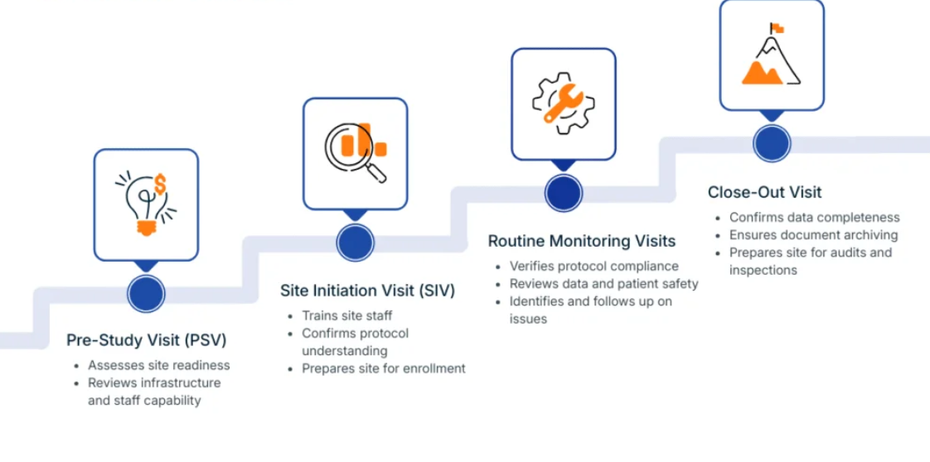
Clinic visits and regular monitoring take time and have to be planned and these may interfere with regular operations. In the case of patients who are under dialysis, it may have a great effect on their day-to-day life. Haemodialysis usually involves visiting a hospital or dialysis centre a number of times per week at varying times of the day of a number of hours (Kidneyresearchuk, 2025). As much as it is performed at home, peritoneal dialysis is also subject to rigorous routines and equipment handling. Such schedules may restrict flexibility, social life and traveling.
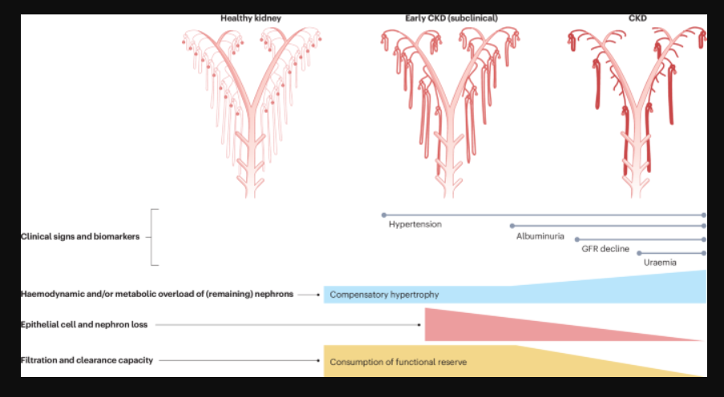
The family meals and social occasion may be impacted by dietary restrictions, including salt, potassium or fluid limitation, which can occasionally result in isolation. Care giving roles may be undertaken by family and this may pose emotional and physical burden (Kingsfund, 2025). The carers can have stressful feelings or become tired or anxious regarding the health of the loved one. In the long term, these alterations may influence relations, self-reliance and life quality, which is why social and practical assistance is of significant value.

UK model for Chronic Kidney Disease
The UK model on the management of Chronic Kidney Disease is based on identifying the disease at an early stage, coordinated care and patient centered management (Nick, 2025). It focuses on primary care screening in order to detect CKD at early stages led by the National Health Service (Nick, 2025). General practitioners would work with specialists to do the assessment of the risk and make timely referral. The model embraces self-management by educating patients, changing lifestyles and using medications. Holistic care involves multidisciplinary teams which include dietitians and nurses. In more severe cases, it is treated by means of renal replacement therapy either dialysis or transplant (Zhang and Yuan,2023). In general, the UK strategy will focus on decreasing the rate of disease development, enhancing the quality of life, and reducing healthcare expenditures.

International model for Chronic Kidney Disease
The global model of managing chronic kidney disease is based on prevention, early detection, and standard care of healthcare systems. International organizations such as World Health Organization and Kidney Disease (WHO, 2026): Improving Global Outcomes present international guidelines in the diagnosis, staging, and treatment. The model focuses on screening of high-risk populations, diabetes and hypertension patients. The teams of multidisciplinary care facilitate treatment, such as medication, diet, and lifestyle changes (WHO, 2026). In developed stages, dialysis and transplantation is given priority. Generally, the global strategy will minimize the burden of diseases, enhance the outcomes, and provide equitable kidney care globally.

Local and national political and care agendas
The Chronic Kidney Disease political and care agendas in the UK are centered on the prevention, early detection, and alleviation of health disparities in the UK. The National Health Service focuses on integrated care by means of primary and specialist services. The NHS Long Term Plan is one of the national policies that focus on enhanced screening, digital health, and community-based care (NHS, 2025). On the local level, Integrated Care Systems arrange services to achieve the accessibility and individualized treatment. The emphasis on the population health programs against risk factors such as diabetes and hypertension is also great (NHS, 2025). In general, the agenda will improve patient outcomes, efficiency, and kidney care service sustainability.

NHS Treatments and Management
Chronic Kidney Disease (CKD) management in the NHS is aimed at slowing the progression of the disease, the alleviation of complications, and promoting general wellbeing. Constant observation is necessary.
Drugs play an important role in therapy. ACE- inhibitors and angiotensin receptor blockers (ARBs) are usually administered to help lower blood pressure and decrease the load on the kidney (Pollock et al. 2024). SGLT2 inhibitors are newer medicines that are proven to be helpful in preserving the health of the kidney especially in individuals with diabetes (Di Costanzo et al. 2023).
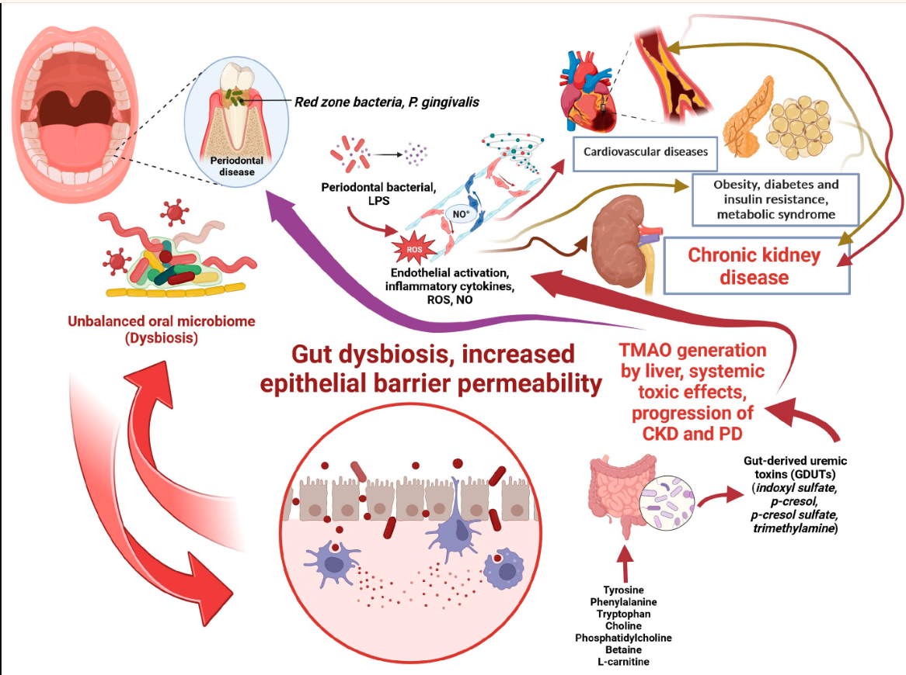
Haemodialysis is the process of filtering out the blood through a machine typically on a number of occasions a week. Peritoneal dialysis involves the use of the abdominal lining to eliminate waste products and may be done at home (NIDDK, 2026). Kidney transplant can provide the most successful long-term solution to an appropriate patient. In other cases, especially amongst those with other serious health conditions, conservative (non-dialysis) management can be adopted to concentrate on comfort and quality of life (Seery and Buchanan, 2022). The provision of care is multidisciplinary with the involvement of GPs, nephrologists (kidney specialists), renal nurses, dietitians, and pharmacists. Early diagnosis and proper treatment can greatly enhance the results and may slow down or avoid the development of kidney failure (NHS, 2025).
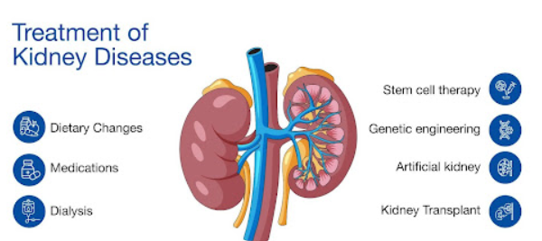

Self-Management and Person-Centred Care
Self-management is significant to delay the development of Chronic Kidney Disease (CKD) and health conditions. There are numerous elements of care that require lifestyle modification, which patients may actively participate in. Healthy food, especially salt, can assist in managing blood pressure and lessening water retention (Mayoclinic, 2024). Individuals with diabetes are advised to watch and control their levels of blood sugar thoroughly as elevated levels of glucose may cause even more harm to kidneys. Physical exercise, when used properly, helps maintain the heart, as well as weight. It is highly recommended to quit smoking because it predisposes people to cardiovascular disease and additional kidney damage.
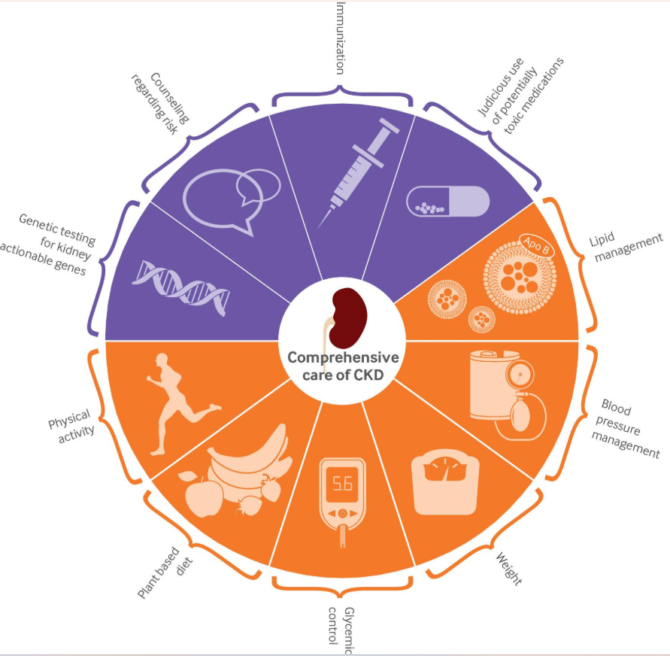
One of the principles of the NHS is person-centered care. It is a strategy that acknowledges the fact that every individual experience of CKD is individual (NHS, 2025). Shared decision-making enables the patients to consult the healthcare specialists in discussing the treatment options and select the solutions that would be most appropriate to their values and way of life (RCSED, 2025). Personal care plans are created based on individual health demands, culture and social set up.

Signposting and Support Organisations
Life with Chronic Kidney Disease (CKD) might be overwhelming, yet one may be supported (de la Cuesta-Benjumea et al. 2023). The NHS site is a good source of information concerning CKD, treatment and lifestyle tips. Kidney care organisations like the Kidney Care UK and the National Kidney Federation provide practical advice, financial advice, support, and helplines that provide emotional support to the patients. In the case of diabetes patients, Diabetes UK offers further information regarding the control of blood sugar and the avoidance of complications (Richmondgroupofcharities, 2025).
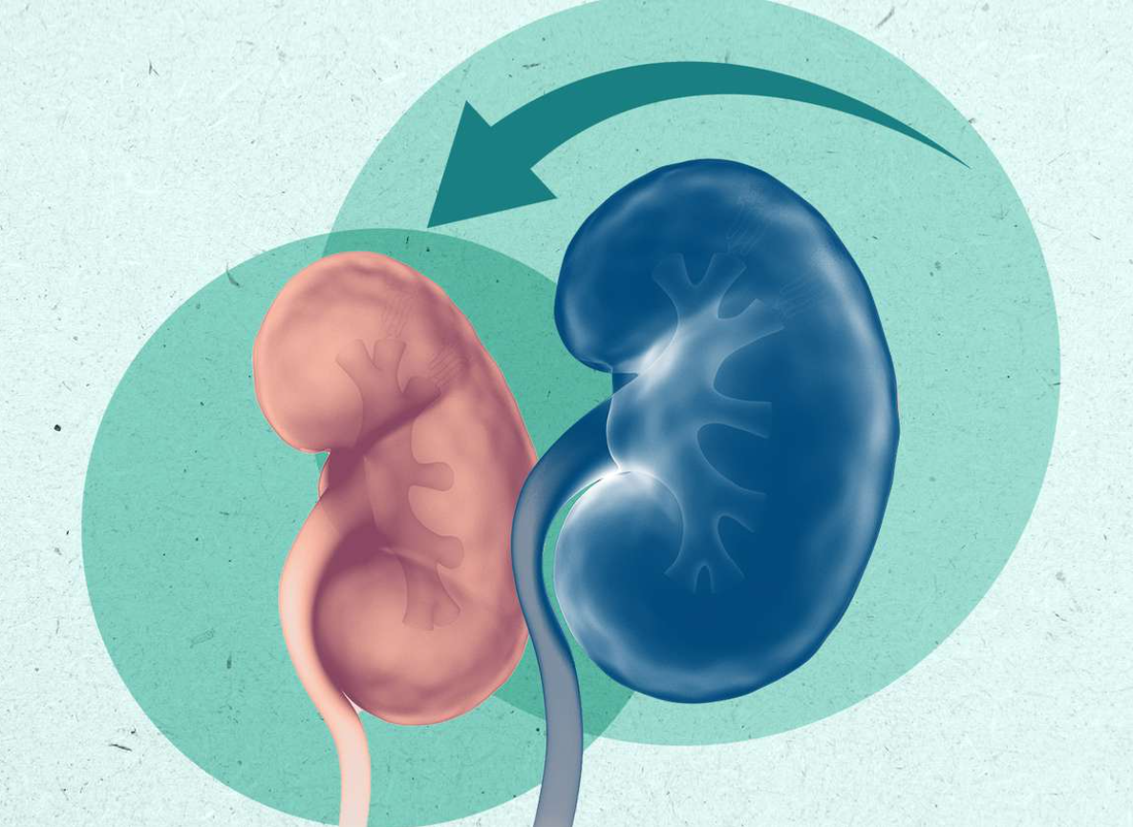
Personalised advice can also be provided by your team of local GPs and renal clinics and you can be referred to specialist services by them when necessary. Family members can receive support services through carer support services in the event of need of guidance or respite. Early seeking support has the capability of enhancing confidence, wellbeing and improved long-term health outcomes

Epidemiology
Chronic Kidney Disease (CKD) occurs in some percent of the world population, which constitutes a major and increasingly more important health issue in population. In the United Kingdom, the population is estimated to be prevalent among the adult population with an increase of more than in people aged above 65 years (Gov UK, 2025). The rising prevalence of CKD is representative of broader demographic and metabolic patterns, specifically, the ageing population, as well as the rising cases of diabetes and obesity. These are often comorbid with hypertension, which leads to a clustering of cardiovascular and metabolic risk factors that increase the rate at which kidney damage occurs.
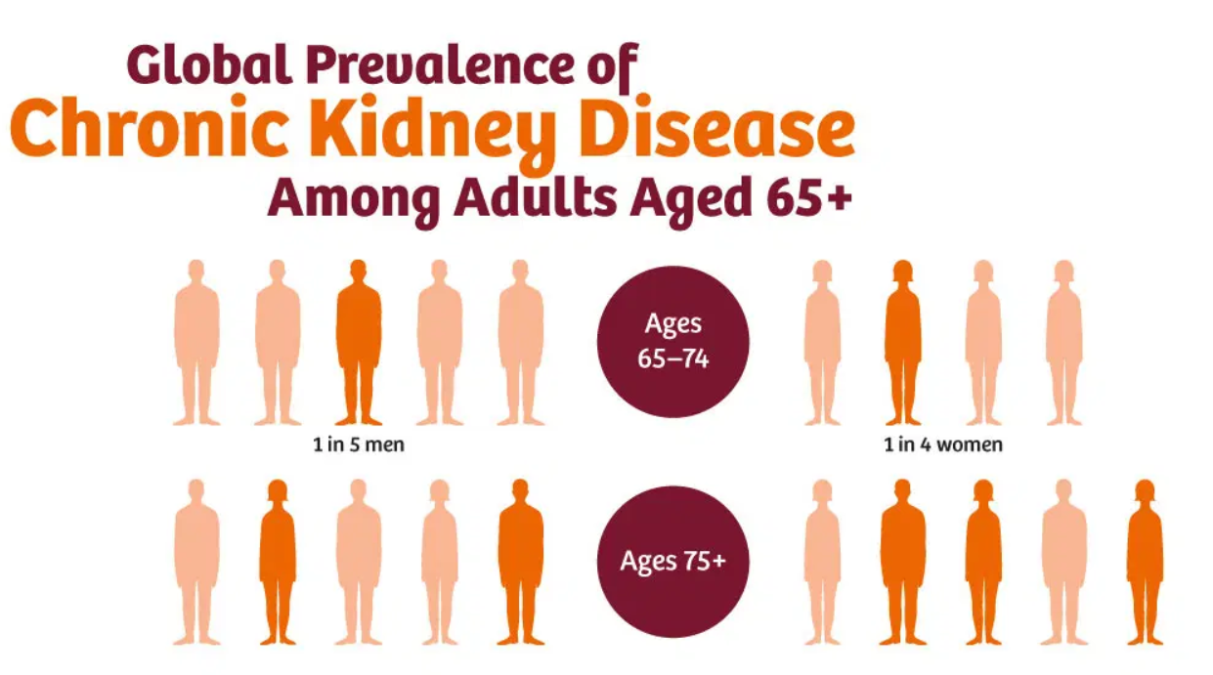
Notably, cardiovascular morbidity and mortality have a strong link with CKD. Patients with compromised renal activity have a very high susceptibility to cardiovascular complications, among them being myocardial infarction and stroke (Kingsfund, 2025). Existence has hinted that a substantial part of patients with CKD have a higher chance of passing away of cardiovascular disease than advancing in end-stage kidney failure. CKD is thus both a progressive renal disease as well as a major risk magnifier of cardiovascular disease in populations with multimorbidity.
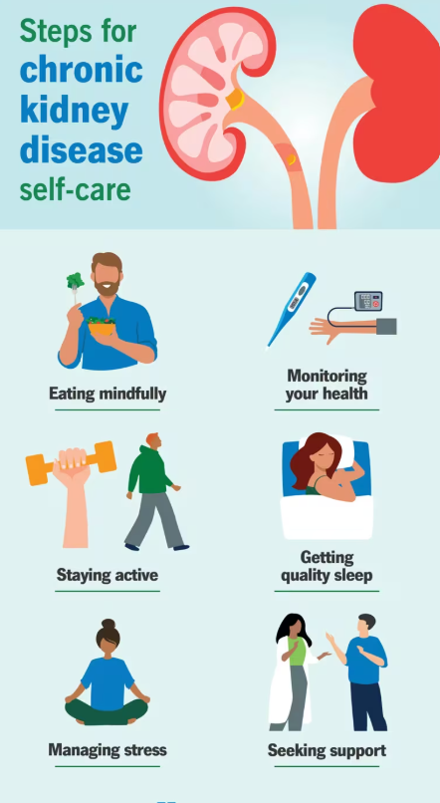

Financial Scale
- The approximate annual cost of dialysis per patient in the UK (enter up to date figure of a reputable reference).
- Indicate that compared to peritoneal dialysis, haemodialysis is more costly in terms of hospital facilities, staffing and transport (Roberts et al. 2022).
- Discuss that, despite the initial high cost of surgical and post-operative expenses of kidney transplantation, it is more economical than dialysis in the long run.

Middle: System Pressure
- Increased demand for renal replacement therapy (RRT).
- The multimorbid elderly population makes it harder to provide clinical care (Seghers et al. 2023).
- Patients are now admitted with diabetes, cardiovascular disease, weakly, - raising the cost of care.
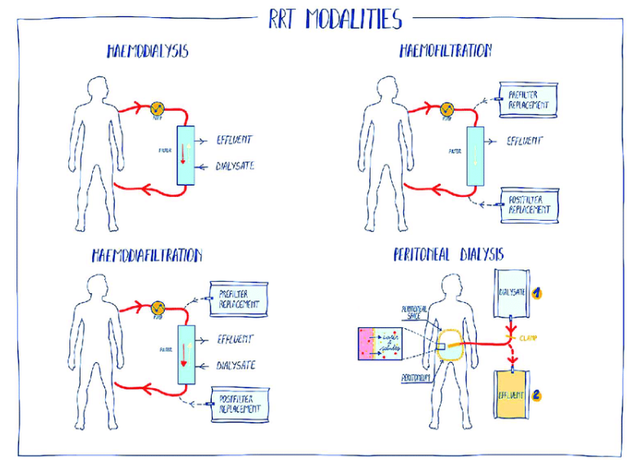

Closing: Critical Sustainability Argument
- Connection to budget constraints of Integrated Care System (ICS).
- Conclusion: Critical Sustainability Thesis.
- The CKD occupies a disproportionate portion of the NHS spending in comparison to its prevalence (Mayoclinic, 2024)
- The existing model of the service is highly treatment-based as opposed to prevention-oriented.
- Bring up the issue of sustainability in the long run.
- Implicate that demand for RRT might surpass service capacity without previous intervention strategies in place.



Part 1: Diagnostic Gaps in Primary Care
- In spite of accepted screening guidelines, CKD is often diagnosed at the end of primary care.
- Stage 1–2 of CKD is usually not widely known, since patients are not symptomatic.
- CKD can be entered into electronic records but not given priority in the management plans.
- Electronic grieving of the eGFR can be lost in the work pressure and conflicting clinical priorities (Mayoclinic, 2024).

Part 2: Consequences of Late Detection
- Late diagnosis removes early opportunities of intervention.
- Poor blood pressure and glycaemic control also hastens the progression.
- This helps generate more referrals at later stages.
- Increased strain on dialysis and transplant.

Part 3: Sustainability Argument (Forward-Looking Close)
- In the absence of enhancement of the primary diagnosis and proactive management channels, the increased prevalence of renal replacement therapy is likely to exert unsustainable pressures on the future NHS renal services.
Begin with a critical positioning statement:
Despite the national recommendations and the focus on early diagnosis in particular, the CKD is still diagnosed late at the primary care level. Stage 1 and 2 CKD (Early stage) is an under-recognised condition because of its lack of symptoms. Declines in eGFR can be entered into the electronic systems and not always escalated and acted upon. Competing chronic disease priorities uproot proactive follow-up because of high GP workload (Kristensen et al. 2025). Screening is limited in its scope to high-risk groups (e.g., diabetes, hypertension) and does not have a greater impact on prevention.
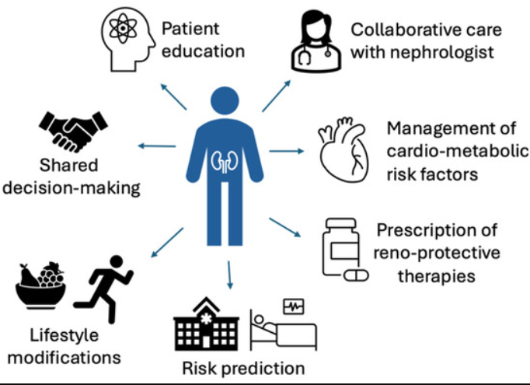
The QOF indicators encourage documentation and blood pressure control but might not reflect the risk of progression and albuminuria patterns and early patterns. Late intervention is a cause of ameliorated disease development. Increased patients are at an advanced stage that needs renal replacement therapy (Emedicinehealth, 2025). The allocation of resources thus turns into a dialysis-driven as opposed to prevention-based approach. The tendency of a healthcare system to spend on late-stage treatment would indicate a lack of investment in early preventative pathways. The increasing pressure on the NHS renal services due to rising demand of renal replacement therapy will put an unsustainable burden on renal primary care intervention and system redesign without its reinforcement.
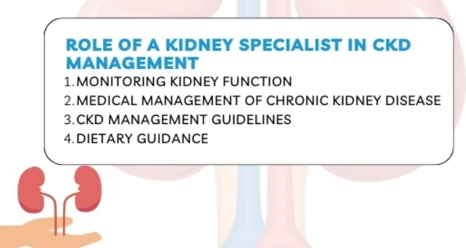
The result of further dependence on dialysis and transplantation unless prevention and early-stage intervention are prioritized as part of CKD pathways is that pressure is likely to mount up, necessitating ongoing reliance on existing NHS renal infrastructure, which will be unable to maintain itself through time. The lack of integrated early diagnosis mechanisms and positive primary care measures would mean additional pressure would be placed on the effective treatment at late stages, hence affecting the financial stability and service sustainability of NHS renal services (Gettingitrightfirsttime, 2025). Unless preventative management and earlier identification are put at the forefront, the increasing renal replacement therapy burden will only keep growing to a level that the financial and workforce ability of the NHS renal services can no longer sustain it on a long-term basis.
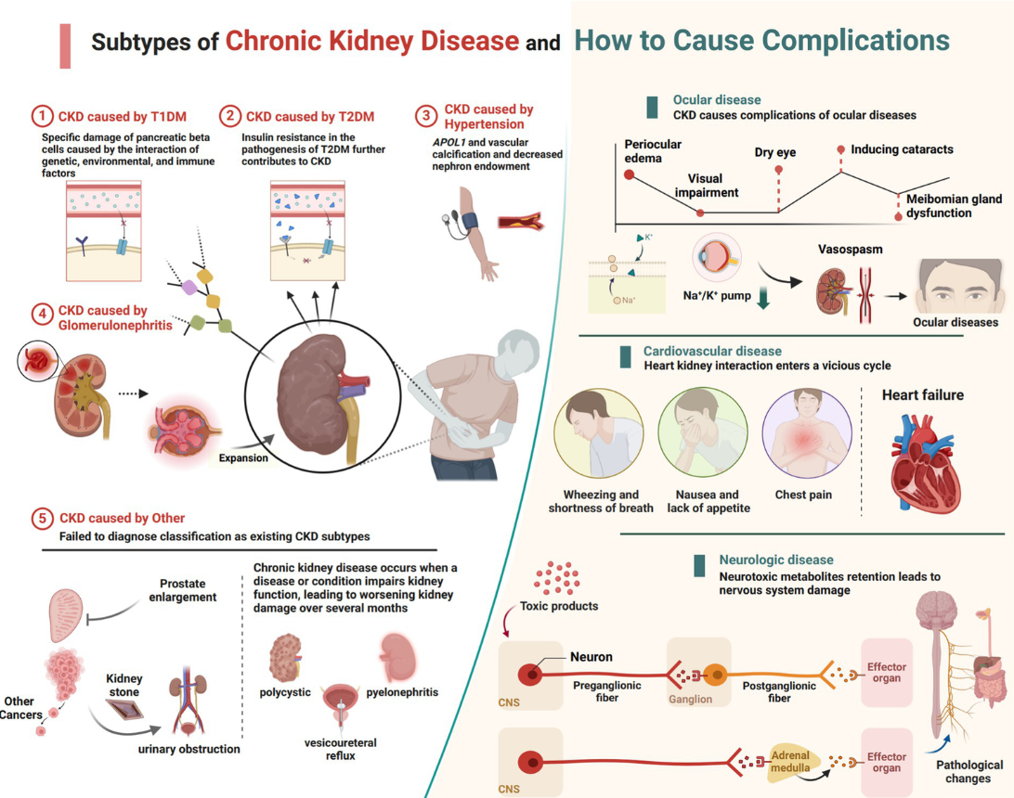
Start with your three core points:
• In spite of national guidance, CKD continues to be diagnosed too late in primary care.
• The initial phases (1&2) are not well-recognized, due to their being asymptomatic.
• The decrease in eGFR can be registered but not intensified.
Now expand analytically:
• Explain why this happens
• Competing chronic disease priorities in general practice.
• Time constraints and workforce shortages.
• CKD is often perceived as lower priority compared to cancer or acute illness.
• Over-reliance on automated alerts without structured follow-up pathways.
Discuss screening limitations
• General practice competing chronic disease priorities.
• Limited time and workforce.
• CKD is considered as a less important priority than cancer or acute sickness (Gettingitrightfirsttime, 2025).
• Excessive dependence on automated alerts based on unorganized follow-up channels.
• Talk about the screening restrictions.
• The screening process is mostly restricted to high-risk groups (diabetes, hypertension).
• Poor proactive case-finding in the deprived communities.
• QOF incentives do not have to be based on progression tracking, but instead on BP targets.
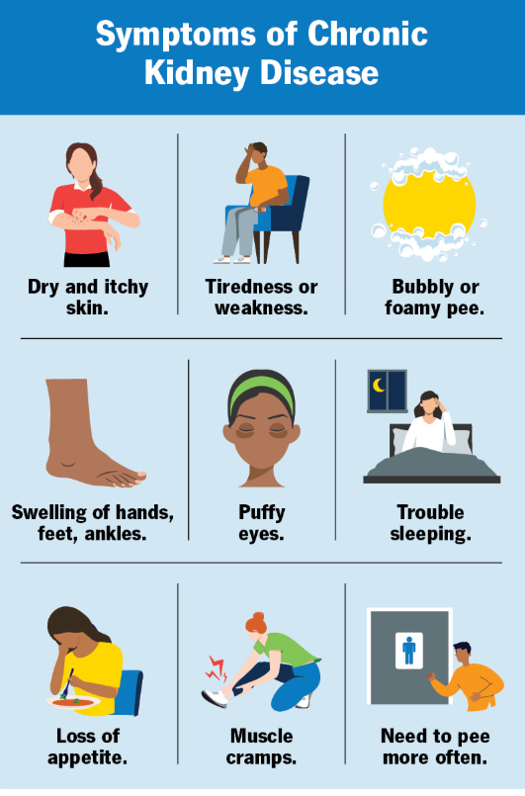
Close analytically
• Late access to early intervention.
• Accelerated development to progressive phases.
• Additional stress to the nephrology services and dialysis units.
• This trend demonstrates a reactive model of care and not a preventive one.
• Casts doubts on the sustainability of renal services in the long run.
Final analysis
Opening: Linking Individual and System Burden
Begin by synthesising both booklets:
• CKD is a huge long-term condition with physical, psychological and social implications on individuals (Kingsfund, 2025).
• At the same time, it causes significant epidemiological and economic burden to the NHS.
• The interplay between personal disease burden and systemic resource allocation is an example of a two-fold clinical and structural complication CKD poses.
Prevention vs Reactive Care Model
• Even with the powerful policy frameworks, CKD management is still imbalanced towards being reactionary.
• In primary care, late diagnosis is one of the factors that cause advancement to a later stage.
• The expenditure pattern indicates that the state spends a lot of money on dialysis and renal replacement therapy (Richmondgroupofcharities, 2025).
• This implies that there is underinvestment in the early detection and preventive measure.
• Put this in terms of unbalance between treatment and prevention.
• Social Determinants & Health Inequalities.
• Increased prevalence and progression of CKD in Black and South Asians.
• Relatedness with deprivation, prevalence of diabetes and access to care.
• Both the incidence and outcomes are dependent on structural and socio-economic determinants.
Health Inequalities & Social Determinants
• NHS Long Term Plan and personalised care model put an emphasis on prevention and integration.
• Chronic Care Model fosters multidisciplinary management that is proactive.
• Nonetheless, there are still gaps in implementation of primary care workload, workforce shortages, as well as, screening reach.
• The rising cases of diabetes and ageing of the population would probably increase the rate of CKD. Stakeholders in the renal replacement therapy sector will keep increasing the demand unless there is a systemic redesign that focuses more on the early detection, integrated pathways and digital monitoring. Sustainability of the NHS in the long term relies on the ability to move out of the late-stage treatment and focus on care models based on prevention and equity (Kingsfund, 2025). Focus on strategic investment in preventive care, workforce, and specific inequality reduction.
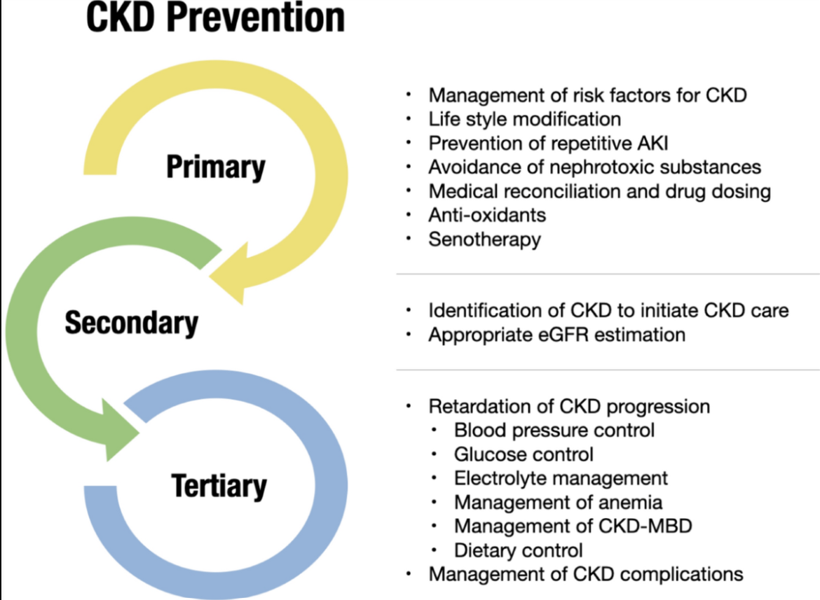
Conclusion
Chronic Kidney Disease is an emerging serious issue in the area of population health as well as in the healthcare systems. It has immense physical, psychological and social implications.
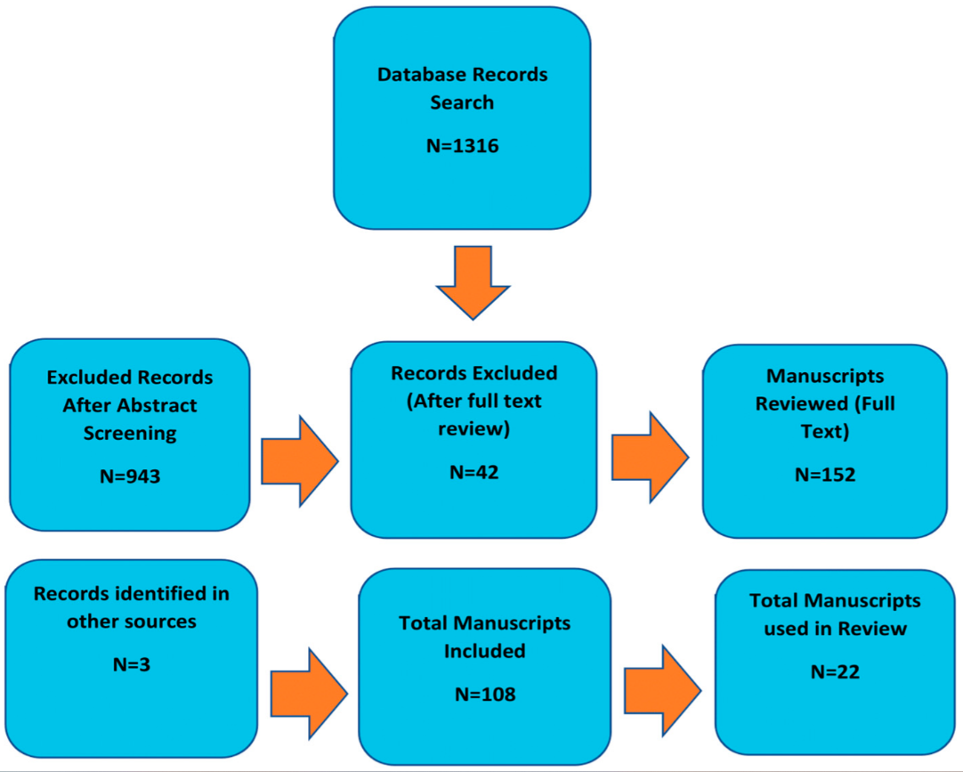
On the population level, it is a significant contributor to the NHS expenditure and service demand. Increased prevalence associated with ageing, diabetes and obesity. Good correlation with cardiovascular morbidity and mortality. Diagnosis and under-recognition during primary care may lead to progression. The existing trends in services are still skewed towards dialysis as opposed to prevention. The interplay between an individual disease burden and structural service pressures points to the necessity of more integrated interventions of earlier nature. The sustainability of renal services in the long term relies on the enhancement of early diagnosis, the minimization of disparities, and the transformation of investments to prevention-oriented models of the person-centred care. Reverse diagnosis and uneven early treatment will lead to the course of the disease.

Reference list
Abbas, A. and Ali, F., (2023). Psychosocial Support For Enhancing The Well-Being Of Chronic Kidney Disease (Ckd) Patients. Indus Journal Of Bioscience Research, 1(2), pp.1-25.
Cardol, C.K., Boslooper-Meulenbelt, K., Van Middendorp, H., Meuleman, Y., Evers, A.W. and Van Dijk, S., (2022). Psychosocial barriers and facilitators for adherence to a healthy lifestyle among patients with chronic kidney disease: a focus group study. BMC nephrology, 23(1), p.205.
de la Cuesta-Benjumea, C., Hernádez-Ibarra, L.E. and Arredondo-González, C.P., (2023). Living normally without being oneself: A qualitative study on the experience of living with advanced chronic kidney disease. Plos one, 18(12), p.e0295506.
Di Costanzo, A., Esposito, G., Indolfi, C. and Spaccarotella, C.A.M., (2023). SGLT2 inhibitors: a new therapeutical strategy to improve clinical outcomes in patients with chronic kidney diseases. International Journal of Molecular Sciences, 24(10), p.8732.
Edgman-Levitan, S., (2025) Patient-centered care: achieving higher quality by designing care through the patient’s eyes. Available at: https://pmc.ncbi.nlm.nih.gov/articles/PMC7934513/ (Accessed on: 24.02.2026)
Elias, M.A., Van Damme, W., Ku, G.M.V., Kadammanavar, M. and Wouters, E., (2025). Lived experiences of people with chronic kidney disease on maintenance dialysis: a systematic review and thematic synthesis of qualitative studies. BMC nephrology, 26(1), p.22.
Emedicinehealth, (2025) Chronic Kidney Disease. Available at: https://www.emedicinehealth.com/chronic_kidney_disease/article_em.htm (Accessed on: 24.02.2026)
Español, E., (2025) Dialysis. Available at: https://www.kidney.org/kidney-topics/dialysis (Accessed on: 24.02.2026)
Frandsen, C.E., Dieperink, H., Trettin, B. and Agerskov, H., (2024). A life‐changing process when living with chronic kidney disease: A qualitative study. Journal of Renal Care, 50(3), pp.232-240.
Frontiersin, (2025) Myalgic Encephalomyelitis/Chronic Fatigue Syndrome Diagnosis and Management in Young People: A Primer. Available at: https://www.frontiersin.org/journals/pediatrics/articles/10.3389/fped.2017.00121/full (Accessed on: 24.02.2026)
Gettingitrightfirsttime, (2025) Renal Medicine. Available at: https://www.gettingitrightfirsttime.co.uk/wp-content/uploads/2021/03/Renal-Medicine-10-03i-EMBARGOED.pdf (Accessed on: 24.02.2026)
Gov UK, (2025) Profile of the older population living in England and Wales in 2021 and changes since 2011. Available at: https://www.ons.gov.uk/peoplepopulationandcommunity/birthsdeathsandmarriages/ageing/articles/profileoftheolderpopulationlivinginenglandandwalesin2021andchangessince2011/2023-04-03 (Accessed on: 24.02.2026)
Kidney, (2025) Diabetes and Kidney Disease (Stages 1-4). Available at: https://www.kidney.org/kidney-topics/diabetes-and-kidney-disease-stages-1-4 (Accessed on: 24.02.2026)
Kidney, (2026) Chronic Kidney Disease (CKD). Available at: https://www.kidney.org/kidney-topics/chronic-kidney-disease-ckd (Accessed on: 24.02.2026)
Kidneyresearchuk, (2025) What is haemodialysis? Available at: https://www.kidneyresearchuk.org/kidney-health-information/living-with-kidney-disease/care-and-treatments-for-people-with-kidney-failure/haemodialysis/ (Accessed on: 24.02.2026)
Kidneyresearchuk, (2026) A systematic scoping review. Available at: https://kidneyresearchuk.org/wp-content/uploads/2019/09/Appendix_6.pdf (Accessed on: 17 March, 2026)
Kidneyresearchuk, (2026) The health economics of kidney disease to 2033. Available at: https://www.kidneyresearchuk.org/wp-content/uploads/2023/06/Economics-of-Kidney-Disease-full-report_accessible.pdf (Accessed on: 24.02.2026)
Kingsfund, (2025) Co-ordinated care for people with complex chronic conditions. Available at: https://www.kingsfund.org.uk/insight-and-analysis/projects/co-ordinated-care-for-people-with-complex-chronic-conditions (Accessed on: 24.02.2026)
Kristensen, M.A.T., Risør, M.B., Heltberg, A.S., Willadsen, T.G. and Guassora, A.D., (2025). ’Stuck or unstable’—partnerships between GPs and patients with complex chronic conditions: A qualitative study. BJGP open, 9(2).
Kuma, A. and Kato, A., (2022). Lifestyle-related risk factors for the incidence and progression of chronic kidney disease in the healthy young and middle-aged population. Nutrients, 14(18), p.3787.
Kumar, M., Saini, A. and Jeet, K., (2024). Sustaining mental health amidst high-pressure job scenarios: a narrative review. International Journal of Community Medicine and Public Health, 11(8), pp.3319-3325.
Li, X. and Luo, J.K., (2023). Perceptions and attitudes of kidney supportive care among elderly patients with advanced chronic kidney disease and dialysis healthcare professionals in China: a qualitative study. Bmc Nephrology, 24(1), p.316.
Mayoclinic, (2024) 10 ways to control high blood pressure without medication. Available at: https://www.mayoclinic.org/diseases-conditions/high-blood-pressure/in-depth/high-blood-pressure/art-20046974 (Accessed on: 24.02.2026)
Mayoclinic, (2025). Overview. Available at: https://www.mayoclinic.org/diseases-conditions/chronic-kidney-disease/symptoms-causes/syc-20354521 (Accessed on: 24.02.2026)
Nature, (2025) High prevalence of chronic kidney disease and its related risk factors in rural areas of Northeast Thailand. Available at: https://www.nature.com/articles/s41598-022-22538-w (Accessed on: 17 March, 2026)
NHS, (2025) Fit for the Future: 10 Year Health Plan for England. Available at: https://www.england.nhs.uk/long-term-plan/ (Accessed on: 17 March, 2026)
NHS, (2025) Person-centred care. Available at: https://www.hee.nhs.uk/our-work/person-centred-care (Accessed on: 24.02.2026)
Nick, R., (2025) Primary care-based disease management of chronic kidney disease (CKD), based on estimated glomerular filtration rate (eGFR) reporting, improves patient outcomes. Available at: https://academic.oup.com/ndt/article/23/2/549/1854350 (Accessed on: 17 March, 2026)
NIDDK, (2025) Peritoneal Dialysis. Available at: https://www.niddk.nih.gov/health-information/kidney-disease/kidney-failure/peritoneal-dialysis (Accessed on: 24.02.2026)
Pollock, C., Carrero, J.J., Kanda, E., Ofori-Asenso, R., Palmer, E., Niklasson, A., Linder, A., Woodward, H., Pentakota, S., Garcia Sanchez, J.J. and Kashihara, N., (2024). The lived experience of patients with chronic kidney disease: insights from DISCOVER CKD. American Journal of Nephrology, 55(6), pp.618-628.
RCSED, (2025) Shared Decision Making: an essential step in optimal patient care. Available at: https://www.rcsed.ac.uk/news-resources/rcsed-blog/2023/september/shared-decision-making-an-essential-step-in-optimal-patient-care (Accessed on: 24.02.2026)
Richmondgroupofcharities, (2025) How to deliver high-quality, patient-centred, cost-effective care. Available at: https://www.richmondgroupofcharities.org.uk/wp-content/uploads/2024/11/2010-care-report.pdf (Accessed on: 24.02.2026)
Roberts, G., Holmes, J., Williams, G., Chess, J., Hartfiel, N., Charles, J.M., McLauglin, L., Noyes, J. and Edwards, R.T., (2022). Current costs of dialysis modalities: a comprehensive analysis within the United Kingdom. Peritoneal Dialysis International, 42(6), pp.578-584.
Schoot, T.S., Perry, M., Hilbrands, L.B., van Marum, R.J. and Kerckhoffs, A.P., (2022). Kidney transplantation or dialysis in older adults—an interview study on the decision-making process. Age and ageing, 51(6), p.afac111.
Seery, C. and Buchanan, S., (2022). The psychosocial needs of patients who have chronic kidney disease without kidney replacement therapy: a thematic synthesis of seven qualitative studies. Journal of nephrology, 35(9), pp.2251-2267.
Seghers, P.N., Rostoft, S., O'Hanlon, S., O'Sullivan, B., Portielje, J.E., Wildiers, H., Soubeyran, P. and Hamaker, M.E., (2023). Challenges of caring for older patients with multimorbidity including cancer. Journal of Geriatric Oncology, 14(7), p.101588.
Sluiter, A., Cazzolli, R., Jaure, A., Scholes-Robertson, N., Craig, J.C., Johnson, D.W., Gonzalez, A.M., Sautenet, B., Smith, B.J. and Manera, K., (2024). Experiences of social isolation and loneliness in chronic kidney disease: a secondary qualitative analysis. Clinical Journal of the American Society of Nephrology, 19(11), pp.1405-1416.
Yun, J.Y. and Yun, Y.H., (2023). Health-promoting behavior to enhance perceived meaning and control of life in chronic disease patients with role limitations and depressive symptoms: a network approach. Scientific reports, 13(1), p.4848.
Zafer, A. and Baloch, S., (2023). Aging, chronic kidney disease, and psychological resilience. Indus Journal of Bioscience Research, 1(2), pp.63-88.
Zhang, X. and Yuan, Y., (2023). Effect of replacement therapy (CRRT) and hemodialysis (IHD) on severe acute renal failure. Frontiers in Pharmacology, 14, p.1122778.

