

Student Name: Jigarkumar prajapati

Student ID:2430810

Module: Marketing Management
Module code: LCMB7024
Lecturer: Dr Laila Maazouz
Assignment Title: Assessment component 2: Marketing Portfolio

Word count : 2740

Table of Contents
ELEMENT 1 — STDP ANALYSIS 2
1) Company Introduction 2
2) New Brand Concept: MuscleMetria 2
3) Market Trends & Consumer Behaviour Justification 3
4) Segmentation 4
5) Targeting 6
6) Differentiation Strategy 6
7) Positioning Statement 7
ELEMENT 2 — Marketing Mix — MuscleMetria (4Ps) 7
Product 7
Price 8
Place (Distribution & Channels) 8
Promotion 9
Closing alignment statement 9
ELEMENT 3 — Marketing Strategy Pitch 10
Element 4: Reflection (Gibbs’ Reflective Cycle) 11
Reference List 14

ELEMENT 1 — STDP ANALYSIS

1) Company Introduction
Gymshark is a fitness apparel brand founded in the UK that has grown into a digital community with global recognition. This is a brand with an impressive $1.3B valuation (Medium, 2024).s
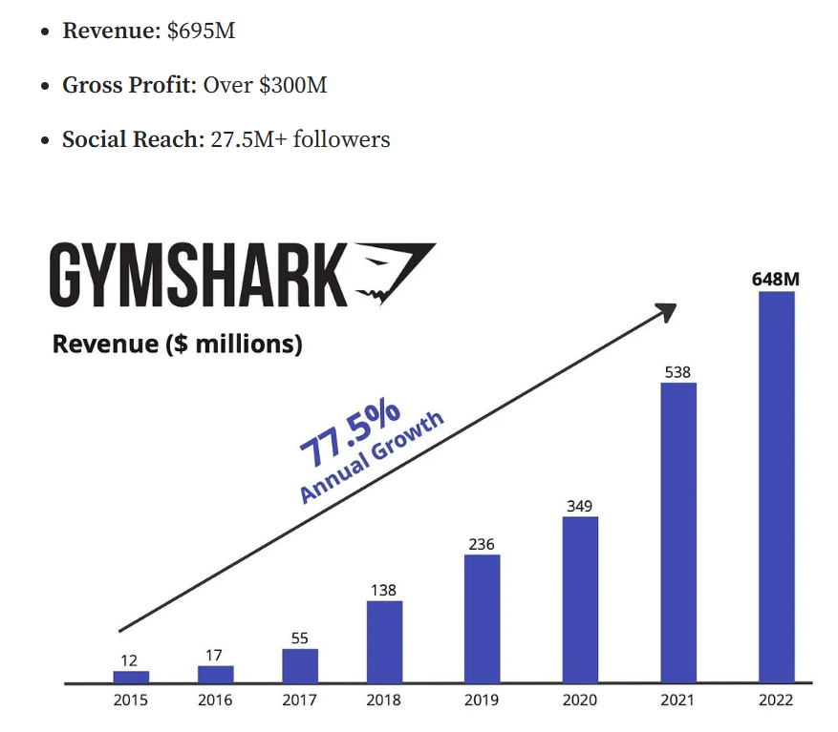
Figure 1: Gymshark Revenue
(Source: Medium, 2024)
According to Gymshark (2025), their business model is thriving that has 10 million members and more than 18 million social media followers. The company’s strength is its fast and responsive D2C operations and its strong social and influencer marketing strategy. Also, it is steadily expanding into the flagship retail experience. Using this technology-first platform and robust brand loyalty, Gymshark is set to launch MuscleMetria, a bright compression clothing line, which combines wearable tech of the future with the brand’s vibrant community.

2) New Brand Concept: MuscleMetria
MuscleMetria is a smart compression garment line that embeds medical-grade muscle sensors, providing a companion AI coaching app. These clothes will measure and monitor muscle load, fatigue, recovery, and movement. By tracking one’s body chemistry in real time, the system will create gentle haptic feedback pulses to signal overexertion or propose that one rest if their muscles are under-recovered. The AI application takes all of these experiences to a performance dashboard, from where the user will also receive a plan for training, notifications to prevent injury, and a plan for recovery. Users can also schedule teleconsultations with a physiotherapist or coach, while teams or families can have a coach monitor more than one wearer on the same platform. The word “MuscleMetria’ is derived from the words Muscle and Metria, which means measurement in Greek. Measurement is the core purpose behind the fabric. All this means more effective workouts, less injury, and data-driven coaching for the consumer, whether the user is an athlete, coach, or fitness buff.

3) Market Trends & Consumer Behaviour Justification
As of 2024, the Global Smart Clothing Market value was nearly USD 5.16 billion, and by 2030, it is anticipated to be USD 21.48 billion with a CAGR of 26.2% (Grandviewresearch, 2025; Grandviewresearch, 2024).
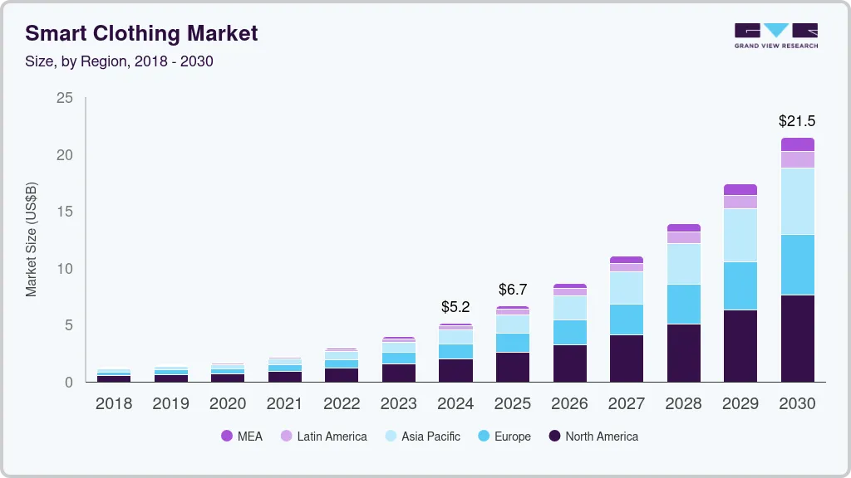
Figure 2: Smart clothing market
(Source: Grandviewresearch, 2025)
The sports and fitness applications have made this sphere expand quite rapidly. Deloitte data on wearables reveals that 57% of households own a wearable (e.g., fitness tracker), and more than 87% of the users are tracking health metrics (e.g., heart rate, activity); many want to share this data with a health provide (Deloitte, 2022).
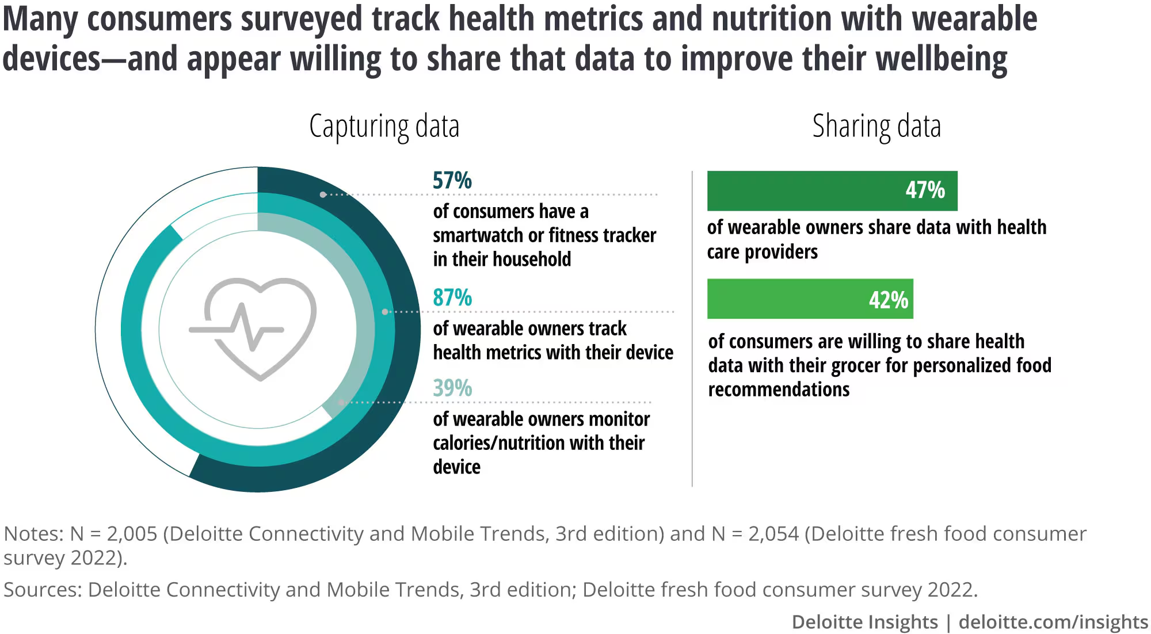
Figure 3: Wearables and health data may tip the scales toward better nutrition
(Source: Deloitte, 2022)
Furthermore, as more individuals converge towards health data ecosystems, they will also seek tech that supports performance and recovery. Gymshark is an extraordinary company that has a robust global community and, as an expert in digital-first engagement, gives it a special advantage in delivering smart apparel that is tied into a trusted brand and data-rich coaching.

4) Segmentation
MuscleMetria’s potential customer base can be segmented as follows:
- Demographic: | - Income: Middle to high income — able to afford premium smart apparel and subscription-based services.
- Demographic: | - Age: 18–34 (serious gym-goers, semi-pro athletes), 35–50 (amateur athletes), 50+ (rehab, recovery).
- Psychographic: | - Tech adopters / biohackers: Early adopters excited by biometric insights, quantification.
- Psychographic: | - Performance-driven: Athletes focused on improving strength and performance.
- Psychographic: | - Health-conscious exercisers: Those motivated by recovery, injury prevention, and long-term wellness.
- Behavioural: | - App subscribers: Already on training or fitness tracking apps.
 | - Frequent gym users: Train 3+ times/week.
 | - Community seekers: Follow fitness influencers, attend events, and join brand-led ecosystems.
 | - Premium buyers: Loyal to high-end activewear brands, willing to pay more.
- Geographic: | - Focus on urban, fitness-dense markets in the UK, US, and EU — regions with strong digital adoption and large Gymshark customer bases.
These groups match the demand for smart clothing, particularly health-conscious and tech-savvy consumers (Grandviewresearch, 2025).

5) Targeting
Primary target: Fitness-obsessed consumers aged 18–34 who train hard (3+ times/week) and prioritize measurable performance gains. Also, willing to pay for fitness products through disposable income. These people are regular at the Gymshark community, follow influencers, and are early adopters of fitness technology. Because of their high digital engagement and capacity to purchase premium apparel, MuscleMetria will target them.
Secondary target: People between the ages of 35-50 are focused more on injury repair and recovery, as well as long-term health, than on having extreme performance. They often have a greater amount of excess money and value scientifically confirmed products. Although they may not exercise as frequently as the younger group, they value integrated health-tech.

6) Differentiation Strategy
Product differentiation: | MuscleMetria integrates calibrated, medical-grade muscle sensors directly into compression fabrics — unlike generic wearables or off-the-shelf trackers.
Brand differentiation: | Because it’s under Gymshark, a digitally native, influencer-backed brand, the line enjoys built-in community trust and social momentum. While competitors might offer sensor patches or smart clothing, none combine Gymshark’s design aesthetic, social reach, coaching platform, and user-community scale.
Service differentiation: | It offers an end-to-end system: real-time biometrics, AI-informed training plans, haptic feedback, and teleconsultation with physiotherapists or coaches.

7) Positioning Statement
If you are a serious athlete or fitness enthusiast, you should know about MuscleMetria from Gymshark. It is a smart compression clothing that helps measure muscle load, assess recovery, and connect to an AI coaching app to provide real training information from Gymshark.

ELEMENT 2 — Marketing Mix — MuscleMetria (4Ps)

Product
Core offering: MuscleMetria is high-quality intelligent compression clothing with inbuilt, calibrated muscle sensors to record muscle load, fatigue patterns, and movement mechanics. An AI app subscription service complements the clothing system by translating raw data output into custom training plans, haptic notifications (ie vibration alert when overload), recovery suggestions, and teleconsult booking with physiotherapists or coaches. Coaches or parents can monitor many wearers via Team/family dashboards.
Quality & validation: MuscleMetria is set to use validated sensor modules and partner with academic labs for validation studies, which would differ it from consumer trackers. Clinical calibration protocols and ISO/medical-device readiness will be used where appropriate. Ensuring data security and the laws of GDPR will be high-level design constraints. An anonymised dashboard for researchers/coaches will be developed. Users can choose to share data. A regulatory framework is necessary since connected technology more frequently sits at the intersection of consumer wearables and medical devices (Deloitte, 2023).
Product variants & ecosystem. New product launches will entail men’s and women’s training tights, performance shorts, and compression tops in two sensor tiers. The basic level helps with activity and load, while the pro level provides multi-channel EMG and recovery analytics. Each clothing item comes with an app subscription. Thereafter, revenue will come from monthly/annual app plans & premium physio teleconsult packs plus team licenses. The ability to upgrade and wash easily is provided by sensor pods that can be replaced. MuscleMetria is in the premium range and, with a Gymshark design language, looks part performance tech, part lifestyle apparel. Growth of the smart clothing market drives demand for various products (Grandviewresearch, 2025).

Price
Pricing strategy: Incorporate a value-based premium pricing strategy for the garments. This will ensure that the price will be higher than the standard Gymshark apparel, as these garments will include sensors and a suite of services. For example, it would set the launch price range from GBP 120-220 per garment, with the price depending on the sensor tier. In addition, price would tier subscription pricing for the app system. This will include the Freemium basic dashboard; Standard ~GBP 6.99/mo, Pro ~GBP 19.99/mo, including teleconsult credits. By offering bundles for garments along with a yearly Pro membership, as well as trade-in and upgrade options for old sensor pods, a lifetime value is incentivised.
Rationale & elasticity. The target customers who are performance-driven and aged between 18 and 34 years are on the lookout for high-quality materials and pay a premium for performance apparel and tech. Meanwhile, customers who are secondary-tier and aged between 35 and 50 years are typically possess a higher disposable income and are more accepting of subscription models for health services. By combining hardware and software, there is less likelihood of customers leaving. To create social proof and scarcity, we will evaluate pricing through price anchoring (limited founder/ambassador discounts) and pre-launch cohorts.
Promotions & reimbursement. For the clinical/rehab use (50+ section), explore partnerships with insurers, physiotherapy clinics and employer wellbeing programmes to subsidise the cost (or provide group buy discounts) to overcome initial price resistance and to enhance adoption.

Place (Distribution & Channels)
Primary channel — D2C e-commerce: Through all of Gymshark’s global D2C platforms (14 online stores, 230+ countries reach), and by leveraging existing customer accounts, loyalty data and fast logistics for direct fulfilment (Gymshark, 2025). This provides control over pricing, customer data, and upgrade paths.
Selective retail & experiential: Enhance online sales by opening Gymshark flagship stores and pop-up labs (a product demo and sensor calibration booth) in fitness hubs (London, NYC, Dubai)- a store to convert clients and educate. According to Vogue (2022), Gymshark’s new retail expansion and experiential store strategy provide the perfect touchpoints to showcase haptics and live dashboards.
B2B channels: The coaches and trainers of professional sports teams, chains of physiotherapy boutiques, hotels, and corporate wellness programs can all buy team and wholesale licenses. The credibility boosters that institutional pilots (sports academies, university sports departments) provide result in use-case case studies.
Logistics & aftercare: When products come with sensors, the organisation needs a strong return/delivery and sanitising policy. The organisation should provide a local repair hub and speedy replacement of sensor pods. The company should also give prepaid return labels and 24-7 digital tech support to reduce downtime. This will also protect your brand reputation.

Promotion
Community & influencer-led demand: The promotion in this instance will follow a sewn fund gym shark proven ambassador and influencer seeding model, elite physiotherapists creator coaches to create content with measurable performance and injury prevention. Long-form testimonials and quantified case studies can convert sceptical buyers. For example, pre-and post-strength and/or recovery metrics will provide hard evidence. The 10 million-strong Gymshark community and 18 million social followers are a high-velocity launch platform (Futurefit, 2025).
Content & education: The funnels will be “How it works” explainers, mini-documentaries on validation studies, webinars with physiotherapists and interactive app demos. The organisation will use paid social, retargeting, and programmatic native ads to push trial offers. SEO strategy will target smart compression, EMG apparel, and recovery wearables.
PR & clinical credibility: Distribute white papers, validation results from academic partners, and secure endorsements (sports med journals, physiotherapy associations). Use press releases and experiential pop-ups to earn media coverage in fitness and health publications. This combination of social and scientific narrative helps bridge the gap between consumer trust and clinical acceptance (Deloitte, 2023).
Metrics & KPI alignment: It is imperative to evaluate the ratio between lifetime value and customer acquisition cost, the conversion rate within the application, the amount of active users per month, the differences in reported incidence of injuries in pilot cohorts, and the improvement of social engagement. Cohort-based pricing experiments and A/B testing of creative content should be used to optimise messaging, especially with regard to privacy, accuracy, and the process of returns in recovery.

Closing alignment statement
The 4Ps above suggest that, as a premium product which will target Gymshark’s community and build on D2C strengths, MuscleMetria offers something unique: a product engineered for measurable outcomes, a price that reflects hardware + software value, a distribution where Gymshark commands trust and a promotion through the influencer-driven, community-centric engine that built the brand. According to Deloitte (2022), the expansion of the smart clothes industry and increased wearable adoption validate the product and consumer readiness.

ELEMENT 3 — Marketing Strategy Pitch
Good afternoon. I am excited to present the next evolution of Gymshark performance innovation, namely MuscleMetria. With more than 10 million athletes and creators in the Gymshark community globally, MuscleMetria takes that ambition one step further – it transforms everyday training into intelligence and performance data.
MuscleMetria is a smart compression apparel line containing embedded muscle-centric technology connected to an AI coach app. It tracks muscular activity, fatigue and recovery in real-time; offers personalised programs; notifies with haptic alerts against over-training; and optional physiotherapist teleconsult.
The market of smart apparel is growing at an alarming rate; it is estimated that the value of the market will be USD 5.16 billion in 2024, and the market will reach USD 21 billion in 2030. This direction offers Gymshark a chance to place itself at the top of the performance-product markets in the United Kingdom and other countries in the world, by combining the high level of design with the latest smart technologies.
We have an easy plan: we are going to open exclusive direct-to-consumer Gymshark platforms and market them through the influence circles and prove the products by physiotherapists and sport teams. We will also be able to create a recurring revenue by creating an application subscription. MuscleMetria is the way ahead of evidence-based training, with its intelligent and aesthetically pleasing solution which is set to provide quantifiable results.
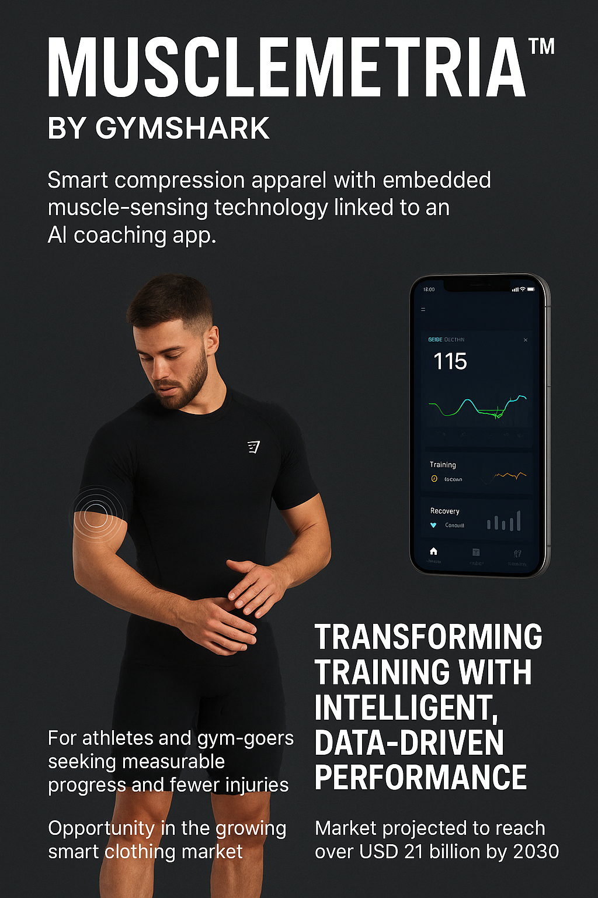

Element 4: Reflection (Gibbs’ Reflective Cycle)
Description
The brand new name, MuscleMetria, required a set of a marketing plan and the pitch to go along with it. These objectives included the conduction of the necessary research, the development of accurate segmentation and targeting decisions, and marketing mix planning. The combination of these elements was aimed, in the end, to produce a strong and convincing point. The first thing that made the endeavour look daunting was the fact that each of the elements appeared to need strategic alignment with the other.
Feelings
To begin with, I was sure about the innovative component of the campaign, but less sure about incorporating the data justification. Further exposure to superior managerial obligations heightened my awareness of the challenges of achieving coherent segmentation, positioning, product design, and promotional planning concurrently. The planning of the pitch has raised mixed feelings in me, as I was afraid of articulating myself and at the same time excited to tell a coherent brand story.
Evaluation
Several aspects of the project were successful. The justification for critical decisions was supported by rigorous research of competitors and customers. I relished creating the branding identity and promotion’s story in this project. However, there were limitations. It was difficult to boil down a lot of research to a strategic decision, making it too complicated for a pitch. I also noticed that some of the early choices were made based on assumptions and not evidence. This required a large rewrite later.
Analysis
I have been able to appreciate the central role of the iterative process of development in overcoming complex problems through its systematic implementation. In 1988, Gibbs determined that a deeper understanding is derived through reflective analysis of the negative and positive sides of an experience (Ahmadpour et al., 2025). This piece of information is a timely alert that the best strategic choice might not always be the first choice on a list. Therefore, the need to integrate all elements, starting with the definition of the customer need, ensured that the marketing plan was aligned with key goals.
Another thing that I have realised is that the aspect of effective communication is closely related to the aspect of analytical competence. The idea of transforming a tiresome written plan into a three-minute presentation required a breakdown of complex information, a strengthening of the coherence of the narrative, and customization of the information to the audience. This strategy conforms to the findings of Duarte (2010), who states that effective pitches are more about clarity and consistency of the story rather than attention to detail.
Conclusion
I learned strategically thinking, interpreting data, inventiveness, and persuading while working on that project. I now comprehend the workings of Marketing Management Models in real life. Likewise, how essential it is to back a creative idea with evidence. In the process of developing projects, I also learned to be more self-critical and flexible.
Action Plan
When working on future projects, I will start writing at a later date and start the process of revising earlier. Also, I want to enhance the quality of my visual presentations and become skilled in Canva. I will also aim to incorporate evidence in a more systematic way, thus avoiding the necessity to reconsider and include support material in the later stages of the strategy, which, in its turn, will maintain the coherence of the whole plan. Similar to the model by Gibbs, the application of these reflective practices will positively influence my future performance in further academic and professional marketing activities.

Reference List
Ahmadpour, N., Shariati, A. and Moghadam, M.P., 2025. Effect of narrative writing based on Gibbs’ reflective model on the empathy and communication skills of nursing students. BMC Medical Education, 25(1), p.10.https://link.springer.com/article/10.1186/s12909-024-06593-7
Deloitte, 2022. Healthy holidays: Wearables and health data may tip the scales toward better nutrition. Available at: https://www.deloitte.com/us/en/insights/industry/technology/wearable-technology-wellbeing-health-nutrition.html [Accessed on 24th October 2025]
Deloitte, 2023. When digital tech becomes a medical device. Available at: https://www.deloitte.com/nl/en/Industries/tmt/perspectives/when-digital-tech-becomes-a-medical-device.html [Accessed on 24th October 2025]
Duarte, N., 2010. Resonate: Present visual stories that transform audiences. John Wiley & Sons.https://books.google.com/books?hl=en&lr=&id=JJsM3Sedy0IC&oi=fnd&pg=PA3&dq=Resonate:+Present+Visual+Stories+that+Transform+Audiences&ots=FHpkBxWa1Q&sig=gDGM7yJV_fnieabymXiSFOLoaI4
Futurefit, 2025. 60+ Impressive Gymshark Statistics that explain why customers love this brand. Available at: https://www.futurefit.co.uk/blog/gymshark-statistics [Accessed on 24th October 2025]
Grandviewresearch, 2024. Smart Clothing Market Size To Reach $21.48 Billion By 2030. Available at: https://www.grandviewresearch.com/press-release/global-smart-clothing-market [Accessed on 24th October 2025]
Grandviewresearch, 2025. Smart Clothing Market (2025 - 2030). Available at: https://www.grandviewresearch.com/industry-analysis/smart-clothing-market-report [Accessed on 24th October 2025]
Gymshark, 2025. ABOUT US. Available at: https://eu.gymshark.com/pages/about-us [Accessed on 24th October 2025]
Medium, 2024. Gymshark: A $1.3B Powerhouse with Zero Ad Spend. Available at: https://medium.com/illumination/gymshark-a-1-3b-powerhouse-with-zero-ad-spend-3c77cb51975e [Accessed on 24th October 2025]
Vogue, 2022. Gymshark CEO on building an athleisure unicorn. Available at: https://www.vogue.com/article/gymshark-ceo-on-building-an-athleisure-unicorn [Accessed on 24th October 2025]

