
An investigation into the effects of various network redundancy protocols on the performance of a simulated campus style network.

By
Max Beasley

Supervisor: Munyaradzi Nicholas Murira
Second Marker: Nitheesh Kaliyamurthy

Project submitted as part of the requirements for the award of BSc (Hons) Computing (Computer Networks and Cybersecurity)

May 1st, 2026

DECLARATION

I, Max Beasley declare that I am the sole author of this Project; that all references cited have been consulted; that I have conducted all work of which this is a record, and that the finished work lies within the prescribed word limits.
This work has not previously been accepted as part of any other degree submission.

Date : 30/04/2026

FORM OF CONSENT

I, Max Beasley hereby consent that my Project, submitted in candidature for the B.Sc.(Hons) Computing (Computer Networks and Cybersecurity) degree, if successful, may be made available for inter-library loan or photocopying (subject to the law of copyright), and that the title and abstract may be made available to outside organisations.

Date : 30/04/2026

Abstract
this project will conduct detailed research and experimentation to answer the question of ‘what impact do various network redundancy protocols have on network performance’, this will take the shape of an analysis of a number of network redundancy protocols in both layer 2 and 3 of the networking model. Specifically, this will include the PVST, RPVST and MST protocols for layer 2 and the HSRP, VRRP and GLBP first hop redundancy protocols for layer 3. Unlike previous research this project will combine the analysis of layer 2 and 3 protocols into a unified place, with all testing conducted on the same simulated network environment.
To achieve this, this project follows a broadly experimental methodology, focusing on producing reliable and reproducible results that can be confidently used to make informed choices when considering the use of these protocols. Furthermore, this project has been developed around the ideas of the Saunders research onion methodology, this is done to provide consistency with previous and future research.
This has been made possible by the development of a robust simulated network simulation procedure using the GNS3 software, that has allowed data to be collected on how these protocols affect network performance, this Is analysed through the use of a number of key network performance metrics, such as Jitter, Delay and throughput.
The results of the testing that this project has conducted show that there is indeed a strong link between what network redundancy protocol is used and the overall performance of the network, furthermore, this project will also provide recommendations based on the results of the testing on which protocols would provide the greatest performance benefit for a the given network topology.

Contents

Table of Contents
Contents
DECLARATION 2
FORM OF CONSENT 2
Abstract 3
Contents 4
Table of Contents 4
Table of Figures 6
CHAPTER 1 - INTRODUCTION 7
CHAPTER 2 - RESEARCH & REVIEW OF LITERATURE 9
Layer 2 protocols 9
Layer 3 protocols 10
Performance analysis 10
Network simulation 11
Conclusion 11
CHAPTER 3 - RESEARCH AND DEVELOPMENT METHODOLOGY 12
Experiment Methodology 12
Software and Hardware 13
Simulation and emulation 13
Performance monitoring tools 15
Hardware 16
Overview of procedures 17
Pre Data collection testing 17
Data collection and analysis methods 19
CHAPTER 4 - DESIGN & IMPLEMENTATION 20
Design 20
Requirements 20
Network design 21
Implementation 23
Routing - Devices 24
Switching – Devices 25
Host Devices 26
Network topology implementation 27
Network routing 28
Connectivity testing 29
Protocols 30
Testing 31
Applying load 31
Collecting data 32
Results 34
CHAPTER 5 – EVALUATION 37
Aims and Objectives 37
Areas of improvement 38
CHAPTER 6 - CONCLUSIONS AND RECOMMENDATIONS 39
Conclusion 39
CHAPTER 7 – Reflection 40
CHAPTER 8 – REFERENCES 41

Table of Figures
Figure 1 Saunders research onion 12
Figure 2 Example D-ITG output 16
Figure 3 Layer 2 topology 21
Figure 4 Layer 3 topology 22
Figure 5 Full topology 23
Figure 6 GNS3 VM running trough the VMware software 24
Figure 7 GNS3 Router configuration 25
Figure 8 GNS3 Router configuration cont. 25
Figure 9 GNS3 Switch configuration 26
Figure 10 GNS3 Switch configuration cont. 26
Figure 11 Ubuntu device specifications 27
Figure 12 Network implementation in GNS3 28
Figure 13 Router, Routing table 29
Figure 14 .10 host connectivity test 29
Figure 15 .20 host connectivity test 29
Figure 16 GLBP configuration 30
Figure 17 GLBP details 30
Figure 18 Iperf3 server 31
Figure 19 Iperf3 client 32
Figure 20 D-ITG testing command 32
Figure 21 GLPB backup router taking over as default gateway 33
Figure 22 GLBP test results 33
Figure 23 GLBP backup router reverting to its standby status 33
Figure 24 GLBP details 2 34
Figure 25 L3 Jitter 36
Figure 26 L2 Jitter 36
Figure 30 L3 Bitrate 36
Figure 29 L2 Bitrate 36
Figure 27 L3 Delay 36
Figure 28 L2 Delay 36

CHAPTER 1 - INTRODUCTION
In a modern world where we are increasingly reliant on the digital world around us to achieve many aspects of our daily lives [1], it is more important than ever that the digital services that we surround ourselves with are as reliable as possible and always available, otherwise countless people’s daily lives could be negatively impacted. One of the most basic but essential parts of this is the ability for the data that we create and consume to be transmitted, it is the physical networking infrastructure that facilitates this transfer of information, and its reliability is a key aspect in the seamless functioning of various aspects of our daily lives. There are many ways of achieving this reliability. This paper will investigate some of the software solutions that can be implemented to help maintain this reliability.
This examination will take the form of an investigation into the various protocols that are used on the switching and routing layers of the TCP/IP model (layer 2 and 3) to facilitate redundancy on the network. I will examine the effectiveness of protocols such as HSRP, VRRP and GLBP on L3 and RPVST, PVST and MST on L2 to determine what combination of these protocols if any provide the best performance outcomes for a simulated and physical network environment. This will be done by analysing the performance of these protocols using known network design and then using statistical methods to analyse how the network performance suffers when experiencing a simulated failure.
To summarise this project will aim to answer the question ‘to what extent the combination of both layer 2 and 3 redundancy protocols effects a networks overall performance’ as previously mentioned this will be done using statistical analysis of data collected through testing. To achieve this, I will conduct an investigation into this question using some key objectives listed below.

Objectives
- To produce a developed analysis of the protocols to be used in the research, in order to allow an informed conclusion of the results.

- Develop robust procedures to allow for accurate testing and analysis to take place, and allow for reliable results to be produced

- To design and develop a suitable network topology that can be used to test, compare and implement redundancy protocols.

- To analyse the effects of the network redundancy protocols on the performance of the network and its reliability using a simulated environment

- Use statistical methods to analyse the collected data to determine if there is a relationship between the protocols used and the performance of the network

- To compare the data gathered from this research with that of previous research to determine if the combination of both layer 2 and 3 protocols has a marked effect compared to that of the previous single layer analysis.

In the following chapters of this report will explain the methods and processes that I will use to fulfil the aforementioned objectives; this will begin with a detailed analysis and review of previous research and literature to provide a for this baseline for this research and establish pre-existing methods (Chapter 2). This will be followed by a comprehensive explanation of the research methodology’s to be used to conduct this research (Chapter 3. Followed by the implementation and design of the systems used to collect the research data (Chapter 4), which will then lead to a comprehensive analysis of the results which will be concluded with a detailed evaluation of the results with a set of conclusions made from these results (Chapters 5,6).

CHAPTER 2 - RESEARCH & REVIEW OF LITERATURE
During this chapter, a detailed review of the preexisting literature surrounding the varying aspects of this project will be conducted. This is done so that the methods employed by this project are developed inline with the best standards already in use, furthermore the analysis of previous research and results will allow a comprehensive analysis of the data collected during this research, which can then be compared and contrasted with that done by others, so that a more accurate and insightful conclusion can be reached.

Layer 2 protocols
When it comes to establishing the L2 protocols which provide the greatest performance benefits for the network, previous work would suggest that the choice of protocol does indeed have significant impacts on network performance, this is clearly show in Wang Zejia’s ‘measurement of spanning tree performance between different protocols (2014)’ in which the author conducts testing on the PVST+, RSTP and MSTP protocols and the associated convergence times for these protocols, this research show a clear advantage to using the RSTP protocol [2]. However, this analysis only takes the performance of small-scale networks into account and importantly omits the standard STP protocol, both of which would detract from the accuracy of any conclusions drawn from the data.
However, enhancing the previously mentioned paper Rashid et al. expands on the data collected by Wang Zejia in his research article ‘Performance Evaluation using Spanning Tree Protocol, Rapid Spanning Tree Protocol, Per-VLAN Spanning Tree, and Multiple panning Tree’ where analysis of SPT is included and he furthermore repeats the tests previously conducted but in the environment of a larger network also including more detailed breakdowns of the results [3]
The data collected by the two aforementioned researchers is further backed up by Parita Rathod in their comparative analysis of STP and RSTP protocols, where they use a small network environment to test the two protocols and achieve results within a reasonable margin of error of the previous sources [4]. This allows for a baseline of data that can be used during my research to compare and draw conclusions.

Layer 3 protocols
Unlike with the research into L2 protocols there has been significantly more work done on establishing the performance benefits around the different L3 protocols. A good example of this can be seen in Mohamed Hamied’s paper ‘Gateway Redundancy Protocols in the Smart Grid’ in which they provide an in-depth analysis of the three main routing redundancy protocols (also known as gateway redundancy protocols) these being HSRP, VRRP and GLBP. The results produced from Hamied’s analysis clearly shows GLBP protocol having the smallest impact on the performance of the network, this was determined through the use of negotiation time and the delay time metrics [5]. However, like many other sources in this area of study, the report only analyses the performance impact on a network of a smaller size.
The conclusions of the Hamied’s paper are also substantiated by research conducted by Usman Anwar et al. in the paper ‘Performance Analysis and Functionality Comparison of FHRP Protocols’ in which the same three protocols are analysed, however this paper also includes analysis into additional metrics such as CPU utilisation, bandwidth and packet size [6]
Finally, the work by Imelda Ristanti Julia et al. can be used to determine the scalability of the data provided by the aforementioned sources. This is due to the fact that their paper ‘Performance Evaluation of First Hop Redundancy Protocol (FHRP) on VRRP, HSRP, GLBP with Routing Protocol BGP and EIGRP’ a network of a larger complexity as it uses four layers of routing devices instead of the usual one layer. The data is gathered on the performance of the three aforementioned protocols and also supports the conclusions of the previous works as it also determines the GLB protocol to have the shortest downtime impact on the network [7].

Performance analysis
To be able to analyse what effects the protocols have on network performance we need to establish how we are going to measure and quantify the effects on this performance. In all of the aforementioned works this is done by using performance metrics, these are pieces of data that give information on how a network is operating. David J. Lilja in his book Measuring Computer Performance A Practitioner's Guide [8] gives insight into what makes a good metric, these factors being reliability, repeatability ease of measurement, consistency and independence. These are the features that make a good metric. For computer networks the most commonly used metrics jitter, bandwidth, latency (delay) and packet loss [9], these are the metrics used in the analysis conducted by the previous works.
Now that we know what metrics are and how to use them, the question turns to how we are going to collect this data and produce the network traffic required for these metrics to be collected, there are many tools and methods used to do this, like with the choice of metrics there is generally a consensus on the best ways to do this, the most commonly used method is the tool known as IPperf [10], this is used extensively in the aforementioned research [5,6,7], this is commonly used alongside the Wireshark network analysis software[11]. However, in the research paper ‘Comparative study of various Traffic Generator Tools’[12], Shalvi Srivastava provides an analysis of the IPerf tool compared to another tool, this being D-ITG [13], this research shows that the compared to the IPerf D-ITG provides better use case when using it to generate and monitor traffic in both UDP and TCP when operating in a multithreading mode.

Network simulation
In order to conduct this research, a simulated network environment needs to be created, much research has been conducted about the best way to achieve this. There is a variety of different software solutions available that allow for accurate emulation of network devices. The two main solutions for this are Cisco modelling labs (VIRL) [14] and GNS3 [15]. The differences and benefits of each software was analysed by S. V Tagliacane Et al in there paper ‘Network simulations and future technologies in teaching networking courses: Development of a laboratory model with Cisco Virtual Internet Routing Lab (Virl)’, this research gives a detailed critical overview of the two software’s and the benefits of and drawback of both, it highlights the key differences being that of cost, with the GSN3 software providing best value due to its free nature [16].

Conclusion
Finally, it is important to note that all of the sources analysed in this literature review do not include comparison or integration of both L2 and L3 protocols in the same work, this is the gap between the current research and the research that this paper aims to conduct. However, all of these previous works give a baseline for the data collected in this research to be compared to and to determine if there is a correlation between L2 and L3 protocols used and the overall performance metrics of the network.

CHAPTER 3 - RESEARCH AND DEVELOPMENT METHODOLOGY

Experiment Methodology
The research conducted during this paper will broadly follow the principles and structure of the ‘Saunders research onion’ methodology, this has been done to provide consistency with other works and provide a coherent structure for the research [17]. See below for an example of the Saunders research onion
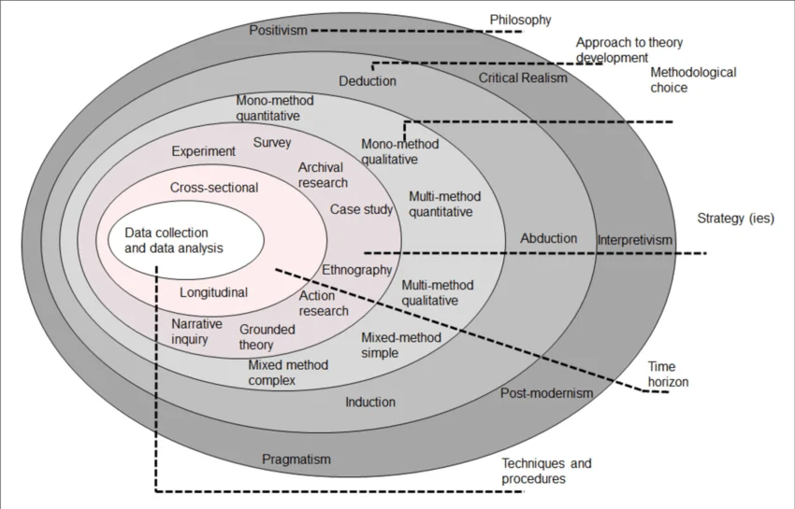
Figure 1 Saunders research onion
The questions that this project aims to answer requires that the research conducted follow a broadly experimental approach. This is due to the fact that the research question is to investigate combinations of protocols and any given effects on a network environments performance, this will require multiple sets of experiments to be conducted so that sufficient data can be collected to determine if a given hypothesis can be regarded as proven or not. Whereas a development focused investigation would lend more focus to the design of the network, although this is an aspect of this investigation, it is not the focus, therefore a more research-based approach has been selected.
The nature of the project also requires that a strictly quantitative approach be taken during the entirety of the project, this is to allow the results to be as reproducible as possible. Furthermore, approach will facilitate research that can provide a high degree of accuracy and objectivity through the collection of large data sets and a statistical approach to data analysis.
As previously mentioned, this research will follow an experimental approach to its research, this allows the conditions of the research to be tightly controlled through the strict use of experimental variables to ensure that only the desired results are observed. This will take the form of aspects like the protocol used being treated as an independent variable during the research and the resultant performance metrics the dependant, with the rest of the variables remaining constant, such as network layout and implementation, this will ensure that the collected data is as accurate as possible. In line with the quantitative approach, this will also include the process of repeating experiments a multitude of times so that a large pool of data can be produced to increase the value and validity of the results.
In line with the quantitative and experimental nature of the research the analysis of the results will follow a strictly statistical approach, this will include various statistical methods such as the use of averages, variance and deviation to produce the clearest and most accurate presentation of the data possible. Doing this will allow the conclusions drawn from said data to be as well informed accurate as possible.

Software and Hardware

Simulation and emulation
In order to conduct this, experiment a variety of different software is required so that a detailed and accurate simulation can be conducted and reliable data collected. It is for this reason that the choice of software for this project is of great importance. The software chosen for this project needs to be compatible with the methods and processes that this project aims to follow, therefore for each aspect of the project a set of requirements were established before software was chosen, this allowed for the process of deciding on what software to use to be structured and streamlined.
The backbone of this project is the ability to simulate the operation and use of a given network, therefore it the most vital component and piece of software for this project is the software that will be used to conduct the device emulation and enable valuable data to be collected from this environment.
When deciding on the simulation software a number of key requirements where considered, these included the ability to accurately emulate real devices, to run on commonly available computer hardware and have a large and detailed documentation and support. Taking these requirements into consideration the decision was made to move forward with the GNS3 [15] software. This was done because for the scope of this project this software most accurately fits the aforementioned requirements in the fact that the software operates under a free opens source model under the GPLV3 licence [18], allows the use of genuine cisco IOS device images and can run locally on both windows and Linux based systems, The GNS3 platform also comes with comprehensive documentation and a large community based addon marketplace and forum [19].
The GNS3 platform operates using two components the first being the GNS3 all in one software, this acts as the graphical interface, and the GNS3 virtual machine which is used to emulate the virtual network and emulate the individual network devices, this VM then interacts with the GUI to provide a simple graphical representation of the network.
The aforementioned features and capabilities of the GNS3 software make it an ideal solution to the simulation needs of this project and as it is widely used in previous projects and research in this area of study the comparison of data and conclusions can be more accurately conducted.
However, the GNS3 software will not be used in the design process of the network topology, this is due to the advanced features of the GNS3 software slowing down the initial development process, therefore the decision has been made to use the Cisco Packet tracer software to design the topology. This will allow for a more agile development and ideation process. Once the design has been finalised in the packet tracer software, the topology will then be recreated in the GNS3 software for emulation and testing.

Network end devices
To enable simulated load and traffic to be placed on the network, and to observe how this effects the performance of said network, end devices need to be placed on the network to send traffic between the network nodes and to run software to enable this. To provide this functionality these end devices will take the form of virtual machines running a Linux based operating system. This was chosen over a windows-based solution as a Linux based system provides a less performance overhead when compared to a windows system [20] and enables a wider range of tools to be used.
As Linux has been chosen as the operating system for the end devices, a decision had to be made on what Linux distribution would be used on the end devices, this decision was based on one main factor, that being compatibility with the tools that would be used to conduct the network testing. The first choice, that being Kali Linux [21] because of its focus on network integration and large library of inbuilt tools, however Kali Linux suffered from compatibility issues with the main tool used for performance analysis. Therefore, a choice was made to move forward with the use of Ubuntu Linux [22]. This was done because versions of Ubuntu Linux that are compatible with the testing software and the GNS3 VM are available to use, it was also determined that the drawbacks of using Ubuntu did not require that the processes be altered or changed in a drastic manner, as the increased performance and hardware requirements are negligible and the software availability can be rectified by manually installing the needed software.

Performance monitoring tools
The process of evaluating the performance impacts of the different network protocols requires that specific metrics and data be collected. To do this, various different types of software are needed to monitor the different aspects of the network. The tools that were considered for this task covered a variety of use cases and capabilities, however only software that could either be run locally through a CLI or a low-cost GUI were considered as the goal remains that as much hardware utilisation be reserved for network operations as possible.
Following the aforementioned requirements the following software was selected. To monitor the performance and calculate metrics such as delay, packet loss, throughput and jitter, a tool called D-ITG (Distributed Internet Traffic Generator) [23] was selected, this software allows for the automated collection and calculation of key metrics of network performance, this greatly increases the rate at which data can be collected and analysed. The D-ITG tool also provides the ability to alter the size of the traffic generated as part of its analysis, however this is limited in its functionality therefore other software is required for reliable large scale traffic generation. see Figure 1 [24] below for an example of the produced output from this tool.
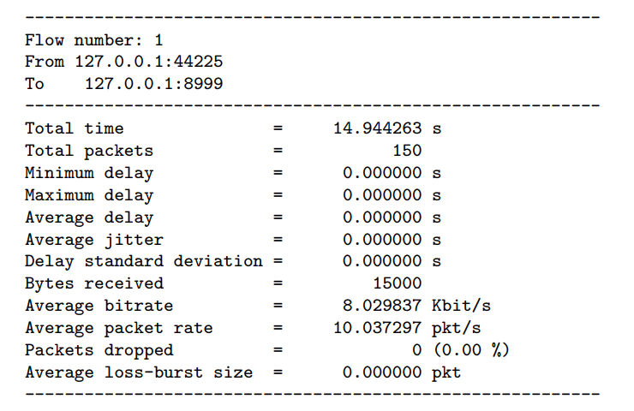
Figure 2 Example D-ITG output
To generate larger amounts of traffic reliably another tool was selected, this being the IPerf3 Tool [F3], this tool was selected to primarily act as redundant method of generating background traffic on the network and its ability to completely saturate the network with data. This allows the D-ITG tool to be focused on collecting performance metrics, it also gives a greater deal of control when managing the data collection. This tool provides a large volume of different modes and parameters that can be set to produce a wide range of outcomes and testing capabilities.
The final software used for the purpose of monitoring the network is the Wireshark tool [F4] this tool which provides powerful network capture capabilities allows for detailed and fast troubleshooting during the network development and subsequent testing period. A although this tool is not strictly necessary for the function and the conduct of this experiment it allows for in depth analysis of incoming and outgoing packets from a given device, which through its advanced filtering capabilities greatly speeds up many aspects of the experimentation process.

Hardware
To conduct the simulations necessary to gather the data for this experiment, a machine of sufficient power is required so that the hardware bottleneck can be eliminated or reduced as much as possible, this is so the differences in the data represent the effects of the chosen protocol not variations introduced by hardware limitations. For this reason, it is also essential that all testing be conducted on the same hardware, this allows for the amount of unknown variable to be reduced and controlled.
The most vital aspect of the hardware when simulating multiple network devices is the amount Random access memory (RAM) and CPU time allocated to each device as this will determine whether the devices will encounter large scale bottlenecks when being emulated. Therefore, it is important that host machine contain a substantial quantity of RAM to be allocated out to the given devices and the CPU be of sufficient power to give adequate processing time to each device. Therefore, the machine used for this experiment uses a high-performance processor in line with a large quantity of high-speed memory alongside high-speed storage. The exact specifications can be seen bellow.
Host machine hardware and Operating system
Component type | Component
CPU | AMD Ryzen 9 9900x 12 core
RAM | 64 GB DDR5 5200 MT/s
Storage | 1TB Samsung 990 EVO plus, NVMe SSD
GPU | NVIDIA RTX 3080 (10GB VRAM)
OS | Windows 11 Pro
Table 1 Host machine specifications
Software
Category | Software
Device Emulation | GNS3
Virtualisation software | VMware Workstation pro
Traffic generator | IPerf3
Performance analyser | D-ITG
Monitoring / troubleshooting | Wireshark
Table 2 Software used during project

Overview of procedures
During the conduct of this experiment a number of procedures were followed on order to ensure that the data collected was as reliable and reproducible as possible. These procedures in line with the chosen research methodology and the approaches outlined in the ‘Saunders research onion’ framework. This has been done with the explicit aim to align the methods and procedures used in this project with those used in wider research and literature in this field.

Pre Data collection testing
As previously mentioned, great importance is places on the ability to produce data that is reliable and provides the most accurate representation of the processes that are being observed. The procedures that have been developed and used for this project that satisfies the above are as follows.
To begin, before any data is collected a number of tests are conducted to ensure that the current simulation is fully functional and behaving as expected, so that any misconfiguration on the network can be identified before they have the ability to produce anomalous data. This procedure begins by conducting thorough research into the correct implementation of the protocol being tested, this is done using only primary sources such as official documentation, to ensure the upmost accuracy of the steps being followed. Following the implementation of the protocol according to established standards multiple baseline test are conducted using the same tools used to conduct the experiment so that observations on the operation of the network can be made to identify an expected baseline to compare with the experimentation to follow. Finally, after the network is determined to be stable a number of mock experiments are conducted, this is done using the same procedure as the final testing used to collect the data, again this is done to ensure that there is no obviously anomalous data being produced that could affect the final tests. Below is a list of the tests conducted to cover the aforementioned procedures.

Tests conducted
- Basic operation testing – testing the general operability of the network with the new configuration implemented, this includes Connectivity testing and observation of basic network functions.

- Stress testing – Passing large amount of data through the network to saturate it, this ensure that the network is operating as expected with the new configuration enabled and determining if any new unwanted bottlenecks are introduced.

- Rebound testing – This test observes the functionality of the expected redundancy functions provided by the protocols being tested to ensure they are operating correctly.

- Data collection test – this test replicates the conditions of the final data collection by running sample test with the same parameters as the final tests to ensure correct data output and collection.

To ensure the upmost reliability all of the above tests are conducted a multitude of times to ensure that all behaviours observed are correct and not anomalous. Only one all of the above tests have been conducted and the outcomes observed as operating in the expected way will the process move onto the data collection phase.

Data collection and analysis methods
Once the aforementioned testing has been completed and all issues resolved can the move onto collecting the data required for the experimental analyses on the given protocol to be tested.
This begins much alike the testing procedures with ensuring the network has been completely reset and is not experiencing the effects from previous testing, this is to ensure that all of the data collected is taken from the baseline. This is done by resetting the protocols and the testing software then given ample time for the network to ‘settle’ before continuing with the experiment.
Once the baseline is established, the testing begins with the simulated load being placed onto the network followed by the testing software being initiated shortly after. The software will be allowed to complete its testing process in line with the specified parameters. Throughout the duration of the test the operation of the network will be monitored to ensure that no anomalies occur. Once the testing software has completed its testing procedure the results will first be analysed to determine if the data has been correctly recorded and no obvious errors have occurred, after this the data will then be recorded and labelled for later analysis. This will then be repeated a total of three times so that an average can be calculated and increase the reliability of the data. If the data collected contains obvious errors and is not consistent with other data collected, the data will be discarded and that test conducted again, if this continues to be a problem the cause will then be investigated and resolved.
When all of the data is collected that information will then be analysed using various statistical methods to give a greater insight into the data and allow for a conclusion to be presented which unlocks the full potential of the information collected (the details of this will be covered in Chapter 5 – Evaluation).

CHAPTER 4 - DESIGN & IMPLEMENTATION

Design
In this section of this report, I will outline the processes, requirements and decisions that culminated in the final design of this experiment, using the procedures outlined in the previous chapter as a guide for building and designing the experiment used for this project.
Furthermore, I will also discuss the practical implementations of the designs and processes created and will show how these were used to collect the results that will ultimately be used for the upcoming analyses to determine the outcome of this experiment.

Requirements
Using the hardware software and procedures outlined above it is now necessary to produce a practical design that will allow for this experiment to be physically conducted. To create this design a set of requirements is needed to aid in this process, these requirements are based on the experimental methods selected and the discussed processes. The requirements for the design are as follows:

- A network topology that mimics a ‘campus style environment’ and is compatible with the following protocols. L2 PVST, MSTP, RPVST L3 – HSRP, GLBP, VRRP.

- A simulated environment to support the aforementioned network and allow for accurate testing to be conducted.

- A testing configuration that satisfies both the testing procedures and the reality of the simulated network.

- A design that allows for an efficient collection and evaluation of results, while being as reproducible as possible.

Network design
When the design of the network was being created it was done with the purpose of fulfilling the requirements set above, specifically aspects 1 and 4. To begin the network will follow the basic principles of network design, such as being of a hierarchical design [25]. in order to allow all of the chosen protocols to be tested the network must also be built around the principle of redundancy and redundant design [26], this is done so that the protocols can be properly implemented.
Throughout the design process the Cisco packet tracer was used for the initial design of the network topology, this was done as the software allows for a more agile design process, this design can then be transferred into the GNS3 simulation software for the conduct of the experiment.

Layer 2 (Access)
Working with the hierarchical approach the first element of the network to be designed is the access layer, this provides the initial connectivity into the network and the hosts [27]. This is the area of the network where the layer 2 protocols will be implemented and tested, these being PVST, MSTP and RPVST. When designing this section, the choice was made to use a simple redundant link design, this allowed for the number of devices to limited while still allowing the observation of the required protocols. An example of this can be found bellow in Figure 3.
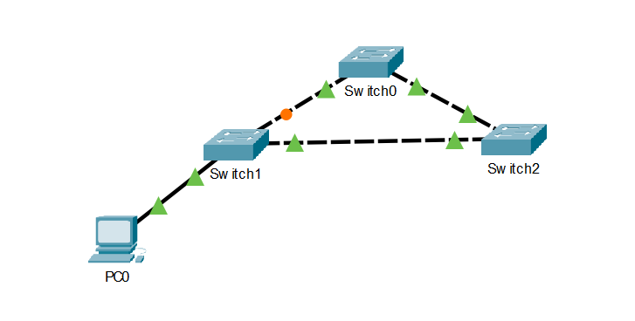
Figure 3 Layer 2 topology

This configuration will be deployed on both sides of the network to create a symmetrical network; this is done to ensure that regardless of the area of the network effected the results can be as reproducible as possible.

Layer 3 (Distribution and core)
Continuing with the aforementioned design principles, the routing portion of the network also follow the redundant hierarchical approach, this allows for a more accurate representation of a medium scale network based on the campus design philosophy, it also provides the features that allow for the testing of the layer 3 FHRPs (first hop redundancy protocols), these being HSRP, GLBP and VRRP, this is done by providing redundant paths so that the failure in one of the distribution layer devices does not cause the failure of the network as a whole. Figure 4 bellow shows how this design philosophy is implemented.

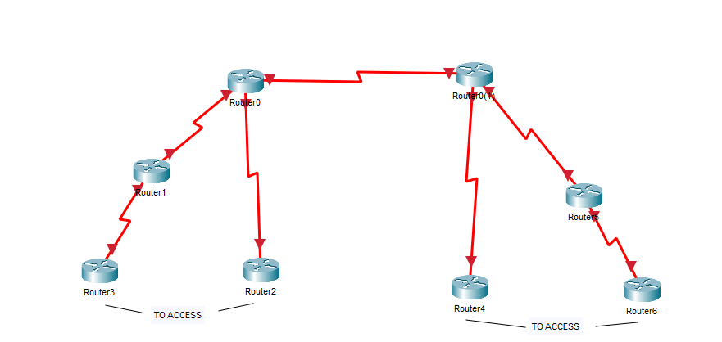
Figure 4 Layer 3 topology

Network layout
To create a fully functional network that can fulfil the requirements of this project, both the layer 2 and 3 designs are combined to create a single network that can support the testing of all the features that are required. This can easily be done by using redundant links to connect the access layer to the access routers on the distribution layer. This can be seen in Figure 5 bellow.

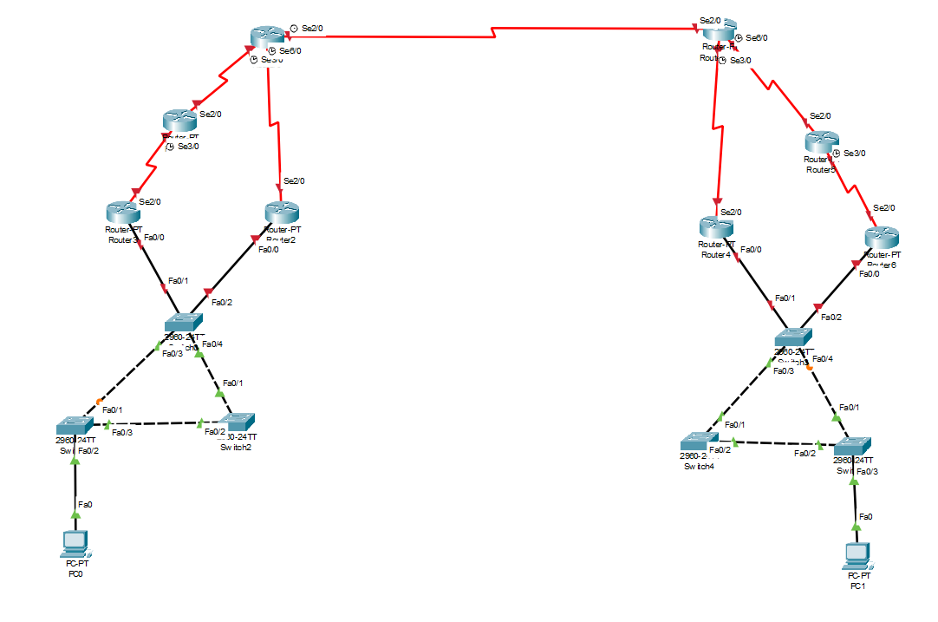
Figure 5 Full topology
The above topology is derived from both the design philosophies of the layer 2 and 3 designs; it implements all of the features required to enable the operation of all the protocols to be tested. Furthermore, the design also eliminated unwanted complexity, this allows for a more streamlined testing process, this also helps reduces the possibility for the introduction of errors that may adversely affect the data and its authenticity.
The choice was also made to include two host devices on the network, this was done due to the fact that all of the testing procedures and software only require a single sending and receiving node, therefore to limit complexity and the performance overhead associated with the inclusion of more nodes, the decision was made to limit the network to two nodes. However, the network has been designed with the potential to include more nodes if they were to be required.

Implementation
This begins with the installation of and setup of the GNS3 software, as previously mentioned this is formed of two parts, the GNS3 GUI and the GNS3 VM. The instillation of the GNS3 GUI follows the process of a simple program instillation, however the GNS3 VM requires that it be installed on one of a number of virtualisation software. For this the decision was made to implement this in the VMware software [28], this was mainly done due to the need for robust and developed nested virtualisation support, this is required in order for the GNS3 VM to function as it relies on nested virtualisation to simulate the various network devices and host devices.
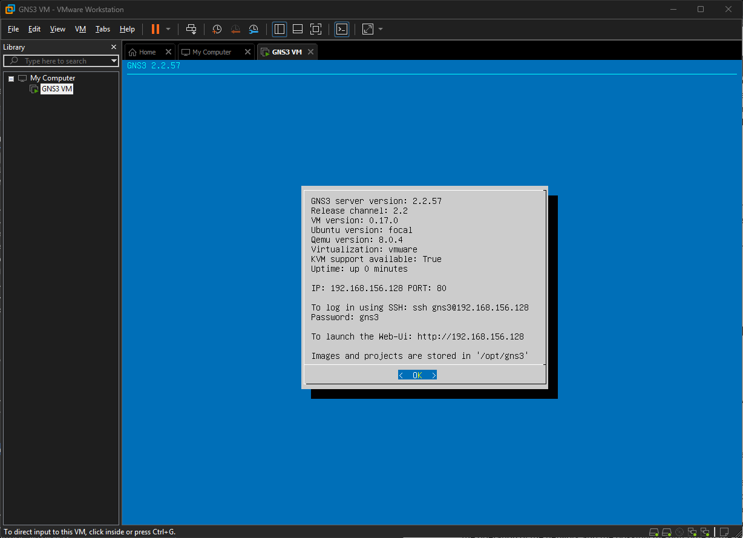
Figure 6 GNS3 VM running through the VMware software
With the design of the network finalised it is then necessary to implement the chosen topology into the GNS3 software so that the test can be conducted. This was a multiple step process that required many different decisions to be made, the first of these and arguably the most important being the choice of what types of switches and routers where to be emulated. This is due to the fact that the GNS3 software uses real software images to simulate the devices, therefore the choice of device to emulate will impact the operation of the network and the possibly the outcome of the testing, therefore it is vital that the correct images be chosen. Finaly, the ultimate deciding factor in determining which device to emulate is that of availability, many of the most modern device images are limited in access, so a balance needs to be struck between using the newest models and having access to the required features.

Routing - Devices
For the purpose of network routing the Cisco 7200 series router has been used for the emulation of the layer 3 protocols, this decision has been made as the 7200 software supports all of the required redundancy protocols and providing compatible connection methods [29]. Furthermore, this image is widely used and available through the GNS3 marketplace with large volumes of documentation and support available [30]. All devices are used with the default hardware configurations provided by the appliance; this is done to ensure compatibility. The router hardware configuration can be seen bellow.

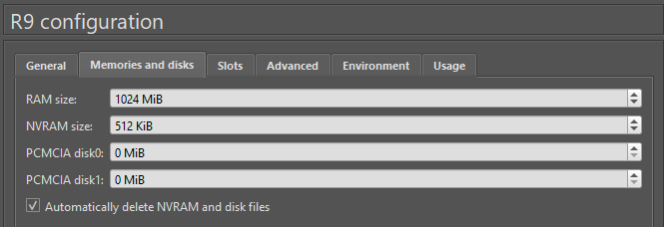
Figure 7 GNS3 Router configuration
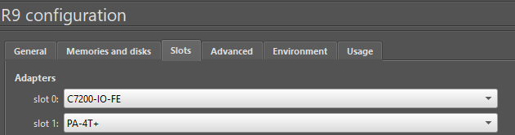
Figure 8 GNS3 Router configuration cont.

Switching – Devices
In the case of layer 2 devices, it was necessary to use the Cisco IOSvL2 platform, this provides an implementation of the vast majority of the layer 2 protocols, including the ones necessary to conduct the testing required for this project [31]. This was used with the newest freely available version of cisco IOS, that being version 15.0. This implementation does suffer a bandwidth limitation; however, this will not have an effect the testing as the parameters used for the testing take this into account. [32]. Unlike the layer 3 devices the implementation of the layer 2 using IOSvL2 allow for a greater amount of modularity when configuring the layer 2 devices, therefore the configuration of these devices has been tailored to the scenario of these tests, this comes in the form of an increased memory budget for each device, which supports the inclusion of an increased number of interfaces. See below for details.
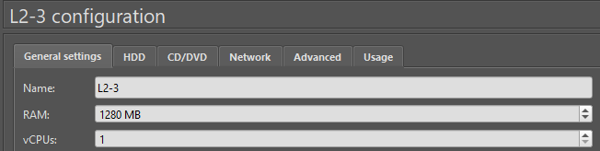
Figure 9 GNS3 Switch configuration
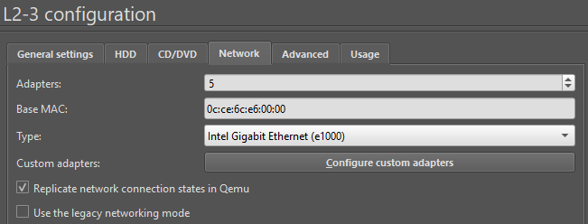
Figure 10 GNS3 Switch configuration cont.

Host Devices
As previously discussed, the host devices are to be created using Ubuntu Linux virtual machines, this has been done on both end devices. the version of Ubuntu chosen is the 20.04.06 release of the software, this has bene done to aid in compatibility with the D-ITG testing software. Along with the other devices these host virtual machines have been configured with default and developer recommended specifications to ensure optimal performance. With the host devices operation, the software required to conduct the testing was then installed onto both machines, this software being Wireshark, D-ITG and IPerf3.
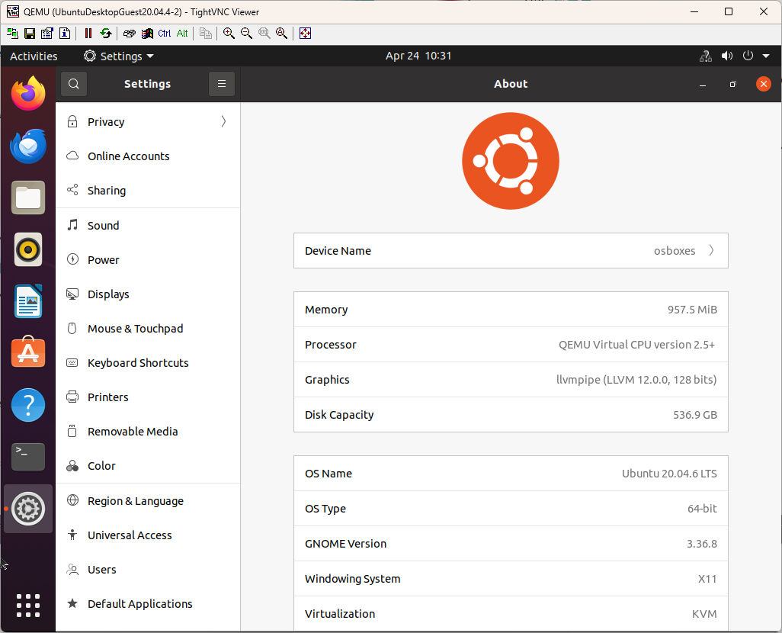
Figure 11 Ubuntu device specifications

Network topology implementation
With the setup and configuration of the individual network devices complete, the designed network topology can could now be assembled. This was done by recreating the packet tracer topology in the GNS3 software using the emulated devices. with the topology implemented, the next process is that of establishing the basic connectivity and function of the network.
The first step in achieving this is the creation of an IP addressing scheme, this was done with the routing layer working in the 10.10.0.0 range, with the hosts operating in the 192.168.0.0 range. With this base an addressing table was constructed following the above parameters. Bellow can be seen the Ip addressing table, fields filled with ‘N/A’ are interfaces that are required later testing but not initial configuration and connectivity, the IP address’ for these interfaces will be configured and defined during the sections requiring their use.
For the testing of the layer 2 protocols the default gateways of the devices are set to the router holding the .1 interface. For the testing of the layer 3 protocols the default gateways are set as set as the .100 addresses used by the FHRP interface.
Device | Interface | Ipv4 address | Default Gateway | Network Mask
Host 1 | eth0 | 192.168.10.10 | 192.168.10.100 | 255.255.255.0
Host 2 | Eth0 | 192.168.20.10 | 192.168.20.100 | 255.255.255.0
R1 | G0/0 | 192.168.10.1 |  | 255.255.255.0
 | S1/0 | 10.10.11.1 |  | 255.255.255.0
R2 | G0/0 | 192.168.10.2 |  | 255.255.255.0
 | S1/1 | 10.10.13.1 |  | 255.255.255.0
R3 | S1/0 | 10.10.11.2 |  | 255.255.255.0
 | S1/1 | 10.10.12.1 |  | 255.255.255.0
R4 | S1/1 | 10.10.12.2 |  | 255.255.255.0
 | S1/2 | 10.10.13.2 |  | 255.255.255.0
 | S1/0 | 10.10.10.1 |  | 255.255.255.0
R5 | S1/0 | 10.10.10.2 |  | 255.255.255.0
 | S1/1 | 10.20.13.2 |  | 255.255.255.0
 | S1/3 | 10.20.12.2 |  | 255.255.255.0
R6 | S1/2 | 10.20.13.1 |  | 255.255.255.0
 | G0/0 | 192.168.20.1 |  | 255.255.255.0
R7 | S1/0 | 10.20.11.1 |  | 255.255.255.0
 | G0/0 | 192.168.20.2 |  | 255.255.255.0
R8 | S1/0 | 10.20.11.2 |  | 255.255.255.0
Table 3 IPv4 addressing
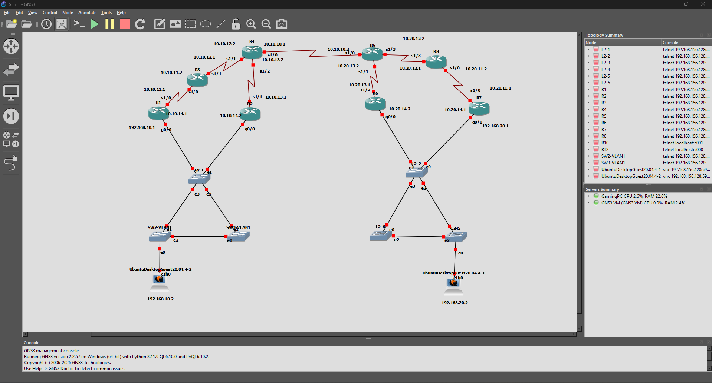
Figure 12 Network implementation in GNS3

Network routing
To handle routing the routing needs of the network all of the routers have been configured with a simple single area OSPF configuration, this has been done to sped up the testing process as any changes in network addressing can automatically be advertised across the network. This OSPF configuration will stay constant throughout the testing process.
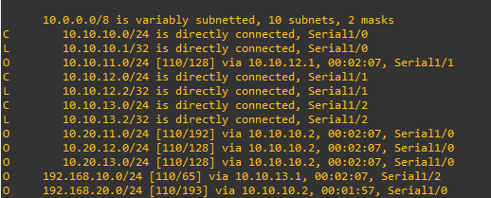
Figure 13 Router, Routing table

Connectivity testing
With the IP addressing complete and a routing solution implemented, the network is now fully operational and can receive and route traffic between the host devices, this is shown below with the two-host able to send ICMP pings across the network and receive replies form the opposing host.

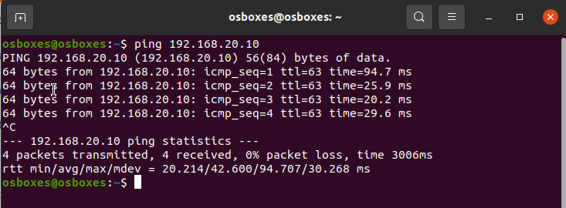
Figure 14 .10 host connectivity test
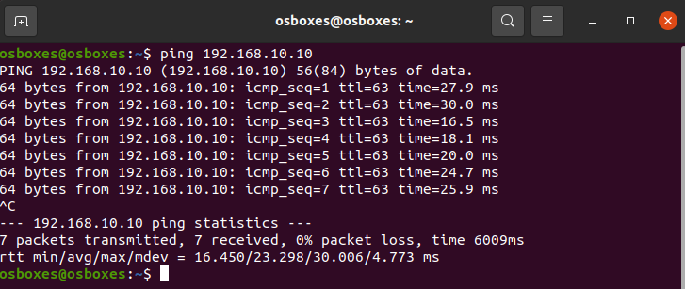
Figure 15 .20 host connectivity test

Protocols
The followings sections contain examples from the implementation and testing of the GLBP protocol. All the steps and procedures described and shown are the same for the other protocols tested.
To implement the various protocols for testing the network is first saved and a snapshot (restore point) is taken so that once one protocol is implemented and tested the network configuration can be quickly and accurately reset. This aids in ensuring that all tests are conducted using the same baseline and configuration variables, this furthermore reduces the risk of errors being implemented and the possibility of them compounding over the period of the testing.
All of the protocols tested have been configured using the recommended processes set out in the specific documentation of that protocol. This is done so that all of the protocols are configured similarly, this improves the reliability of the data and aids in comparison of the subsequent results. Below is an example of the configuration of a router interface with the GLBP protocol, this configuration uses the minimum required configuration to achieve the required operations. It done in line with the GLBP documentation [33].
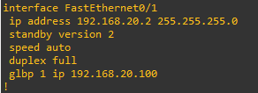
Figure 16 GLBP configuration
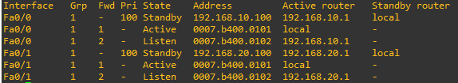
Figure 17 GLBP details
The process of outlined above is the same process that is used when configuring the other protocols (both layer 2 and 3), they are all implemented using the official documentation and processes, all of the configurations are then confirmed and tested using the aforementioned pre data collection testing procedures.

Testing

Applying load
With the implementation of the devices, hosts, software and protocols, the testing process can begin. As detailed in the testing procedure, this process begins with the application of a simulated background load onto the network using the iperf3 tool. This is used to pass a base stream of 10Mb/s across the network. This process can be seen bellow with the Iperf3 server running on the .10 host and the client on the .20 host, this stream is applied for 60 seconds to ensure the D-ITG tool has sufficient time to complete the testing.
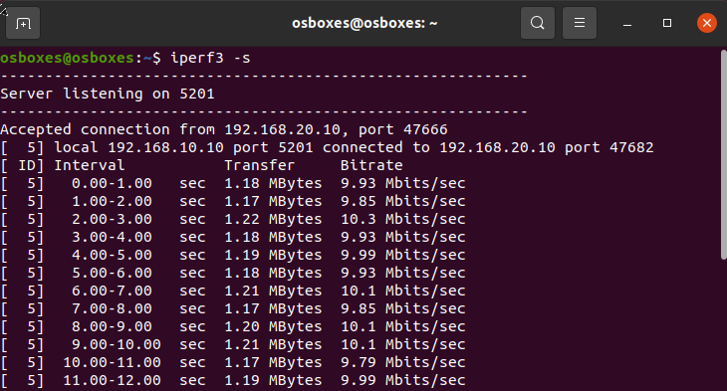
Figure 18 Iperf3 server
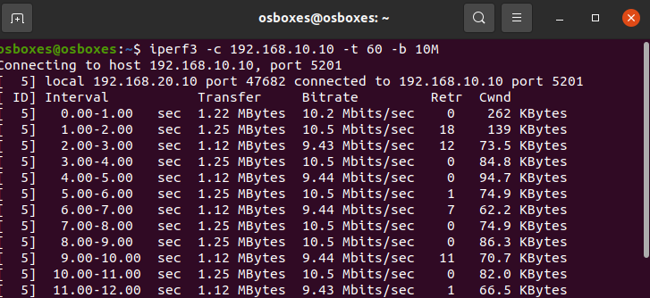
Figure 19 Iperf3 client

Collecting data
With the load being applied across the network the next steps can now be taken. This takes the form of running the D-ITG testing software to collect detailed metrics about the operation of the network. This begins similarly to the Iperf3 software, the .10 host initiates a D-ITG server while the .20 host operates in the client role. With this relationship established the following command is executed on the client shortly after the initiation of the Iperf3 software.
Figure 20 D-ITG testing command
This command initiates a data stream between the hosts; this is done using the TCP protocol. The software will attempt to send a stream of 1000 bytes constantly over the network for a period of 15 second, with the results recorded in the testbigr10.log. This is the same command that will be for the testing of all protocols, the only difference being the name of the log file generated.
With the data stream now in effect the process of causing a simulated failure on the network begins. After 5 seconds have elapsed from the initiation of the data stream a predetermined device is issued an immediate shutdown command through the GNS3 software, this is done to simulate the sudden failure of that device on the network. This then prompts the protocol being tested to rely on the designated backup, it is the delay in this process taking place that is being analysed.
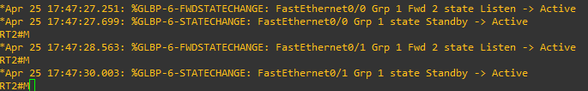
Figure 21 GLPB backup router taking over as default gateway
Once the set time has elapsed, and all data has been transferred across the network the D-ITG software then compiles the performance results from the test into the chosen log file. These results are then recorded for later comparison and analysis.
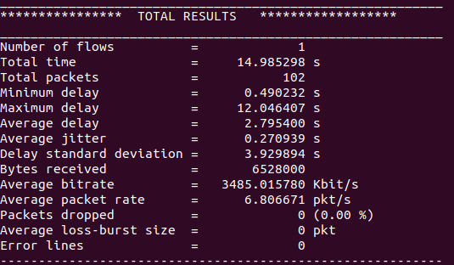
Figure 22 GLBP test results
With the results recorded, the test is then repeated another two times. To do this the IPerf3 data stream is ended and the server shutdown, this ensures that the process is completely stopped, the same is done with the D-ITG server. This is followed by the rebooting of the device that was disables to simulate the failure, the network is monitored to ensure that that this process is completed. Finaly the baseline test is reconducted, if the results are as expected the testing process can then be repeated.
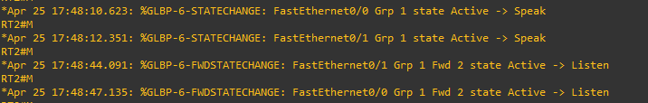
Figure 23 GLBP backup router reverting to its standby status
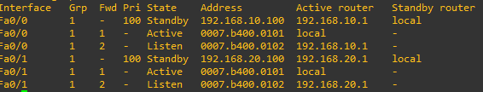
Figure 24 GLBP details 2
With the collection of the three data sets the network is then rolled back to the snapshot taken before the protocol implementation. This then allows for all of the previously described steps to be repeated for the remainder of the protocols.

Results
Below are the results that were observed after completing the aforementioned experiment using the different protocols. the following results give an accurate view into the performance of the various protocols using the data collected form the D-ITG software and the averages of these tests.
Protocol | Test | Time | Delay | Delay SD | Jitter | AVG Bitrate
PVST | Baseline | 15 | 0.17 | 0.009 | 0.0065 | 770.1
 | 1 | 60 | 10 | 21.5 | 0.2 | 52.7
 | 2 | 61 | 6.4 | 17.7 | 0.13 | 59.5
 | 3 | 83 | 7.5 | 22.8 | 0.15 | 50.8
Average |  | 68 | 7.97 | 20.67 | 0.16 | 54.33
RPVST | Baseline | 15 | 0.17 | 0.0067 | 0.0067 | 796
 | 1 | 15 | 0.36 | 0.57 | 0.0092 | 694
 | 2 | 15 | 0.37 | 0.6 | 0.0096 | 686
 | 3 | 15 | 0.36 | 0.57 | 0.0096 | 685
Average |  | 15 | 0.36 | 0.58 | 0.0095 | 688.33
MST | Baseline | 15 | 0.17 | 0.0096 | 0.0067 | 771
 | 1 | 43 | 4.6 | 12.3 | 0.095 | 81.7
 | 2 | 42 | 4.8 | 12.6 | 0.1 | 77
 | 3 | 44 | 5.3 | 13.4 | 0.11 | 70.7
Average |  | 43 | 4.9 | 12.77 | 0.10 | 76.467
Table 4 Layer 2 protocol testing results

Protocol | Test | Time | Delay | Delay SD | Jitter | AVG Bitrate
HSRP | Baseline | 15 | 1.05 | 0.21 | 0.06 | 781
 | 1 | 26 | 2.33 | 4.87 | 0.34 | 244
 | 2 | 30 | 1.84 | 3.68 | 0.18 | 344
 | 3 | 24 | 1.79 | 3.78 | 0.3 | 186
Average |  | 26.66667 | 1.99 | 4.11 | 0.27 | 258
VRRP | Baseline | 15 | 1.2 | 0.14 | 0.07 | 778
 | 1 | 15 | 1.63 | 1.51 | 0.12 | 774
 | 2 | 15 | 1.67 | 1.53 | 0.11 | 782
 | 3 | 15 | 1.77 | 1.66 | 0.12 | 775
Average |  | 15 | 1.69 | 1.57 | 0.12 | 777
GLBP | Baseline | 15 | 1.22 | 0.15 | 0.006 | 769
 | 1 | 15 | 2.78 | 3.92 | 0.27 | 348
 | 2 | 15 | 2.34 | 3.22 | 0.17 | 347
 | 3 | 15 | 1.71 | 1.74 | 0.13 | 561
Average |  | 15 | 2.28 | 2.96 | 0.19 | 418.67
Table 5 Layer 3 protocol testing results

The above results are the show that there is indeed a noticeable difference between what protocol is implemented and the performance of the network. This is shown in multiple of the above metrics, such as the observed delay (convergence), jitter and Bitrate. This can be clearly seen when plotting the mean averages of the results of the various tests onto a graph.
Furthermore, when taking the standard deviations of the delay statistics, we can see a clear trend of some protocols also providing more reliable outcomes, this is seen in the low deviation metrics for protocols such as RPVST and VRRP. whereas the high deviation score presented by other protocols is a clear indicator instability and therefore worse performance.
When done this shows that for example, in various metrics the PVST layer 2 protocol suffers from the wors performance with the highest delay and jitter, with the lowest throughput. This can be seen in the figures bellow.

Figure 25 L3 Jitter
Figure 26 L2 Jitter
Figure 30 L3 Bitrate
Figure 29 L2 Bitrate
Figure 27 L3 Delay
Figure 28 L2 Delay

CHAPTER 5 – EVALUATION
As previously mentioned, these results show a clear trend in the data, that being there is a noticeable difference in the performance impacts of the protocols, and in some cases a significant impact. Using these findings, it is possible to determine what combinations of these protocols would have the greatest impact on performance and therefore answer the main question that this project aims to answer. Using the results it can be confidently said that to achieve the best performance on this style of network an administrator would want to use a combination of the RPVST and VRRP protocols, as this will achieve the overall best results.
The data collected during this research supports the results from previous research and literature, this experiment and the data collected from it confirms these conclusions by conducting this analysis in a unified manner, compared to other research which is fragmented. This is seen in the fact the data from this experiment has a strong correlation with the results of previous research which comes to similar conclusions, them being that in the case of Layer 2 protocols the RPVST protocol provides by far the best performance, similarly that the VRRP layer 3 protocol is likewise the protocol that provides the smallest performance impact. These results produced by this testing where as expected, from the previous work conducted it was shown that there are significant differences between protocols, and this research confirms that in a way that shows this in a more complete setting.

Aims and Objectives
When evaluating the outcome of this project against the aim and objectives set out at the beginning of this project, I feel there is strong evidence to say that this project fulfils both the aim of this project, that being to answer the question of ‘to what extent the combination of both layer 2 and 3 redundancy protocols effects a networks overall performance’. This question is clearly answered by the data produced by the research, the data shows that different protocols indeed have an impact on network performance and that this is true for both layer 2 and layer 3. Likewise, this entire project has been developed in line with the objectives set out at the beginning of this project.

Areas of improvement
If this project where to be re attempted in the future, there are a number of aspects that would be improved on and further developed. Theas would include a further analysis of the effects of sub configurations available for the protocols tested and what effects they may have. Furthermore, there is significant room for an expanded analysis of the network topology and its effects on performance.

CHAPTER 6 - CONCLUSIONS AND RECOMMENDATIONS

Conclusion
This project has been focused on answering one question, that being, what impact do various network redundancy protocols have on network performance, this project has done this in an inclusive way looking at both layer 2 and layer 3 protocols, where previous research has only focused on one or the other. In order to answer this question a detailed set of procedures have been developed in order to ensure that this question can be answered as reliably as possible and that all data can be easily reproduced. This included doing detailed research into the best methods that could be used to achieve this goal. All the procedures developed in this project where subsequently used to conduct a variety of experiments that were developed to collect the required data needed to definitively answer the reserved question.
Using the data collected through this project it was possible to draw the conclusion that there are impacts in network performance. Furthermore, recommendations were able to be made on the best combination of protocols to be used and those to be avoided. All of this allows for a satisfactory answer to be given to the research question posed by this project, that being ‘that there is correlation between the network protocol used and the performance of the network’.
In conclusion this work provides a unified analysis of the effects of redundancy protocols of both layer 2 and 3 on the performance of a simulated campus style network. It clearly shows that RPVST and VRRP protocols are the best choice for network performance. This is largely consistent with the results observed by previous research.

CHAPTER 7 – Reflection
Throughout the process of completing this project I have encountered many challenges and successes, all of which have bene invaluable in allowing me to learn new skill and further develop existing ones. The most significant example of this is my time management skill, this skill is one that I have greatly developed over the project through my struggles with managing the time allocated to different aspects of this project while managing the scope of the project. This initially proved costly as to much focus and time was placed on research and testing and not on developing my methods and producers to actually conduct the experiment, this led to time constraints and the reduction in project scope to allow for reallocation of time. This has taught me many valuable lessons about time and scope management in large projects. Naturally this project has also allowed me to develop many technical and soft skills, especially in the area of network simulation and virtual machines in general, along with many project management and research skills.
Reflecting on the challenges and success of this project, there are many aspects that I would like to change if where to do this again. This would include better use of planning and developing a more constrained scope which can then be expanded, instead of a large scope that then needs to be reduced. However, I am confident that the lessons and skills learned from this project would allow me to do all of the above with a far greater deal of confidence.

CHAPTER 8 – REFERENCES
[1] Petroc Taylor. "UK: internet penetration 1991-2022." statista. Accessed: Apr 30 2026. [Online]. Available: https://www.statista.com/statistics/468663/uk-internet-penetration/?srsltid=AfmBOoqxX9GFsR9szV1VMajWERBPrbeiGnjWR6f0alnQzWzVtP_H-Rij
[2] W. Zejia, "MEASUREMENT OF SPANNING TREE PERFORMANCE BETWEEN DIFFERENT PROTOCOLS," Batchelors, MAMK university of applied sciences, 2014. [Online]. Available: https://www.theseus.fi/bitstream/handle/10024/78426/Wang_Zejia.pdf?sequence=1&isAllowed=y
[3] D. F. Abd, R. A. Rashid, D. A. Othman, and H. M. Abdulqader, “Performance Evaluation using Spanning Tree Protocol, Rapid Spanning Tree Protocol, Per-VLAN Spanning Tree, and Multiple Spanning Tree”, UHD J SCI TECH, vol. 8, no. 1, pp. 20–30, Jan. 2024. [Online]. Available: https://journals.uhd.edu.iq/index.php/uhdjst/article/view/1254/841
[4] Parita Rathod, Comparative Analysis of Spanning Tree Protocol and
Rapid Spanning Tree Protocol using Packet Tracer, 2022. [Online]. Available: https://soe.rku.ac.in/conferences/data/75_8556_ICSET%202022.pdf
[5] M. H. A. Hamied, "Gateway Redundancy Protocols in the Smart Grid", pp. 186–190. [Online].doi: 10.1109/ICCIT52419.2022.9711652.Available: https://ieeexplore.ieee.org/xpls/abs_all.jsp
[6] U. Anwar, et al., "Performance Analysis and Functionality Comparison of FHRP Protocols", pp. 111–115. [Online].doi: 10.1109/ICCSN.2019.8905333.Available: https://ieeexplore.ieee.org/xpls/abs_all.jsp
[7] I. Ristanti Julia, et al., "Performance Evaluation of First Hop Redundancy Protocol
(FHRP) on VRRP, HSRP, GLBP with Routing Protocol BGP and EIGRP", pp. 1–5. [Online].doi: 10.1109/CITSM50537.2020.9268799.Available: https://ieeexplore.ieee.org/xpls/abs_all.jsp
[8] D. J. Lilja, Measuring Computer Performance: A Practitioner’s Guide. Cambridge: Cambridge University Press, 2000. Available at: https://www.cambridge.org/core/books/measuring-computer-performance/946D068B22B9333DE321112DE61712DD#fndtn-information
[9] Y. Liu, et al., "PerfTrace: A New Multi-metric Network Performance Monitoring Tool", 2022 18th International Conference on Network and Service Management (CNSM), pp. 240–246. [Online].doi: 10.23919/CNSM55787.2022.9964543.Available: https://ieeexplore-ieee-org.uwtsd.idm.oclc.org/document/9964543
[10] iPerf - The TCP, UDP and SCTP network bandwidth measurement tool. Accessed: Apr 29, 2026 2026. [Online]. Available: https://iperf.fr/
[11] Wreshark.org (open sourced), Wireshark. 4.6. Accessed: 29/04/26 [Online]. Available: https://www.wireshark.org/
[12] S. Srivastava, et al., "Comparative study of various traffic generator tools", 2014 Recent Advances in Engineering and Computational Sciences (RAECS), pp. 1–6. [Online].doi: 10.1109/RAECS.2014.6799557.
[13] S. Avallone, S. Guadagno, D. Emma, A. Pescapè and G. Ventre,D-ITG Distributed Internet Traffic Generator. 2004. [Online]. Available: https://www.researchgate.net/profile/Antonio-Pescape/publication/221406698_D-ITG_Distributed_Internet_Traffic_Generator/links/09e41509ba1c1cf0d3000000/D-ITG-Distributed-Internet-Traffic-Generator.pdf
[14] Cisco, Cisco Modeling Labs. (2025. 2.9. [Online]. Available: https://developer.cisco.com/modeling-labs/
[15] SolarWinds, GNS3. 2.2.58.1. [Online]. Available: https://gns3.com/
[16] S. V. Tagliacane, et al., "Network simulations and future technologies in teaching networking courses: Development of a laboratory model with Cisco Virtual Internet Routing Lab (Virl)", 2016 International Conference on Wireless Communications, Signal Processing and Networking (WiSPNET), pp. 644–649. [Online].doi: 10.1109/WiSPNET.2016.7566212.Available: https://ieeexplore.ieee.org/abstract/document/7566212

[17] T. P. Club. "Saunders’ Research Onion." The PHD CLUB. Accessed: Apr 30 2026. [Online]. Available: https://thephdclub.com/blog/f/saunders%E2%80%99-research-onion [G1] S. Seuring, T. Stella and M. Stella, "Developing and Publishing Strong Empirical Research in Sustainability Management—Addressing the Intersection of Theory, Method, and Empirical Field," vol. 1, 2021, doi: 10.3389/frsus.2020.617870.
[18] I. Free Software Foundation, The GNU General Public License v3.0 - GNU Project - Free Software Foundation. (2007. 3.0. Accessed: Apr 29, 2026 2026. [Online]. Available: https://www.gnu.org/licenses/gpl-3.0.en.html#license-text
[19] gns3.com. "GNS3 Marketplace." GNS3. [Online]. Available: https://www.gns3.com/marketplace/featured
[20] S. Narayan, P. Shang and N. Fan, "Performance Evaluation of IPv4 and IPv6 on Windows Vista and Linux Ubuntu", 2009 International Conference on Networks Security, Wireless Communications and Trusted Computing, pp. 653–656. [Online].doi: 10.1109/NSWCTC.2009.368.
[21] OffSec, Kali linux. 2026.1. [Online]. Available: https://www.kali.org/
[22] Canonical Ltd, Ubuntu Linux. 26.04 LTS. [Online]. Available: https://ubuntu.com/download/desktop
[23] A. Botta, A. Dainotti and A. Pescapé, "A tool for the generation of realistic network workload for emerging networking scenarios," vol. 56, no. 15, pp.3531–3547, Oct 15 2012, doi: 10.1016/j.comnet.2012.02.019. Available at: https://dx.doi.org/10.1016/j.comnet.2012.02.019.
[24] Alessio Botta, Walter de Donato, Alberto Dainotti, Stefano Avallone and Antonio Pescap´e, "D-ITG 2.8.1 Manual," pp.9, Oct 28 2013, Accessed: Apr 18, 2026. Available at: https://traffic.comics.unina.it/software/ITG/manual/D-ITG-2.8.1-manual.pdf.
[25] "Chapter 7 The Network as a System and as a System Component," in Principles of Computer System Design An Introduction, J. H. Saltzer and M. Frans Kaashoek, Ed., Massachusetts Institute of Technology: Massachusetts Institute of Technology, 2009, Available: https://ocw.mit.edu/courses/res-6-004-principles-of-computer-system-design-an-introduction-spring-2009/46bd7ae60f3adfbdcfaca03df7892c24_networks_open_5_0.pdf
[26] H. Dong, M. Lv and W. Fan, "Fault-Tolerant Communication in HSDC: Ensuring Reliable Data Transmission in Smart Cities," vol. 73, no. 4, pp.1933–1945, 2024, doi: 10.1109/TR.2024.3371953.
[27] H. Li and H. Bai, Principle of Architecture, Protocol, and Algorithms for CoG-MIN: A Sustainably Ecological & Evolutionary Solution for Packet Network System. Singapore: Springer Nature, 2025. doi: 10.1007/978-981-96-3596-2.
[28] Broadcom, VMware workstation pro. (2026. 25H2. [Online]. Available: http://vmware.com/products/desktop-hypervisor/workstation-and-fusion
[29] Cisco Systems Inc, "Cisco 7200 Series Router," in Available: https://at.ingrammicro.eu/content/pdf/6779380.pdf
[30] J. Duponchelle. "Cisco 7200." GNS3 Marketplace. [Online]. Available: https://gns3.com/marketplace/appliances/cisco-7200
[31] J. Grossmann. "Cisco IOSvL2." GNS3 Marketplace. [Online]. Available: https://gns3.com/marketplace/appliances/cisco-iosvl2
[32] Cisco systens. "IOSvL2." Cisco DevNet. [Online]. Available: https://developer.cisco.com/docs/modeling-labs/iosvl2/
[33] Cisco systems. "GLBP - Gateway Load Balancing Protocol 12.2 T." Cisco.com. [Online]. Available: https://www.cisco.com/en/US/docs/ios/12_2t/12_2t15/feature/guide/ft_glbp.html

