Network operating systems and services

Part 1 - building a virtual lan
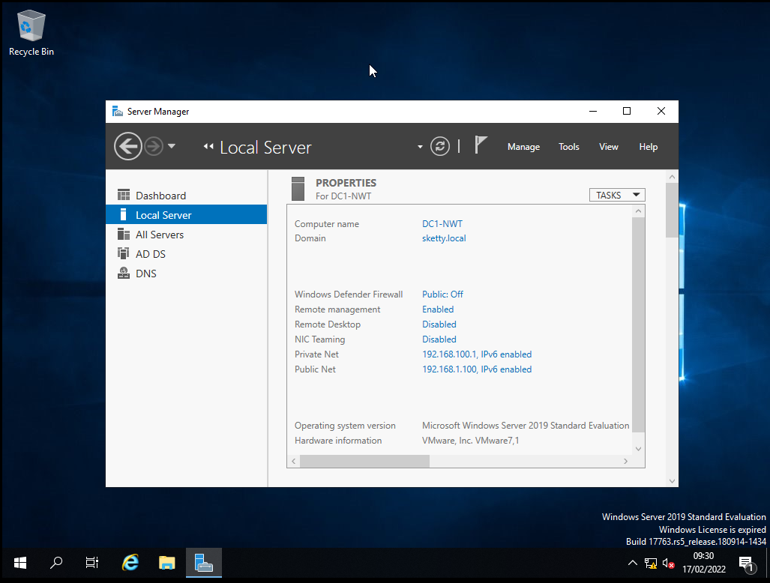
Here I have made 2 network ports so a private net (port 1) that works locally and a public net (port 2) that can connect externally this is server ones Ip addresses
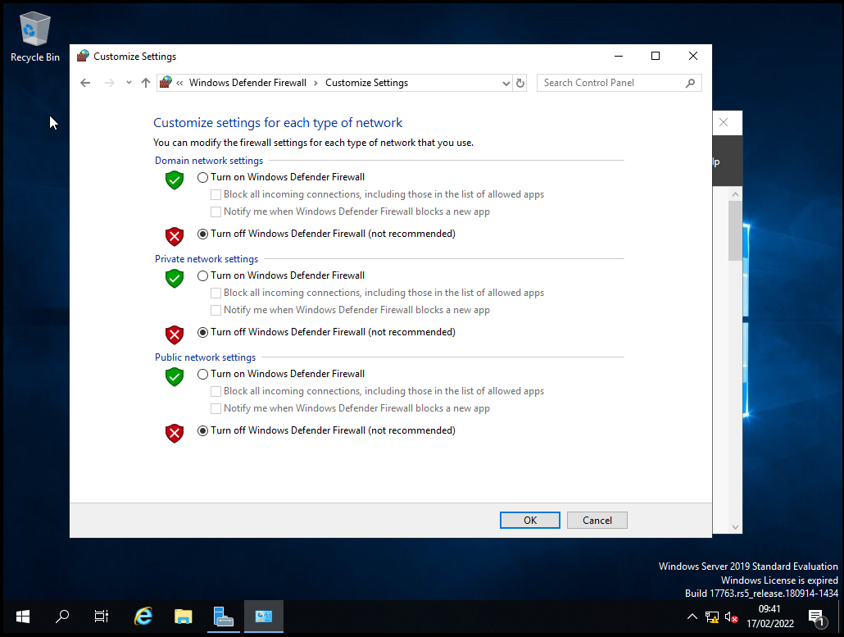
This screenshot shows the settings for the firewall and the ways to turn it on and off.
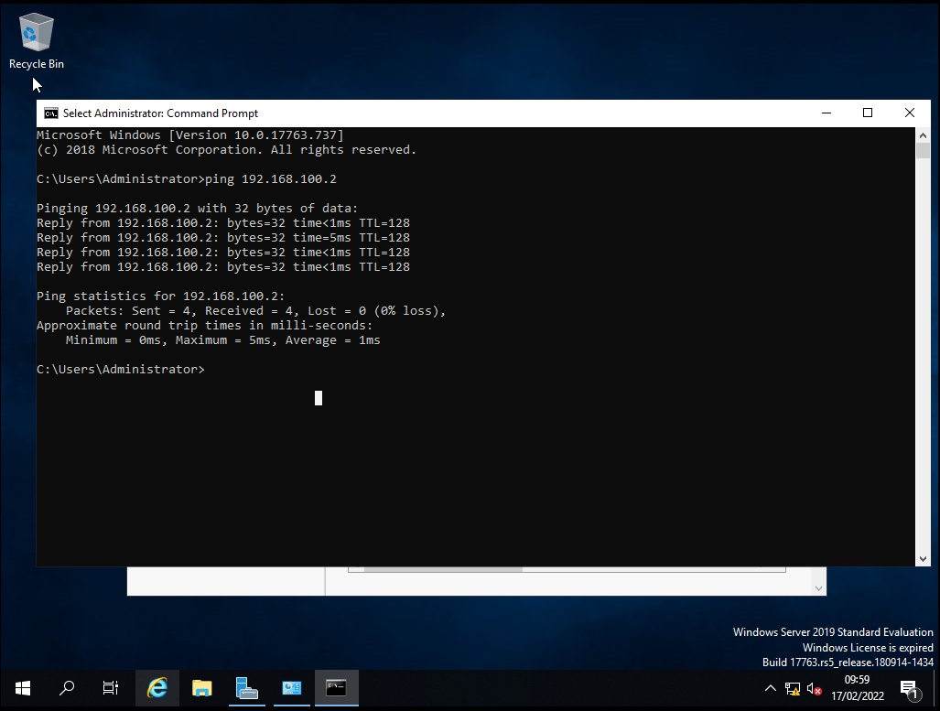
This shows that the server can ping to the client successfully

Part 2 - active directory network
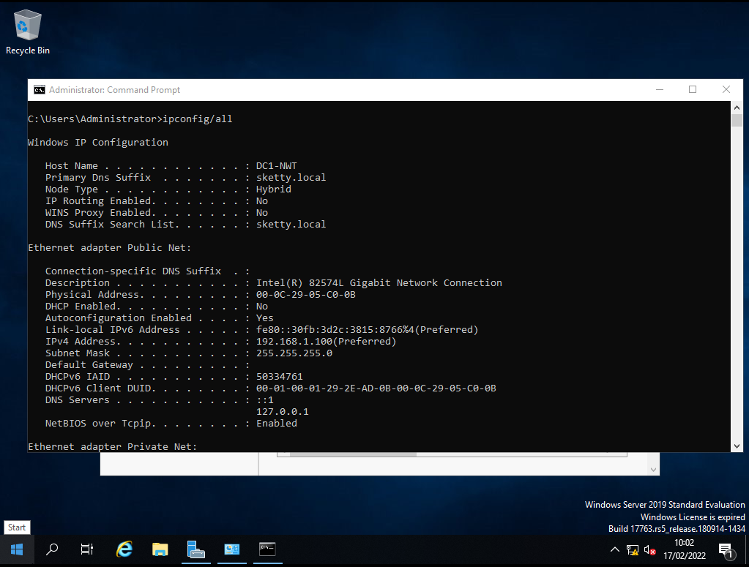
This screenshot shows that the network doesn’t have an active dhcp
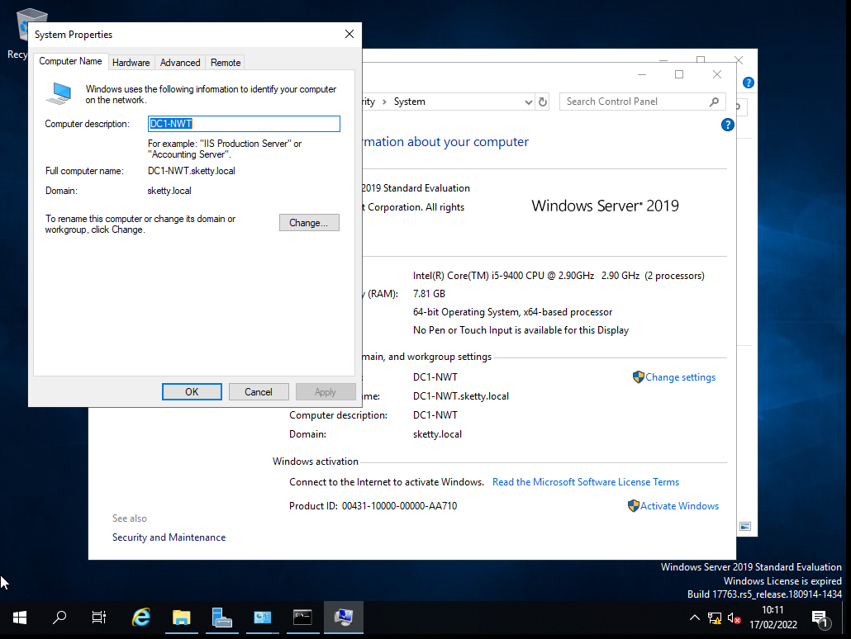
This shows the name of the computer and it also allows you to change it
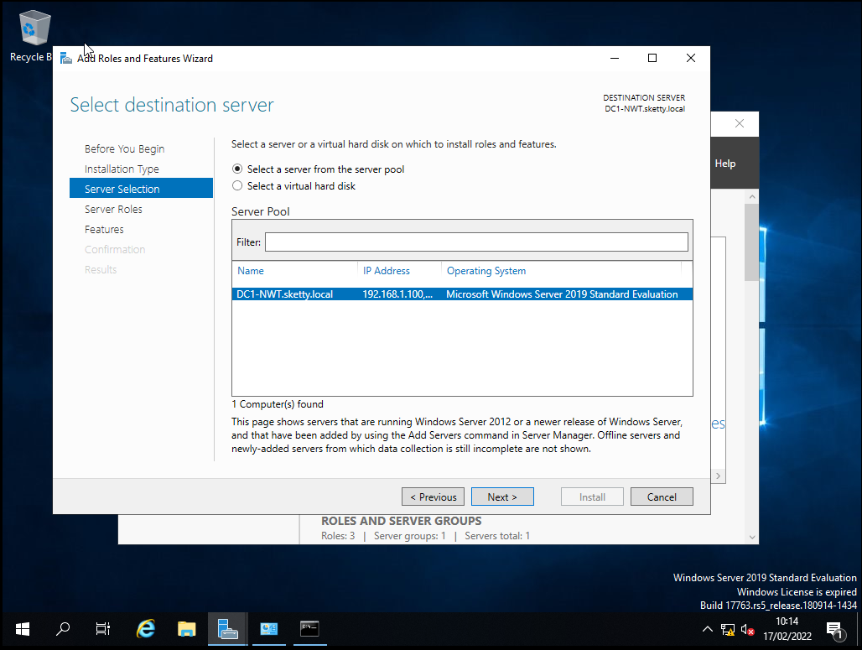
Here the user is selecting the server that the want to place role and responsibilities on.
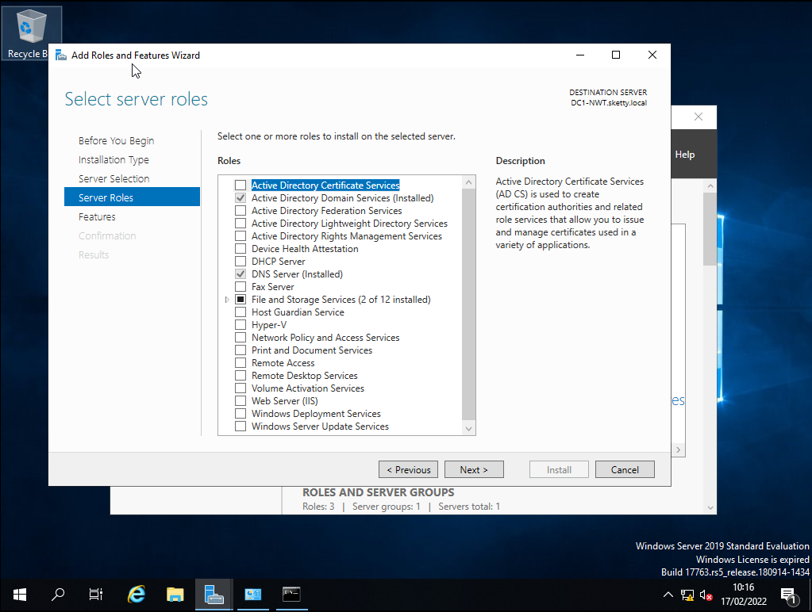
Here are the roles that the user can add and install to the sever and you can see that they have selected active directory and dns sever.
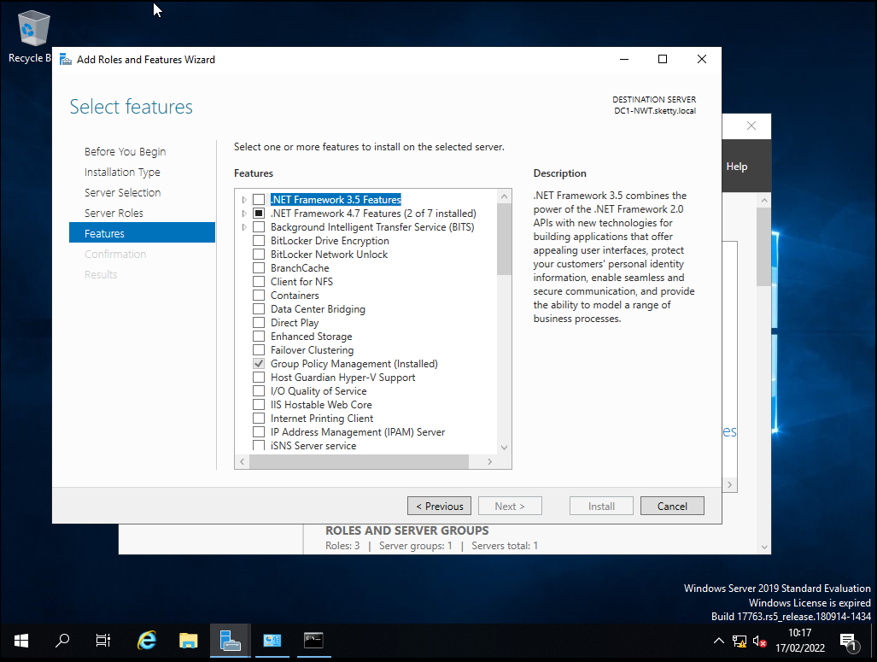these show what type of things you can install on to the sever and allows you to have basic server tools.
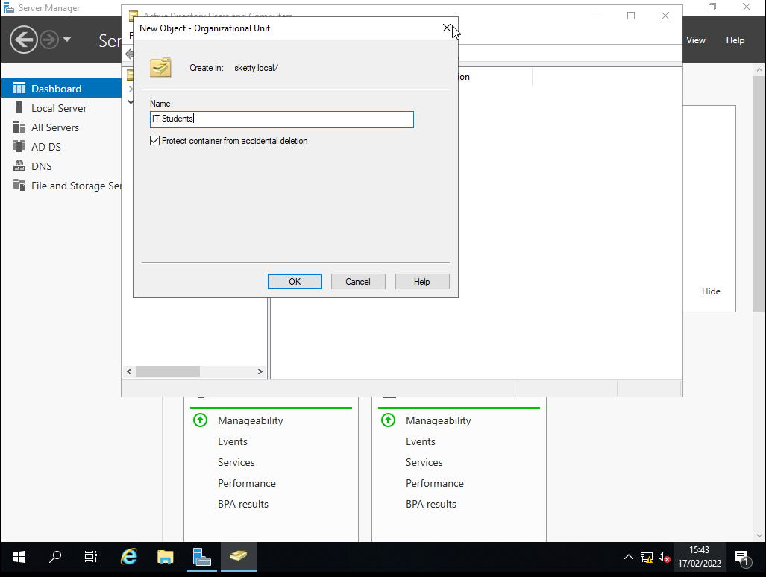
This shows that the user is creating a new organizational unit called it students
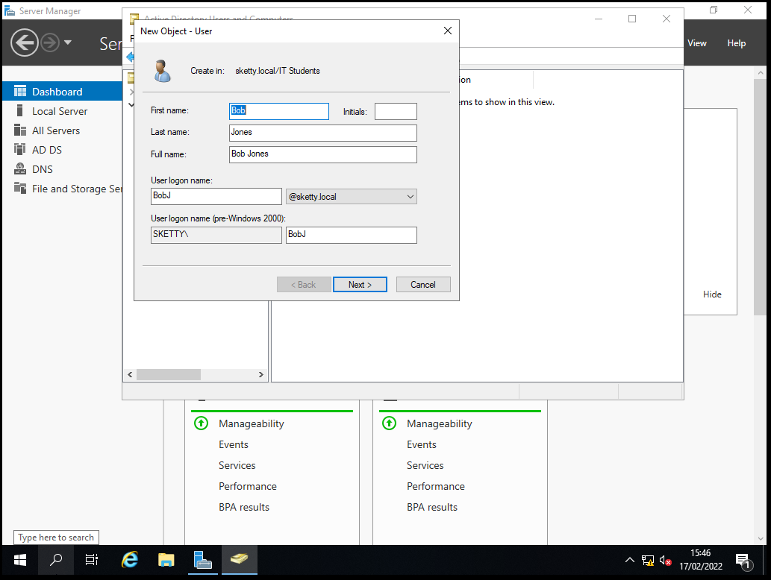
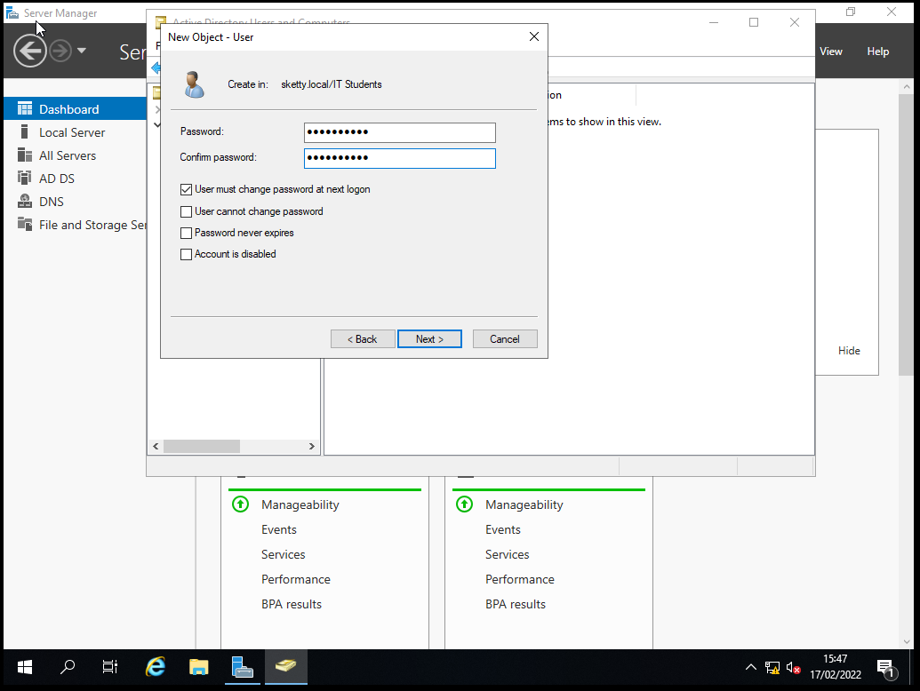
Here you can see the user making a new user for the client pc with a login and password.
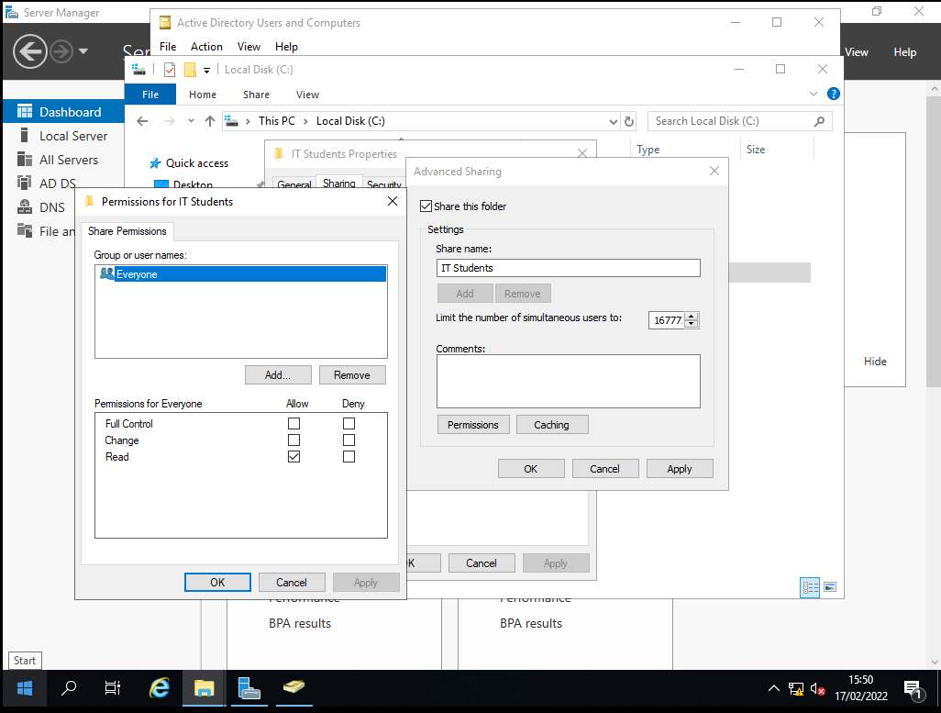
Here the user is creating a folder that the it students can all access.
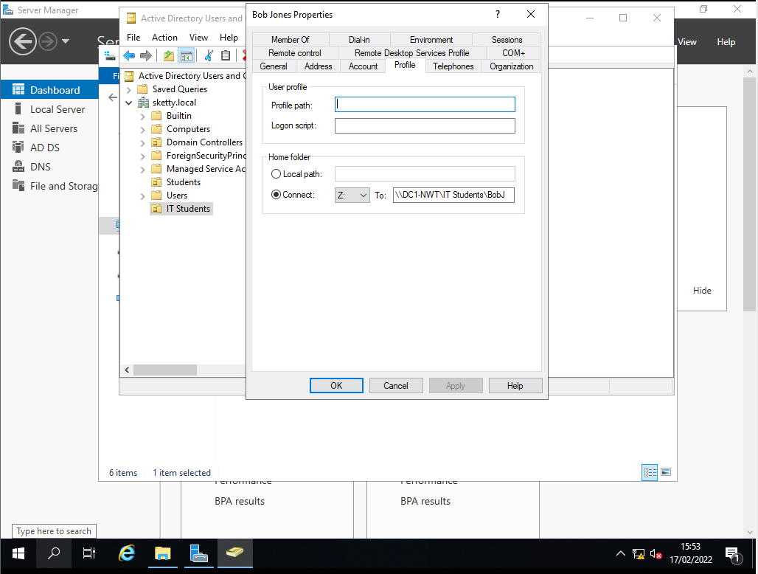
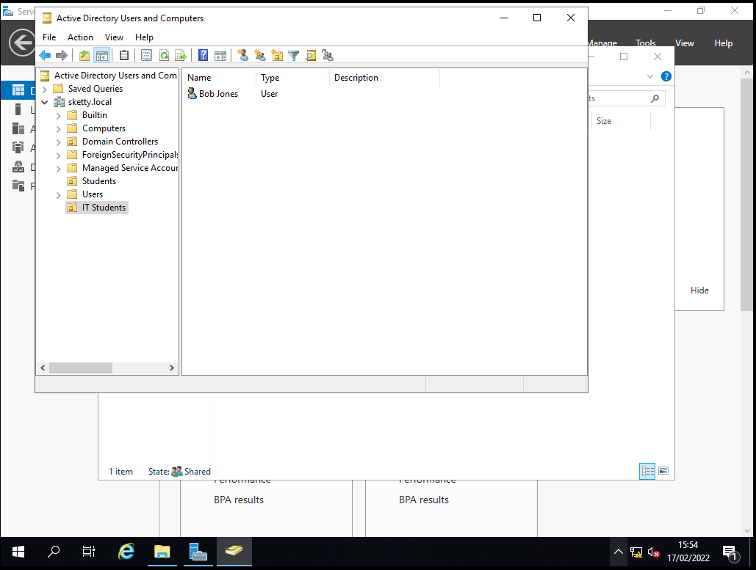
Here the user has created a specific folder on drive z that is for the it student

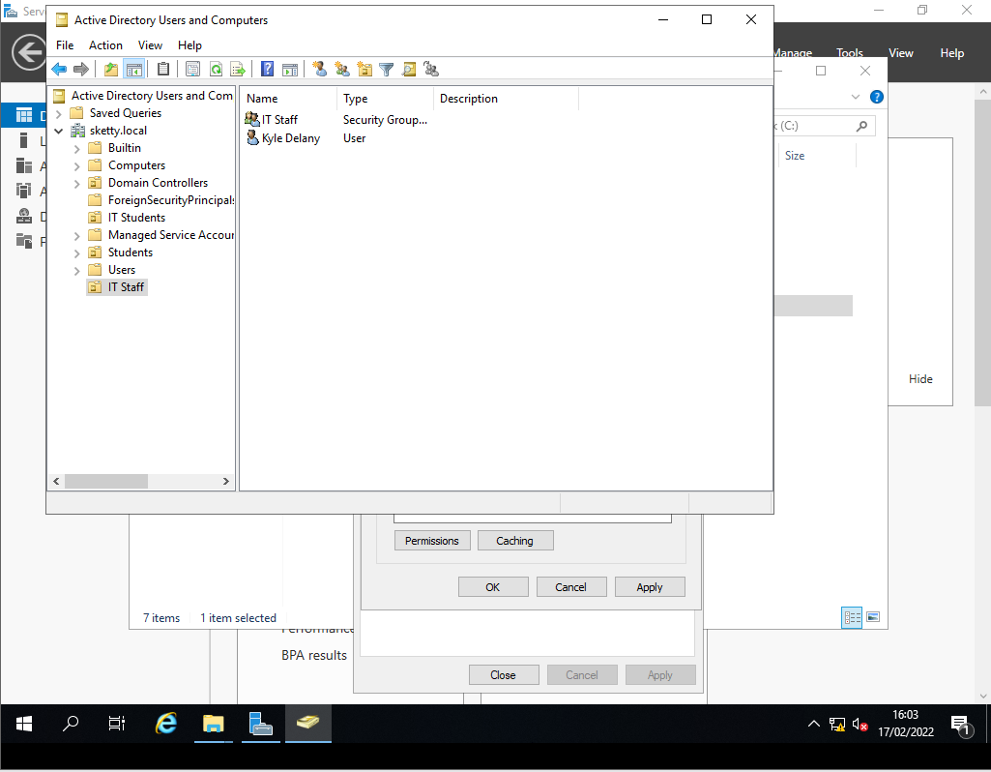
Here the user has made the unit it staff with the user and a group in the unit called it staff
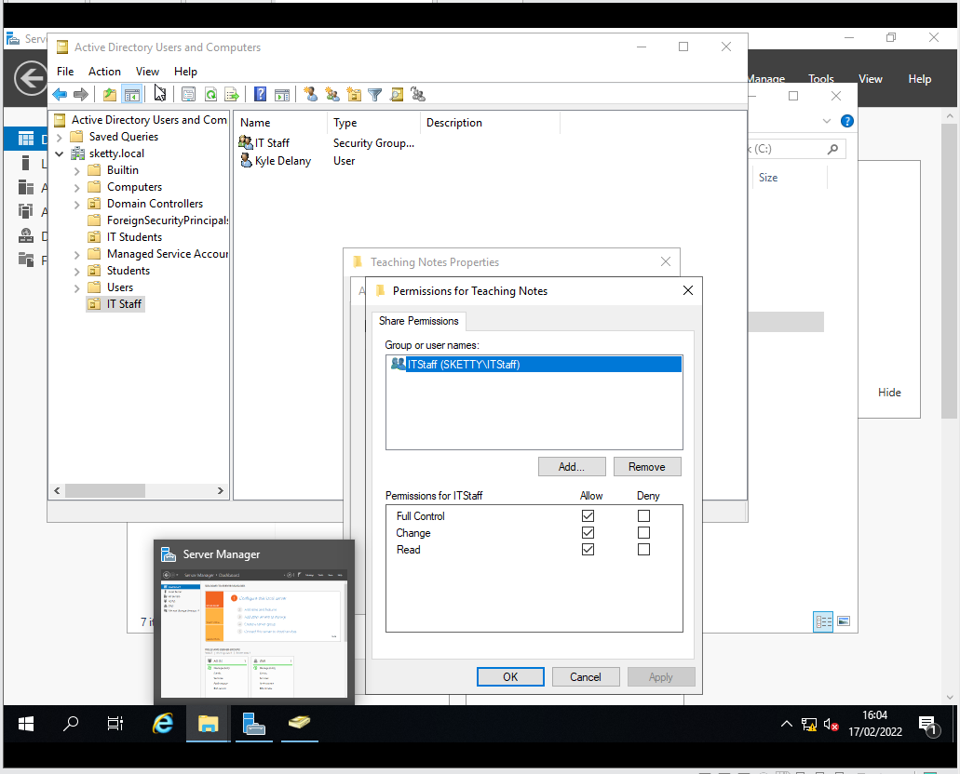
Here the user is giving permission to the folder in the c drive called teaching note so that the it staff group are the only ones that can change and access the folder
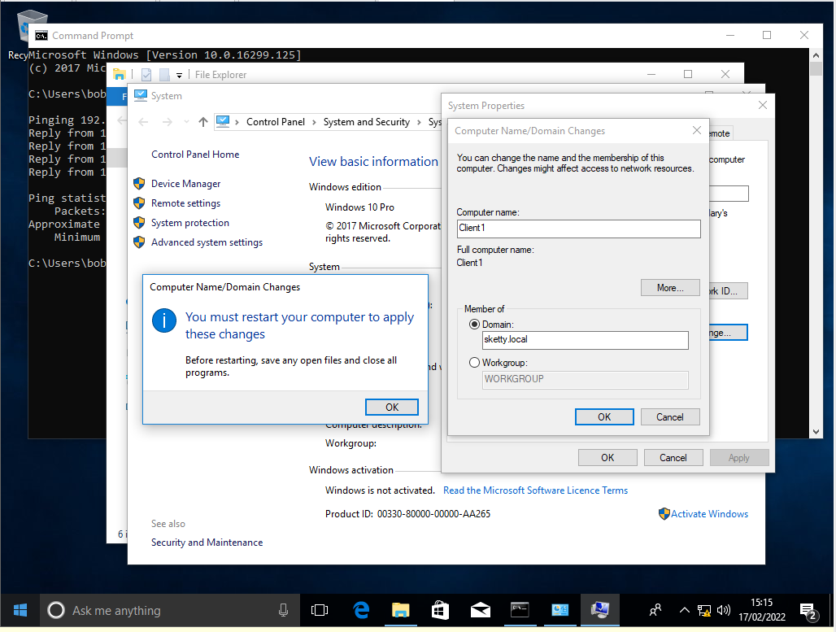
Here the user is connecting the client to the sever domain.
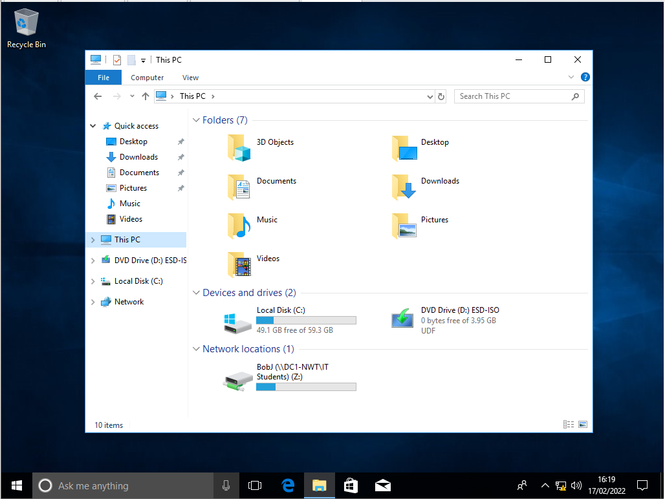
Here you can see that the client has connected to the server and the user is the one that was created on the server.

Observational task
- The main difference between type 1 and 2 hypervisor is that type one run specifically on “bare metal” that means that it doesn’t need to load any type of operating system and type 2 is installed on to an existing operating system as it relies on the host CPU, memory storage and network.
Type 1 | Type 2
Benefits  - They have direct access to the physical hardware  - Has higher security | Benefits  - Quicker and easier to use  - Easy access to user separate os alongside the host
Drawbacks  - Needs a different management device to manage other vm and to control the main hardware | Drawbacks  - Must have access to the main pc components (memory and network resources)  - Potential security risks

- Cloud computing is a bunch of different things that works through the internet for example you could have data storage, databases, software and servers. Cloud computing allows the user to keep files of a server instead of a hard drive or a local storage device this allows for the user to access the files from different locations if needed to.
Benefits | Drawbacks
- Easy to access  - Minimum costs and management  - Backups and easy to recover lost data | - Needs a reliable internet speed  - Security issues  - Limited controls
- The ping command
  - With the ping command you are able to check if the Ip address you are trying to connect to it will send 4 different packets to said ip and will reply whether said packet made it after all the packets have been sent it will let the user know how many made it (if any did) and how many were lost along the way.
- In this worksheet I was tasked in creating 2 severs and 2 clients with the servers having 2 network cards one being a public key that allows the servers to connect and a private key that allows the clients to connect to their respected sever for example client 1 connecting to sever 1 then I was tasked to create active directory on both servers and to create some clients.

