DATABASEMANAGEMENTSYSTEMS |  | Marin Zaharidov  1814694  Module Code : ACCC5001  Module Lecturer: Paul Jenkins

Veterinarian Surgery Database

Security and Data Manipulation Triggers

DDL and DML Transactions

Transaction and Concurrency

The ACID properties of a DBMS, Two – phase locking.

SECURITY

The most important part of database is the security.
Very powerful features are implemented in SQL server to protect the data.
Security can be one of the foremost complex issues to fight with when overseeing a SQL Server occasion, however it’s also one of the foremost critical, particularly when delicate and individual information are on the line. In truth, for numerous organizations, security is their number one need, which ought to come as no astonish, given what’s at stake.

SQL Server Authentication and Authorization:
Securing information begins with the capacity to confirm clients and authorize their get to particular information. To this conclusion, SQL Server incorporates an confirmation component for confirming the personalities of clients attempting to interface to a SQL Server occasion, as well as an authorization instrument that decides which information assets that authorized clients can get to and what activities they can take.

Authorizations characterize the level of get to allowed to principals on particular protection.
Configuring authorizations for different standards on numerous protection can be a complex and in some cases baffling handle. SQL Server moreover gives a few other highlights for controlling get to information.
For illustration, you'll execute row-level security on a particular table by making a security arrangement that calls one or more predicates. A security approach characterizes the structure fundamental to apply row-level security to a table.
Predicate may be a table-value work that gives the rationale fundamental to decide which columns the security arrangement applies to.

SQL SERVER DATA ENCRYPTION
Encryption isn't an access-control instrument, that's , it does not anticipate unauthorized clients from getting to information. In any case, encryption can restrain the introduction of touchy information ought to unauthorized clients oversee to break through SQL Server’s access-control guards. For illustration, in case cybercriminals secure scrambled credit card data from a database, they will not be able to create sense of that information unless they’ve too figured out a way to decode it.

Protecting a SQL Server

In expansion to taking steps inside SQL Server to ensure information, DBAs ought to too be certain to actualize securities related to the SQL Server occasion as a entirety, such as crippling unused SQL Server components, applying security patches and benefit packs in a convenient way, and guaranteeing that database and reinforcement records are completely secured and secure at all times.

Security model

Defense in Depth is the SQL concept for Security. It’s adding extra layer to the security and each layer increase the security. Important fact is that this model significantly strength the system. We recognize two type of accounts: windows accounts – active directory domain or local accounts, these accounts can be used in SQL server directly and SQL server accounts – they can have access within SQL server. These type of accounts are not secure as Windows accounts and can’t be used to log in Windows. The SQL server accounts are disabled by default. Login accounts need to be mapped to allow access. They are specific to a database.
Server Roles
SQL server can perform a number of actions like a multiple logins and providing the rights for performing these actions to each login. Server roles allow grouping of logins under a single name. Server roles can contain both Windows accounts and SQL server accounts. SQL server has fixed Server roles and these roles can’t be removed or changed.
Fixed Server roles are :
- SysAdmin: play administrator role on the server, allowing all activities
- ServerAdmin: server in administrator , allow to change server settings
- SecurityAdmin: manage logins and permissions
- ProcessAdmin: manage SQL server processes
- SetupAdmin: manage linked servers
- BulkAdmin: using BULK INSERT for adding huge number of rows to a table
- DiskAdmin: manage database files
- DbCreator: manage database: CREATE,DROP,ALTER
- Public: least access to the system

Custom Server Roles - These roles are completely manageable and requires a name. They can be used from Windows and SQL accounts. Custom Database roles are those that are meant to provide specific groups to which you can assign different database level permissions. (Simplilearn, 2015)
DATA MANIPULATION TRIGGERS
Triggers are the SQL codes that are automatically executed in response to certain events on a particular table. Used to maintain the integrity of the data.
Syntax of the trigger is :
Create Trigger Trigger _Name
Before | After
[INSERT|UPDATE|DELETE]
ON Table _ Name
For each row | For each column
Trigger _ Body
Trigger name has to be unique and shouldn’t be repeat. The statement before or after we use to tell as the time when the trigger is activated using DML operations : INSERT , UPDATE and DELETE. With this operations we can create a Nested trigger. These triggers are two types : 1 type - AFTER triggers , 2 type - INSTEAD OF. When DML or DDL operation is performed in action is the 1 type(AFTER). The 2 type(INSTEAD OF) are executed in place of DDL, DML operations. (Edureka, 2019)

OPERATIONS IN TRIGGERS
DROP TRIGGERS – to remove a trigger from the database.
Syntax is : DROP Trigger Trigger _ Name;
If a table is dropped then all related triggers are dropped . If a trigger is dropped, information about the trigger is deleted from the views list views of sys.objects, sys.triggers and sys.sql modules. Multiple DDL triggers can be dropped using the DROP command: DROP TRIGGER [trigger_Name].
To display triggers statement is:
SHOW TRIGGERS Trigger _ Name
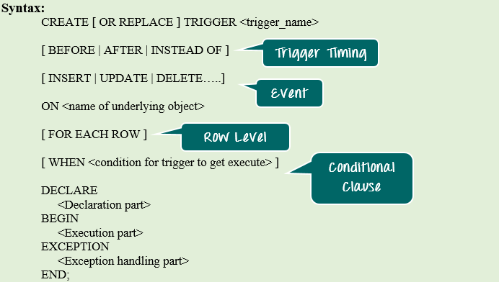
INSERT TRIGGERS are used to update or validate record values before they are saved to the database.
Syntax is :
CREATE TRIGGER Trigger _ Name
BEFORE INSERT
ON Table _ Name
FOR EACH ROW
SET Trigger _ body;
After INSERT triggers are used to access field values that are set by the system and to effect changes in other records.
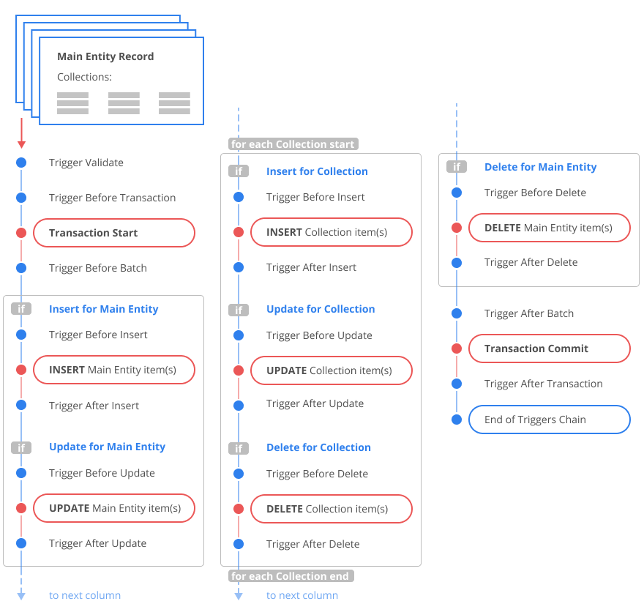

Advantages and Disadvantages of Triggers
Advantages : It helps to maintain the integrity constraints in database tables, particularly when there is no description of the primary key and the foreign key limit. It also often helps to keep the SQL codes short and easy like I demonstrate in the example in real-life. It helps to keep track of all changes (UPDATE, DROP and INSERT) that occur in tables by adding the new records and storing the changes. Often if the code is not well maintained, it will help to keep the database constraints established in the tables where the trigger is described.
Disadvantages: Difficult to manage as there could be a risk that the new developer may not be able to learn about the trigger specified in the database and wonder how data is automatically INSERTED, DROPED, or UPDATED. They are difficult to monitor because they are difficult to view in conjunction with stored procedures, views, functions, etc. Excessive or overuse of triggers will slow down the application 's output because if we defined the triggers in several tables they kept executing automatically whenever data is INSERTED,DROPED or UPDATED in the tables (based on the description of the trigger) and this makes processing very slow. If complex code is written in the triggers then the applications output will be slowed down. The cost of generating triggers can be higher on the tables at which DML operation (insert, delete, and update) like bulk attach is greater incidence. (Johari, 2018)

DDL and DML Transactions in Microsoft SQL Server
A transaction is a series of one or more SQL statements that are handled as
a unit by Oracle Database Express Edition: either all statements are made, or none are. The basic statements regarding transactions are:
COMMIT, which terminates the current transaction, perpetuates its changes, erases its savepoints and releases its locks.
ROLLBACK, which either rolls back the entire current transaction or just the changes after the defined savepoint.
SAVEPOINT, which marks a savepoint in a transaction – a point you can roll back to later. Savepoints are optional, and several savepoints may be present in a transaction.

Committing transaction makes the modifications permanent, erases the savepoints and removes its keys. To commit a transaction directly, use either the COMMIT expression or the Commit Modifications icon (in the SQL Developer environment). Your modifications are available to you, but not to other Database users.
Before you commit transaction: your modifications are available to you, but not to other Database instance users. Your changes aren't final - you can reverse them with a statement ROLLBACK. After you commit: your modifications are apparent to other users, and to their comments after the transaction is completed. The changes are final and can’t reverse with ROLLBACK.

Rolling back transaction undoes modifications thereof. You can rewrite the entire current transaction or roll it back to a defined savepoint only. Rolling back the whole transaction currently in progress:
1.Finishes transaction
2.Reverse all its modifications
3.Delete all its savepoints
4. Lets locks of every transaction.
Rolling back transaction back to defined savepoint only:
1.Does not end transaction
2.Only reverses the changes after the defined savepoint
3.Only the savepoints placed after the specified savepoint are deleted (except for the specified savepoint itself)
4.Releases all table and row locks acquired after the savepoint listed.

The SAVEPOINT statement marks a savepoint in a transaction — a point you can then roll back to later. Savepoints are optional, and several savepoints
may be present in a transaction.

Transactions and Concurrency

The transactions are set of operations which involve data items. There are four essential transaction properties which must be maintained by a database. The first one is Atomicity: requires every transaction to be anything or everything. Second one is Compatibility: when every transaction is consistent and the database is consistent, it will end up consistent. Third is Quality: when one of transaction is separated from another systematically and processed one by one. The last is Durability: means it can continue intact in the event of power failure, failures, or mistakes after a transaction has been committed. For example, in a relational database the results need to be stored permanently after a group of SQL statements are executed.
When a transaction is executed, the results thereof remain. A transaction begins with any SQL statement and ends with a ROLLBACK or COMMIT statement. The COMMIT statement makes permanent improvements to the database and ROLLBACK reverses changes. One transaction involves one or more access operations to the database. Those can involve operations requiring insert, delete, update or retrieve. (Tiwari, 2019)

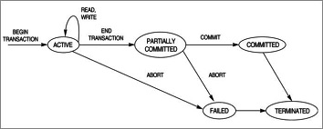

Concurrency Control: productivity management is defined as the method of controlling concurrent execution of transactions in a shared database. Productivity management essentially ensures that accurate results are produced for concurrent operations, while at the same time achieving those results as fast as possible.
- Lost Update – when two transactions have access to the same database
- Dirty Read Problems;
- Inconsistent Retrievals: This problem occurs when a transaction finishes operating with these data before and after another transaction(s).

DIRTY READ
Problem that occur when running simultaneous transactions is the Dirty Read. When first transaction is able to read data that is being changed by second transaction that is running simultaneously but that has not processed itself yet.
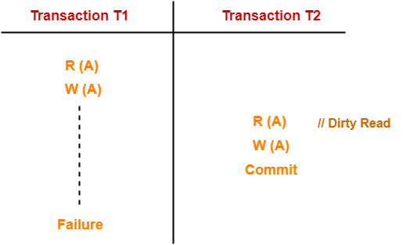
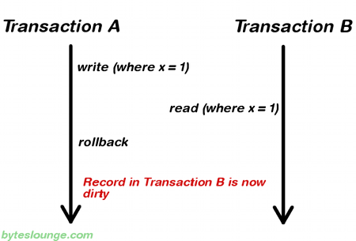
DIRTY READ
UNREPEATABLE READ
A Unrepeatable Read happens when an object is processed two times during a transaction and it is changed by another one between the process. This process mean the read operation is non-repeatable.

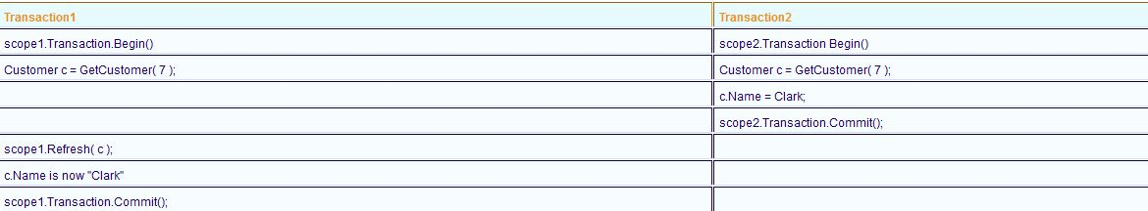
LOST UPDATE
A lost update happen when two transactions access the same object and then autonomously change it. The transaction that was last committed overwrites the improvements that the previous transaction made. Anomaly in rivalry-Missed update
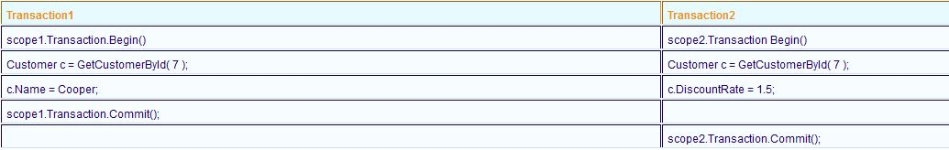

We use concurrency control:
The quantity of information is sufficiently big to allow a portion of this info to be in Primary Memory at any time, and rest should be transferred from Secondary Memory when is necessary, and the whole database may be present in Primary Memory.
Schedule: a pattern to define transaction execution running on the network and assume that a schedule is a sequence of read, write, abort and commit transactions from a collection of transactions.
Serial Schedule
T1 | T2
 | R(M)
 | W(M)
R(N)
W(N)
Serial Schedule
T1 | T2
R(N)
W(N)
 | R(M)
 | W(M)
Complete Schedule
T1 | T2
R(M)
W(M)
 | R(N)
Commit
 | W(N)
 | Abort
Complete Schedule
T1 | T2
R(M)
W(M)
Commit
 | R(N)
 | W(N)
 | Abort

Complete Schedule: A schedule for each transaction involving either a commit or an abort action. Therefore a complete schedule at the end of the schedule will not contain any active transaction.
Non-serial schedules: they improve system performance and we have to try to identify timetables where transactions is overlap and interleaved.

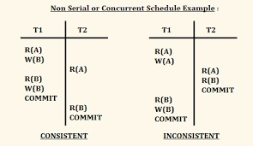

ACID PROPERTIES IN DBMS AND TWO PHASE LOCKING
One of the oldest and most important concepts of database theory is the ACID model of database design. It sets four objectives that each database management system must strive for: atomicity, consistency, isolation, and durability. It can not be considered reliable to have a relational database which does not meet any of these four objectives. A database with these characteristics is deemed to be ACID. (Chapele, 2020)
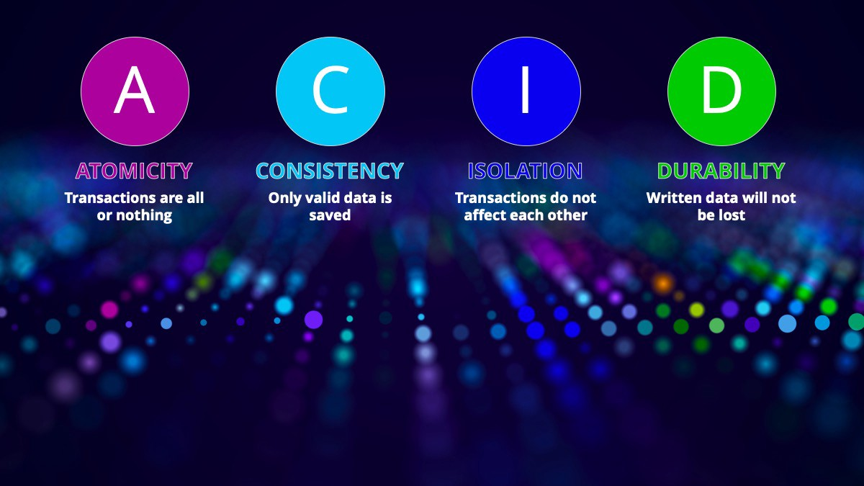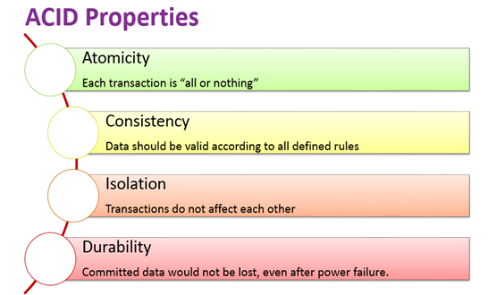
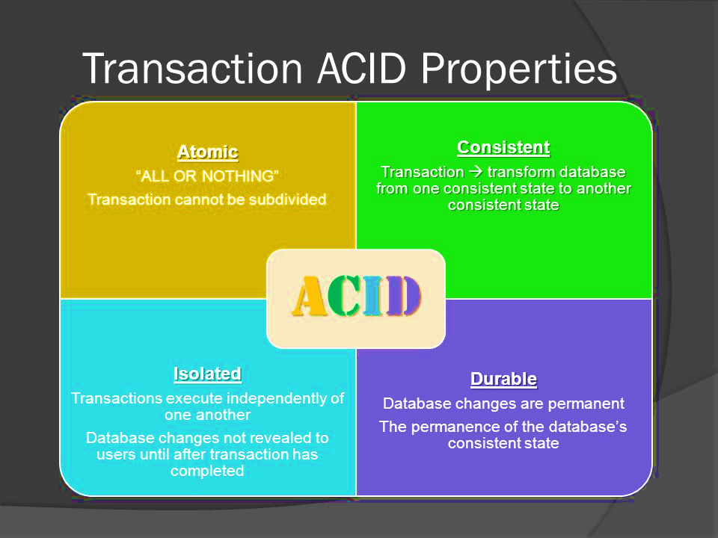
1. Atomicity notes that changes to databases will obey a law of "all or nothing." It's said every transaction is atomic. If one aspect of the transaction fails, the transaction will fail entirely. It is critical that, despite any DBMS, operating system, or hardware failure, the data base management system maintain the atomic nature of transactions.
2. Consistency states that the report is written to only true data. When, for whatever reason, a transaction that breaches the compliance rules of the database is executed, the whole transaction will be rolled back.
3. Isolation requires that multiple transactions starting at the same time not impact each other’s processing.
4. Durability guarantees no failure of any transaction that is added to the database.

Two Phase Locking Protocol
A concurrency Locks alone aren't enough to avoid confrontation. Special plan for concurrency management must specify how locks are obtained and released, as this often has an effect on interleaving transactions. The 2PL protocol specifies a lock management technique for this purpose, to ensure strict security and integrity. The 2PL protocol divides a transaction into two parts
1. Expanding process (locks purchased and no locks released)
2. Shrinking process (all locks are released, and no other locks can be acquired).
The expanding process for a database transaction means that locks are allowed to be developed from the beginning of the transaction to its end, while the shrinking phase is displayed by the commit or rollback process, as all the locks obtained are released at the end of the transaction. (Mihalcea, 2020)
For my report I present some of the operations and commands used to upgrade the database.
Example:
In my database we used Triggers to prevent new users to have access to any information. With their help we can monitor all the data when is updated or modified , deleted or requested.

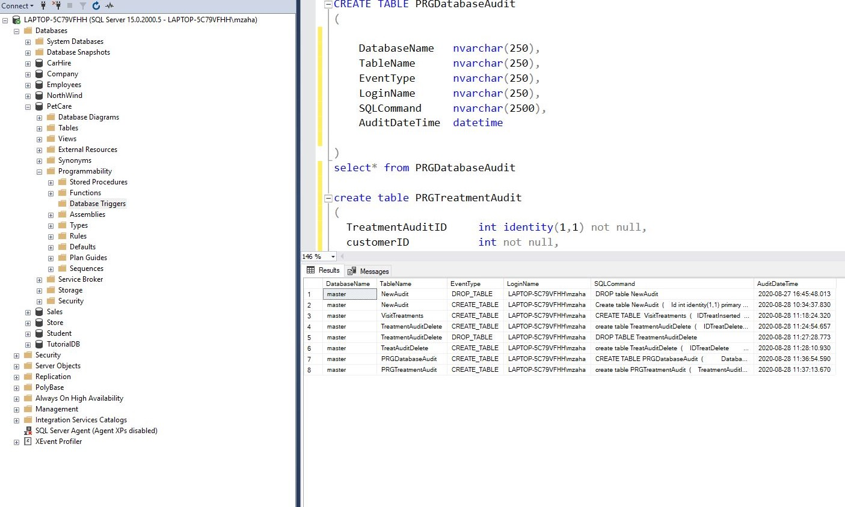

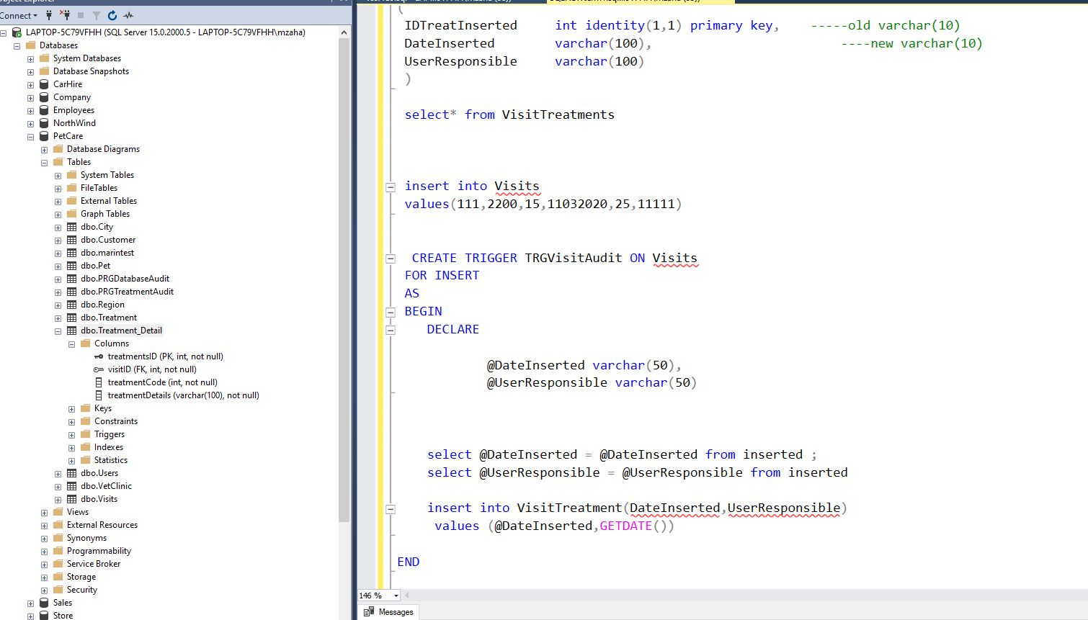

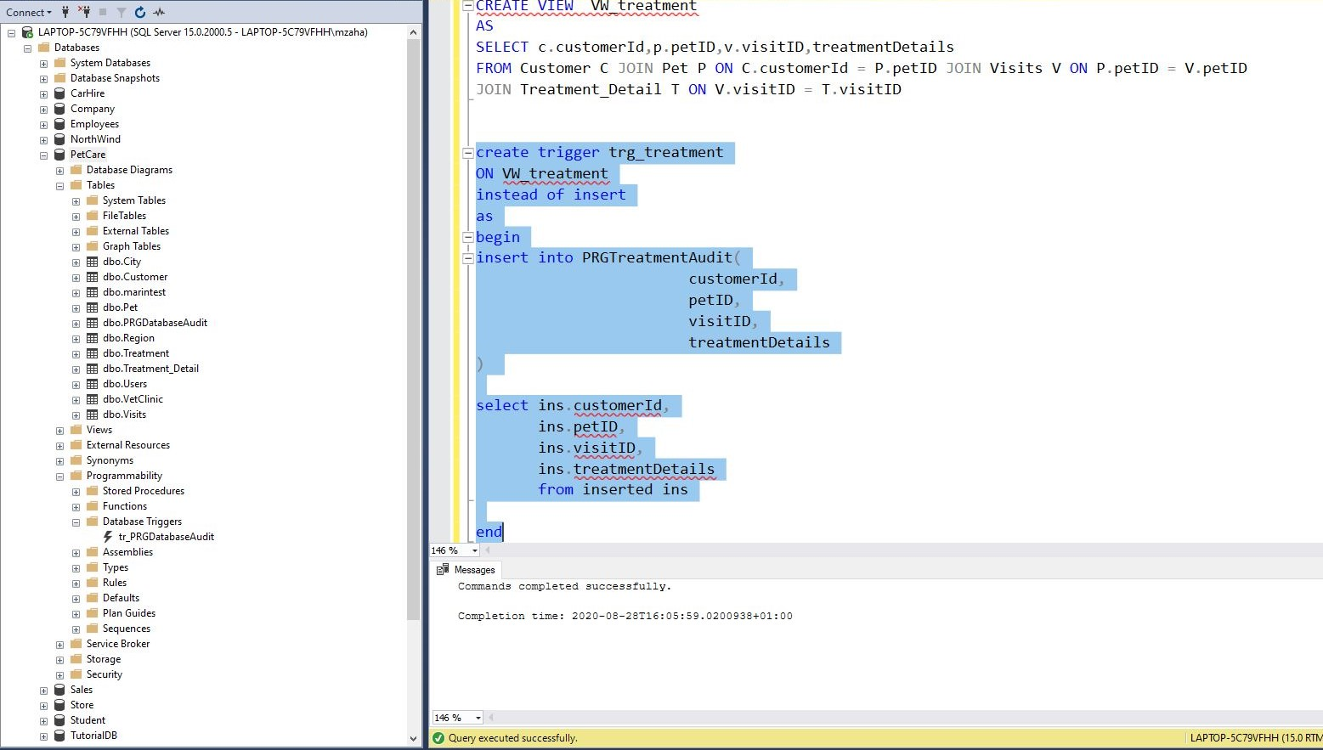

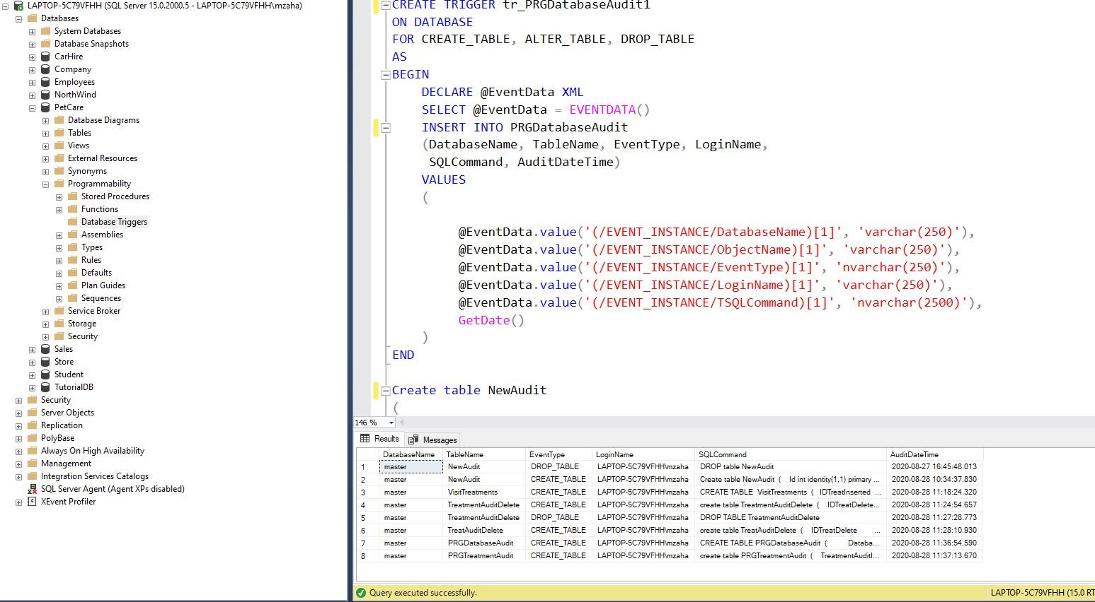

References
Chapele, M. (2020, 01 03). Lifewire. Retrieved from https://www.lifewire.com: https://www.lifewire.com
Edureka. (2019, 10 30). https://www.edureka.co/mysql-dba. Retrieved from https://www.edureka.co/mysql-dba: https://www.edureka.co/mysql-dba
Johari, V. (2018, 11 1). Advantages & Disadvantages of SQL Trigger. Retrieved from Advantages & Disadvantages of SQL Trigger: https://www.techmixing.com
Mihalcea, V. (2020, 02 7). How does the 2PL (Two-Phase Locking) algorithm work. Retrieved from https://vladmihalcea.com: https://vladmihalcea.com
Simplilearn. (2015, 08 01). https://www.simplilearn.com/. Retrieved from https://www.simplilearn.com/: https://www.simplilearn.com/
Tiwari, R. (2019, 10 02). Gradeup. Retrieved from https://gradeup.co: https://gradeup.co

