
Community Mental Health
Key Challenges in Community Mental Health
Despite improvements in community mental health services, several challenges remain in the UK.Increasing Demand for mental health services continues to rise. The Mental Health Foundation reports that mental health conditions are becoming increasingly common, placing significant pressure on community services. Workforce Shortages There is a shortage of mental health professionals across the NHS. This can lead to longer waiting times for treatment and increased workload for healthcare staff. Funding Limitations Although mental health funding has increased in recent years, many services still struggle with limited resources. Insufficient funding can affect the availability of community programmes, therapy services, and early intervention initiatives. Social Determinants of Mental Health. Factors such as poverty, unemployment, housing insecurity, and social isolation can significantly impact mental wellbeing. Community services must address these wider determinants to effectively support individuals. Stigma and Access to Care Stigma surrounding mental health remains a barrier to seeking help. Some individuals may delay accessing services due to fear of discrimination or misunderstanding about mental illness.

Bing,(2019)
Introduction:
Community mental health refers to services and support provided outside of hospital settings to help individuals manage mental health conditions within their local communities. In the United Kingdom, community mental health services are a key part of the care system delivered primarily through the National Health Service (NHS). These services aim to improve mental wellbeing, promote recovery, and support individuals to live independently.
Mental health problems are common in the UK. According to the NHS England, approximately one in four people experience a mental health problem each year. Community mental health services include multidisciplinary teams such as nurses, psychologists, psychiatrists, and social workers working together to provide treatment, support, and rehabilitation.
Community-based approaches help reduce the need for hospital admissions and encourage early intervention. The shift from institutional care to community-based mental health services began in the late 20th century following policy changes aimed at improving patient rights and quality of life. This approach focuses on person-centred care, social inclusion, and accessible mental health support.

Community Mental Health Interventions and Support
Several interventions are used within community mental health care to support individuals.
Psychological Therapies
Therapies such as Cognitive Behavioural Therapy (CBT) help individuals understand and manage negative thought patterns. These therapies are widely provided through NHS services.
Early Intervention
Early intervention services focus on identifying mental health problems at an early stage to prevent deterioration and reduce long-term impacts.
Social Support and Recovery Programs
Community programmes aim to improve social inclusion and wellbeing. Activities may include group therapy, community activities, employment support, and housing assistance.
Crisis Support Services
Crisis teams provide urgent mental health support to individuals experiencing severe distress. These services aim to prevent hospital admissions and provide immediate care in community settings.
Integrated Care Systems
Integrated Care Systems (ICS) encourage collaboration between healthcare providers, social services, and voluntary organisations to deliver coordinated mental health support.
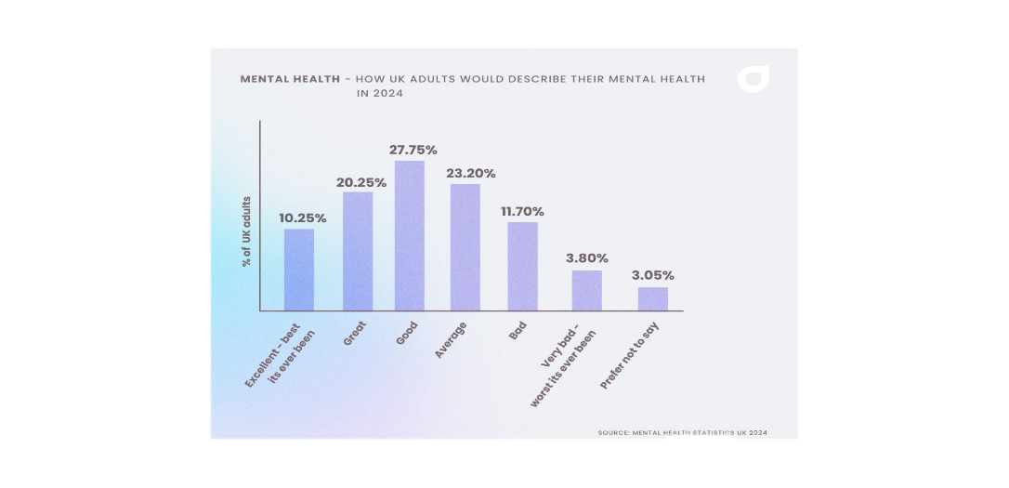

Background of Community Mental Health Services
Community mental health care in the UK developed following deinstitutionalisation policies that aimed to reduce reliance on psychiatric hospitals. The Department of Health and Social Care introduced policies promoting care within community settings, ensuring that individuals receive treatment close to home.
Community Mental Health Teams (CMHTs) provide assessment, treatment, and ongoing support. These teams include professionals from multiple disciplines who work collaboratively to manage mental health conditions such as depression, anxiety disorders, bipolar disorder, and schizophrenia.
Primary care also plays a significant role in mental health support. General practitioners (GPs) often serve as the first point of contact and can refer patients to specialist services, including psychological therapies through programmes such as Improving Access to Psychological Therapies (IAPT).
Community mental health care focuses on recovery-oriented practice. This approach encourages individuals to take an active role in their treatment, develop coping strategies, and maintain independence within society. Support services may include therapy, medication management, housing support, employment assistance, and peer support groups.

Mental Health Statistics uk, (2024)

