

Blake James McGrath Auchterlonie

The application of Design of Experiments methodology in predicting of the range of a catapult device.

UWTSD
Ordnance Munitions and Explosives Apprenticeship (BEng)

Lecturer: Dave Holley
April 2026

Academic integrity declaration
I declare that:
- the thesis submitted has been written by me alone.
- the thesis submitted has not been previously submitted to this university or any other.
- that all content, including primary and/or secondary data, is true to the best of my knowledge.
- that all quotations and references have been duly acknowledged according to the requirements of academic research.
I understand that to knowingly submit work in violation of the above statement will be considered by examiners as academic misconduct.

Abstract
This report investigates the use of the Taguchi method as a structured approach to variable searching and process optimisation. Using a wooden catapult and ping pong balls, an L8 orthogonal array was employed to systematically evaluate five control variables: front band position, band anchor position, stop position, pullback angle, and operator. Each variable was tested at two levels across eight experimental runs, with three firings recorded at each configuration and an average distance calculated.
front band position and pullback angle were identified as the two key control factors with the greatest influence on projectile range. These two variables were then used in a second phase of testing, in which four additional configurations based on the key variables were fired to establish a predicted range for an untested variable combination. The estimated distance of 140.25cm was subsequently validated by a final test firing, which produced an average distance of 140cm, representing an error of just 0.25cm, further validating the use of the Taguchi method.

Table of Contents
Academic integrity declaration i
Abstract ii
List of Figures iv
List of Tables v
1 Taguchi method for variable search 1
2 Experiment objectives 2
3 Method and apparatus 3
4 Experimental data orthogonal table population 5
5 Experimental data unknow perimeter range calculation 7
6 Conclusion 8
7 References 9

List of Figures
Figure 1 - BC Interaction 6
Figure 2 - Operator 6
Figure 3 - Pullback angle 6
Figure 4 - Stop position 6
Figure 5 - AB interaction 6
Figure 6 - Anchor position 6
Figure 7 - Front band position 6

List of Tables
Table 1 - L8 orthogonal array 3
Table 2 - Completed table 5
Table 3 - Key control factor range table 7
Table 4 - Estimated range tables 7

Taguchi method for variable search
The Taguchi Method is a structured engineering approach developed by the Japanese statistician Genichi Taguchi [1]. It is an experimental design approach used for process optimization without having to test every possible combination of inputs. This method of variable searching allows engineers to optimise systems far more efficiently than traditional methods such as linear search algorithms [2].
The Taguchi method uses orthogonal arrays to determine which factors need to be tested [3]. An orthogonal array means the design is balanced so that factors are weighted equally when they change. Due to this each factor can be assessed independently. This reduces testing time and cost during manufacturing. The results from these tables are then able to show both the variable range as well as which variables are the most critical to change for a desired result.

Experiment objectives
There were two aims for the experiment. Firstly, to determine they key control factors for operating the catapult. This will be achieved by testing the catapult using the Taguchi method and recording the results. Using the appropriate orthogonal array will then show how each of the variables affect range.
Part two will use the experimental data obtained to estimate a range using a new set of variables, ones that have not been tested experimentally. Once an estimated range is determined, a new set of test firings will occur, and the difference in distance between the estimate and actual distances will be calculated.

Method and apparatus
A wooden catapult was used to catapult ping point balls across a table length. The catapult had five different variables which were changed throughout the experiment. These variables where:
• Front band position
• Band anchor position
• Stop passion
• Pull back angle
• Operator
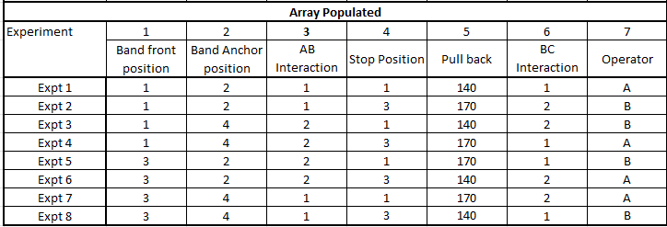
For simplicity, each variable only had two options. This allowed for a L8 orthogonal array to be used [2]. As a L8 orthogonal array required 7 inputs, and the experiment is only testing 5, the remaining two will be left blank. These two blank variables, known as the AB and BC interactions will help in determining any variables that are not already accounted for in the method. The variable range for these two should therefore remain minimal, however if there are any significant differences for them then it will prove that there are unintended variables affecting the experiment [4]. The populated array can be seen in Table 1 below.
Table 1 - L8 orthogonal array

Due to the use of projectiles in the experiment, a health and safety brief will occur before the experiment. The length of table that the ping pong ball will go down shall also be checked that it is free of personnel before each firing. A tape measure is also attached to the table as well to show the distance at which the ping pong ball first impacts. A firing at each distance will happen three times, and an average distance is then recorded into the array.
The method of the second part of the experiment will use the data obtained experimentally during the first part. The two variables that have the greatest differences are selected and then both are tested together in four more firings. The data from these four more firings are then combined and used to determine the shot distance that would happen when a new setting is used on the catapult. After this distance is determined from the data, a final firing is done to test the estimated distance. These two distances can then be compared.

Experimental data orthogonal table population
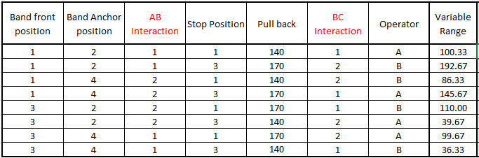
The table below shows the data obtained from the first part of the experiment.
Table 2 - Completed table
From this data range, the below graphs can be produced.
The two points on each graph show how the difference in each variable affects the overall distance. For example, the pull back graph shows that the second position (170º pullback) provides much greater addition distance to the first position (140º pullback). From this we can determine that the greatest variables that affect distance is the pullback and position of the front elastic band. This is what is expected, as a more forward elastic band, and hence the band will be under greater elastic potential when stretched, as well as a larger pullback provide greater distance. These two where the two key control factors that where then used in the second part of the experiment.
While there is a measurable difference between the two-anchor position ass seen in Figure 6, the difference is relatively small and as such it, as well as other variables such as the operator and stop distance, can be left for the purposes of the second part of the experiment.

Figure 1 - BC Interaction
Figure 2 - Operator
Figure 3 - Pullback angle
Figure 4 - Stop position
Figure 5 - AB interaction
Figure 6 - Anchor position
Figure 7 - Front band position

Experimental data unknown perimeter range calculation
Now that the two key control factors had been selected, a further run of 4 firings where conducted three times each to determine an average distance. Each control factor was tested against the other two so that a full range bound could be calculated. From this the midpoint was then able to be calculated at 140.25cm.
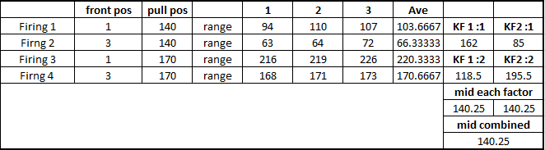
Table 3 - Key control factor range table
The final firing was then done with the catapult set to have the front position at 2 and the pullback angle to 155º. This was the midpoint of the two key control factors, and as the catapult acted linearly, it then therefore should hit the calculated midpoint from the prior firings. The below table shows the results, with the average hitting 140cm, only o.25cm away from the calculated range
Table 4 - Estimated range tables

Conclusion
The experiment successfully demonstrated the effectiveness of the Taguchi method as a way to identifying key control factors without the need to test every possible variable combination. Through the use of an L8 orthogonal array, five variables were able to be evaluated quickly and efficiently. This revealed that the front band position and pullback angle were the two most significant factors influencing projectile range.
The second part of the experiment validated these results by using experimental data to predict the outcome of an untested variable combination using the key factors. This provided an estimation that was 0.25cm of the final result, well within a 1% error margin.
The AB and BC interaction columns showed little variation as well, suggesting that the experiment variables had been controlled well.

References

[1] | ASQ, “Genichi Taguchi, Innovative Methods and Techniques,” [Online]. Available: https://asq.org/about-asq/honorary-members/taguchi?srsltid=AfmBOorxVlCbJw1bKBsiAvlIa7sejv54t1A1lV6XJw-oZcu7rTWDmGZR. [Accessed 6 4 2026].
[2] | geeksforgeeks, “Linear Search Algorithm,” 2 april 2026. [Online]. Available: https://www.geeksforgeeks.org/dsa/linear-search/. [Accessed 8 4 2026].
[3] | minitlab, “What is a Taguchi design (also called an orthogonal array)?,” [Online]. Available: https://support.minitab.com/en-us/minitab/help-and-how-to/statistical-modeling/doe/supporting-topics/taguchi-designs/taguchi-designs/. [Accessed 8 4 2026].
[4] | C. Zaiontz, “2-level Taguchi Design,” [Online]. Available: https://real-statistics.com/design-of-experiments/taguchi-design-of-experiments/2-level-taguchi-design/. [Accessed 6 4 2026].

