Declaration
Certificate of Authenticity
This work has not previously been accepted in substance for any degree and is not being concurrently submitted in candidature for any degree.
Signed ...................................................................... (candidate)
Date August 13, 2024

STATEMENT 1 This work is the result of my own investigations, except where otherwise stated. Other sources are acknowledged by footnotes giving explicit references.
A bibliography is appended.
Signed ..................................................................... (candidate)
Date August 13, 2024

STATEMENT 2 I hereby give consent for my work, if accepted, to be available for photocopying and for inter-library loan, and for the title and summary to be made available to outside organizations.
Signed ..................................................................... (candidate)
Date August 13, 2024

Acknowledgements

I would first like to thank God for his blessings throughout my research from the beginning through to its completion.
I would like to express appreciation to my research supervisor Roisin Mullins -Associate Professor at the University of Wales Trinity for providing invaluable guidance throughout this research.

My sincere gratitude to the individuals who participated in my survey as well as those who took part in my interviews. The information provided was invaluable to the completion of my dissertation and added immeasurable context to the research. I could not have completed my research without the time sacrificed by everyone and for that I thank you.

I am extremely grateful to my husband, Terral Mapp, for his love, support, care and sacrifices during my dissertation. I am thankful for his patience and understanding. Special thanks to my work colleagues and manager, Monique Hull, for their keen interest as well as allowing me the time needed to complete my research successfully.

Abstract

In March 2023, the Bank of St. Vincent and the Grenadines, an indigenous bank, acquired the book of business of the First Caribbean International Bank “FCIB” marking a historic turning point in the country’s financial structure into one predominated by indigenous institutions. With the departure of the last international bank, it is intuitive to expect industry dynamics to change, which may affect overall stability. This research paper assesses the stability of the financial sector of St. Vincent and the Grenadines with a focus on the effects of the departure of the First Caribbean International Bank “FCIB”, its advantages and disadvantages. As well as the other shocks such as Covid-19, the Volcanic Eruption and Hurricane Elsa.
To accurately determine if the sector was stable after these challenges, research was conducted which saw several theorists highlighting elements of stability in the literature review. That of regulations, politics, bank performance, management, credit, and financial inclusion.
Conventional qualitative and quantitative approaches were used in the methodology to underpin this research paper. In Interviews, questionnaires, and a synopsis of the banking performance of each of the major financial institutions were conducted.
The Interviews provided insights into the regulatory framework of the sector, as well as the managerial approach of the sector. The questionnaire gave an appreciation of the public perspective on the topics. Analysis of the financial reports and statements of each of the major financial institutions for the period 2020-2022 provided a quantitative understanding of the individual health of these institutions.
The conclusion was reached based on the evidence collected in the data analysis that the sector is stable. This stability was illustrated in the sector's excellent performance with growth in critical areas such as profitability, credit, assets and customer deposits. This was attributed to the three main drivers’ positive political intervention, dynamic leadership, and strong regulatory oversight. Despite the stability of the sector, some areas need improvement such as the ability to effectively use assets to generate revenue, access to banking networks, the affordability of banking services, and the ability to attract expertise.

Table of Contents
Acknowledgements 3
Abstract 4
Introduction 9
Literature Review 12
Comparison between international banking vs local banking 12
Regulatory compliance 12
Credit: 13
Management: 14
Roots of stability in the financial sector 15
Elements of sustainability/stability: 16
Financial regulatory developments: 16
Government involvement: 17
Performance of the Banking Industry: 18
Balanced profitability 20
Financial inclusion 21
Innovation 22
Methodology 24
Research Design 25
Research Philosophy 29
Research Approach 29
Ethical Considerations 34
Data Analysis 35
Questionnaire Results 35
Questionnaire Demographic 36
Discussion 59
Conclusion 64
Research Limitations 65
Implications of the findings 65
Recommendations 66
Bibliography 67
Appendices 68

List of Figures

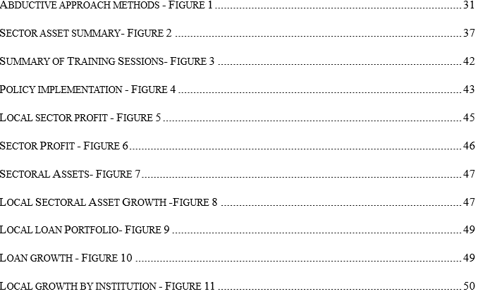

List of Tables

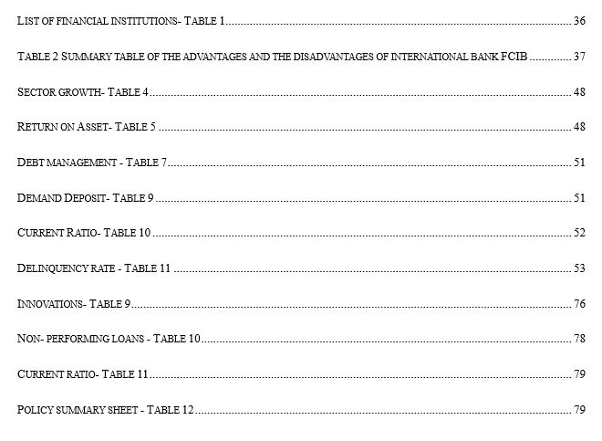

Introduction

The financial industry is the lifeblood of any economy. It facilitates savings and provides businesses and consumers with access to the credit, capital and investment options that are essential for enterprise and economic development. The current financial industry within St. Vincent and the Grenadines comprises commercial banks which are the dominant players, credit unions, building societies and money lenders. The Caribbean is no stranger to banking; the sector which began over 180 years ago started with only a handful of small local banks providing only what can be described as the most basic of services. This changed with the subsequent arrival of foreign-based, international banks including Bank of Nova Scotia and Barclays Banks/First Caribbean International Bank “FCIB”. Upon entry, these foreign-based, international banks rapidly became the region’s market leaders by leveraging the resources afforded to them by their large parent banks in Canada.

These international outposts brought greater funding, technology, and operations focused on customer service, cementing their place as sustainable leaders within the sector for decades. According to Yaohua Liao (2022), Sustainable leaders not only understand the complexity of the world around them but embrace it. Moreover, they are long-term in their approach, taking bold steps, and prioritizing organizational growth, while requiring a high level of performance from management. This was certainly the attitude displayed by FCIB as they constantly pushed for excellence from all subbranches in the Caribbean, expecting higher profits each year, and making bold investments in Information Technology.
However, Over the last decade, the trajectory of banking sector within the Caribbean has changed as De-risking, among other restrictions, has brought the sector’s growth to a halt. In 2018, the Bank of Nova Scotia announced the sale of its businesses in nine Caribbean markets for US$123 million to the Trinidad and Tobago-based company Republic Financial Holdings Ltd (RFHL) “Republic Bank” (Padin-Dujon, 2021). Republic Bank operates in 14 territories (Suriname, British Virgin Islands, Barbados, Cayman Islands, Trinidad, St. Vincent, Grenada, Guyana, Anguilla, St. Maarten, Dominica, St. Lucia, St. Kitts and Nevis and Ghana). Similarly, on October 12, 2021, a consortium of leading banks in the Eastern Caribbean Currency Union announced that it had entered into a definitive agreement to acquire the branches and banking operations of CIBC First Caribbean in Dominica, Grenada, St Kitts and Nevis and St. Vincent and the Grenadines (Loop News, 2021) of which BOSVG was a part of acquiring FCIB St. Vincent. The Bank of St. Vincent and the Grenadines is owned primarily by the government of St. Vincent and the Grenadines and the Government Owned-National Insurance Services with 63.13 % of the shares, collectively, see Figure 1 in the appendix below.
These announcements sent shockwaves across the region, as these banks were seen as anchors. Within St. Vincent and the Grenadines, the departure of both Scotia Bank in 2018 and the announcement of FCIB in 2021 (LOOP News, 2021) had citizens understandably fearful with many unsure of what’s next and more specifically, how will the region survive without the international banks that dominated the sector for so long. Given how vulnerable small island developing states are to market shocks, having no international banks could spell disaster if mismanaged. According to the IMF (1991), weaknesses in the financial sector can affect the economy, especially growth. Other challenges such as the COVID-19 pandemic, the volcanic eruption and Hurricane “Elsa” further compounded matters. This led to the selection of my research topic “?”. With the multitude of challenges within only a three-year window of 2020-2022, the state of the sector was in question. “Can citizens rely on its continued stability with only 5 major financial institutions all without parent banks in wealthy countries such as America and Canada? “
The research findings will contribute greatly to the information available on the financial sector of St. Vincent and the Grenadines as little has been written on the subject. The research will shine a light on how strong or weak the current financial sector is, with a focus on the challenges surrounding it and if it has the necessary pillars to ensure stability and ultimately continuity. These pillars encompass regulatory framework, credit distribution, debt, delinquency, liquidity, and asset management. The aims and objectives of the research paper are as follows:
- To compare the Indigenous bank BOSVG to its international counterpart FCIB.
- To gain clarification on what is perceived as stability in the financial sector.
- To assess the elements needed for financial stability; and
- To show how the sector remained stable despite recent shocks.

Literature Review
This chapter illustrates the theories that underpin the study. It highlights the views of various authors with similar as well as opposing views on what makes international banks different from local ones. In this sector, the different hypotheses on what elements are needed for a stable sector are presented. This gives one insight into how you can assess stability within the financial sector as well as what advantages and disadvantages can be gained from the presence or absence of international banks.

Comparison between international banking vs local banking
Regulatory compliance:
This issue is a long-standing one with researchers as far back as 1986 (Shafer and James, 1986) noted that there was not adequate supervision for international banks, unlike their local counterparts whose regulators were local or regional. The idea of who should be supervising each of the international bank’s branches had become confusing as debates on whose jurisdiction it is has allowed gaps to form. Central Banks in the Caribbean are unable to adequately assess the operations of the branches locally without the information provided by the foreign banks’ home country due to the complexity of the banks’ structure which can cause delays in enforcement. This maybe by design as (Tunay, 2017) noted that strict legal regulations affect foreign banks' operations negatively. Therefore, these banks strive to move into countries that have flexible legal regulations.
A glimmer of hope was seen in the 21st century back in 2001 when domestic banking systems strived to cooperate with international and multinational organizations. However, any meaningful change was slow, guarded and cautious, as if flirting with the prospect of real change according to the New York School of Law (2001). While it can seem as if international banking activities are largely the same as domestic banks by nature, international banking requires different regulatory examinations due to the difference in accounting procedures, documentation requirements and laws.

Credit:
Credit is the total amount of money that a person or business can borrow from a bank secured or unsecured (The Economic Times , n.d.) & (Baluch, 2022). The growth of a country’s economy is dependent on access to credit. When comparing international to local banks as it relates to credit, researchers (Tram Vu & Skully, 2015) note that in accessing credit from local banks borrowers have the advantages of geographical proximity and soft information, the closer the lender the easier it is for them to gather information. This can therefore translate into more favourable loan terms for the borrower. However, some researchers believe asymmetric information or soft information has a negative effect such as (Tarver, 2022) (Cowen & Tabarrok, 2015) who believe that the local banks have exploited this to charge higher loan prices which is also known as the hold-up problem.
Most foreign banks do not have this information therefore they are more likely to demand collateral while requiring shorter maturities (Vasso Ioannidou & Schafer, 2012). Foreign banks tend to lean on easy-to-gather information and are therefore more likely to lend to large and transparent firms rather than small and medium enterprises SMEs. As a result, foreign banks according to Thorsten Beck (2012) rely on transaction-based techniques rather than relationship-based techniques which are usually employed by domestic banks. Foreign banks have greater access to capital from abroad; they have more stable funding sources and patterns of lending than other banks. They also hold a geographically differentiated credit portfolio and would not be as affected during periods of downturn in the domestic financial markets Chen et al. (2019).

Management:
There is a deep perception that international or foreign banks are managed or operated differently than local, national, or domestic banks. (Walters, n.d.) suggested that while there are some differences, there are still similarities in pace or culture. The areas where there are major differences include remuneration, decision-making, client focus, culture and investment. (Acevedo, 2023) agreed as it related to investment and client focus, stating that local banks offer a more personalized banking experience, more flexibility in lending options, fewer fees and are more involved with the community. (Greinke, 2023) & (Khartit, 2022) continued in this vain concluding that local banks are inextricably intertwined with their local economy; they support small businesses, have local knowledge, and vary in cost.
However, (Maly, 2023) & (Mortlock, 2021) highlighted that foreign banks are not without their benefits to a country and its citizens as their management focuses on greater technological progression, having broader visions, a greater mixture of cultures, and international payment options. Francisco et al. (2015) agreed, having concluded that there is a huge difference in technology (program efficiency) and managerial capacities as foreign banks were more efficient than domestic ones overall. Culture plays a significant role in how the local banks are managed versus the foreign banks. Large corporations such as international banks follow either Hierarchy (corporate culture) or market culture (Barry and Saka, 2023) where the workplace is driven by deadlines and formality. According to Bianca Decu (2022), there is a top-down management style. This according to Barry Eichengreen and Saka Orkun (2023) is a result of combining the culture of their branches in the Caribbean, this influence comes from the parent banks in Canada. While the local banks may have some of the market and hierarchy culture. it lends itself to the Adhocracy culture where the size of the bank is still small and therefore has a culture of openness, flexibility, innovation, and collaboration. According to Matteo Puddu (2023), it welcomes people with bright ideas regardless of their position within the company. The environment is more supportive of professional progression with a keen eye on the future development of the organization. Now that we understand the difference between local banks and international ones along with their advantages and disadvantages to the customers, staff and by extension the country, we now turn our attention to the root of stability within the financial sector. With the departure of international banks described above, how can the sector remain stable?

Roots of stability in the financial sector
The terminology “financial stability” came to prominence in the wake of the financial crisis within the regulatory circles (Stefaniak, 2018). Overnight, it became ubiquitous with many institutions forming their own opinions. However, all seem to differ based on the institution's background. The World Bank as well as the European Central Bank described financial stability as the resilience of a financial system to shocks or stress without unravelling (The World Bank, n.d.) (European Central Bank, n.d.). IMF researcher (Schinasi, 2004) went a step forward by stating that the concept is broad as it encompasses all of the financial system that collectively consists of infrastructure (regulations, supervision and surveillance), institutions, and markets.
The US Federal Reserve simplifies the terminology “financial stability”, claiming it is simply the financial system being able to meet the requirements of average citizens and businesses when it comes to the need to borrow money to buy what they need when they need it the most (Federal Reserve, n.d.) (Council of Financial Regulators , n.d.) Australian regulators agreed with the US Feds, they stated that financial stability is one in which financial intermediaries, markets and infrastructure facilitate the smooth flow of funds between savers and investors, thereby enabling growth in the economy. Therefore, one can conclude that financial stability is a condition of continuity, it is dynamic in its fluidity while being constant in its approach it is resistant to external shocks by insulating its operations. Financial Stability is the continuous flow of funds between those who have money (savers) to those who need it (borrowers). But what are the drivers of this financial system that makes a country's financial system stable?

Elements of sustainability/stability:

Financial regulatory developments:
As the theology of financial stability is still developing, so too are the ideas surrounding the measures, elements, principles, or indicators for what makes the financial sector or system stable. Various central banks and researchers believe robust regulations are imperative to the stability of the system, and that poor regulations have the potential to create instability (The World Bank, n.d.) (Central Bank of Ireland , n.d.), (Franklin & Gu, 2018) and (Udaibir S. Das & Quintyn, 2004) all agreed on this principle. These claims were also expressed in the “Policy Blueprint for Caribbean Economies” by (Caribbean Development Bank, 2018) while adding that a proactive approach is needed to create adequate regulation and supervision to ensure a strong banking sector that has ample capital adequacy ratios.
However, researchers such as (Holt, 2023) (Abou-Jaode, 2012) and (Mezzetta, 2014) believe that the banking system is over-regulated, and if we continue to add more regulations, we can even damage the industry that so many rely on. The aforementioned researchers saw over-regulation as one of the biggest risks that the global banking sector faces today. Despite the risk of over-regulation, I have concluded that tight banking regulations are necessary for a safer financial system as presented by the (Inter-American Development Bank, 2021). They highlighted that, within the Caribbean, we must not lower financial regulation but strengthen it, given the great importance of banks within the region’s financial system. The (Inter-American Development Bank, 2021) stated that it is only through strict regulations can institutions be prepared to deal with severe shocks to their trading activities, have the fortitude to keep lending during an economic downturn, while preventing lending overheating, improve technologies with safeguards, and strengthening insolvency procedures

Government involvement:
Studies including those published by (Rafael La Porta & Lopez-De-Silanes, 2002) inferred that government interference, intervention and the presence of government-owned banks take place in all economies but are more prevalent in poorer countries with less developed financial markets. The IMF researchers (Quintyn & Quintyn, 2004) noted that political interference in the regulatory process can make a bad situation worse by hindering the supervision of banks. This cripples the sector, delaying any possible recognition of an upcoming crisis and thereby slowing possible corrective measures and inevitably, increasing the cost of the crisis inherited by the stakeholders (Franklin & Gu, 2018). (Song & Thakor, 2012) supported this theory and adds that state ownership of banks gave rise to a great deal of political influence in the bank's operations especially credit extension and capital allocation. Therefore, any potential crisis will be overlooked in favour of the availability of benefits such as curry favoring their voters to increase the odds of being re-elected.

(Quintyn & Quintyn, 2004) had a contradictory viewpoint, they stated that government intervention can have a positive impact, especially in cases where government intervention such as taking over the operations of a failing institution is necessary to ensure financial soundness. (Robert Cull & Martinez Peria, 2017) agreed referring to Stiglitz’s 1993 study that concluded that Government owned banks can promote welfare by enhancing investments, and allocating resources to strategically important industries that are usually under-serviced by private banks such as agriculture, thereby jump-starting economic development. (Alsup, 2020) suggests that 42% of all banks worldwide are government owned. This is a direct result of the 2008 financial crisis which saw the government stepping in to save banks. (Marois, 2021) suggested the sector to be worth a staggering XCD$$49 trillion in 2021 with more than 900 public banks worldwide. With so many institutions linked to governments, one can conclude that the health of the financial sector as well as the wider economy is linked to political stability. Ozun et al. (2019) shared a similar if not identical view that any major political instability makes it all but impossible to have a stable financial system.

However, governments globally and those within the Caribbean are steadfast in their actions to uphold stability with quick intervention in the fight against de-risking. The Caribbean Community (CARICOM) has committed to the Financial Stability Board’s four-point plan to address de-risking which contains a plan to build capacity in the countries affected which includes amending laws, regulations and policies (Central Bank of the Bahamas , 2016). Therefore, this leads me to conclude that government intervention is helpful, even lifesaving to the financial industry in a crisis but in good times needs to be monitored closely for overreach.

Performance of the Banking Industry:
The performance of the banking sector is tied to the stability of any economy and the growth seen within. (Mkwawa, 2020) (The World Bank, n.d.) along with other researchers agreed that the banking industry is fundamental for true economic stability. This is painfully apparent during times of instability when banks are reluctant to finance projects, extend credit to general citizens, businesses and the government. This results in the slowing of economic activity within the country and its ability to conduct transactions beyond its borders. The greater the performance the better the industry can withstand shocks from both the internal and external environment Athari et al. (2023). Researcher (Williams, 2012) proposed that performance/profitability is influenced by external factors such as the macroeconomic environment and market/industry characteristics and internal factor such as bank-specific characteristics.

Researchers from the University of the West Indies (Wood & Mc Conney, 2018), on other the hand, claimed that empirical results indicate that capital risk, credit risk, liquidity risk, interest rate risk and Operational risk are those with statistically significant impact on financial performance. (Wood & Mc Conney, 2018) highlighted credit risk to be the most significant, emphasizing that banks must ensure they adopt measures to minimize the impact of this particular risk. To detect these risks tools such as stress tests must be implemented.
Stress tests are generally used to assess a banking industry/institution's ability to withstand shocks. These tests, according to IMF researcher Martin et al. (2019), typically cover the areas of solvency (does the bank have enough capital to absorb losses) as well as liquidity (does the bank have enough cash to pay off their deposits and other short-term debts). Researchers such as Antonio et al. (2008), (Kenton, 2022), Beverly et al (2016) concluded that stress tests are vital to assessing the strength of individual banks and the financial system as a whole. These tests fundamentally support improving risk management and aiding supervisors in analyzing the risk profiles as noted above (credit, capital, operational (debt and delinquency) and liquidity risk). However vital stress tests are, they like any other tool have their own unintended consequences. (BIS, 2019) and (Kasim & Calice, 2022) noted that stress tests cause the reduction in the extension of credit to higher-risk individuals such as entrepreneurs with small businesses. The contraction in lending has the potential to suppress innovation and hinder growth in the economy. Therefore, a degree of caution must be taken when adapting the practice of stress testing and making hardline decisions based on their results. As such, when assessing the results of these tests a balance must be struck between profitability and risk.
Balanced profitability
Balanced profitability is now seen as an intricate element of a stable banking sector. Indeed, researchers such as (Anjali & Kashiramaka, 2023) , Xu et al. (2019) and (Albulescu, 2015) noted that profitability matters as a determinant of stability, as a highly profitability banking sector is better able to withstand negative shocks, ensure growth and guard against over-heating or stagnation within the sector. Findings from these researchers indicate that non-interest income and NPL have a negative impact on stability. However, in emerging economies, the quality of the institution can play a vital role in maintaining financial stability. However low or declining profitability can bring about instability in the financial sector. The (International Monetary Fund, 2016) concluded that during such times banks need to become more efficient, weak banks will have to shut down, be taken over or shrink and policymakers will have to complete regulatory reform. The (International Monetary Fund, 2016) also noted that banks in most emerging markets do not have the capital and liquidity to cushion the fallout from their nonperforming loans. To do this, the banks must increase their buffers, thereby increasing provisions and reducing profits. To counteract the downturns of low profitability that threatens the sectors stability banks must expand. This means reaching the unbanked through financial inclusion.

Financial inclusion
Financial inclusion is critical for stability; it goes beyond opening a bank account to more so being able to access services, take out loans, credit/debit cards, investments, and mobile banking services Afzal et al. (2022). Researcher (Slack, 2015) stated that financial inclusion and financial stability are two faces of the same coin as they are both dependent on each other. However, in emerging markets, it is the non-traditional institutions leading the way, especially money providers (Adams, 2018). As the regulations are only now catching up, regulations are either looser or non-existent compared to those within the formal banking institutions. (Slack, 2015) concluded that the lack of inclusion in the formal banking market stems from a lack of information (documentation) and transaction costs (high fees).
Globally financial inclusion stands at 69% with developing countries treading below at 63% compared to 94% in the developed countries according to Afzal et al. (2022). Within the Caribbean, the (Eastern Caribbean Central Bank, 2023) ECCU’s survey on financial inclusion concluded that 9 out of 10 persons or 86% of the individuals surveyed responded yes to having some form of saving account at a financial institution, trending higher than the average 63% for developing regions. However, this is only for saving accounts with a participation rate of 41.6 percent for electronic transactions with only 4 out of 10 respondents stating they had conducted at least one transaction within the last year. Therefore, more must be done to raise financial inclusion, especially in the area of digital/ electronic transactions.
In contrast, (Banerjee, 2023) and (Peterson, 2020), suggested that granting some individuals access to the financial system may hurt more than help them as these persons are liable to make poor decisions, are not financially literate and are more likely to take high-interest rate loans for their immediate desires not thinking about the future. If this theory holds the Caribbean will be hard hit as the survey conducted by (Eastern Caribbean Central Bank, 2023) shows that financial literacy in the region is low with an average score of 12.2 out of 20 or 61%. Aguilla registered the highest score at 13.1 while St. Vincent and the Grenadines scored the lowest at 11.7 (figure 2). However, this viewpoint is in the minority with more researchers concluding that financial inclusion has a positive effect on stability.

Innovation
Innovation within the sector is necessary for stability. According to Oliver Wyman (2017), innovation-driven changes are happening; innovation is seen as a great disruption in the market as it reshapes the financial services landscape. Customers now expect rapid changes due to innovation, as life has become intertwined with instant convenience, customers now believe this should also apply to banking. (Wackerbeck & John, 2021) agreed, adding that traditional banks must employ best-in-class solutions that address several friction points which cost the bank money and negatively impact customer experiences. Therefore, to survive, banks must accelerate their adaptation of technology, banks can no longer be standalone institutions as before, but need the expertise of other firms to provide software updates to keep pace with the demand for services such as peer-to-peer lending, crowdfunding, E-trading, and robo-advice.
However, not all researchers believed in the rapid expansion of innovation. The (European Central Bank , 2018) suggested that the sector is not ready and cited the lack of policies and regulations within the sector as it relates to the new technology and services. Research conducted by the (International Monetary Fund, 2021) and (The European Central Bank, n.d.) concluded that cybersecurity threats have and will persist due to innovation. Similarly, (Ulgen, 2013) asserted that not only is innovation a threat but there is no link between financial innovation and economic evolution or stability.
These views on the threat of cybersecurity and the lack of regulations on innovation are all valid points. However, the demand from customers means that banks must find a workaround. According to the Organization of American States (2018), banks within the region as early as 2010 began implementing solid plan for information security awareness, the banks sought legislation to protect their infrastructures thus allowing them to have greater control especially as it relates to privacy information leakage. The banks started using encryption tools to secure their networks and started to put more money into their budget for Cybersecurity. This commitment by the banks shows how critical technological innovation is to their operations and the stability of the sector.
Despite the need for innovation getting the buy-in from all stakeholders at the same time is always a challenge. Diffusion of innovation theory highlights this, outlining how new technology spreads throughout society. According to Clay Halton (2023), the theory created by E.M. Rogers in 1962, confirms that adoption moves differently for different people. The theory states there are the innovators, early adopters, and early majority of the technological innovations who we noted above who desire change. They are interested in trying new technologies versus the late majority and the laggards who stated that the sector is not ready for innovations. However resistant the laggards may be, the diffusion of innovation theory is clear that once innovation makes it mainstream it is impossible to return and therefore forces even the laggards to begin to use it.

Methodology

This section of my report focuses on the choice of methodology and how it is applied to the research. Research methodology is a structured and scientific approach where one collects, analyzes and interprets data to answer research questions or test one’s hypotheses according to Divya Sreekumar (2023). This is ultimately the aim of this report to answer the question of how stable the current financial sector is within St. Vincent and the Grenadines. To do so effectively, we must make use of all available resources. This entails quantitative data in the form of tables from the financial reports of each major financial institution and qualitative data in the form of interviews and a survey.
A qualitative approach was selected as the main approach after it was concluded that there were little to no formal reports on the overall financial environment within St. Vincent and the Grenadines. The literature available focuses on the Global perspective with few researchers focusing on Latin America and the Caribbean region. This highlights the lack of reports done on small islands such as St. Vincent and the Grenadines. As such, this report will shine a light on an area of study that has not been explored previously. With this in mind, care had to be taken as to how this research should be conducted, and what would be the most beneficial method to be implemented.
To gain an appreciation of the Vincentian perspective, interviews with industry professionals (employed in the major financial institutions) were conducted. Additionally, a survey was sent out to general citizens to gain the point of view of customers. Purposive sampling, a type of non-probability sampling, was the sampling approach used to conduct the interviews. This type of sampling method is used when gathering data from experts as it allows the researcher to select individuals based on a non-random criterion and for that reason, is often used in qualitative research (McCombes, 2019). The particular type purposive sampling was selected as it allows the researcher to use their expertise to select the sample that is the most useful given the purpose of the research. According to (McCombes, 2019) it is used when the researcher needs detailed knowledge about a particular phenomenon rather than inference. This is in keeping with the small sample size of interviews. When selecting interviewees the purposive sampling technique of expert sampling was engaged Kassiani Nikolopoulou (2022). The inclusion and exclusion criteria used in this research were “study-specific” variables such as occupation, years in position, knowledge about the sector and availability of individuals. By applying those conditions, the research ensures the external and internal validity of the data. Therefore, other researchers should be able to replicate the data if they follow the same method.
In relation to the survey, the snowball sampling method, another non-probability sampling technique, was used. As noted by Julia Simkus, (2023), this approach relies on the initial survey respondents to refer the survey to others. It is a type of sampling frequently used in qualitative research with sensitive topics. The technique adopted is exponential non-discriminative snowball sampling with each new referral providing more potential research subjects. This continues until there are enough participants or there are no more willing participants.

Research Design
Due to the nature of the research, a descriptive method will be the most appropriate, as it can be used for both quantitative and qualitative research according to Shona McCombes (2019). Descriptive research aims to accurately describe the situation or phenomenon. It will allow me to answer what, where when and how. Additionally, it identifies characteristics, frequencies, trends and categories. However, it does not give me full control over the variables and places me in the position of observer.
The particular type of descriptive research to be employed is a combination of observations and case studies. Observational approaches will allow the gathering of data based on behaviour to understand how people act in real-life situations. The case-study element will be used to describe the characteristics of a specific subject, in this case the Bank of St. Vincent and the Grenadines. This approach will allow for the gathering of detailed data, focusing on the complexity of the situation thereby revealing something new. The case study approach according to Shona McCombes (2019) is good for not only describing but also comparing, evaluating, and understanding the different aspects of the research question. It allows for concrete, contextual, in-depth knowledge about a real-world subject (McCombes, 2019) . The case study will be structured like a standard scientific paper with sectors on methods, results and discussion but will endeavor to explore the case from various angles by using textual analysis. Textual analysis (Caulfield, 2019) is used to describe, interpret, and understand texts. The methods used to analyze texts are based on the aim of the research. Textual analysis according to Jack Caulfield, (Caulfield, 2019) in social sciences applies to interview transcripts as well as various types of media, through which the researcher draws empirical conclusions about relations.

Research bias: any deviation from the truth while preparing a research paper. According to (Simundic, 2013), this can occur internationally or unintentionally. (Bonneau, 2023) & (Denison, 2023) noted that there are several types of research bias: sampling bias, design bias, measurement bias, response bias, reporting bias, and procedural bias among others. To eliminate or reduce the incidences of these biases, the following measures were conducted:
1. Where possible results were compared to similar results, there were no conflicts of interest as there was no personal relationship with any participant.
2. The research was not funded; therefore, there was no undue pressure from any external force.
3. There were no complaints about biased questions from respondents; and
4. The data was analyzed objectively not favoring any outcome and personal perspective was removed.
One type of bias that could not be avoided during the survey and interviews was that of recall bias. As noted by (Nikolopoulou, 2022), this refers to the participant's ability to accurately recall information. As each participant would be surveyed on past experiences with the bank and interviewed about past events recall bias was one that could not be avoided. To aid with this, financial reports were used to supplement the data collected in the interviews and survey.

Research reliability and validity: The reliability in research describes how reproducible the study conducted is. Moreover, similar results must be obtained if the same sample was used under the same conditions. According to (Middleton, 2019) , One should be able to get the same results and if not the method of measurement may be unreliable or even biased. To ensure the reliability of the survey and interview results, the questions asked cannot be influenced by mood as they are fact-based questions focusing on past interactions, time, accessibility and cost.
Inter-rater reliability would not be gathered as a similar study was not conducted within the region. Internal consistency was the primary method used to ensure reliability given there was no other research with a similar topic.
Validity in research refers to the accuracy of the data presented. According to (Yeshaswi, 2024), in research, there are different types of validity, in the survey provided construct validity can be found as the questions are crafted to gain a genuine reflection of customer satisfaction with performance, features, areas of annoyance, and overall satisfaction. Content validity was also ensured with the questions covering all aspects of the topic being researched. Criterion validity shows how well a test correlates with an established standard of comparison (Nikolopoulou, 2022). Given that no similar research exists, there is no gold standard.

Research Philosophy
Research philosophy refers to a system of beliefs and assumptions as it relates to the development of knowledge Saunders et al. (2009). The nature of my research points to ontological and epistemology philosophies as being the most appropriate. Ontological focuses on the state of being, dealing with what is reality, and what an individual constitutes to be facts. Epistemology focuses on what can be accepted knowledge. Both of these views are broken down into sub-theoretical areas inclusive of positivism, pragmatism, critical realism and interpretivism Saunders et al. (2009).
Positivism is the most effective of the four types of research as it follows the line that factual knowledge can be gained through observation and measurements (Trivedi, 2020). This philosophy forces researchers to limit their data collection and all interpretations of this data by having the researcher always review it objectively. The researchers must distance themselves from any type of personal feelings. However, a purely positivism view cannot be adopted as it will result in the researcher having minimal interaction with participants. This will not be effective as completing the research requires interviews and a survey. Therefore, a pragmatism research philosophy is needed to help bridge the gap caused by critical objectivity. It encourages flexibility and stresses a problem-solving report (Rashid, 2023).

Research Approach
Research approach refers to the ways in which the researcher conducts research, the strategies, processes or techniques utilized to collect the necessary data to understand the topic and give accurate results, as noted by (University of Newcastle, 2023) (Chetty, 2016).There are three main types of research approaches, namely deductive, inductive and abductive according to (Hassan, 2024).

Deductive is a type of research that begins with a hypothesis or a generalized statement, which is then tested through observation. (Streefkerk, 2023) confirms, adding that it can even test an existing theory. Deductive research approach has four stages, namely creating a problem statement after reviewing the existing theories, formulating a falsifiable hypothesis due to the existing theory, collecting data, analyzing data, and deciding whether to reject it (Streefkerk, 2023). Inductive theory seeks to develop a theory where there is little to no existing literature on the topic. This type of research approach is grounded in three main concepts observation, seeking patterns and preliminary conclusions (Streefkerk, 2023).

Finally, there is the abductive approach which is a combination of both approaches. Given the research topic focuses on stability is an under-researched area of study, abductive research is the most suitable. Moreover, this approach allows the researcher to identify the problem that may not be fully understood and thereafter develop a theory which can be tested through the collection of data. The researcher will then analyze the data and generate a plausible explanation which may be open to further testing (Hassan, 2024). To gather data for this approach, the following activities were conducted: questionnaires, interviews and additional data gathered from company-specific publications such as financial reports.

Abductive approach methods
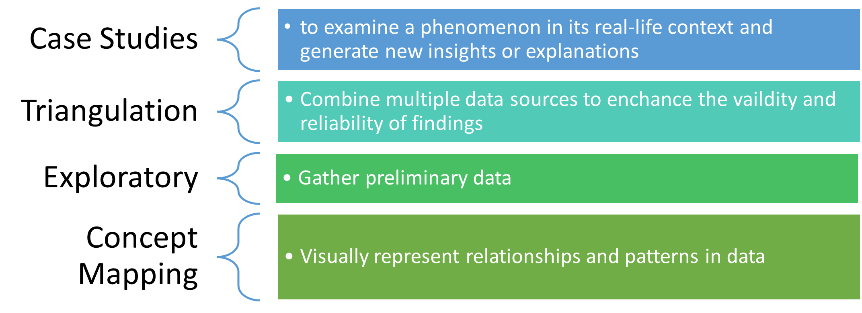
Abductive approach methods - Figure 1
Structured Questionnaire: One of the instruments used to gather the data needed to reach a conclusion on the stability of the financial services sector in St. Vincent and the Grenadines is that of a structured survey. This type of survey according to (Salvatori, 2023) will allow for quantitative responses, data that can be measured and allows for comparisons to be extracted thereby giving quantifiable insights. There is usually a high response rate which allows for greater consistency, comparability and relevancy through restrictions in answers thereby boasting efficiency giving the researcher useful data by which trends, patterns or other insights can be conferred.
The respondents were given a survey titled “Banking survey” with the use of Google Forms covering sections on financial literacy, affordability of banking services, gender disparities and a section of the general banking experience with a comparison between BOSVG, FCIB and Republic bank. There was a total of 30 questions which comprised single–choice questions, dichotomous questions (yes or no), interval scale questions (level of agreement), Semantic differential questions (rate experience), and open-ended questions.
Interviews: Interviewing is one of the most common data collection formats when conducting qualitative research according to Jamshed (2014). There are four main types of interviews, namely unstructured, semi-structured, structured and in-depth. Unstructured interviews are conducted to allow participants an opportunity to express their ideas without the researcher’s influence. An unstructured interview can feel more like a casual conversation than an interview, as there are little to no set questions prior to the interview.
According to Jamshed (2014), these interviews usually last an estimated 30 minutes to over an hour. Due to this lengthy duration, most researchers use a recording device as it is difficult as well as impractical to write all that is being said while sustaining a conversation. Semi-structured interviews, according to George (2022), have a blended approach with the interviewer having an idea of what questions they would like to ask, but there is no set order for these questions with many being open-ended. Structured interviews are systematically conducted according to (Merkus & George, 2022). Given the explorational nature of the research, a semi-structured interview was selected as the interview type. Seven participants were enlisted.
Online publications: As noted by Jain (2023), online publications have become one of the main instruments for modern researchers given their accessibility, low to no cost and global reach. A researcher can now “scour the internet” for journals or other documents related to their field of study from the comfort of their homes or any location in which there is internet access. This method of research is one of the fastest and most convenient when compared to visiting libraries. Documents can now be downloaded from company websites, therefore saving time and finances. Global reach means data can be accessed anywhere by anyone therefore it is easy for my professors to search for and analyze the data and information presented in my report independently.
Limitations: The following limitations were noted for the survey:
- There were restrictions on the number of questions as a long survey would discourage completion; and
- The Google Form used to create the survey, while an excellent survey generator, it could not be completed without an internet connection, and persons must have a Google account to complete the form. Additionally, you cannot choose more than one answer per question. Further, I was unable to password-protect the form therefore, the survey responses were only reviewed on my password-protected laptop.
Interviews also come with limitations. Each interview lasted over one hour therefore time-consuming both for the interviewer and interviewee who took time out of their busy schedule for in-person or over-telephone meetings. In addition, communication breakdowns can hinder the effectiveness of the interview. Differences in speech and the use of jargon can also significantly reduce the efficiency of the interview.
Online publications also have limitations. Written communication can only go so far as it cannot explore every concept, and the researcher cannot ask for clarification from the author if confused. Further, data is not always available via online publications; some topics are not well-researched or even researched at all. Unfortunately, this was the case with the selected topic; no online publication was found, having looked into the stability/sustainability of the current banking industry here in St. Vincent and the Grenadines.

Ethical Considerations
According to Bhandari (2023), ethical considerations are principles that guide research design and its practices consisting of a certain code of conduct for the proper gathering of data from participants. The principles expressed when conducting research are to protect the rights of the participants, maintain integrity and ensure validity (Bhandari, 2023). While undertaking research no personal information was collected to ensure the anonymity of the participants, thereby protecting their rights. Participation was voluntary, the topic discussed had no illegal element therefore no warnings were needed before completing the survey or engaging in the interviews. The research follows all the ethical requirements outlined in the P2G2/E1 form, UWTSD Research Ethics & integrity Code of Practice, UWTSD Research Data Management Policy and UWTSD Group Data Protection Policy.

Data Analysis
This section of the report presents the data gathered on the research topic “How stable is the current financial sector within St. Vincent and the Grenadines”. The data was collected through financial reports, interviews, and a survey. It was analyzed based on research objectives to form a conclusion on how stable the current financial sector, despite the recent shocks of the departure of the international commercial bank “FCIB”, the Covid-19 pandemic, the volcanic eruptions in April 2021, and Hurricane Elsa in July 2021.
A survey assessing the public opinion on the financial sector, their experiences with the institutions, the products, and services was conducted. This survey was broken down into eight (8) sections, namely access to banking services, financial literacy, affordability and access to overall banking services, gender disparities, access to credit, customer service, management, and innovation. Interviews with key personnel were conducted to gain insight into the operations of the organizations under investigation. The financial reports as well as other related reports were also used to bluster the data collected giving a snapshot of the industry . The analysis of the results follows.

Questionnaire Results
This section illustrates the data collected from the 28 completed questionnaires. A sample of the structured questionnaire can be found under Figure 2 in the appendix, which was circulated to 40 potential respondents. It received a reasonable response rate of 70%.

Questionnaire Demographic
The participants held various occupations from semi-skilled such as farm workers and warehouse assistants to skilled workers such as secretaries, tellers, and florists to highly skilled such as doctors, IT technician, Energy specialist and a Chief operating officer.
Participants banking habits:
Given the answers provided, respondents are frequent participants in the banking sector. Of the respondents, only 1 stated that they did not have access to banking services. This was due to the individual working abroad 8 months a year. The chart below depicts the financial institutions that the respondents currently use . . Of the total respondents, only 1 held a business account.
Name of respondents' financial institution
List of financial institutions- Table 1
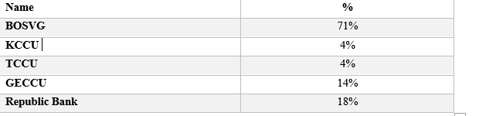
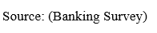
The respondents listed no other institution with which they presently do banking. This confirms that our analysis captures the market makeup as it relates to financial institutions. As of 2022, these institutions had assets of over $45 billion dollars.
However, when compared to the market in 2018 there is a significant contraction within the sector, with the departure of both Scotia and FCIB the asset pool that Vincentians had access to has decreased by 63% in 2020 and 77% in 2022 if we remove the contribution of FCIB, when compared to 2018 when both financial institutions were operational.
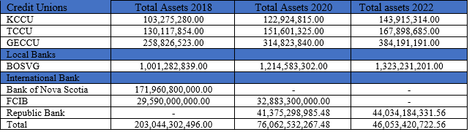
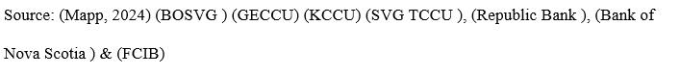
Sector asset summary- Figure 2
Table 2 Summary table of the advantages and the disadvantages of international bank FCIB
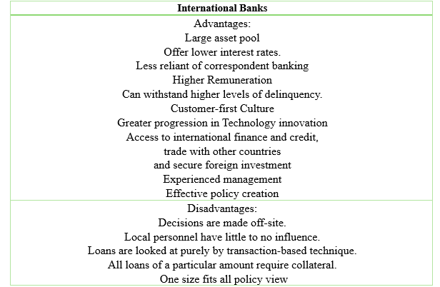
Sources: (Mapp, 2024)
Interviews with key personnel confirm many of the advantages and disadvantages of FCIB to the citizens of St. Vincent and the Grenadines
Network: FCIB was able to give out large loans to the business community due to its large network of 54 branches in 15 Caribbean countries (First Caribbean Internation Bank, 2022), as well as the backing of its parent company CIBC- Canadian Imperial Bank of Commerce.
Low interest rates: It was also able to offer lower interest rates and longer terms, with the interviewee stating that mortgages were given for up to 25 years which was a reduction from the 35 years given in 2018 see appendix Figure 3. However, of the survey respondents 58% were dissatisfied, 33% found them reasonable and only 8% were satisfied with the interests offered on loans from FCIB see Figure 19 in appendix.
Can withstand large shocks (Covid-19): COVID-19 sent loans valuing $1.7 billion into delinquency, due to job loss. Under the moratorium program payments were suspended and interest frozen (Bank, 2022). Again, size allowed the international bank to weather the storm and return to normalcy by 2022 with no loans under the program (First Caribbean Internation Bank, 2022).
Less reliant on correspondent banking: The bank was not as dependent upon corresponding bank services as the bank had 54 branches within the Caribbean and its parent bank in Canada to provide support. Additionally, the reputation of CIBC allowed FCIB to develop and sustain vital relationships with other banks.
Remuneration: FCIB remuneration was reasonable according to the interviewee. The salary bands were large with a high starting salary. This resulted in individuals remaining in positions longer without maxing out of their salary scales. Therefore, many people were in the same position for over 5 years, resulting in a wealth of experience, and individuals became experts within their departments.
Culture: There was a culture of excellence at FCIB where employees pride themselves in providing a consistent standard of customer service in every branch. The interviewee stated that this commitment to standards meant that the bank was customer-centric in its approach. However, of FCIB respondents only 40% agreed that the bank was customer-centric, while the other 60% disagreed see Figure 26.
Technology: FCIB had great technological capabilities with its system being state of the art according to the interviewees. The platform was built internally and consisted of one program with all the functions of the bank rolled into one. The bank continued along this pattern by being one of the first to launch a mobile banking app. Respondents agreed that FCIB had great technological abilities with 64% of surveyed respondents indicating yes to their digital need being met while only 36% stated no. However, this was not without its issues with 60% of respondents finding the mobile and online banking platform difficult to use, while 40% of respondents found it easy.
Innovations: FCIB had innovation as one of its core elements according to the interviews and FCIB’s (First Caribbean Internation Bank, 2022) report, one of the most recent achievements was the launch of a Digital lending App, which gave clients the ability to apply for unsecured loans and credit cards remotely. They also created a platform for digital client onboarding, which allows new clients to remotely open accounts, which helped to double new client relations within one year. Similarly, the mobile banking app and the Online banking platforms enabled a 43% increase in transactions in one year. FCIB also introduced 39 Smart Automated Banking Machines “ABM”, 6 of which are drive-through. These investments while not all seen in St. Vincent and the Grenadines show the lengths that FCIB will go to in the name of innovation. But those that are present have made an impression. As 64% stated Yes “FCIB” met their digital financial services needs and 36% stated No, see Figure 27 in the appendix. When asked about their experience using the platforms 60% of the respondents stated challenging while 40% stated easy. It should be noted that 0% found it difficult, see Figure 28 in the appendix.
Management: According to the interviewee, FCIB management focused on efficiency. FCIB had a top-down management style with all significant decisions being made by the top executives in Canada. This type of management may have been efficient as the overall vision was consistent and firmly handled. This point of view was shared by the respondents with 70% stating that the management of FCIB was effective, while 20% disagreed stating management was ineffective see Figure 25.
Disadvantages:
Regulations: FCIB was efficient in policy creation as policies were created to cover the entire region. As such, branches did not have to pour resources into creating their own policies. However, it was stated by the interviewee that some policies did not match the context of St. Vincent and the Grenadines as they were created as a one-size-fits-all.
Credit: While access to funding was a welcomed benefit to the citizens, many respondents found the process difficult, as the interviewee stated that individuals with low income were turned away. The loan process was usually lengthy as applications were sent to the headquarters for approval. This delay may explain why 42% of survey respondents found the loan process difficult while only 8% found it easy, see Figure 17. According to FCIB (2022) annual report, their credit card portfolio showed customer spending of over $1 Billion, while the number of Visa debit cardholders grew by 31% in 2022 over 2021. However, when asked 55% of respondents stated that the process of getting a credit card is difficult, see Figure 18. Nevertheless, the report indicates that individuals still applied for and received credit cards in record numbers despite the difficulties met in applying for one. It should be noted that 45% found the process reasonable but 0% found it easy.
While international banks such as FCIB provided many benefits for St. Vincent’s financial services sector, it also had drawbacks. However, de-risking has ensured that these banks will not soon return, thus ending a hundred-year-old legacy. Therefore, one must assess the sector that remains. Can it provide the stability needed to carry the country forward, how has it weathered other shocks that followed such as COVID-19, the Volcanic eruption and Hurricane Elsa? The assessment compared the pillars of stability in the literature review with the data gathered from interviews, a survey and financial reports from 2020 – 2022.
Regulations
Adequate regulations are one of the cornerstones of financial stability. FCIB, as an international bank with multiple branches, operated under many regulators, with naturally diverse regulatory requirements.,. The financial services sector in St. Vincent and the Grenadines has two main regulators, the Eastern Caribbean Central Bank (ECCB) which regulates commercial banks and the Financial Services Authority (FSA) which regulates credit unions, building societies, money lenders, and insurance companies. The ECCB is guided by the Banking Act 2015, while the FSA enforces regulations through the Co-operative Societies Act 2012.
To ensure compliance all financial institutions adopted a central committee and department was created called “the compliance department’ staffed by “compliance officers” and a committee created by the board of directors consisting of 5 to 6 members. During the interviews, participants stated that they felt that the regulators had taken a hardline approach, requiring the institutions to submit a plan of action for COVID-19 in the form of a five-year strategic plan, starting between 2021 to 2022, when the situation was still evolving. The interviewees stated that they were able to provide the regulators with the plan requested. This shows the tenacity of the institutions, despite the challenges of retrofitting the offices, reduced working hours, remote working and the resulting loss of income during the pandemic.
Training- Training in Corporate Governance is essential for the stability of the financial sector. It is one of the ways to ensure both staff and committee members understand their roles according to (Deshmukh, 2022).
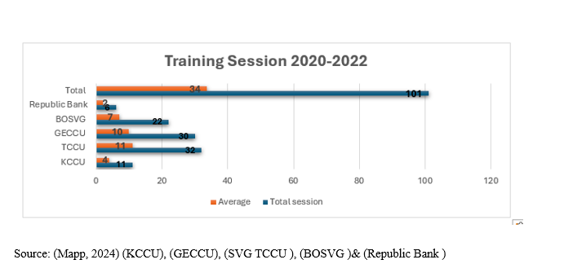
Summary of Training Sessions- Figure 3
Over the last three (3) years, financial institutions in SVG invested in a significant amount of training as it relates to compliance and corporate governance. Specifically, over 100 sessions were conducted, averaging 34 sessions a year. The three institutions that conducted the bulk of this training are TCCU with 32 sessions, GECCU with 30 and BOSVG with 22 while Republic bank and KCCU had the lowest at 6 and 11 respectively. Despite the large amount of training done, some interviewees doubted the impact of such training, noting that staff did not retain the information due to the distraction of being home during the pandemic. Other interview participants stated that training was necessary especially for new staff, as well as board and committee members as part of the onboarding process. See a summary of the training type under Figure 9 in the appendix.

Policy implementation
The graph below depicts the implementation/review of policies over the last three (3) years. Detailed policy review and implementation tables can be found in appendices listed under Figure 4 and Figure 5.1.

Policy implementation - Figure 4

Results: Within the sector, BOSVG was the top performer with 64 policies reviewed and or created. This was followed by the TCCU with 11 and KCCU with 10. GECCU had the worst performance with 0 policies reviewed or implemented. During the interview process, GECCU’s compliance officer stated that the constant changing of board and committee members, lack of understanding of the policies and the lack of personnel to create such policies was the root of the policy gap. TCCU representative stated that policy creation was not due to recommendations from regulators only, but an internal push led by management to close policy gaps and improve operations, thus reducing the incidents of ambiguity. A similar sentiment was echoed by KCCU’s former board member, noting that while the FSA provided recommendations after each onsite examination, the board of directors also saw the need for policy expansion. This highlights the institutions' efforts to not only meet regulatory expectations but to surpass them.
Indicators (policies):
To ensure stability in the modern era the following policies are essential: Cybersecurity, data protection, fraud, risk management, climate/disaster policies, employment policies and succession. These are the modern areas that are high risk and in need of urgent policy development. BOSVG was the only financial institution to have policies and plans in place for all seven challenges followed by Republic Bank (5), GECCU ( 4). KCCU (3) and TCCU (2).
This indicates that the sector still needs to build capacity in policy creation as it relates to the ever-growing digital threats. Policies against fraud and data protection are vital. Despite all institutions having a risk management policy in place, more needs to be done. See the detailed table in the appendix Figure 10 and Figure 10.1.
Political/ Government involvement:
Interference within the financial sector can affect the stability of the sector for better or worse. If the government intervenes to prevent collapse or implement much-needed regulations, their input can have a positive effect. However, if the interference is geared towards the exploitation of the sector, the government not honoring loans, increased overdrafts, and fluctuating repayment days; this will ultimately have a negative effect and threaten stability. The following were uncovered while analyzing the reports of each institution for the years 2020-2022:
- All institutions purchased government bonds and other securities.
- All institutions donated to government agencies especially the Ministry of Education.
- All local institutions participated in the National recovery effort in the aftermath the volcanic eruptions in April 2021;
- BOSVG partnered with the government to implement its debit card project which saw the production of 40,000 debit cards distributed under the government's Covid -19 Response Programme, Volcano Eruption Emergency Project (VEEP) and the VEEP Labour intensive Temporary Employment Project partly funded the World Bank.
- KCCU entered a Memorandum of Understanding (MOU) with the Ministry of Agriculture towards financing a national fleet expansion programme (granting of loans to eligible persons for the purchase of fishing boats backed by a 20% Government deposit) for over one million dollars.
- KCCU constructed two bus stops at the entrance of the Argyle International Airport which will serve as a public good.
- Credit Unions only have financial securities of the government and no loans. The CEOs of TCCU and GECCU, however, stated that their institutions were open to lending the government short-term loans.

Exposure to the government through Securities (bonds, bills etc.)
Results: Of the financial institutions BOSVG has the highest amount of government treasury bills and bonds at 62% this can be linked to the bank being owned by the government, however, the Banking Act 2015 allows for this with an exemption for Governments from its 25% exposure limit based on the bank’s capital base (BANKING ACT, [2015]). Of the others, the General Employees Credit Union GECCU was second at 32% followed by KCCU at 4 % and TCCU at 2%, see detailed table in appendix under Figure 11.

Profitability
The profitability of the sector is one of the pillars of stability noted during the literature review. The following assessment was conducted, and the findings are listed below.
Local sector profit - Figure 5
Results: The local sector in 2020 and 2021 profitability hovered around $9.4 million but declined by 2 million or 22% in 2022 to 6 million. A breakdown by institution explains the decline.

Sector Profit - Figure 6
Results: The chart above depicts the profitability by institution. It can be inferred from the data above that the decline in the sector’s profitability in 2022 was due to the loss sustained by KCCU and the decline in net income by TCCU. BOSVG maintained their profitability while GECCU saw growth. This shows that not all the institutions were affected the same way by the challenges and that the larger institutions GECCU and BOSVG could withstand the shock better than the others.
Asset Management

Sectoral Assets- Figure 7
Results: With assets of XCD$1.3 billion, BOSVG has the largest market share, followed by GECCU, TCCU & KCCU with the lowest at XCD$143 million see detailed table in appendix under Figure 13.

Local Sectoral Asset Growth -Figure 8
Results: The Chart above illustrates the growth in assets across the local sector. Asset growth was consistent in the years 2020 & 2021 despite COVID-19 and the volcanic eruption, driven by the BOSVG. However, in 2022 BOSVG saw a 64% decline in growth, causing the sector growth to contract by 37%. This depicts how important BOSVG is to the market. See the detailed table in the appendix under Figure 14 below.
Return on Asset- Table 5
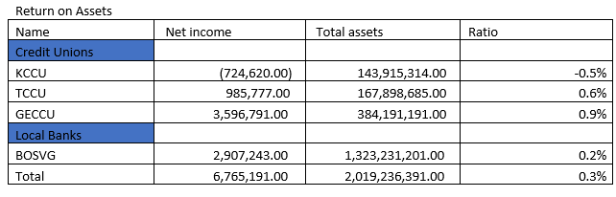
Results: Despite having such a large asset base the sector could only generate an ROA of 0.3
%, far below the industry average of 5%. This was due to the low performance of all major local players with KCCU making a loss that year. No individual institution was able to meet the 5% ROA.

Credit Management

Local loan Portfolio- Figure 9

Result: The total local loan portfolio is that of XCD$1 billion with BOSVG having the largest portfolio of over XCD$600 million or 63% of the market, while TCCU has the smallest at XCD$96 million representing 9% of the total loan market see detailed table under figure 15 in the appendix.

Loan growth - Figure 10
Results: Loan growth had a significant decline in 2021 as major institutions such as TCCU and BOSVG saw a reduction in their loan profiles of approximately 18 million causing a sectoral decline of XCD$6.3 million. However, the sector saw a resurgence in 2022 exceeding its 2020 growth by XCD$12 million. This growth was credited to leadership according to TCCU’s CEO, the Board of Directors, Credit Committee and the loans department were prudent in their assessment of loans.

Local growth by institution - Figure 11

Results: the chart above illustrates the growth of the individual company’s loan portfolio during the period. Only KCCU saw consistent growth, all other institutions saw a decline with BOSVG experiencing the greatest with an XCD$12 million contraction in 2021 compared to 2020. The resurgence in 2022 was credited to better economic conditions according to TCCU ‘s CEO, as well as a greater risk appetite by the institutions, GECCU’s representative associated the growth with the ending of the pandemic and customer confidence, while KCCU’s representative indicated that effective management saw KCCU portfolio growing while others saw losses.

Debt Management
The debt within the sector centers around six major category deposits due to customers, taxes, pension funds, provisions, accounts payables and borrowings (including Bank overdrafts).
Debt management - Table 7
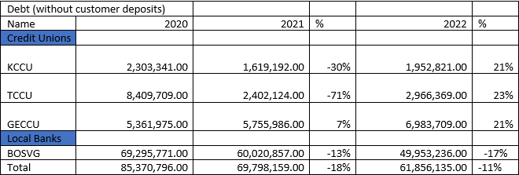
Results: The table shows the level of debt in the sector has decreased in the last three years, falling by over 10% consistently. The greatest contributor is TCCU which saw a drop in debt of 71% in 2021. However, BOSVG was a significant contributor with a reduction in debt in both 2021 and 2022 of 13% and 17% respectively. Apart from BOSVG, all other institutions saw increases in debt in 2022. TCCU CEO stated that the decrease in debt in 2021 was due to them paying off for work done to retrofit the build for COVID-19, a reduction in operating activities was also seen as a factor. The Increase in 2022 was noted as a return to normal.
Demand Deposit- Table 9
On-Demand Deposits
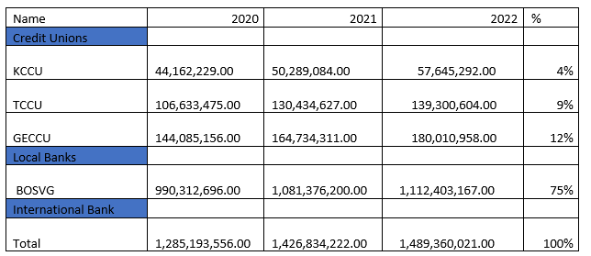

Results: depositor confidence remained constant with deposits growing each year despite the effects of Covid-19 and the volcanic eruptions. BOSVG holds 75% of the market with over a billion dollars in deposits followed by GECCU at only 12%. TCCU CEO and GECCU’s accountant both stated that the increase in deposits displayed the success of the member drives, school savings programs and membership confidence during trying times. KCCU’s representative also joined in that perspective stating that members continued to save despite the challenges this was partly due to the government intervention with programs to help the most affected.
N.B All three major credit unions placing all their deposits into BOSVG. TCCU and GECCU’s representatives stated that despite attempts to open accounts with Republic Bank they have not received a response, leading them to believe that Republic Bank is unwilling to work with them. BOSVG representative stated that they will continue to take deposits from the credit union but have concerns about the sector's lack of policies, especially concerning Know Your Customers regulations KYC.

Liquidity Management
The liquidity resources of the financial sector are cash and cash equivalents, investment securities, inventories, and deposits with other banks.
Liquidity ratios
Current Ratio- Table 10
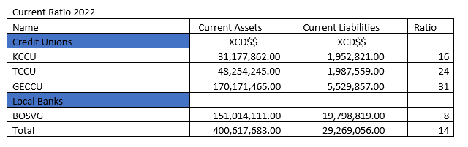
Results: A ratio of over 2 is considered adequate as it indicates that the company has twice the funds needed to clear its current debts. The sector’s current ratio is 14, which means that the sector has 14 times more cash resources than debts due within the next two years. GECCU has the highest ratio at 30 times and BOSVG has the lowest at 7 times. TCCU CEO stated that regulators FSA mandated frequency liquidity reports to ensure adequate levels. This was also required of GECCU and KCCU, whose representatives characterized the activity as time-consuming. However, the FSA used this as a basis to prevent the credit unions from executing pending projects deeming their liquidity levels inadequate. However, the FSA has since relented, and projects are set to go ahead soon.
Delinquency Management

Non-performing loans
Delinquency rate - Table 11
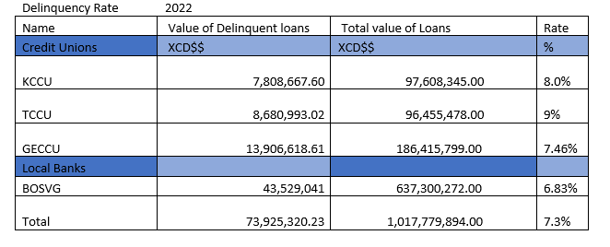
Results: Only 7.3% of the sectoral total loan portfolio is delinquent, TCCU has the highest level of delinquency at 9%, when asked TCCU CEO stated that the job loss due to COVID-19 and less than proficient loan recovery methods was to blame. KCCU was not far behind at 8%, while GECCU was at 7% however BOSVG saw the lowest at 6.83%, even lower than the overall sector at 7.3% prudence in leading was praised, as well as swift action during the Covid-19 pandemic in setting up a program to mitigate the effects on BOSVG’s loan portfolio.
Innovation within the financial sector
Innovation within the sector is necessary for stability according to (Wyman, 2017) research, as it reshapes the financial services landscape to ensure continuity, reliability and sustainability. The table can be seen in Figure 16 the appendix below, outlines the technological advancements that the sector has made over the years to modernize. All institutions have mobile banking, websites, and some form of Internet banking as well as ATM Cards and machines. However, the Credit unions have not gotten Debit/Credit Cards to allow for online purchases.
All institutions claim that their management is effective, customer services “is top of the line”, the products are affordable, and client confidence is at an all-time high, but does the public agree? BOSVG, the market leader and the only international financial institution Republic Bank were put to the test, the responses will have significant implications for the stability of the sector.
Management: 68% of BOSVG respondents believe that the bank has effective management, compared to 66% of Republic Bank respondents. 18% of BOSVG started management was very effective while 16% for Republic Bank and 8% considered Republic Bank’s management poor compared to 0% for BOSVG. This shows that respondents believe BOSVG is better managed when compared to Republic Bank see Figure 25 in the appendix. However, only 55% of respondents found BOSVG to be customer-centric in its approach with 45% of respondents lacking. Contrastingly, 41% of respondents believed that Republic Bank was customer-centric in their approach while 58% of the majority believed that the bank is not, see Figure 26 in the appendix. Although respondents did not overwhelmingly state that BOSVG was customer-centric it little over half, of respondents had an even poorer view of Republic Bank with only 41%. This shows that customers of both banks do not believe that the banks have their customer satisfaction as their top objective. In spite of this customers still believed that the overall management of both banks was effective.

Easy of doing business: 45% of BOSVG respondents believe the loan process is reasonable while another 25% believe it to be easy and 30% found it difficult compared to 41% of Republic bank respondents who found the loan process difficult, 50% reasonable and 8% easy see appendix figure 17. Similarly, when asked about accessing a line of credit through credit cards or overdrafts, 61% of BOSVG respondents found access reasonable, 22% found it difficult and 16% found it easy. Comparatively, only 7% found it easy, 31% found it difficult and 62% found it reasonable see Appendix Figure 18. This shows that more individuals found the loan process and access to other lines of credit easier at BOSVG compared to Republic bank.

Affordability: When asked how affordable current bank charges the majority are, 38.5%, stated they were expensive. see Figure 9 in the appendix. 55% of BOSVG’s respondents stated that they were dissatisfied with the interest rates on loans, 44% believed the rates were reasonable and 22% were satisfied. However, 0% of Republic Bank respondents were satisfied with the rates on their loans, only 29% found them reasonable and the majority, 55%, stated they were “dissatisfied” see Figure 19 in Appendix.
Satisfaction with the fees charged on savings, loan (administration fees) overdrafts and credit/debit cards, was low with 41% of BOSVG respondents dissatisfied however Republic banks had a higher percentage of dissatisfied clients at 64%, with only 29% of Republic Bank respondents found the rates reasonable compared to 58% for BOSVG, see figure 20 in Appendix. This indicated that customers were “dissatisfied” with the fees for both banks. However, respondents found BOSVG’s fees more reasonable than those of Republic Bank.

Customer services: 65% of BOSVG’s respondents, when asked about their customer service experience, described it as adequate, similarly 66% found Republic Bank’s adequate as well. 22% stated it was a pleasant experience at BOSVG while 13% for Republic Bank see Figure 21 in the appendix. The over-the-phone experience was worse, with 70% finding the experience “difficult to very difficult” at Republic Bank and BOSVG. 30% of BOSVG respondents found it “not difficult to easy” to reach staff over the phone, 31% of Republic Bank respondents had the same experience see figure 22 in the appendix.
Waiting times in the banks were deemed long according to 65% of BOSVG’s respondents, compared to 36% for Republic Bank. 43% of Republic Bank’s respondents stated the wait time is very long compared to only 9% for BOSVG. While no respondent selected short, 26% of BOSVG respondents stated the wait time “was not long” compared to 21% for Republic Bank see Figure 23 in the appendix. 50% of BOSVG’’s respondents stated that the average wait time for issues to be resolved was within a week, 41% for Republic Bank. Within a day 28% of BOSVG respondents stated that the problems were resolved versus only 8% of Republic Bank respondents. Fortunately, only 22% stated that issues were resolved in a month by BOSVG compared to 50% by Republic Bank see Figure 24 in the appendix. This indicates that both banks need to work on improving customer service. However, BOSVG outperformed Republic bank with respondents having better customer service experience in the areas of in-branch waiting time and issue resolution.
Despite all the challenges encountered within the last 3 years when asked if they were satisfied with the overall banking experience, BOSVG respondents were split 50/50 between yes and no. However, the majority, 81% of Republic Bank respondents stated no with only 27% saying yes see Figure 30 in the appendix.
Financial inclusion: is critical for stability, researcher (Slack, 2015) stated that financial inclusion and financial stability are two faces of the same coin they are both dependent on each other. When asked what have the respective financial institutions done concerning financial inclusion, the representatives from the credit unions stated that they have continued to offer loans to the underprivileged and underserviced in the communities with loans trailed to farmers, fishermen and small business owners. BOSVG representatives were of the same viewpoint noting that they give out loans to low-income individuals and try to work with business owners to secure loans to start and or grow their businesses. BOSVG’s representative stated that the bank has done its best to reach as many individuals as possible.
However, according to ECCB (The Eastern Caribbean Central Bank) while it is important to have access to financial services, individuals need the knowledge and skills required to make good decisions and not be left in a worse financial position. Financial literacy is seen as the best way to combat the negative elements of inclusion. Financial Literacy allows citizens to understand and make proper financial decisions. When asked from whom respondents learnt to manage money the majority 42.3% stated from family members, followed by 34.6 % stating workplace and the remaining 23.1% from formal education, see Figure 5 in the appendix below. Despite this when asked where they get information about money matters most respondents stated the internet at 61.5% and the family member who they learnt from was second at 26.9% and friends at 11.5% see Figure 8 in the appendix below. But what concepts have respondents learnt from their family members and the internet, 40% stated bank loans, followed by interest payments at 24% then return on investment at 20% see Figure 6 in the appendix. However, these seem to be all the concepts they need to know. When asked what concepts they interacted with the most during their banking activities 57% stated bank loans and 14% interest payments see Figure 7 in the appendix. This narrow view was confirmed by (Eastern Caribbean Central Bank, 2023) financial literacy survey that put Vincentians at the bottom with an 11.7 which is last. With a Knowledge rating of 4.1 out of 7, which was also one of the lowest, attitude was also found lacking with a rating of 1.8 out of 4 the lowest in the region see Figure 5.3 in the appendix.

Discussion
This study tried to answer the question of how stable the current financial services sector in St. Vincent and the Grenadines is. To do this a comparison was drawn between the international banking sector and the local sector as well as identifying the pillars of stability and assessing if those pillars were present. The literature review gave key areas of comparison such as regulations, credit and management. The pillars necessary according to theorists for a stable sector were comprehensive regulations, positive government involvement, financial inclusion, and strong performance in the areas of profitability, asset management, credit distribution, liquidity, and debt management.
However, not all theorists agreed others warned that some pillars such as regulations are at present overblown and that the tools used for performance assessment could cause a reduction in the sector with managers only looking at the numbers and making hardline decisions. A handful of theorists doubt the merits of financial inclusion stating that while it is good for financial institutions it can be harmful to citizens especially those who are not financially literate.
However, after conducting a review of the financial reports, a survey, and several interviews with key personnel, the following results were uncovered, the financial services sector has five main financial institutions Republic Bank, BOSVG, KCCU, TCCU, and GECCU, according to participants of the survey when asked to list the name of the bank they use, only these five banks were listed. However, Republic Bank given that its origins are outside St. Vincent, was therefore not considered in the review of the local market as it like FCIB can depart at any time, unlike the indigenous banks and credit unions. Due to this, the research focused on the local sector as its stability is vital for the survival of the sector.
The Departure of international banks such as FCIB saw the asset pool shrinking by 63% in 2020 and 77% in 2022. Apart from the reduction in the asset pool, the departure also saw the loss of network, (thereby deepening the reliance on correspondent banks such as “Bank of America”), low interest rates, less resilience and employment, more reliance on correspondent banking, and slow growth in technology and innovation. Apart from the many benefits FCIB’s presence provided, the survey highlighted some drawbacks in the areas of regulation and credit. The bank would push a one-size-fits-all approach to policy creation having all branches adopt the same policy document without considering their culture and regulatory differences.
While FCIB advertised low interest rates at the time much lower than other institutions, the public found the process to obtain these loans difficult according to the majority, 42% of respondents. The interviewees agreed, stating that the process was often lengthy with delays due to the loans having to be sent to the headquarters for review and approval. Despite these shortcomings, the impact on the sector was significant, the loss sent shockwaves many lamenting about the benefits they once had.
However, this departure was not the only recent shock, the COVID pandemic, a volcanic eruption in April 2021 and Hurricane Elsa in July 2021 all tested the sector’s resilience. Nevertheless, the sector grew in all significant areas such as profits, assets, credit, and customer deposits and as a consequence showed prominent levels of liquidity, thereby showing resilience. An excellent performance as highlighted in the literature review by the researchers is vital if the sector is to withstand shocks from both the internal environment ( lay-offs local due to Covid-19, destruction of homes etc.) and external (de-risking) according to Athari et al. (2023). FSA confirmed also in its annual report (2022) that the credit unions “provided their members with sound financial products and sustained growth in loans, deposits, and liquidity.” This performance was attributed to three main elements positive government intervention, strong regulations, and leadership.
The government intervention within the sector was seen through emergency packages such as the Volcanic Eruption Emergence Project VEEP which saw an injection of over 15 million into the local economy targeting those affected by the eruption, and a refusal to lockdown the country which allowed most persons to maintain employment thereby mitigating some of the effects of the Covid-19 pandemic. Effectively, stabilizing the economy and by extension preventing the collapse of the sector confirmed the theory set forth by (Quintyn & Quintyn, 2004) which pointed to government intervention having a positive impact and how important it is to stability. The financial institutions embraced this intervention by purchasing government bonds, signing MOUs and partnering to provide debit cards. Beyond government packages, the government’s influence was seen through local regulators such as the FSA and the FUI as noted by the interviewees, during this time these regulations pushed the preparation of disaster preparedness plans, risk management and a strategic plan on how the institutions were going to navigate these shocks. Therefore, strong regulations became the focal point for surviving and were ultimately praised as one of the reasons for the sector’s resiliency.
While reviewing the financial reports and conducting the interviews it was noted that over 100 training sessions were held related to corporate governance and 87 policies implemented 64 for BOSVG only, key personnel stated that these were as a result of recommendations made by the regulators, consultants, committees and management findings. This falls in line with the research presented by (Caribbean Development Bank, 2018) that claims in the “Policy Blueprint for Caribbean Economies” that a proactive approach is needed to create adequate regulation and supervision to ensure a strong banking sector. Policies are needed to give clear guidance on how situations are to be managed and remove ambiguity within the process. This was vital as the pandemic forced staff to work remotely, with reduced contact the staff had to rely on policies for guidance. This resulted in the sector's resilience armed with policies and backed with training, the sector strived despite the shocks faced. This gives validity to the claims of researchers and theorists such as (The World Bank, n.d.) (Central Bank of Ireland , n.d.), (Franklin & Gu, 2018) and (Udaibir S. Das & Quintyn, 2004) who claimed that robust regulations are imperative to stability and that poor regulations can harm the sector.
The regulators agreed with this outlook, according to ECCB in their Annual financial stability report (The Eastern Caribbean Central Bank, 2021) “Although COVID-19 was of global proportions, the environmental risk associated with the volcano was significantly more localized with destruction to property and infrastructure as a result of mudflows, heavy ash fall and a combination of factors which resulted in financial losses. Nevertheless, the sector remained stable and negative spill-overs of these macro-financial risks were mitigated, with The commercial banks and credit unions continuing to provide access to credit and other financial services” The FSA also noted the sector's resilience in its Annual report for 2022, according to the (Financial Services Authority SVG, 2022), “the sector maintained relatively stable governance structures for the year ended December 31, 2022. The governance teams performed their duties in accordance with the Cooperative Societies Act, No. 12 of 2012.” This highlights the efforts of management (board, committees and managers) and the leadership they provided, which was hailed as one of the elements credited for ensuring the pillars remained intact thereby preventing the sector’s collapse.
Leadership was championed by the interviewees, as one of the reasons the sector remained stable despite multiple shocks. The Board of directors, committee members and managers quickly implemented strategic plans on how to combat COVID-19- 19, moved to a remote working environment, reduced branch opening hours, retro-fitted offices for greater protection, created policies through in-house resources or consultants, renewed focus on innovation and a more prudent management approach. This resulted in the implementation of virtual loan meetings between customers and loan officers, new software for greater efficiency, Zoom Annual General Meeting, and an updated telephone network to allow the branches to handle a greater volume of calls. FSA knowledge this in its annual report (2022) “made significant strides to improve online and virtual services to support the growing needs of its members”.
The moratoria program was also a measure put forward to manage the effects of the pandemic, as at 2022 the FSA notes that 179 loans valued at 8.6 million remained to be transferred to the NPL portfolio from this program within the credit union sector (Financial Services Authority SVG, 2022). (The Eastern Caribbean Central Bank, 2021) also hailed the importance of this program stating that it provided much-needed relief to households and contributed to the stability of the financial sector after the effects of COVID-19 and the volcanic eruption in Saint Vincent and the Grenadines.”
Despite, ECCB's encouragement to further enhance financial access and inclusion in the region, the interviewees disagreed stating that the sector is already inclusive in its approach to financial access stating that it could be harmful, especially with financial literacy being low. This claim was backed up by the ECCB’s survey which showed that financial literacy was low across all Eastern Caribbean countries, St. Vincent and the Grenadines received the lowest score of 11.7 out of 20, due to it receiving the lowest score for knowledge (Eastern Caribbean Central Bank, 2023) please see Figure 5.2 in the appendix, the survey I conducted supports this with only 23.1% of respondents having formal education as it relates to money management, with 61.5% getting advice on spending, saving and investments from the Internet. This shows that citizens do not have the education and other tools to make the best financial decisions.

Conclusion
The research aimed to assess the stability of the financial sector in St. Vincent and the Grenadines. Upon concluding the data analysis and discussion it was concluded that the sector is indeed stable. Despite the departure of international bank FCIB, whose loss was a significant setback for the sector. Due to the benefits loss such as a large network with over 50 branches in 15 Caribbean countries along with access to Canada through its parent company CIBC. Low interest rates, long loan repayment periods, employment, advanced technology, effective management style.
The sector saw other obscures to stability such as the Covid-19 pandemic, volcanic eruption and Hurricane Elsa which along with the aforementioned resulted in significant shocks to the sector. Nevertheless, the sector continued to see growth in all the areas albeit subdued growth due to the shocks. In the areas of profitability, credit, asset, and customer deposits all saw meaningful growth. The sector also bolstered its regulations not just to meet regulatory requirements but to surpass them by creating policies that were not highlighted by their regulators. The sector also put time and money into innovation apart from modernizing operations in the physical place (all locations were retrofitted during the COVID -19), all institutions ensured they had a digital presence through a website and mobile apps. High level of customer confidence in the management of the sector-leading financial institution BOSVG with 68% of the majority of respondents stating that the bank management is effective.
Despite the sector’s excellent performance, there are areas in need of improvement such as generating more returns on assets, as the sector is far below the industry standard of 5%, at 0.3%. This indicates that the local sector is not putting its assets to work and is relying on the institution's operations to generate all the income. Debt was also on the rise within the sector this is cause for concern as high debt will reduce the profitability of the sector, resulting in low dividend payments and therefore loss of confidence among shareholders. Other areas of concern were the perceived unaffordability of financial services with the majority, 38.5% of respondents believing bank charges are expensive. Lack of talent/ expertise within the sector with most policies being written by consultants. Lack of network, resulting in a heavy reliance on correspondence banking services from international banks outside the region such as Bank of America.
Despite this, the sector has proven itself to be stable and capable of enduring multiple shocks even devoid of international banks such as FCIB and is poised to surpass the growth seen thus far.

Research Limitations
There are no existing research papers, therefore the study was restricted to the literature review, interviews, financial reports and a survey, which could be deemed insufficient to adequately represent the Vincentian population's opinion. The topic selected was more complex and some of the data collected did not make it into the paper due to the word limit and relevance to the main topic.

Implications of the findings
The study implies that the sector is stable, with strong local and regional financial institutions the sector can withstand the departure of international banks from wealthy countries such as FCIB. With government support and the right leadership, the sector can survive shocks such as COVID-19, a volcanic eruption and hurricanes. It is therefore the belief of this researcher that the findings of this study would ultimately benefit the financial sector of St. Vincent and the Grenadines. By highlighting what areas grew and those that need closer observation to ensure that the sector remains stable. It will also lay the groundwork for other researchers to build on this topic.

Recommendations
While the sector is presently stable, areas of weakness must be bolstered to ensure continued stability.
Networks: Interregional networks must be formed and where they already exist these must be strengthened. This network will allow greater access to funds, technological developments, and training. As well as reduce dependence on corresponding international banks for regional transactions.
Assets: The sector has a large, underutilized asset base, that can be put into building branches, lease holdings, starting new business ventures or even reinvested into the business in the form of loans, improving websites, and mobile apps, hiring experts in areas of weakness such as Human Resources, Information technology, and Compliance. Implementation of the aforementioned will put much more of the assets to work, ensuring higher returns and therefore ensuring continued stability.
Employment: There is a need in the sector for more experts, the financial institutions should implement programs to attract and retain talent. This will reduce the current dependence on consultants. Programs that focus on embracing flexibility, offering competitive compensation, and promoting career development. To ensure that only the best candidates will be interviewed, technology such as an Applicant Tracking System (ATS) can be used to streamline and automate the recruitment process (Henderson, 2024). It filters the applications based on the keywords that the employer has outlined in the job description. Such systems are Zoho Recruit, Pinpoint, Greenhouse, and Bamboo HR.
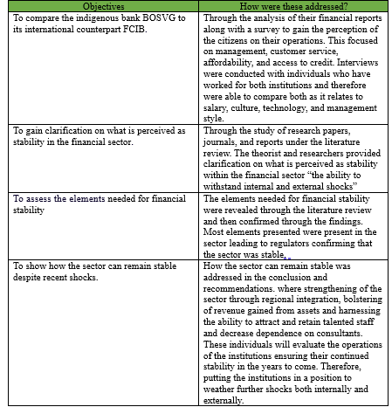

Bibliography
Garry J. Schinasi, 2005. 6 a Framework for Financial Stability. [Online]
Available at: https://www.elibrary.imf.org/display/book/9781589064409/ch006.xml
[Accessed 3 Jan 2024].
Jeanne Gobat , n.d. Banks: at the heart of the matter. [Online]
Available at: https://www.imf.org/en/Publications/fandd/issues/Series/Back-to-Basics/Banks
[Accessed 12 Feb 2024].
Organization of American States, 2018. State of Cybersecurity in the Banking Sector in Latin America and the Caribbean. [Online]
Available at: https://www.oas.org/es/sms/cicte/sectorbancarioeng.pdf
[Accessed 13 Jan 2024].
Abou-Jaode, N., 2012. Over regulation: the short-sighted solution. [Online]
Available at: https://www.thebanker.com/Over-regulation-the-short-sighted-solution-1351760557
[Accessed 10 Dec 2023].
Acevedo, S., 2023. What are the pros and cons of banking locally?. [Online]
Available at: https://www.businessinsider.com/personal-finance/why-bank-local
[Accessed 3 Jan 2024].
Adams, T., 2018. Why Financial Inclusion Matters. [Online]
Available at: https://www.centerforfinancialinclusion.org/why-financial-inclusion-matters?gclid=Cj0KCQiA7OqrBhD9ARIsAK3UXh3Hpxf-sjY2EM5ZnaFvWGUnxvgsy1D5SY7b2fie8aaS07kcMaN2waEaAm6iEALw_wcB
[Accessed 14 Dec 2023].
Albulescu, C. T., 2015. Banks’ Profitability and Financial Soundness Indicators. [Online]
Available at: https://core.ac.uk/download/pdf/82682204.pdf
[Accessed 13 Dec 2023].
Alper Ozun, D. K. a. H. M. E., 2019. How is financial stability impacted by political and economic stabilties in emerging markets. [Online]
Available at: https://ipe.ro/rjef/rjef4_19/rjef4_19p148-159.pdf
[Accessed 12 July 2023].
Alsup, A., 2020. New study highlights the real cost of political interference in banking. [Online]
Available at: https://news.warrington.ufl.edu/faculty-and-research/new-study-highlights-the-real-cost-of-political-interference-in-banking/
[Accessed 9 Dec 2023].
Anjali & Kashiramaka, S. a. S., 2023. Profitability–Stability Nexus in Commercial Banks: Evidence from BRICS. [Online]
Available at: https://journals.sagepub.com/doi/10.1177/09721509231184765
[Accessed 13 Dec 2023].
Anon., 2014. Corporate Governance and Strategic Planning. [Online]
Available at: https://www.cram.com/essay/Relationship-Between-Corporate-Governance-And-Strategic-Planning/FKMPKJZLGR4E5
[Accessed 17 Feb 2024].
Antonio Marcelo, A. R. &. C. T., 2008. Stress tests and their contribution to financial stability. [Online]
Available at: https://link.springer.com/article/10.1057/jbr.2008.1
[Accessed 10 Dec 2023].
Baluch, A., 2022. Bank Credit Explained. [Online]
Available at: https://www.thebalancemoney.com/what-is-bank-credit-5191577
[Accessed 18 Dec 2023].
Banerjee, P., 2023. Financial Inclusion. [Online]
Available at: https://www.wallstreetmojo.com/financial-inclusion/
[Accessed 17 December 2023].
Bank of Nova Scotia , n.d. [Online]
Available at: https://www.scotiabank.com/ca/en/about/investors-shareholders/annual-reports.html
[Accessed 14 July 2024].
Bank, F. C. I., 2022. Annual Report. [Online]
Available at: https://www.cibcfcib.com/binaries/content/assets/annual-reports/2020/cibc-fcib-group-ar-2020.pdf
[Accessed 11 June 2024].
BANKING ACT, [2015]. BANKING ACT. [Online]
Available at: https://www.eccb-centralbank.org/viewPDF/documents/2022-03-17-02-37-19-BankingBill2015.pdf
[Accessed 18 April 2024].
Banking Survey, 2024. [Online]
Available at: https://docs.google.com/forms/d/128vgyl7jkC7h-fEn0qPQyT5Zxrf7HnU4Q_rAhF12Q6A/edit#responses
Barry and Saka, E. a. O., 2023. Cultural Stereotypes of Multinational Banks. [Online]
Available at: https://www.lse.ac.uk/european-institute/Assets/Documents/LEQS-Discussion-Papers/EIQPaper179.pdf
[Accessed 25 May 2024].
Bazeley, P., 2004. Issues in Mixing Qualitative and Quantitave Approach. [Online]
Available at: https://www.researchgate.net/publication/228469056_Issues_in_Mixing_Qualitative_and_Quantitative_Approaches_to_Research
[Accessed 26 Sept 2023].
Beck, T., 2012. Foreigners vs. Natives: Bank Lending Technologies and Loan Pricing. [Online]
Available at: https://blogs.worldbank.org/allaboutfinance/foreigners-vs-natives-bank-lending-technologies-and-loan-pricing
[Accessed 18 December 2023].
Beverly Hirtle, A. K. J. V. a. M. B., 2016. Assessing financial stability: The Capital and Loss Assessment under Stress Scenarios (CLASS) model. [Online]
Available at: https://www.sciencedirect.com/science/article/abs/pii/S0378426615002940
[Accessed 10 December 2023].
Bhandari, P., 2020. External Validity | Definition, Types, Threats & Examples. [Online]
Available at: https://www.scribbr.com/methodology/external-validity/
[Accessed 18 December 2023].
Bhandari, P., 2023. Ethical Considerations in Research. [Online]
Available at: https://www.scribbr.com/methodology/research-ethics/
[Accessed 25 Jan 2024].
BIS, 2019. Unintended side effects: stress tests, entrepreneurship, and innovation. [Online]
Available at: https://www.bis.org/publ/work823.htm
[Accessed 10 Dec 2023].
Bonneau, C., 2023. Understanding the different types of bias in research (2024 guide). [Online]
Available at: https://dovetail.com/research/types-of-bias-in-research/
[Accessed 3 June 2024].
BOSVG , n.d. Consolidated Financial Statements. [Online]
Available at: https://www.bosvg.com/annual-reports-listings/
[Accessed 14 July 2024].
Caribbean Development Bank, 2018. A policy Blueprint for Caribbean Economies. [Online]
Available at: https://www.google.com/search?q=state+owner+banks+in+the+caribbean+necessary+to+stabilize&sca_esv=596289650&sxsrf=AM9HkKnluXIx1kqNlMkYIKGPPait3cY48A%3A1704597289194&ei=KReaZeK7C7iuqtsP3JeGiAI&oq=state+owner+banks+in+the+caribbean+nec&gs_lp=Egxnd3Mtd2l6LXN
[Accessed 7 Jan 2024].
Carnarvon, A., 2023. What is a Financial Framework and Why Every Business Needs One. [Online]
Available at: https://coloringfolder.com/what-is-a-financial-framework
[Accessed 3 Jan 2024].
Caulfield, J., 2019. Textual Analysis. [Online]
Available at: https://www.scribbr.com/methodology/textual-analysis/
[Accessed 15 Jan 2024].
Central Bank of Ireland , n.d. What is financial regulation and why does it matter. [Online]
Available at: https://www.centralbank.ie/consumer-hub/explainers/what-is-financial-regulation-and-why-does-it-matter
[Accessed 6 Dec 2023].
Central Bank of the Bahamas , 2016. De-risking. [Online]
Available at: https://www.centralbankbahamas.com/news/general-news/de-risking-faqs
[Accessed 7 Jan 2024].
Chen, M., 2020. Text Analysis. [Online]
Available at: https://towardsdatascience.com/a-guide-text-analysis-text-analytics-text-mining-f62df7b78747
[Accessed 27 Jan 2024].
Chetty, P., 2016. Importance of research approach. [Online]
Available at: https://www.projectguru.in/selecting-research-approach-business-studies/
[Accessed 21 Jan 2024].
Cleave, P., 2023. Structured or Semi-Structured Questionnaire. [Online]
Available at: https://www.smartsurvey.co.uk/blog/structured-or-semi-structured-questionnaire
[Accessed 21 Jan 2024].
Council of Financial Regulators , n.d. What is Financial Stability. [Online]
Available at: https://www.cfr.gov.au/financial-stability.html
[Accessed 6 Dec 2023].
Cowen & Tabarrok, A. a. T., 2015. The end of Asymmetric Information. [Online]
Available at: https://www.cato-unbound.org/2015/04/06/alex-tabarrok-tyler-cowen/end-asymmetric-information/
[Accessed 18 Dec 2023].
Decu, B., 2022. What is Hierarchy Culture. [Online]
Available at: https://www.neuroworx.io/magazine/what-is-hierarchy-culture/
[Accessed 25 May 2024].
Denison, G., 2023. Uncovering the types of bias in research: Identification, prevention and examples. [Online]
Available at: https://www.prolific.com/resources/uncovering-the-types-of-bias-in-research-identification-prevention-and-examples
[Accessed 3 June 2024].
Deshmukh, A., 2022. Compliance Training in financial services. [Online]
Available at: https://elearningindustry.com/compliance-training-in-financial-services
[Accessed 18 Feb 2024].
Eastern Caribbean Central Bank, 2023. The ECCU's Financial Literacy and Financial Inclusion report on Survey 2022/2023. [Online]
Available at: https://www.eccb-centralbank.org/viewPDF/documents/2023-09-15-09-55-07-ECCU-Financial-Literacy-and-Financial-Inclusion-Survey-Report.pdf
[Accessed 8 Jan 2024].
European Central Bank , 2018. Financial regulation and innovation. [Online]
Available at: https://www.ecb.europa.eu/press/key/date/2018/html/ecb.sp180314.en.html
[Accessed 17 December 2023].
European Central Bank, 2005. The institutional framework for financial market policy. [Online]
Available at: https://www.econstor.eu/bitstream/10419/154488/1/ecbop035.pdf
[Accessed 4 Jan 2024].
European Central Bank, n.d. Financial Stability. [Online]
Available at: https://www.ecb.europa.eu/pub/financial-stability/html/index.en.html
[Accessed 6 Dec 2023].
Faria, F. A. a. D., 2017. Strenghts and Limitations of Qualitative and Quantitative Research Methods. [Online]
Available at: https://www.researchgate.net/publication/319852576_Strengths_and_Limitations_of_Qualitative_and_Quantitative_Research_Methods
[Accessed 26 Sept 2023].
FCIB, n.d. Annaul Reports. [Online]
Available at: https://www.cibcfcib.com/about-us/investor-relations/annual-reports
[Accessed 14 July 2024].
Federal Reserve, n.d. What is financial stability?. [Online]
Available at: https://www.federalreserve.gov/faqs/what-is-financial-stability.htm
[Accessed 6 Dec 2023].
Financial Services Authority SVG, 2022. Annual Report. [Online]
Available at: https://svgfsa.com/library-publications/
[Accessed 1 June 2024].
First Caribbean Internation Bank, 2022. Annual Report. [Online]
Available at: https://www.cibcfcib.com/binaries/content/assets/annual-reports/2022/cibc-fcib-group-ar-2022.pdf
[Accessed 11 June 2024].
Francisco Javier Saez-fernandez, A. J. P.-T. &. M. B.-E., 2015. Assessing the performance of the Latin American and Caribbean banking industry: Are domestic and foreign banks so different?. [Online]
Available at: https://www.tandfonline.com/doi/full/10.1080/23322039.2015.1006976
[Accessed 7 Jan 2024].
Franklin & Gu, A. a. X., 2018. The interplat between regulation and financial stability. [Online]
Available at: https://link.springer.com/article/10.1007/s10693-018-0296-7
[Accessed 6 Dec 2023].
GECCU, n.d. Reports & Accounts. [Online]
Available at: https://geccu.com/agm-magazines/
[Accessed 14 July 2024].
George, T., 2022. Semi-structured Interview. [Online]
Available at: https://www.scribbr.com/methodology/semi-structured-interview/
[Accessed 24 Jan 2024].
Greinke, T., 2023. BANKING WITH PURPOSE: Why You Should Bank Locally. [Online]
Available at: https://www.bankofthebluegrass.com/2023/04/12/banking-with-purpose/
[Accessed 3 Jan 2024].
Halton, C., 2023. Diffusion of Innovations Theory: Definition and Examples. [Online]
Available at: https://www.investopedia.com/terms/d/diffusion-of-innovations-theory.asp
[Accessed 22 May 2024].
Hassan, M., 2024. Research Approach. [Online]
Available at: https://researchmethod.net/research-approach/#google_vignette
[Accessed 21 Jan 2024].
Henderson, R., 2024. Applicant Tracking Systems: Everything You Need to Know. [Online]
Available at: https://www.jobscan.co/applicant-tracking-systems
[Accessed 2024 July 2024].
Holt, A., 2023. Why the over-regulation needs to stop. [Online]
Available at: https://www.fnlondon.com/articles/why-the-over-regulation-of-banks-needs-to-stop-20230915
[Accessed 9 December 2023].
Inter-American Development Bank, 2021. The Caribbean must build sound fiscal, monetory, financial. [Online]
Available at: https://www.google.com/search?q=why+regulations+are+key+to+the+stability+of+the+caribbean&oq=why+regulations+are+key+to+the+stability+of+the+caribbean&gs_lcrp=EgZjaHJvbWUyBggAEEUYOTIHCAEQIRigATIHCAIQIRigATIHCAMQIRigATIHCAQQIRigAdIBCTE2NzUwajBqN6gCALACAA&s
[Accessed 6 Jan 2024].
International Monetary Fund, 2016. Low Growth, Interest Rates Impact Financail Stability. [Online]
Available at: https://www.imf.org/en/News/Articles/2016/10/04/AM16NAGFSR100416
[Accessed 13 Dec 2023].
International Monetary Fund, 2021. The Global Cyber Treat. [Online]
Available at: https://www.imf.org/external/pubs/ft/fandd/2021/03/global-cyber-threat-to-financial-systems-maurer.htm
[Accessed 17 Dec 2023].
International Monetory Fund , 1991. Banking Crises. [Online]
Available at: https://www.elibrary.imf.org/display/book/9781557751874/ch01.xml#:~:text=A%20banking%20crisis%20has%20immediate,the%20cost%20of%20credit%20intermediation.&text=It%20induces%20a%20flight%20to,weakens%20monetary%20and%20budgetary%20control.
[Accessed 28 April 2024].
Jain, A., 2023. Benefits you get when publishing contents in online journals. [Online]
Available at: https://innovareacademics.in/blog/publishing-contents-in-online-journals/
[Accessed 10 April 2024].
Jamshed, S., 2014. Qualitative research method-interviewing and observation. [Online]
Available at: https://www.ncbi.nlm.nih.gov/pmc/articles/PMC4194943/
[Accessed 23 Jan 2024].
Kasim & Calice, A. a. G., 2022. The effects of supervisory stress testing on bank lending. [Online]
Available at: https://www.ncbi.nlm.nih.gov/pmc/articles/PMC9012153/
[Accessed 10 December 2023].
KCCU, n.d. Financial Reports and Accounts. [Online]
Available at: https://www.kingstowncreditunion.com/kccu-financials
[Accessed 14 July 2024].
Kenton, W., 2022. What Is Stress Testing? How It Works, Main Purpose, and Examples. [Online]
Available at: https://www.investopedia.com/terms/s/stresstesting.asp#:~:text=Stress%20tests%20are%20forward%2Dlooking,should%20do%20to%20mitigate%20risks.
[Accessed 12 Dec 2023].
Kevin M Makhuga , 2022. Effects of Corporate Governance on Strategic planning Practices within Equity Bank in Kenya. [Online]
Available at: http://erepository.uonbi.ac.ke/handle/11295/162719
[Accessed 17 Feb 2024].
Khartit, K., 2022. Benefits of Local Banks vs. Big Banks. [Online]
Available at: https://www.thebalancemoney.com/benefits-of-local-banks-vs-big-banks-4177411
[Accessed 3 Jan 2024].
Liao, Y., 2022. Sustainable leadership: A literature review and prospects for future researc. [Online]
Available at: https://www.frontiersin.org/articles/10.3389/fpsyg.2022.1045570/full
[Accessed 7 Oct 2023].
Loop News, 2021. CIBC FCIB banking assets to be sold in 4 OECS Countries. [Online]
Available at: https://caribbean.loopnews.com/content/cibc-fcib-banking-assets-be-acquired-4-oecs-countries
[Accessed 19 November 2023].
LOOP News, 2021. CIBC FCIB banking assets to be sold in 4 OECS countries. [Online]
Available at: https://caribbean.loopnews.com/content/cibc-fcib-banking-assets-be-acquired-4-oecs-countries
[Accessed 2 June 2024].
Malpass, M. P., 1999. The Financial Framework. In: Housing Policy and Practice.. [Online]
Available at: https://doi.org/10.1007/978-1-349-27443-7_8
[Accessed 4 Jan 2024].
Maly, S., 2023. International Banking: How it works, types & services. [Online]
Available at: https://www.google.com/search?q=why+bank+with+international+banks&sca_esv=595514857&sxsrf=AM9HkKl2543x_GI8GPBynsSSANlNvEkYIw%3A1704327954176&ei=EvuVZcSwCsinqtsPhMC7qAc&ved=0ahUKEwjEgaiyvMKDAxXIk2oFHQTgDnUQ4dUDCBA&uact=5&oq=why+bank+with+international+bank
[Accessed 3 Jan 2024].
Mapp, R. D.-., 2024. s.l.:s.n.
Mark NK Saunders, P. a. A. T., 2009. Understanding research philosophies and approaches. [Online]
Available at: https://www.researchgate.net/publication/309102603_Understanding_research_philosophies_and_approaches
[Accessed 2024 Jan 2024].
Marois, T., 2021. A dynamic theory of public banks and why it matters. [Online]
Available at: https://www.ucl.ac.uk/bartlett/public-purpose/sites/public-purpose/files/final_a_dynamic_theory_of_public_banks_2021-06.pdf
[Accessed 9 Dec 2022].
Martin Cihak, H. O. L. S., 2019. Checking the health of banks is crucial to financial stability. [Online]
Available at: https://www.imf.org/en/Publications/fandd/issues/2019/09/what-is-stress-testing-basics#:~:text=Stress%20tests%20typically%20cover%20solvency,their%20deposits%20and%20other%20debts.
[Accessed 10 Dec 2023].
McCombes, S., 2019. Descriptive Research. [Online]
Available at: https://www.scribbr.com/methodology/descriptive-research/
[Accessed 15 Jan 2024].
McCombes, S., 2019. Sampling Methods, Types, Techniques and examples. [Online]
Available at: https://www.scribbr.com/methodology/sampling-methods/
[Accessed 2 June 2024].
McCombes, S., 2019. What is a Case Study. [Online]
Available at: https://www.scribbr.com/methodology/case-study/
[Accessed 15 Jan 2024].
Merkus & George, T. a. J., 2022. Structured interview. [Online]
Available at: https://www.scribbr.com/methodology/structured-interview/
[Accessed 24 Jan 2024].
Mezzetta, R., 2014. Overregulation a major issue for banks. [Online]
Available at: https://www.investmentexecutive.com/newspaper_/news-newspaper/overregulation-a-major-issue-for-banks/
[Accessed 10 Dec 2023].
Middleton, F., 2019. The 4 Types of Reliability in Research | Definitions & Examples. [Online]
Available at: https://www.scribbr.com/methodology/types-of-reliability/
[Accessed 5 January 2024].
Mkwawa, K., 2020. The Importance of the banking industry stability on the economy. [Online]
Available at: https://medium.com/@KelvinMkwawa/the-importance-of-banking-industry-stability-on-the-economy-c9ac8e293d1b
[Accessed 10 Dec 2023].
Mortlock, S., 2021. We’ve worked for Singapore banks and global banks: these are the big differences. [Online]
Available at: https://www.efinancialcareers.sg/news/2021/02/differences-working-for-singapore-banks-and-global-banks
[Accessed 3 Jan 2024].
Munshi Naser Ibne Afzal, M. A. N. S. S. A. S., 2022. Financial inclusion using corporate social responsibility: a socio-economic demand. [Online]
Available at: https://www.emerald.com/insight/content/doi/10.1108/AJEB-04-2022-0039/full/html
[Accessed 14 December 2023].
Musacchio, E. P. &. A., 2020. State Owned Enterprises in Latin America. [Online]
Available at: https://blogs.iadb.org/gestion-fiscal/en/solving-the-state-owned-enterprises-puzzle-in-latin-america-and-the-caribbean/
[Accessed 6 Jan 2024].
NEW York Law School, 2001. INTERNATIONAL BANKING REGUL AL BANKING REGULATION IN TION INTO THE 21ST CENTURY: FLIR Y: FLIRTING WI TING WITH REVOLUTION. [Online]
Available at: https://digitalcommons.nyls.edu/cgi/viewcontent.cgi?article=1497&context=journal_of_international_and_comparative_law
[Accessed 18 December 2023].
Nikolopoulou, K., 2022. Inclusion and Exclusion Criteria | Examples & Definition. [Online]
Available at: https://www.scribbr.com/methodology/inclusion-exclusion-criteria/
[Accessed 2 June 2024].
Nikolopoulou, K., 2022. What Is Criterion Validity? | Definition & Examples. [Online]
Available at: https://www.scribbr.com/methodology/criterion-validity/
[Accessed 5 June 2024].
Nikolopoulou, K., 2022. What Is Probability Sampling? | Types & Examples. [Online]
Available at: https://www.scribbr.com/methodology/probability-sampling/
[Accessed 3 June 2023].
Nikolopoulou, K., 2022. What is recall bias. [Online]
Available at: https://www.scribbr.com/research-bias/recall-bias/
[Accessed 5 June 2024].
Osbaldeston, A., 2021. 5 Reasons to Combine Qualitative and Quantitative Research. [Online]
Available at: https://www.questback.com/blog/5-reasons-to-combine-qualitative-and-quantitative-research/
[Accessed 26 Sept 2023].
Padin-Dujon, A., 2021. Scotiabank wants to leave small Caribbean Markets. It's not that easy. [Online]
Available at: https://blogs.lse.ac.uk/internationaldevelopment/2021/08/23/scotiabank-wants-to-leave-small-caribbean-markets-its-not-that-easy/#:~:text=On%20November%2027%2C%202018%2C%20the,Kitts%20and%20Nevis%2C%20St.
[Accessed 19 Sept 2023].
Peterson, P. O. K., 2020. Financial inclusion: a strong critique. [Online]
Available at: https://mpra.ub.uni-muenchen.de/101813/1/MPRA_paper_101813.pdf
[Accessed 17 Dec 2023].
properties, S., n.d. [Online]
Available at: https://www.signatureproperties.bb/cibc-firstcaribbean-mortgage-fair
[Accessed 8 July 2024].
Puddu, M., 2023. Adhocracy Culture: A key structure to sucess in modern organization. [Online]
Available at: https://www.consizos.com/strategy/adhocracy-culture/
[Accessed 25 May 2024].
Quintyn & Quintyn, M. a. M., 2004. Should financial sector regulators. [Online]
Available at: https://www.imf.org/external/pubs/ft/issues/issues32/index.htm
[Accessed 6 Dec 2023].
Rafael La Porta & Lopez-De-Silanes, F. a. A. S., 2002. Government Ownership of Banks. The Journal of Finance, LVII(1), pp. 265-286.
Rashid, H. A., 2023. Research philosophy. [Online]
Available at: https://limbd.org/research-philosophy-positivism-interpretivism-and-pragmatism/
[Accessed 18 Jan 2024].
Republic Bank , n.d. Annual Reports. [Online]
Available at: https://www.republicbankstvincent.com/about/annual-reports
[Accessed 14 July 2023].
Robert Cull & Martinez Peria, M. M. S. a. J. V., 2017. IMF Working Paper. Bank Ownership: Trends and Implications, 2017(060), p. 49.
Roman, A., 2011. Financial Innovation and Its Effects on Financial Stability and Efficiency. [Online]
Available at: https://www.google.com/search?q=Financial+Innovation+and+Financial+Stability&sca_esv=128e6746b1b6fe9f&biw=1707&bih=748&sxsrf=AM9HkKkV3WV6fYq-LG4Iq7ebKBJPj-ecgQ%3A1702788161849&ei=QXx-ZeesM4urqtsPkaie8Ak&ved=0ahUKEwin0Y6c1JWDAxWLlWoFHRGUB54Q4dUDCBA&uact=5&
[Accessed 17 December 2023].
Rutledge, P., 2020. In-Depth Interviews. [Online]
Available at: https://onlinelibrary.wiley.com/doi/abs/10.1002/9781119011071.iemp0019
[Accessed 24 Jan 2024].
Salvatori, H., 2023. Structured vs. Unstructured Questions. [Online]
Available at: https://www.cvent.com/en/blog/events/structured-vs-unstructured-questions#:~:text=High%20Response%20Rate%3A%20Because%20structured,to%20understand%20and%20answer%20accurately.
[Accessed 8 April 2024].
Schinasi, G. J., 2004. Defining Financial Stability. [Online]
Available at: https://www.imf.org/external/pubs/ft/wp/2004/wp04187.pdf
[Accessed 6 Dec 2023].
Scotia Bank, 2015. Annual Report. [Online]
Available at: https://www.scotiabank.com/ca/en/about/investors-shareholders/annual-reports.html
[Accessed 24 September 2023].
Seyed Alireza Athari, F. I. a. A. H., 2023. Country risk factors and banking sector stability: Do countries’ income and risk-level matter? Evidence from global study. [Online]
Available at: https://www.ncbi.nlm.nih.gov/pmc/articles/PMC10539665/#:~:text=Banking%20sector%20stability%20has%20an,the%20internal%20and%20external%20environments.
[Accessed 10 Dec 2023].
Shafer and James, H. V. &. K. L., 1986. The Regulation of International Banking. [Online]
Available at: https://scholarship.law.unc.edu/cgi/viewcontent.cgi?referer=&httpsredir=1&article=1314&context=ncilj
[Accessed 18 December 2023].
Sichong Chen, M. I. N. S. H. H. a. R. S., 2019. Bank Competition, Foreign Bank Entry, and Risk-Taking Behavior: Cross Country Evidence. [Online]
Available at: https://www.mdpi.com/1911-8074/12/3/106
[Accessed 7 Jan 2024].
Simkus, J., 2023. Snowball Sampling Method: Techniques & Examples. [Online]
Available at: https://www.simplypsychology.org/snowball-sampling.html
[Accessed 3 June 2024].
Simundic, A.-M., 2013. Bias in Research. [Online]
Available at: https://www.researchgate.net/publication/255709616_Bias_in_research#:~:text=Any%20such%20trend%20or%20deviation,unethical%20to%20conduct%20biased%20research.
[Accessed 3 June 2024].
Slack, A., 2015. Financial Inclusion. [Online]
Available at: https://www.centerforfinancialinclusion.org/financial-stability-and-financial-inclusion-two-faces-of-the-same-coin?gclid=Cj0KCQiA7OqrBhD9ARIsAK3UXh038nbX8nNdXxzsPpegs1SUKSEEf91ElCcWzcelYz8MOu-inQjQT9AaAh8DEALw_wcB
[Accessed 14 Dec 2023].
Slovenia, L., 2022. Financial Stability and Stress Testing. [Online]
Available at: https://www.cef-see.org/22-cb11
[Accessed 10 Dec 2023].
Song & Thakor, F. a. A., 2012. Political Intervention in Financial System Development: Its Nature, Causes, and Consequences. [Online]
Available at: https://blogs.worldbank.org/developmenttalk/political-intervention-in-financial-system-development-its-nature-causes-and-consequences
[Accessed 12 Dec 2023].
Sreekumar, D., 2023. What is Research Methodology? Definition, Types, and Examples. [Online]
Available at: https://paperpal.com/blog/academic-writing-guides/what-is-research-methodology
[Accessed 14 Jan 2024].
Statista, 2023. Return on equity (ROE) of EU banking industry from 2007 to 2022. [Online]
Available at: https://www.statista.com/statistics/1259170/roe-eu-banking-industry/
[Accessed 16 March 2024].
Stefaniak, S., 2018. Defining "Financial Stability. Plosh review of international and European Law , 7(1), p. 9.
Stistista, 2024. Delinquency rate on consumer loans of all commercial banks in the United States from 1st quarter 2007 to 4th quarter 2024. [Online]
Available at: https://www.statista.com/statistics/1325074/delinquency-rate-on-consumer-loans-at-commercial-banks-in-the-us/
[Accessed 24 Mar 2024].
Streefkerk, R., 2023. Inductive vs Deductive Research approach. [Online]
Available at: https://www.scribbr.com/methodology/inductive-deductive-reasoning/
[Accessed 21 Jan 2024].
SVG TCCU , n.d. [Online]
Available at: https://tccusvg.com/annual-reports/
[Accessed 14 July 2024].
Tarver, E., 2022. How financial Markets Exhibit Asymmetic information. [Online]
Available at: https://www.investopedia.com/ask/answers/042915/how-do-financial-market-exhibit-asymmetric-information.asp#:~:text=Financial%20markets%20exhibit%20asymmetric%20information%20in%20any%20transaction%20in%20which,information%20leads%20to%20market%20failure.
[Accessed 18 December 2023].
TengTeng Xu, K. H. a. U. S., 2019. Monetary and Capital Markets Department, s.l.: International Monetary Fund.
The Eastern Caribbean Central Bank, 2021. Annual Financial stability Report. [Online]
Available at: https://cdn.eccb-centralbank.org/documents/2023-09-15-02-00-04-Financial-Stability-Report---2021.pdf
[Accessed 1 June 2024].
The Eastern Caribbean Central Bank, n.d. https://www.eccb-centralbank.org/financial-literacy-and-financial-inclusion. [Online]
Available at: https://www.eccb-centralbank.org/financial-literacy-and-financial-inclusion
[Accessed 25 June 2024].
The Economic Times , n.d. What is Credit. [Online]
Available at: https://economictimes.indiatimes.com/definition/credit#:~:text=What%20does%20the%20word%20%22credit,you%20secured%20or%20unsecured%20credit.
[Accessed 18 December 2023].
The European Central Bank, n.d. Financial stability vulnerabilities stemming from cyber risks within financial market. [Online]
Available at: https://www.ecb.europa.eu/pub/financial-stability/fsr/focus/2016/pdf/ecb~8d1f9dc751.fsrbox201605_04.pdf
[Accessed 17 December 2023].
The World Bank, n.d. Financial stability. [Online]
Available at: https://www.worldbank.org/en/publication/gfdr/gfdr-2016/background/financial-stability
[Accessed 6 Dec 2023].
Tram Vu & Skully, V. D. a. M., 2015. Local versus foreign banks : a home market advantges in loan syndications. International Review of Financial Analysis, Volume 37, pp. 29-39.
Trivedi, C., 2020. Ontology and epistemology. [Online]
Available at: https://conceptshacked.com/epistemology-and-ontology/
[Accessed 18 Jan 2024].
Tunay, K. B., 2017. The relationship between corporate governance and foreign ownership of the banks in developing countries. [Online]
Available at: https://www.redalyc.org/journal/395/39557431009/html/
[Accessed 13 Jan 2024].
Udaibir S. Das & Quintyn, M. a. K. C., 2004. Does Regulatory Governance Matter for financial system stability. [Online]
Available at: https://www.imf.org/external/pubs/ft/wp/2004/wp0489.pdf
[Accessed 9 Dec 2023].
Ulgen, F., 2013. Is the financial innovation destruction creative? A Schumpeterian reappraisal. Dans Journal of Innovation Economics & Management , 1(11), pp. 231-249.
University of Newcastle, 2023. What are research methods. [Online]
Available at: https://www.google.com/search?q=Defination+of++reaearch+approaoch&sca_esv=598377228&biw=1707&bih=748&sxsrf=ACQVn0-X-jIcss7myDqf80uh-TWe4XSZiw%3A1705877802611&ei=KqGtZaHyJPOWwbkP_6i8wA0&ved=0ahUKEwihr9GDyu-DAxVzSzABHX8UD9gQ4dUDCBA&uact=5&oq=Defination+of++
[Accessed 21 Jan 2024].
Vasso Ioannidou & Schafer, L. a. T. B., 2012. Foreigners vs. natives: Bank lending and loan pricing. [Online]
Available at: https://cepr.org/voxeu/columns/foreigners-vs-natives-bank-lending-and-loan-pricing
[Accessed 18 December 2023].
Wackerbeck & John, L. a. D. P., 2021. Banks must accelerate tech innovation to survive. [Online]
Available at: https://www.strategyand.pwc.com/de/en/industries/financial-services/transforming-eu-banks/tech.html
[Accessed 11 Jan 2024].
Walters, R., n.d. Local vs foreign bank. [Online]
Available at: https://www.robertwalters.com.my/insights/career-advice/blog/working-in-a-local-vs-foreign-bank.html
[Accessed 18 December 2023].
Williams, A., 2012. Determinants of Bank Performance in Jamaica. [Online]
Available at: https://boj.org.jm/uploads/pdf/papers_pamphlets/papers_pamphlets_Determinants_of_Bank_Performance_in_Jamaica.pdf
[Accessed 7 Jan 2024].
Wood & Mc Conney, A. a. S., 2018. OF RISK FACTORS ON THE FINANCIAL PERFORMANCE OF THECOMMERCIAL BANKING SECTOR IN BARBADOS. [Online]
Available at: https://www.researchgate.net/publication/324095978_The_impact_of_risk_factors_on_the_financial_performance_of_the_commercial_banking_sector_in_Barbados/link/5abd910645851584fa6fbe80/download?_tp=eyJjb250ZXh0Ijp7ImZpcnN0UGFnZSI6InB1YmxpY2F0aW9uIiwicGFnZSI6
[Accessed 7 Jan 2024].
World Bank , 2022. The EU Sustainable Framework. [Online]
Available at: https://thedocs.worldbank.org/en/doc/8dea75f98f65a824e389bdbd422f06d8-0430012022/related/Andreas-Rajchl-EU-Commission.pdf
[Accessed 4 Jan 2024].
Wyman, O., 2017. Balancing financial Stability, innovation and economic growth. [Online]
Available at: https://www.oliverwyman.com/our-expertise/insights/2017/jun/balancing-financial-stability--innovation--and-economic-growth.html
[Accessed 17 December 2023].
Yeshaswi, G., 2024. Validity in Research: Definitions, Types, Significance, and Its Relationship with Reliability. [Online]
Available at: https://www.entropik.io/blogs/validity-in-research-definitions-types-significance-and-its-relationship-with-reliability
[Accessed 5 June 2024].

Appendices

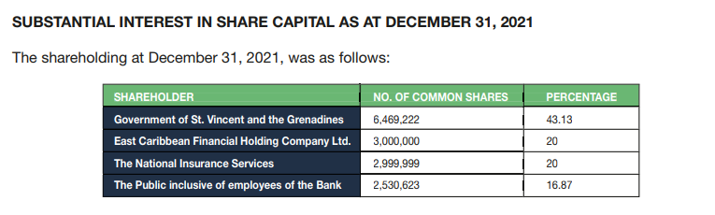
Figure 1- BOSVG- Shareholdings

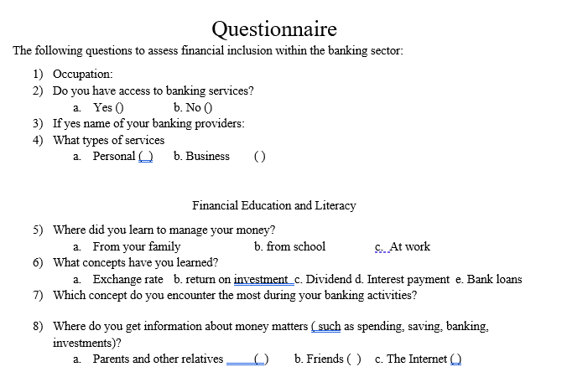

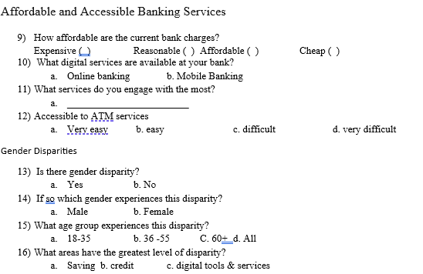
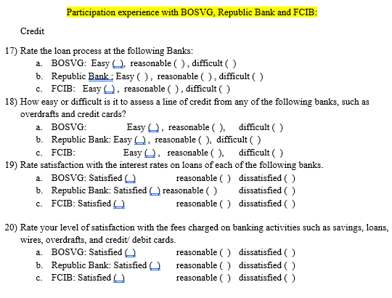

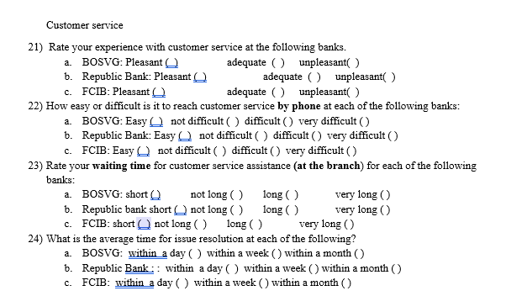
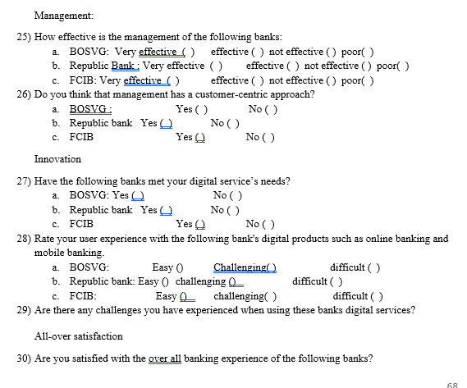

Figure 2 – Survey Questionnaire


Figure 3 FCIB loan advertisement 2018- source (properties, n.d.)

Banks list of policies used or reviewed in the last 3 years.
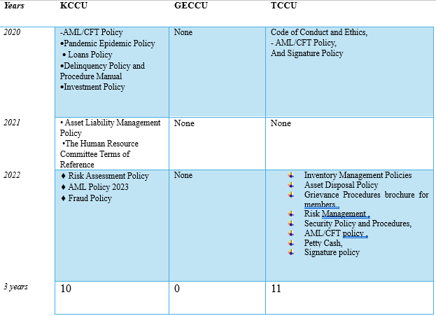

Figure 4
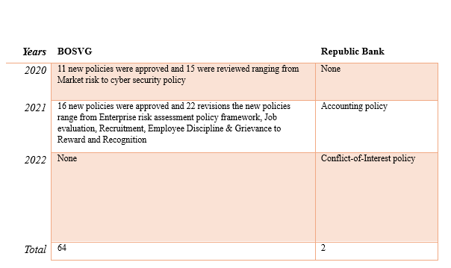
Figure 5

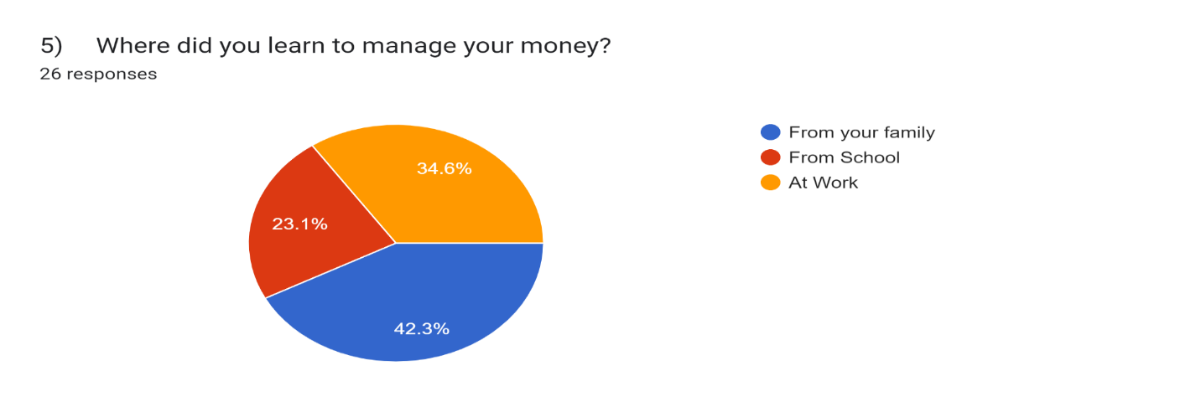
Figure 5.1

Financial Literacy scores
Country | Score
Anguilla - AI | 13.1
Antigua and Barbuda- AG | 12.7
Commonwealth of Dominica- DM | 12.2
Grenada - GD | 12.2
Montserrat - MS | 12.6
Saint Christopher (St Kitts) and Nevis- KN | 12.2
Saint Lucia - LC | 11.8
St. Vincent and the Grenadines - VC | 11.7
Source: (Eastern Caribbean Central Bank, 2023)
Figure 5.2

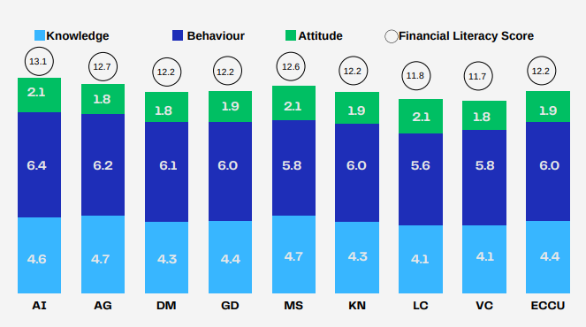
Source: (Eastern Caribbean Central Bank, 2023)
Figure 5.3

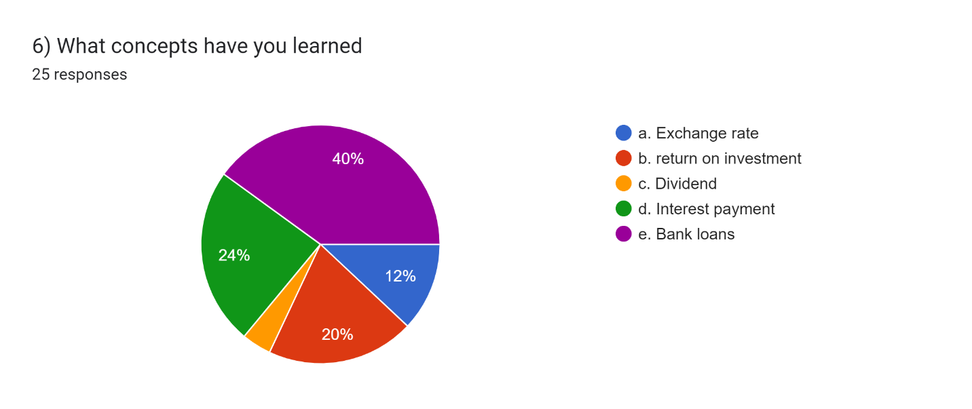

Figure 6

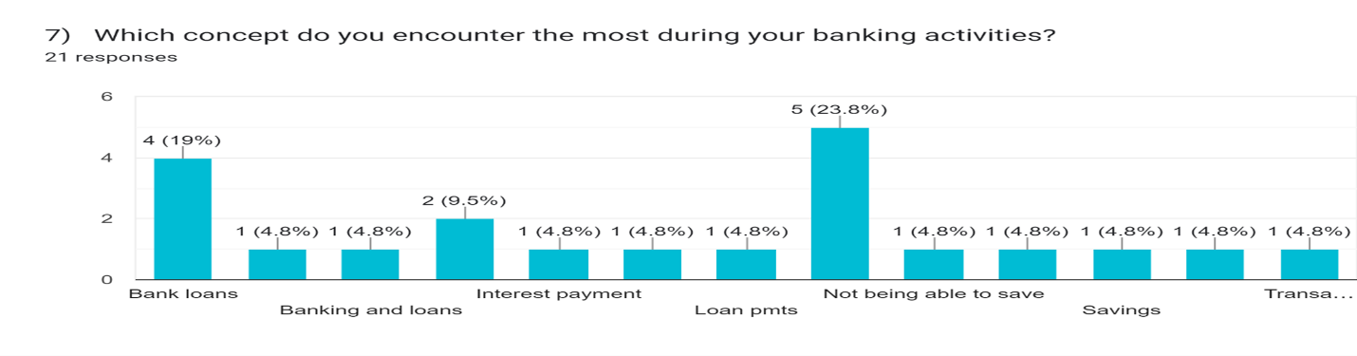
Figure 7
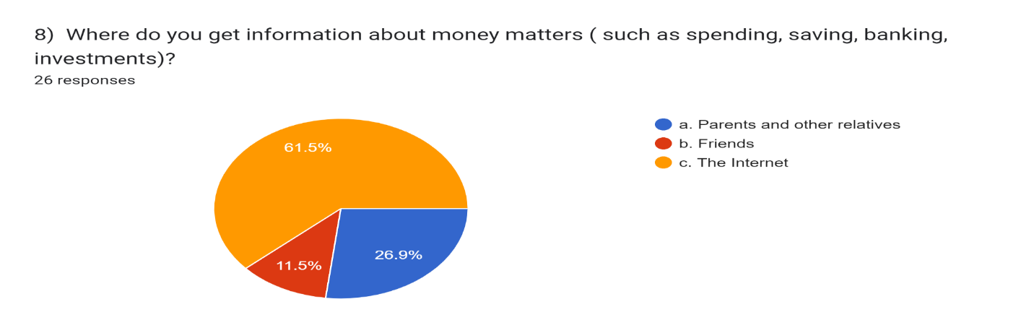
Figure 8

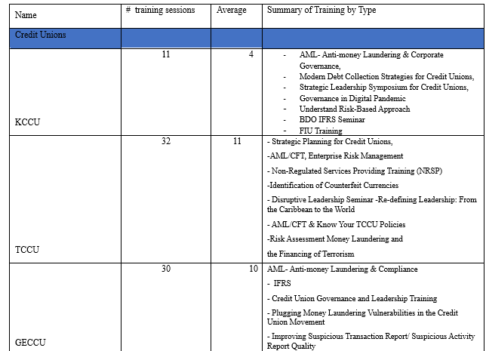
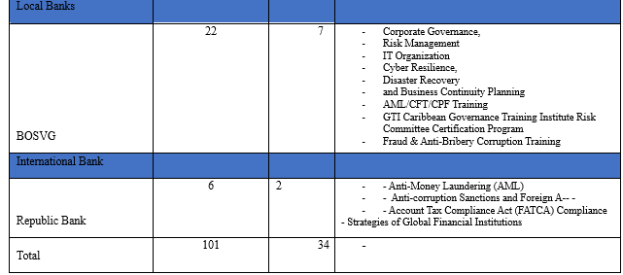
Figure 9

Policy indicator summary
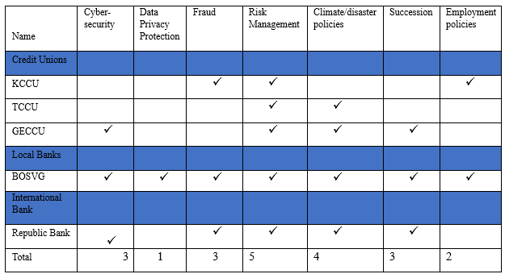
Figure 10
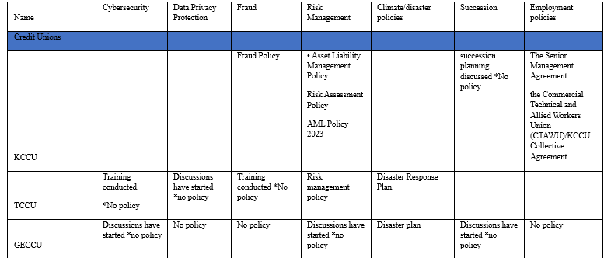
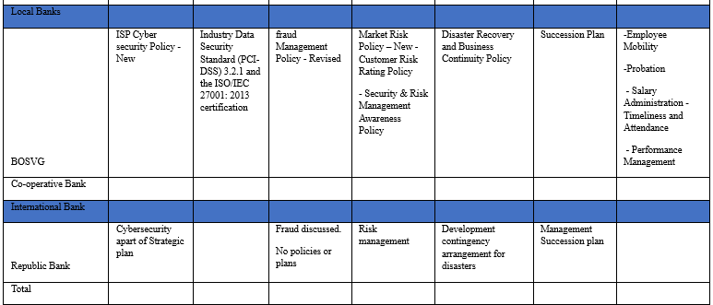
Figure 10.1
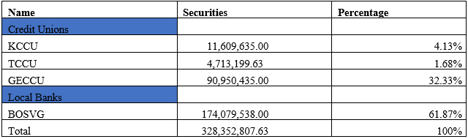
Figure 11
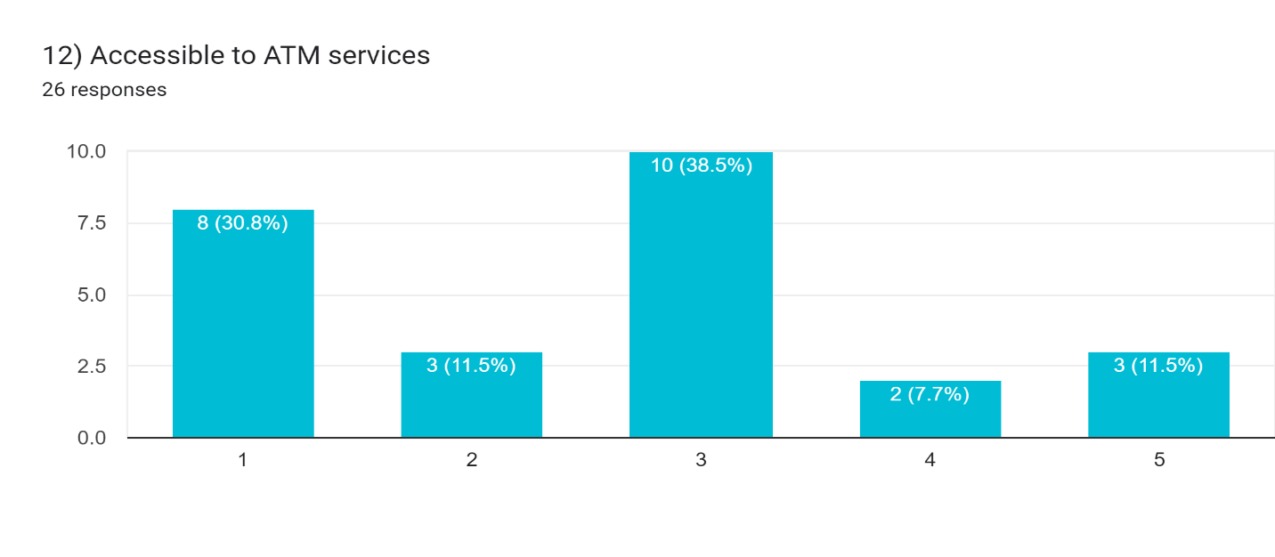
Figure 12
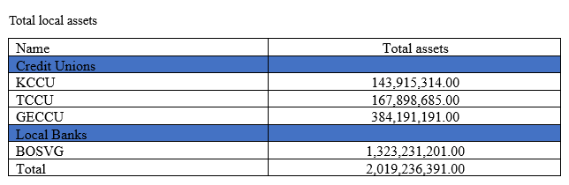
Figure 13
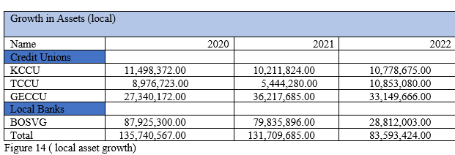
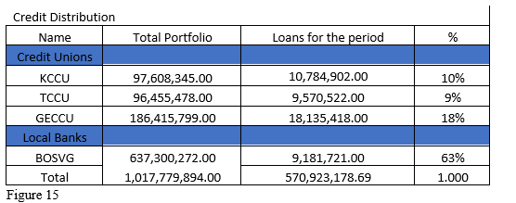
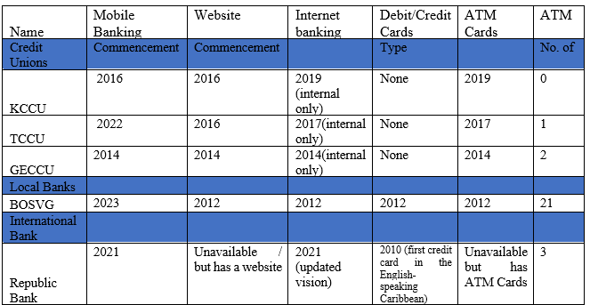
Figure 16

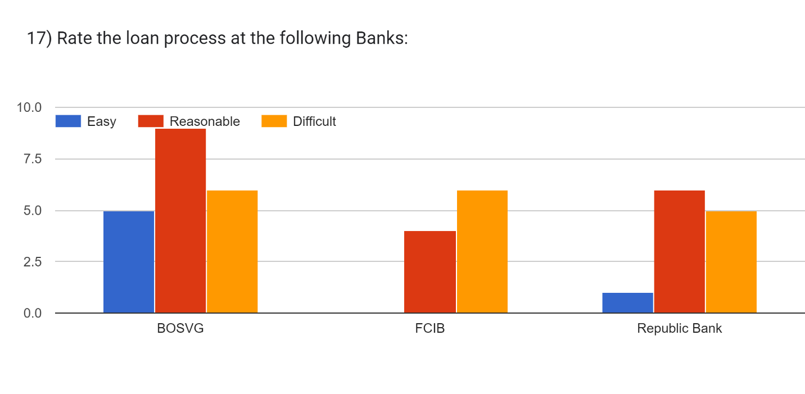
Figure 17

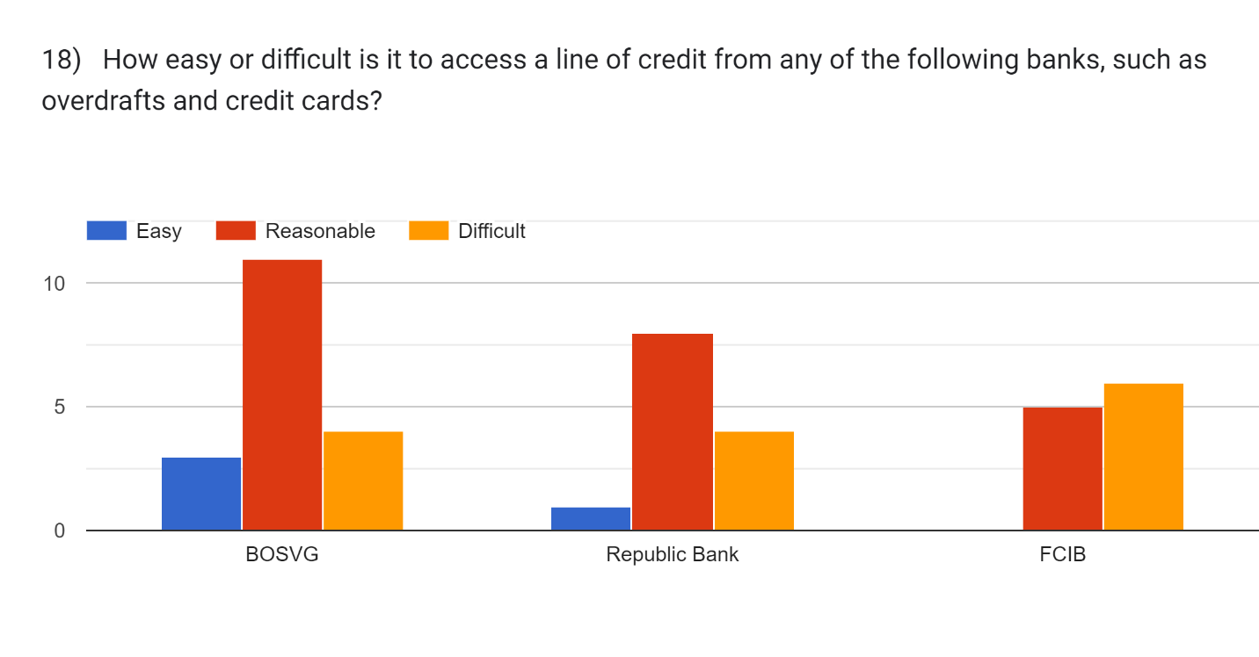
Figure 18

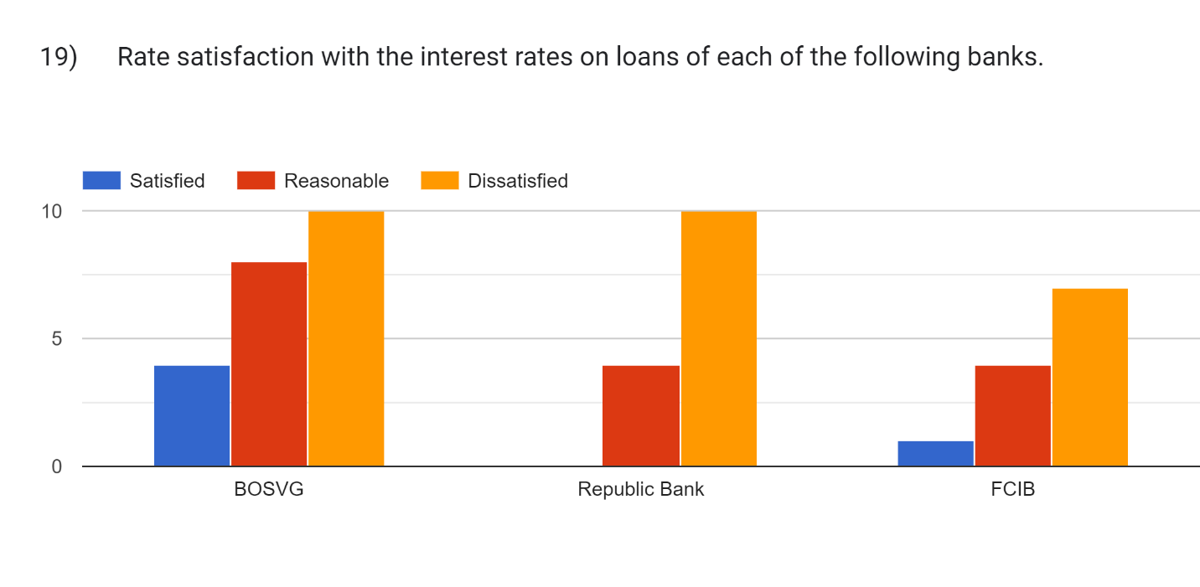
Figure 19

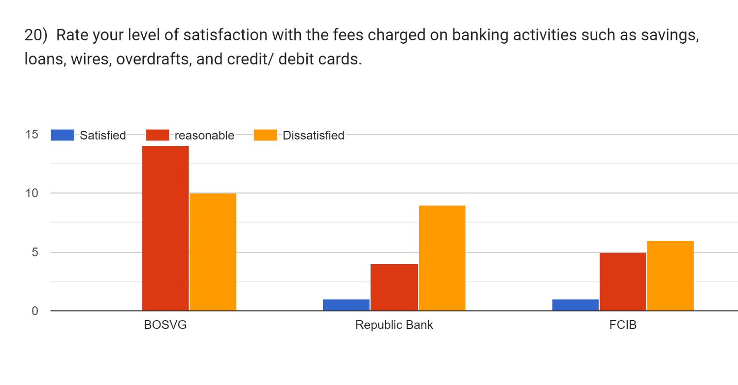
Figure 20

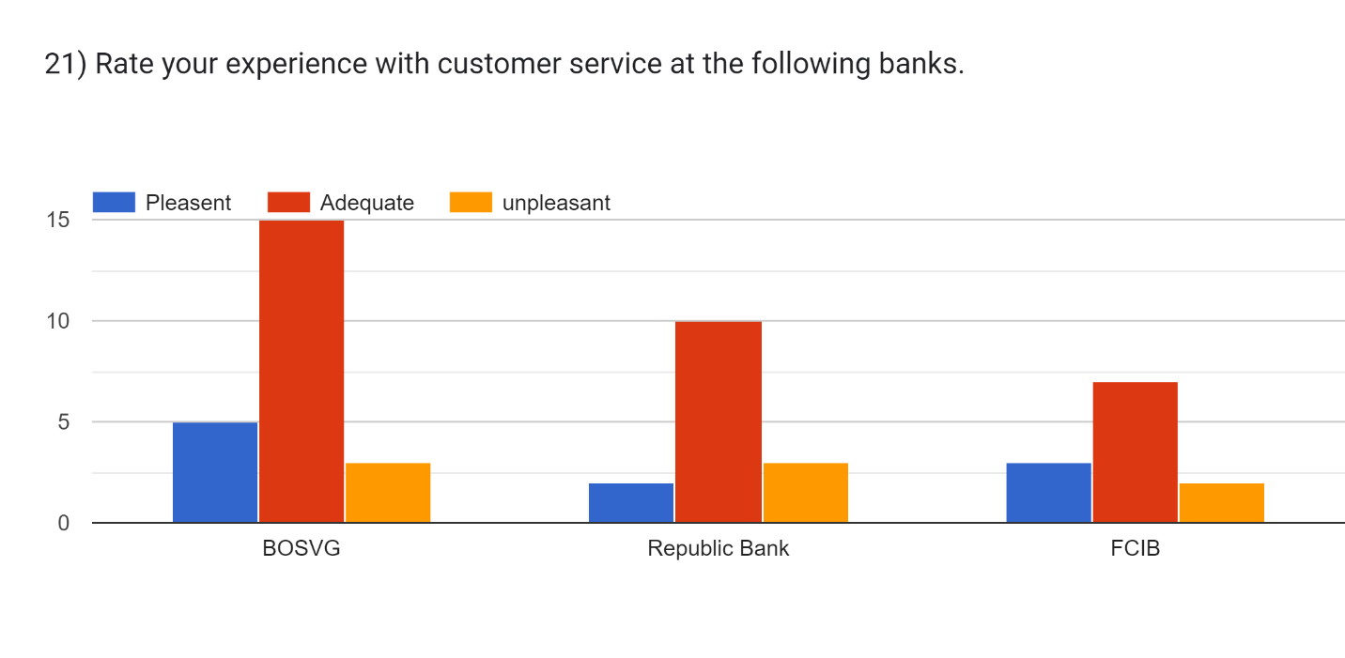
Figure 21

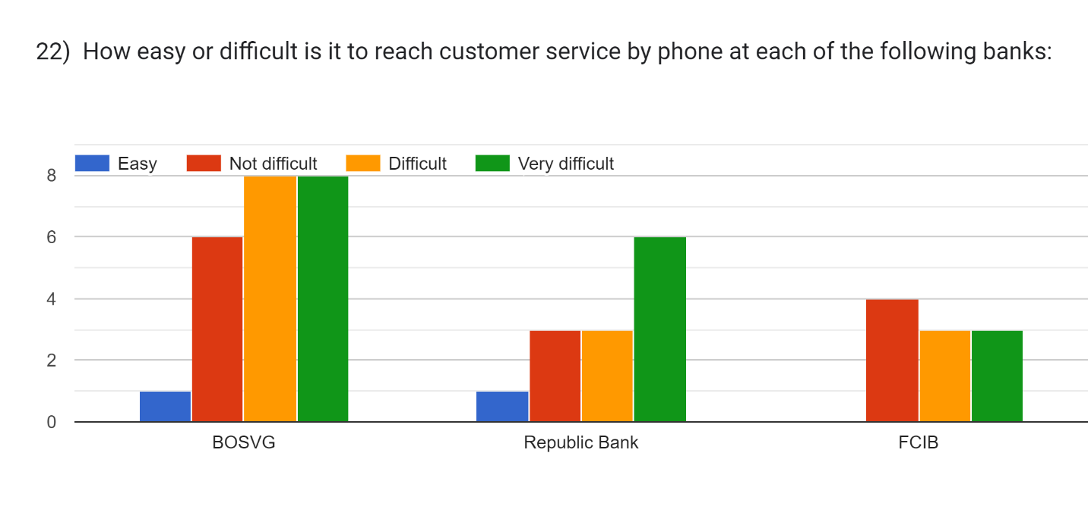
Figure 22
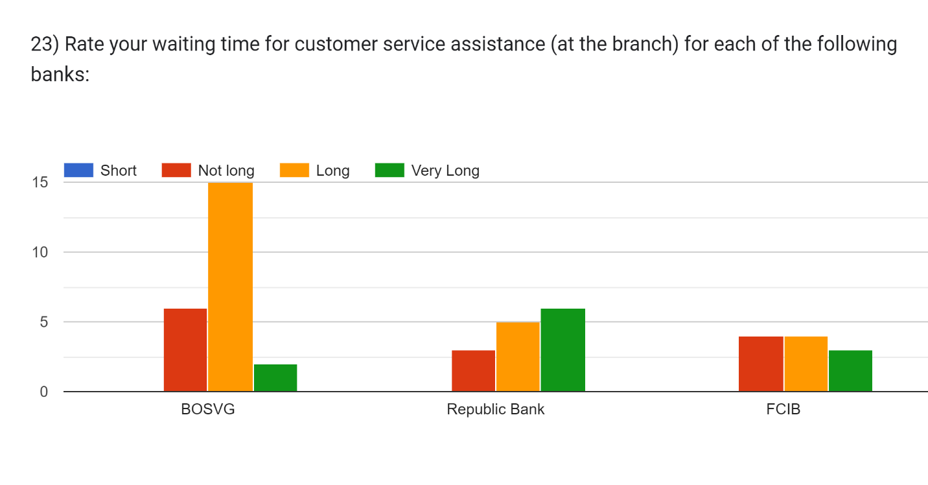
Figure 23

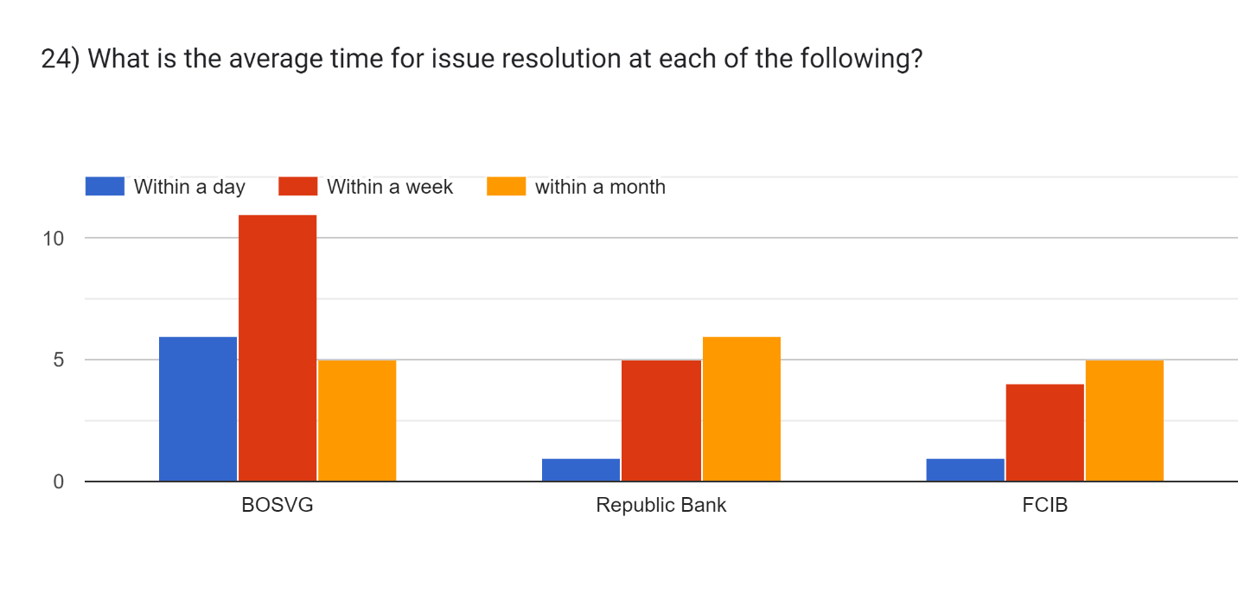
Figure 24
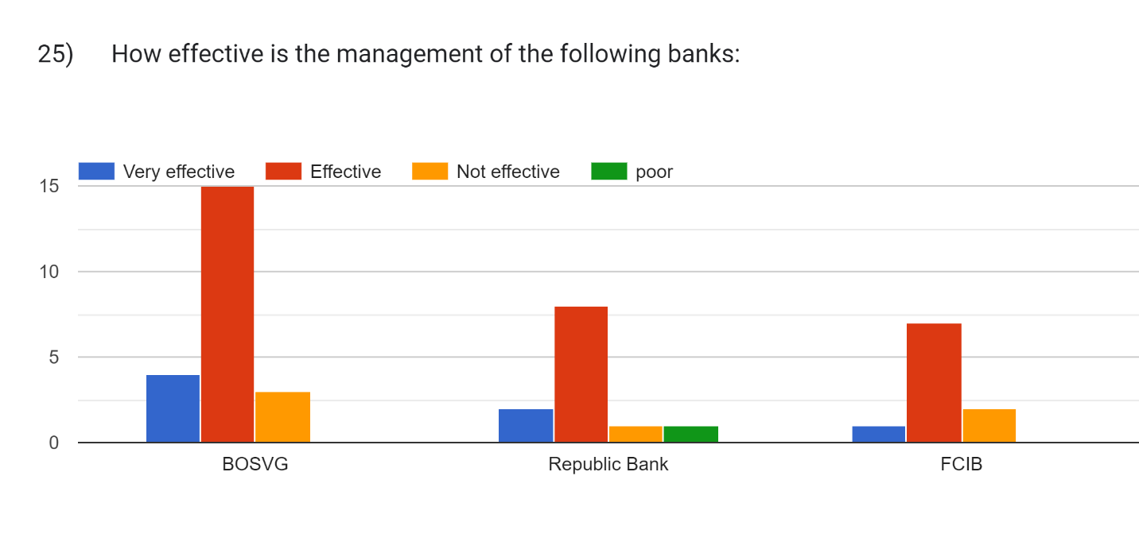
Figure 25
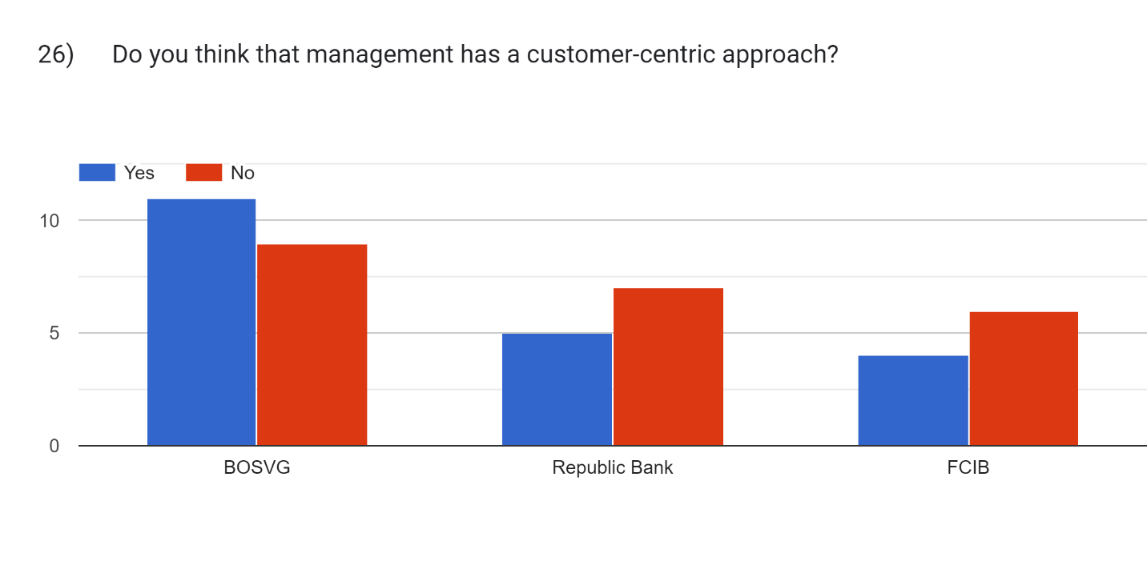
Figure 26

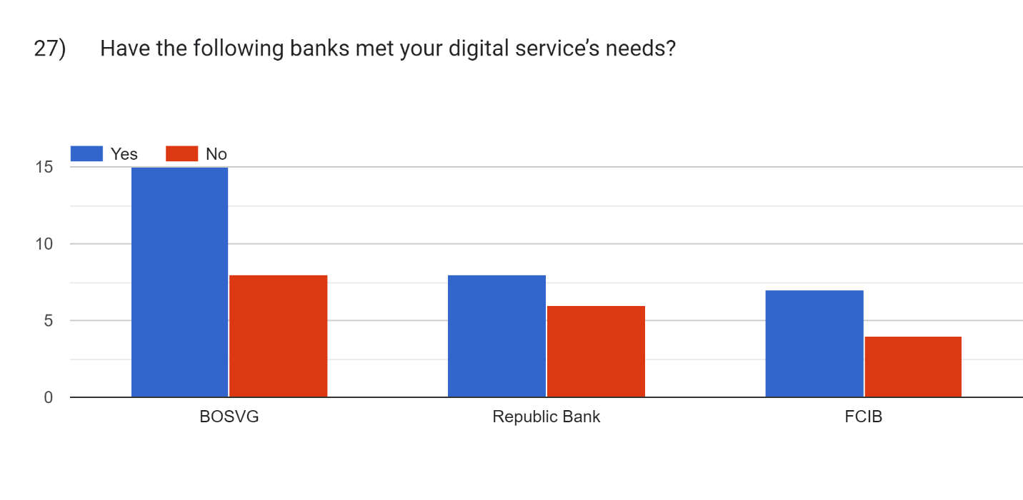
Figure 27
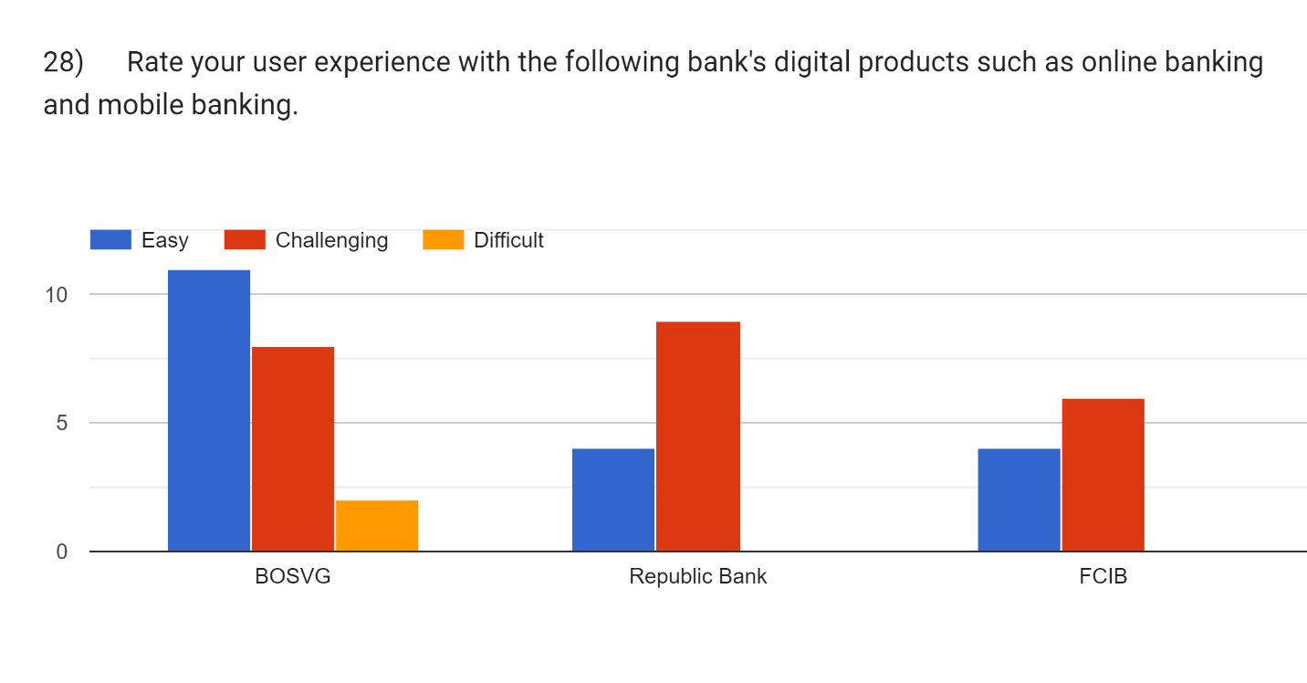
Figure 28
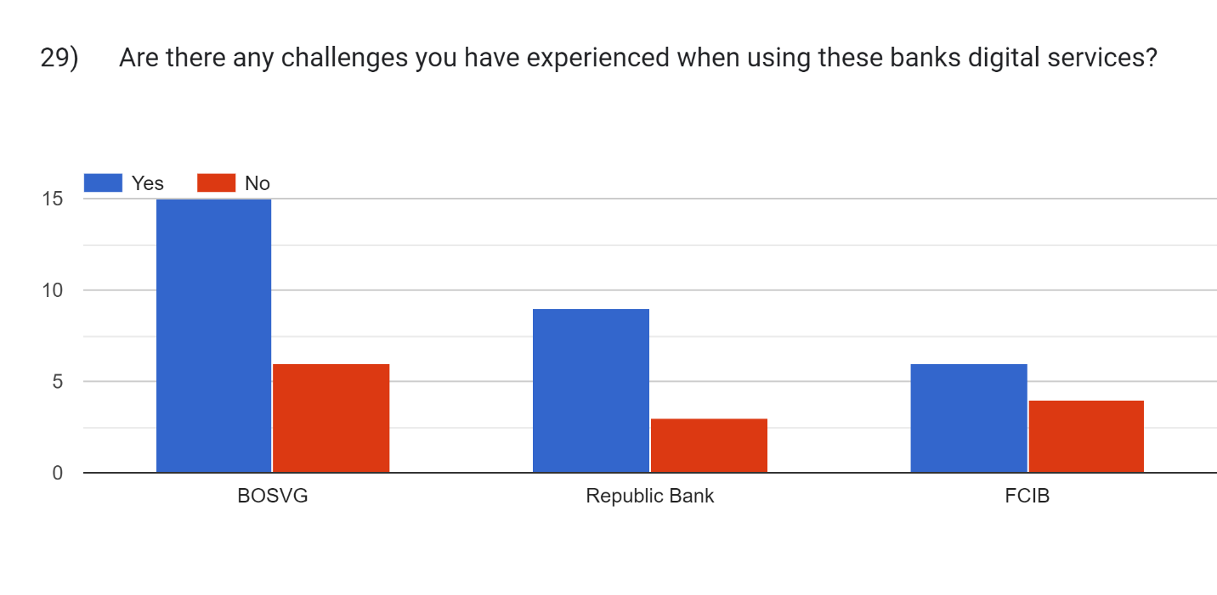
Figure 29

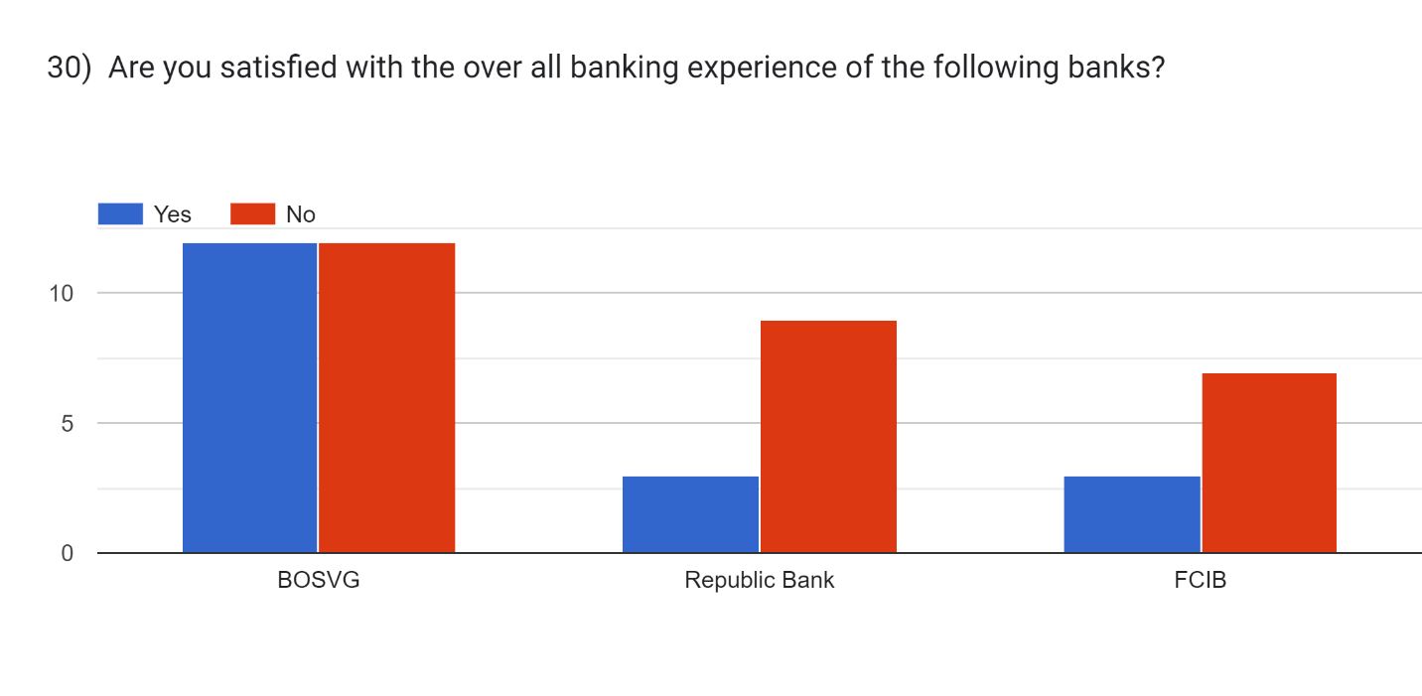
Figure 30

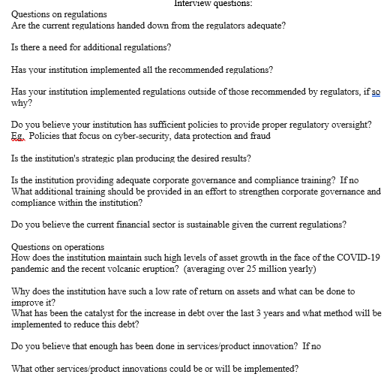
Figure 31

The Indigenous bank “BOSVG”, the 3 largest credit unions(KCCU, GECCU and TCCU) and regional bank “Republic bank
Republic Bank operates in 14 territories (Suriname, British Virgin Islands, Barbados, Cayman Islands, Trinidad, St. Vincent, Grenada, Guyana, Anguilla, St. Maarten, Dominica, St. Lucia, St. Kitts and Nevis and Ghana)
Uses non-random criteria, used for exploratory and qualitative research, there are five common types.
Employed at the following organizations- BOSVG (3), SVGTCCU (1) GECCU (1), KCCU (1), and FSA (1)
No interview could be conducted with a representative of Republic Bank
The data collection spans 2020-2022
The year 2023 reports could not be obtained as these were not available at the time of data collection.
A 2020 – 2022 data range was used to ensure all financial institutions had the same data set, Republic Bank started its operations within St. Vincent and the Grenadines on 1st November 2019, therefore the bank’s full financial year of operations would not have been completed until 2020.
FCIB was not entered by respondents as the bank operations in St. Vincent has ceased by 2024 the year of the survey.
0.7 billion or 8% of assets were held in the Caribbean for Scotia bank in 2018 before the sale to Republic bank
Ceased operations in 24th March 2023 and was subsumed as part of Bank of St. Vincent and the Grenadines operations
These committee members are appointed by the board of directors or by the general membership. These individuals are given a stipend that varies based on the institution as the larger the credit union or bank the higher the risk and therefore the stipend.
It was noted that both KCCU and Republic plan did not provide a period for their strategic plan.
All institutes stated they will not be returning to the 5-year plans and will stick to a 3-year strategic plan due to difficulties experienced during COVID-19.
However, due to the interview date the postmortem was yet to be completed to assess the effectiveness of the plans.
During the interviews, KCCU’s former president indicated that the displacement of staff due to the volcanic eruption resulted in the low amount of training conducted over the period.
During the interview process, GECCU’s compliance officer stated that the constant changing of committee members and the Board of Directors due to their short terms caused a backlog in the approval of policies.
Consultant are hired to fill this gap in knowledge.
GECCU’s Compliance officer also stated that the help of a consultant was needed for the creation of the data protection policies which were approved by the BOD in 2023.
KCCU’s former president stated that the policy gap will be closed soon. Once a consultant is hired to create them.
The CEO of TCCU noted in the interview that these policy gaps were closed in 2023 and early 2024.
Republic Bank did not take part.
BOSVG is owned by the government of St. Vincent and the Grenadines with 63.13 shares.
The local financial sector refers to the three major credit unions (KCCU, TCCU & GECCU) and the local bank (BOSVG
Loss was due to an increase in loan loss provisioning- “The increases in income were offset by an increase in Loan loss provision given the significant growth in loans and delinquencies” by the Board of Directors of KCCU
The slow in growth was attributed to the eruption of the La Soufriere volcano and the COVID-19 Pandemic’s prolonged negative impacts.
Partnership between the government of St. Vincent and the Grenadines and the World Bank

