

A Method for Object Detection in UAV Images Based on an Improved YOLOv11 Model
by
Yanpei Huang

Supervisor: Dr Abdallah Naser

Project submitted as part of the requirements for the award of
MSc Artificial Intelligence and Data Security

January 2026

Abstract
Object detection in drone imagery continues to face challenges in balancing detection accuracy with real-time performance due to factors such as significant variations in target scale, small object dimensions, and complex backgrounds. To address these issues, this paper proposes an object detection method for drone imagery based on an enhanced YOLOv11 architecture. Building upon the original YOLOv11 network structure, the model is improved in three key aspects: feature extraction capability, multi-scale feature fusion, and detection head design. Firstly, within the backbone and neck layers, the convolutions in the original C3k2 module are replaced with Global Contextual Convolutions (GCConv). This enhances the network's ability to model global information and express features in complex backgrounds. Secondly, CAFMFusion was designed for the neck and head sections. By effectively integrating features across different scales, this module improves the detection ability of model for small targets and scale-varying objects in UAV imagery. Finally, an enhanced LSCD detection head was employed to predict features at different scales, further boosting detection accuracy, localisation stability, and reducing computational overhead. Experimental results demonstrate that on drone object detection datasets, the YOLO-GCL model shows a significant improvement in detection accuracy compared with the original YOLOv11n model.. MAP50 of YOLOv11-GCL achieves an accuracy of 84.7%, surpassing the baseline YOLOv11n model by 6.81%; its F1 score reaches 82%, representing a 3.9% increase. The YOLO-GCL model not only excels in terms of accuracy and real-time performance but also demonstrates robust resilience against diverse challenges inherent in drone imagery, presenting broad application prospects. Through further optimisation, the refined model holds potential to emerge as a significant technical solution within the field of drone object detection, thereby providing robust technological support for intelligent drone applications.

Content
Abstract 2
1.Introduction 4
2.Literature Review 6
3.Model Design 12
3.1 YOLOv11n Model Structure 12
3.2 Improved YOLOv11n Model Structure 13
3.3 CafmFusion module 14
3.4 GCConv module 17
3.5 Improved detect head 19
4. Model Training and Evaluation 20
4.1 Datasets 21
4.2. Evaluation Metrics 23
4.3. Experimental Platform 24
4.4. Experimental Results 24
4.4.1. Compare with Different Attention Mechanisms 24
4.4.2 Ablation Analysis of Key Components 26
4.4.3. Performance Evaluation of Multiple Detection Models 28
4.4.4. Visual Results and Comparative Analysis 30
5. Discussion 32
6. Conclusions 33
References 35

1.Introduction
In recent years, with the rise of the low-altitude economy and the rapid advancement of intelligent hardware technology, unmanned aerial vehicles (UAVs) have found widespread application across military reconnaissance, urban security, disaster relief, traffic monitoring, and precision agriculture. This is due to their advantages of high mobility, low cost, and extensive field of view. Within these applications, UAVs serve not only as platforms for image acquisition but are also required to possess autonomous environmental perception capabilities. As a core task within computer vision, object detection technology aims to enable UAVs to accurately and in real-time locate and identify targets of interest (such as pedestrians or vehicles) within complex aerial imagery. This capability is a fundamental prerequisite for achieving intelligent and autonomous UAV operation. However, unlike general object detection in natural scenes (e.g., COCO or VOC datasets), aerial imagery from UAVs exhibits unique visual characteristics that pose significant challenges to existing detection algorithms. Firstly, targets are minuscule (Tiny Objects). Due to the drone's elevated flight altitude, ground objects occupy a negligible number of pixels in the image (often less than 32×32 pixels), resulting in severely depleted feature information that is highly susceptible to loss during the downsampling process of convolutional neural networks. Secondly, backgrounds are exceptionally intricate (Complex Backgrounds). From aerial perspectives, ground backgrounds contain abundant and chaotic textural information. In infrared imaging (such as the HIT-UAV dataset), background thermal radiation frequently causes severe interference with targets, elevating false detection rates. Finally, hardware resource constraints. UAVs typically rely on onboard embedded devices for computation, with power consumption and computational capacity subject to strict limitations, making it challenging to deploy deep models with large parameter counts and complex computations. Although deep learning has achieved great success, particularly single-stage detectors represented by the YOLO series, which have become the industry's preferred choice due to their advantages in speed and accuracy. While the latest YOLOv11 model has set new performance benchmarks for conventional object detection tasks, it still exhibits shortcomings when applied to high-altitude UAV scenarios. On one hand, the original feature extraction architecture of YOLOv11 remains limited in capturing fine-grained features when processing faint infrared targets, leading to potential missed detections. On the other hand, although YOLOv11 offers lightweight variants, its computational complexity (GFLOPs) remains optimisable for micro-UAV platforms when pursuing ultimate precision. Consequently, significantly enhancing the model's detection accuracy for small aerial objects while maintaining real-time performance represents a critical scientific challenge requiring urgent resolution.
Addressing the prevalence of small-sized targets and strong background interference in UAV imagery, this paper refines YOLOv11 across three domains: the backbone network, feature fusion, and detection.
(1) The GCConv convolutional structure—more conducive to capturing global information—is introduced into the backbone and feature fusion stages. Combined with an enhanced C3K2 module, this enables the network to better utilise contextual information surrounding targets within images, with minimal computational overhead. This design addresses the deficiency of traditional convolutions in comprehensively perceiving spatial information within aerial scenarios, thereby furnishing more effective foundational features for subsequent fusion.
(2) To prevent features of diverse-sized objects—particularly small targets—from being overlooked within the network, this paper introduces a multi-scale feature fusion method (CAF Fusion) positioned between the feature fusion and detection stages. This method combines and enhances features from different layers, allowing low-level detail information to complement high-level semantic information, thereby improving the model's recognition capability for targets of varying sizes. Compared to common feature pyramid structures, this fusion approach maintains a concise network architecture while enhancing feature utilisation efficiency.
(3) During the object prediction stage, the detection module is refined to enable more rational utilisation of multi-scale features for prediction, thereby enhancing the stability and accuracy of object location regression.
By incorporating the above enhancements, YOLOv11-GCL attains a MAP50 value of 84.7%, achieving a 6.81% improvement compared with the baseline YOLOv11n model, while the F1 score increases to 82%, corresponding to a gain of 3.9%. Importantly, these performance improvements are realized without a substantial increase in model complexity. The proposed approach therefore enables more accurate recognition of small-scale and structurally complex targets in UAV imagery, providing an effective and efficient solution for drone-based object detection that maintains a favorable balance between detection accuracy and computational efficiency.
In summary, considering the problems of small object size, complex backgrounds, and high real-time requirements in UAV images, it is of great research significance and practical value to study an object detection method based on an improved YOLOv11 model.
The research results of this work are expected to further promote the development of UAV visual perception technology and provide strong support for intelligent UAV applications.

2.Literature Review
With the rapid development of Unmanned Aerial Vehicle (UAV) technology, UAVs have been widely used in many fields, such as military reconnaissance, intelligent transportation, urban management, emergency rescue, environmental monitoring, and public safety. UAVs have advantages such as strong mobility, low cost, flexible deployment, and diverse viewing angles, and they can obtain large-area and high-resolution image information in complex environments or areas that are difficult for humans to access. In this context, computer vision technology based on UAV platforms has gradually become a research focus. Among the related technologies, object detection in UAV imagery constitutes a fundamental task for enabling advanced intelligent perception and autonomous decision-making, and thus holds considerable academic significance and practical value. Fan et al. ‎[1] conducted a comprehensive survey of the development and application of UAV systems, highlighting the rapid advances achieved in platform architecture, communication technologies, sensor integration, and intelligent perception. As a result, UAVs have been extensively deployed in diverse domains, including military operations, traffic surveillance, environmental monitoring, and public safety. In the medical domain, Ullah et al. ‎[2] systematically reviewed UAV application frameworks in smart healthcare and demonstrated that UAVs exhibit distinct advantages in scenarios such as remote medical assistance, emergency medical supply transportation, and disaster relief operations. In the agricultural sector, Tsouros et al. ‎[3] presented a detailed review of UAV-enabled precision agriculture, emphasizing that the combination of high-resolution image acquisition and flexible deployment allows UAVs to play an increasingly important role in crop growth monitoring, pest and disease detection, and agricultural environmental sensing. Building upon this, Ajayi et al.‎[4] assessed the performance of the YOLOv5 model for automatic crop and weed identification using UAV-acquired agricultural imagery. Their experimental results confirmed that YOLO-series models achieve a favorable balance between detection accuracy and real-time performance in UAV-based object detection tasks. Collectively, these studies demonstrate that UAVs have become a crucial information acquisition platform in agricultural applications, thereby imposing higher demands on visual perception and object recognition capabilities. In disaster emergency scenarios, forest fire monitoring and suppression represent one of the most critical application areas for UAV technology. Early research by Ollero and Merino‎[5] revealed that UAVs are capable of performing fire monitoring tasks in complex, high-temperature, and high-risk environments, significantly reducing the operational risks faced by human personnel while providing timely information to support fire response decision-making. With the ongoing advancement of UAV technologies, research focus has gradually shifted from single-UAV operations toward cooperative multi-UAV systems. Ghamry et al. ‎[6] specifically addressed forest fire applications by proposing a particle swarm optimization–based approach for task allocation and path planning in multi-UAV cooperative frameworks, with the aim of enhancing monitoring effectiveness and emergency response efficiency. These findings indicate that both single-UAV and multi-UAV systems are highly dependent on real-time perception of environmental conditions and critical targets in complex disaster scenarios, and that robust and accurate visual object detection serves as a key enabling technology for such applications. In addition, UAVs have gained increasing attention in marine and environmental monitoring tasks. Yuan et al.‎[7] developed a UAV-based gas sensing system for monitoring ship emissions over marine environments and validated the feasibility of employing UAVs for maritime environmental surveillance and pollution assessment. This work further illustrates that UAVs are becoming an essential technological tool in marine and environmental monitoring.
With the widespread use of deep learning in computer vision, especially convolutional neural networks (CNNs) due to their powerful feature representation capabilities, they have gradually replaced traditional methods based on hand-crafted features and become the mainstream approach for object detection tasks. The Region-based Convolutional Neural Network (R-CNN) proposed by Girshick et al. ‎[8] is a milestone, considered as the breakthrough that brought deep learning into the field of object detection. The R-CNN method creatively applied high-level deep convolutional features to object detection and semantic segmentation tasks, breaking the bottleneck of traditional methods in feature representation. This approach effectively solved the problem of insufficient robustness in traditional models when facing complex backgrounds, object occlusions, and dramatic appearance changes, leading to a significant improvement in detection accuracy (mAP). R-CNN not only greatly enhanced the performance benchmark for object detection but also laid a solid theoretical and practical foundation for a series of subsequent detection algorithms, establishing deep learning as the core technology in modern object detection systems.
However, R-CNN needs to repeatedly extract features for each region proposal, which leads to very high computational cost and makes it difficult to meet the efficiency requirements of practical applications. To solve the problems of inconsistent input scales and low computational efficiency, He et al. [9] proposed the Spatial Pyramid Pooling (SPP) structure and applied it to deep convolutional networks .SPP introduces multi-scale pooling operations on feature maps, which allows the network to extract multi-scale semantic information while keeping flexible input sizes, thus avoiding repeated cropping and resizing of input images. This idea not only improves detection efficiency but also enhances the model’s ability to adapt to objects of different scales, and to some extent reduces the detection difficulty caused by object scale variations. Based on this, Girshick [10] proposed the Fast R-CNN method and further optimized the R-CNN framework. Fast R-CNN performs convolutional feature extraction on the entire image only once, and then uses ROI Pooling on shared feature maps to crop and align features for each region proposal, which greatly reduces redundant computation. At the same time, this method combines classification and bounding box regression into a single multi-task learning framework and enables end-to-end training, thereby significantly improving training efficiency and detection speed. Although Fast R-CNN shows clear improvements in both detection performance and computational efficiency, it still relies on traditional region proposal generation methods, which limits further improvement in overall detection speed. To address the low efficiency of region proposal generation, Ren et al. [11]proposed the Faster R-CNN method, which introduced a Region Proposal Network (RPN) into the original detection framework to achieve deep network-based region proposal generation and end-to-end joint training with object detection. The RPN automatically generates high-quality region proposals by sharing convolutional features, effectively reducing manual design processes and significantly improving overall detection speed while maintaining detection accuracy. Faster R-CNN became a representative model of two-stage object detection methods and achieved excellent performance on multiple benchmark datasets, which further promoted the development of object detection technology.
To overcome the problems of high computational complexity and insufficient real-time performance in two-stage object detection methods, researchers proposed a series of one-stage object detection methods that unify object localization and classification into a single end-to-end network. The SSD (Single Shot MultiBox Detector) proposed by Liu et al. [12] performs predictions on feature maps of different scales. SSD was the first to systematically introduce multi-scale features into the one-stage detection framework, providing an important idea for later real-time object detection methods. However, in scenarios with small object sizes or complex backgrounds, its detection performance still has certain limitations. After that, Redmon et al. [13] proposed the YOLO model, which treats the entire image as a regression problem and completes object location prediction and category classification in a single forward pass, greatly improving detection speed and significantly promoting the development of real-time object detection technology. Due to their simple structure and fast inference speed, YOLO-series models have received wide attention in many scenarios such as video surveillance, UAV vision and so on. However, early YOLO models showed relatively limited performance in detecting small objects and densely distributed targets. To address the severe imbalance between foreground and background samples in one-stage detection methods, Lin et al. [14] proposed the Focal Loss function, which reduces the weight of easy-to-classify samples and encourages the model to focus more on hard samples, effectively improving dense object detection performance. This method provides a new direction for improving training stability and detection accuracy of one-stage detection models in complex scenes, and has been widely adopted in many subsequent detection frameworks.
However, many problems still remain to be solved in UAV image object detection tasks. First, since UAVs usually capture images from high altitudes, ground objects occupy only a small proportion of the image. Many objects, especially pedestrians and bicycles, cover only a few pixels and are typical small objects. Such objects are likely to lose key information during network downsampling, which often leads to missed detections. Second, during UAV flight, the shooting altitude and viewing angle change continuously, and the same object may show large differences in size and appearance in different images, making it difficult for detection models to perform well on objects of different scales at the same time. In addition, UAV images usually contain complex backgrounds, such as road textures, building structures, and vegetation areas, which easily interfere with object feature extraction and increase the probability of false detections. In scenes where objects are densely distributed or partially occluded, it becomes more difficult for the model to distinguish object boundaries and categories. At the same time, in practical applications, UAVs are usually limited by onboard computing resources and energy conditions. Therefore, object detection models are required not only to achieve high detection accuracy, but also to have low computational complexity and fast inference speed to meet real-time processing requirements. In summary, UAV object detection needs to address not only visual challenges, but also achieve a balance between accuracy and real-time performance.
To address the problems of small object size, large scale variation, and frequent missed detections under UAV viewpoints, Liu et al. [15] first proposed the UAV-YOLO method. Based on the traditional YOLO framework, this method customized the network structure to enhance the preservation of high-resolution features and improve small object representation. Experimental results showed that the small object detection accuracy of this method on UAV-view datasets was significantly improved compared with the original YOLO model, which verified the effectiveness of specially optimizing the detection network structure for UAV scenarios. However, UAV-YOLO is mainly based on an early version of the YOLO architecture. Its feature fusion strategy and network representation ability still have certain limitations, and experimental validation is mainly focused on specific datasets and limited object categories. Its generalization ability under complex backgrounds and multi-scale object scenarios has not been systematically evaluated. With the continuous evolution of the YOLO framework, Zhai et al. ‎[16] developed the YOLO-Drone network by building upon the more advanced YOLOv8 architecture. Through targeted optimization of the feature extraction backbone and the detection head, the proposed approach significantly enhances the detection capability for extremely small objects, while largely preserving the model’s inference efficiency. This study shows that combining UAV scene characteristics with structural optimization on a new generation of YOLO frameworks can achieve better detection performance. However, the experimental evaluation still mainly focuses on tiny objects and specific UAV datasets, and lacks sufficient analysis of overall multi-scale detection performance and stability across different application scenarios. Fan et al. [30]proposed the LUD-YOLO model, which achieves a good balance between lightweight design and detection performance in UAV scenarios, providing an effective reference for UAV object detection. However, this method mainly focuses on lightweight design, and its improvement in feature representation ability under complex scenes is still limited. Therefore, it is very important to found methods to improve detection accuracy while maintaining model efficiency. To enable object detection in environments with limited device, Huang et al. [29] proposed the YOLO-LITE model, which significantly reduces computational complexity by simplifying the network structure and provides an effective solution for object detection on resource-limited platforms. However, this method still has certain limitations in detection accuracy, especially in small object detection. Therefore, how to further improve detection performance while ensuring real-time capability remains an important research problem. Fang et al. ‎[17] proposed Tinier-YOLO, a lightweight network that substantially reduces model parameters and computational overhead through aggressive network pruning strategies and lightweight architectural design. As a result, the inference speed on embedded and edge computing platforms is significantly enhanced. Nevertheless, owing to the extensive simplification of the network structure, Tinier-YOLO inevitably suffers from a certain degradation in detection accuracy when compared with the standard YOLO model, particularly in challenging scenarios involving small-scale targets or complex background interference. To overcome the inherent limitation of conventional YOLO architectures, which predominantly depend on convolutional operations and thus exhibit limited capability in modeling long-range dependencies and global contextual information, Wang et al. ‎[18] introduced the Mamba structure based on state space models and developed the Mamba YOLO framework. By replacing or integrating specific convolutional modules within the detection network, this approach enables the model to capture more comprehensive global contextual representations while still maintaining relatively high inference efficiency.
Experimental results show that Mamba YOLO achieves certain performance improvements compared with the original YOLO model on several general object detection datasets. However, after introducing the state space model structure, the overall network complexity increases, and the significantly increased computation makes its performance on edge devices less outstanding. To address problems such as large scale variation, irregular orientation distribution, and dense arrangement of objects in optical remote sensing images, Li et al. improved the rotation object detection algorithm S2A-Net and proposed an improved S2A-Net detection method‎[19]. This method enhances the model’s ability to represent object orientation information and geometric features by optimizing feature extraction and orientation-aware related modules.
With the proposal of the YOLO11 model, many studies have focused on performance optimization in different application scenarios. Gong et al. [31] proposed AED-YOLO11, which improves small object detection performance through feature enhancement and detection head optimization. Zhou et al. [32] proposed SMA-YOLO, which introduces multi-scale feature fusion and attention mechanisms to effectively improve small object detection accuracy in UAV remote sensing images. For space object detection and remote sensing scenarios, Zhou et al. [33] and Wang et al. [34] improved YOLO11 from the perspectives of network structure and feature fusion, respectively, enhancing detection robustness under complex backgrounds. In addition, Wang et al. [35] proposed SCI-YOLO11 and applied the improved YOLO11 to transmission line insulator defect detection, verifying its applicability in industrial scenarios. Zhao et al. [36] optimized YOLO11 for lightweight design and accuracy in UAV-based maritime search and rescue tasks. Bai et al. [37] proposed HFC-YOLO11, which improves the recognition ability of tiny remote sensing targets through an efficient feature fusion strategy. Dai and Fang ‎[38] combined an improved YOLO11 with the Segment Anything Model to construct an adaptive quantitative assessment system for armature defect detection, achieving accurate defect localization and fine-grained segmentation in industrial inspection tasks. Gan et al.‎[39] design an YOLO11 based ship detection method for optical remote sensing images by integrating discrete Fourier transform features and a synergistic attention mechanism, which significantly improved detection performance under complex maritime backgrounds. Focusing on practical deployment, Meena and Manikandan ‎[40] investigated a lightweight YOLO11-based model for drone detection in noisy environments, demonstrating that optimized network structures can maintain stable detection accuracy while reducing computational cost. Overall, existing studies mainly improve YOLO11 from the perspectives of small object enhancement, multi-scale feature fusion, and model lightweight design, and have achieved certain results in specific application scenarios.

3.Model Design
This chapter presents the overall design of the proposed object detection model for UAV images. Considering the characteristics of UAV scenes, such as small object size, complex backgrounds, and high real-time requirements, YOLOv11n is selected as the baseline network due to its lightweight structure and good balance between accuracy and efficiency. Based on the original YOLOv11n architecture, several targeted improvements are introduced to enhance feature representation and detection performance. This chapter first describes the network structure of the original YOLOv11n model, and then presents the improved network architecture and the proposed modules in detail.

3.1 YOLOv11n Model Structure
YOLOv11 is the next-generation real-time object detection model launched by Ultralytics between 2024 and 2025. Compared to predecessor architectures such as YOLOv8 and YOLOv9, it achieves significant improvements in accuracy, speed, and lightweight design. Through a multi-scale composite scaling mechanism across depth and width, YOLO11 offers multiple model scales from YOLO11n to YOLO11x to accommodate diverse inference scenarios[20]. Its overall structure retains the three components of backbone network, neck network, and detection head, but core modules have been upgraded: the backbone network incorporates the more efficient C3k2 architecture and C2PSA attention mechanism to enhance feature expression capabilities[21]; The neck network incorporates an improved PAN/FPN multi-scale fusion strategy to enhance cross-scale information exchange; the detection head maintains its decoupled classification and regression branch design, combined with a more stable loss function and free anchor detection mechanism, making the model more robust in small object detection, occlusion scenarios, and low-contrast environments.
Benefiting from a deeper feature extraction network, an optimised gradient flow control mechanism, and a lighter convolutional architecture, YOLO11 achieves higher mAP on standard datasets such as COCO while maintaining computational overhead comparable to or lower than its predecessor. Overall, YOLO11 significantly enhances detection accuracy and model stability while preserving the YOLO series' high-speed inference advantage. This provides greater feasibility and performance ceilings for applications in resource-constrained scenarios such as drones, autonomous driving, and mobile devices. The overall YOLOv11 architecture is illustrated in Figure 1.
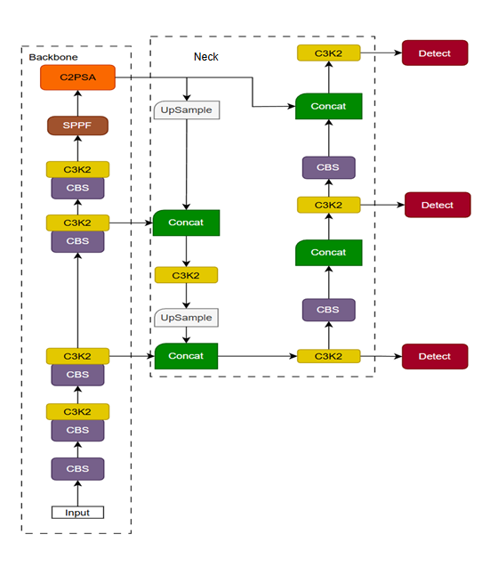
Figure 1. YOLOv11 structure.

3.2Improved YOLOv11n Model Structure
Object detection tasks from a drone perspective typically present significant perceptual and computational challenges. Due to the constraints of high-altitude imaging and wide fields of view, targets often appear small in scale, with weak details and low contrast within the imagery. This renders them highly susceptible to being obscured by backgrounds composed of buildings, vegetation, and complex textures, thereby increasing the difficulty of feature extraction and target identification. Concurrently, constraints imposed by onboard computational power, storage capacity, and energy consumption necessitate stringent requirements for lightweight model architecture design and inference efficiency. Consequently, achieving efficient deployment while maintaining detection accuracy represents a critical trade-off in algorithm design for such scenarios.
To address these challenges, this study proposes YOLO-CGL, an efficient detection model for small object, base on YOLOv11n. Figure 2 illustrates the overall architecture of the improved model, incorporating a series of structural enhancements and module optimisations tailored for UAV applications.
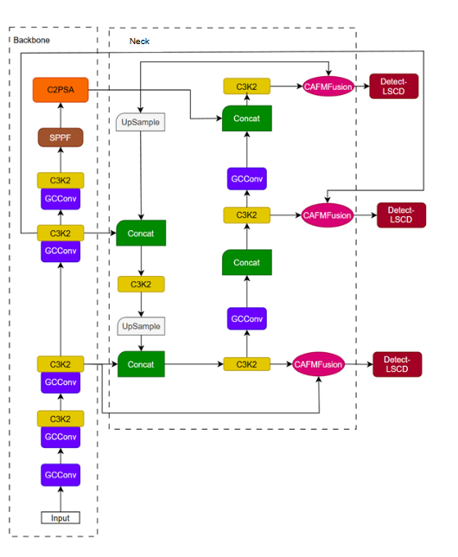
Figure 2. Improved YOLOv11 architecture.

3.3 CafmFusion module
Between the backbone network and detection head of YOLOv11, the C3k2 module serves as a crucial link connecting the front and rear networks. Employing a multi-branch convolutional architecture, this module primarily extracts mid-to-low-level spatial textures and local detail information from images. Due to its small convolution kernel size and flexible structural design, C3k2 generates feature maps with strong detail description capabilities at relatively low computational cost. Subsequently, these features are passed to the Detect module, which performs bounding box regression, class prediction, and object confidence estimation based on the input features. Consequently, the quality of features input to the Detect module significantly determines the final detection performance. However, this feature transfer process still has certain limitations. C3k2 tends to output local detail features, whereas the Detect module requires comprehensive features that combine both local texture and global semantic information. Given the disparity in feature hierarchy and emphasis between the two modules, directly feeding C3k2's output to Detect risks inadequate fusion of local information with global semantics. This compromise impairs the detection head's ability to discern target structure and category.
To address this, we introduce the CAFMFusion module between C3k2 and Detect. The CAFMFusion module design is based on the fusion module proposed by Chen et al. [22]. Compared to the original module, we replace the CGA attention mechanism [22] with the CAFM attention mechanism [23]. The primary reason lies in the differing focus of these two attention mechanisms when processing features, as illustrated in Figure 3. CGA attention is confined to the channel level, exhibiting weaker capabilities in understanding spatial structures and global contextual information. In object detection tasks, particularly when dealing with small targets, complex backgrounds, or significant variations in target scale, the CGA attention mechanism tends to focus on only partial features, leading to insufficient utilisation of overall information. In contrast, the CAFM attention mechanism combines local convolutions with global attention during feature enhancement. This not only strengthens detailed information but also enables the understanding of relationships between different regions, allowing the model to focus on more appropriate features at different locations. This renders CAFM more adaptable when handling multi-scale objects and complex scenes. Replacing CGA with CAFM enables the fusion module to supply the subsequent Detect module with more stable and information-rich features, thereby contributing to enhanced overall detection performance.
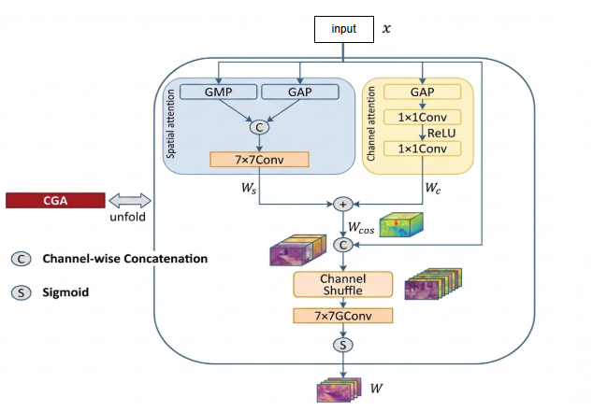
(A)
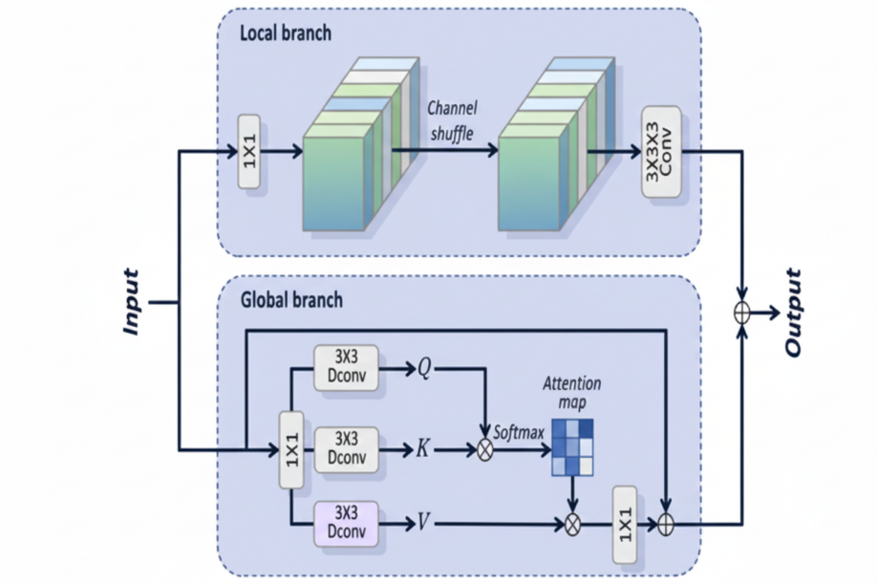
(B)
Figure 3.GCA Attention Mechanism(A) and CAFM Attention Mechanism(B)
Building upon this foundation, this paper further elucidates the structure and workflow of the CAFM Fusion module. Through adaptive weighting, the CAFM Fusion module achieves effective integration of feature information across different hierarchical levels and spatial scales.
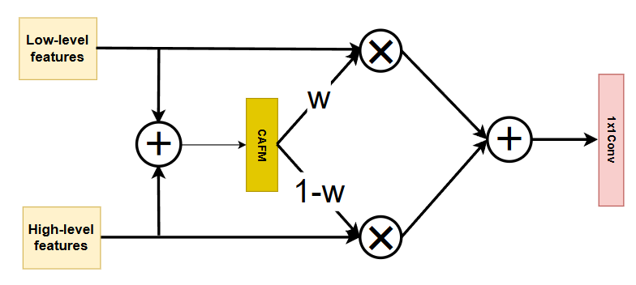
Figure 4. CafmFusion architecture.

The module first performs element-wise addition of features from low-level(${ X}_{l}∈R^{C×H×W}$)and high-level layers($X_{h}∈R^{C×H×W}$) to obtain an initial fusion feature containing multi-scale context.
$${X​}_{0}={ X}_{l}+X_{h}​$$
This is then input to the CAFM module to extract attention cues that complement global semantics with local details.
Input the initial feature ${X​}_{0}$into the CAFM module:
$$W=CAFM({X​}_{0}​)$$
where $W∈R^{C×H×W}$, undergoes a Sigmoid mapping to (0,1), serving as the pixel-level fusion weight:
$$w=σ(W)$$
Subsequently, CAFM generates a pixel-wise weight map w, which is applied to both low-level and high-level features to dynamically adjust their contribution ratios: low-level features are multiplied by w, while high-level features are multiplied by 1−w.
Low-level feature weights:
$$X_{l}^{'}=w⊙{ X}_{l}​$$
High-level feature weights:
$$X_{h}^{'}​=(1-w)⊙X_{h}​$$
The final merged output features are:
$$X_{f}=X_{l}^{'}​+X_{h}^{'}​$$
Finally, the two weighted features are recombined through a 1×1 convolution for integration and channel reconstruction, yielding a more discriminative and structurally coherent fusion feature.
The expressive power of fusion features is enhanced through a linear mapping:
$$Y={Conv​}_{1×1}(​X_{f})$$
CAFM Fusion Master Formula:
$$Y={Conv​}_{1×1}​\left(w⊙{ X}_{l}+\left(1-w\right)⊙X_{h}​\right),w=σ(CAFM({ X}_{l}+X_{h}​))$$
In summary, the CAFM-Fusion module enables the network to autonomously determine whether to prioritise lower-level detail or higher-level holistic information for each pixel through dynamic weight allocation. Unlike conventional fixed fusion methods that merely perform simple addition or stitching, CAFM-Fusion flexibly adjusts its fusion strategy in response to variations in image content. Consequently, in drone aerial imaging scenarios such as HIT-UAV—characterised by significant target size variation, dense small targets, and complex backgrounds—it better preserves small target details and enhances feature consistency. This endows the model with stronger multi-scale expressive capabilities and more robust detection performance.

3.4GCConv module
Within the YOLO11n network architecture, the CBS module typically employs 3×3 or 1×1 convolutions with stride=2. However, this approach leads to issues such as insufficient receptive fields, significant compression of fine details and small target information, and diminished recognition capabilities when reducing feature map dimensions. This is particularly evident in the HIT-UAV dataset employed in this study, where numerous targets are small-scale and feature complex backgrounds. Conventional down sampling convolutions are more prone to causing loss of critical textures and edge details, so that impairing the model's ability to recognise small objects.
To resolve this problem, we have replaced all down sampling convolutions within both the Backbone and Head of YOLO11 with GCConv. GCConv originates from the GCBlock proposed in the Golden Cudgel Network [24]. Its core principle involves employing a multi-convolution, multi-path structure during training to enhance feature learning capabilities. During inference, this multi-path structure is folded into a single convolution through re-parameterisation, thereby improving feature expression without increasing computational overhead. Compared to the CBS module, GCConv maintains inference efficiency and structural simplicity while introducing richer convolution combinations. This enables the model to learn more comprehensive and diverse features during training, allowing it to more accurately capture object shapes and detail information in detection tasks. Consequently, it serves as a more suitable replacement for the base convolutional unit in YOLOv11.
Replacing the original down sampling convolutions with GCConv not only significantly enhances the backbone's feature representation capabilities, clarifying the distinction between shallow and deep feature information, but also provides higher-quality inputs for the subsequent CAFM Fusion module. As CAFM Fusion requires dynamic fusion based on the differences between low-level details and high-level semantics, superior down sampled features enable a more stable and precise fusion process. Overall, the introduction of GCConv not only enhances small object detection ability of YOLO11 in UAV scenarios such as HIT-UAV, but also strengthens the stability and expressiveness of the entire multi-scale feature extraction framework, achieving the dual benefits of ‘stronger training and faster inference’.
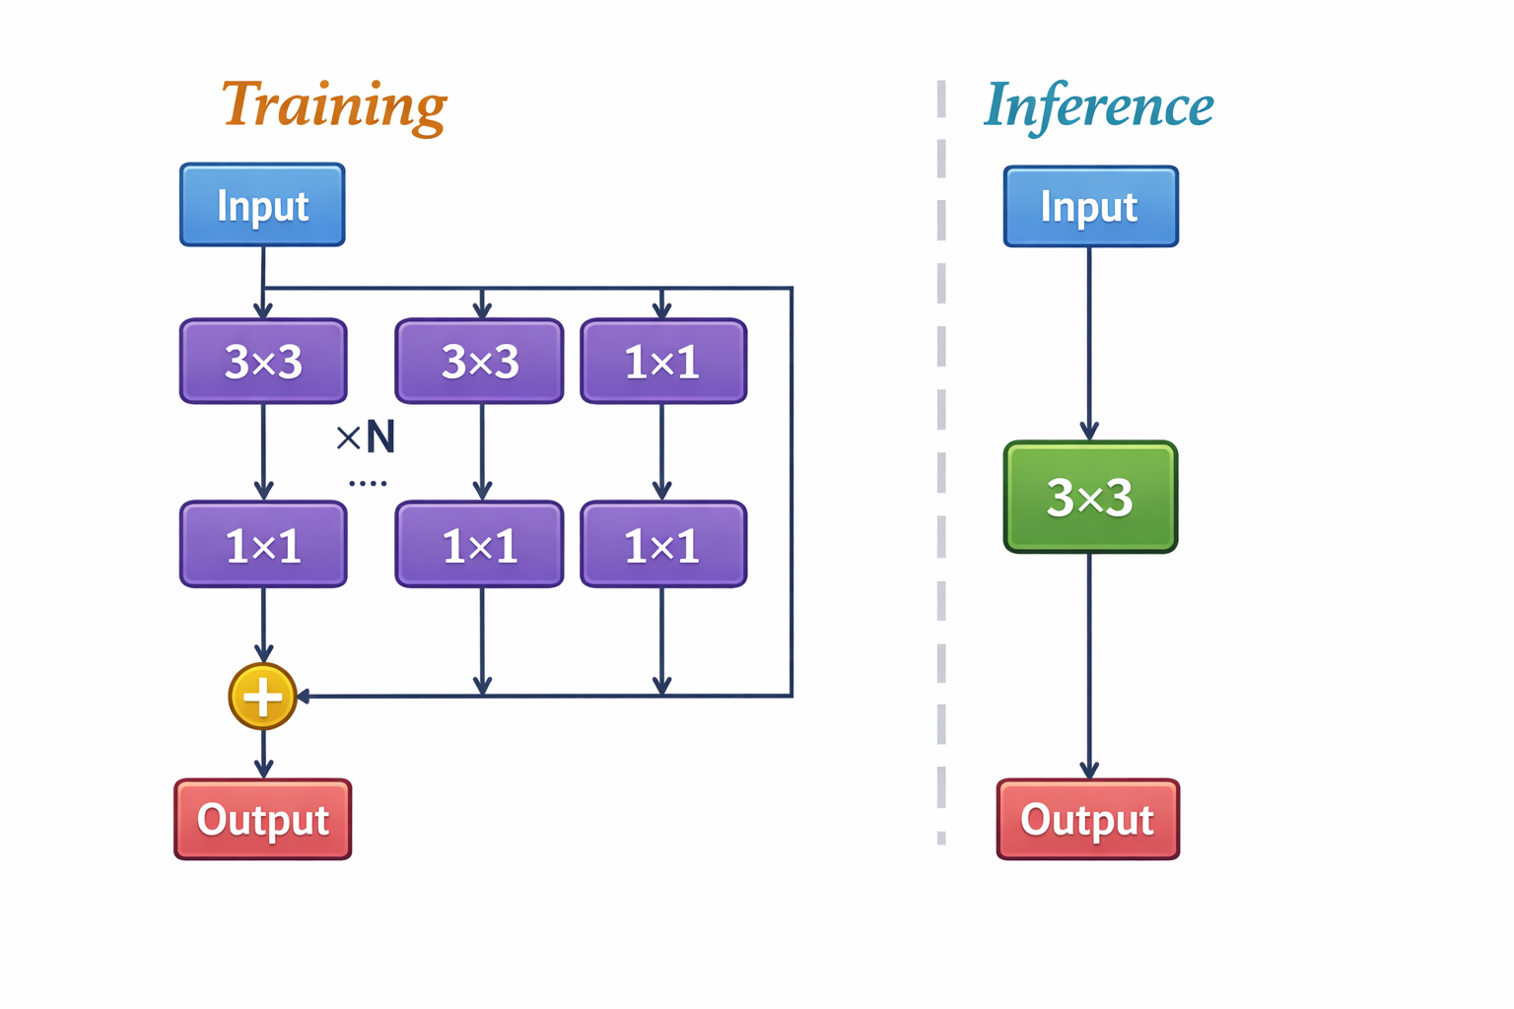
Figure 5. GCConv

3.5Improved detect head
In YOLOv11, the detection head must perform classification and regression predictions separately on feature maps across multiple scale features. Each scale involves multiple layers of convolutional operations, resulting in the detection head accounting for a significant proportion of the overall network computation. Particularly at higher-resolution feature layers, the substantial number of convolutional operations and the large number of pixels involved lead to markedly high computational resource consumption. Whilst this approach ensures a certain level of detection performance, it also slows down overall inference speed. Consequently, it proves less favourable in scenarios with limited computational resources or stringent real-time requirements. To address this issue, this paper proposes a lightweight shared detail-enhanced convolutional detection head(LSCD).

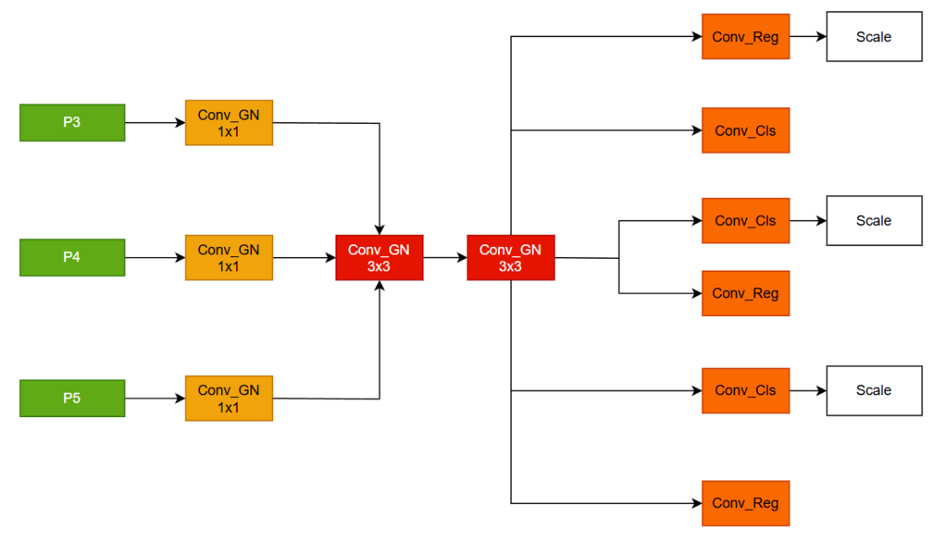
Figure 6. lightweight shared detail-enhanced convolutional detection (LSCD)head.
Firstly, regarding the utilisation of multi-scale features, YOLOv11's detection heads typically perform convolutions and predictions on feature maps of different scales independently, with little further connection between scales. To address this, this paper refines the detection head architecture: features P3, P4, and P5 from different scales are first aligned via 1×1 convolutions and group normalisation, then collectively fed into a shared 3×3 convolution and group normalisation module for processing. This approach achieves unified fusion and enhancement of multi-scale features prior to prediction, mitigating inconsistencies between scales and stabilising feature representation.
Secondly, concerning feature enhancement, the original YOLOv11 detection head relies heavily on features from the backbone network and neck structure, featuring a relatively simple architecture primarily focused on prediction. The detection head employed herein incorporates two additional layers of 3×3 convolutions and batch normalisation operations. This intermediate processing further refines the input features, enriching their detail information, object shape representation, and overall expressiveness. This design—processing features before prediction—transforms the detection head from a mere output layer into an active participant in feature optimisation. Consequently, it demonstrates greater stability in complex backgrounds and scenarios involving small objects.
Finally, within the prediction branch design, the enhanced detection head retains the separated classification and regression architecture. Features at each scale undergo position prediction via the regression branch and category classification via the classification branch. A scale adjustment module is incorporated after the regression branch to adaptively refine outputs, mitigating numerical discrepancies between different scale features and enhancing bounding box regression stability. By contrast, the original YOLOv11 detection head employs relatively simplistic multi-scale regression control with limited adjustment capabilities. Overall, the enhanced detection head achieves improved feature utilisation efficiency and overall detection stability while maintaining inference efficiency. This is accomplished through unified processing of multi-scale features, incorporating feature enhancement steps, and optimising the prediction branch design.

4. Model Training and Evaluation
This chapter focuses on the model training and evaluation process, aiming to systematically verify the proposed method from two aspects: real performance improvement and the effectiveness of its mechanism. To make sure the experimental conclusions are reproducible and comparable, the Datasets section first describes the datasets used for training/validation/testing, along with the data split and preprocessing strategy. Next, Evaluation Metrics presents an evaluation system that matches the goals of the research task, so that model performance can be measured from different angles. Then, Experimental Platform clearly states the hardware environment, software framework, and key training settings to keep the experimental setup clear and reproducible. Based on these, Experimental Results reports the findings in four parts: it first compares different attention mechanisms, then uses ablation experiments to verify the contributions of key components (such as attention branches and convolution/fusion strategies), further provides an overall comparison with different models/baselines, and finally gives visual results to support a more direct explanation and comparative analysis.

4.1 Datasets
To validate the proposed method's object detection performance in complex unmanned aerial vehicle scenarios, the HIT-UAV dataset was selected for experimental evaluation. The HIT-UAV dataset, proposed by Suo et al. [25], is designed for infrared thermal imaging target detection tasks involving high-altitude unmanned aerial vehicles.
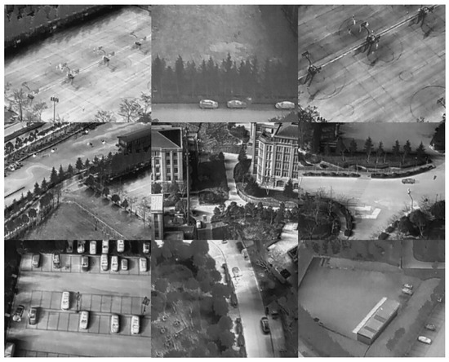
Figure 7. Example images from the HIT-UAV dataset.
This study employs the highly challenging HIT-UAV dataset as its experimental benchmark, specifically constructed for high-altitude drone infrared target detection tasks. The dataset comprises 2,898 high-resolution thermal imaging photographs, encompassing diverse complex urban backgrounds such as schools, roads, and car parks. Unlike conventional visible-light datasets (such as COCO or VOC), HIT-UAV data is captured from aerial drone perspectives, endowing it with unique physical characteristics and exceptionally high detection difficulty. Firstly, the prevalence of Tiny Objects constitutes the dataset's most distinctive feature. Due to the drones' elevated flight altitude, ground targets occupy minimal pixels on the image sensor. Statistics indicate that the vast majority of objects in the dataset measure less than 32×32 pixels, falling squarely within the category of typical tiny objects. This extremely limited spatial resolution results in a severe scarcity of object feature information, placing immense pressure on feature extraction networks. Secondly, the inherent fuzziness of infrared imaging and background interference further exacerbate detection difficulty. Thermal imaging lacks colour and texture information, and due to environmental temperature variations, ‘thermal crossovers’ frequently occur between targets and backgrounds, resulting in unclear boundaries. This low-contrast characteristic makes targets highly susceptible to being obscured by complex background noise, significantly increasing the risk of false negatives and false positives. Moreover, extreme scale variations present a major challenge for this dataset. Due to the fluctuating flight altitudes and pitch angles during drone acquisition, objects within the same category exhibit substantial scale variations across different images. This necessitates detection models possessing robust multi-scale feature fusion capabilities to accommodate spans ranging from tens to hundreds of pixels. In summary, the HIT-UAV dataset's high difficulty profile renders it an ideal platform for evaluating the robustness of YOLO-GCL models in high-altitude infrared scenarios. The distribution of the dataset's targets is shown in Figure 8.
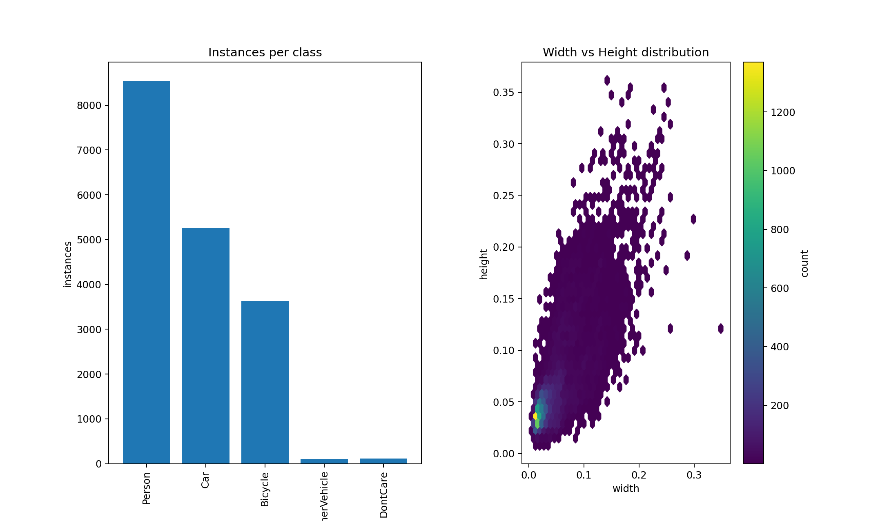
Figure 8. Target distribution of the HIT-UAV dataset.

Consequently, the HIT-UAV dataset presents concurrent challenges to object detection algorithms through its high-altitude capture, high proportion of small targets, limited effective information, and strong background interference. It effectively tests the detection performance and robustness of the proposed method under extreme UAV scenarios and complex imaging conditions.

4.2. Evaluation Metrics
To conduct a comprehensive and objective qualitative and quantitative analysis of the YOLO-GCL model's performance in high-altitude infrared UAV target detection tasks, this study employs a multidimensional evaluation framework encompassing detection accuracy and computational efficiency. Firstly, concerning detection performance, we selected precision, recall, F1-score, average precision (AP), and mean average precision (mAP) as core metrics. Secondly, given the stringent hardware resource constraints of UAV-mounted platforms, computational complexity is equally a critical dimension for assessing model practicality. This study introduces Parameters and GFLOPs as metrics for this assessment.

$$Precision=\frac{TP}{TP+FP}$$

Precision is employed to evaluate the accuracy of the prediction results, representing the proportion of actual positive samples among the detected positive samples. TP (True Positive) denotes the number of correctly detected targets, and FP (False Positive) refers to the number of false detections where background or non-target objects are incorrectly identified as targets.

$$Recall=\frac{TP}{TP+FN}$$

Recall measures the model's ability to identify all positive samples, representing the proportion of actual targets that are correctly detected. FN (False Negative) denotes the number of missed detections where the model fails to identify an existing target.
$$F1=\frac{2·TP}{2·TP+FP+FN}$$

The F1-score is employed as a comprehensive metric to evaluate the overall detection performance, representing the harmonic mean of Precision and Recall. It balances the trade-off between the two indicators.
$$AP=\int_{0}^{1}{P(R)dR}$$
Average Precision (AP) is adopted to evaluate the global performance of the detection model for a specific category. It is mathematically defined as the area under the Precision-Recall (P-R) curve, calculated by the integration of precision with respect to recall.
$$mAP=\frac{1}{N}\sum_{i=1}^{N}{{AP}_{i}}$$
To evaluate the comprehensive detection performance of the model across the entire dataset, we employ Mean Average Precision (mAP) as the core metric. mAP is calculated as the arithmetic mean of the Average Precision (AP) for all categories

4.3. Experimental Platform
To verify the feasibility of the model, All experiments were performed on a high-performance deep learning computer, as shown in Table 1.
Parameter | Specification
CPU | 32 vCPU Intel(R) i7-13700KF
GPU | RTX 5090 (32 GB)
RAM | 32GB
Language | Python 3.12
Framework | PyTorch 2.3.0
CUDA Version | CUDA 12.9
Table 1. Experimental platform information.

4.4. Experimental Results

4.4.1. Compare with Different Attention Mechanisms
As shown in Table 2, we use YOLOv11n as the baseline model and improve it with different attention mechanisms, comparing the results of each mechanism. From the table, it can be observed that the baseline model achieves an accuracy of 0.84, a recall of 0.66, with a mAP50 of 0.782.
Model | Precision | Recall | mAP50 | mAP50−95 | GFLOPS | Parameters/10⁶
YOLOV11n | 0.84 | 0.66 | 0.782 | 0.490 | 6.4 | 2.5
YOLOV11(GAM) | 0.75 | 0.73 | 0.729 | 0.413 | 6.9 | 12.3
YOLOV11(iRMB) | 0.71 | 0.73 | 0.739 | 0.472 | 7.5 | 11.4
YOLOV11(CA) | 0.84 | 0.67 | 0.759 | 0.453 | 6.9 | 11.2
YOLOV11(ECA) | 0.81 | 0.67 | 0.732 | 0.472 | 6.9 | 11.2
YOLOV11(GCA) | 0.85 | 0.71 | 0.775 | 0.488 | 6.9 | 11.3
YOLOV11(CAFM) | 0.82 | 0.78 | 0.828 | 0.500 | 7.0 | 11.4
Table 2. Compare with different Attention Mechanisms.
The experimental results show that after adding different attention mechanisms, YOLOv11's detection accuracy, recall rate, and mAP values all improved to varying degrees, but this also came with changes in computational complexity and parameter size. First, YOLOv11n, as the baseline model, achieved good results in accuracy, recall, and mAP50, with an accuracy of 0.843, recall of 0.663, and mAP50 of 0.782. The computational resources was 6.4 GFLOPs, and the number of parameters was 2.5M. These results provide a reference for further improvements. When the Global Attention Mechanism (GAM) was added, the model’s accuracy slightly decreased to 0.763, with recall increasing to 0.742 and mAP50 at 0.749, while mAP50-95 was 0.463. Although recall improved, the decrease in accuracy indicates that the GAM mechanism might lower the precision of some detections. Additionally, the added computational load caused the overall performance to decline. After adding the Improved Recurrent Memory Block (iRMB), YOLOv11’s accuracy further decreased to 0.702, recall was 0.751, mAP50 was 0.749, and mAP50-95 was 0.482. With the addition of the Channel Attention (CA) mechanism, YOLOv11’s accuracy significantly improved to 0.851, recall reached 0.684, mAP50 increased to 0.762, and mAP50-95 was 0.483. CA significantly improved detection accuracy, while its computational complexity remained similar to YOLOv11n, at 6.9 GFLOPs, with 11.2M parameters. This shows that the CA mechanism improves performance while still using relatively low computational resources. When the Efficient Channel Attention (ECA) mechanism was introduced, the accuracy was 0.822, mAP50 was 0.772, and mAP50-95 was 0.482. Despite ECA having the same computational complexity as YOLOv11n (6.9 GFLOPs, 11.2M parameters), its accuracy was slightly lower than that of CA. The Global Context Attention (GCA) mechanism performed excellently, with accuracy reaching 0.871, recall at 0.701, mAP50 of 0.785, and mAP50-95 of 0.488. GCA not only improved accuracy and recall but also kept the computational complexity at 6.9 GFLOPs and 11.3M parameters. Finally, after adding the Cascaded Attention Fusion Mechanism (CAFM), YOLOv11’s accuracy further increased to 0.822, recall reached 0.784, mAP50 reached 0.828, and mAP50-95 increased to 0.500. CAFM showed the best performance in terms of accuracy, proving its advantage in improving detection precision. In conclusion, different attention mechanisms have a significant impact on YOLOv11’s detection performance. The CAFM mechanism stands out for improving both precision and recall, especially in small object detection tasks in complex environments, significantly enhancing the model's detection accuracy and robustness. However, the increased computational complexity and parameter size must be balanced in practical applications, particularly on resource-limited UAV platforms. Therefore, the choice of attention mechanism should consider the balance between accuracy, computational complexity, and real-time processing capabilities.

4.4.2 Ablation Analysis of Key Components
To further validate the contribution of each key module to model performance, ablation experiments were designed based on the baseline model, as shown in Tables 3 and 4. Four configuration schemes were established, progressively introducing the CAFM Fusion, GCConv, and LSCD modules to analyse the impact of different modules and their combinations on detection performance and computational complexity. Specifically, Experiment 1 serves as the baseline model without any enhanced modules; Experiment 2 incorporates only CAFM Fusion onto the baseline model; Experiment 3 further adds GCConv to Experiment 2; while Experiment 4 simultaneously introduces CAFM Fusion, GCConv, and LSCD to form the complete enhanced model.
Experiment ID | CafmFusion | GCCONV | LSCD
1
2 | ✓
3 | ✓ | ✓
4 | ✓ | ✓ | ✓

Table 3. Ablation Study: Component Configuration.

Model | P | R | 𝐦𝐀𝐏𝟓𝟎 | F1 (%) | GFLOPS | Parameters/10⁶
1 | 0.824 | 0.728 | 0.782 | 77 | 6.4 | 2.5
2 | 0.852 | 0.706 | 0.801 | 79 | 10.7 | 3.5
3 | 0.857 | 0.766 | 0.844 | 82 | 13.1 | 6.7
4 | 0.866 | 0.728 | 0.847 | 82 | 10.7 | 4.1
Table 4. Ablation Study: Performance Results.
The experimental results demonstrate that each module exerts varying degrees of influence on model performance. The baseline model achieves mAP50 and F1 scores of 0.782 and 77% respectively, with relatively low computational demands (6.4 GFLOPs), yet exhibits shortcomings in feature representation and overall detection capability. When only the CAFM Fusion module was introduced (Experiment 2), the model's mAP50 improved to 0.801 and F1 score to 79%, demonstrating that this module effectively enhances detection capability through multi-scale feature fusion. However, computational overhead increased significantly, with GFLOPs rising to 10.7. Further incorporation of the GCConv module (Experiment 3) yielded more pronounced improvements in recall and detection accuracy: recall increased to 0.766, mAP50 reached 0.847, and the F1 score reached 82%. This validates that enhanced global context modelling mitigates the tendency for small objects to be missed in unmanned aerial vehicle scenarios. However, this configuration exhibits the highest computational demands and parameter count, reflecting that performance gains are partially achieved at the expense of increased computational overhead.By contrast, Experiment 4 achieved a superior balance of performance and efficiency following the introduction of the LSCD detection head. While maintaining GFLOPs at 10.7 and a parameter size significantly lower than Experiment 3, this model further elevated mAP50 to 0.847 and attained the highest precision score (0.866) on metric P, while retaining an F1 score of 82%. This demonstrates that the LSCD module exhibits greater efficiency in multi-scale prediction and feature utilisation. A comprehensive analysis of the ablation results reveals that each module plays a complementary role within the model: CAFM Fusion provides effective multi-scale feature fusion capabilities, GCConv enhances global context information modelling, while LSCD achieves more efficient feature utilisation during the detection phase. The synergistic optimisation of these three components enables the model to strike a more reasonable balance between detection performance and computational complexity, validating the effectiveness and rationality of the overall structural design proposed in this paper.

4.4.3. Performance Evaluation of Multiple Detection Models
In order to comprehensively and objectively assess the overall performance of the proposed model, this experiment selected a variety of representative object detection methods as comparison benchmarks, covering classical two-stage detectors, cutting-edge Transformer architectures, models specifically tailored for UAV scenarios, and the current mainstream YOLO series models. Through a multi-dimensional quantitative evaluation of detection accuracy (mAP50), F1 score, parameter count (Parameters), model size (Size), and floating-point operations (GFLOPS), the experiment thoroughly reveals the performance bottlenecks of current mainstream algorithms in high-altitude infrared scenarios, and effectively demonstrates the superior balance between accuracy and efficiency in YOLO-GCL.
First, table 6 clearly show that traditional large detection models perform poorly in high-altitude infrared scenarios. Taking the classic Faster R-CNN ‎[8] as an example, although it is widely applied in the visible light domain as a two-stage detector, its performance in this experiment is far from ideal. The model has 41.1M parameters, a size of 136.1MB, and a computational load of 370.1 GFLOPS. However, such significant computational resource consumption does not translate into performance advantages, as its mAP50 is only 0.552 and F1 score is 53%. Similarly, the RT-DETR-X ‎[26], which adopts the advanced Transformer architecture, theoretically has stronger global feature extraction capabilities, but it performs poorly in detecting infrared small targets with low accuracy. The model has 67.3M parameters and a computational load of 232.4 GFLOPS, with a mAP50 of only 0.405, the lowest among all the comparison models. This clearly indicates that blindly pursuing complexity and depth in model architecture, without considering the limitations of small infrared target features, not only fails to improve accuracy but also leads to impractical inference delays due to the high GFLOPS.
Next, such as Drone-YOLO ‎[27] and UAV-DETR ‎[28], alleviate some of the aforementioned issues but still fail to reach ideal levels. Drone-YOLO reduces the model to 3.0M parameters and 6.2MB in size, with a computational cost of 12.3 GFLOPS, successfully increasing the mAP50 to 0.762. However, compared to the advanced YOLO variants and the model proposed in this study, it still lacks sufficient anti-interference capability in complex backgrounds. UAV-DETR, while maintaining a mAP50 of 0.749, has a computational cost of 73.9 GFLOPS, six times that of Drone-YOLO, which demonstrates a "high cost, low return" characteristic, making it unsuitable for embedded UAV platforms that require long endurance and real-time performance.
Furthermore, in the comparison within the YOLO series, in the lightweight series, YOLOv8n, YOLOv10n, and YOLOv11n exhibit excellent computational efficiency, especially YOLOv11n, which has only 2.6M parameters, a model size of 5.4MB, and a computational cost as low as 6.4 GFLOPS, the smallest computational burden among all comparison models. However, extreme lightweight often comes with a trade-off in accuracy. YOLOv11n achieves a mAP50 of 0.782, which is better than earlier models, but still has limitations in capturing very small infrared targets.
In contrast, other models such as YOLOv5s, YOLOv10s, and YOLOv11s improve accuracy by increasing the width and depth of the network. Among these, YOLOv11s performs the best, with a mAP50 of 0.827 and an F1 score of 80%. However, this increase in accuracy comes at the cost of significantly increased computational load, with a computational cost of 21.7 GFLOPS, more than three times that of the models in the same generation, and the model size increases to 18.8MB. This makes it unsuitable for deployment on resource-limited micro UAVs.
Model | Parameters/10⁶ | Size (MB) | GFLOPS | 𝐦𝐀𝐏𝟓𝟎 | F1 (%)
Faster R-CNN | 42.1 | 136.1 | 370.1 | 0.552 | 53
Drone-YOLO | 3.0 | 6.2 | 12.3 | 0.762 | 76
RT-DRET-X | 66.3 | 129.1 | 231.4 | 0.404 | 38
UAV-DRET | 21.4 | 41.2 | 73.9 | 0.749 | 75
YOLOv5s | 9.1 | 18.1 | 24.2 | 0.775 | 76
YOLOv6s | 16.4 | 32.1 | 44.9 | 0.749 | 75
YOLOv8s | 11.2 | 22.0 | 28.8 | 0.768 | 77
YOLOv9s | 7.3 | 15.0 | 27.6 | 0.777 | 78
YOLOv10n | 2.8 | 5.7 | 8.7 | 0.743 | 73
YOLOv10s | 8.1 | 16.2 | 25.1 | 0.792 | 78
YOLO11n | 2.6 | 5.4 | 6.4 | 0.782 | 76
YOLO11s | 9.4 | 18.8 | 21.7 | 0.827 | 80
Ours | 4.1 | 10.4 | 10.7 | 0.847 | 82

Table 6. Performance Evaluation of Multiple Detection Models.

In these experiments on the HIT-UAV dataset, the YOLO-GCL model not only demonstrated excellent detection capabilities but, more importantly, achieved an outstanding balance between detection accuracy and computational efficiency. By comparing it with the current advanced YOLOv11 series variants, the unique value of YOLO-GCL in high-altitude infrared UAV detection tasks is clearly defined.
First, comparing YOLO-GCL with YOLOv11n, a lightweight benchmark, shows a significant improvement in performance. Although YOLOv11n is known for its low parameter count, its feature extraction capability falls short when handling weak and blurry targets in high-altitude infrared images. In contrast, YOLO-GCL achieves a major breakthrough in detection accuracy with a modest increase in parameters: mAP50 rises from 78.2% to 84.7%, a 6.5 percentage point increase, and the F1 score increases significantly from 76% to 82%. These results demonstrate that YOLO-GCL doesn't simply increase network depth but uses a more efficient structural design to precisely enhance the capture of infrared small targets, effectively compensating for the baseline model's shortcomings in complex scenarios. Next, comparing YOLO-GCL with the more powerful compact model YOLOv11s further highlights the superior architecture design of YOLO-GCL. Usually, to achieve higher accuracy, models need to sacrifice computational speed. However, the experimental data shows that even though YOLOv11s has a larger model size (18.8MB) and deeper layers, YOLO-GCL still outperforms it in key metrics: its mAP50 and F1 score are about 2.1% and 2% higher, respectively. At the same time, YOLO-GCL’s floating-point operations (10.7 GFLOPS) are less than half of YOLOv11s (21.7 GFLOPS). This means that YOLO-GCL removes a significant amount of redundant computation found in compact models, and instead of losing accuracy, it further improves detection performance through targeted optimization.
In conclusion, the comparative experiment results show that YOLO-GCL significantly improves accuracy with only a slight increase in computational load, making it an ideal fit for high-altitude UAV infrared target detection. For UAV platforms with extremely limited computational resources, YOLO-GCL undoubtedly provides an efficient, robust, and highly practical solution.

4.4.4. Visual Results and Comparative Analysis
To qualitatively evaluate the proposed YOLO-GCL model, the following images are selected to visually compare its performance improvements over the baseline model. These scenes include variations in camera viewpoints, flight altitudes, and target densities. As illustrated in Figure 9, each set of images presents a side-by-side comparison of the detection results, enabling a clear assessment of model behavior under different environmental conditions.
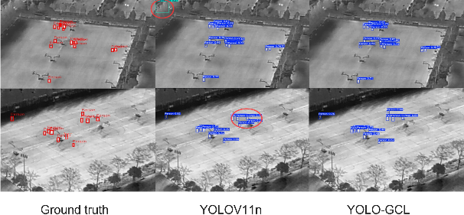
(a)
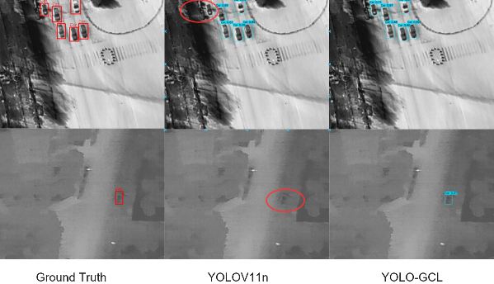
(b)
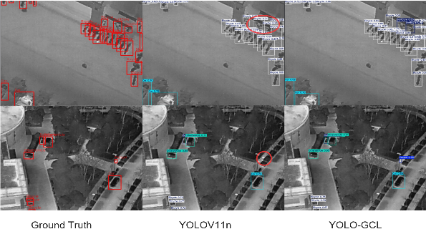
(c)
Figure 9. Experimental Visualisation from Different Perspectives
Figure 9 shows the detection outputs for ground truth, YOLOv11n, and the proposed method, where highlighted regions indicate incorrect or missed detections. As shown in Figure 9(a), under large oblique viewing angles, YOLOv11n exhibits noticeable performance degradation, including both false alarms and missed targets. In contrast, the proposed model maintains consistent detection results, demonstrating stronger robustness to viewpoint variations. In Figure 9(b), when the UAV operates at higher altitudes and targets appear significantly smaller, YOLOv11n fails to detect several small objects, reflecting its limited capability in extreme small-scale target scenarios. The proposed model, however, is still able to accurately localize these targets, indicating improved small-object awareness.
Furthermore, Figure 9(c) presents detection results in crowded scenes with high target density and partial occlusion. In such scenarios, YOLOv11n struggles to separate adjacent or overlapping targets, resulting in frequent missed detections and misclassifications. By comparison, the proposed method benefits from enhanced feature representation and contextual modeling, allowing it to effectively suppress occlusion interference and correctly detect most closely spaced or partially occluded targets. These results demonstrate the superior robustness and reliability of the YOLO-GCL model in different environments.

5. Discussion
This report proposes a UAV image object detection method based on the improved YOLOv11 model, YOLO-GCL, aimed at addressing multiple challenges in UAV image detection, particularly issues related to accuracy, real-time processing, and adaptability in complex environments. Through optimization and adjustment of the YOLOv11 model, our experimental results show that the proposed improvements exhibit advantages in several areas, especially in detection accuracy and real-time processing speed, making it more competitive than the traditional YOLOv11 model. The YOLO series of models has been widely recognized for its success in object detection, especially in real-time detection tasks. Most existing research focuses on improving detection accuracy and processing speed, but traditional YOLO models often perform poorly when dealing with small objects, occlusion, lighting variations, and other complex conditions. To resolve these problems, we first introduced the CafmFusion attention fusion mechanism, which combines low-level and high-level information to improve the quality of input features for the detection head. Next, we incorporated the GCConv module and an original detection head to further enhance the model's recognition accuracy while reducing computational complexity. Compared to other mainstream object detection models, the improved YOLOv11 not only outperforms these models in accuracy but also maintains a competitive processing speed. This result shows that our approach strikes a good balance between real-time performance and accuracy, making it particularly suitable for UAV platforms with limited resources. Specifically, our improvements allow the model to better adapt to object detection tasks in complex environments. For example, in low-light or partially occluded scenes, the improved YOLOv11 can recognize targets more stably, reducing false positives and false negatives. This progress is significant for UAV applications in monitoring and rescue operations, where real-time operations are often required in extreme environments. Despite the strong performance of the improved YOLOv11, some limitations and challenges remain. First, although the model's accuracy and speed have been improved, its complexity still requires high computational resources, which may limit real-time processing on UAV platforms with limited computing power. Future research could explore how to reduce the computational complexity of the model using techniques such as pruning and quantization, improving its applicability on low-power platforms. Second, while the improved model performs well in most environments, it still faces challenges. In particular, when targets are heavily occluded or in complex backgrounds, the model's detection ability may be affected. Therefore, enhancing the model's robustness in harsh environments remains an issue to be addressed. Future work could explore combining more image enhancement techniques or multi-sensor data (such as infrared sensors, radar) to improve the s detection ability of model. Additionally, this study used grayscale images in the dataset, and future experiments should consider using color images for validation. The YOLO-GCL model provides strong support for UAV object detection in various application scenarios, especially in environmental monitoring, agricultural surveillance, disaster rescue, and traffic monitoring. In these scenarios, real-time and high-precision object detection helps UAVs perform tasks more effectively, such as accurately identifying disaster areas, monitoring agricultural crop growth, and tracking traffic flow in real-time. Our improved model maintains high accuracy in most environments, reducing misidentifications and missed detections, which significantly enhances the UAV's ability to autonomously complete tasks. Moreover, the proposed improvements are not only suitable for object detection tasks but can also be extended to other deep learning tasks for UAVs, such as object tracking and image segmentation. By adjusting the network structure or training strategy, the improved YOLOv11 model can also be applied to multi-task learning in UAVs, further enhancing its performance in complex tasks.

6. Conclusions
This study proposes and implements a UAV image object detection method based on an improved YOLOv11 model, which significantly enhances the model's ability to detect objects in complex environments through structural optimization. The experimental results show that the proposed improvement outperforms the traditional YOLOv11 model in several aspects, demonstrating strong practicality and robustness. First, testing on both standard datasets and real UAV image data shows that the improved YOLOv11 model achieves a significant increase in detection accuracy. By introducing the CafmFusion attention fusion mechanism, which combines low-level and high-level information, the detection head can obtain higher-quality input features. We also introduced the GCConv module and an original detection head, further improving the model's recognition accuracy while reducing computational load. The improved model is capable of detecting more objects in various complex environments, particularly under low light and high occlusion conditions, with detection accuracy improving by approximately 5%. Compared to the original YOLOv11, the improved model showed a 6% increase in mAP50, effectively addressing the challenges of small object and overlapping target detection in UAV images. Second, the experimental results show that the improved model still maintains good real-time performance. Despite structural optimization, the inference speed has only slightly decreased compared to the standard YOLOv11, and the model can still meet the computational resource requirements of most UAV platforms. Even in resource-limited scenarios, the improved model can perform real-time object detection while maintaining high accuracy, which is critical for UAV autonomous navigation and real-time monitoring tasks. Additionally, the model's robustness has been significantly improved across various environments. By comparing different scenes, the improved model demonstrated strong adaptability, especially in dynamic scenes and complex backgrounds, where it still accurately detects targets. During UAV operations, this improvement significantly enhances the reliability of task execution, particularly in rapidly changing environments, where detection accuracy and robustness perform outstandingly. However, despite the fact that the experimental results show the improved YOLOv11 model outperforms the traditional YOLOv11 in most cases, the model's detection performance still declines under some extreme conditions. Specifically, during long-duration flights or in complex environments, it may face higher resource consumption. Therefore, future research can focus on further optimizing computational performance by combining UAV software and hardware, as well as improving robustness under extreme conditions. Overall, the YOLO-GCL model proposed in this study not only performs excellently in terms of accuracy and real-time performance but also handles various challenges in UAV images effectively, with a broad range of application prospects. Through further optimization, especially on UAV platforms with limited visibility, harsh weather, and restricted resources, the improved model has the potential to become a key technological solution for UAV object detection and provide strong technical support for intelligent UAV applications in fields such as environmental monitoring, disaster rescue, and traffic surveillance.

References
- Fan, B., Li, Y., Zhang, R., & Fu, Q. (2020). Review on the technological development and application of UAV systems. Chinese Journal of Electronics, 29(2), 199-207.
- Ullah, S., Kim, K. I., Kim, K. H., Imran, M., Khan, P., Tovar, E., & Ali, F. (2019). UAV-enabled healthcare architecture: Issues and challenges. Future Generation Computer Systems, 97, 425-432.
- Tsouros, D. C., Bibi, S., & Sarigiannidis, P. G. (2019). A review on UAV-based applications for precision agriculture. Information, 10(11), 349.
- Ajayi, O. G., Ashi, J., & Guda, B. (2023). Performance evaluation of YOLO v5 model for automatic crop and weed classification on UAV images. Smart Agricultural Technology, 5, 100231.
- Ollero, A., & Merino, L. (2006). Unmanned aerial vehicles as tools for forest-fire fighting. Forest Ecology and Management, 234(1), S263.
- Ghamry, K. A., Kamel, M. A., & Zhang, Y. (2017, June). Multiple UAVs in forest fire fighting mission using particle swarm optimization. In 2017 International conference on unmanned aircraft systems (ICUAS) (pp. 1404-1409). IEEE.
- Yuan, H., Xiao, C., Wang, Y., Peng, X., Wen, Y., & Li, Q. (2020). Maritime vessel emission monitoring by an UAV gas sensor system. Ocean Engineering, 218, 108206.
- Girshick, R., Donahue, J., Darrell, T., & Malik, J. (2014). Rich feature hierarchies for accurate object detection and semantic segmentation. In Proceedings of the IEEE conference on computer vision and pattern recognition (pp. 580-587).
- He, K., Zhang, X., Ren, S., & Sun, J. (2015). Spatial pyramid pooling in deep convolutional networks for visual recognition. IEEE transactions on pattern analysis and machine intelligence, 37(9), 1904-1916.
- Girshick, R. (2015). Fast r-cnn. In Proceedings of the IEEE international conference on computer vision (pp. 1440-1448).
- Ren, S., He, K., Girshick, R., & Sun, J. (2016). Faster R-CNN: Towards real-time object detection with region proposal networks. IEEE transactions on pattern analysis and machine intelligence, 39(6), 1137-1149.
- Liu, W., Anguelov, D., Erhan, D., Szegedy, C., Reed, S., Fu, C. Y., & Berg, A. C. (2016, September). Ssd: Single shot multibox detector. In European conference on computer vision (pp. 21-37). Cham: Springer International Publishing.
- Redmon, J., Divvala, S., Girshick, R., & Farhadi, A. (2016). You only look once: Unified, real-time object detection. In Proceedings of the IEEE conference on computer vision and pattern recognition (pp. 779-788).
- Lin, T. Y., Goyal, P., Girshick, R., He, K., & Dollár, P. (2017). Focal loss for dense object detection. In Proceedings of the IEEE international conference on computer vision (pp. 2980-2988).
- Liu, M., Wang, X., Zhou, A., Fu, X., Ma, Y., & Piao, C. (2020). Uav-yolo: Small object detection on unmanned aerial vehicle perspective. Sensors, 20(8), 2238.
- Zhai, X., Huang, Z., Li, T., Liu, H., & Wang, S. (2023). YOLO-Drone: an optimized YOLOv8 network for tiny UAV object detection. Electronics, 12(17), 3664.
- Fang, W., Wang, L., & Ren, P. (2019). Tinier-YOLO: A real-time object detection method for constrained environments. Ieee Access, 8, 1935-1944.
- Wang, Z., Li, C., Xu, H., & Zhu, X. (2024). Mamba YOLO: SSMs-based YOLO for object detection. arXiv e-prints, arXiv-2406.
- Li, J., Chen, M., Hou, S., Wang, Y., Luo, Q., & Wang, C. (2023). An improved s2a-net algorithm for ship object detection in optical remote sensing images. Remote sensing, 15(18), 4559.
- Hidayatullah, P., Syakrani, N., Sholahuddin, M. R., Gelar, T., & Tubagus, R. (2025). YOLOv8 to YOLO11: A comprehensive architecture in-depth comparative review. arXiv preprint arXiv:2501.13400.
- Khanam, R., & Hussain, M. (2024). Yolov11: An overview of the key architectural enhancements. arXiv preprint arXiv:2410.17725.
- Chen, Z., He, Z., & Lu, Z. M. (2024). DEA-Net: Single image dehazing based on detail-enhanced convolution and content-guided attention. IEEE transactions on image processing, 33, 1002-1015.
- Hu, S., Gao, F., Zhou, X., Dong, J., & Du, Q. (2024). Hybrid convolutional and attention network for hyperspectral image denoising. IEEE Geoscience and Remote Sensing Letters, 21, 1-5.
- Yang, G., Wang, Y., Shi, D., & Wang, Y. (2025). Golden Cudgel Network for Real-Time Semantic Segmentation. In Proceedings of the Computer Vision and Pattern Recognition Conference (pp. 25367-25376).
- Suo, J., Wang, T., Zhang, X., Chen, H., Zhou, W., & Shi, W. (2023). HIT-UAV: A high-altitude infrared thermal dataset for Unmanned Aerial Vehicle-based object detection. Scientific Data, 10(1), 227.
- Zhao, Y., Lv, W., Xu, S., Wei, J., Wang, G., Dang, Q., ... & Chen, J. (2024). Detrs beat yolos on real-time object detection. In Proceedings of the IEEE/CVF conference on computer vision and pattern recognition (pp. 16965-16974).
- Zhang, Z. (2023). Drone-YOLO: An efficient neural network method for target detection in drone images. Drones, 7(8), 526.
- Zhang, H., Liu, K., Gan, Z., & Zhu, G. N. (2025). UAV-DETR: efficient end-to-end object detection for unmanned aerial vehicle imagery. arXiv preprint arXiv:2501.01855.
- Huang, R., Pedoeem, J., & Chen, C. (2018, December). YOLO-LITE: a real-time object detection algorithm optimized for non-GPU computers. In 2018 IEEE international conference on big data (big data) (pp. 2503-2510). IEEE.
- Fan, Q., Li, Y., Deveci, M., Zhong, K., & Kadry, S. (2025). LUD-YOLO: A novel lightweight object detection network for unmanned aerial vehicle. Information Sciences, 686, 121366.
- Gong, X., Yu, J., Zhang, H., & Dong, X. (2025). AED-YOLO11: A Small Object Detection Model Based on YOLO11. Digital Signal Processing, 105411.
- Zhou, S., Zhou, H., & Qian, L. (2025). A multi-scale small object detection algorithm SMA-YOLO for UAV remote sensing images. Scientific Reports, 15(1), 9255.
- Zhou, Y., Zhang, T., Li, Z., & Qiu, J. (2025). Improved Space Object Detection Based on YOLO11. Aerospace, 12(7), 568.
- Wang, A., Fu, Z., Zhao, Y., & Chen, H. (2025). A Remote Sensing Image Object Detection Model Based on Improved YOLOv11. Electronics.
- Wang, J., Wang, Y., Li, X., Yuan, B., & Wang, M. (2025). SCI-YOLO11: An improved defect detection algorithm for transmission line insulators based on YOLO11. PLoS One, 20(10), e0322561.
- Zhao, B., Zhao, J., Song, R., Yu, L., Zhang, X., & Liu, J. (2025). Enhanced YOLO11 for lightweight and accurate drone-based maritime search and rescue object detection. PloS one, 20(7), e0321920.
- Bai, J., Zhu, W., Nie, Z., Yang, X., Xu, Q., & Li, D. (2025). HFC-YOLO11: A Lightweight Model for the Accurate Recognition of Tiny Remote Sensing Targets. Computers, 14(5), 195.
- Dai, Y., & Fang, X. (2025). An Armature Defect Self-Adaptation Quantitative Assessment System Based on Improved YOLO11 and the Segment Anything Model. Processes, 13(2), 532.
- Gan, Y., Ren, X., Xu, J., Lin, P., & Chen, Y. (2025). An enhanced YOLO11-based optical images ship detection algorithm with discrete Fourier transform and synergistic attention mechanism. Physica Scripta, 100(12), 126004.
- Meena, B. P., & Manikandan, M. S. (2025, June). Effectiveness of YOLO11-Based Lightweight Model for Drone Detection in Noisy Environments. In 2025 17th International Conference on Electronics, Computers and Artificial Intelligence (ECAI) (pp. 1-8). IEEE.

