

Evaluating Cross-Project Generalisation in Refactoring Classification: Traditional Machine Learning versus Large Language Models

by
Parjal Rai

Supervisor: Tim Bashford

Second Supervisor: TBD

January 2026

Table of Contents
Abstract 1
1. Introduction 1
2. Background, Literature Review and Motivation 2
2.1 Refactoring 2
2.2 Software Metrics as Refactoring Indicators 4
2.3 Traditional Refactoring Process 5
2.4 Machine Learning Paradigms 6
2.5 Large Language Models and Refactoring 9
2.5 Literature Review 13
3. Motivation 16
4. Methodology 17
4.1 Research Philosophy 17
4.2 Research Approach 18
4.3 Methodological Choice 18
4.4 Research Strategy 19
4.5 Time Horizon 20
4.6 Techniques and Procedures 20
5. Implementation 31
5.1 Data processing and extraction 31
5.3 ML evaluation 32
5.4 LLM evaluation 33
5.5 ML vs LLM evaluation: Real-world validation 34
6. Results 35
6.1 ML model evaluation 35
6.2 LLM evaluation 37
6.3 Real-World Validation 39
7. Discussion 40
7.1 ML model evaluation 40
7.2 LLM model evaluation 42
7.3 Real world validation 43
7.4 Limitations and Future works 44
8. Conclusion 45
9. References 47

Abstract
Automated refactoring improves code quality, but current methods rely either on hand-crafted structural metrics or the semantic reasoning of large language models (LLMs). This study examines whether traditional machine-learning (ML) models can form a generalised refactoring classifier comparable to modern LLMs.
Three ML classifiers (Random Forest, SVM, Logistic Regression) trained on structural metrics achieved low accuracy (21–33%), indicating limited generalisability due to sparse features and data. In contrast, four state-of-the-art LLMs achieved substantially higher accuracy (74–79%), with no significant performance differences among them, demonstrating strong semantic understanding from minimal context.
A final validation testing on new untrained data showed a large performance gap: the best LLM reached 93% accuracy, while the best ML model dropped to 9.8%. Overall, the results show that traditional ML approaches are insufficient for generalised refactoring classification under current constraints, whereas LLMs provide robust and accurate predictions. Substantially richer features and larger datasets would be required for ML models to approach LLM-level performance.

Introduction
Refactoring plays a fundamental role in sustaining software quality by improving the internal structure of code while preserving its external behaviour. As software systems evolve, accumulate technical debt, and undergo continuous modification, effective refactoring becomes essential for maintaining readability, extensibility, and long-term maintainability [1–9]. However, identifying and classifying refactorings at scale remains a challenging task, particularly in large and heterogeneous codebases. Prior to the emergence of LLMs research in automated refactoring detection relied primarily on ML models and specialised static-analysis tools that depend heavily on structural metrics.
Previous work, such as Aniche et al., has demonstrated that traditional ML classifiers can achieve high accuracy when trained on large, feature-rich, multi-project datasets [13]. Yet high performance within a combined dataset does not necessarily imply strong generalisation to entirely new projects. Numerous studies in empirical software engineering have shown that ML models trained on structural metrics often suffer substantial performance degradation when applied to unseen projects, largely due to differences in coding styles, metric distributions, architectural patterns, and domain characteristics. Although this phenomenon is well documented in related areas such as defect prediction and code-smell detection [57, 58], it has received limited attention in the context of refactoring classification specifically. This lack of cross-project evaluation represents a gap in existing research and motivates the need to examine how well structural ML models generalise compared with modern LLMs.
Recent advances in LLMs have introduced a new paradigm for source-code analysis. Models such as ChatGPT, Claude and Gemini exhibit strong semantic understanding of code and can perform a wide range of software-engineering tasks, including refactoring. Their ability to reason about context, intent, and naming conventions suggests potential advantages over traditional ML models, particularly for classification tasks with well-defined output categories. Despite this promise, LLMs remain computationally expensive, opaque in their internal reasoning, and sensitive to prompt design, offering far less controllability than traditional ML models that can be fully designed, trained, and interpreted. [50-55].
These contrasting strengths and limitations motivate a core question for modern software-engineering automation: to what extent can lightweight, metric-based ML classifiers generalise across previously unseen projects, and how do they compare to state-of-the-art, black-box LLMs in refactoring-type classification?
To address this question, the study compares the cross-project generalisation performance of traditional ML classifiers and LLMs for refactoring-type classification using Java projects. To support this investigation, the following hypotheses are proposed:
H1: Among the evaluated ML algorithms (Random Forest, SVM, Logistic Regression), the Random Forest classifier will achieve the highest predictive accuracy and stability across projects.
H2: Among the evaluated LLMs (ChatGPT 4.0, Gemini 1.5, Claude 3.5, and Amazon Q Developer), Amazon Q Developer will achieve the highest accuracy due to its code-specialised training.
H3: LLMs will outperform traditional ML classifiers in refactoring classification accuracy owing to their superior semantic and contextual understanding of source code. While accuracy is the primary metric for evaluating H3, secondary metrics (Precision, Recall, F1-Score) were also computed to ensure robust performance assessment.
This study addresses these hypotheses by conducting a controlled comparative investigation of traditional ML classifiers and modern LLMs for refactoring-type classification. Using a curated dataset of refactoring instances extracted from multiple open-source Java repositories, the study evaluates the predictive performance of Random Forest, SVM, and Logistic Regression models, alongside state-of-the-art LLMs including ChatGPT 4.0, Gemini 1.5, Claude 3.5 and Amazon Q Developer. The strongest models from each paradigm are then validated on unseen real-world Java projects to assess cross-project generalisation.

2. Background, Literature Review and Motivation

2.1 Refactoring
Refactoring is the disciplined process of improving the internal structure of source code without altering its external behaviour, as defined by Fowler [59]. While its primary objective is to enhance code maintainability and comprehensibility, refactoring also plays a vital role in improving software reusability, extensibility, and testability [60]. Numerous empirical studies [1–9] have shown that systematic refactoring enhances software quality, readability, and long-term maintainability- all of which are essential for sustainable software evolution.
In the context of software maintenance, refactoring is crucial because software systems must continually adapt to changing requirements, fix defects, and improve performance. Maintenance activities often account for the majority of a software system's total lifecycle cost, and poor code quality can significantly increase the effort and risk involved in these tasks. By improving the internal structure of the codebase, refactoring reduces complexity and technical debt, which in turn lowers maintenance costs and makes future enhancements easier and safer to implement [60, 61].
As software systems undergo continuous feature additions and architectural changes, maintaining high code quality becomes increasingly challenging. In such a dynamic environment, refactoring provides a structured and repeatable approach to improving code clarity, modularity, and resilience to change [60].
A common indicator of degraded code quality is the presence of code smells- surface symptoms in source code that suggest deeper design issues. These range from concerns such as duplicated code and overly long methods to more fundamental problems like low cohesion, high coupling, or inappropriate class responsibilities [62]. According to Beck and Fowler, identifying code smells is often the first step in recognising where refactoring is required. For example, large or complex methods can be simplified using techniques such as Extract Method or Decompose Conditional, thereby improving both readability and modularity [61-63].
More broadly, code smells often reflect violations of object-oriented design principles and are closely associated with the accumulation of technical debt- the long-term cost of design compromises made during development. Refactoring serves as a key mechanism for managing and reducing technical debt, enabling developers to improve internal code quality without affecting the system’s external behaviour [60, 61].

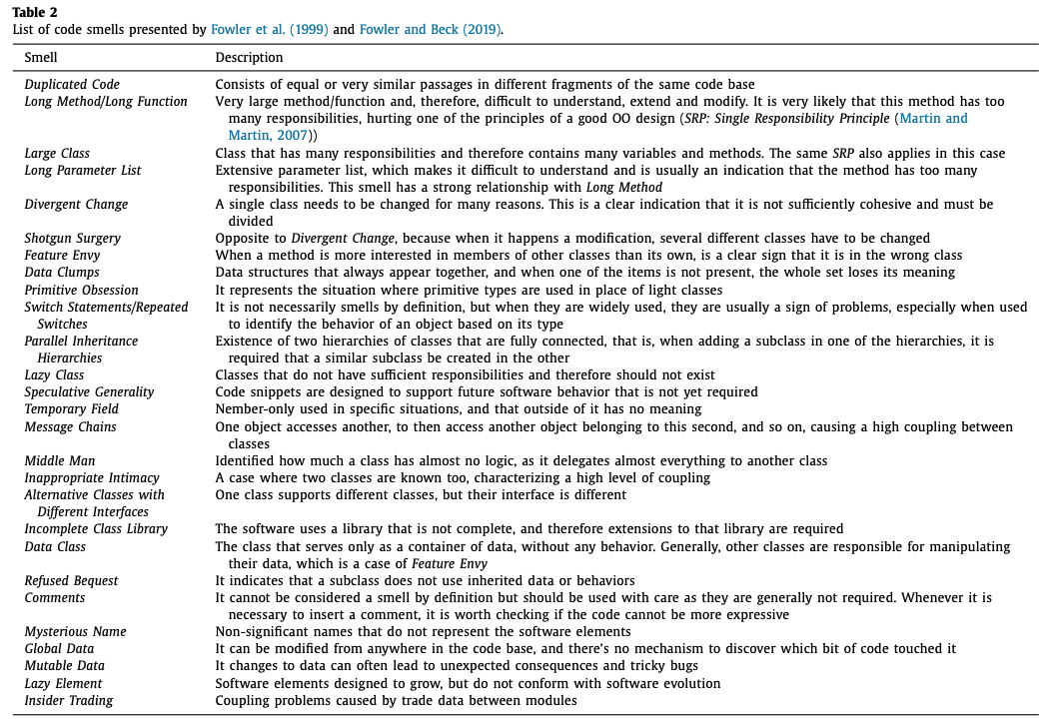
Table 1 – List of code smells presented by Fowler et al (1999) [59].

2.2 Software Metrics as Refactoring Indicators
While code smells offer qualitative cues of poor design, software metrics provide quantitative insights that help developers make more informed decisions about when and where to refactor. These metrics capture key structural attributes of code, such as complexity, cohesion, coupling, and size, and enable the systematic identification of potential design flaws. When metric values deviate from accepted thresholds or established best practices, they serve as refactoring indicators, highlighting areas where code quality may be improved.
Some of the most commonly used metrics include:
- Cyclomatic Complexity (CC):
Measures the number of independent control paths in a method and serves as a proxy for testability and cognitive complexity [64]. Methods with high CC values are often strong candidates for refactoring techniques such as Extract Method, Decompose Conditional, or Replace Nested Conditional with Guard Clauses, all of which aim to simplify control flow and reduce mental load [66].
- Lack of Cohesion in Methods (LCOM):
Introduced by Chidamber and Kemerer [65], LCOM quantifies how closely related the methods in a class are, based on their shared use of instance variables. A high LCOM score indicates low cohesion, which is commonly linked to the "God Class" smell. Refactorings such as Extract Class or Move Method can help improve modularity and enforce the Single Responsibility Principle [66].
- Lines of Code (LOC) and Number of Methods:
These are simple yet powerful indicators of code size and structural complexity. Excessively long classes or methods often correlate with poor readability and reduced maintainability. High LOC values may point to "Long Method" or "God Class" smells, and typically prompt decomposition or simplification [67].
- Coupling Between Objects (CBO):
High coupling reflects strong interdependence between classes, which reduces modularity and hinders reuse. Classes with high CBO values are often difficult to test and modify. Refactorings that reduce coupling, such as Extract Interface or Introduce Parameter Object, can improve both system flexibility and testability [68].
- Depth of Inheritance Tree (DIT) and Number of Children (NOC):
These metrics assess the complexity of the inheritance hierarchy. While deeper trees can promote reuse, they also increase the difficulty of comprehension and modification. Extremely high or low DIT and NOC values may signal violations of object-oriented design principles and warrant a review of class hierarchies [67].

2.3 Traditional Refactoring Process
Translating refactoring principles into practice typically involves a manual, multi-step process comprising the following stages [69]:
- Understanding the Code and Identifying Refactoring Opportunities:
The process begins with a thorough understanding of the existing codebase to identify areas in need of improvement. This step is often guided by the detection of code smells - surface indicators of deeper design issues. Fowler et al. identified 22 common code smells in their foundational work [70].
- Selecting Appropriate Refactoring Techniques:
Once problematic areas are identified; developers select suitable refactoring techniques. These range from minor adjustments at the variable level to more substantial structural changes at the class or module level (see Table 1). Martin Fowler’s catalogue of refactoring techniques remains a key reference [71].
- Applying the Refactoring:
Developers implement the selected changes carefully, aiming to keep modifications focused and manageable to minimise disruption.
- Assessing the Impact of Refactoring:
After changes are made, developers must ensure that the system’s external behaviour remains unchanged. This is typically achieved by executing existing unit tests to verify functional equivalence.
- Ensuring Consistency and Following Best Practices:
Refactored code should uphold recognised design principles such as Don’t Repeat Yourself (DRY), Keep It Simple, Stupid (KISS), and the Single Responsibility Principle (SRP), ensuring overall maintainability and quality.
While refactoring is widely recognised as a means of improving code quality, its adoption is often hindered by practical challenges. Effective refactoring requires a deep understanding of the codebase to avoid introducing bugs or degrading performance. Common obstacles include limited development time due to competing priorities, the complexity of legacy code, lack of managerial support, inadequate tooling, and, at times, a shortage of experienced developers [72]. Moreover, the manual nature of refactoring increases the risk of inadvertently introducing errors [69].
The concept of automated refactoring began to emerge in the late 1990s and early 2000s with the advent of integrated development environments (IDEs). Tools such as Eclipse and IntelliJ IDEA introduced features like Rename, Extract Method, and Move Method, which assist developers by suggesting safe structural changes. However, these tools still require user confirmation and rely primarily on static code analysis and heuristic rules to identify refactoring opportunities [69, 70, 73].
From the mid-2000s onwards, fully automated refactoring systems began appearing in research contexts. Like early IDE tools, these systems also rely on static analysis and heuristics but aim to detect and apply refactorings automatically, without developer intervention. Many such systems incorporate program transformation frameworks that ensure behavioural preservation. Nevertheless, the widespread use of fully automated refactoring in real-world software development remains limited, due largely to concerns around correctness, reliability, and developer trust [69, 73].

2.4 Machine Learning Paradigms

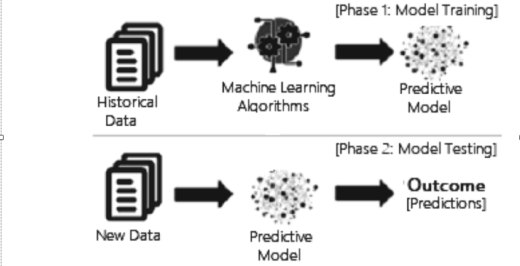
Figure 1: Process of Machine Learning [74].
Machine learning (ML) is a subfield of artificial intelligence focused on enabling systems to learn patterns from data and make informed decisions or predictions without being explicitly programmed. The origins of ML trace back to Arthur Samuel’s pioneering work in 1959 and were more formally defined by Mitchell (1997), who stated that “a computer program is said to learn from experience EEE with respect to some class of tasks TTT and performance measure PPP, if its performance at tasks in TTT, as measured by PPP, improves with experience EEE” [75, 76]. The ML process begins with collecting and preparing data, which is then used to train a model. The model learns to recognise patterns and relationships within this data and once trained, can make predictions on new, unseen inputs (fig. 1). Model accuracy typically improves over multiple training iterations, enhancing performance over time [74].
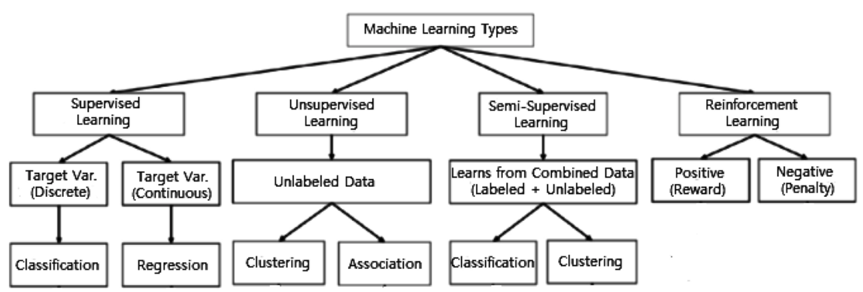
Figure 2: Machine Learning Types [74].
ML methods are broadly categorised into four main paradigms: supervised learning, unsupervised learning, semi-supervised and reinforcement learning. Although all three have applications within software engineering, supervised learning is the most pertinent to automated code refactoring and is therefore the primary focus of this project [13, 74].
In supervised learning, models are trained on labelled datasets that map input features to known outputs, such as specific refactoring types. The model learns to generalise from these examples and can subsequently predict appropriate refactoring strategies for previously unseen code segments. This makes supervised learning particularly suitable for tasks such as identifying where refactoring is needed and recommending the most appropriate technique. The effectiveness of supervised learning is further enhanced by the availability of open-source datasets annotated with refactoring labels.
In contrast, unsupervised learning involves discovering patterns in unlabelled data and is commonly applied to clustering or anomaly detection tasks. Reinforcement learning trains an agent to make sequential decisions based on reward feedback. While these paradigms offer intriguing possibilities, such as using reinforcement learning to explore alternative refactoring sequences guided by code quality metrics, they fall outside the scope of this study [13, 74].
Within supervised learning, classification is a key method whereby a model predicts a class label for a given input. This process involves using labelled data to learn relationships between input features and corresponding categories. Classification types include [13]:
- Binary classification, which involves two class labels, such as yes/no or true/false.
- Multiclass classification, which includes more than two possible class labels.
- Multi-label classification, where each example can be associated with multiple labels simultaneously.
Several algorithms are commonly employed for classification tasks, including Support Vector Machines (SVM), Decision Trees (DT), and Random Forests (RF).
Support Vector Machines (SVM) operate by finding a boundary, known as a hyperplane, that best separates different groups of data within a high-dimensional space. SVM attempts to maximise the margin, or distance, between the closest data points of each class and the hyperplane, with a wider margin generally leading to better generalisation on unseen data. For more complex datasets, kernel functions (such as linear or polynomial kernels) transform data to enhance separability. However, SVM may struggle with noisy data or when classes overlap significantly [74, 77].
A Decision Tree (DT) is a non-parametric supervised learning method that recursively partitions the dataset based on input feature values, forming a tree-like structure. Starting from the root node, internal decision nodes evaluate attributes until a leaf node assigns the predicted class or value. Prominent algorithms include ID3, C4.5, and CART, which differ in attribute selection and tree pruning techniques. Splitting criteria such as Gini impurity or entropy assess the quality of splits by measuring class separation. Decision trees are valued for their interpretability and ability to handle both numerical and categorical data, although they can be prone to overfitting without proper regularisation [13, 74].
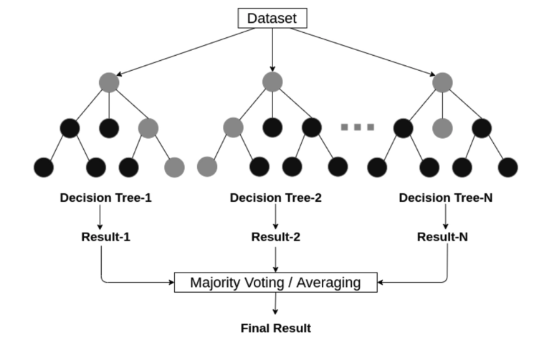
Figure 3: Random Forest structure considering multiple decision trees [74].
Random Forest (RF) utilises an ensemble approach by training multiple decision trees in parallel on different subsets of the training data. Final predictions are made through majority voting (for classification) or averaging (for regression), which improves accuracy and reduces overfitting risk. RF achieves robustness via two key strategies: bootstrap aggregation (bagging), which generates diverse training datasets through random sampling with replacement, and random feature selection, which promotes tree diversity. This combination yields a collection of varied yet accurate trees, resulting in more reliable predictions compared to single decision tree models [13, 74].

2.5 Large Language Models and Refactoring

LLMs have emerged as powerful tools for software engineering tasks, particularly those requiring deep semantic understanding of source code and the ability to generate syntactically correct transformations. While LLMs build upon the transformer architecture, not all aspects of transformers are equally relevant for automated refactoring. The concepts most central to refactoring involve the mechanisms that enable models to capture long-range code dependencies, represent structural relationships, and perform context-aware code rewriting [45-49]. This section therefore highlights the components of LLMs that directly support the semantic and syntactic reasoning required for automated refactoring.

2.5.1 Transformer Self-Attention as a Foundation for Code Understanding for LLMs.

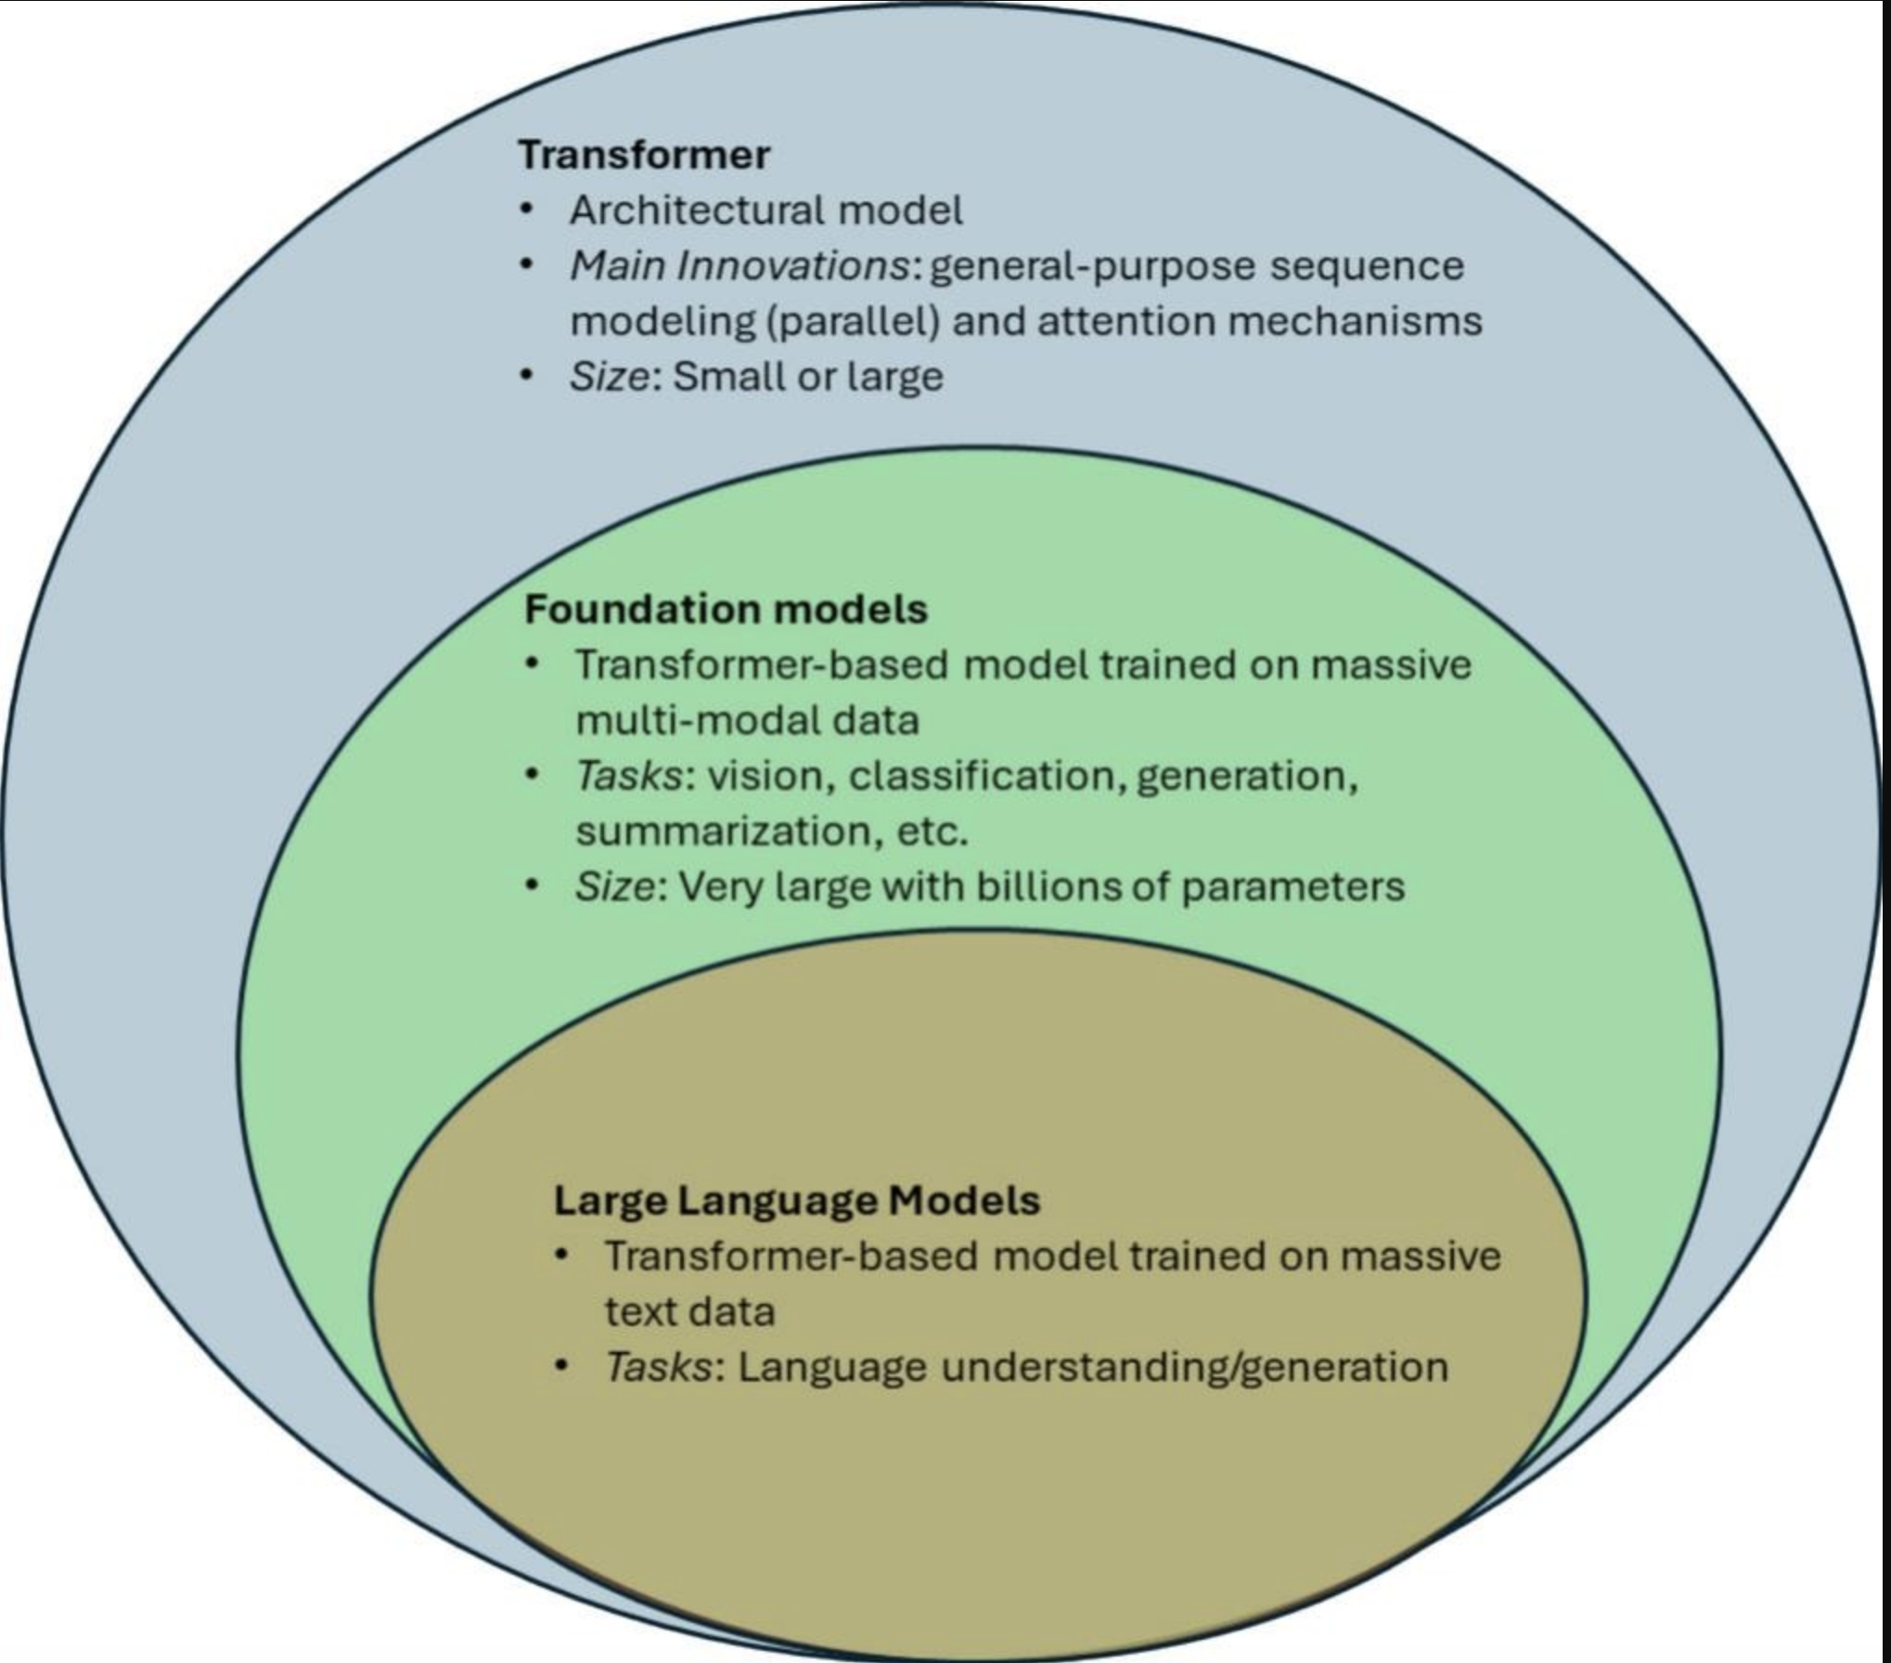
Figure 4: Structural Relationships Among Transformers, Foundation Models, and Large Language Models
Transformers operate using a self-attention mechanism that computes contextual relationships between all token pairs in an input sequence [47]. For code, this mechanism is particularly advantageous because software often contains dependencies that span multiple lines or even entire functions, such as variable definitions, type declarations, method invocations, and control-flow relationships. Self-attention enables the model to evaluate these dependencies by projecting each token into query, key, and value vectors and computing relevance scores between them. The resulting weighted aggregation allows the model to focus on semantically linked elements: for example, relating a variable's usage to its declaration or connecting an overridden method to its parent definition [46, 47].
Unlike earlier architectures such as Recurrent Neural Networks, which struggle with long-range dependencies due to sequential processing constraints, transformers process all tokens in parallel. This global receptive field is essential for refactoring tasks that require understanding interactions across an entire code block or file, such as renaming identifiers consistently, removing redundant logic, or restructuring complex conditionals [49, 45].
Because self-attention does not inherently encode token order, transformers incorporate positional encodings to represent syntactic structure. In programming languages, where control flow, indentation, and block boundaries have semantic significance, positional encoding assists the model in capturing hierarchical relationships and scope boundaries. These properties allow transformers to build contextual representations that align with the structural requirements of static analysis and code transformation tools [45, 46].

2.5.2 Encoder–Decoder to Decoder-Only Models in Code Transformation
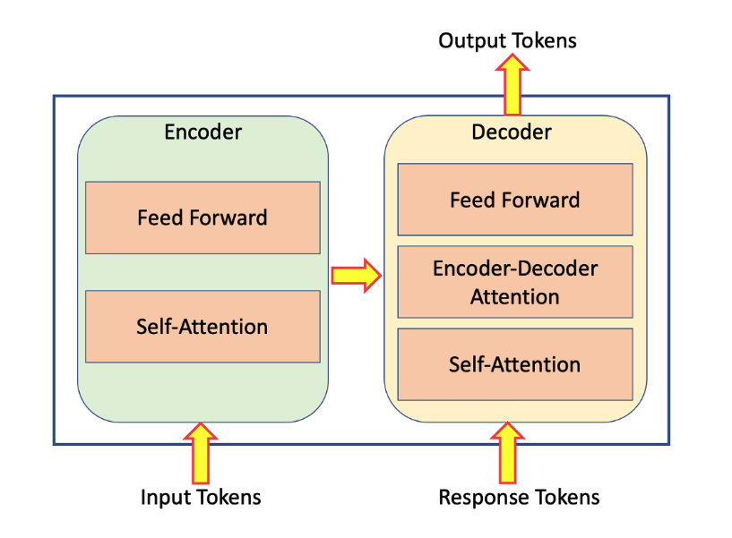
Figure 5: High-level architecture of encoder-decoder transformer [50]
Traditionally, transformer models were organised into an encoder–decoder structure, where the encoder produced a bidirectional contextual representation of the input, and the decoder generated output tokens autoregressively while attending to the encoder (fig 5). For code understanding tasks, encoder–decoder architectures such as T5, BART, and CodeT5 have demonstrated strong performance in tasks like code translation, summarisation, and defect detection, as they combine full–context comprehension with flexible sequence generation [47].

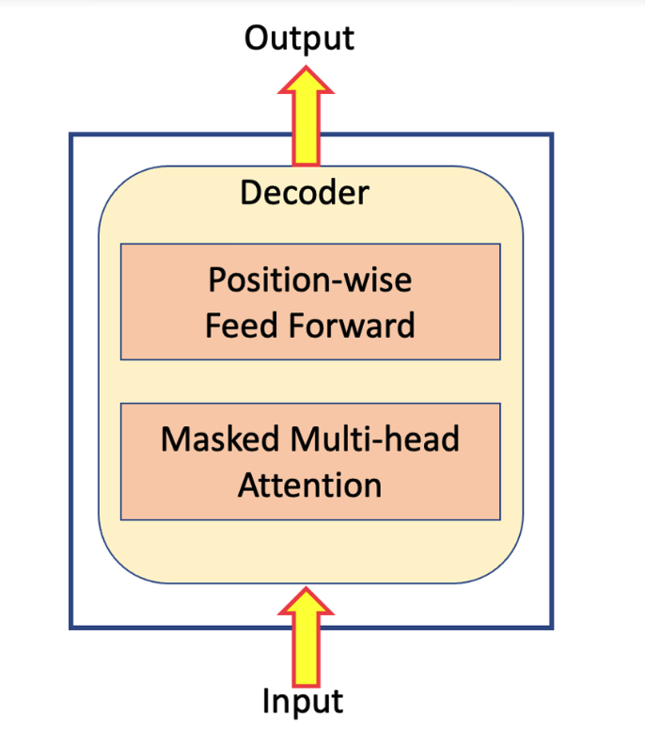
Figure 6: High-level architecture of decoder transformer [50]
However, the rise of large decoder-only models, such as GPT and LLaMA, has been driven by their scalability and simplified training objectives. Decoder-only models learn to predict the next token in a sequence using causal self-attention, enabling them to perform transformation tasks by treating them as text completion problems (fig. 6). In a refactoring context, this means a model can be prompted with the existing code and a refactoring directive (“Rename variable x to count”, “Replace loop with list comprehension”, etc.), and the model autoregressively generates the revised code. Despite lacking an explicit encoder component, decoder-only models implicitly learn internal representations sufficient for complex structural transformations. The unified next-token prediction paradigm simplifies training and improves performance at scale, enabling decoder-only LLMs to generalise across diverse software engineering tasks, including repair, mutation, and refactoring, without dedicated task-specific architectures [46, 50].

2.5.3. Transformer Models Trained Specifically for Code
While general-purpose LLMs can operate on source code, models trained on code-specific corpora exhibit superior structural and semantic understanding. CodeBERT represented a significant advancement by learning joint embeddings for programming languages and natural language descriptions. Through masked language modelling and replaced token detection objectives, CodeBERT demonstrated that transformer-based models can capture program syntax, control-flow patterns, and semantic equivalences, enabling applications such as semantic code search and documentation alignment [47].
Subsequent models such as CodeT5 and Codex extended these capabilities to generative tasks, enabling context-aware code rewrite operations, structural transformations, and patch generation. These models leverage the same self-attention mechanisms as natural language LLMs but are trained on billions of lines of code, exposing them to diverse patterns of software evolution found in version-control histories. As a result, they implicitly learn common refactoring idioms and best practices, such as loop unrolling, variable hoisting, or API modernisation. In addition, by treating code as a structured language with strict syntax rules, transformer models develop internal representations of abstract syntax tree (AST) patterns even without explicit AST supervision. This latent structural modelling is crucial for refactoring tasks, which require precise modifications that respect syntactic and semantic correctness [45, 46].

2.5.4 Relevance and limitations of LLM Capabilities to Automated Refactoring

Automated refactoring places specific demands on analysis and transformation tools: they must understand program structure, model long-range dependencies, infer developer intent, and generate behaviour-preserving code modifications. The capabilities discussed in the previous subsections, i.e. global attention, context-aware generation, and exposure to large-scale code corpora, position LLMs as promising candidates for these tasks. However, their relevance becomes clearer when mapped directly to refactoring requirements. First, many refactorings require consistent updates across all occurrences of an entity, such as renaming variables or propagating structural changes across method calls. The transformer’s ability to model global token-token relationships allow LLMs to track these dependencies across an entire file or function. Second, generative refactorings such as method extraction or API migration require the creation of new code that preserves original behaviour. Decoder-only LLMs support such transformations by producing contextually grounded code completions conditioned on the existing code and a transformation directive. Third, exposure to large repositories enables LLMs to internalise common refactoring patterns and idiomatic code improvements, allowing them to propose transformations that align with established developer practices [45, 46].
Despite these strengths, several limitations constrain the use of LLMs in automated refactoring. LLMs may hallucinate syntactically invalid or semantically incorrect code, challenging the requirement for behaviour preservation. Their token-based representations lack explicit access to structural artefacts such as abstract syntax trees or type information, limiting deep semantic reasoning. Outputs can be sensitive to prompt phrasing and are not deterministic, which complicates their deployment in automated tooling. Finally, limited context windows restrict the model’s ability to process entire projects or multi-file refactorings. These limitations underline the need for carefully scoped applications of LLMs in refactoring pipelines and motivate the investigation of refactoring classification as a more controlled and tractable problem setting [45, 46, 51].

2.5 Literature Review
Recent years have seen significant progress in applying ML techniques to software refactoring and code quality improvement. Early work by Aniche et al. [13] applied supervised ML methods to predict whether methods in Java projects required refactoring, using static code metrics such as lines of code, cyclomatic complexity, and coupling. Their classifiers, including Random Forests and SVM, were evaluated using standard metrics such as precision, recall, and F1-score on over two million refactorings mined from over 11,000 Java projects across the Apache, F-Droid, and GitHub ecosystems. Their models predicted 20 distinct refactoring types with accuracies often exceeding 90% identifying Random Forests as the most effective algorithm. However, the study also noted several limitations, including class imbalance via random under-sampling, which may not reflect real-world distributions. Moreover, their assumption that past refactorings represent desirable future patterns remains unverified. Despite these limitations, the dataset’s openness and methodological transparency make this one of the most robust empirical baselines for ML-driven prediction. Importantly, its exclusive focus on predictive accuracy, without assessing whether the suggested refactorings preserved program behaviour or improved maintainability, highlights a critical evaluation gap that directly motivates the present study.
Building on this foundation, Emon et al. [14] introduced a framework combining code smell detection with refactoring recommendations. Using classifiers such as Random Forests, SVM, and K-Nearest Neighbours (KNN) trained on static code and design metrics, their approach demonstrated improved accuracy in identifying problematic code. The study evaluated 13 ML models across multiple metrics and similar to Aniche et al. [13] found Random Forests to achieve highest accuracy especially for Long Method and Large Class, achieving over 92%. While methodologically rigorous, the study’s focus primarily on predictive accuracy rather than assessing the downstream effects of refactoring suggestions on software quality. Its reliance on small-scale, static datasets and threshold-based definitions of code smells may also limit generalisability. This reflects a recurring gap in ML-driven refactoring research; high performing predictive models that are seldom validated for behavioural correctness or maintainability improvements.
Similarly, Cui et al. (2022) proposed RMove, a ML based tool which integrates structural and semantic code representations, to predict Move Method refactorings. Specifically, RMove extracts method-level structural information, such as calling relationships, and semantic information from code content, then combines these representations to train ML classifiers that guide method relocation to appropriate classes. While RMove demonstrated improved effectiveness compared to its alternatives like PathMove, JDeodorant, and JMove, its evaluation had notable limitations. RMove’s evaluation focused on specific datasets, raising questions about cross-project generalisability and its performance on unseen or larger-scale software systems. Moreover, the approach currently relies on default embedding hyper-parameters and simplified structural features, such as basic calling relationships, without incorporating fine-grained information like callee types or invocation frequencies. These limitations suggest that, although classical machine learning approaches like RMove are promising for identifying potential refactoring opportunities, additional work is required to validate their real-world applicability and ensure safe, generalisable refactorings.
Complementing this research, Yadav et al. [16] conducted a comprehensive survey of 42 studies on machine learning approaches for code smell detection, spanning publications from 2005 to 2024. They identified persistent challenges in the field, including the scarcity and imbalance of labelled datasets, subjective and inconsistent definitions of code smells, and difficulties in generalising models across projects, programming languages, and dataset scales. The study also underscored the lack of standardised benchmarks and evaluation metrics, which complicates cross-study comparison and replication. In addition, the study discussed several threats to validity, such as potential omissions due to inconsistent keywords across digital libraries, and the exclusion of some relevant conference and journal papers. Despite a rigorous search and evaluation process, these factors may introduce bias or limit completeness. Overall, their findings emphasise the need for robust, transparent evaluation methodologies, further motivating this project’s focus on ensuring that ML-based refactorings preserve behaviour and improve maintainability in real-world contexts.
Following classical ML, Yu et al. [15] proposed MovePerf, a deep learning framework predicting both the likelihood and runtime and memory performance impacts of Move Method refactorings. MovePerf selects relevant features from different level either class, method or semantic level from real-world projects and uses a hybrid model combining a factorisation machine (FM) for low-order feature interactions and a deep feedforward neural network (DFNN) for high-order interactions. Evaluated on multiple real-world Java projects, it achieved an average mean relative error (MRE) of 7.69%, outperforming CNN, DeepFM, DeepPerf, and HINNPerf by 1.83% to 8.61%, demonstrating both predictive accuracy and stability. To ensure performance label reliability, the authors employed the Java Microbenchmark Harness (JMH) for precise execution-time measurements. However, threats to validity remain: the dataset was relatively limited due to the manual collection of execution times, potentially restricting the diversity of refactoring scenarios, and the model’s interpretability is limited, making it challenging for developers to understand the influence of individual features. Despite these limitations, MovePerf illustrates an emerging trend of multi-dimensional assessment of refactoring quality, combining structural correctness with runtime performance evaluation.
Transitioning to LLMs, recent work demonstrates that LLMs can automate both detection and transformation tasks. Liu et al. [12] leveraged LLMs such as ChatGPT (GPT-4) and Google Gemini to automate refactoring detection and code transformation. Their evaluation was twofold: first, measuring the detection accuracy of refactoring opportunities, where ChatGPT’s baseline accuracy was 15.6%, increasing to 86.7% when provided with explicit prompt labels specifying the refactoring type (e.g., Extract Method, Rename Variable). Second, they assessed the quality of the generated refactorings by comparing them with human developer solutions, finding that 63.6% of ChatGPT’s suggestions matched or surpassed human performance. Crucially, to ensure correctness, they developed RefactoringMirror, a hybrid system that re-applies LLM-proposed changes using IDE refactoring tools such as Eclipse and IntelliJ, achieving a high reapplication success rate of 94.3%. This combination of prediction accuracy and practical validation exemplifies a more comprehensive evaluation approach.
However, Liu et al. also identified several limitations and threats to validity. The study only evaluated two LLM, GPT and Gemini, limiting the generalisability of results to other models, and it focused exclusively on within-file refactorings due to LLM context-length constraints. The authors also acknowledged the inherent stochasticity of LLM outputs, which complicates reproducibility, and noted that while RefactoringMiner ensure syntactic and semantic safety, it cannot distinguish between safe but low-quality refactorings and genuinely beneficial ones. These limitations directly inform and motivate the present work, which seeks to systematically compare multiple LLMs on their capability to perform refactoring tasks across different types and contexts. By expanding both the scale of evaluation and the range of models, this study aims to address prior gaps in generalisability and reproducibility, offering a clearer understanding of which LLMs perform most effectively and reliably in automate refactoring scenarios.
Even lightweight small language models (SLMs) have been explored to capture code behaviour signals, although their capabilities are limited for complex, multi-file transformations compared to full-scale LLMs. Evaluations in Java and Python projects showed that SLMs could identify certain issues with reasonable accuracy (~84%), yet struggled with complex, multi-file transformations [7]. However, they struggled with valid refactorings incorrectly blocked by IDEs (Type II bugs), achieving only ~40% success. These results suggest that even compact models capture useful code signals, but the lack of rigorous multi-tiered evaluation frameworks limits the generalisability of their findings. Threats to validity also include the small size of the dataset (100 real-world refactoring bugs), reliance on manually verified ground truth, and potential human bias in evaluating model explanations. Moreover, results may not generalise to all programming languages or multi-file, cross-module refactorings. Despite these limitations, SLMs demonstrate strong potential as lightweight, hardware-efficient tools for behaviour-preserving bug detection, reducing reliance on costly static or dynamic analyses.
Emerging agentic AI approaches represent a further evolution in automatic refactoring. Gautam et al. (2025) introduced RefactorBench, a benchmark of 100 multi-file refactoring tasks designed to evaluate the stateful reasoning capabilities of language model (LM) agents. Their agents solved only 22% of tasks compared to 87% of human developers, largely because of difficulty of in tracking cross-file dependencies and maintaining consistent transformations. However, there are limitations including the risk of overfitting due to small sample size. Moreover, agents produce different results for the same task across runs. This undermines reproducibility and makes it hard to reliably compare models or benchmark improvements. Moreover, RefactorBench focuses on reasoning ability rather than verifying behavioural correctness or maintainability; an evaluation gap this study addresses through systematic behavioural validation [6].
Building on reasoning benchmarks, subsequent research explored multi-agent collaboration and hybrid human-in-the-loop approaches, each tackling different facets of automated refactoring. The Multi-Agent Refactoring Assistant (MANTRA) is an experimental multi-agent framework built around LLMs, in which a team of coordinated agents collaboratively automate method-level refactorings in Java codebases. Beyond simple code generation, MANTRA integrates a self-repair loop and inter-agent collaboration, enabling it to achieve an 82.8% success rate in producing refactorings that compile and pass all associated tests. This emphasis on behavioural validation parallels the present study’s use of test-suite based correctness checks. However, MANTRA primarily focuses on generating new refactorings rather than classifying or validating existing ones across multiple projects [9]. The current work complements this by providing a reproducible ML vs LLM framework that evaluates both predictive accuracy and behavioural correctness, addressing reproducibility and generalisability across diverse codebases.
Mo et al. [5] investigated interactive AIs agents for code refactoring but with combination of human guidance, where developers could review, override or steer the AI’s refactoring suggestions. Their system integrated real-time code analysis with adaptive interaction protocols, allowing the agent to respond dynamically to developer preferences and contextual requirements. In controlled experiments with 45 professional developers, the approach improved refactoring quality by 37% compared to traditional automated tools, achieving an 89.2% user acceptance rate.
Despite these promising results, the system has notable limitations. Its effectiveness decreases for domain-specific refactoring patterns outside the training distribution, such as embedded systems or high-performing computing code. Performance also degrades on very large codebases with complex interdependencies, and maintaining real-time responsiveness during comprehensive code analysis remains technically challenging. Additionally, the evaluation largely reflects human-agent collaboration metrics, without systematically verifying whether refactorings preserve program behaviour, and it is constrained to the specific projects and contexts used in the study [5].
Together, these studies illustrate the growing potential of ML, LLMs, SLMs, and agentic AI in automated refactoring. However, persistent challenges remain: most approaches evaluate only predictive or generative accuracy, neglect behavioural correctness and cross-project generalisation, and rely heavily on static metrics or limited evaluation benchmarks. These gaps underscore the need for rigorous, structured evaluation frameworks that verify both the identification of refactoring opportunities and the functional correctness of transformations, directly motivating the methodology adopted in this study.

3. Motivation
ML based refactoring detection has been studied extensively, with prior work predominantly relying on supervised classifiers trained on refactorings extracted from the same projects in which they are evaluated [1-16]. While these approaches show promising within-project accuracy, they rarely assess cross-project generalisation, despite the fact that real refactoring tools are expected to operate on software systems they have never previously encountered. This methodological gap means that the practical reliability of ML-based refactoring detection in real-world development environments remains largely unknown.
Recent work leveraging LLMs [8–12] has demonstrated strong semantic understanding of source code, suggesting potential advantages over traditional metric-based ML classifiers. However, LLMs remain largely black-box systems, and existing studies often evaluate them only on curated datasets or isolated examples. As with ML models, their ability to generalise across diverse, unseen projects has not been systematically examined.
The lack of empirical research on cross-project performance constitutes a critical omission in the refactoring literature. Developers require tools that maintain accuracy when applied to unfamiliar, heterogeneous codebases, including legacy systems, modern libraries, and long-lived open-source projects. Without evaluating generalisation, there is no evidence that existing ML or LLM approaches are robust enough for practical adoption.
This project directly addresses this gap by conducting the first systematic comparison of cross-project ML models and LLMs for refactoring-type classification. A model is trained on refactorings from six projects and evaluated on four unseen real-world systems, providing a realistic assessment of how well both ML and LLM approaches transfer beyond their training distributions. By combining traditional ML techniques, LLM inference, and controlled manual refactorings to establish ground truth, this study delivers a comprehensive evaluation of generalisability, stability, and practical suitability.
Java is chosen due to its static typing, extensive open-source ecosystem, and mature analysis tooling such as RefactoringMiner, which enables reproducible extraction and verification of refactoring instances. The findings provide insights into whether conventional metric-based models remain viable for automated refactoring, or whether modern LLMs offer superior robustness for real-world software maintenance scenarios.

4. Methodology

This section outlines the methodological framework used in this research, structured according to the Research Onion Model originally proposed by Saunders et al. in 2007 (fig. 7). The framework progressively justifies the philosophical stance, research approach, methodological choices, strategy, time horizon, and the techniques and procedures employed in conducing the experiments. This layered structured ensures that the research design is coherent, logically grounded, and aligned with best practices in empirical software engineering.
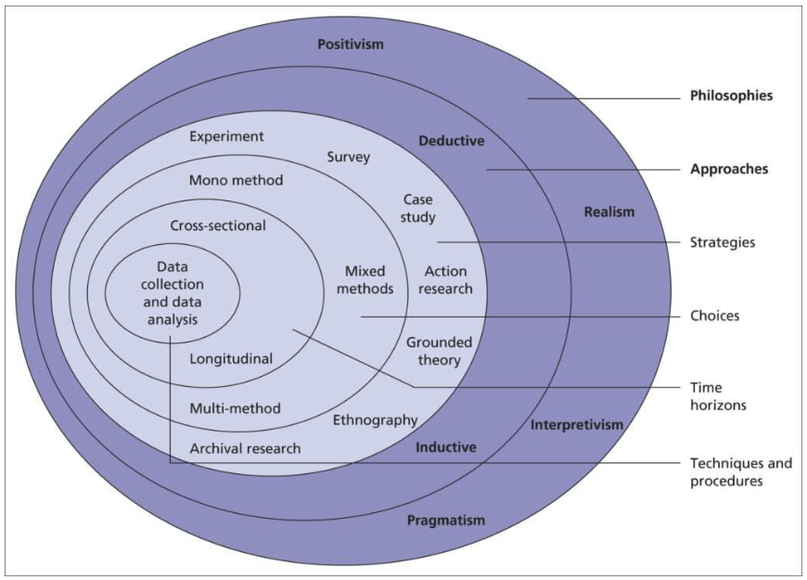
Figure 7: Research Onion model [53].

4.1 Research Philosophy

This study adopts a positivist research philosophy, whish asserts that knowledge is derived from objective, observable phenomena and can be measured through empirical evidence [54]. Positivism is appropriate for this research because all evaluations are based on quantifiable model outputs i.e. accuracy, precision, recall and F1-score. The study does not rely on subjective interpretation but instead uses controlled experiments and statistical tests to determine how effectively different predictive models classify refactoring operations. This philosophical stance underpins the use of hypothesis-driven evaluation and ensures methodological rigour consistent with empirical software engineering research [1].

4.2 Research Approach

The research follows a deductive approach, in which predefined expectations (grounded in prior literature) are formally tested through experimentation. Previous studies [13, 16] suggest that Random Forest classifiers outperform other ML models in code-smell or refactoring prediction tasks, and that recent LLMs exhibit strong semantic understanding of source code [45, 46]. These initial expectations guide the structure of the experiments, which aim to confirm or refute hypothesis in Section 1. The deductive approach is therefore well-suited to this study, as it involves systematic testing, comparison of measurable outcomes, and statistical inference to draw conclusions from the data [55].

4.3 Methodological Choice

This research adopts a mono-method quantitative methodological choice. All of the data collected and analysed in this study, including model predictions, performance metrics, and statistical comparisons, is numerical. The study does not incorporate qualitative analyses, case studies, or interviews, and instead relies exclusively on quantitative assessment of predictive accuracy and behavioural correctness across multiple datasets and tools. This choice aligns with the positivist and deductive stance, providing a consistent methodological basis for evaluating model performance objectively [56].

4.4 Research Strategy
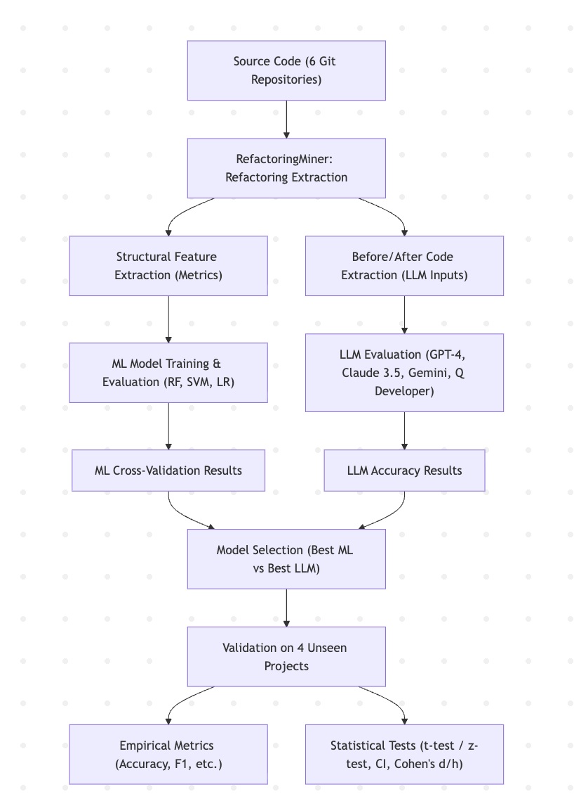
Figure 8: End-to-End Experimental Pipeline for Model Evaluation

The system is organised into a three-phase experimental workflow designed to evaluate model performance, select the strongest candidates, and assess their generalisability to unseen real-world projects (fig 8). The process begins by extracting source code from six Git repositories. RefactoringMiner is applied to these repositories to detect refactoring instances and generate structured before-and-after representations. From these instances, structural metrics are computed to support ML-based classification, while the corresponding code pairs are used as inputs for LLMs.
In Phase 1, multiple ML algorithms are trained and evaluated across the six curated projects to identify the model with the highest predictive accuracy and stability. In Phase 2, several LLMs are evaluated on the same test instances to determine the best-performing LLM under consistent prompt and evaluation conditions. Finally, in Phase 3, the selected ML model and LLM are evaluated on four entirely unseen, real-world validation projects. Controlled refactorings are applied manually to these projects, and RefactoringMiner is used to provide ground-truth labels, enabling a fair comparison of how well each model generalises to new codebases. This workflow provides a structured and reproducible pipeline for selecting the strongest models and assessing their practical robustness in realistic software maintenance scenarios.

4.5 Time Horizon
The study employs a cross-sectional time horizon, in which all data is collected and analysed at a single point in time [52]. This is appropriate because the goal is not to observe changes in model performance over time but to provide a snapshot comparison of how ML and LLM models perform on structured and unseen datasets. Although LLMs evolve rapidly across versions, this study focuses on a fixed model state for consistency and reproducibility.

4.6 Techniques and Procedures

4.6.1 Data Sources

This study relies data sources collected from open-source repositories and external tools. The aim was to assemble a dataset capturing structural, behavioural, and contextual aspects of refactoring activities in large-scale Java systems. These sources were selected to ensure diversity in software domains, scale, and architectural patterns, providing a representative and robust foundation for evaluating refactoring prediction approaches.

The empirical foundation of the study is drawn from six major open-source Java projects, selected for their maturity, scale and representation of diverse domains:
- Apache Commons Lang - utility library. Chosen for its focused utility functionality and well-structured code, providing a reliable basis for training predictive models.
- Apache Kafka - Distributed messaging system. Provides complex, concurrent code patterns typical of large-scale enterprise systems, useful for assessing model generalisation.
- IntelliJ IDEA Community - Integrated development environment. Represents large, interactive developer tools with diverse modules, allowing evaluation of models on complex software architecture.
- Spring Framework - Enterprise Web framework. Offers a large-scale framework with layered architecture, testing models against enterprise-level code patterns.
- Mockito - Unit testing/mocking framework. Provides domain-specific testing utilities, enabling evaluation of models in specialised libraries.
- Hibernate ORM - Object-relational mapping framework. Contains extensive database. Interaction code, adding diversity in coding patterns and refactoring types.

Projects for testing real-world validation:

- Java-WebSocket - A legacy networking codebase feature long methods, deeply nested loops and pre-modern design patterns
- Apache Commons-beanUtils– Another legacy project containing reflective utilities and large procedural methods representative of older enterprise libraries.
- OpenPdf – A modern document-processing library whose codebase includes areas requiring restructuring and cleanup, making it useful for evaluating model performance on real-world maintainability issues.
- Ant– A long-standing build automation tool with an older procedural architecture, providing examples of mature but outdated design patterns that commonly require refactoring.

Collectively, these projects provide a broad spectrum of software types and coding patterns, offering a variety of contexts for training and evaluating predictive models and testing their robustness and generalisability.

4.6.2 Data Collection

Several types of primary data were collected from the selected projects to support the experimental evaluation of predictive models and behavioural preservation:

1. Refactoring data - were automatically extracted from the selected projects’ commit histories using RefactoringMiner 3.0, which provides state-of-the-art detection and classification of refactoring operations [18]. These data form the basis for training and evaluating predictive models.
2. Code metrics - structural (lines changed, cyclomatic complexity), contextual (file paths, commit metadata) and temporal (commit timestamps, evolution sequences). These metrics constitute the feature set by ML models and support contextual analysis of refactoring activities. Collecting diverse structural, contextual, and temporal information enables the models to captures patterns in code changes and facilitates feature importance analysis in Section 4.6.4.2.1.
3. Performance data - results of ML models and LLMs, including accuracy, precision, recall, F1), LLM outputs and cross-validation scores. These data allow quantitative assessment of predictive performance across datasets. Detailed definitions, formulas, and statistical analyses for these metrics are presented in Section 4.6.4, where they are used to quantify model reliability, sensitivity to refactoring types, and overall classification effectiveness.

In addition to refactoring and performance data, relevant repository metadata such as commit histories, contributor activity, branch information, and build configurations were recorded to ensure traceability and reproducibility of the experimental workflow. These metadata supported data collection and validation but were not directly used as input features in model training or evaluation.

Refactoring Detection

For each project, the full Git history was cloned locally, and all commits modifying Java source files were identified. Merge commits and commits without source-code changes were excluded to reduce noise, resulting in a curated subset of commits more likely to contain meaningful structural edits.
Ten refactoring types were selected for this study based on their frequency in real-world Java systems, as determined through preliminary analysis of the curated repositories. These types span method-, parameter-, and variable-level modifications and thus provide representative coverage of common structural and behavioural refactoring activities:

- Add Method Annotation
- Change Parameter Type
- Change Return Type
- Change Variable Type
- Extract Method
- Extract Variable
- Move Method
- Rename Method
- Rename Parameter
- Rename Variable

RefactoringMiner was used to detect these operations and to produce a structured JSON representation of each instance, including its type and associated structural changes. These data formed the basis for training and evaluating the machine-learning models.
Using the location metadata supplied by RefactoringMiner, both pre-commit and post-commit code fragments were extracted. These fragments were trimmed to the relevant method or variable scope based on the exact line ranges modified in the commit, thereby avoiding unnecessary syntactic context. The resulting before- and after-pairs served as the input samples for evaluating the refactoring capabilities of LLMs in Section 4.6.7.2.

Evaluation Metrics

This study evaluates the predictive performance of ML models and LLMs using a set of standard classification metrics and statistical comparison techniques. These metrics support a rigorous and consistent assessment of model accuracy, stability, and cross-project generalisation. The following evaluation criteria are used throughout the three experimental phases of the study.

4.6.4.1 Primary Classification Metrics

These metrics quantify the predictive capability of ML models and LLMs across the selected refactoring datasets, forming the foundation for evaluating classification accuracy and model reliability.

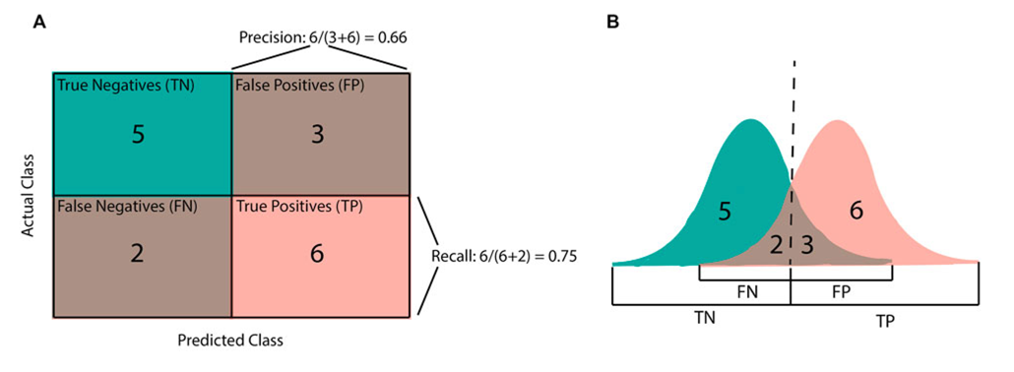
Figure 9: Illustration of classification evaluation concepts. (A) Confusion matrix showing the distribution of true positive (TP), true negative (TN), false positive (FP), and false negative (FN) predictions used to compute accuracy, precision, and recall. (B) Normal distribution of model prediction scores illustrating how the classification threshold determines positive and negative outcomes [1].

Accuracy

Accuracy measures the proportion of correctly classified refactoring instances across all types and provides and overall indication of model correctness [1]. It is calculated as
$$Accuracy = (TP + TN) / (TP + TN + FP + FN)$$
This metric is useful for assessing general predictive performance of ML and LLM models in identifying refactoring operations. However, because refactoring datasets are often imbalanced, where one type of refactorings such as Rename method could occur more frequently than others, accuracy alone may not fully capture performance across all datasets [19]. For this reason, it is complemented by precision, recall and F1-score, which provide a more balanced evaluation of model performance across heterogeneous refactoring types.

        - Precision, recall and F1-score

The confusion matrix (fig 9) forms the foundation for classification metrics such as precision, recall and F1-score by recording the number of correctly and incorrectly classified instances. Panel B shows the distribution of model prediction scores, illustrating how the classification threshold determines positive and negative outcomes [1].
From this matrix, precision and recall are calculated as:
$$Precision = TP / (TP + FP), Recall = TP / (TP + FN)$$
Precision and recall are complementary metrics: precision measures the reliability of positive predictions, reducing false suggestions, while recall ensures that model captures majority of actual refactoring instances. The F1-score, defined as the harmonic mean of precision and recall, balances these two metrics to provide a single indicator of predictive performance and represented as:

$$F1 score = 2 * (Precision * Recall) / (Precision + Recall)$$
A high F1-score indicates that a model is both accurate and complete in detecting refactoring changes. This is particularly relevant in refactoring prediction, where datasets are often imbalanced; a model may achieve high accuracy by predicting non-refactorings but fail to detect genuine ones. Using precision, recall and F1-score together provides a more balanced and informative evaluation of predictive performance across heterogeneous refactoring types [2,3].

4.6.4.2 Model evaluation metrics:

Model evaluation metrics will be employed to assess the reliability, stability, and interpretability of model performance across different evaluation settings. Unlike primary classification metrics, which quantify predictive accuracy on individual test sets, validation metrics evaluate how consistently and transparently models perform under varying data partitions and feature configurations.
These metrics collectively ensure that the results obtained from ML classifiers are not only accurate but also generalisable and statistically robust.

4.6.4.2.1 Feature Importance Analysis

Feature importance analysis will be employed to identify which structural characteristics of the code contributed most to the model’s refactoring predictions. This technique enhances interpretability by quantifying the relative contribution of each input feature to classification outcomes, supporting a clearer understanding of how the machine learning model distinguishes refactoring types.
An initial set of features was explored, including both structural and contextual attributes such as textual metrics (e.g., description length, word count) and path-based indicators (e.g., is_test_file, package depth). However, preliminary experiments showed that these additional features did not consistently improve predictive accuracy and often reduced generalisation performance, suggesting that the added contextual and textual dimensions introduced noise or redundancy rather than meaningful predictive value.
Consequently, the final model focused on three core structural features extracted directly from code metrics: Lines Changed, Cyclomatic Complexity, and Nesting Depth. These metrics improved predictive stability during early experimentation and were selected because they are well-established indicators of code structure and maintainability in software engineering research [22, 23].
For the LLM experiments, contextual (e.g., file paths, commit metadata) and temporal (e.g., commit timestamps) features were additionally utilised. These attributes were primarily necessary for retrieving the before and after code segments presented to the LLM, enabling it to infer the type of refactoring that had occurred.

4.6.4.2.2 k-Fold Cross Validation

The k-fold cross-validation (CV) technique is used to reliably estimate a model’s performance on unseen data. It is implemented by randomly splitting the available data into k folds. Models are trained on k-1 folds and tested on the remaining fold iteratively until k times. Every fold gets used as a test set exactly once and as part of the training set k-1 times. Performance metrics, i.e., accuracy, precision, and recall, are then averaged across all folds. This method provides a robust measure of model generalisation and mitigates overfitting, making it widely used for model selection and hyperparameter tuning [20].
For this study, five-fold CV scheme will be employed to balance computations efficiency with reliable performance estimation, which is appropriate given the moderate size of the refactoring dataset. While large number of folds, i.e., >9 folds, can produce more precise estimates, this can significantly increase computation time. Recent research shows that reducing from 10-fold CV to 6-fold CV reduced computation time and energy use by approximately 40%, while maintaining performance differences below 2% for larger datasets (> 300,000 instances) [21]. This demonstrates that smaller fold counts, like five-fold, can provide accurate and computationally efficient performance estimates for medium-sized datasets.

4.6.4.2.3 Confidence Interval (CI) Estimation and Training Stability

Confidence Interval (CI) estimation will be applied to quantify the uncertainty in model performance scores obtained from cross-validation. This approach provides a statistical measure of reliability for each ML model’s predictive results, ensuring that observed performance differences are not due to random variation across folds. The use of CIs has been formally established in recent literature, which demonstrates their validity for estimating test error variability and supporting fair model comparison [24, 25].
The t-distribution, similar to normal distribution, has a bell shape but heavier tails. This will produce larger t-values, which increase the margin of error when estimating parameters, thereby accounting for the additional uncertainty associated with small sample sizes. A 95% confidence interval will be calculated for each metric (accuracy and F1-score) using the t-distribution:
$$=\overset{‾}{x}±t_{α/2,df}⋅\frac{s}{\sqrt{n}}$$
where $\overset{‾}{x}$ is the mean score across folds, $s$ is the standard deviation, $n$ is the number of folds, $df=n-1$ the degrees of freedom, and $t_{α/2,df}$ is the t-value for a 95% confidence level [2].
Training stability will be further assessed using CI width, which reflects the consistency of model performance across folds:
$$=CI_{upper}-CI_{lower}=2⋅t_{α/2,df}⋅\frac{s}{\sqrt{n}}$$
A narrower CI Width indicates greater model stability and generalisation reliability. Following recent recommendations for uncertainty quantification in machine learning [26], models are categorised as excellent (CI < 4%), moderate (4-10%), or poor (> 10%). CI overlap analysis will be used to determine whether observed performance differences between models were statistically significant [2,3].

4.6.4.3 Statistical Comparative Analysis metrics:

Following model validation, statistical comparative analysis metrics will be employed to evaluate whether observed performance differences within and across ML models and large LLMs are statistically and practically significant. These analyses extend the validation framework by determining whether variations in model performance reflect genuine differences in predictive capability rather than random variation in the data.

4.6.4.3.1 P-value analysis

The p-value measures the probability of obtaining the observed results assuming that the null hypothesis is true. It is widely used in inferential statistics to test whether the differences observed between groups are likely to have occurred by random chance.
Both t-tests and z-tests are statistical hypothesis tests that generate a test statistic describing how far an observed result deviates from the null expectation. The p-value is then derived from that statistic, representing the probability of obtaining such a deviation under the null hypothesis. In practice, t-tests use the t-distribution, which accounts for uncertainty in smaller samples, while z-tests rely on the normal distribution and are more appropriate for larger or proportion-based datasets (n > 30).
A conventional threshold of p < 0.05 will be adopted to denote statistical significance, corresponding approximately to values more than two standard deviations from the mean under a normal distribution. This threshold reflects the conventional 5% risk level for rejecting the null hypothesis when it is true, providing a balance between sensitivity and false-positive risk [27]. Further details regarding these experimental comparisons are provided in Section 3.5.

4.6.4.3.2 Cohen’s d and Cohen’s h calculation

While p-values indicate whether observed differences are statistically significant, they do not reflect the magnitude or practical importance of those differences. Therefore, even when a result is statistically significant, it may represent only a trivial effect in practical terms. To address this limitation, Cohen’s d and h will be calculated to quantify the effect size, providing a standardised measure of the mean difference between two groups and indicating how substantial that difference is in practice.
Cohen’s d is calculated as:
$$d=\frac{{\overset{ˉ}{X}}_{1}-{\overset{ˉ}{X}}_{2}}{s_{p}}$$

where ${\overset{ˉ}{X}}_{1}$and ${\overset{ˉ}{X}}_{2}$are the sample means of the two groups being compared, and $s_{p}$is the pooled standard deviation. The resulting value expresses how many standard deviations apart the two means are, allowing comparisons that are independent of the original measurement scale.
Cohen’s h is used when comparing two proportions. It measures the distance between proportions $p_{1}$and $p_{2}$after applying the arcsine square-root transformation, which stabilises variance and makes proportion differences more mathematically consistent [36]:
$$ψ1 = 2 ⋅[arcsin\left(\sqrt{p1}\right)-\arcsin\left(\sqrt{p2}\right)$$
Cohen’s d is appropriate for continuous normally distrusted data with a measurable standard deviation while Cohen’s h is appropriate when comparing two proportions of metrics such as accuracy, precision or recall especially when there is one measurement per model [37].
Interpretation of effect size follows conventional thresholds proposed by Cohen in 1988, where d < 0.2 indicates a negligible effect, 0.2–0.5 a small effect, 0.5–0.8 a medium effect, and > 0.8 a large effect [28].
In this study, Cohen’s d will be applied to quantify the magnitude of performance differences between ML models where data is likely to be continuous because of five-fold validation whereas Cohen’s h will be used to find the performance of best LLM models and comparison between the best LLM and ML model since they are going to be one measurement proportion.

4.6.7 Planned Experiments And Expectations
Building upon the methodological foundation established in the previous sections, covering data collection, experimental design, and evaluation metrics, this section outlines the experiments to be conducted, and the expected outcomes associated with each. The focus is on translating the defined framework into a series of reproducible experimental procedures and presenting theoretically grounded expectations regarding model performance and generalisation.

4.6.7.1 Identifying the best ML model

Using the six projects introduced in Section 4.6.1, this experiment will evaluate the cross-project performance of three machine learning algorithms, Random Forest, SVM, and Logistic Regression, to determine which achieves the highest predictive accuracy and stability. A training-to-testing ratio of approximately 3:2 (350 training and 150 testing instances) will be used. Refactoring instances will be extracted using RefactoringMiner 3.0. Then the three structural metrics, i.e. lines of code changed, cyclomatic complexity and nesting depth, will be derived as the input features for model training and testing. A single generalised model per algorithm will be trained across projects and tested on each project to assess how effectively it can classify refactoring types within a consistent codebase.
To determine whether performance differences between models are statistically meaningful, five-fold cross-validation will be applied using accuracy, precision, recall and F1-score as evaluation metrics. The individual fold scores from the cross-validation, rather than their mean values, will be compared using t-tests for all pairwise combinations of the three ML algorithms. Using individual fold scores preserves information about the variability and consistency of performance across folds, which would otherwise be lost if only mean values were compared [24, 25]. For example, two algorithms may yield identical mean accuracies but differ substantially in their fold-to-fold stability. Therefore, this approach will provide a more reliable assessment of whether observed performance differences are statistically significant.
The paired t-test will be chosen over the z-test, even though the overall dataset is relatively large, because the t-test is more appropriate when the sample size per comparison (i.e. the five folds) is small and the population variance is unknown. Moreover, while a z-test evaluates performance on a single random split, cross-validation will examine multiple data splits, offering a more robust estimate of general model performance [29].
In addition to using the paired t-test for statistical significance, Cohen’s d test will also be performed to evaluate the magnitude of the differences between folds across pairs of algorithms. This will provide a measure of practical significance beyond the p-values obtained from the t-tests.
Furthermore, 95% confidence intervals will be computed for each metric across folds to assess the reliability and stability of the validation results. Narrow confidence intervals will indicate consistent performance across folds, whereas wider intervals will suggest higher variability.
Together, the t-test, Cohen’s d, and confidence intervals will provide a comprehensive view of both the statistical and practical significance of performance differences between models.
Based on prior research [13, 30], it is anticipated that the Random Forest classifier will achieve the highest overall predictive accuracy and stability across projects, owing to its ensemble learning mechanism and robustness to feature variability. The SVM is expected to perform competitively on less complex datasets or projects such as Apache Commons Lang but may exhibit reduced generalisability due to sensitivity to parameter selection [31]. Logistic Regression, while interpretable and efficient, is anticipated to underperform relative to non-linear models given the expected complexity of refactoring patterns.

4.6.7.2 Identifying the best LLM

This experiment will evaluate the capability of LLMs to classify refactoring operations based on their semantic understanding of source code. For each project, the same 150 test cases used in the machine learning experiments will be employed to ensure a fair and consistent comparison. The evaluated models will include ChatGPT 4.0, Gemini 1.5, Claude 3.5, and Amazon Q Developer.
These models were selected to represent a diverse range of architectures and accessibility levels, with most being publicly available models, while Amazon Q Developer serves as a premium, code-specialised system for comparison. Preliminary testing was also conducted using a small language model (SLM) through Ollama; however, it was excluded due to inconsistent and unreliable outputs.
For each project, a subset of correctly extracted refactoring instances identified by RefactoringMiner is used to generate before-and-after code pairs. These code pairs are provided to each LLM together with a predefined list of possible refactoring types (Section 4.3.1.2.1). Prior to the main evaluation, a prompt calibration phase is conducted to identify a stable and reproducible instruction format. This involves iteratively refining prompt phrasing until consistent outputs are observed. Once finalised, the same standardised prompt structure is applied across all LLMs and projects to ensure methodological consistency.
In contrast to the ML classifiers, which are evaluated using five-fold cross-validation and therefore yield multiple performance estimates per model and metric (accuracy and F1-score), each LLM in this experiment is evaluated in a single inference setting on a fixed test set without retraining. Consequently, each LLM produces a single aggregate performance outcome per project rather than fold-level scores. Because this design does not yield multiple independent samples per model, F1-score and related metrics cannot be meaningfully compared using the same statistical procedures applied to the ML baselines. Accuracy is therefore used as the primary evaluation metric and is calculated as the proportion of correctly classified refactoring instances [19].
To assess whether differences in accuracy between LLMs are statistically meaningful, pairwise z-tests for proportions are conducted, with effect sizes quantified using Cohen’s h. This approach is appropriate for comparing proportions derived from single-sample evaluations rather than mean-based statistics.
It is anticipated that Amazon Q Developer may achieve the highest overall accuracy, given its positioning as a premium model fine-tuned for software engineering tasks. Prior work suggests that code-specialised LLMs often outperform general-purpose models on program understanding and transformation tasks due to domain-specific training and enhanced contextual reasoning capabilities [34, 35].

4.6.7.3 Real-World Validation of the Selected ML and LLM Models

For the final comparison between ML classifiers and LLMs, the best-performing model from each group will be selected based on the results of experiments 4.6.7.1 and 4.6.7.2. This comparison will be conducted exclusively on the four unseen real-world validation projects, as these projects were not used during training or prompt calibration and therefore provide a realistic assessment of cross-project generalisation.
For each of the four validation projects, controlled refactorings will be applied manually. Each refactoring will be committed individually, after which RefactoringMiner will be used to detect and classify the refactoring type, providing the ground-truth labels. These labelled instances will then serve as the test cases for evaluating the best-performing ML model using structural metrics.
The corresponding before-and-after code pairs will also be provided to the selected LLM, which will be asked to identify the refactoring type from the predefined taxonomy. The LLM’s predictions will then be compared directly against the RefactoringMiner labels under the same experimental conditions. This design ensures a fair and balanced comparison of how well the best ML model and the best LLM generalise to entirely new software systems.
Similar to the experiment described in Section 4.6.7.1, accuracy, precision, recall, and F1-score will be calculated for each model. Because these metrics will be calculated only once in this evaluation, CIs will be reported as high and low values, rather than as a mean ± standard deviation as done in the five-fold cross-validation in Section 4.6.7.1.
A paired z-test will be conducted on accuracy using the instance-level predictions of both models on the combined set of refactoring instances drawn from the four validation projects. Precision, recall, and F1-score cannot be tested with a standard z-test on a single run because they are ratios over subsets of predictions, not the entire dataset, and their values are dependent rather than independent Bernoulli trials like accuracy (See 4.6.4.1.2).
Since the ML and LLM models will be evaluated on exactly the same labelled examples, the comparison will be based on matched binary outcomes (correct/incorrect) for each instance. This will allow the statistical test to directly quantify whether the LLM achieves a significantly higher proportion of correct classifications than the ML model. Cohen’s h will be computed on the two accuracy proportions to assess the magnitude of the expected difference.
It is expected that LLMs will outperform traditional ML models because they are capable of understanding the semantic and contextual relationships within source code, rather than relying solely on quantitative structural metrics such as lines of code changed, cyclomatic complexity, and nesting depth. LLMs leverage large-scale pretraining on diverse codebases to generalise across projects and infer developer intent behind refactoring operations. Their ability to model code semantics, structural dependencies, and natural-language identifiers enables them to distinguish refactoring types more accurately and consistently than metric-based ML classifiers [32, 33].

4.6.8 Threats to Validity
This study employs a structured methodology; however, several threats to validity must be acknowledged.

4.6.8.1 Construct validity

A primary threat concerns the use of RefactoringMiner as the source of ground-truth labels. Although RefactoringMiner is widely used and empirically validated, its detection is not flawless, and any false positives or false negatives may propagate into both model training and evaluation. A second construct threat relates to the limited feature set used by the machine-learning classifiers. Only three structural metrics, lines changed, cyclomatic complexity, and nesting depth, were included in the final models. While these features are grounded in software-engineering literature, they represent only a narrow view of refactoring behaviour and do not capture semantic information, developer intent, or contextual code properties. As a result, the ML models’ measured performance may not fully reflect their ability to detect more complex or subtle refactorings in real-world settings

4.6.8.2 Internal validity

For the real-world validation phase, refactorings were applied manually to the four unseen projects. Although these refactorings were introduced only where they were genuinely needed and reflect realistic maintenance activities, manually applied refactorings tend to be more isolated and cleaner than naturally occurring developer commits, which often mix refactorings with other modifications. This may reduce the realism of the validation dataset, even though the refactorings themselves are authentic.

4.6.8.3 External validity

The study focuses exclusively on Java systems and a predefined set of ten refactoring types. While this ensures methodological control and alignment with commonly studied refactorings, it limits the generalisability of the findings to other programming languages, additional refactoring categories, or industrial systems with different architectures and development practices. The open-source projects used in training and validation, despite being diverse and mature, may also differ from proprietary codebases in ways that influence model behaviour.

4.6.8.4 Conclusion validity

ML models were evaluated using five-fold cross-validation, allowing estimation of performance variability through confidence intervals. LLMs, however, cannot be evaluated in the same manner and instead produce a single accuracy score per project. This means that LLM performance stability and variance cannot be quantified to the same degree as ML models. Although the paired statistical tests used in the final comparison are appropriate, the difference in evaluability introduces an inherent imbalance in how confidently the results can be interpreted.

Implementation
All implementation and experimentation were conducted on a MacBook Pro equipped with an Apple M2 Pro chip and 32 GB of memory. All code development was carried out in Visual Studio Code (v1.100.2). Python 3.11.3 and its associated libraries were used throughout the project: pandas for dataset processing and analysis, csv for structured data handling, and scikit-learn as the primary framework for ML model development. Additional tooling, such as Lizard for static metric extraction and joblib for model persistence, supported the construction of the ML pipeline.

5.1 Data processing and extraction

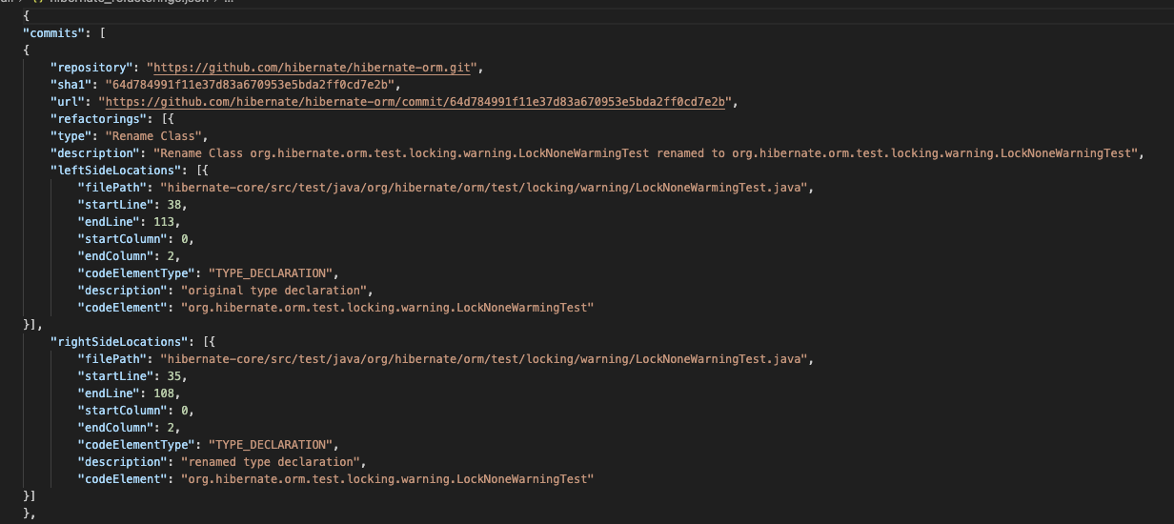
Figure 10: RefactoringMiner JSON Output Structure for Rename Class Refactoring Detection

Five open-source Java repositories were selected from the list described in Section 3.3.1.1 and were cloned locally for analysis. Refactoring instances were extracted using RefactoringMiner 3.0, which automatically identifies refactoring operations across commit histories and outputs structured JSON metadata for each detected change. The number of lines of code affected by each refactoring was estimated by summing the leftSideLocations and rightSideLocations, which indicate the corresponding code fragments before and after the transformation. This automated approach was selected for practicality: although prior studies such as Aniche et al. (2020) and Tsantalis et al. (2018) employed detailed git-diff reconstruction for finer-grained line-level analysis, such methods involve significant manual resolution of noise, particularly when individual commits contain multiple refactorings or unrelated changes such as formatting edits or small bug fixes. Given the scale of the dataset and the constraints of this project, a simplified yet systematic extraction method was therefore adopted.
Structural metrics were computed using the Lizard static analysis tool, which produced cyclomatic complexity and nesting-depth measurements for each method-level code segment involved in the refactoring. A custom Python script was developed to run Lizard on all relevant pre- and post-refactoring file versions and merge the extracted metrics with the RefactoringMiner output.

Figure 11: Sample CSV dataset showing extracted structural metrics and commit metadata for refactoring classification

After metric extraction, the dataset was assembled into training and testing partitions. Of the original entries, some were excluded due to missing files referenced in the RefactoringMiner report or because Lizard was unable to parse specific code fragments. The final dataset comprised 1,786 valid instances, of which 1,250 were used for training and 536 for testing (fig 11). Although the initial project list included Commons Lang, extraction for this repository proved unreliable due to inconsistencies between historical commit references and available file paths; accordingly, the dataset was limited to the remaining five projects.

5.3 ML evaluation

The ML evaluation was implemented in Python using pandas for data processing and scikit-learn for model construction and assessment. The dataset consisted of 2,050 refactoring instances extracted from five Java projects, each annotated with structural metrics such as cyclomatic complexity and nesting depth, computed using the Lizard static analysis tool. Three supervised learning algorithms, Random Forest, SVM, and Logistic Regression, were trained to classify instances into ten refactoring categories.
A five-fold cross-validation procedure was applied to evaluate model performance under varying training–testing partitions. Statistical significance testing was conducted using paired t-tests to compare the performance of the models across folds. Evaluation metrics included accuracy, precision, recall, and F1-score, allowing a comprehensive comparison of classifier behaviour across different refactoring types. To enable reproducibility and facilitate subsequent analyses, all trained models were saved using joblib.

5.4 LLM evaluation

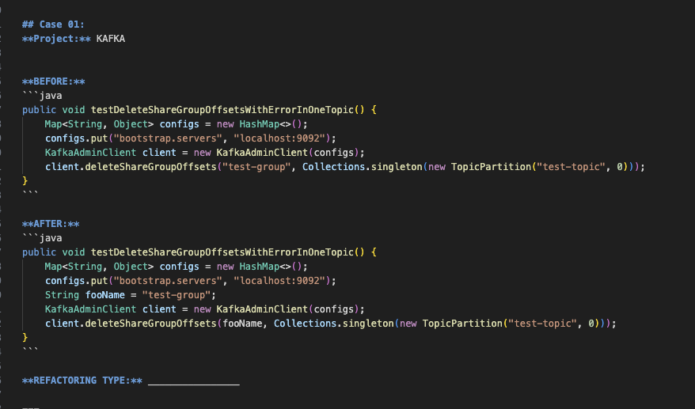
Figure 12: Code extracted using leftSideLocations, rightSideLocations and lines changes

The LLM evaluation used the same underlying dataset as the ML analysis but relied directly on code fragments rather than structural metrics. For each refactoring instance, before and after code snippets were extracted using RefactoringMiner’s leftSideLocations (pre-refactoring) and rightSideLocations (post-refactoring) fields, providing precisely aligned code segments associated with each transformation.
Four state-of-the-art language models were evaluated: Amazon Q Developer, Claude 3.5 Sonnet, GPT-4, and Gemini 1.5 Pro. Each model received the code pair and was tasked with predicting the correct refactoring type. A subset of 270 samples was selected for LLM testing to balance computational cost with evaluation depth. Model performance was assessed using accuracy and 95% confidence intervals, while single-proportion z-tests and Cohen’s h effect sizes were used to determine whether observed differences between models were statistically or practically meaningful relative to ML baselines.

5.5 ML vs LLM evaluation: Real-world validation

To assess generalisability beyond the curated dataset, a real-world validation study was conducted using four additional open-source Java projects: Java-WebSocket, Apache Commons BeanUtils, OpenPDF, and Apache Ant. These repositories were manually examined to collect instances of the ten refactoring types considered in this study, yielding 100 refactoring examples for evaluation.
For the ML models, RefactoringMiner was applied to the commit history of each project, and the resulting JSON outputs were converted into CSV format containing the structural metrics required by the trained classifiers. The best-performing ML model from Section 4.2 was then used to classify the refactoring types.
For the LLMs, the same commits were processed to extract before/after code snippets using leftSideLocations and rightSideLocations. Each LLM received the extracted code pair and predicted the associated refactoring category.
Performance was evaluated using accuracy with corresponding confidence intervals, and pairwise z-tests combined with Cohen’s h were used to assess whether differences between ML and LLM performance on this unseen dataset were statistically or practically significant.

Results
The results are reported according to the three experimental phases established in the methodology: ML model evaluation, LLM evaluation and real-world validation.

6.1 ML model evaluation

Algorithm | Accuracy (Mean ± Std) | Precision (Mean ± Std) | Recall (Mean ± Std) | F1-Score (Mean ± Std)
Random Forest | 32.80% ± 2.22% | 33.75% ± 3.48% | 32.20% ± 2.16% | 30.99% ± 2.33%
SVM | 21.12% ± 1.46% | 9.67% ± 1.18% | 20.05% ± 1.30% | 12.09% ± 0.87%
Logistic Regression | 21.12% ± 0.93% | 12.64% ± 4.05% | 19.84% ± 0.88% | 13.04% ± 0.69%

Table 2: Performance metrics of the machine learning models using five-fold cross-validation

Comparison | Accuracy | Precision | Recall | F1-Score
Random Forest vs. SVM | t = 9.17, p = 0.0008* | t = 13.13, p = 0.0002* | t = 9.77, p = 0.0006* | t = 16.47, p = < 0.001*
Random Forest vs. LogisticRegression | t = 10.63, p = 0.0004* | t = 6.25, p = 0.0033* | t = 11.18, p = 0.0004* | t = 13.92, p = 0.0002*
SVM vs. LogisticRegression | t ≈ 0.00, p = 1.000 | t = −1.18, p = 0.304 | t = 0.57, p = 0.598 | t = −1.48, p = 0.213

Table 3: Results of paired t-tests comparing model performance across cross-validation folds for Accuracy, Precision, Recall, and F1-Score. * represents statistically significant at p < 0.05.

To evaluate the predictive performance of the ML models, a five-fold cross-validation experiment was conducted using project-independent splits. The mean accuracy, precision, recall, and F1-score for the Random Forest, SVM, and Logistic Regression classifiers are presented in Table 2. All three models exhibited uniformly low performance, with mean accuracies ranging from 21% to 33%, far below the levels typically reported in prior refactoring-prediction studies. These results reinforce the difficulty of cross-project refactoring classification when relying solely on three structural metrics, which provide limited discriminative power across heterogeneous software systems.
Among the evaluated models, as expected Random Forest clearly outperformed both SVM and Logistic Regression across all performance metrics. It achieved the highest mean accuracy (32.80%), precision (33.75%), recall (32.20%), and F1-score (30.99%), while also exhibiting relatively stable performance across folds. In contrast, SVM and Logistic Regression demonstrated markedly weaker results, with nearly identical mean accuracies (21.12%) and substantially lower precision and F1-scores. Notably, SVM showed particularly poor precision (9.67%), indicating a high rate of false positives, while Logistic Regression exhibited greater variability in precision despite marginally outperforming SVM in F1-score (table 3).
To determine whether observed performance differences were statistically significant, paired t-tests were conducted using fold-level results for each evaluation metric, as summarised in table 2. The results reveal strong and consistent statistical significance in favour of Random Forest. Specifically, Random Forest significantly outperformed both SVM and Logistic Regression across all four metrics, with highly significant p-values (p < 0.001 in most cases). These results indicate not only statistical significance but also substantial practical differences in model behaviour.
In contrast, no statistically significant differences were observed between SVM and Logistic Regression for any metric. Accuracy comparisons yielded effectively zero difference (t ≈ 0, p = 1.000), and differences in precision, recall, and F1-score were similarly non-significant. This confirms that both models performed comparably poorly in this experimental setting, indicating that both linear and margin-based classifiers are ill-suited to this feature configuration under cross-project conditions (table 3).
Taken together, these findings demonstrate that Random Forest is the most effective and reliable classifier among those evaluated, both in terms of mean predictive performance and statistically significant improvements over competing models. Given its consistent superiority and robustness across all evaluation metrics, Random Forest was selected as the machine learning model for subsequent real-world validation on unseen projects, providing the strongest empirical foundation for further experimentation.

6.2 LLM evaluation
Model | Metric | Score (%) | CI (Low %) | CI (High %)
Amazon Q Developer (Claude 4 Sonnet) | Accuracy | 78.8 | 74.4 | 83.7
 | Precision | 100.0 | 100.0 | 100.0
 | Recall | 78.8 | 74.4 | 83.7
 | F1-score | 88.1 | 85.3 | 91.1
Claude 3.5 Sonnet | Accuracy | 78.8 | 73.7 | 83.7
 | Precision | 100.0 | 100.0 | 100.0
 | Recall | 78.8 | 73.7 | 83.7
 | F1-score | 88.1 | 84.9 | 91.1
ChatGPT 5.1 | Accuracy | 77.2 | 72.2 | 82.2
 | Precision | 100.0 | 100.0 | 100.0
 | Recall | 77.2 | 72.2 | 82.2
 | F1-score | 87.1 | 83.9 | 90.2
Gemini 1.5 | Accuracy | 74.8 | 69.6 | 80.0
 | Precision | 100.0 | 100.0 | 100.0
 | Recall | 74.8 | 69.6 | 80.0
 | F1-score | 85.6 | 82.1 | 88.9

Table 4: Comparative Performance Evaluation of LLMs.

Comparison | Z-score | p-value | Cohen's h
Amazon Q vs. ChatGPT | 0.417 | 0.677 | 0.036
Amazon Q vs. Claude | 0.000 | 1.000 | 0.000
Amazon Q vs. Gemini | 1.122 | 0.262 | 0.097
ChatGPT vs. Claude | -0.417 | 0.677 | -0.036
ChatGPT vs. Gemini | 0.706 | 0.480 | 0.061
Claude vs. Gemini | 1.122 | 0.262 | 0.097
Table 5: Pairwise Z-Test and Cohen’s h size results for LLMs comparison for accuracy. h < 0.2 indicates a negligible effect, 0.2–0.5 a small effect, 0.5–0.8 a medium effect, and > 0.8 a large effect

To assess the effectiveness of modern LLMs in classifying refactoring types, four models were evaluating on the refactoring set comprising 270 instances. The number of correct predictions and corresponding accuracies are shown in table 4. Overall, all LLMs performed substantially better than the traditional ML models (see Section 6.1), achieving accuracies between 74 % and 79% (table 4). Amazon-Q developer (Claude 4 Sonnet) and Claude 3.5 Sonnet achieved the highest accuracy, likely reflecting the shared underlying Claude model family. However, the difference in performance between the two remained identical despite Amazon-Q being the more premium version. ChatGPT 5.1 followed closely with 209 correct predictions (77.4%), while Gemini 1.5 achieved 202 correct predictions (74.8%) (table 4). Precision, recall, and F1-score are also reported in Table 4 for completeness; however, because all models achieved perfect precision and recall closely tracked accuracy, these metrics do not alter the comparative conclusions.

To determine whether these performance differences were statistically meaningful, pairwise two-proportion z-tests were conducted for all model combinations for accuracy, with the effect sizes expressed using Cohen’s h (table 5). The results indicate that none of the pairwise comparisons reached statistical significance of < 0.05 threshold. For example, the difference between Amazon Q Developer and ChatGPT yielded p = 0.677 and Amazon Q and Gemini produced p = 0.262, again reflecting a negligible effect. Cohen’s h values also ranged from 0.00 to 0.097, all of which fall well below the 0.20 threshold for a small effect. This indicates that, although minor numerical differences in accuracy exist, the practical differences between the models are negligible. The substantial overlap in 95% confidence intervals further supports the absence of practically meaningful differences (table 4). When combined with the non-significant z-test results, this provides converging statistical evidence that the four LLMs perform equivalently on this dataset. The absence of meaningful effect sizes is particularly important, as it suggests that increasing the sample size would be unlikely to change the overall conclusion.
These results demonstrate that although the models differ in raw accuracy, the observed differences are small relative to the sample size and fall within the range of negligible effect sizes. In practical terms, the four LLMs perform at statistically indistinguishable levels on this task. Their comparatively high accuracy relative to traditional ML methods reflects the advantage of language-model-based reasoning over purely structural metrics. However, because no LLM showed a statistically significant improvement over the others, model selection for downstream use can be based on secondary factors such as inference speed, cost, interpretability, or integration convenience rather than performance differences. As a result, Claude 3.5 was selected for the subsequent ML and LLM comparison. This model offers performance comparable to Amazon Q Developer while being freely accessible, reproducible, and slightly more accurate, though not significantly, than ChatGPT 5.1 and Gemini 1.5. It therefore provides a strong representative LLM for the comparison without introducing licensing or cost constraints.

6.3 Real-World Validation

Model | Metric | Score | CI (Low) | CI (High)
ML (Random Forest) | Accuracy | 9.8% | 4.0% | 15.6%
 | Precision | 16.8% | 9.5% | 24.0%
 | Recall | 9.8% | 4.0% | 15.6%
 | F1-Score | 6.7% | 1.9% | 11.6%
LLM (Claude 3.5) | Accuracy | 93.0% | 88.0% | 98.0%
 | Precision | 93.0% | 88.0% | 98.0%
 | Recall | 93.0% | 88.0% | 98.0%
 | F1-Score | 93.0% | 88.0% | 98.0%
Table 6: Accuracy, Precision, Recall and F1-Score and CI Analysis of the ML and LLM Models.

Comparison | Z-score | p-value | Cohen’s h (to 2 dp)
ML vs LLM | 10.8 | < 0.00001 | 1.76
Table 7: Pairwise z-test and Cohen’s h results for ML and LLM Comparison for accuracy. d < 0.2 indicates a negligible effect, 0.2–0.5 a small effect, 0.5–0.8 a medium effect, and > 0.8 a large effect.

To compare the effectiveness of traditional ML approaches with modern LLM, the best-performing ML model (Random Forest) was evaluated alongside the best-performing LLM (Claude 3.5) on the same held-out validation dataset. Table 6 reports the resulting accuracy, precision, recall, and F1-score, together with their corresponding 95% CIs.
The Random Forest model achieved low performance across all evaluation metrics (table 6). The wide CIs across these metrics indicate substantial uncertainty and poor generalisation to unseen projects, consistent with the cross-validation results reported in Section 6.1. In contrast, Claude 3.5 demonstrated consistently high performance across all metrics, achieving 93.0% accuracy, precision, recall, and F1-score, each with a narrow 95% CI of 88.0%–98.0%. This consistency across metrics indicates both strong predictive effectiveness and high stability in the model’s outputs.
To assess whether this difference is statistically meaningful, a two-proportion z-test was performed, with effect size measured using Cohen’s h (table 7). The results show an extremely large and statistically significant difference between the models (z = 10.8, p < 0.00001, h = 1.76). This effect size greatly exceeds the threshold for a large effect (h > 0.8), indicating that the performance gap is not only statistically significant but also overwhelmingly substantial in magnitude.

These results clearly demonstrate that the LLM’s performance is vastly superior to that of the traditional ML model on the refactoring classification task. While Random Forest struggled to generalise to unseen projects consistent with earlier cross-validation findings in Section 6.1, the LLM achieved highly accurate and stable predictions across the validation set. This provides strong empirical support for the conclusion that modern LLMs capture semantic and contextual information that cannot be inferred from structural metrics alone and are therefore much better suited for this task.

Discussion

7.1 ML model evaluation

Hypothesis H1 proposed that Random Forest would achieve the highest predictive accuracy and overall stability across the evaluated machine learning algorithms. The results strongly support this hypothesis. Among the three models, Random Forest consistently achieved the best performance across all evaluation metrics, while both SVM and Logistic Regression performed substantially worse and exhibited broadly comparable results. Despite Random Forest’s relative superiority, overall predictive performance remained low, with mean accuracies ranging from approximately 21% to 33%. Although Random Forest has demonstrated strong performance in prior work, such as Aniche et al. [13], who reported accuracies above 90% and precision and recall exceeding 80% for method- and variable-level refactoring detection - such performance levels were not observed in this study. Instead, all models struggled to generalise effectively across projects. This discrepancy underscores the impact of experimental context: cross-project prediction introduces substantially greater heterogeneity and distributional shift than within-project settings, particularly when the feature space is severely constrained.
A key explanation for the observed performance gap lies in differences in feature richness and dataset scale. Aniche et al. [13] extracted more than 20 structural metrics for method- and variable-level prediction, many of which, such as number of methods, number of unique words, and Lack of Cohesion in Methods (LCOM), were not included in this study. While Lines of Code (LOC), the most frequently occurring metric in their work, was retained here, the absence of other informative metrics significantly limits discriminative capacity. Furthermore, their study relied on a dataset containing more than two million refactoring instances, whereas the present study used just over 1,250 instances in total. Prior research has consistently shown that small datasets are more susceptible to poor generalisation and increased variance, whereas large-scale datasets yield substantially higher classification accuracy [38, 39]. Although a dataset of this size is not inherently insufficient, the orders-of-magnitude difference in scale is likely a major contributor to the lower predictive performance observed here.
These findings are consistent with the conclusions of Yadav et al. [16], who reviewed 42 studies on ML techniques for detecting code smells and found that no single algorithm consistently outperforms others across all contexts. Instead, model performance is highly sensitive to dataset characteristics, feature selection, and experimental design. Their review also highlights that successful models typically rely on a richer set of structural metrics, Weighted Methods per Class (WMC), Depth of Inheritance Tree (DIT), Lack of Cohesion in Methods (LCOM), Cyclomatic Complexity (CC) and Number of Children (NoC), which capture multiple dimensions of structural complexity and design quality. The limited metric set and small dataset used in this study therefore represent known risk factors for reduced performance, particularly in cross-project scenarios where class imbalance and distributional shift are common.
While Random Forest clearly outperformed both competing models, no statistically significant differences were observed between SVM and Logistic Regression across any evaluation metric (table 3). Both models achieved nearly identical mean accuracies and similarly weak precision and F1-scores, indicating that neither was able to learn effective decision boundaries from the available features. This finding contrasts with earlier expectations that SVM might offer stronger performance in small-sample or noisy settings and suggests that the extreme feature sparsity and cross-project variability outweighed any such advantages in this context [13, 16].
Random Forest’s superior performance can be attributed to its ensemble-based learning mechanism, which allows it to model limited non-linear interactions even in low-dimensional feature spaces. Importantly, Random Forest also demonstrated relatively low variance across folds, indicating greater stability compared to the other models. This robustness has been widely reported in prior studies [1, 13, 23] and supports its selection as the most reliable classifier in this experimental setting. Nevertheless, the constrained feature space restricted the depth and diversity of decision-tree splits, preventing the model from achieving stronger predictive accuracy.
By contrast, Logistic Regression exhibited greater variability in precision, reflecting the sensitivity of linear decision boundaries to shifts in feature distributions across projects. Because Logistic Regression assumes a single global linear separator, even modest cross-project covariate drift can lead to unstable predictions and inconsistent performance [41]. The similarly weak results obtained by SVM suggest that margin-based optimisation alone is insufficient to overcome the lack of informative features in this task.
Taken together, these findings indicate that although Random Forest is the most effective model among those evaluated, substantial limitations remain in the overall approach. The uniformly low performance across all classifiers demonstrates that a small set of structural metrics cannot adequately capture the complexity of refactoring behaviour across heterogeneous software projects. These results highlight the necessity of richer feature representations, larger and more diverse datasets, and potentially alternative learning paradigms in order to achieve reliable cross-project refactoring prediction.

7.2 LLM model evaluation

The evaluation of LLMs on the refactoring dataset highlights several important observations regarding their capabilities and limitations in refactoring classification. The absolute performance achieved by all four models ranged from 74% to 79% accuracy, which is substantially higher than the accuracy achieved by the traditional ML models evaluated earlier. This improvement is consistent with recent studies demonstrating that modern LLMs excel at semantic reasoning and program understanding tasks, enabling them to capture contextual signals that simple structural metrics cannot [42, 43]. For example, a recent empirical assessment of LLM-based refactoring achieved an accuracy of 15.6%, increasing to 86.7% from generative to classifying refactoring [42].
Hypothesis H2 predicted that Amazon Q Developer would achieve the highest accuracy due to its specialised training for software-development tasks. However, the results did not support this hypothesis. Amazon Q Developer achieved the same accuracy as the standalone Claude models. This is unsurprising, as both services rely on the same underlying Anthropic models, and recent provider documentation indicates that Q Developer adds workflow tooling and task orchestration rather than altering or fine-tuning the underlying foundation model [44]. Thus, no meaningful performance difference would be expected between Q Developer and Claude when evaluated on a pure classification task.
Despite the comparatively strong performance of all evaluated LLMs, statistical analysis revealed that none of the models differed significantly from one another. Pairwise z-tests returned p-values greater than 0.05 in all comparisons, and all Cohen’s h values were below the 0.20 threshold for a negligible effect size. Even comparisons with the largest raw accuracy gap, such as Amazon Q Developer versus Gemini, produced effect sizes too small to indicate practically meaningful superiority (table 5). This suggests that minor differences in correct predictions fall within normal sampling variability rather than reflecting genuine differences in model capability. In practical terms, the four LLMs behave similarly on this dataset, and none demonstrates a reliably higher performance.
These results have several implications. First, they suggest that the refactoring-classification task may be approaching a performance ceiling for current LLMs when evaluated using discrete accuracy measures; distinctions in architecture or model scale do not translate into statistically robust improvements and may instead surface in factors such as inference cost, latency, or integration constraints. Second, the absence of statistically meaningful differences implies that model selection among frontier LLMs may have limited impact for small, structurally defined classification tasks [43, 45]. This is consistent with the broader observation that LLMs derive their advantage primarily from semantic richness and contextual reasoning. However, the dataset in this study provides only short, isolated code fragments, which substantially restrict the contextual cues available to the models. This limitation not only prevents LLMs from leveraging their full semantic reasoning capabilities but may also contribute to errors typically associated with hallucination. Prior work shows that when LLMs lack surrounding code context, they may infer incorrect intent, misidentify relationships between elements, or fill in missing information with statistically plausible but incorrect assumptions [45, 46]. In this study, the restricted code context may therefore act as a bottleneck, capping performance in the 74–79% range and preventing the models from achieving higher levels of accuracy, even when their underlying reasoning capacity is far greater.
Overall, the results show that LLMs have strong capability for refactoring classification, underscoring the maturity of current models in general code-understanding tasks while also indicating that meaningful differentiation between them requires evaluation criteria beyond simple accuracy comparisons.

7.3 Real world validation

H3 predicted that LLMs would outperform traditional ML classifiers, and the results strongly support this hypothesis. Claude 3.5 achieved dramatically higher accuracy and consistency than the Random Forest model, whose performance on unseen data collapsed to near-baseline levels. The CIs and statistical tests confirm that the gap between the two models is not merely significant but overwhelming, with virtually no overlap in their performance distributions. In practical terms, Claude 3.5 demonstrates a level of semantic understanding and contextual reasoning that cannot be derived from structural metrics alone. This finding reinforces the broader conclusion that traditional ML approaches, when restricted to small, shallow feature sets, are fundamentally limited for cross-project refactoring prediction, whereas LLMs are far better suited to the semantic nature of the task.
These results have several implications. At first glance, one might conclude that traditional ML models are inherently weaker for refactoring prediction than modern LLMs. However, this interpretation would overlook the constraints of the experimental design. Prior studies, such as Aniche et al. [13] and Yadav et al. [16], report accuracies between 80% and 90% using ML algorithms including SVM and Random Forest - levels comparable to those achieved by LLMs in this study. This contrast indicates that the poor performance of the ML models here does not reflect intrinsic algorithmic limitations. Rather, it is primarily attributable to the restricted feature set: with only three structural metrics available, the models were unable to learn sufficiently discriminative patterns and therefore approached baseline performance.
This limitation is reinforced by the use of cross-project evaluation. When the Random Forest model was trained on one dataset and applied to an entirely different one, its accuracy dropped from approximately 33% to 9%, illustrating how sensitive feature-poor models are to shifts in project context. When such underpowered models are compared to commercial-grade LLMs, whose predictions leverage semantic reasoning, token-level code understanding, and rich contextual priors, the superior performance of the LLMs becomes unsurprising [43, 46]. The comparison highlights both the strength of LLMs and the critical importance of rich, informative feature sets for achieving strong performance with traditional ML techniques.

The datasets themselves could also explain the strong performance of LLMs relative to ML classifiers. Many of the method- and variable-level refactorings in the dataset, such as Rename Method, Rename Variable and Change Parameter Type, depend heavily on semantic cues rather than on structural properties. LLMs are explicitly optimised for semantic interpretation and code-understanding tasks, enabling them to infer likely intent even from short snippets. Refactorings such as Move Method or Change Return Type further require contextual understanding beyond the immediate method body, and although the dataset provides limited context, LLMs can leverage prior knowledge learned from millions of code repositories to approximate missing relationships. These characteristics help explain why ML accuracy collapsed toward random guessing, while LLM accuracy remained high despite the constrained input format and inherent ambiguity of some refactoring types.

Overall, the superior performance of the LLM is likely attributable to both the scale and richness of its training, rather than solely to a difference in modelling paradigm. Unlike the ML classifiers in this study, which were trained on just over 2,000 structurally defined instances using only three structural metrics, the LLM was trained on vast dataset comprising millions of code examples. Prior work, such as Aniche et al.[13], demonstrates that ML models can achieve high accuracy when trained on substantially larger datasets and far richer metric sets. This suggests that the low ML performance observed here reflects the limited feature space and training size, rather than an inherent inability of ML algorithms to perform refactoring classification. Further research is needed to determine how ML models perform when trained on more expressive metric sets and on larger datasets.

7.4 Limitations and Future works

This study has several limitations that should be acknowledged when interpreting the results. First, the dataset used for training the traditional ML models was relatively small, comprising just over 1,000 instances, far fewer than the millions of examples used in prior machine-learning research on refactoring detection [13, 16] and the large-scale corpora used to train modern LLMs. The feature set was also highly constrained: only three structural metrics were available, whereas earlier studies typically rely on 20-60 metrics capturing complexity, cohesion, invocation patterns, or naming characteristics. This limited feature space restricted the discriminative power of the ML models and likely contributed to their low cross-project performance. In addition, one of the metrics, lines of code changed, was computed as a simple aggregation of all code modifications before and after a refactoring. This differs from standard practices in research, which typically use git diff to measure additions and deletions for lines of code changed. Adopting diff-based metrics was not feasible within the project constraints, as commits often contain multiple refactorings or unrelated changes, making automatic filtering or noise reduction extremely resource-intensive even with tools such as RefactoringMiner. Furthermore, the use of code excerpts derived from lines-of-code diffs limited the contextual information available to the LLMs. While this approach works for method- and variable-level refactorings, class-level refactorings would require significantly larger code contexts to be represented accurately. Finally, comparing commercial-grade LLMs, trained on massive multimodal corpora and optimised for semantic reasoning, with relatively rudimentary ML classifiers trained on sparse structural features introduces an inherent imbalance. As a result, the performance gap should not be interpreted purely as a reflection of algorithmic superiority.
These limitations suggest several avenues for future work. A natural extension would be to construct a richer and more comprehensive feature set for traditional ML models, incorporating metrics such as WMC, DIT, LCOM, CC, and identifier-based attributes, which prior research has found to be highly predictive. Obtaining metrics more rigorously, particularly through diff-based analysis of refactoring-related commits, would provide greater fidelity and reduce noise. Expanding the dataset to include a significantly larger and more diverse set of projects would also improve the robustness of ML approaches and enable more meaningful cross-project evaluation. Future studies could additionally explore class-level refactorings by extracting broader code contexts and evaluating how LLMs perform when given more complete semantic information. Finally, comparing LLMs with more advanced ML baselines (e.g., gradient boosting, deep learning architectures, or graph-based representations of code) would offer a fairer and more informative assessment of the relative strengths of each paradigm. Together, these directions would help build a more balanced, rigorous, and scalable framework for evaluating refactoring-detection techniques.

Conclusion

This study set out to evaluate the effectiveness of traditional ML models and modern LLMs for refactoring classification, with a particular focus on their ability to generalise across previously unseen software projects. The objectives were to assess the predictive performance of established ML models trained on lightweight structural metrics, examine the capabilities of state-of-the-art LLMs on the same task, and compare the strongest models from each paradigm using real-world validation data. The results across the three experimental phases reveal clear and systematic differences between these approaches.
Among the evaluated ML algorithms, Random Forest demonstrated the most consistent performance, partially supporting H1. However, overall predictive accuracy remained low and unstable across projects. This limitation is attributable to the restricted feature space, comprising only three structural metrics, and the small training dataset, which constrained the models’ ability to capture the complexity of refactoring patterns. These findings are consistent with prior research indicating that effective refactoring prediction using traditional ML techniques requires richer metric representations and larger, more diverse datasets.
In contrast, the evaluated LLMs achieved substantially higher and more stable accuracy across all experimental settings, strongly supporting H3. Notably, no statistically significant performance differences were observed among ChatGPT 4.0, Gemini 1.5, Claude 3.5, and Amazon Q Developer, leading to the rejection of H2. This result suggests that, for small-scale refactoring-type classification tasks based on limited code context, architectural and training specialisations among current advanced LLMs provide minimal practical advantage. The real-world validation phase further accentuated the divergence between the paradigms: while the ML models’ performance degraded to near-baseline levels on unseen projects, the LLMs maintained high and reliable accuracy, demonstrating superior cross-project generalisation through their ability to leverage semantic and contextual knowledge acquired during large-scale pretraining.
Traditional ML models showed limited predictive ability when trained on a small dataset with only three structural metrics. Although Random Forest performed most consistently within the ML group, overall accuracy remained low and unstable across projects, reflecting the constraints imposed by the narrow feature space and limited training data. These results align with prior work emphasising the need for richer metric sets and larger datasets for effective refactoring prediction. In contrast, the LLMs exhibited substantially stronger performance, achieving high accuracy and stable predictions even when limited to short code snippets. The four evaluated models performed at statistically indistinguishable levels, suggesting that architectural differences among current advanced LLMs offer little advantage on small, structurally defined classification tasks. The real-world validation further highlighted the divergence between the approaches: while the ML model’s performance degraded to near-baseline levels on unseen data, the LLM delivered high and reliable accuracy, demonstrating its advantage in leveraging semantic cues learned from large-scale datasets.
Overall, these findings indicate that LLMs are currently far better suited than lightweight, metric-based ML classifiers for semantically grounded refactoring classification, particularly under realistic cross-project conditions. At the same time, the results do not imply inherent limitations of traditional ML approaches; rather, they underscore the critical dependence of such models on feature richness, data volume, and representation quality. This study therefore provides empirical evidence supporting the growing shift toward semantically informed models in software-engineering automation, while reaffirming the continued relevance of feature engineering in ML-based research.
Future work should explore larger and more diverse datasets, incorporate more expressive structural and semantic metrics, and apply more sophisticated diff-based feature extraction techniques. Extending the analysis to class-level and architectural refactorings that require broader contextual understanding may further illuminate the comparative strengths of ML and LLM-based approaches. Additionally, investigating advanced or hybrid ML architectures may offer insight into how traditional methods can be enhanced to remain competitive. In summary, this study demonstrates the practical advantages of LLMs for automated refactoring analysis while identifying key limitations and research opportunities necessary to advance both ML- and LLM-based techniques in software-engineering research.

9. References
[1]
C. Wohlin, P. Runeson, M. Höst, M. C. Ohlsson, B. Regnell, and A. Wesslén, Experimentation in Software Engineering. Berlin, Heidelberg: Springer Berlin Heidelberg, 2012. doi: https://doi.org/10.1007/978-3-642-29044-2.

[2]
O. Rainio, J. Teuho, and R. Klén, “Evaluation metrics and statistical tests for machine learning,” Scientific Reports, vol. 14, no. 1, pp. 1–14, Mar. 2024, doi: https://doi.org/10.1038/s41598-024-56706-x.

[3]
C. Miller, T. Portlock, D. M. Nyaga, and J. M. O’Sullivan, “A review of model evaluation metrics for machine learning in genetics and genomics,” Frontiers in Bioinformatics, vol. 4, Sep. 2024, doi: https://doi.org/10.3389/fbinf.2024.1457619.

[4]
H. Wang, J. Gong, H. Zhang, and Z. Wang, “AI Agentic Programming: A Survey of Techniques, Challenges, and Opportunities,” arXiv.org, 2025. https://arxiv.org/abs/2508.11126

[5]
T. Mo, Z. Jiang, and Q. Zheng, “Interactive AI Agent for Code Refactoring Assistance: A Study on Decision-Making Strategies and Human-Agent Collaboration Effectiveness,” Academia Nexus Journal, vol. 4, no. 1, Apr. 2025.

[6] D. Gautam, S. Garg, J. Jang, N. Sundaresan, and R. Z. Moghaddam,
“RefactorBench: Evaluating Stateful Reasoning in Language Agents Through Code,”
arXiv preprint arXiv:2503.07832, Mar. 2025. [Online]. Available: https://arxiv.org/abs/2503.07832

[7]
R. Gheyi, M. Ribeiro, and J. Oliveira, "Evaluating the Effectiveness of Small Language Models in Detecting Refactoring Bugs," arXiv preprint arXiv:2502.18454, Mar. 2025. [Online]. Available: https://arxiv.org/abs/2502.18454.

[8]
Y. Xu, F. Lin, J. Yang, and N. Tsantalis, "MANTRA: Enhancing Automated Method-Level Refactoring with Contextual RAG and Multi-Agent LLM Collaboration," arXiv preprint arXiv:2503.14340, Mar. 2025. [Online]. Available: https://arxiv.org/abs/2503.14340.

[10]
E. A. AlOmar, L. Xu, S. Martinez, A. Peruma, M. W. Mkaouer, C. Newman, and A. Ouni, "ChatGPT for Code Refactoring: Analyzing Topics, Interaction, and Effective Prompts," CASCON 2025 Technical Papers, 2025. [Online]. Available: https://conf.researchr.org/details/cascon-2025/technical-papers-track/20/ChatGPT-for-Code-Refactoring-Analyzing-Topics-Interaction-and-Effective-Prompts.

[11]
M. Agnihotri and A. Chug, “A Systematic Literature Survey of Software Metrics, Code Smells and Refactoring Techniques,” Journal of Information Processing Systems, vol. 16, no. 4, pp. 915–934, 2020, doi: https://doi.org/10.3745/JIPS.04.0184.

[12] B. Liu, Y. Jiang, Y. Zhang, N. Niu, G. Li, and H. Liu, “An empirical study on the potential of LLMs in automated software refactoring,” arXiv preprint arXiv:2411.04444, Nov. 7, 2024.

[13][1]
M. Aniche, E. Maziero, R. Durelli, and V. Durelli, “The Effectiveness of Supervised Machine Learning Algorithms in Predicting Software Refactoring,” IEEE Transactions on Software Engineering, pp. 1–1, 2020, doi: https://doi.org/10.48550/arXiv.2001.03338

[14] S. I. Emon, M. M. Rahman, A. Akter, Srikanto Rajbongshi, and Y. Majeed, “Automated Code Smell Detection for Software Quality Assurance Using a Web-Based Machine Learning Framework, Journal of Software Maintenance and Evolution: Research and Practice, vol. 34, no. 3, pp. 1-20, 2022. doi: 10.21203/rs.3.rs-6474801/v1

[15] S. Yu, M. Li, W. Zhang, and X. Zhao, “MovePerf: Predicting performance impacts of Move Method refactorings using deep learning,” in Proc. IEEE Int. Conf. on Software Maintenance and Evolution (ICSME), 2024.

[16]
P. S. Yadav, R. S. Rao, A. Mishra, and M. Gupta, “Machine Learning-Based Methods for Code Smell Detection: A Survey,” Applied Sciences, vol. 14, no. 14, pp. 6149–6149, Jul. 2024, doi: https://doi.org/10.3390/app14146149.

[17]
D. Cui, S. Wang, Y. Luo, X. Li, J. Dai, L. Wang, and Q. Li, "RMove: Recommending Move Method Refactoring Opportunities using Structural and Semantic Representations of Code," in Proceedings of an IEEE venue, 2022. (Available as arXiv:2212.12195v1)

[18]
Nikolaos Tsantalis, Ameya Ketkar, and D. Dig, “RefactoringMiner 2.0,” IEEE Transactions on Software Engineering, vol. 48, no. 3, pp. 930–950, Mar. 2022, doi: https://doi.org/10.1109/tse.2020.3007722.
‌

[19]
Poldrack, R. A., Huckins, G., and Varoquaux, G. (2020). Establishment of best practices for evidence for prediction: a review. JAMA Psychiatry 77, 534–540. doi:10.1001/jamapsychiatry.2019.3671

[20]
V. Teodorescu and L. O. Brașoveanu, “Assessing the Validity of k-Fold Cross-Validation for Model Selection: Evidence from Bankruptcy Prediction Using Random Forest and XGBoost,” Computation, vol. 13, no. 5, pp. 127–127, May 2025, doi: https://doi.org/10.3390/computation13050127.

[21]
C. Mahlich, T. Vente, and J. Beel, “From Theory to Practice: Implementing and Evaluating e-Fold Cross-Validation,” arXiv.org, 2024. https://arxiv.org/abs/2410.09463 (accessed Oct. 17, 2025).

[22]
R. Panigrahi, S. K. Kuanar, S. Misra, and L. Kumar, “Class-Level Refactoring Prediction by Ensemble Learning with Various Feature Selection Techniques,” Applied Sciences, vol. 12, no. 23, p. 12217, Nov. 2022, doi: https://doi.org/10.3390/app122312217.

[23]
P. S. Sagar, E. A. AlOmar, M. W. Mkaouer, A. Ouni, and C. D. Newman, “Comparing Commit Messages and Source Code Metrics for the Prediction Refactoring Activities,” Algorithms, vol. 14, no. 10, p. 289, Sep. 2021, doi: https://doi.org/10.3390/a14100289.

[24]
P. Bayle, A. Bayle, L. Janson, and L. Mackey, “Cross-validation Confidence Intervals for Test Error,” arXiv.org, 2020. https://arxiv.org/abs/2007.12671 (accessed Oct. 18, 2025).
‌

[25]
M. Boyd, J. S. Lendle, S. R. Wang, S. A. Hubbard, and M. J. van der Laan, “Computationally efficient confidence intervals for cross-validated area under the ROC curve,” Statistical Methods in Medical Research, vol. 24, no. 5, pp. 2424–2436, Oct. 2015, doi: 10.1177/0962280214533123. Available: https://pmc.ncbi.nlm.nih.gov/articles/PMC4533123/

[26]
C. Lehmann and Y. Paromau, “Quantifying Uncertainty and Variability in Machine Learning: Confidence Intervals for Quantiles in Performance Metric Distributions,” arXiv.org, 2025. https://arxiv.org/abs/2501.16931 (accessed Oct. 18, 2025).

[27]
C. Andrade, “The P Value and Statistical Significance: Misunderstandings, Explanations, Challenges, and Alternatives,” Indian Journal of Psychological Medicine, vol. 41, no. 3, pp. 210–215, May 2019, doi: https://doi.org/10.4103/ijpsym.ijpsym_193_19.

[28]
J. Cohen, Statistical Power Analysis for the Behavioral Sciences, 2nd ed., Hillsdale, NJ: Lawrence Erlbaum Associates, 1988.

[29]
O. Rainio, J. Teuho, and R. Klén, “Evaluation metrics and statistical tests for machine learning,” Scientific Reports, vol. 14, no. 1, pp. 1–14, Mar. 2024, doi: https://doi.org/10.1038/s41598-024-56706-x.

[30]
I. Palit, G. Shetty, H. Arif, and T. Sharma, “Automatic Refactoring Candidate Identification Leveraging Effective Code Representation,” 2023 IEEE International Conference on Software Maintenance and Evolution (ICSME), pp. 369–374, Oct. 2023, doi: https://doi.org/10.1109/icsme58846.2023.00047.

[31]
M. Akour, M. Alenezi, and H. Alsghaier, “Software Refactoring Prediction Using SVM and Optimization Algorithms,” Processes, vol. 10, no. 8, p. 1611, Aug. 2022, doi: https://doi.org/10.3390/pr10081611.

[32]
A. Shirafuji, Y. Oda, J. Suzuki, M. Morishita, and Y. Watanobe, “Refactoring Programs Using Large Language Models with Few-Shot Examples,” arXiv.org, Nov. 20, 2023. https://arxiv.org/abs/2311.11690

[33]
B. Liu, Y. Jiang, Y. Zhang, N. Niu, G. Li, and H. Liu, “An Empirical Study on the Potential of LLMs in Automated Software Refactoring,” arXiv.org, 2024. https://arxiv.org/abs/2411.04444

[34]
S. Bistarelli, M. Fiore, I. Mercanti, and M. Mongiello, “Usage of Large Language Model for Code Generation Tasks: A Review,” SN Computer Science, vol. 6, no. 6, Jul. 2025, doi: https://doi.org/10.1007/s42979-025-04241-5.

[35]
Z. Zhang et al., “Unifying the Perspectives of NLP and Software Engineering: A Survey on Language Models for Code,” arXiv.org, Jan. 22, 2024. https://arxiv.org/abs/2311.07989

[36]
Cohen, J. (1988). Statistical Power Analysis for the Behavioral Sciences (2nd ed.). Hillsdale, NJ: Lawrence Erlbaum Associates, Publishers.

[37]
L. Laurencelle and D. Cousineau, “Analysis of proportions using arcsine transform with any experimental design,” Frontiers in psychology, vol. 13, Jan. 2023, doi: https://doi.org/10.3389/fpsyg.2022.1045436.

[38]
A. Althnian et al., “Impact of Dataset Size on Classification Performance: An Empirical Evaluation in the Medical Domain,” Applied Sciences, vol. 11, no. 2, p. 796, Jan. 2021, doi: https://doi.org/10.3390/app11020796.

[39]
D. Rajput, W.yaJ. Wang, and C.-C. Chen, “Evaluation of a decided sample size in machine learning applications,” BMC Bioinformatics, vol. 24, no. 1, 2023, doi: https://doi.org/10.1186/s12859-023-05156-9.

[40]
M. I. Azeem, F. Palomba, L. Shi, and Q. Wang, “Machine learning techniques for code smell detection: A systematic literature review and meta-analysis,” Information and Software Technology, vol. 108, pp. 115–138, Apr. 2019, doi: https://doi.org/10.1016/j.infsof.2018.12.009.

[41]
F. Bayram, B. S. Ahmed, and A. Kassler, “From concept drift to model degradation: An overview on performance-aware drift detectors,” Knowledge-Based Systems, vol. 245, p. 108632, Jun. 2022, doi: https://doi.org/10.1016/j.knosys.2022.108632.

[42]
J. Cordeiro, S. Noei, and Y. Zou, “An Empirical Study on the Code Refactoring Capability of Large Language Models,” arXiv (Cornell University), Nov. 2024, doi: https://doi.org/10.48550/arxiv.2411.02320.

[43]
H. Naveed et al., “A Comprehensive Overview of Large Language Models,” ACM Transactions on Intelligent Systems and Technology, Jun. 2025, doi: https://doi.org/10.1145/3744746.

[44]
“The Claude 3 Model Family: Opus, Sonnet, Haiku Anthropic.” Available: https://assets.anthropic.com/m/61e7d27f8c8f5919/original/Claude-3-Model-Card.pdf

[45]
J. Cordeiro, S. Noei and Y. Zou, "LLM-Driven Code Refactoring: Opportunities and Limitations," 2025 IEEE/ACM Second IDE Workshop (IDE), Ottawa, ON, Canada, 2025, pp. 32-36, doi: 10.1109/IDE66625.2025.00011.

[46]
D. Nam, A. Macvean, V. Hellendoorn, B. Vasilescu, and B. Myers, “Using an LLM to Help With Code Understanding,” Apr. 2024, doi: https://doi.org/10.1145/3597503.3639187.

[47]
G. Antonesi, T. Cioara, I. Anghel, V. Michalakopoulos, E. Sarmas, and L. Toderean, “A systematic review of transformers and large language models in the energy sector: towards agentic digital twins,” Applied Energy, vol. 401, p. 126670, Dec. 2025, doi: https://doi.org/10.1016/j.apenergy.2025.126670.

[48]
T. Brown et al., “Language Models are Few-Shot Learners,” Jul. 2020. Available: https://arxiv.org/pdf/2005.14165

[49]
M. Schöne, B. Rahmani, H. Kremer, F. Falck, H. Ballani, and J. Gladrow, “Implicit Language Models are RNNs: Balancing Parallelization and Expressivity,” arXiv (Cornell University), Feb. 2025, doi: https://doi.org/10.48550/arxiv.2502.07827.

[50]
D. Naik, I. Naik, and N. Naik, “Decoder-Only Transformers: The Brains Behind Generative AI, Large Language Models and Large Multimodal Models,” Lecture Notes in Networks and Systems, pp. 315–331, 2024, doi: https://doi.org/10.1007/978-3-031-74443-3_19.

[51]
Andrei Kucharavy, “Fundamental Limitations of Generative LLMs,” ArODES (HES-SO (https://www.hes-so.ch/)), pp. 55–64, Jan. 2024, doi: https://doi.org/10.1007/978-3-031-54827-7_5.

[52] M. Saunders, P. Lewis, and A. Thornhill, *Research Methods for Business Students*, 7th ed. Harlow, England: Pearson Education Limited, 2019.

[53]
15 Writers, “Understanding the Research Onion,” 15 Writers, 2020. https://15writers.com/research-onion/

[54]
Park YS, Konge L, Artino AR Jr. The Positivism Paradigm of Research. Acad Med. 2020 May;95(5):690-694. doi: 10.1097/ACM.0000000000003093. PMID: 31789841.

[55]
Soufiane Ouariach, F. Z. Ouariach, and M. Khaldi, “A software engineering approach for conceptualising an online learning scenario for a deductive approach,” International Journal of Intelligent Engineering Informatics, vol. 13, no. 1, pp. 1–25, Jan. 2025, doi: https://doi.org/10.1504/ijiei.2025.144277.

[56]
C. Foster, “Methodological Pragmatism in Educational research: from qualitative-quantitative to exploratory-confirmatory Distinctions,” International Journal of Research & Method in Education, vol. 47, no. 1, pp. 1–16, May 2023, doi: https://doi.org/10.1080/1743727X.2023.2210063.

[57]
A. Abdu et al., “Cross-project software defect prediction based on the reduction and hybridization of software metrics,” Alexandria Engineering Journal, vol. 112, pp. 161–176, Nov. 2024, doi: https://doi.org/10.1016/j.aej.2024.10.034.

[58]
D. A. Rebro, S. Chren, and B. Rossi, “Source Code Metrics for Software Defects Prediction,” Proceedings of the 38th ACM/SIGAPP Symposium on Applied Computing, Mar. 2023, doi: https://doi.org/10.1145/3555776.3577809.

[59]
M. Fowler, Refactoring: Improving the Design of Existing Code. Boston, MA, USA: Addison-Wesley, 1999.

[60]
A. Almogahed et al., “Code Refactoring for Software Reusability: An Experimental Study,” pp. 1–6, Aug. 2024, doi: https://doi.org/10.1109/esmarta62850.2024.10638872.

[61]

G. Lacerda, F. Petrillo, M. Pimenta, and Y. G. Guéhéneuc, “Code smells and refactoring: A tertiary systematic review of challenges and observations,” Journal of Systems and Software, vol. 167, p. 110610, Sep. 2020, doi: https://doi.org/10.1016/j.jss.2020.110610.

[62]
E. Oliveira, H. Keuning, and Johan Jeuring, “Student Code Refactoring Misconceptions,” Jun. 2023, doi: https://doi.org/10.1145/3587102.3588840.

[63]
M. Agnihotri and A. Chug, “A Systematic Literature Survey of Software Metrics, Code Smells and Refactoring Techniques,” Journal of Information Processing Systems, vol. 16, no. 4, pp. 915–934, 2020, doi: https://doi.org/10.3745/JIPS.04.0184.

[64]
T. J. McCabe, “A complexity measure,” IEEE Transactions on Software Engineering, vol. SE-2, no. 4, pp. 308–320, Dec. 1976. https://doi.org/10.1109/TSE.1976.233837

[65] S. R. Chidamber and C. F. Kemerer, “A metrics suite for object oriented design,” IEEE Transactions on Software Engineering, vol. 20, no. 6, pp. 476–493, Jun. 1994.
[Online]. Available: https://doi.org/10.1109/32.295895

[66] R. Alzamil, “A Coupling-Cohesion Quality Model for Software Components,” Journal of Systems and Software, vol. 203, p. 111677, May 2023.
[Online]. Available: https://doi.org/10.1016/j.jss.2023.111677

[67]
D. A. Rebro, S. Chren, and B. Rossi, "Source Code Metrics for Software Defects Prediction," in Proc. 38th ACM/SIGAPP Symp. on Applied Computing (SAC '23), New York, NY, USA: ACM, 2023, pp. 1469–1472. doi: 10.1145/3555776.3577809

[68]
S. Counsell, Mahir Arzoky, G. Destefanis, and D. Taibi, “On the Relationship Between Coupling and Refactoring: An Empirical Viewpoint,” arXiv (Cornell University), pp. 1–6, Sep. 2019, doi: https://doi.org/10.1109/esem.2019.8870191.

[69]
S. M. Akhtar, M. Nazir, A. Ali, A. S. Khan, M. Atif, and M. Naseer, “A Systematic Literature Review on Software-refactoring Techniques, Challenges, and Practices,” VFAST Transactions on Software Engineering, vol. 10, no. 4, pp. 93–103, Oct.–Dec. 2022.

[70]
M. Fowler, K. Beck, J. Brant, W. Opdyke, and D. Roberts, Refactoring: Improving the Design of Existing Code, Boston, MA, USA: Addison-Wesley, 1999.

[71]
M. Fowler, Refactoring: Improving the Design of Existing Code. Boston, MA, USA: Addison-Wesley, 1999.

[72]
D. L. Lima, R. De, G. P. Garcia, Silva, C. França, and Luiz Fernando Capretz, “Software Testing and Code Refactoring: A Survey with Practitioners,” arXiv (Cornell University), Oct. 2023, doi: https://doi.org/10.1109/icsme58846.2023.00064.

[73]
G. Bavota, A. De Lucia, R. Oliveto, and M. Di Penta, “Automated refactoring: A systematic review,” in Proc. IEEE 37th International Conference on Software Maintenance and Evolution (ICSME), 2021, pp. 311–322, doi: 10.1109/ICSME52100.2021.00038.

[74]
I. H. Sarker, “Machine Learning: Algorithms, Real-World Applications and Research Directions,” SN Computer Science, vol. 2, no. 3, pp. 1–21, Mar. 2021, Available: https://link.springer.com/article/10.1007/s42979-021-00592-x

[75] A. L. Samuel, "Some studies in machine learning using the game of checkers," IBM Journal of Research and Development, vol. 3, no. 3, pp. 210–229, Jul. 1959, doi: 10.1147/rd.33.0210.

[76] T. M. Mitchell, Machine Learning. New York, NY, USA: McGraw-Hill, 1997.

[77] D. Al-Fraihat, Y. Sharrab, A. Al-Ghuwairi, N. Sbaih, and A. Qahmash, "Detecting refactoring type of software commit messages based on ensemble machine learning algorithms," Scientific Reports, vol. 14, no. 1, Art. no. 21367, Sep. 12, 2024, doi: 10.1038/s41598-024-72307-0.

