Contemporary Themes in e-Business

SBUS6104

Brent Jones

PepsiCo

Dr. Roisin Mullins

Table of Contents
Background 1
Stage One 1
EFE 1
IFE 3
CPM 4
Stage Two 4
SWOT Analysis 4
SPACE Matrix 5
Boston Consulting Group 7
Internal-External Matrix 8
Grand Strategy Matrix 12
Quantitative Strategic Planning Matrix (QSPM) 13
References 15

Background:
Pepsi cola was founded in 1898 by Caleb Bradham in North Carolina. A pharmacist that designed and created the soft drink for his customers in his drug store. It became so popular that he incorporated the Pepsi-Cola in 1902 (Encyclopaedia Britannica). In 1965 it became PepsiCo and was founded by Donald Kendall, president of Pepsi-Cola and Herman Lay who was the chairman of Frito Lay (PepsiCo Annual Report, 2018).
PepsiCo has now expanded from one single Pepsi Cola to having 22 brands that generate $1 billion each in retail sales (PepsiCo Annual Report), and a brand name worth over $10 billion (Statista, 2018). PepsiCo continues to expand its borders by introducing new brands and beverages and is currently performing better than its main competitor in the stock market as it has gained 30.64% over the past five years in comparison to Coca-Cola with 9.25% (Mourdoukoutas, 2018). However, Coca-Cola is still dominating the cola market with 40.8% of the market share compared to PepsiCo’s 20.5% (Statista, 2015).
For this report a comparison is made between PepsiCo in 2018 and from 2009. To aid in this comparison Fred David’s strategy Formulation Framework will be used to guide the report to provide a suitable strategy for the future of PepsiCo. Fred David’s strategy formulation framework is shown below (Figure 1)(Sanal, Torlak, 2007)
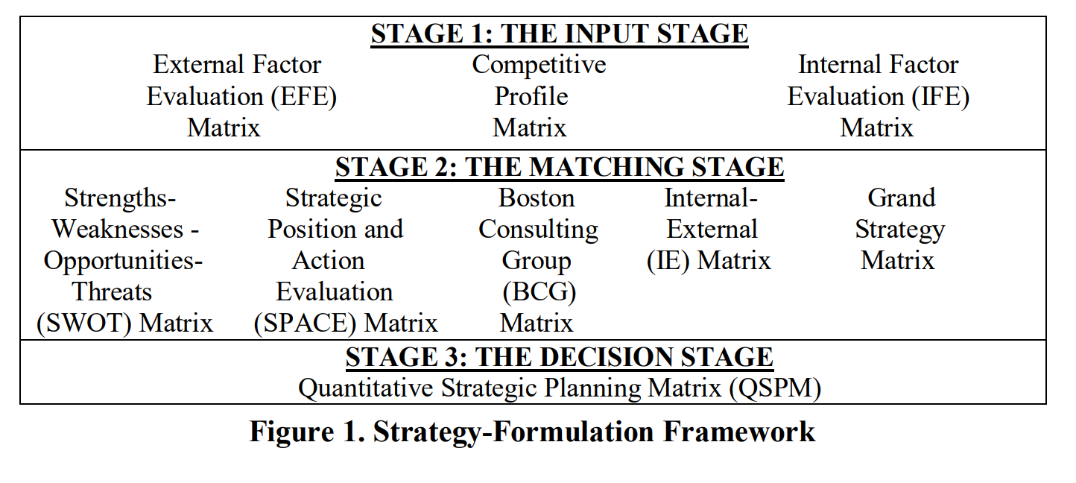
Three stages can be viewed from this image, the input stage where techniques and methods are used to determine alternative strategies. Stage two describes the domestic operations used for analysing the company, stage three is the application, and the final stage discusses limitation and weaknesses. Using this strategy formulation framework, a current report of PepsiCo will be created in the following pages.
Stage One:
Housing the External Factor Evaluation, the Competitive Profile Matrix, and the Internal Factor Evaluation, stage one will compare the results provided from 2009 to 2018 as well as provide feedback about the results obtained.
External Factor Evaluation (EFE)
EFE summarizes the opportunities and threats that are outside of PepsiCo’s control. These can be political, economical, technological, social, legal, and environmental. A weight is assigned to each external factor ranging from 0.0 to 1.0. These weights communicate the company’s importance of success from that external factor. The EFE is presented in a table below. (Figure 2)
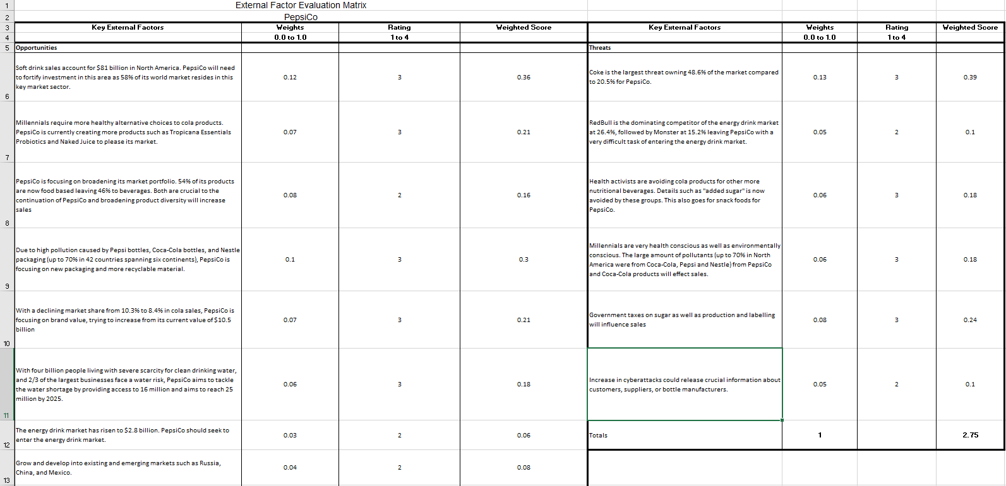
The total weighted score is 2.75 which suggests that PepsiCo is performing above average and is quite prepared for external threats to its company. Soft drink sales ranked as one of the highest opportunities in weight (.12) as the cola market is currently worth $81 billion in North America (Wiener-Bronner, 2018) and PepsiCo currently has 58% of its consumers in North America as we can see from the diagram below. (Figure 3) (PepsiCo Annual Report, 2018)
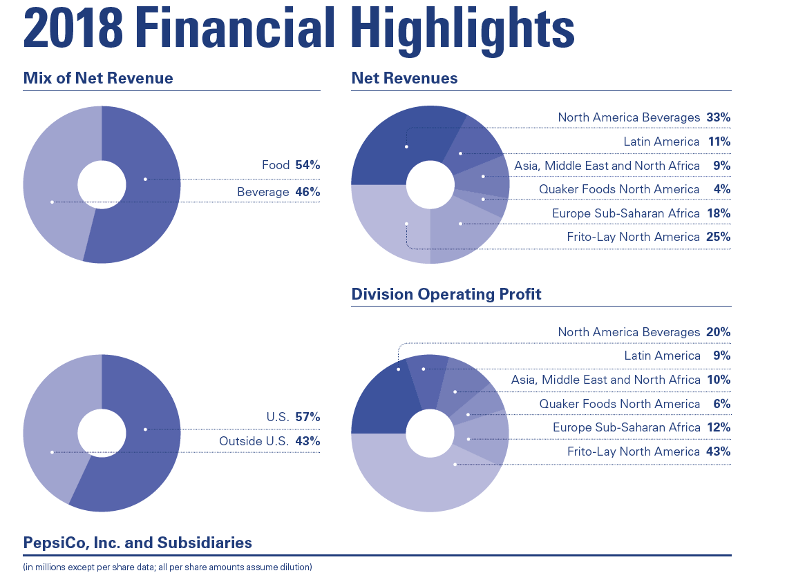
At .08 is the focus of broadening its market portfolio. 54% of PepsiCo products are now food based leaving the remainder 46% to be liquid (see Figure 3). Broadening both types of products will help hedge losses in a sector as well as increase sales due to diversity in the market.
Millennials account for 25% of the North American population and one third of consumer packaged spending (Fitzpatrick, A. 2018). Focusing on millennials also means focusing on healthier products which PepsiCo is also doing by introducing new flavours and brands such as Tropicana Essentials Probiotics and Naked Juice which the latter is fast on its way to being the new $1 billion brand (Kell, J. 2017).
The highest weight from the threats aspect of the EFE is the rival competitor Coca-Cola. Coke dominates the market with a leading 40.8% market share while PepsiCo has a 20.5% which can be seen in the figure below. (Figure 4) (Statista 2015)
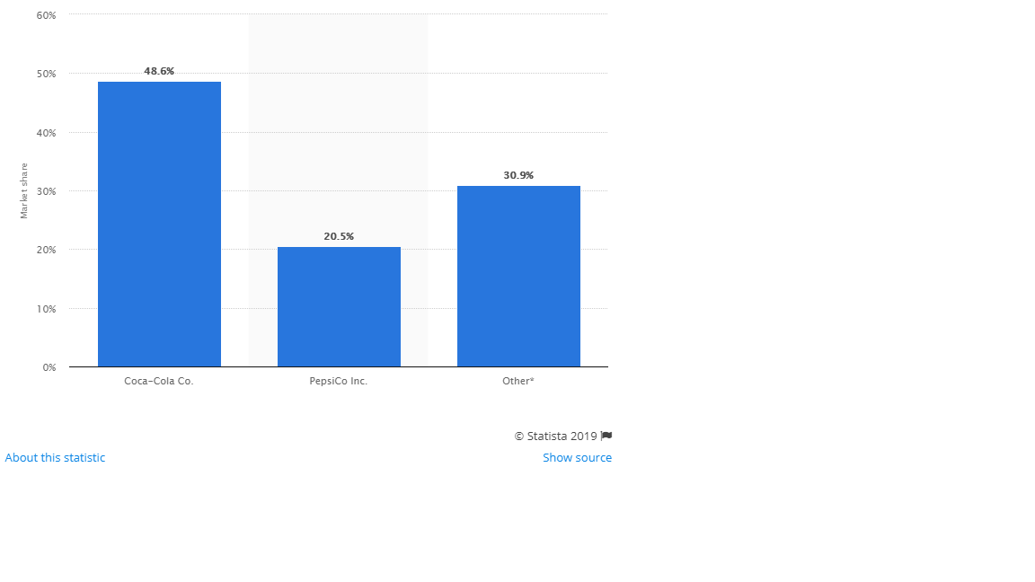
The following higher external threat comes in at .08 and involves governments changing laws to impose further taxes. The introduction of sugar taxes, labelling restrictions can diminish sales (PepsiCo Annual Report, 2018) as consumers don’t want to pay extra for a product and also don’t like seeing words such as “added sugar” on labels.
Internal Factor Evaluation (IFE)
The IFE evaluates the strengths and weaknesses of PepsiCo. It has a similar weight scale rating to help determine the best strategic course of action by focusing on what is most important to PepsiCo to focus their money and efforts towards. Figure 5 below shows the IFE for PepsiCo. (Figure 5)
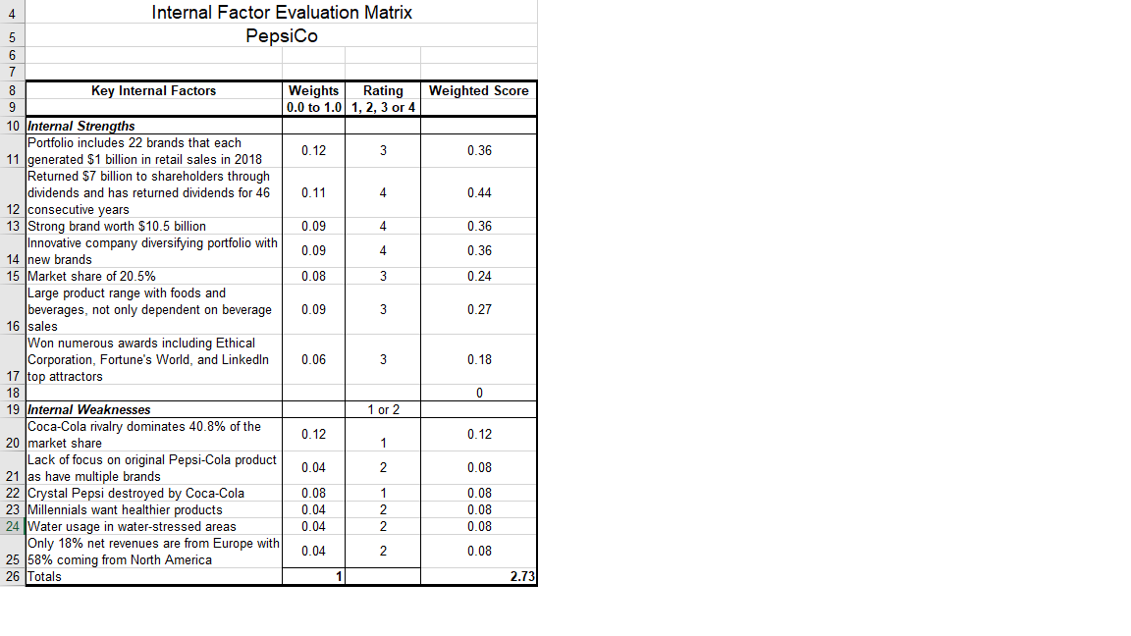
The total weight of the IFE is 2.73 suggesting that PepsiCo is above average in formulating strategies on strengths and lowers their weaknesses. Leading at .12 is the brand recognition of PepsiCo. With 22 brands each bringing in $1 billion in retail sales (PepsiCo Annual Report, 2018), PepsiCo will keep focus of its many brands. These brands can be seen in figure 6 below. (Figure 6) (PepsiCo Annual Report 2018)
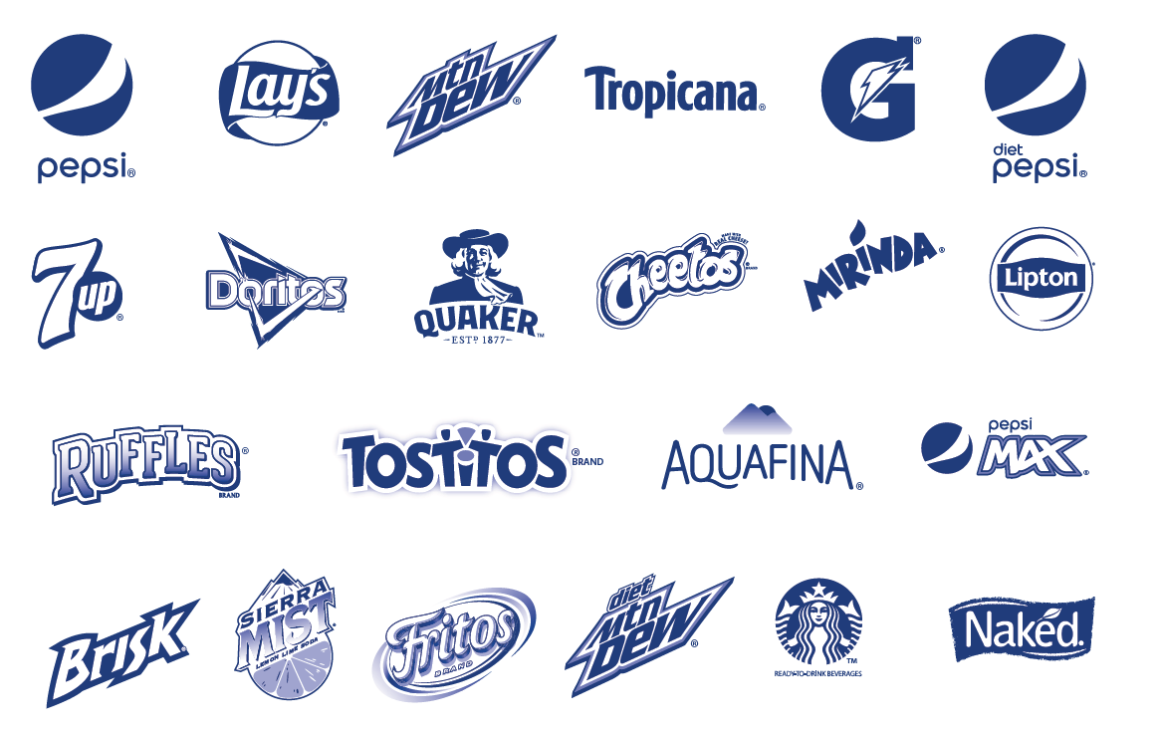
PepsiCo understands that it must take care of its consumers to succeed as a company. Taking care of its shareholders is also a top priority. PepsiCo has returned increased dividends for its shareholders for the past 46 years and has also returned $7 billion in dividends to its shareholders (PepsiCo Annual Report, 2018).
As for weaknesses, the top weight came in at .12 and showed that the dominating market share for its rival is a substantial loss for PepsiCo. Coming in second place at .08 was also related to its rival as Pepsi lost one of its popular product lines named “Crystal Pepsi”. Crystal Pepsi was a popular drink that quickly gained sales of $474 million. Coke in the meantime had a brand named “Tab clear” that was on a kamikaze mission to destroy Crystal Pepsi. Having been strategically placed near Crystal Pepsi and confusing customers to believe it was a diet beverage with medicinal properties, Crystal Pepsi soon became obsolete (Mind, 2016).
Competitive Profile Matrix (CPM)
The CPM provides broader success factors that provide strategic information. See figure 7 below for PepsiCo’s CPM. (Figure 7)
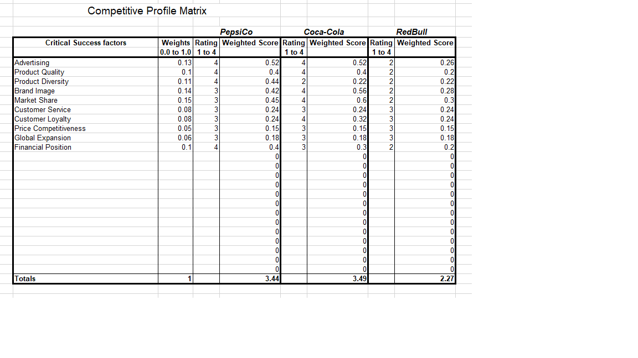
The CPM will compare the importance of advertising, brand image, and global expansion of PepsiCo versus its two main competitors Coca-Cola and Red Bull. As seen from the figure above, Coca-Cola is in the lead with a score rating of 3.49, followed closely by PepsiCo with 3.44. Red Bull is currently dominating the energy drink market which Coke and Pepsi are having a difficult time breaking into. Advertising for PepsiCo is at $2.4 billion (Pratap, A, 2018) and Coca-Cola is at $3.96 billion (Statista, 2017). Market share is also high in the weight scale and it is shown that Coca-Cola is in the lead as shown in figure 4. Red Bull has a market share of 43% (Mitchel, D. 2015)
As for financial positions, PepsiCo is doing the best as although the soft drink industry has taken a small hit, it has hedges involved in food products as well, increasing its earnings whereas Coca-Cola has seen declines in sales for the past 12 years (Kinahan, JJ, 2018).
Stage Two: Matching
SWOT Analysis
As David’s formulation shows for stage two, a SWOT analysis of PepsiCo will be established showing the SO (strengths and opportunities), WO (Weaknesses and Opportunities), ST (Strengths and Threats), and WT (Weaknesses and Strengths) (Sanal, Torlak, 2007). This SWOT analysis will help PepsiCo realize advantages to use internal strengths against external opportunities and how to better defend itself to reduce internal weaknesses.
Figure 8 SWOT Analysis

SO | ST | WO | WT
(O3, O2, S5)  Utilize budget to continue expansion into the Asian markets such as China, as well as Russia and Mexico. | (T6, T3, S3)  Explore and create healthier alternative foods and beverages to satisfy Millennial consumers | (W3, W5, 03, 06)  Europe and Asia count for 22% of sales, focus on expanding the target market in these sectors | (W5, T1, T3)  There is understandably a large focus on the North American market, however more effort should be spent internationally
(O1, O2, 03, S7)  Continue strengthening brand in the North American market | (O2, 03)  Offer feedback surveys to customers to allow them to create their own beverages and test the market | (W3, W5, O4, O3)  Sports drinks Gatorade is not well known in Europe. Focus on bringing sports drinks to compete with Powerade and Lucozade | (W3, T3)  Clean water supplies are in danger to two thirds of the largest companies in North America
(03, O1, O3, S7)  Sponsorships for NFL, NHL, and Major League Baseball, and continue sponsorships for NBA | (T6, S4)  Millennials are increasingly concerned about plastic waste, develop more environmentally friendly containers | (W3, O4)  PepsiCo to have a larger presence in the pub industry in the UK. | (W3, W5, T6)  Coke is still the largest dominator of cola in the market. Focus more on brand and create new beverage to set PepsiCo apart
(03, O1, S4)  Water is a growing demand, respond to this as soft drink are steadily decreasing in North America | (T3, S4)  Clean water is a growing concern for the world, create a campaign that shows PepsiCo cares and is doing something about these shortages | (W5, O2, O3)  PepsiCo to sponsor FIFA and rugby games in Europe to increase brand strength
(02, 01, O4, S4)
Europe has little market share compared to North America, efforts should be made to increase European desire for PepsiCo products.

SPACE Matrix
The SPACE Matrix is the Strategic Position and Action Evaluation Matrix. Based on financial strength (FS), Competitive Advantage (CA) for internal and environmental stability (ES) and Industry Strength (IS) The SPACE Matrix derives a four quadrant framework that determines which strategy will be better equipped for PepsiCo from aggressive, conservative, competitive, or defensive. (Sanal, Torlak, 2007).
As the SPACE matrix focuses on financial strengths the flowing figures have been produced to enable to the reader to view the current financial state of PepsiCo.
(Figure 9)(PepsiCo Balance Sheet, 2018)
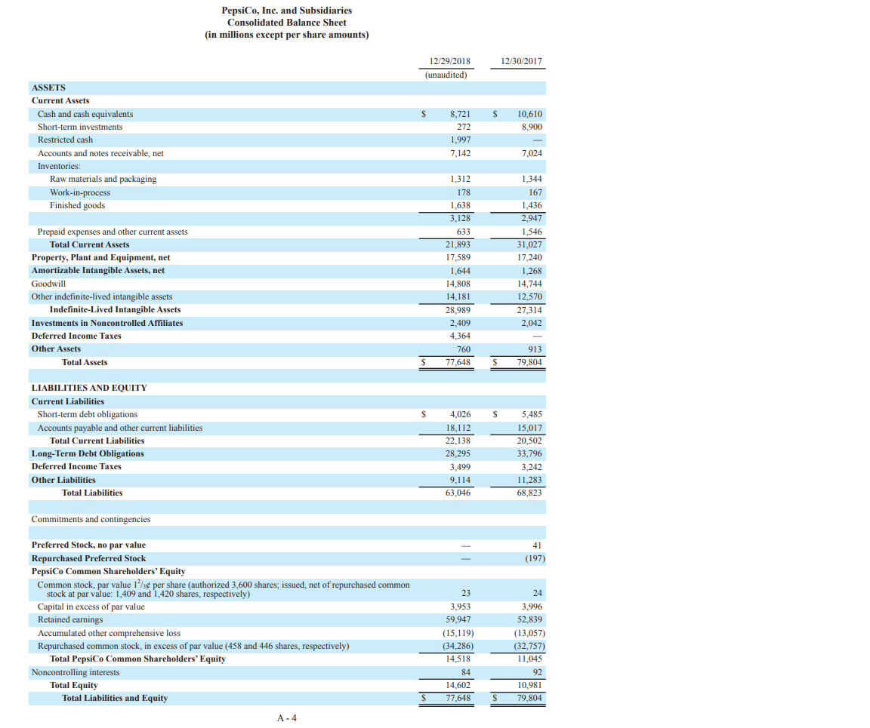
Figure 10 (PepsiCo Income Statement, 2018)
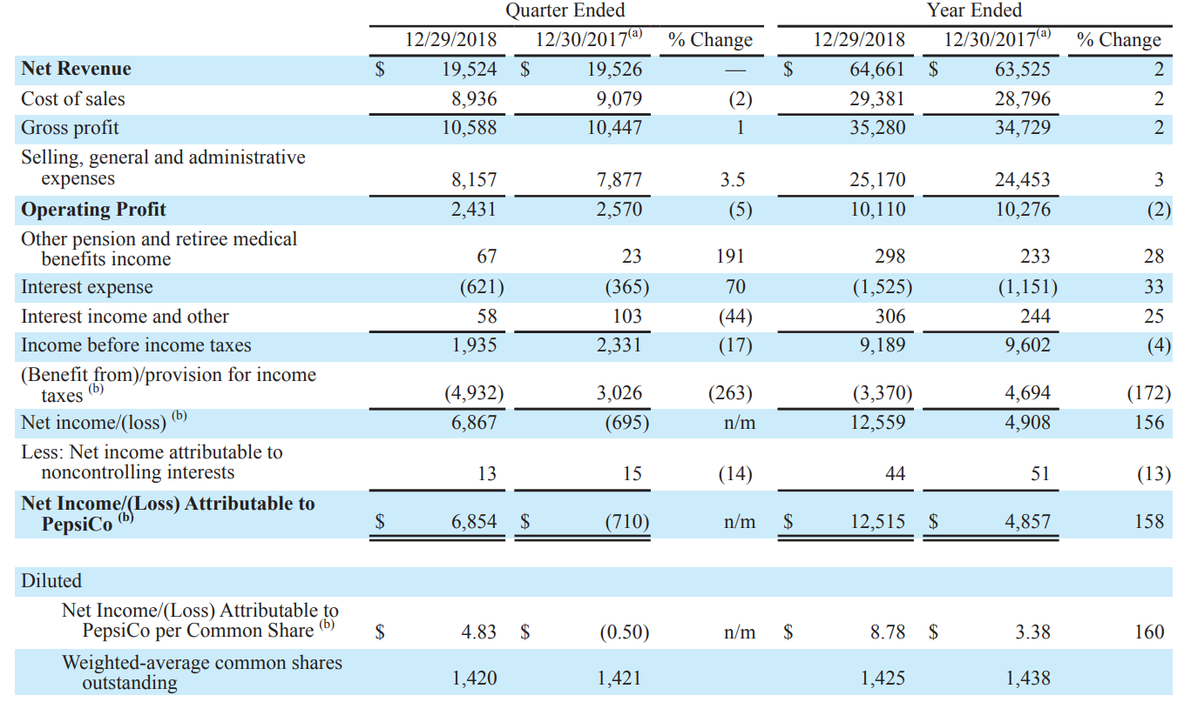
Figure 11 (Space Matrix)
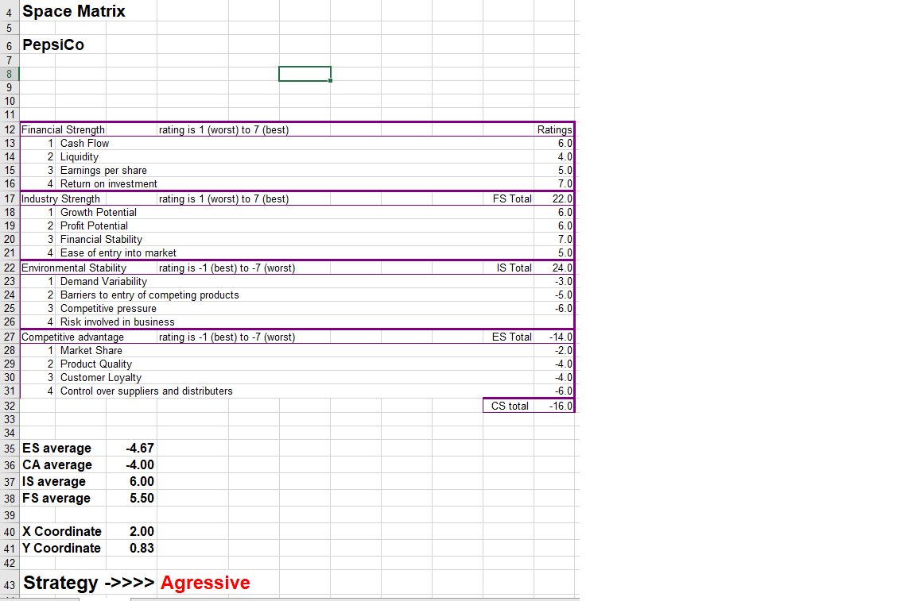
PepsiCo scored a ranking of 16 indicating that it has an aggressive strategic formula, Aggressive strategies are often enabled by corporations with a competitive advantage as it is financially stable. This allows it to increase market share, create new products, and penetrate new markets. These have been common factors for strategic progression for PepsiCo based on the report so far. The Space graph has also been depicted in the figure below.
Figure 12 (Space Graph)
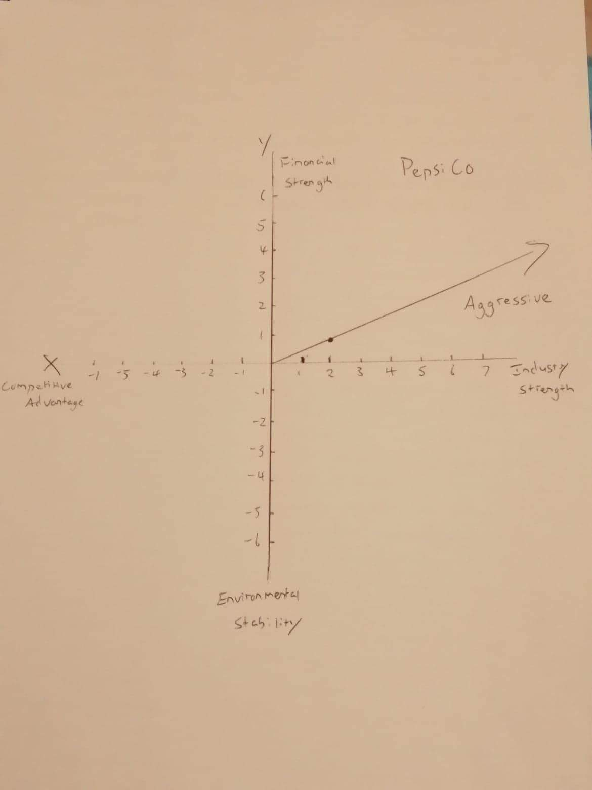
This graph shows that PepsiCo is in a strong position in the industry and financially. It can adopt aggressive strategies to penetrate new markets, create new products and increase its market share.

Boston Consulting Group (BCG)
The BCG portrays the different market shares and industry growth rate. The creation of a BCG matrix will allow PepsiCo to place its products in either the Stars, Question Marks, Cash Cows, or Dogs to see where their product lines fit in the market place. This will allow for better handling and strategic planning of future growth operations.
Figure 13
Stars  PepsiCo has many star segments, this is  expected because it is one of the world’s largest beverage and food processing corporation. In 2015 PepsiCo’s soft drinks generated 33% of PepsiCo’s total revenue, which was 20.6 billion and its market share was 10%. (Kasi, 2017) | Question Mark  PepsiCo’s Quaker foods is in the question mark category. This segment manufactures, distributes, and sells cereal and breakfast bars. The share of revenue was reported as 3.56% of total revenue and the market share was only around 1.02%.
Cash Cows  PepsiCo’S FLNA can be considered the backbone of the company because they keep on generating revenue for the company long-term. FLNA are products such as; Cheetos, Doritos tortilla chips and ruffles Potato chips. | Dogs  PepsiCo do not have any low relative market share in low sales growths industries. Therefore, PepsiCo does not fit into this category.

The size of the circles represents the relative marketing share positions. (Stars 33% and Cash Cows 22%). As shown in the figure above, some of PepsiCo’s product lines such as Quaker oats fit into the question marks, this allotment allows PepsiCo to focus on strengthening the product with further market development, or to decide whether to be rid of the products.
Stars hold the most in PepsiCo’s product line. These represent the best opportunities for growth and profitability. As seen in the figure, it holds PepsiCo’s beverage lines including Pepsi, Pepsi Max, Mountain Dew, and many others.
Cash Cows generate excess cash, these are products that PepsiCo will want to manage to maintain their strong position.
Using PepsiCo’s aggressive strategy, it will maintain its ability to continue investment in its question marks as well as its stars which can deliver a higher income in the future. The cash cows should be managed accordingly to carry on with its low growth industry.
Internal – External Matrix (IE)
The IE matrix determines three major regions based on total weighted scores. These regions are places in quadrants of a nine cell display table that can be seen below for PepsiCo in figure 15. (Sanal, Torlak, 2007).
Figure 14 (PepsiCo Reports, 2018)
Product | Revenue | % Total Revenue | EFE | IFE
Frito-Lay NA | 15798 | 25 | 2.47 | 2.87
Quaker Foods NA | 2503 | 4 | 1.27 | 3.2
NA Beverages | 20936 | 34 | 2.89 | 2.96
Latin America | 7208 | 11 | 3.02 | 1.29
Europe | 11050 | 17 | 2.31 | 2.48
Asia | 6030 | 9 | 2.03 | 2.13

Figure 14 shows the EFE and IFE results for beverage sales in Asia, Europe, Latin America, North American beverages, Frito Lay, and Quaker foods and how they fit due to revenue and total revenue percentage. Once these figures are placed onto the IE matrix, it will help determine a suitable strategic pathway for PepsiCo to undertake.
Figure 15
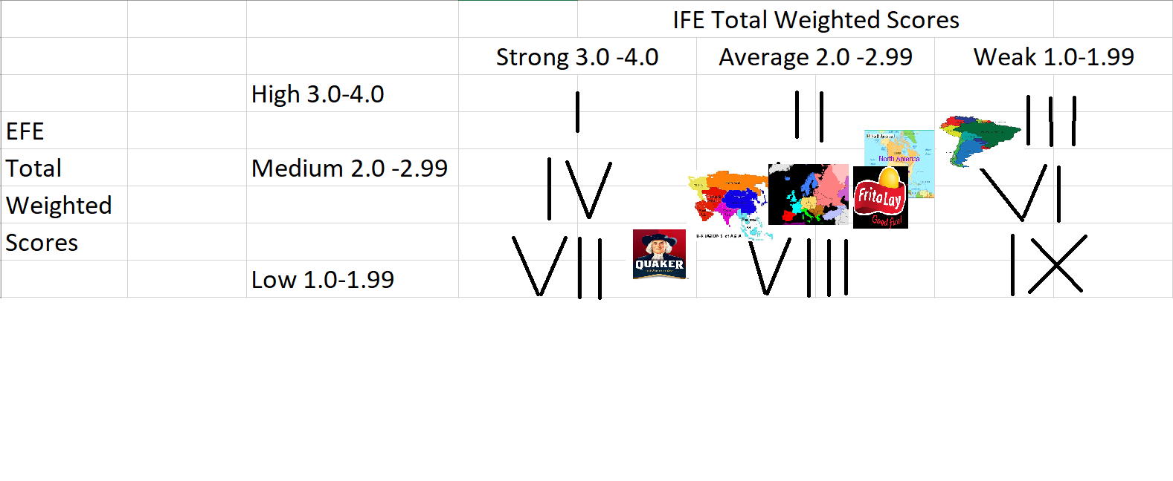
Based on these results PepsiCo fits into the Hold and maintain category which stipulates that market penetration and product development would be best suited for these products.
Grand Matrix

 | Rapid Market Growth
Quadrant II |  | Quadrant I  Starbucks  Gatorade  Pepsi
Quadrant III |  | 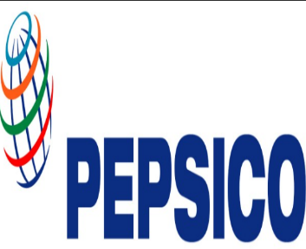  Quadrant  IV  FLNA  Cheetos  Doritos tortilla chips  Ruffles potato chips  Mountain Dew
 | Slow Market Growth

Strong
Competitive
Position
Weak
Competitive
position

PepsiCo has been put into Quadrant I and Quadrant IV because some of PepsiCo brands such as Starbucks, Pepsi and Gatorade fit into the rapid market growth and strong competitive position because Starbucks is still rapidly growing, and Gatorade is still the number one sport drink in the US. Pepsi is in Quadrant I because it is sold in most restaurants and stores, and they have brought out many variants such as Pepsi max. The others are in quadrant IV is that there are in a strong completive market and doing well but their market growth has slowed down a lot over the years.

Quantitative Strategic Planning Matrix (QSPM)
 | Weights | Increase Healthy alternatives for food and beverages  1 to 5  AS | Increase Healthy alternatives for food and beverages  1 to 5  TAS | Increase Sales in North America  1 to 5  AS | Increase Sales in North America  1 to 5  TAS
Strengths  - PepsiCo owns many well-known brands.  - PepsiCo is Known worldwide.  - PepsiCo and their brands are advertised well.  - PepsiCo are competing in many different markets.  - PepsiCo have reduced the amount of salt and sugar in some of their products.  - 8 out of 10 of the best selling snack brands in the US are owned by PepsiCo (Jurevicius, 2019)  - Strong Distribution  - Sales in North America are very high | 0.11  0.1  0.1  0.1  0.11  0.13  0.17  0.18 | 4 | 0.11  0.1  0.1  0.1  0.44  0.13  0.17  0.18 | 4 | 0.11  0.1  0.1  0.1  0.11  0.13  0.17  0.72
 | 1 | 4 | 3.31 | 4 | 3.34
Weaknesses  - There is a reduction in the sales of soft drinks which is affecting some of their brands such as Pepsi.  - PepsiCo have a lot of competition because they are in most of the markets.  - Pepsi is still behind Coca-Cola.  - PepsiCo is focusing mainly on the US markets. | 0.35  0.25  0.2  0.2  1
Opportunities  - Increase their sales in North America because it where the majority of their market is.  - To make their soft drinks more appealing to the new market.  - To reduce the amount of waste from their products | 0.33  0.37  0.3 | 4  3 | 0.33  1.48  0.9 | 4 | 1.33  0.37  0.3
 | 1 | 4  3 | 2.7 | 4 | 2
Threats  - PepsiCo have strong competition  - Health Factors on some products  - Campaigns against Plastic waste | 0.25  0.4  0.35  1 | 4  3 | 0.25  1.6  1.05 | 2 | 0.5  0.4  0.35
 | 0.25  0.4  0.35  1 | 4  3 | 2.9 | 2 | 1.25

References:
Csimarket(2018). Pepsico Inc’s Business Segments Description. Retrieved from:
http://csimarket.com/stocks/segments.php?code=PEP
Encyclopaedia Britannica. PEPSIO INC. Feb 03, 2017 Retrieved from: https://www.britannica.com/topic/PepsiCo-Inc#ref225972
(Fitzpatrick, A.).(2018). PepsiCo Is Trying to Change With the Times. Retrieved from: https://www.fool.com/investing/2018/06/27/pepsico-is-trying-to-change-with-the-times.aspx
Gurufocus. (2018). PepsiCo Inc (NAS:PEP). Retrieved from: https://www.gurufocus.com/term/current_ratio/PEP/Current%252BRatio/PepsiCo%2BInc
Kasi.K.).(2017). BCG Matrix of PepsiCo. Retrieved from: https://bcgmatrixanalysis.com/bcg-matrix-of-pepsico/
(Kell, J).(2017). PepsiCo's Promise to Get Healthier Is Paying Off. Retrieved from: http://fortune.com/2017/02/15/pepsico-healthy-paying-off/
Kinahan, JJ. (2018). Earnings Preview: How Is Coca-Cola Battling 12 Years Of Falling Soda Sales? Retrieved from: https://www.benzinga.com/news/earnings/18/02/11199136/earnings-preview-how-is-coca-cola-battling-12-years-of-falling-soda-sal
Macrotrends. (2018). PepsiCo Return on Investment 2006-2018. Retrieved from: https://www.macrotrends.net/stocks/charts/PEP/pepsico/roi
Mind. (2016). How Kamikaze Marketing Killed Crystal Pepsi. Tab Clear, Anyone? Retrieved from: https://www.minddevelopmentanddesign.com/blog/how-kamikaze-marketing-killed-crystal-pepsi/
Mitchel, D. (2015). These Are the Top 5 Energy Drinks. Retrieved from: http://time.com/3854658/these-are-the-top-5-energy-drinks/
Mourdouukoutas, P. (2018). Pepsi Beats Coke. Retrieved from: https://www.forbes.com/sites/panosmourdoukoutas/2018/07/14/pepsi-beats-coke/#3114d42911d0
Nasdaq. (2018). PEP Company Financials. Retrieved from: https://www.nasdaq.com/symbol/pep/financials?query=cash-flow
PEP’s Competition by Segment and its Market Share. Retrieved from.
http://csimarket.com/stocks/competitionSEG2.php?code=PEP
PepsiCo. About The Company. Retrieved from: https://www.pepsico.com/about/about-the-company
PepsiCo 2015 annual report. Retrieved from.
https://www.pepsico.com/docs/album/annual-reports/pepsico-2015-annual-report_final_s57dqszgmy22ggn.pdf?sfvrsn=0
PepsiCo Annual Report. (2018). Retrieved from:https://www.pepsico.com/docs/album/annual-reports/2018-annual-report.pdf?sfvrsn=35d1d2bc_2
PepsiCo Balance Sheet. (2018). PepsiCo Reports Fourth-Quarter and Full-Year 2018 Results; Provides 2019 Financial Outlook. Retrieved from: https://www.pepsico.com/docs/album/investors/q4-2018/q4-2018-earnings-release_jxwwalwh2hhtz213.pdf
PepsiCo Income Statement. (2018). PepsiCo Reports Fourth-Quarter and Full-Year 2018 Results; Provides 2019 Financial Outlook. Retrieved from: https://www.pepsico.com/docs/album/investors/q4-2018/q4-2018-earnings-release_jxwwalwh2hhtz213.pdf
(PepsiCo Reports).(2018). PepsiCo Reports Fourth-Quarter and Full-Year 2018 Results; Provides 2019 Financial Outlook. Retrieved from: https://www.pepsico.com/docs/album/investors/q4-2018/q4-2018-earnings-release_jxwwalwh2hhtz213.pdf
(Pratap, A).(2018). Pepsico advertising and marketing budget. Retrieved from https://notesmatic.com/pepsico-advertising-and-marketing-budget/
(Sanal, M. Torlak, N). (2007). David’s Strategy Formulation Framework In Action: The Example Of Turkish Airlines On Domestic Air Transportation. Retrieved from: https://ticaret.edu.tr/uploads/kutuphane/dergi/f12/M00201.pdf
Statista. (2018). PepsiCo - Statistics & Facts. Retrieved from https://www.statista.com/topics/1503/pepsico/
Statista. (2015). Market share of carbonated beverages worldwide as of 2015, by company. Retrieved from: https://www.statista.com/statistics/387318/market-share-of-leading-carbonated-beverage-companies-worldwide/
Statista. (2017). Coca-Cola Company's advertising expense from 2014 to 2017 (in billion U.S. dollars). Retrieved from: https://www.statista.com/statistics/286526/coca-cola-advertising-spending-worldwide/
Statista. (2019). Market share of leading energy drink brands in the United States in 2018, based on dollar sales. Retrieved from https://www.statista.com/statistics/306864/market-share-of-leading-energy-drink-brands-in-the-us-based-on-case-volume-sales/
(Wiener-Bronner, D.).(2018). Why Coke is winning the Cola Wars. Retrieved from https://money.cnn.com/2018/02/20/news/companies/cola-wars-coke-pepsi/index.html
(Jurevicius. O).(2019) Retrieved from:https://www.strategicmanagementinsight.com/swot-analyses/pepsico-swot-analysis.html

