

Student name: Cynthia nelson-yeboah
Student ID: 2333272

Module name: Changemakers: Creativity and Value Creation
Module code: BMHP5014
Lecturer’s name: G1: Dr Laila Surani G2: Caroline Salami (Module leader)
Assignment Title: Component 2: Assignment (Report)

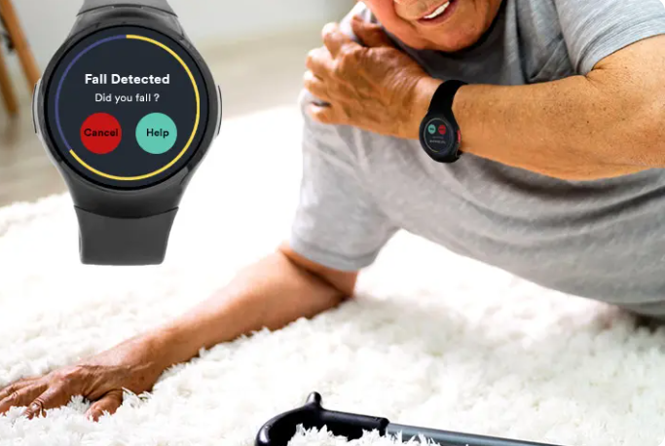  Fig 1: The SOS Smartwatch Now Offers Fall Detection (Bay Alarm Medical, 2023) |  | Target Audience and Impact  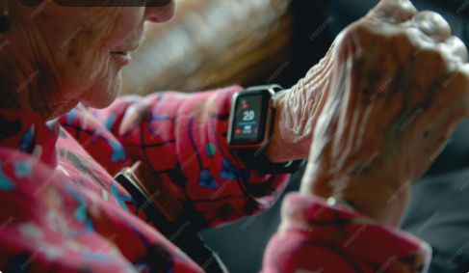  Fig 3: Senior woman checking heart rate on smartwatch during daytime (Freepik, n.d) |  | Technology Integration 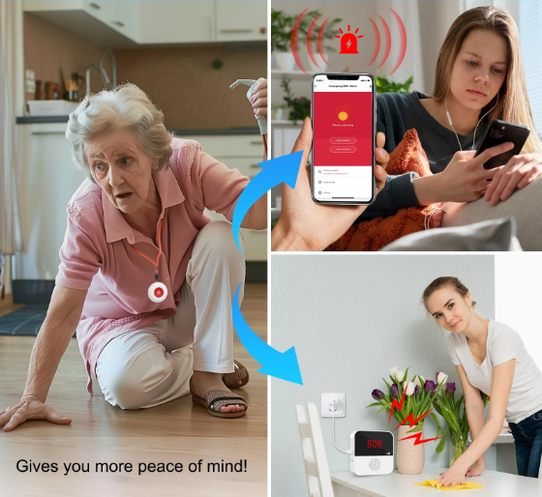  Fig 4: CallTou WiFi Rechargeable Smart Stay Safe with Smart Caregiver Pager System (CallTou, n.d)
Introduction  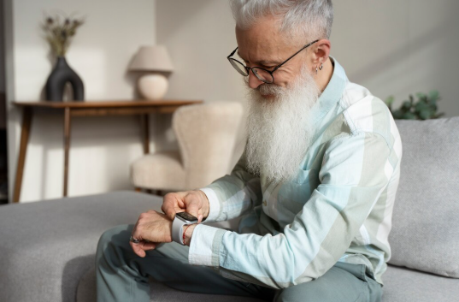  Fig 2: Grandparent learning to use technology (Freepik, n.d). One in three adults aged 65 and over have at least one fall every yea |  |  |  | Conclusion  SmartFall wrist watch helps the elderly quickly get assistance, stay healthy, and be independent. The new idea benefits everyone by supporting the UK's goal sustainable, people-focused, and technologically driven care.

Development and Regulations

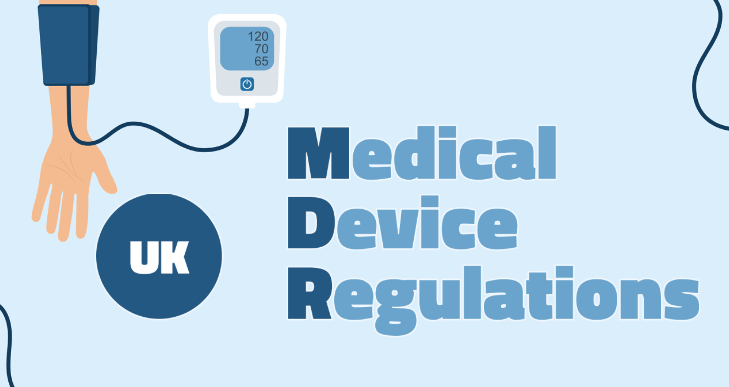
Fig 4: Navigating the Future of Medical Device Regulations in the UK: A Focus on Safety and Innovation (Hodgkins, 2024)

Poster Title
SmartFall wrist watch: An AI-Powered Home Support and Fall Detection System for the Elderly
Introduction
In the UK, more people aged 65 and over are surviving, which increases the risk of falls and daily living difficulties. Office for Health Improvement and Disparities (OHID, 2022) describes that one in three adults aged 65 and over have at least one fall every year and that falls are responsible for the majority of older adults going to hospital with injuries. These conditions can do more than cause physical harm, but also loss of freedom, distress, and lowering the quality of life. The Care Act 2014 is focused on helping people care for themselves and allows older adults to stay in their own homes as long as possible (Legislation.gov.uk, 2014). SmartFall wrist watch is a new technology that is designed to help achieve these goals. It possesses technology that includes fall detection, tracks people in real time, and provides emergency responses, allowing older people to stay safe at home yet remain independent (Mauldin et al., 2018).

The Issue / Gaps in Health and Social Care
Falls in older people are still a monumental healthcare problem across the UK. There are over 4 million hospital admissions every year in England as a result of falls, and they represent a cost to the NHS of around £2.3 billion (Machiavelli et al., 2025) Current interventions like home visits or personal alarms have some drawbacks. They usually need an operator to turn them on and will not be able to respond to emergencies when a human being is quiet, say when unconscious. There is clear need for intelligent monitoring systems that are responsive and capable of protecting people's privacy and dignity. The Digital Health and Care Plan (DHSC, 2022) emphasizes the benefit of using data and technology to prevent avoidable problems and improve the outcomes for vulnerable individuals. SmartFall wrist watch helps by alerting on unusual movement using artificial intelligence. It automatically calls carers or the emergency services if a fall is detected, meaning older people do not have to make the call.

Target Audience and Impact
The main group being addressed is the elderly, 65 and above, who live independently or in residential care. Secondary recipients are those like caregivers, family members, and social and healthcare workers in charge of the patient.
Impacts:
- Increases safety and independence via intelligent fall detection.
- Ensures quicker response times during emergencies, which can save lives.
- Reduces the number of people coming to the hospital and decreases the cost of medicine.
- Enhances confidence and satisfaction for the elderly and their loved ones.
SmartFall wrist watch makes people able to take care of themselves and reduces reliance on nursing homes. This supports the WHO (2021) perception of aging in place, allowing people to live with respect and good quality of life.

Implementation and Timeline
SmartFall wrist watch will be launched in three phases:
- Pilot Phase (Months 1–6):
  - Test it in 50 homes in Wales with help from local councils and community nurses.
  - Gather usage feedback on ease of use, comfort, and accuracy of responses
- Evaluation and Refining (Months 7–12):
  - Analyse the data from pilot users to improve the AI and its sensitivity.
  - Train healthcare workers and caregivers to understand the system's data.
- Rollout (Months 13–24):
  - Expand the program using NHS Digital systems and local adult care teams.
  - Set up a 24/7 monitoring and response centre that works with community care services.
Local authorities will lead the program, with support from NHS Trusts and digital health companies.

Development and Regulations
SmartFall wrist watch must comply with these UK laws and regulations:
- NHS Information Standards Framework: facilitating interoperability and ensure data security (NHS England Digital, 2025).
- General Data Protection Regulation (ICO, 2018): law to ensure individuals' personal information and confidential details are safe.
- Medical Device Regulation (Legislation.gov.uk, 2002): making wearable technology safe and of good quality.
- Care Quality Commission (CQC, 2025) regulations – to ensure safety where care is provided.
The AI software is designed using data that does not disclose personal information, making sure that health information is processed safely and responsibly.

Technology Integration
SmartFall wrist watch utilizes three main technologies:
- Wearable sensors which measure movement and position changes.
- AI fall detection system which distinguishes between falls and normal movement by identifying patterns.
- Mobile app dashboard which provides family and carers with real-time views and alerts.
The AI helps the system to learn from user behaviour, minimizing false alarms and individualizing detection of risk. The data collected is retained securely according to NHS guidelines, which increases confidence and trust in the system (Health Education England, 2019).
Dissemination and Promotion
The innovation will be disseminated through:
- Health awareness campaigns at doctors' offices, community centres, and pharmacies.
- Social media online marketing campaigns by NHS and Age UK.
- Community health workers and care home staff training sessions.
- Partnering with local authorities, voluntary agencies like Age UK, and health care organizations.
Such channels will make sure that there is community trust and that older persons and their families are encouraged to participate.
Conclusion
SmartFall wrist watch is a worthwhile innovation to help the elderly live independently and safely. It is in line with the health goals of the UK, uses modern technology, and meets a key problem of caring for the elderly in regards to fall prevention. SmartFall wrist watch helps the elderly quickly get assistance, stay healthy, and be independent. The new idea benefits everyone by supporting the UK's goal sustainable, people-focused, and technologically driven care.

Pitch
SmartFall wrist watch: An AI-Powered Home Support and Fall Detection System for Seniors
Given that the UK population is an ageing one, facilitating them to live independently safely has been a priority area of interest for health and social care. Office for Health Improvement and Disparities (OHID, 2022) describes that one in three adults aged 65 and over have at least one fall every year and that falls are responsible for the majority of older adults going to hospital with injuries. As age advances, the likelihood of falls becomes increasingly common. This results in injury, makes them less confident, and sometimes leads to hospital stays (OHID, 2022). Not fixing fall risks in homes is estimated to cost the NHS in England £435 million. SmartFall wrist watch was created to help with all of these problems. It is a wearable device that makes use of AI to detect falls and provide in-home assistance. It is meant to help the elderly stay independent, healthy, and safe. The system has the capability to detect falls in real time and send alerts to family members, caregivers, or emergency services right away. This allows them to act fast and avoid serious injuries. SmartFall wrist watch differs from the standard personal alarms in that it does not need to be activated by a human. Instead, it employs smart technology and sensors to automatically pick up on patterns of movement. This way, it can provide protection even if the user is asleep or disoriented.

The Need for Innovation
Older forms of fall prevention equipment like pendant alarms and home sensors have some problems. They need people to trigger them, tend to go off by accident, and may not necessarily deal with feelings that come with aging, like fear and loneliness. Evidence supports that about 80% of older people who have an emergency alarm do not use it after they fall. (Chaudhuri et al., 2014) SmartFall wrist watch deals with these problems as it is an effective, automatic, and tailored solution. With the help of wearable sensors and intelligent computer software, it monitors your movement, posture, and activity levels to detect any issues. In case of a detected fall, the system automatically triggers alarms through a mobile app that is connected. Family members or carers can view real-time data to offer immediate assistance. The technology bridges the gaps in UK health and social care provision. The Royal College of Physicians' Falls and Fragility Fracture Audit Programme (FFFAP, n.d) has stressed the necessity to identify ways of early detection of falls and implement community-wide interventions for their prevention. SmartFall wrist watch helps by monitoring individuals continuously on a daily basis in the home or residential care. It fills the gap between professional care and personal independence.
Development and Regulations
SmartFall wrist watch is in conformity with UK rules and legislations focusing on care that is safe, technologically enabled, and person-centred. In accordance with the Care Act 2014, local authorities are responsible for assisting individuals in staying well, independent, and preventing their care needs from worsening. SmartFall wrist watch helps by preventing falls, lowering hospital admissions, and allowing older people to remain independent in their own homes. SmartFall wrist watch helps district nurses, social workers, and families to collaborate by safely sharing critical fall information and intervening early. The system is compliant with UK data protection law of 2018, NHS Digital data security standards, and the Digital Technology Assessment Criteria (DTAC) (NHS England, 2025). Data is all stored securely, and the citizen is in control of who is able to access their data, with fair and transparent digital practices. Additionally, Digital Health and Care Plan (DHSC, 2022) is a national plan that promotes the utilization of digital technology for revolutionizing healthcare through prevention, personalization of care, and productivity enhancement. SmartFall wrist watch helps to attain these goals by providing an accessible digital service that is beneficial to both health professionals and users. The NHS England (2019) Long Term Plan focuses on the uptake of new technology and supporting individuals to self-manage long-term conditions.

Dissemination and Promotion
To get more individuals to utilize SmartFall wrist watch, it will be marketed through engaging communities, practitioners, and decision-makers at different levels.
- Community Awareness Campaigns: Partnering with Age UK, Alzheimer's Society, and local councils to plan "Safe Ageing" workshops in community centres and doctors' surgeries.
- Social Media Marketing: Dedicated social media promotions which publish success stories and positive reviews to build trust and interest amongst the elderly and their family members.
- Healthcare Collaborations: Collaborations with regional NHS pilot projects to offer free trial runs to eligible patients in order to show how effective it is and how easy it is to use.
- Caregiver and Nurse Training: Workshops to train nurses, caregivers, and social workers to use SmartFall wrist watch data in providing enhanced preventive care.
- Policy Campaigning: Involvement with NHS Trusts and councils to gain funding for digital development projects. Involvement of the public is significant in helping to tackle digital exclusion. Training will enable older citizens and carers to be more confident when using SmartFall wrist watch, making the technology accessible for everyone.

Conclusion
SmartFall wrist watch shows that new technology, knowledge, and ideas can be brought together to improve care for older adults. Using wearable sensors and artificial intelligence makes it safer, allows people to stay independent, and meets UK care regulations for person-centred care. It is a realistic, ethical, and forward-thinking response to a key challenge in health and social care; fall prevention and enabling a high quality of life for older people. Through working with professionals, working with the community, and building support for policies, SmartFall wrist watch can be at the heart of providing caring, technology-enabled support. This will ensure that aging in the UK is not only longer but also safer, healthier, and more respectful.

References
Bay Alarm Medical, 2023. The SOS Smartwatch Now Offers Fall Detection. [Online]
Available at: https://www.bayalarmmedical.com/wp-content/uploads/bay-alarm-medical-sos-smartwatch-fall-detection.webp
[Accessed 25th October 2025].
Calltou, n.d. CallTou WiFi Rechargable Smart Stay Safe with Smart Caregiver Pager System. [Online]
Available at: https://www.calltou.com/cdn/shop/files/1_Button_1_Receiver-03.progressive.jpg?v=1721962362
[Accessed 25th October 2025].
Care Quality Commission (CQC), 2025. Regulations for service providers and managers. [Online]
Available at: https://www.cqc.org.uk/guidance-regulation/providers/regulations-service-providers-and-managers
[Accessed 25th October 2025].
Chaudhuri S, Thompson H, Demiris G. , 2014. Fall detection devices and their use with older adults: a systematic review. J Geriatr Phys Ther, 37(4), pp. 178-96.
Department of Health & Social Care (DHSC), 2022. A plan for digital health and social care. [Online]
Available at: https://www.gov.uk/government/publications/a-plan-for-digital-health-and-social-care/a-plan-for-digital-health-and-social-care
[Accessed 23rd October 2025].
Fracture Audit Programme (FFFAP), n.d. Fracture Audit Programme (FFFAP). [Online]
Available at: https://www.rcp.ac.uk/improving-care/national-clinical-audits/falls-and-fragility-fracture-audit-programme-fffap/
[Accessed 28th October 2025].
Freepik, n.d. Grandparent learning to use technology. [Online]
Available at: https://www.freepik.com/free-photo/grandparent-learning-use-technology_26322711.htm#fromView=search&page=1&position=6&uuid=e65c5aac-a2ea-4333-b19f-e0be8cadbc25&query=elderly+person+using+smart+watch
[Accessed 23rd October 2025].
Freepik, n.d. Senior woman checking heart rate on smartwatch during daytime. [Online]
Available at: https://www.freepik.com/premium-ai-image/senior-woman-checking-heart-rate-smartwatch-daytime_249236967.htm#fromView=search&page=1&position=18&uuid=2fc8f9bb-6605-43a2-943d-0efe09a39c1c&query=elderly+persons+using+smartfall+watch
[Accessed 23rd October 2025].
Health Education England, 2019. The Topol Review: Preparing the healthcare workforce to deliver the digital future. [Online]
Available at: https://www.hee.nhs.uk/our-work/topol-review
[Accessed 25th October 2025].
Hodgkins, S., 2024. Navigating the Future of Medical Device Regulations in the UK: A Focus on Safety and Innovation. [Online]
Available at: https://media.licdn.com/dms/image/v2/D4E12AQEGQX8-O5mxBA/article-cover_image-shrink_720_1280/article-cover_image-shrink_720_1280/0/1719585613632?e=2147483647&v=beta&t=ix7MA_yoXJxFRcWc0qG6kbj0qRTRA6dxq0ud44VJbVk
[Accessed 25th October 2025].
ICO, 2018. Guide to the General Data Protection Regulation (GDPR). [Online]
Available at: https://ico.org.uk/media/for-organisations/guide-to-the-general-data-protection-regulation-gdpr-1-0.pdf
[Accessed 5th December 2024].
Legislation.gov.uk, 2002. The Medical Devices Regulations 2002. [Online]
Available at: https://www.legislation.gov.uk/uksi/2002/618/contents
[Accessed 25th October 2025].
Legislation.gov.uk, 2014. Care act 2014; Chapter 23. [Online]
Available at: https://www.legislation.gov.uk/ukpga/2014/23/pdfs/ukpga_20140023_en.pdf
[Accessed 23rd October 2025].
Macchiavello et al., 2025. Using a collaborative approach to reduce falls in older people’s adult mental health wards in a local health board in Wales. BMJ Open Quality, 14(2).
Mauldin, T. R., Canby, M. E., Metsis, V., Ngu, A. H. H., and Rivera, C. C. , 2018. SmartFall: A Smartwatch-Based Fall Detection System Using Deep Learning. Sensors, 18(10), p. 3363.
NHS England Digital, 2025. Information standards for health and care. [Online]
Available at: https://digital.nhs.uk/data-and-information/information-standards
[Accessed 25th October 2025].
NHS England, 2019. Online version of the NHS Long Term Plan. [Online]
Available at: https://www.longtermplan.nhs.uk/online-version/overview-and-summary/
[Accessed 1st November 2024].
Office for Health Improvement and Disparities (OHID), 2022. Falls: applying All Our Health. [Online]
Available at: https://www.gov.uk/government/publications/falls-applying-all-our-health/falls-applying-all-our-health
[Accessed 23rd October 2025].
WHO, 2021. Decade of healthy ageing: baseline report. [Online]
Available at: https://www.who.int/publications/i/item/9789240017900
[Accessed 23rd October 2025].

