
Hotel continental budget planner
Report

March 23, 2022
University of Wales Trinity Saint David
[Company address]

Module: Financial Management for the Hotel Industry (BMIH5007)
Code: BMIH5007
Student name: Nelson Capela.
Student number:1905999
Lecturer: Dale Clarke

Executive Summary

This report has the purpose to provide The Regional Accounts Director of Continental Hotel information regarding of the Zero-Base Budgeting tool (ZBB) to in order he can implement the strategies ZBD offer to the future of his company.
The document will focus firstly on Budget in general, them will analysis the difference between Zero Based Budget and the Traditional Budget their advantages, disadvanges and limitations in order to recommend the Hotel Director the use of Zero-Based Budget.
The researcher conclude that Traditional budget represents the old management strategy and are inefficient in today business environment as it focusses on past data with objective to control the resources business need in contrast with Zero Based Budget that provide business necessary technique to achieve higher performance, cost and expenses management and future financial stability that business need to overcome in today challenges business face. Both budgets were important for business, despite their limitation. The TB tool still part of the business management strategy to achieve business goals needing just few adjustments for its higher standard and performance.
The report recommends The Regional Accounts Director of Hotel Continental the use of Zero-Based Budget because the advantage it offer to the business, however the hotel has to follow 5 procedures to implement it.

Table of Contents
Executive Summary 1
1. Introduction 3-4
2. Zero Based Budgeting 5
2.1 Zero-based budgeting 5
2.2 Advantages of Zero-based budgeting over Traditional Based 6
2.3 How the Organisation Might introduce Zero-based Budgeting 7-8
3. Conclusion 9
4. Reference List 10-11

Introduction
This document is to provide information regarding of the Zero-Base Budgeting tool (ZBB) to The Regional Accounts Director of Continental Hotel in order to implement the strategies ZBD offer to the future of the company.
The report will focus firstly on the Budget, secondly in the ZBB, then the Advantages of ZBB over Traditional Based (TD). Moreover, the document will analysis how the Organisation might introduce ZBB.

Shim, Siegel and Shim (2011) stated that Budget is a plan that communicates staff what business to expect from them. Drury (2012), stated that budget is a financial plan managers use to implement business decision based on assumptions for future use. They advocate that the budget involves planning and control because plans help business to forecast the future on what they have to do, how to do, when to do and who has to do, to achieve the goals. Financial control enables businesses to control cost reduction, revenue and operations compared on what was expected to achieve profitability.
According to Lalli (2012) Budget is an extremely useful guideline that empowers and protects the business against any challenge they face on a daily basis and represent the heart of the business survival, their success and prosperity. Lalli (2012) advocates that “Budgeting” is same as Budget and it has various plans which defines the skill and expertise managers need to help the business achieve higher performance and success.
Lalli (2012), Nugus (2009), Corporate Financial Institute CFI (2022) and Educationleaves (2021) stated that Budget shows businesses estimates of their financial transaction for future use and can be implemented by any person, government institutions, private or public companies because it enables them to plan, to program and to control their expenses, income and how to they should be distributed in the business. Harvest Financial Planning (2019) also stated that effective implementation of the budget helps businesses to plan their financial strengths (cost reduction and money saved).
CFI (2022) research, informs that the budget can be flexible or invariable (static). The flexible budget enables changes according to the company internal level of the sales, production, performance and according to the external factor (raise on inflation, interest rate, market demand and price increase). In contrast the invariable (static) budget does not enable any adaptations.
Educationleaves (2022) arguments that the budget is essential in today’s financial and accounting systems because the management can predict the sales and the financial resource they expect, the estimated raw material cost and labour cost, their quantity and quality in order to produce the product and services.
Advantages of Budget: (Educationleaves 2022)
- Define business policies, goals and objectives.
- Enable effective communication, team work and good spirit between all the sectors.
- Identify weakness, difficulties and risk the business face in order for a higher intervention.
- The performance, the improvement and the efficiency of the business can be achieved through the orientation and guides the budget plan can offer.
- All the funding necessary to open and to run the business can be calculated in prior
- Provide information regarding to the progress they established.
Disadvantages of Budget:
- Subject to adjustment/amendments because the budget is made on forecast so the result can be uncertain.
- Its implementation depends on the coordination, and agreement of the different department and not just one individual.
- Encourage business to take hard measures, time consuming, focus on short term goals instead in long term goals (Drury 2012).

Zero Based Budgeting

2.1 Zero-based budgeting
According to Maloney and Hawke (2018) ZBB is more than 50 years old and have been used for businesses since 1970. They consider ZBB as the cost management, performance management tool as it enables the business to allocate all their resource in accordance to business priorities.
Deloitte (2015) states that after 2008 financial crunches and economic recession many businesses started to use frequently ZBB because it enables them to aggregate all the financial resources, in order to achieve higher efficiency and performance. Educationleaves (2022), Deloitte (2015, Corporate Financial Institute (2018) and Stroud International (2015) inform that ZBB starts from zero (blank paper) without any financial past information and all the business expenses has to be clarified one by one and also evaluated by each sector in order for the estimated financial resource to be effectively distributed. For example, if one of the managers need to participate in one international conference, the price of ticket flight and taxi, hotel reservation cost and all extra cost and expenditure need to be detailed. ZBB tool provides the business opportunity to reduce their expenses and cost, to increase business operational efficiency and profitability.
The study conducted by Bunce, Fraser and Woodcock (1995) concluded that TB is outdated, because it does not reflect in today’s business environment where higher performance and efficiency, are the priority for the business to achieve its success in accordance to their necessity. It represents the old management style where the main goals were only to control the cost and how the resource should be used.
Stroud International (2015) explains that in contrast to ZBB, the TB starts with previous year budget and alterations are made in order to adjust it to the business necessity (forecast grow, possible inflation) and its planification only require clarification and justification when there is an incremental change, for example if the wage is forecast to increase or if the price of raw material decrease.

2.2 Advantages of Zero-based budgeting over Traditional Based

According to Stroud International (2015 and 2017) and Deloitte (2015) ZBB has the following advantages/disadvantages/ risk and limitations for the business:
The advantages of ZBB in comparation of the TB:
- Define the right strategy for its purpose.
- Enables effective communication and collaboration between all sector of the business.
- Facilitates cost reduction in accordance what each sector needs enabling business to save money.
- Improves daily efficiency and performance comparing to the estimated expenditures and cost.
Disadvantages of ZBB
- There is no connection and interrelation with Business strategic objectives as it does not analyse the scope of the expenses
- The historical data from previous budget to recent budget can increase stress and strain on business regarding to the allocation of financial resources.
- Require qualified and skilled individual to elaborate it and contribution of people from others departments
- Higher cost and time consuming as it need to be done every year from zero start.
- It can compromise companies long term goals in advance to short term goals because business grow and development are not given especial attention.
- No engagement and accountability on cost reduction on current budget or any future proposal for this solution
- For companies or institutions reduced or limited capital it represents massive challenge when the cost is higher and there is no assurance on higher saving, which can impact negatively on business image and reputation because the limitation they are incurred with impact on costumer’s experience.

- Require several revisions than expected and
- Every year the management has to explain and justify what is need.

2.3 How the Organisation Might introduce Zero-based Budgeting

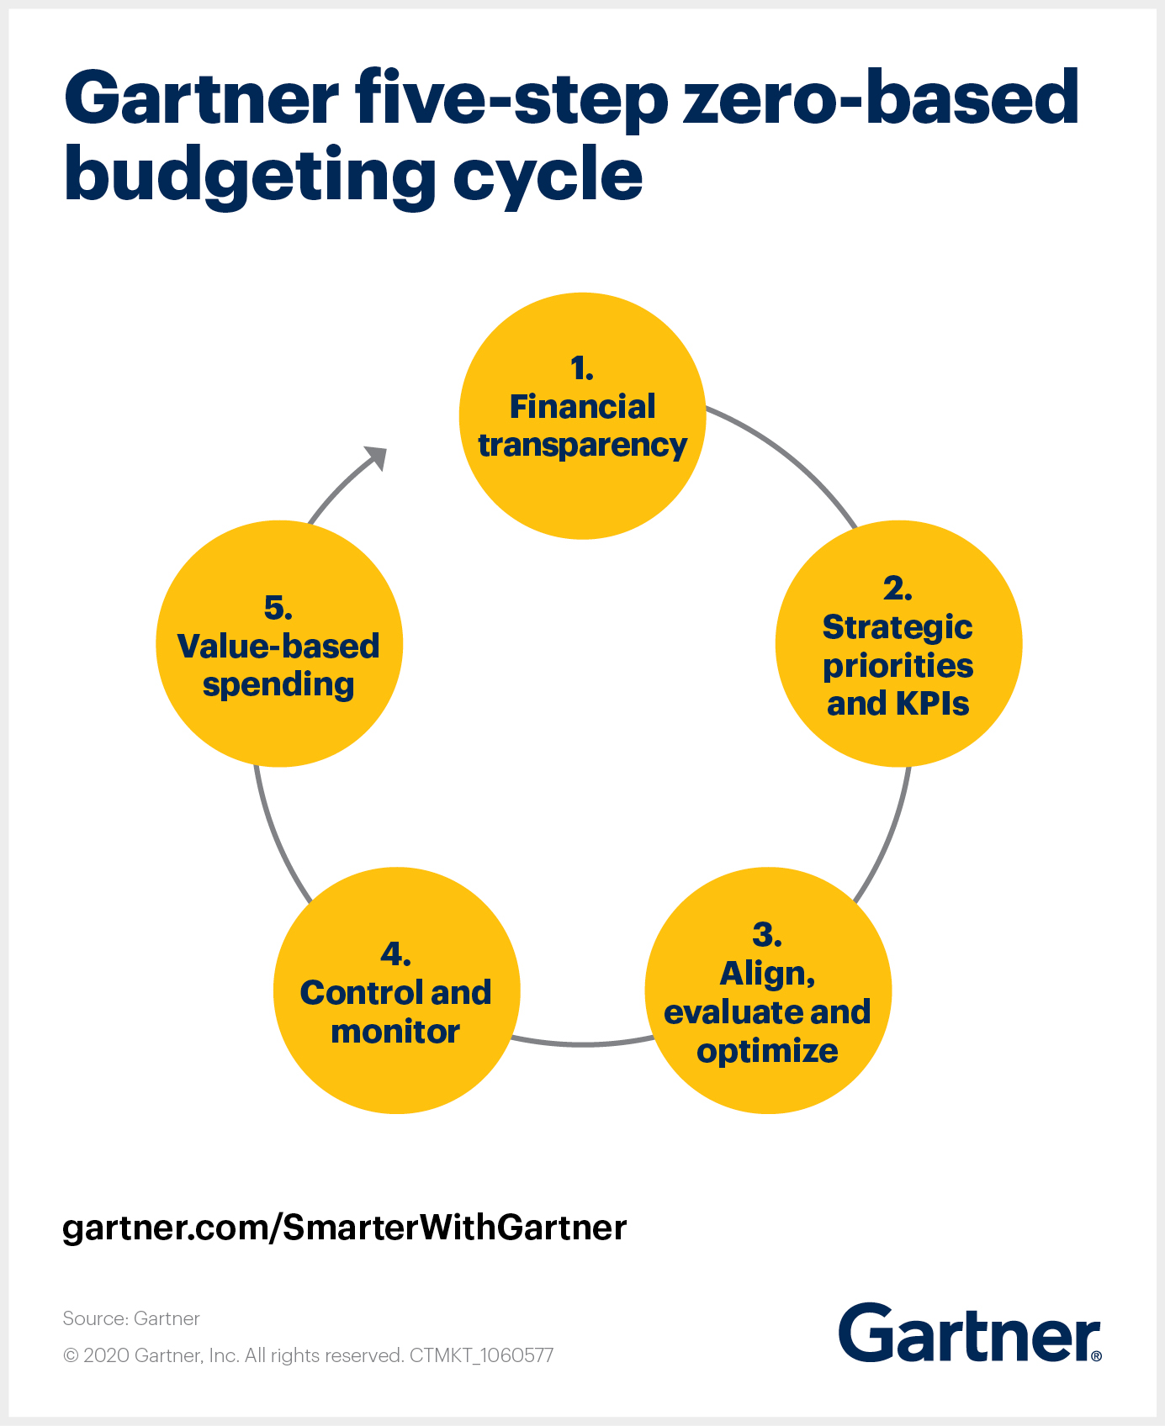Fig 1(ZBB Cycle)
According to Gartner (2020) for an organisation to implement the ZBD efficiently it is necessary they follow 5 steps and procedures represented on fig 1.
1- Ensure financial transparency.
For effective control of the cost, the management needs to have a clear vision to understand the relation between different types of the cost that can impact the budget. For example, if the business has a fixed cost or predicted cost for the electricity and this cost change, it is essential to clarify the reason behind the change and what to do correct it.
2- Identify strategic business priorities and KPIs.
If the leaders propose to reduce expenses and cost, it is essential that all the directors have to work together to identify which expense will be the priority, they accountability to share and to communicate the decision and to find the right strategy and toll to analysis and measure if the performance have increased (cost and expenses reduction), encourage and incentive the use of ZBB and TB across all the business.
3-Align, evaluate and optimize.
The leaders should keep the budget under control because if there is any change in business environment that can affect the ZBB they have to evaluate and make sure if it is not outdated for the initial purpose and in case any alteration it should be again revised in the way it does not compromise its main purpose.
4-Control and monitor the budget.
Every 15 days as or monthly the leaders have to continue to verify and to check the budget with the performance indicator to make sure if they are performing well and if effectively the cost and expenses are reducing or not at level they stablished.
Value-based spending.
The leaders should be role model and be first to make sacrifice in term of following strict ZBD measures and to motivate that ZBB is ideal do discipline a good behaviour spending.

Conclusion

This report concludes that there are many budgets’ methods businesses can use as a tool to help them on daily financial operation.
Traditional budget represents the old management strategy and are inefficient in today’s business environment as it focusses on past data with objective to control the resources business need in contrast Zero Based Budget provides businesses with the necessary technique to achieve higher performance, cost and expenses management and future financial stability that business need to overcome in today challenges. Both budgets were important for business, despite their limitation. The TB tool still part of the business management strategy to achieve business goals needing just few adjustments for its higher standard and performance.
The report recommends The Regional Accounts Director of Hotel Continental the use of Zero-Based Budget because the advantage it offer to the business, however the hotel has to follow 5 procedures to implement it.

4. Reference List
- Bunce, P., Fraser, R. and Woodcock, L. (1995) ‘Advanced budgeting: a journey to advanced management systems. Management accounting research, 6(3), pp.253-265.doi: https://doi.org/10.1006/mare.1995.1017
- Corporate Finance Institute. (2018) What is Zero Based Budgeting? [video]. Available at: https://www.youtube.com/watch?v=C71Dcrf4fh8 (Accessed 12/03/22).
- Corporate Financial Institute. (2022) What is Budget? [online]. Available at: https://corporatefinanceinstitute.com/resources/knowledge/finance/budget/ (Accessed 15/03/22)
- Corporate Financial Institute. (2022a) Four Main Types of Budgets/Budgeting Methods[online]. Available: https://corporatefinanceinstitute.com/resources/knowledge/accounting/types-of-budgets-budgeting-methods/ (Accessed 15/03/22)
- Deloitte (2015) Zero-based budgeting. Zero or hero? [online]. Available:https://www2.deloitte.com/content/dam/Deloitte/global/Documents/Process-and-Operations/gx-us-operations-cons-zero-based-budgeting.pdf (accessed 15/04/22)
- Drury, C. (2012) Management and cost accounting 8th edn. Cengage Learning.
- Educationleaves (2021) What is Zero-based Budgeting? Advantages, disadvantages of Zero-based budgeting. [video]. Available at: https://www.youtube.com/watch?v=VU5MtqCMbVo&ab_channel=Educationleaves (Accessed 10/03/22).
- Educationleaves (2022) What is Budgeting? | Budgetary control | Advantages & Limitations of Budgeting [video]. Available at: https://www.youtube.com/watch?v=INnPo0QPXf4&ab_channel=Educationleaves (Accessed 13/03/22).
- Gartner (2020) Zero-based budgeting (ZBB) is often misunderstood. Learn how it optimizes spending to drive strategic business outcomes — and the 5-step ZBB process for doing so[online]. Available at: https://www.gartner.com/smarterwithgartner/use-zero-based-budgeting-to-rightsize-tight-budgets (Accessed 22/03/2022).
- Harvest Financial Planning (2019) Basic Elements of a Budget[online]. Available at: https://www.hfpllc.com/basic-elements-of-a-budget/ (Accessed 19/03/2022).
- Lalli, W.R. (2012) Handbook of Budgeting 6th edn. John Wiley & Sons, New Jersey.
- Maloney, M and Hawke, K. (2018) What is Zero-based budgeting (ZBB) | McKinsey & Company[video]. Available at: https://www.youtube.com/watch?v=MXYtqbHnaLo (Accessed 15/03/22)
- Nugus, S. (2009) Financial planning using Excel forecasting planning and budgeting techniques. 2nd edn. Amsterdam; CIMA.
- Shim, J.K., Siegel, J.G. and Shim, A.I. (2011) Budgeting basics and beyond 4th ed. John Wiley & Sons, New Jersey.
- Stroud International (2015) What is Zero-Based Budgeting (ZBB)? [video]. Available at: https://www.youtube.com/watch?v=t0KLvsvShsk&ab_channel=StroudInternational (Accessed 13/03/22).
- Stroud International (2017) Understanding the common criticisms of Zero-Based Budgeting (ZBB)[video]. Available at: https://www.youtube.com/watch?v=EcgdEpVNHmw&ab_channel=StroudInternational (Accessed 13/03/22).

