Network Operating Systems and Services (NOSS) (ACCA5023)

Worksheet 2 DEPLOYING A NETWORK DIRECTORY SERVICE AND CREATING AND UNDERSTANDING ACTIVE DIRECTORY NETWORK OBJECTS

John M Williams – Student 1202877

Task 1: Pre-requisite tasks

Checked are made to confirm that server1 has a statically defined IP address and that the firewall has been disabled. This is displayed in figure 1 and 2 below.

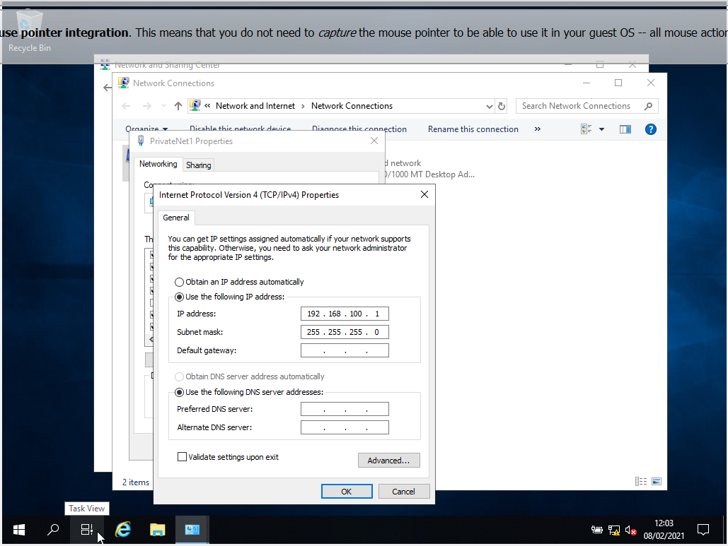
Figure 1 - Static IP no DNS.
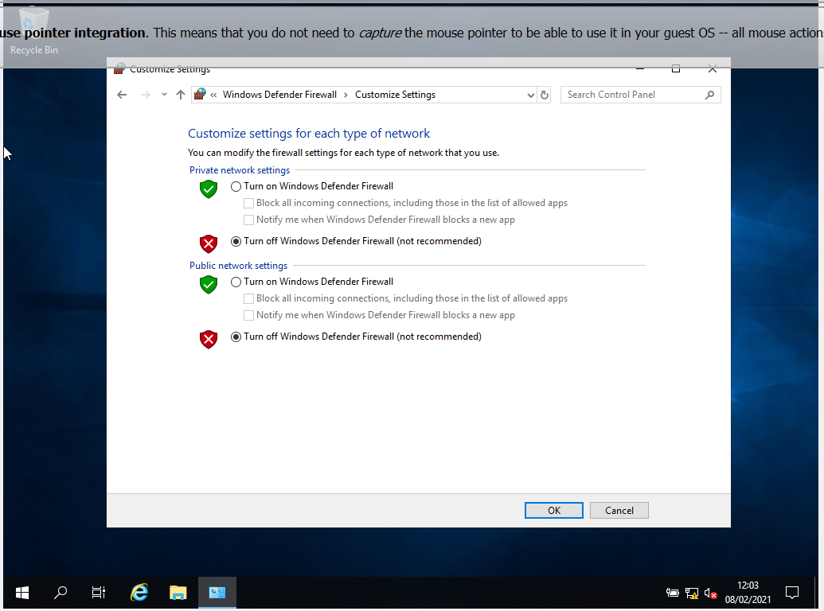
Figure 2 - Disabled firewall.

The server is renamed to DC1-NWT by selecting ‘Change’ under the Computer Name tab.
A reboot is required to complete the rename.

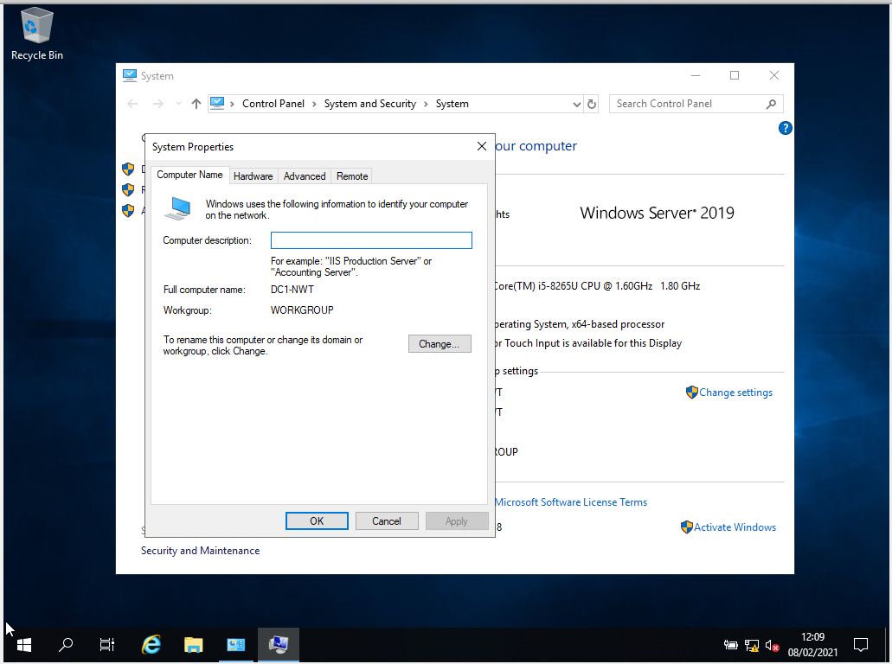
Figure 3 - Rename to DC1-NWT

Task 2: Deploying Active Directory as a role or feature based installation.
Server manager is loaded on server1 and add roles and features is selected from the dashboard.
Active Directory Domain services is selected to be installed on DC1-NWT.
AD DS (Active Directory Domain Service) Tools then Active Directory Administrative Centre are installed.

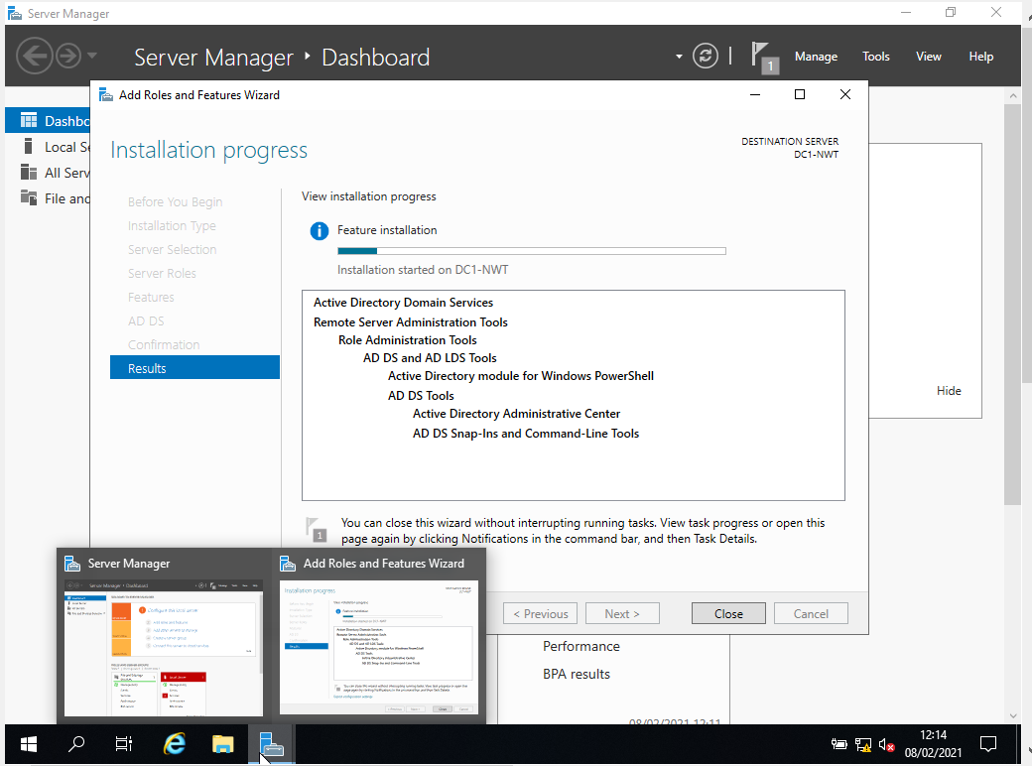
Figure 4 - Installing AD tools on DC1-NWT.

Next server1 is promoted to a domain controller by selecting; ‘Promote this server to a domain controller’ within server manager.
‘Add a new forest’ is selected and root domain name added for nwtraders.msft.
Domain controller capabilities are selected for:
- Domain Name Systems (DNS) server
- Global Catalog option should also be checked on.
- Directory Services Restore Mode (DSRM) password set to N3tW0rk1 the following case sensitive password and Confirm password: N3tW0rk1

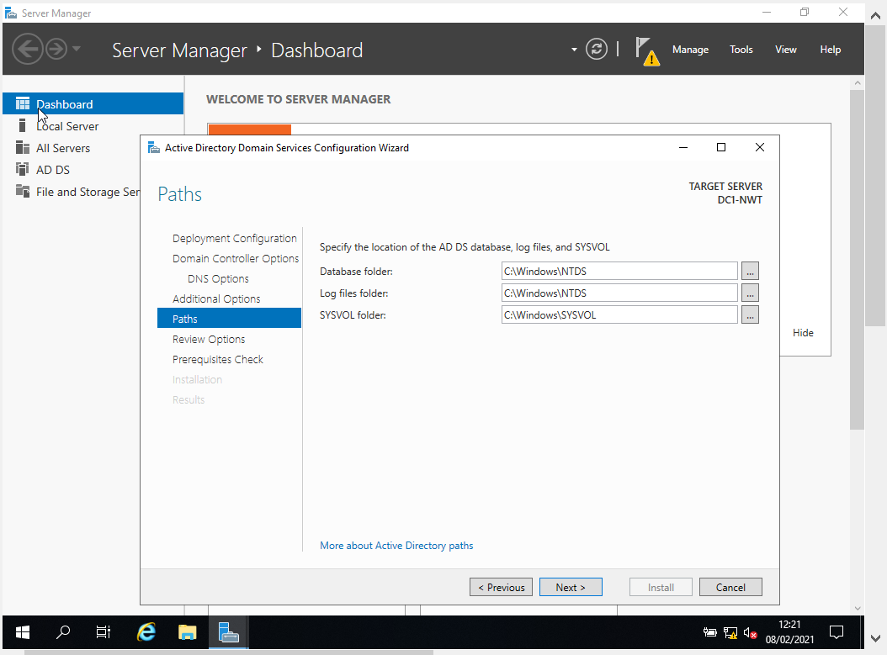
Figure 5 - AD Domain Service Configuration

A prompt is displayed to show the system has successfully be promoted to a domain control and the system is restarted.

The administrator account is used to login to the nwtraders domain.

Task 3: Creating user account objects using Active Directory Users and Computers snap-in console

Administrative tools are selected from the start menu and Active Director Users and Computers is loaded.

Th nwtraders.msft domain is expanded and the domain control OU is selected to confirm that the domain control DC1-NWT (server1) is listed.

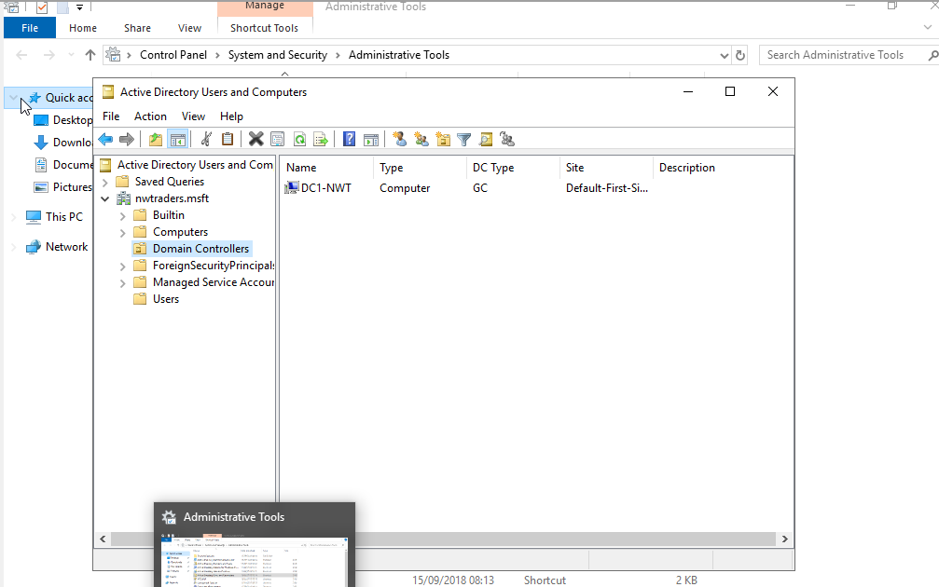
Figure 6 - DC1-NWT in the domain controllers OU

A user is added to the domain admins container in active directory.
The new user ‘john m. williams’ is created by right clicking on the Users container and selecting New User.
The user is then added to the Domain Admins group by double clicking on the Domain Admins container and selecting Add. The username is typed in and the check name option selected then ok is clicked.
The user has been added to the Domain Admins group on the nwtraders.msft domain.

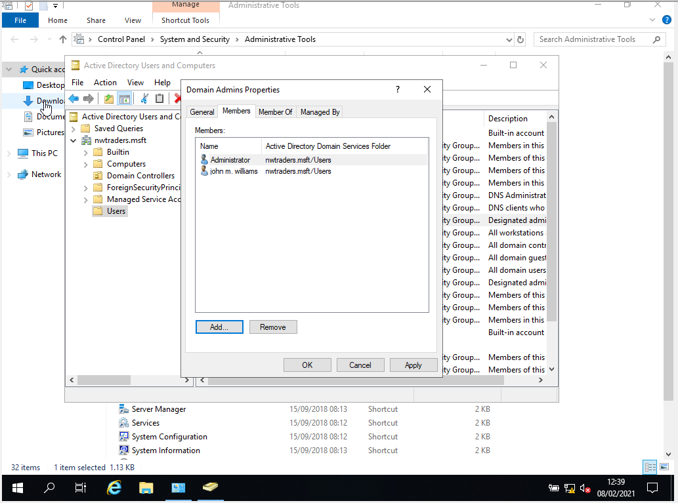
Figure 7 - adding user to Domain Admins.

An additional user ‘tom jones’ is created in the users container on the domain controller.

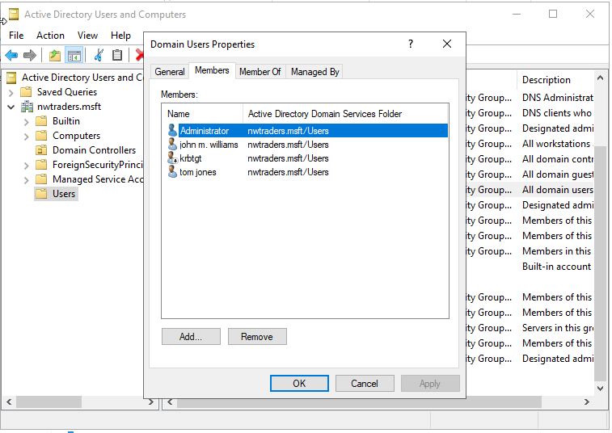
Figure 8 - Creating new user.

Task 4: Object attributes of interest.
The new account created will have logon restrictions set. The logo hours are permitted 8am and 5pm Monday to Thursday and logon is denied between 1pm and 2pm Monday to Friday.
The account is set so that the user is unable to change the password under the account options by selecting ‘User cannot change password’.

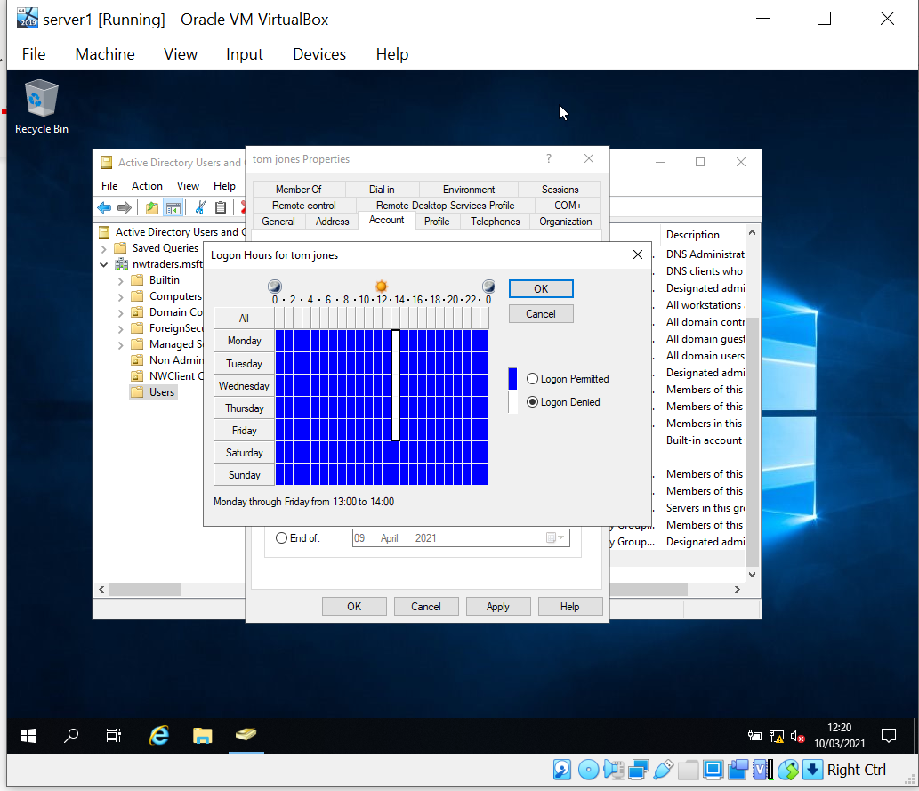
Figure 9 - Logon restrictions being set.

Task 5: Adjoining the domain and testing user logins.
A new computer is created within the computers container on DC1-NWT domain controller.

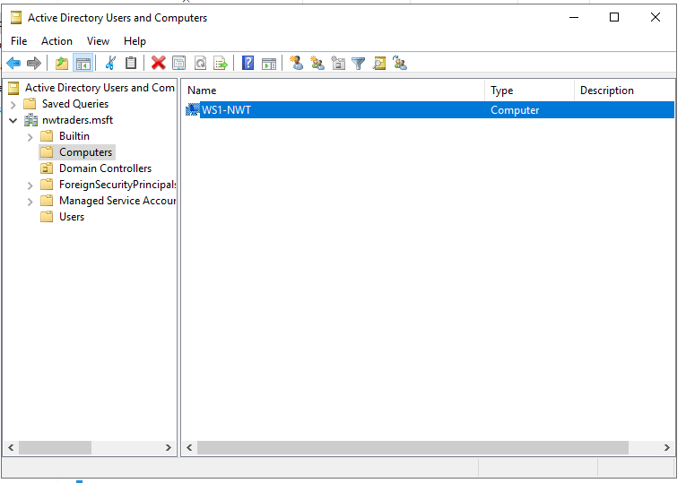
Figure 10 - Creating new computer WS1-NWT.

Client1 is now booted as it will be renamed to WS1-NWT and joined to the domain.
The PC is renamed by right Click on ‘This PC’ desktop app, choose properties then Advanced System Settings.
Client1 is now restarted and logged back into. The DNS settings need to be applied for the nwtraders domain.
The DNS settings are applied to the network adapter on client1.

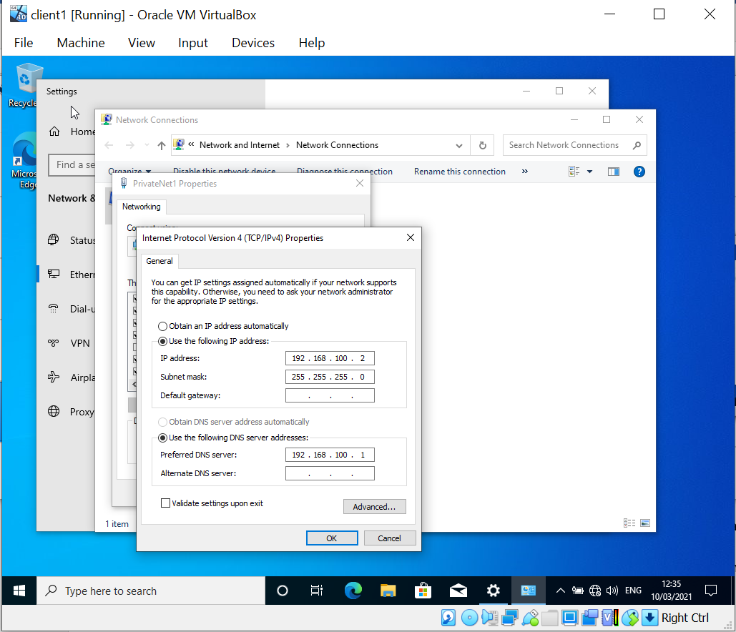
Figure 11 - DNS settings added to client1.

Client1 is joined to domain by selecting the Computer Name tab again under the PC properties and then selecting ‘change’. Under the Member of, the ‘domain’ radio button is selected and nwtraders.msft is entered.
The administrator username and password for the domain controller is used and the PC is joined to the domain.

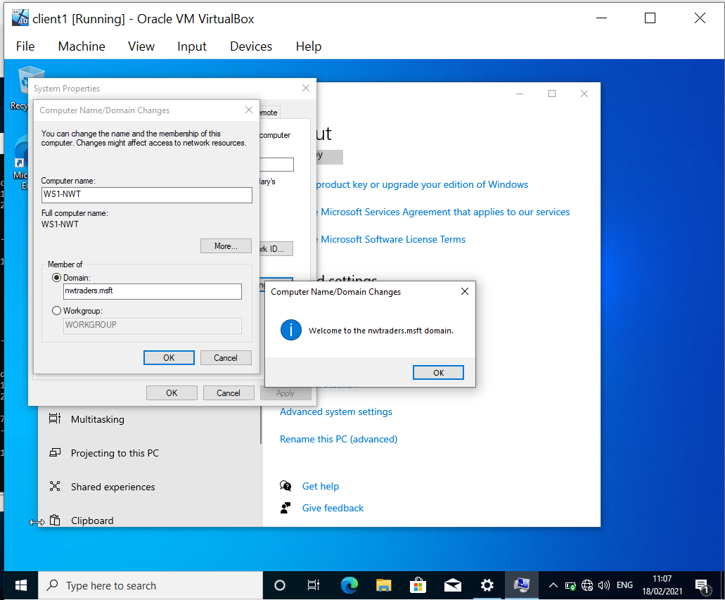
Figure 12 - Joining workstation to domain.

The non-administrative account for tom jones can then be used to login to client1 on the nwtraders domain.

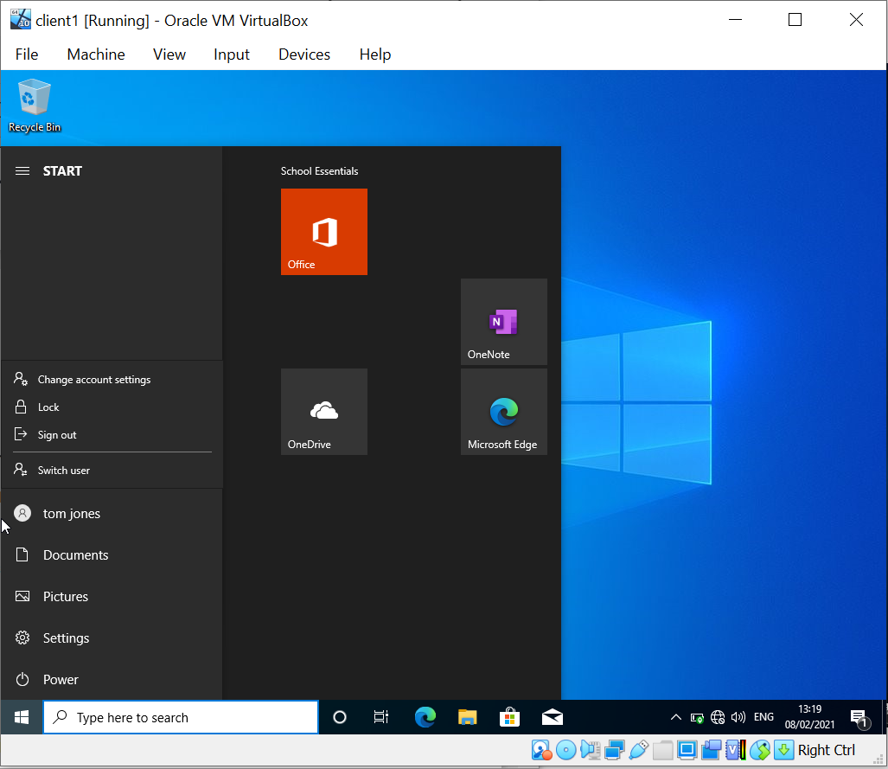
Figure 13 - Logging in as domain user on client1.

The non-administrative account ‘tom jones’ is used to try and logon to the domain controller on server1. This account is unable to login as only accounts elevated to domain administrator level can logon to domain controllers.

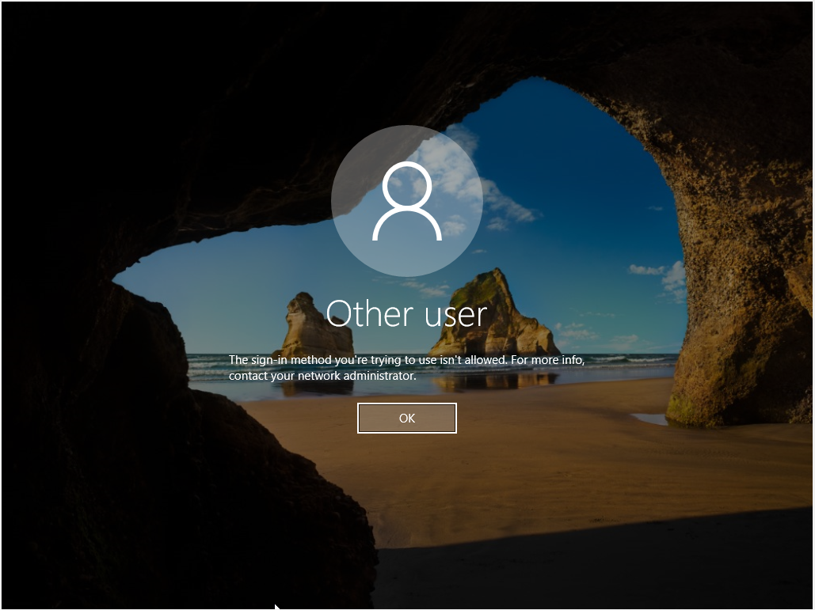
Figure 14 - Unable to logon to domain controller with standard user account.

6 a) DNS - explain what it is, how it works (illustrations) and its significance within Active Directory Domain Services.
Domain Name System, or DNS, is a naming convention created to allow people to access a remote hosts IP address using a familiar phrase or wording. Without DNS, it would be required to remember IP addresses to navigate around a local area network and the internet.
There are a number of explanations as to what DNS is, and ICANN (2021) provide the simplistic definition that “to reach another person on the Internet you have to type an address into your computer - a name or a number. That address has to be unique, so computers know where to find each other”. Computers do not use DNS to communicate with each other and use networking protocol such as TCP/IP, therefore DNS has been created to “… make the Internet accessible to human beings. The main way computers that make up the Internet find one another is through a series of numbers, with each number (called an “IP address”) correlating to a different device. However, it is difficult for the human mind to remember long lists of numbers so the DNS uses letters rather than numbers, and then links a precise series of letters with a precise series of numbers” (ICANN, 2021, para. 4).

Figure 15 gives a basic illustration of how DNS works.
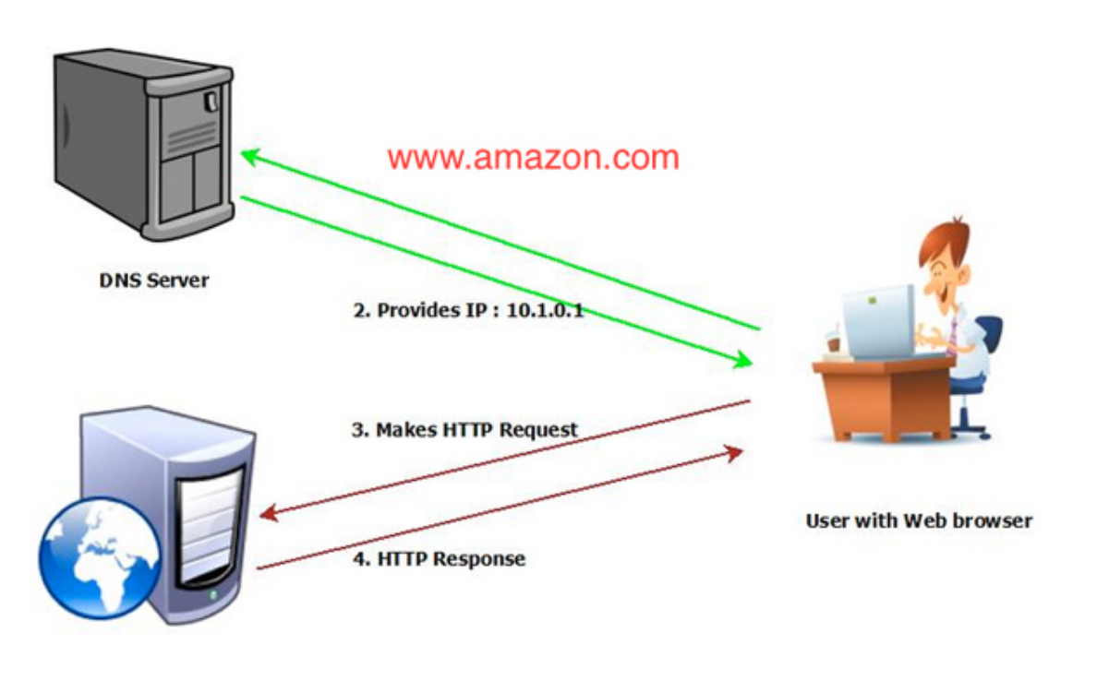
Figure 15 - Basic DNS illustration (POOJARY, 2019).

With reference to figure 15, the user is accessing the www.amazon.com website via a web browser. Any browser could be used, such as Internet Explorer, Firefox or Google Chrome, as all web browsers rely on DNS to work correctly.
The website address is entered into the browser and then enter or ‘go’ is clicked. A DNS request is made by the users device to a DNS server and the DNS server responds to the request providing the device/browser with the IP address for website. The browser then connects to the IP address of the webserver and downloads the contents of the website into the browser.
This is all done in the background without any input required from the end user. The website address remains as www.amazon.com in the browser bar.

In the second example in figure 16 below, a DNS lookup tool is used for the domain ‘carmarthenshire.gov.uk’.
The domain name is resolved to the IP address 212.219.232.156. This is the internet facing address for the website.
The DNS entry was provided by host-it.co.uk who host the DNS records for the Carmarthenshire.gov.uk website.

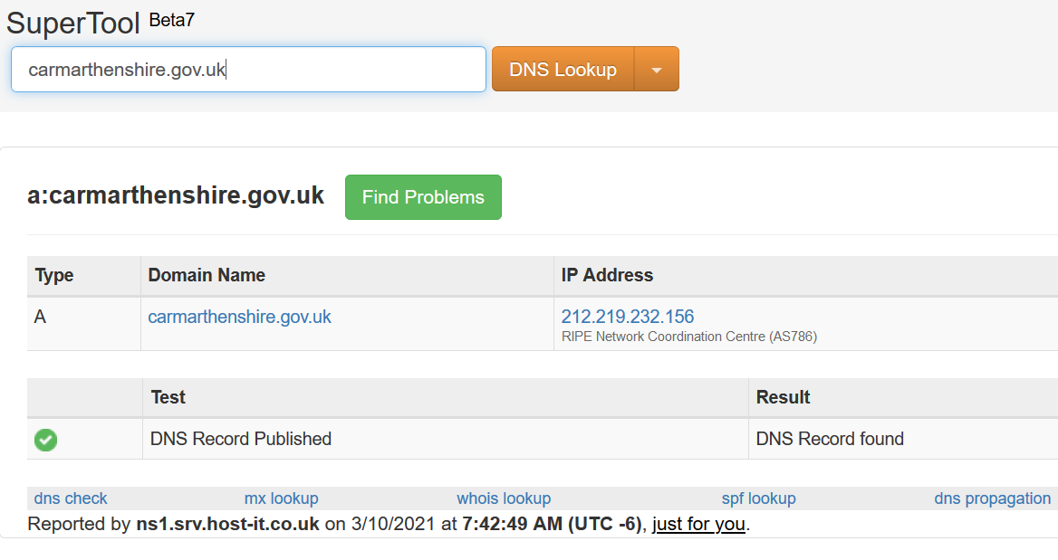
Figure 16 - Carmarthenshire.gov.uk DNS lookup

Internal DNS services are also run-on private networks to resolve IP addresses to names. These are used in the same way as internet DNS services and function to allow internal systems and devices to be accessed by a name rather than IP address.
An example would be a company’s intranet page. The intranet website would be hosted on an internal webserver hosted on the Local Area Network (LAN) that can only be accessed by users connected on the same LAN.
The webserver has an IP address of 192.168.1.100 and could be accessed by entering https://192.168.1.100 in a web browser.
An internal DNS record is created to point the IP address to the DNS name of ‘intranet’ so the web address of http://intranet can be used.

In Windows Server 2016 and 2019, DNS is a server role that can be installed via Server Manager and is usually installed when a new Active Directory domain is setup. Active Directory Domain Service uses DNS to locate other domain controllers and devices on the network. DNS services are enabled on all modern versions of Microsoft Server and Windows client operating systems and are used to authenticate users and devices logging onto a domain. Domains with multiple domain controllers query the DNS service and are provided with the IP address of the domain controller used for logging onto the domain. (Microsoft. 2021)
DNS is part of the application layer in the TCP/IP stack as illustrated below.
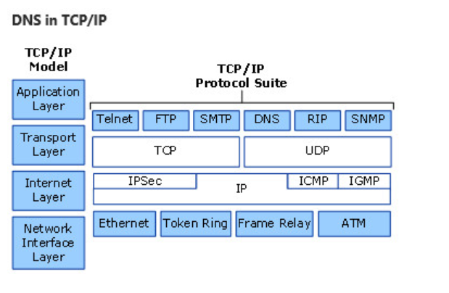
Figure 17 - DNS in TCP/IP (Microsoft, 2021).

6 b) AD is one critical ‘Role or Feature based installation’ as part of an enterprise network, identify and provide a brief overview of 2 other critical roles?
The DHCP service can be a critical role installed as part of the Roles and Feature base installation on a enterprise network. The DHCP service automatically assigns IP address configuration to devices that are connected to the network and setup to use the DHCP service. Dynamic Host Configuration Protocol is configured with a pool of available IP addresses on the network. The IP addresses are then leased to the device for a given period (Microsoft, 2020).
Some benefits of DHCP are that it is far easier to configure large networks as there is no reliance on the end user having to manually enter the IP, subnet and gateway addresses. It also reduces the chances of network errors such as incorrect addressed being used which could causing conflicts.
A disadvantage of DHCP is that it makes it easier for an unauthorised user to gain access to a network, as it automatically provides the network IP settings to any client request DHCP. In addition, if the DHCP service or server it is running on becomes unavailable, no new clients joining the network are able to connect, as they are not assigned an IP address. Statically assigned client will still be able to access the network.
Active Directory certificate services could be another critical role. It is used for setting up digital certificates for domain and forests and improves the security by using encrypted tokens when authenticating with a domain controller. Certificates can also be used to digitally sign documents and allow secure access to web services (Microsoft, 2016).
6 c) Explain why it is important to have different levels of access/roles within the ‘Built in’ Network User Account groups (e.g. Domain Admins, DHCP Admins, etc).
The fundamental reasons for having different levels of roles within active directory would be to improve the security on the domain/network and reduce the risk of potential human error, and ease the administration.
In IT security, the principal of leased privilege is recommended, which means that ‘someone’ or an account should be given the least possible privileges or permissions they require to undertake their job or task (Lau, Zeidenstein 2017). A standard IT engineer who makes visits to repair laptops would not be given ‘Domain Administrator’ permissions on the domain. They would have no need to use the elevated permissions and there is the potential that they could cause accidental damage or loss to network resource.
In additional, accounts with elevated permissions pose a greater threat from malware and cyber-attacks. With the domain administrator group grated access to most services and systems on a network, a ransomware malware attack has the potential to cause catastrophic damage to a business. Hackers could also target employees of an organisation who have heightened permissions to try and compromise the network and steal information (CyberSheath, 2014)

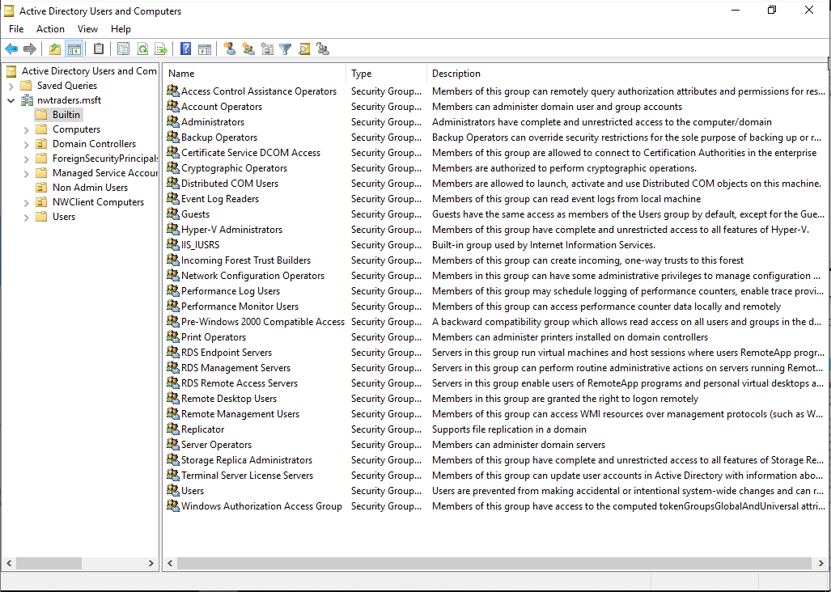
Figure 18 - Built-In Accounts on AD

Figure 18 displayed the standard build-in accounts available in Active Directory 2019. There are several predefined groups which users could be added to by the system administrator.
Examples as to where the groups could be used on the domain are provided below:
- Users – all newly created user accounts are added to this groups. Members in the group are prevented from making accidental or intentional system-wide changes.

- Remote Desktop Users – Users added to this group would have the ability to remote desktop another machine on the domain and login locally.

- Network Configuration Operations – Members of IT staff who work on the telecommunication and network may be added to this group. It would allow them access and to make changes to network configurations on server such as DHCP scopes.

- Event Log Readers – Analysts working for a company could be added to this group if they required access to domain server logs.

- Account Operators – IT Helpdesk staff may be added to this group for the administration of users account on a domain such as creating new users, resetting passwords, setting logon hours.

- Domain Administrations – Members of this group have full access administrative access to the domain servers and devices and would be limited to technical/server specialists.

6 d) Share your ideas in-detail on Microsoft’s recommendations on AGDLP and AGUDLP for assigning permissions. How do you view them in the perspective of a System Administrator in strategizing and implementing within your network?

AGDLP (account, global, domain local, permission) and AGUDLP (account, global, universal, domain local, permission) would be recommended for businesses or organisations that have many users and domains and have a requirement to share data and access. The organisation may have outgrown its current file permissions structure and there is too much reliance on IT administrators to manage permissions.

The use of domain local and global groups could be used by a business who have historically provided permissions to shares and folders directly at the user level. This would improve the management of groups and permissions and the role of data administration and granting permissions could be delegated out to users who work within the department. Delegated permissions would be provided to them so that they had the ability to manage local domain groups. Users could be added and removed to the groups by the departmental users, whereas the overall permissions of the domain local group (read, write, and execute) would have already been setup by the IT administrator and cannot be changed. This is moving away from the practice of providing permissions to users based on ‘them’ and moving into permissions based on job function.
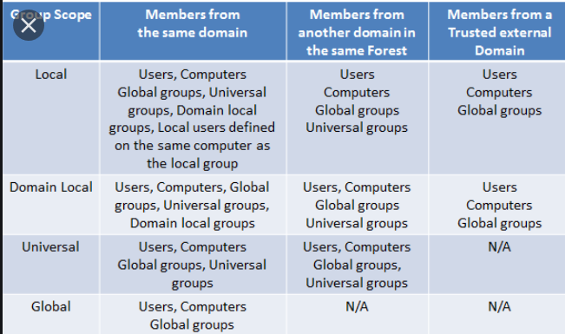
Figure 19 - Domain Groups
Where there are multiple business units and domains that need to share data, universal groups can also be used. Universal groups allow global groups to be combined allowing users from multiple domains to be added, and once the structure has been correctly setup, it reduces replication across the domain (ITFreeTraining, 2012).

Some considerations for a System Administrator in strategizing and implementing AGDLP and AGUDLP within a network would be:
- Understanding the business function and how they currently access data and manage permissions.
- Files and folder permissions in place – implementing AGDLP can be a very time-consuming process and take months or possibly years to establish for organisations who have many network shares and a large file structure. A detailed project plan would need to be created with buy in for the organisation on the benefits.
- Delegation of granting permissions – It is difficult for IT administrators to keep track of who should have permissions to different areas. By moving to a domain group-based system for permissions, it allows the management to be delegated to business areas, who can add and remove employees as and when needed.
- Size of the organisations – An understanding of the size of the business/organisation would be needed and do they, or are they planning on collaborating with other businesses. Universal groups may be a future consideration for this.
- Necessary Skills – Implementing AGDLP and AGUDLP can be very complex and a thorough understanding and skills in Active Directory are required. Businesses should ensure that IT Administrators has the necessary skills to undertake this task.

References
CYBERSHEATH SERVICES INTERNATIONAL, 2014-last update, THE ROLE OF PRIVILEGED ACCOUNTS IN HIGH PROFILE BREACHES [Homepage of CyberSheath Services International], [Online]. Available: https://cybersheath.com/wp-content/uploads/2019/07/CyberSheath_Privileged_Breaches.pdf [10/03/, 2021].
INTERNET CORPORATION FOR ASSIGNED NAMES AND NUMBERS, 2021-last update, What Does ICANN Do?. Available: https://www.icann.org/resources/pages/what-2012-02-25-en [10/03/, 2021].
ITFREETRAINING, 2012-last update, MCITP 70-640: Group Strategy AGDLP. Available: http://itfreetraining.com/70-640/agdlp/ [10/03/, 2021].
LAU, P. and ZEIDENSTEIN, K., 2017-last update, Mitigate insider threats with Guardium and Privileged Identity Manager. Available: https://www.ibm.com/developerworks/library/se-manage-audit-privileged-users-pim-guardium/index.html [10/03/, 2021].
MICROSOFT, 2021-last update, Domain Name System (DNS). Available: https://docs.microsoft.com/en-us/windows-server/networking/dns/dns-top [10/03/, 2021].
MICROSOFT, 2020-last update, Dynamic Host Configuration Protocol (DHCP). Available: https://docs.microsoft.com/en-us/windows-server/networking/technologies/dhcp/dhcp-top [10/03/, 2021].
MICROSOFT, 2016-last update, Active Directory Certificate Services Overview. Available: https://docs.microsoft.com/en-us/previous-versions/windows/it-pro/windows-server-2012-r2-and-2012/hh831740(v&#61;ws.11) [10/03/, 2021].
NITHEESH POOJARY, 2019-last update, How DNS Works – the Domain Name System (Part One) [Homepage of cloudacademy], [Online]. Available: https://cloudacademy.com/blog/how-dns-works/ [10/03/, 2021].

