CURRENT TRENDS OF BUSINESS INTELLIGENCE

Assignment 1

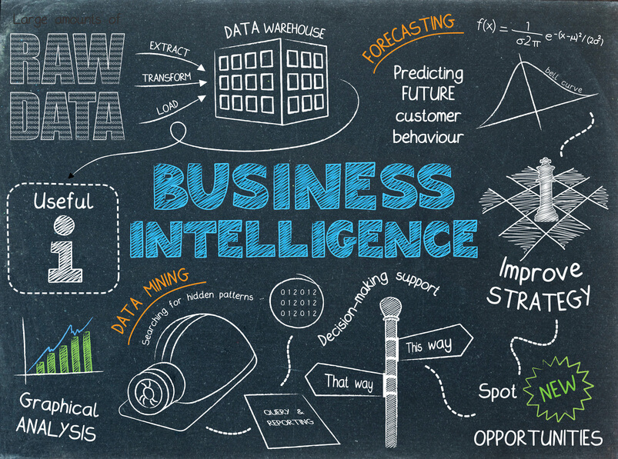
This Photo by Unknown Author is licensed under CC BY-SA-NC

Programme: BA (Hons) Business Management
Module: Data Handling & Business Intelligence
Module code: LCBB5000
Lecturer: Gasso Wilson Mwaluseke, Anupam Mazumdar- GP1 Amitave Banik- GP2
Student Name: Valeria Peeva
Student Number: 2029005
Table of Contents

INTRODUCTION 3
CURRENT BUSINESS INTELLIGENCE TRENDS 3
CONCLUSION 6
REFERENCES 7

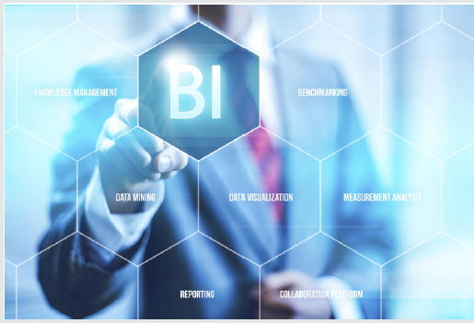
This Photo by Unknown Author is licensed under CC BY

INTRODUCTION
The report will detect and significantly assess the recent developments in information warehousing, corporate communication, and data mining. It will establish a thorough understanding and logical sense of fundamental ideas and ethics, by utilizing analytical critical package. There are several explanations for Business Intelligence, or BI. To place it easily, BI is regarding providing appropriate and dependable data to the correct individuals at the correct point in time with the aim of accomplishing improved outcomes quicker. BI gather techniques and transforms them into data to be capable to improve choices. Business intelligence instruments (BI tools) are all regarding assisting you realize developments and obtaining perceptions from your information so that you be capable of do strategic and planned corporate choices. They likewise assist you discover designs in the piles of information your company develops. Data innovation, which applied to be restricted to the knowledge of sophisticated analytics experts, currently everybody knows how to utilize these implements. And not just that, although these devices also provide you the visions you require to accomplish matters as development, solve problems that are critical, gather all your information in specific location and projected potential consequences.

CURRENT BUSINESS INTELLIGENCE TRENDS
Business intelligence requires the tasks, tactics, and devices firms manage to gather, procedure, and evaluate records. Business intelligence instruments be able to distinguish innovative prospects for enterprises to enhance return on investment (ROI) and economical benefit established on visions discovered. These implements are applied throughout the entire sector, businesses, and corporate consumers. Business intelligence instruments accumulate, manage, and examine huge sums of formal and formless information from equally inside and outside methods. Statistics resources could involve files, pictures, correspondence, tapes, papers, records, social media displays, documents. BI kits locate this data across requests, which can produce the information in customer-responsive presentations such as articles, dashes, graphs, and tables. The devices know how to operate tasks such as data mining, data visualization, implementation supervision, analytics, reporting, text mining, prognostic analytics. Consequently, workers be able to use this knowledge to do excellent quality outcomes centred on projections, market styles, and key performance indicators (KPIs).
- Data discovery
Data visualization has improved its effect in the past time. A study performed registered information innovation in the best 4 corporate information developments by the significance order for 2022. BI experts gradually appear that the encouragement of corporate customers is a robust and reliable fashion. Data finding is the method of gathering information from several inside and outside resources and utilizing sophisticated analytics and visions to establish all the data. This lets companies to maintain each important investor involved with the information by encouraging them to examine and control the data in an insightful manner and obtain actionable understandings. To accomplish this, companies of all ranges point to innovative resolutions such as business intelligence implements that approach data combination, collaborative ideas, a customer-responsive line, and the suppleness to operate with huge quantities of information in an effective and sensitive manner. A vital component to think is that information discovery implements vary upon a procedure, and then, the created outcomes will make enterprise rate. It involves knowledge the connection among information in the manner of statistics training, graphic evaluation, and conducted sophisticated analytics. The superior requirement for statistics discovery devices suggests a massive change in the BI realm in relation to improved information control and the mining of perceptions. Utilizing virtual information image kits to execute those activities is developing a valuable source to generate important visions and produce a balanced outcome-producing method. Corporate customers need package that is simple to utilize, responsive and adaptable, diminishes point to vision, lets effortless processing of a superior quantity and range of information.
- Expert data management/data quality
BARC facts out that there is a straightforward explanation why information excellence and statistics administration are trending in the marketplace. The correct conclusions can merely be established on information that is appropriate and up to date. One should consequently be competent to assume that the statistics is appropriate to get decent judgments. The objective of master data administration is to accumulate and distribute information, such as consumer, provider, or merchandise controller information, throughout numerous procedures.
- Data literacy
The capability to understand and develop information as a cooperative instrument that everybody in the company can use is developing progressively critical for business accomplishment. Data literacy will be one of the important data analytics subjects to maintain in 2022. The phrase data literacy is applied to illustrate an individual's capability to recognize, understand, create, and convey information in a particular situation. It involves realizing the techniques and methods employed to examine the material and the instruments and tools utilized. One of the best considerable inner obstacles to victory is inadequate data literacy. By 2025, data literacy will be a requirement and an essential element in generating commercial significance. The introduction of self-maintenance BI instruments for processing huge datasets, constant communication, imitation information, and enhanced analytics has taken data literacy to the vanguard of a thriving data-driven society.
- Producing a data-driven culture
Lately, several well-established retailers have created this latest tendency in corporate communication. The idea of a data-driven culture at a firm foresees evidence as a crucial source for executing concepts in each district. The important objective is to encourage each worker to aggressively utilize statistics to reinforce their everyday job. This approach, they can utilize the firm's ability and statistics to get efficient outcomes, evaluate existing developments, and get crucial economic benefit further noticeable. The objective is to build an educational structure that improves the corporation's representatives join forces to turn files to the place of choice-making: from the vendor to the worker (dealer, banker, supervisor, HR). The organizational performance is influenced by a vast range of factors such as costs management, productivity and customer service levels, profits, and sales trends. Human potential is one of the most powerful tools within the companies, so the strive for developing human capital through fostering value-oriented approaches and refining knowledge sharing and cognitive progress should be a priority for the corporation.
- Data governance
In compared to BI or assessment supervision, which is about planning and submitting statistics for corporate administration structures, information authority concentrates on the factual records in these structures. Data governance is necessary as a method for a data approach that reports how enterprise policy is interpreted into numbers and evaluation. Data governance is, consequently, necessary to execute a data approach, and includes regulations and structures for management, supervising, and safeguarding information. This is accomplished while contemplating individuals, procedures, and expertise. Determining data authority is a long-time undertaking. Primarily, it involves a transparent and deliberate executive judgment on how to operate along with, and purpose.


This Photo by Unknown Author is licensed under CC BY-SA-NC

CONCLUSION
Massive knowledge is across us and gradually improving with each year. By employing BI and corporate analytics devices, you continue to realize fantastic incentives – your statistics administration will develop further consistent, steady, responsive, and obvious with various elements that these instruments need on advance. The developments from BARC’s analysis showing that firms are prepared to begin operating their personal information and get advantage of it. In supplement, they appear that corporations are involved with superior information value and effective application of information. In brief, this suggests that corporations choose to go outside just gathering as much information as and instead be capable to aggressively utilize decent property records to enhance their judgments. This is also backed by the development of streamlining data stores. In this paper, we must concise what the nearby potential corporate information developments seem similar for us. In our disaster-pushed planet, tools like BI can give a lot to the board: they allow businesses to realize the difficulties they confront, evaluate differences in their schemes and courses, renovate their commercial, kind the correct choices, and defend development and success in the extended track. Various companies are willing to take power of their records and make purpose of it. They also prove that companies concern about superior statistics value and effective records management.


This Photo by Unknown Author is licensed under CC BY-NC

REFERENCES
Azevedo Ana., (2015). Integration of Data Mining in Business Intelligence Systems, Business Science Reference
Connolly, Thomas., (2015). Database systems: a practical approach to design, implementation and management 6th edition, Pearson Education
Top 10 Analytics and Business Intelligence Trends For 2022, Available at: https://www.datapine.com/blog/business-intelligence-trends/ (Accessed on 10/12/22)
What is business intelligence, Available at: https://www.ibm.com/topics/business-intelligence (Accessed on 12/12/22)
What Is Business Intelligence (BI)? Types, Benefits, and Examples, Available at: https://www.investopedia.com/terms/b/business-intelligence-bi.asp (Accessed on 13/12/22)
Witten, I. H., (2011). Data mining [electronic resource]: practical machine learning tools and techniques 3rd edition, Elsevier/Morgan Kaufmann
6 Business Intelligence Trends to Watch In 2022, Available at: https://www.toucantoco.com/en/blog/6-business-intelligence-trends-for-2022 (Accessed on 14/12/22)
11 Business Intelligence Trends for 2022: Latest Predictions You Should Be Thinking About, Available at: https://financesonline.com/business-intelligence-trends/ (Accessed on 11/12/22)

