

Student name:Ortenzia Alexandra Barcea
Student ID:2412822
Module name: Changemakers Building Personal Brend

Module code: BMHP5015_LON

Lecturer name:Brian Mashumba

SUBMITED :31 July

Introduction
Personal branding has become increasingly important in today's competitive employment market, where employers seek candidates who can demonstrate their skills, values, and professional identity. A strong personal brand helps individuals communicate their strengths, build credibility, and create positive impressions in both academic and professional environments. This assignment reflects on the knowledge and skills gained from Uni1, Brand You, and examines how the learning has influenced my understanding of personal branding and career development.
The reflection focuses on three key concepts explored during the lectures: self-awareness, personal branding, and professional digital presence. These concepts have helped me recognise the importance of understanding my strengths, communicating my values consistently, and maintaining a professional image online.
The assignment also connects my learning to relevant academic literature to demonstrate how theory supports practical career development. In addition, screenshots from online activities completed during the unit will be included as evidence of my engagement with the learning materials. Overall, this reflection demonstrates how Unit 1 has contributed to my personal and professional growth while preparing me for future career opportunities.

Task 1 – Unit 1: Brand You
Unit 1, Brand You, introduced the importance of personal branding and how it can influence career opportunities and professional success. Before studying this unit, I thought branding was mainly associated with businesses and products. However, the lectures helped me understand that every individual has a personal brand, which is formed through their behaviour, communication, values, and professional reputation.
According to Peters (1997), personal branding involves identifying and promoting the unique qualities that make an individual stand out from others. This idea encouraged me to think more carefully about how I present myself in both academic and professional settings.The first concept that had a significant impact on my learning was self-awareness. Self-awareness is the ability to understand personal strengths, weaknesses, values, and goals. During the online activities,
I completed self-reflection exercises that encouraged me to evaluate my skills and identify areas where I could improve. These activities made me realise that understanding myself is the foundation of developing an effective personal brand. Goleman (1998) explains that self-awareness is one of the key components of emotional intelligence because it enables individuals to make better decisions and develop stronger relationships.
Through this learning, I became more confident in recognising my abilities while also identifying the skills I need to develop for my future career. The second concept explored during the unit was professional digital presence. The lectures highlighted that employers frequently review applicants' online profiles before making recruitment decisions.
This emphasised the importance of maintaining a professional image on platforms such as LinkedIn and ensuring that online content reflects personal values and career aspirations. Labrecque, Markos, and Milne (2011) argue that social media has transformed personal branding by allowing individuals to actively manage how they are perceived by employers and professional networks.
After completing the online activities, I recognised the importance of creating a professional profile and presenting consistent information across digital platforms. I also understood that my online presence should demonstrate my skills, achievements, and commitment to professional development. The third concept that influenced my understanding was authenticity.
The lectures explained that successful personal branding is not about pretending to be someone else but about communicating genuine values and abilities consistently. Authenticity helps individuals build trust, credibility, and long-term professional relationships. Montoya and Vandehey (2008) state that an authentic personal brand reflects an individual's real personality, strengths, and values rather than an artificial image.
This concept encouraged me to focus on presenting my true abilities and experiences rather than trying to create an unrealistic impression.Overall, Unit 1 significantly improved my understanding of personal branding and its role in career development. Learning about self-awareness, professional digital presence, and authenticity has helped me recognise the importance of continuously developing my skills while presenting myself confidently and professionally.
The lectures, online activities, and academic literature have provided valuable knowledge that will support my academic studies and future career. I now understand that building a personal brand is an ongoing process that requires reflection, continuous learning, and consistent professional behaviour.
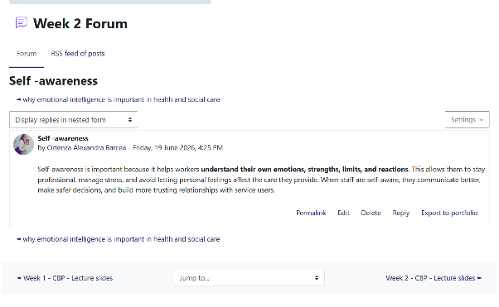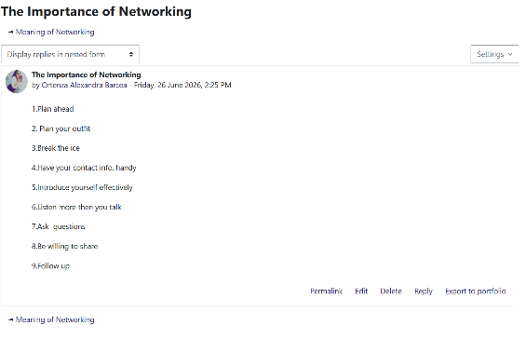

Task 2 – Reflection on Unit 2: It's a Small World
Unit 2, It's a Small World, helped me understand how global issues influence health and social care services and the importance of working effectively in an increasingly connected world. The lectures explored several important topics, including globalisation, cultural diversity, health inequalities, and collaborative working across different countries and communities.
These topics broadened my understanding of the challenges faced by health and social care professionals and highlighted the importance of providing inclusive and person-centred care. I have reflected on my learning using Gibbs' Reflective Cycle (1988).
Description: During Unit 2, I participated in lectures and online learning activities that focused on the impact of globalisation on health and social care. I completed online activities that encouraged me to think about how different cultures, beliefs, and social factors influence people's health and wellbeing. These activities also demonstrated how professionals must work together to address global health challenges.
Feelings: At the beginning of the unit, I had limited knowledge of how global events and cultural differences could affect health and social care. As I progressed through the lectures and activities, I became more aware of the importance of understanding different perspectives when supporting individuals from diverse backgrounds. I felt motivated to learn more because I realised these skills would be essential in my future career as a social worker.
Evaluation: One of the most valuable aspects of the unit was learning about cultural competence. I recognised that every individual has unique beliefs, values, and experiences that influence the support they need. I also learned about health inequalities, which showed me that access to healthcare and social support is not equal across different populations.
Finally, the concept of global collaboration demonstrated that many health and social care challenges require professionals and organisations from different countries to work together. According to the World Health Organization (2021), international collaboration is essential for improving health outcomes and reducing inequalities worldwide.
Analysis: Reflecting on these concepts has changed the way I think about my future role as a social worker. Social workers regularly support people from different cultures, backgrounds, and life experiences. Campinha-Bacote (2002) explains that cultural competence is an ongoing process that enables professionals to provide respectful and effective care to diverse populations.
I now understand that being an effective social worker requires empathy, respect for diversity, and continuous learning about different communities. I also recognise that wider social and global factors, such as poverty, migration, and inequality, can significantly affect people's wellbeing and access to services.
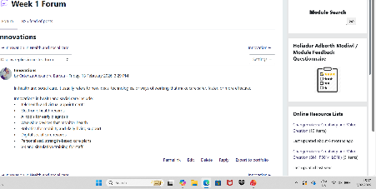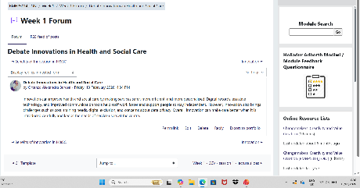
Task 3 – Reflection on Unit 3: Opportunity Knocks
Unit 3, Opportunity Knocks, helped me understand the importance of recognising opportunities that support personal growth, career development, and long-term employability. Before studying this unit, I believed that career opportunities only became available after completing a degree. However, the lectures and online activities showed me that opportunities exist throughout university, including networking, volunteering, work experience, professional development, and skills-building activities.
These experiences encouraged me to become more proactive in preparing for my future career as a social worker.One of the main topics covered during the unit was career planning. The lectures highlighted the importance of setting clear goals and identifying the steps needed to achieve them. Through the online activities, I reflected on my career aspirations and considered the knowledge, skills, and experience required to become a qualified social worker. This helped me recognise that successful career development requires planning, commitment, and continuous learning rather than waiting for opportunities to appear.
According to Super (1990), career development is a lifelong process in which individuals continually develop their skills, interests, and professional identity. This concept encouraged me to take greater responsibility for planning my future. Another important topic was employability skills. The unit emphasised that employers value transferable skills such as communication, teamwork, problem-solving, adaptability, and leadership alongside academic qualifications. Completing the online learning activities helped me evaluate my current skills and identify areas where I need further development.
I realised that these skills are particularly important in social work because professionals must communicate effectively with individuals, families, healthcare professionals, and community organisations. Yorke (2006) argues that employability involves not only knowledge and qualifications but also the personal attributes and skills that enable graduates to succeed in the workplace. This reflection motivated me to improve my communication and teamwork skills through future learning and practical experiences.The unit also introduced the importance of networking and professional opportunities.
I learned that building professional relationships can create opportunities for learning, mentoring, and future employment. Before this unit, I underestimated the value of networking, but I now understand that connecting with lecturers, classmates, placement providers, and professionals can support both personal and career development. Networking also enables individuals to share knowledge, gain advice, and learn about new opportunities within the health and social care sector. Reflecting on this unit has increased my confidence in preparing for my future career. As a future social worker, I understand that I must continue developing my knowledge, practical experience, and professional skills throughout my career. I plan to participate in volunteering opportunities, attend professional events, and continue building my professional network while studying.
Overall, Unit 3 has encouraged me to become more proactive in recognising opportunities for personal and professional development. The knowledge gained from this unit has strengthened my confidence and prepared me to make informed decisions about my future career in social work.
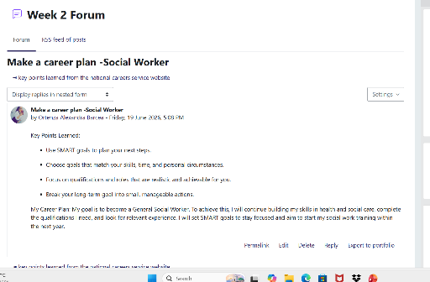
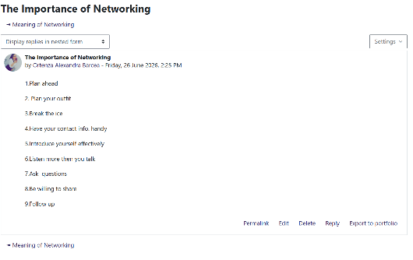

Task 4 – Reflection on Unit 4: The Pursuit of Happiness and Conclusion
Unit 4, The Pursuit of Happiness, helped me understand the importance of wellbeing, resilience, and maintaining a positive mindset in both personal and professional life. Throughout the lectures and online activities, I learned that happiness is influenced by many factors, including physical health, mental wellbeing, relationships, personal achievements, and work-life balance.
The unit encouraged me to reflect on how maintaining my own wellbeing is essential for providing effective support to others, particularly in my future career as a social worker.One of the key topics covered during the unit was wellbeing. I learned that wellbeing is more than simply being free from illness; it includes emotional, psychological, and social health. During the online learning activities, I reflected on the habits that contribute to my own wellbeing and identified areas where I could improve, such as managing stress and maintaining a healthy balance between my studies and personal life.
According to the World Health Organization (2022), good mental health and wellbeing enable individuals to cope with everyday challenges, work productively, and contribute positively to their communities. This learning helped me recognise that caring for my own wellbeing is an important part of becoming an effective health and social care professional.
Health Organization (2022), good mental health and wellbeing enable individuals to cope with everyday challenges, work productively, and contribute positively to their communities. This learning helped me recognise that caring for my own wellbeing is an important part ofbecoming an effective health and social care professional. adversity and continue developing despite challenges.
Reflecting on this concept has encouraged me to develop healthy coping strategies and seek support when needed, allowing me to remain effective in challenging situations.The unit also highlighted the importance of positive psychology and developing a growth mindset. I learned that focusing on strengths, continuous learning, and personal development can improve wellbeing and motivation.
These ideas encouraged me to appreciate my achievements while recognising that personal and professional growth is an ongoing process. As a future social worker, I believe maintaining a positive attitude will help me build trusting relationships with service users and remain committed to providing compassionate and ethical support.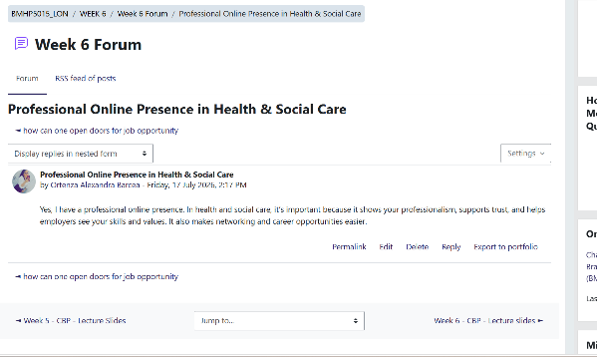
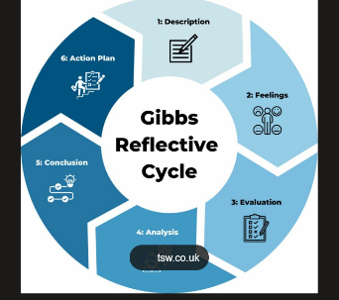

Conclusion
Overall, this module has significantly improved my understanding of personal development, employability, and professional practice within health and social care. Through the four units, I developed a greater awareness of personal branding, global perspectives, recognising opportunities, and the importance of wellbeing and resilience. The lectures, online activities, and reflective exercises have strengthened my confidence, communication skills, and self-awareness while encouraging me to become a lifelong learner.
These experiences have also reinforced my commitment to pursuing a career in social work, where empathy, professionalism, cultural awareness, and reflective practice are essential. I believe the knowledge and skills gained throughout this module will support both my academic success and my future career, enabling me to provide high-quality, person-centred support to individuals and communities.

REFERENCES
Campinha-Bacote, J. (2002). The process of cultural competence in the delivery of healthcare services: A model of care. Journal of Transcultural Nursing, 13(3), 181–184. https://doi.org/10.1177/10459602013003003
Fletcher, D., & Sarkar, M. (2013). Psychological resilience: A review and critique of definitions, concepts, and theory. European Psychologist, 18(1), 12–23. https://doi.org/10.1027/1016-9040/a000124
Gibbs, G. (1988). Learning by doing: A guide to teaching and learning methods. Oxford Polytechnic.
Goleman, D. (1998). Working with emotional intelligence. Bantam Books.
Labrecque, L. I., Markos, E., & Milne, G. R. (2011). Online personal branding: Processes, challenges, and implications. Journal of Interactive Marketing, 25(1), 37–50. https://doi.org/10.1016/j.intmar.2010.09.002
Montoya, P., & Vandehey, T. (2008). The brand called you: Make your business stand out in a crowded marketplace. McGraw-Hill.
Peters, T. (1997, August 31). The brand called you. Fast Company. https://www.fastcompany.com/28905/brand-called-you
Super, D. E. (1990). A life-span, life-space approach to career development. In D. Brown & L. Brooks (Eds.), Career choice and development (2nd ed., pp. 197–261). Jossey-Bass.
World Health Organization. (2021). Global strategy on human resources for health: Workforce 2030. https://www.who.int
World Health Organization. (2022). World mental health report: Transforming mental health for all. https://www.who.int

