Student Name: Muhammad Waqas Akram
Student ID: 2429948
Module: Scripting and Programming Concepts
Module Code: ACCA5036
Submission Date: 17 August 2026
GiThub Repo Link: https://github.com/muhammadwaqasakram07-ctrl/smart-device-manager
Total words COunt: 4700

SMART DEVICE MANAGER
Contents
1. Analysis 5
1.1 Introduction 5
1.2 Requirements Analysis 5
2. Software Design and Development 6
2.1 Development Methodology / SDLC 6
2.2 Flowchart 6
2.3 Pseudocode 8
2.4 Data Structures 8
2.5 Variables 9
2.6 Programming Constructs 10
a. Selection 10
b. Iteration 10
c. Functions 10
d. Input Validation 11
e. Membership Operators and Dictionary Access 11
f. Formatted Output 11
2.7 Python Modules and Libraries 11
2.8 Source Code Listing 12
3. Testing and Debugging 12
3.1 Importance of Testing 13
3.2 Syntax Errors, Logical Errors and Debugging 14
3.3 Test Cases and Results 15
3.4 Testing Evidence and Commentary 16
a. Valid Device Addition 16
b. Duplicate Device Validation 16
c. Empty Input Validation 17
d. Viewing Registered Devices 18
e. Updating Device Status 18
f. Device Search 19
g. Final System Verification 20
4. Evaluation 21
4.1 Challenges Faced 21
4.2 Future Improvements 22
4.3 Self Reflection 23
5. Conclusion 24
References 25
Appendix A: Pseudocode 26
Appendix B: Main Code of Application 31
Appendix C: Streamlit Interface Code 39

List of Figures
Figure 1. Flowchart of the Smart Device Manager (Made with help of LLM) 3
Figure 2. Nested Dictionary of the Application 4
Figure 3. Device status changed to maintenance from offline 9
Figure 4. View Devices response when no device records are available 10
Figure 5. Successful addition of a new smart device 12
Figure 6. Duplicate-device validation 13
Figure 7. Validation of an empty device name 13
Figure 8. Validation of an empty device location 14
Figure 9. Display of all registered smart devices 14
Figure 10. Updating a device to Under Maintenance 15
Figure 11. Updating a device status to Online 15
Figure 12. Successful device search 16
Figure 13. Case-insensitive device search 16
Figure 14. Final Smart Device Manager dashboard after testing 17

List of Tables
Table 1. List of variables used in the application 6
Table 2. Test cases performed to check device functionality 12

1. Analysis

1.1 Introduction
Bright Minds Academy is implementing smart technologies like smart lights, smart thermostat, smart projector in the classrooms to enable a modern learning environment. Currently these devices are manually managed, and it is challenging for staff to keep a proper track on the number of devices available, their location, and if they are online, offline or maintenance. The more are the devices the more it is tedious for the staff members to go into various rooms to check their status or make a guess as to where and what a device is in a room. The Smart Device Manager is thus intended to be a user-friendly centralized application that can be used to record, update and retrieve information about devices used in the classrooms.
Chanda et al. [1] detected several usability challenges with the mainstream smart-home IoT devices, such as the complexity and un-intuitiveness in setting up the devices. Their results confirm that using a simple, intuitive interface is beneficial to avoid confusion among users. Likewise, Stanelytė et al. [2] highlight the need for user-centric smart home management systems that are more user-friendly and require less technical expertise. As a result, the proposed system is designed to be simple, easy to operate and provides relevant feedback to staff.

1.2 Requirements Analysis
The main user of the System is a staff person in Bright Minds Academy. The first functional requirement is to add a new smart device by entering its name and classroom location. Storing each device with its status in a Python dictionary. When a device registers for the first time, it is set to “Offline” on default. Validation is performed to avoid invalid device names, invalid locations and duplicate entries, ensuring that the information stored is unique.
The second functional requirement is device status management. Staff should have options on how to set the device status to one of three allowed statuses: Online, Offline or Under Maintenance. The application shall only accept a valid status, and it shall return an appropriate response if a status change has been achieved.
The third one is the capability of viewing all the registered devices. The system should show the device, where the device is and the status of the device so that staff have immediate information on the status of any devices in each classroom. If no device has been registered, then an informational message should be shown not the application.
Fourth, there must be a device search capability. Staff should be able to type in the device name and get the status and location of the device in the system. Case-insensitive searching can also be done for ease of use so that a valid device won't be missed from the results if the letters are capitalised differently. If no matching device is found, the system should show an obvious error message.
In addition to these functional requirements, the solution should be user-friendly, responsive and easy to use. As functions are the way to isolate operations, a dictionary provides low-encapsulation data storage without relying on a database. This project will not involve real-time communication with physical IoT devices and automated device control, leaving the solution relevant in the current device-management requirements for Bright Minds Academy.

2. Software Design and Development

2.1 Development Methodology / SDLC
The Smart Device Manager is designed to be built step-by-step and in segments. All the above functions were not implemented in a single run but rather broken down into smaller functions for displaying the menu, adding devices, updating device status, viewing registered devices, and searching for a specific device. Program is kept intuitive for staff member to understand, test and maintain due to the well-defined functions. This is the type of modularity that software should be partitioned into modules with specified functions, to make it more comprehensible and flexible [3].
A prototype was first built that runs from the command-line. Once core functionality and validation were tested, a little Streamlit interface was created, and it was more user-friendly method of interacting with the same concepts of device management. The basic functions remained the same: Devices are stored in memory; There is no external databases required; Staff can add, view, search and update devices.

2.2 Flowchart
The flowchart is a representation of the overall control logic of the Smart Device Manager that includes its main menu and validation decisions as well as possible flow through each operation.
The Smart Device Manager processing is summarized in Figure 1, which covers all the processing from the initialisation of the system to the operation of the device and the termination of the program.
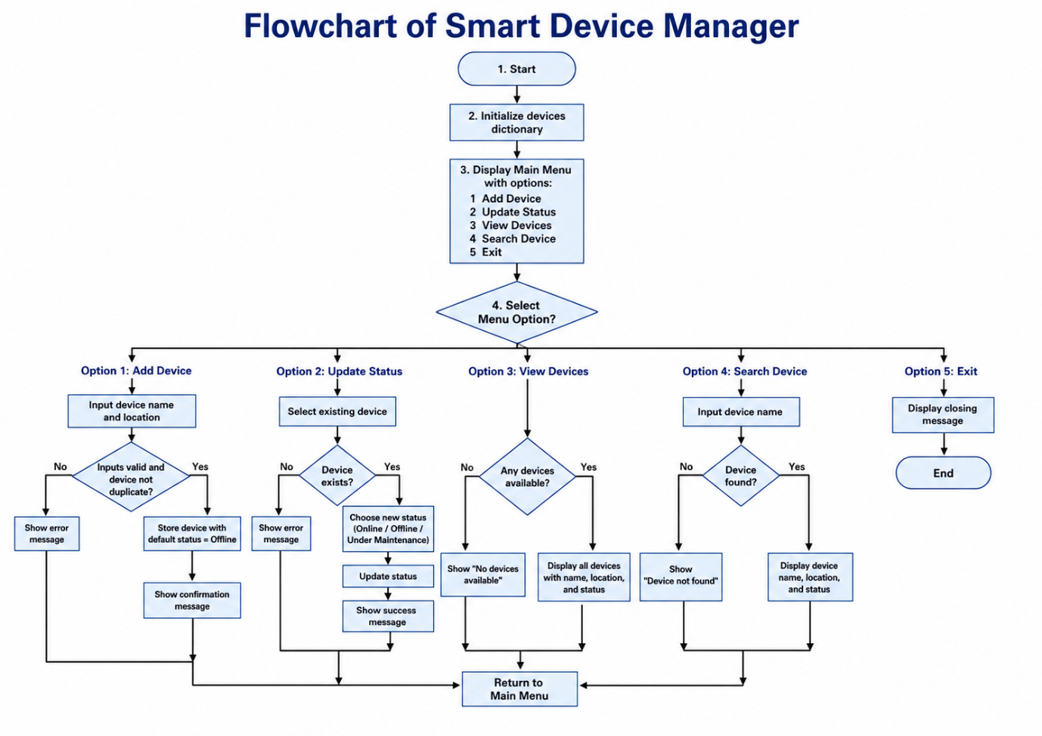
Figure 1. Flowchart of the Smart Device Manager (Made with help of LLM)
The process starts with creating an empty device dictionary and displaying the main menu. The user can then choose one of five operations: Add Device, Update Status, View Devices, Search Device or Exit.
If Add Device is selected, the program asks for the name and location of the device. Validation takes place prior to saving of the record. Blank values are rejected, duplicate device names are rejected, valid devices are stored with status Offline.
To get information about the update status, the device must be registered as an existing device. If the device is available, the user can switch the device to Online, Offline or Under Maintenance. If a device is invalid or does not exist, then it will cause a proper error message.
The View Devices branch will verify the new added or registered devices. The names of the records, their location and their status are shown if a record exists. If not, the system will say that there are no devices available.
The Search Device branch takes a name of a device and tries to find it in the dictionary. If the search is successful, the corresponding location and status are shown, if the search is unsuccessful, a clear “Device not found” message is displayed.
If not Exit, the control returns to the main menu. The 'Exit' command is used to end the command-line version of the application.

2.3 Pseudocode
The Pseudocode of the project is given in Appendix A
Each major operation in the pseudocode is written in a separate procedure. This mirrors the final Python implementation and reduces the amount of logic contained in the main control loop. It also enables each operation to be tested separately.

2.4 Data Structures
The main data structure selected for the project is a Python dictionary. Python dictionaries represent the information in key-value pairs and are appropriate if an associated record is desired, where a unique key can be used to find the record [4].
A nested dictionary was used because each device requires several related attributes. The structure is conceptually represented as follows in Figure 2:
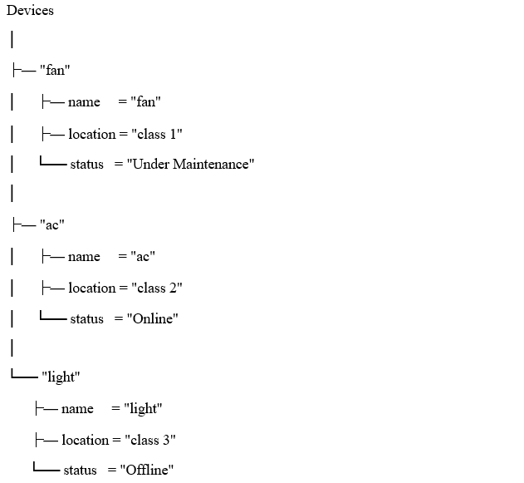
Figure 2. Nested Dictionary of the Application
The outer dictionary is keyed by the lower-case device name, while the inner dictionary holds the original device name, location and status.
A dictionary was chosen over a list because the application often must find a device by its name. Normalised device names are used as keys, so duplicate checking, searching and status updating is easy. It also eliminates the need to scroll through each item in a list to make a direct look up.
Also, the use of .lower() in the construction of the key enables case-insensitive operations. For instance, LIGHT, Light and light are all searches for the same stored device.
Data is only stored in the application when it is running. No persistent storage (e.g., SQLite, remote database) was used, as this was not needed for the current scope.

2.5 Variables
The main variables used in the command-line implementation are shown below in Table 1.
Table 1. List of variables used in the application
Variable | Data Type | Purpose
devices | Dictionary | Stores all device records
choice | String | Stores the user's selected main-menu option
device_name | String | Stores the device name entered by the user
device_key | String | Stores a lower-case version of the device name for lookup
location | String | Stores the room or classroom of the device
status | String | Stores the initial device status
status_choice | String | Stores the selected status-menu option
new_status | String | Stores the new status before updating the record
search_name | String | Stores the device name entered during a search
search_key | String | Stores the normalised search value
device | Dictionary | References an individual device record
number | Integer | Provides sequential numbering when displaying devices

Variable names were chosen that were meaningful rather than shortened identifiers so that the intent of each value is more evident when reading or maintaining the program.
Variables used in the Streamlit implementation are page, selected_name, selected_key, device_options and rows, which are used to control navigation, selection and presentation of the table.

2.6 Programming Constructs
Several fundamental programming constructs were used in the implementation.

Selection
The application makes decisions by using the if, elif and else statements. These conditions decide on what main-menu function to run, to check if a device exists, to check if an input is valid or not, and which status to give.
For example:
if status_choice == "1":
new_status = "Online"
elif status_choice == "2":
new_status = "Offline"
elif status_choice == "3":
new_status = "Under Maintenance"
This construct ensures that only one of the permitted statuses is selected.

Iteration
A while loop keeps the command-line application running until the user chooses Exit. Extra for loops are added in for validation, to avoid the application from ending if invalid data is entered.
view_devices() uses a for loop to iterate through all the devices stored. These constructs are part of Python's language syntax as defined by the Python Software Foundation [4].

Functions
User-defined functions were created to divide the program into manageable units:
- get_non_empty_input()
- display_menu()
- add_device()
- update_device_status()
- view_devices()
- search_device()
- main()
Each function carries out a specific function. This lessens duplication and promotes modular program design. Modular design is beneficial because it makes it easier to modify individual parts of a system and makes the program more comprehensible [3].

Input Validation
The .strip() method was used to strip out unwanted leading and trailing spaces. Empty strings are rejected, duplicate dictionary keys are rejected, and status values are restricted to the three supported choices.
The program also verifies first if a device exists before searching or attempting an update. These checks are performed to avoid invalid operations and generate a message of information rather than an unexpected failure of the program.

Membership Operators and Dictionary Access
The in and not in operators are used for dictionary membership checking:
if device_key in devices:
and:
if device_key not in devices:
This is used for duplicate detection and device existence checks.

Formatted Output
Python f-strings are used to combine stored values with descriptive output:
print(f"Device Name : {device['name']}")
This makes the displayed information easier to read and keeps the formatting concise.

2.7 Python Modules and Libraries
The main command line implementation is designed to avoid external Python libraries. Standard Python features like dictionaries, functions, loops, conditional statements and string operations can be implement through required functionality. This application is accomplished using the built-in high-level data structures and control-flow mechanisms available in Python [4].
A new GUI was created with Streamlit. Because Streamlit makes it possible to present Interactive Python apps in a browser without building a separate HTML, CSS and JavaScript front end.
The library is imported as:
- import streamlit as st
- The interface uses Streamlit components including:
- st.sidebar.radio()
- st.text_input()
- st.selectbox()
- st.button()
- st.form()
- st.metric()
- st.dataframe()
- st.success()
- st.error()
The Streamlit application also uses:
- st.session_state
to store the devices dictionary while the browser is running. This is required as Streamlit will normally rerun the Python script when users interact with widgets. To retain variables between these reruns, Session State offers a way to keep the variables alive during a user's session [5].
The project is therefore designed to be simple in terms of underlying data model and to have a command-line implementation and optionally a web-based GUI.

2.8 Source Code Listing
Project source code is listed in Appendix B
Functions, Loops, Selection Statement, Nested Dictionaries, Validation and Formatted Output are demonstrated in the listing. The entire project, complete with the new streamlit_app.py interface, is also kept up-to-date in the project's GitHub repository. The Streamlit source code is included in the Appendix C as it has been added as an additional interface layer and is much longer than the core command line implementation.

3. Testing and Debugging
The development of the application involving Smart Device Manager was characterized by the testing and debugging process, as the application receives user input and alters the information about the devices stored. A program can run successfully but return incorrect results, if its conditions or its data handling or data validation logic are wrong. Software testing can thus be used to verify that a program performs as expected and that it responds to any unexpected input in ways that are satisfactory. According to Bertolino [7], software testing is a big validation activity which is applied throughout software development to evaluate the behaviour of the software and to find failures of the program .
The primary reason for using functional testing for this project was to ensure that each user-facing requirement was functioning properly. The testing was carried out on adding devices, to ensure that no duplicate devices were added, to validate empty input, to display stored devices, to update device status, and to identify existing and non-existing devices. Valid and invalid inputs were incorporated as these would not prove the working of the validation mechanisms if only valid inputs were tested. Basili and Selby [6] demonstrate that functional testing is a worthwhile technique for fault detection and for the detection of faults related to program behaviour and program control.

3.1 Importance of Testing
Testing gives confidence that the developed solution fulfils its functional requirements before submitting or using it by staff. In the Smart Device Manager, incorrect behaviour could result in duplicate device records, missing locations, invalid status values or incorrect search results. These issues would make it less useful to the system as staff would rely on information within the system to understand where and how classroom devices are situated.
Testing was thus done once the main functionality has been developed. The first tests were conducted on individual operations and then conducted together as an end-to-end workflow. For example, a device was added with initial Offline status, the device list was displayed, the status was updated to another, and the status was searched to confirm that the status had been changed correctly. Figure 3 shows this status update behaviour.
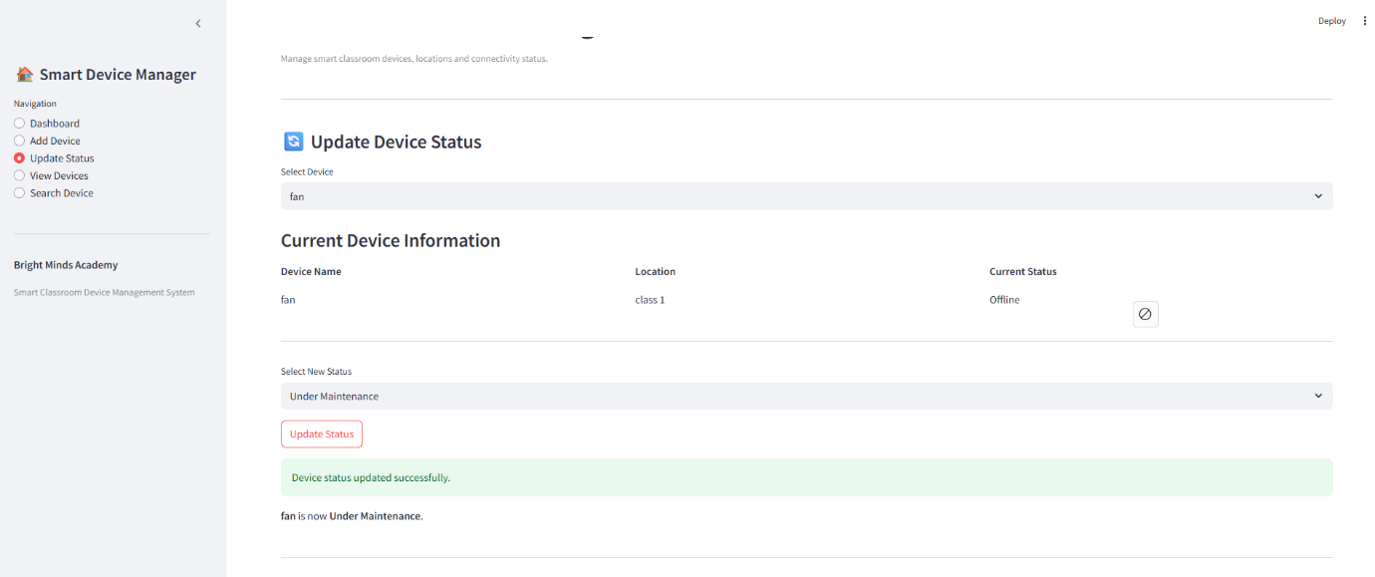
Figure 3. Device status changed to maintenance from offline
Testing also demonstrated that the application responds appropriately when no data is available.
Figure 4 illustrates the behaviour of the device-list function when the system contains no registered devices.
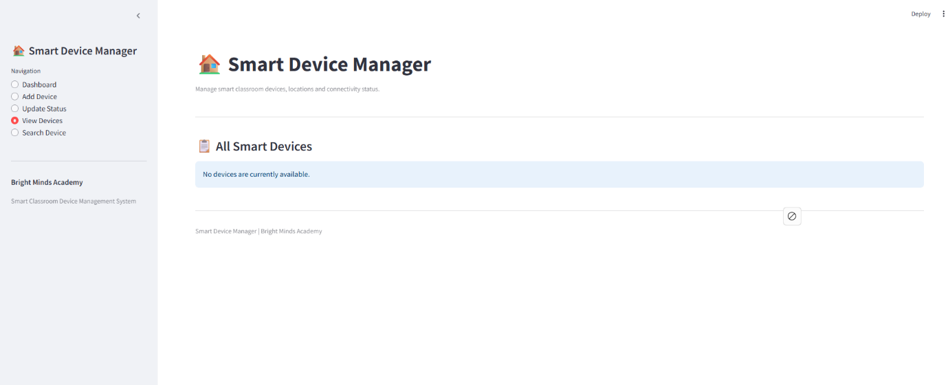
Figure 4. View Devices response when no device records are available
The result confirms that the application does not fail when the dictionary is empty. Instead, an informative message is presented to the user.

3.2 Syntax Errors, Logical Errors and Debugging
A syntax error occurs when Python code does not follow the grammatical rules of the programming language. Examples include a missing colon after an if statement, incorrect indentation, an unmatched quotation mark or an unclosed parenthesis. Syntax errors normally prevent the program from executing. During development, these errors can be identified from the Python interpreter message and the indicated line number. The affected statement can then be corrected before the program is executed again.
A logical error is different because the program may run without producing an exception but give an incorrect result. For example, if the duplicate-device condition were reversed, the program could reject new devices while accepting duplicates. Likewise, if a device name is stored as a capitalized device name and isn't capitalized when searching for the device with LIGHT, LIGHT will not match the device. The logical errors have been detected by comparing the actual output for each test case with the expected output which is predefined.
Validation was used as a preventive debugging technique. Before data are stored, the names and locations of devices are checked; no duplicate dictionary keys are accepted; the predefined device statuses are the only ones available for use by the user. These controls help to minimize the chances of adding invalid data to the application.

3.3 Test Cases and Results
The following test cases (Table 2) were applied to the final Streamlit implementation. They include normal inputs, invalid inputs and edge cases.
Table 2. Test cases performed to check device functionality
Test ID | Function Tested | Test Input / Action | Expected Result | Actual Result | Status
TC01 | Empty system | Open Dashboard before adding devices | All counters display 0 | All counters displayed 0 | Pass
TC02 | View Devices | View devices when dictionary is empty | Informative no-device message | Correct message displayed | Pass
TC03 | Add Device | fan, class 1 | Device added with Offline status | Device added successfully | Pass
TC04 | Add Device | ac, class 2 | Device added with Offline status | Device added successfully | Pass
TC05 | Add Device | light, class 3 | Device added with Offline status | Device added successfully | Pass
TC06 | Duplicate validation | Add ac again | Duplicate rejected | “This device already exists” displayed | Pass
TC07 | Name validation | Blank device name | Input rejected | “Device name cannot be empty” displayed | Pass
TC08 | Location validation | fan with blank location | Input rejected | “Location cannot be empty” displayed | Pass
TC09 | View Devices | View after three records added | Three devices displayed | Three correct records displayed | Pass
TC10 | Update Status | Change fan to Under Maintenance | Status updated | Status updated successfully | Pass
TC11 | Update Status | Change ac to Online | Status updated | Status updated successfully | Pass
TC12 | Search | Search fan | Correct device details displayed | Device found with updated status | Pass
TC13 | Case-insensitive Search | Search LIGHT | Stored light record found | Correct record displayed | Pass
TC14 | Invalid Search | Search camera | Device-not-found message | Correct error displayed | Pass
TC15 | Dashboard | View after status updates | Total 3; Online 1; Offline 1; Maintenance 1 | Correct values displayed | Pass

The test results show that all planned cases passed and that both normal operations and validation rules behaved as expected.

3.4 Testing Evidence and Commentary

Valid Device Addition
Figure 5 shows a successful device-registration test in which fan was added in class 1.
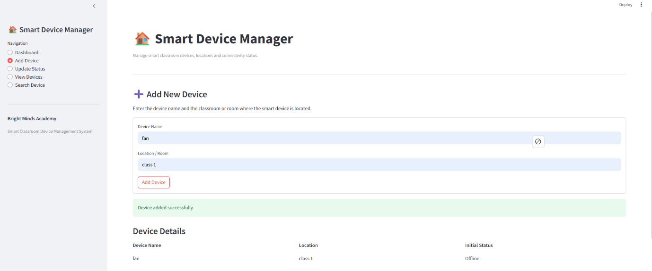
Figure 5. Successful addition of a new smart device
The screenshot demonstrates that a valid device name and location are accepted and that a newly created device is automatically assigned the initial status Offline.

Duplicate Device Validation
Figure 6 demonstrates the validation applied when an existing device name is entered again.
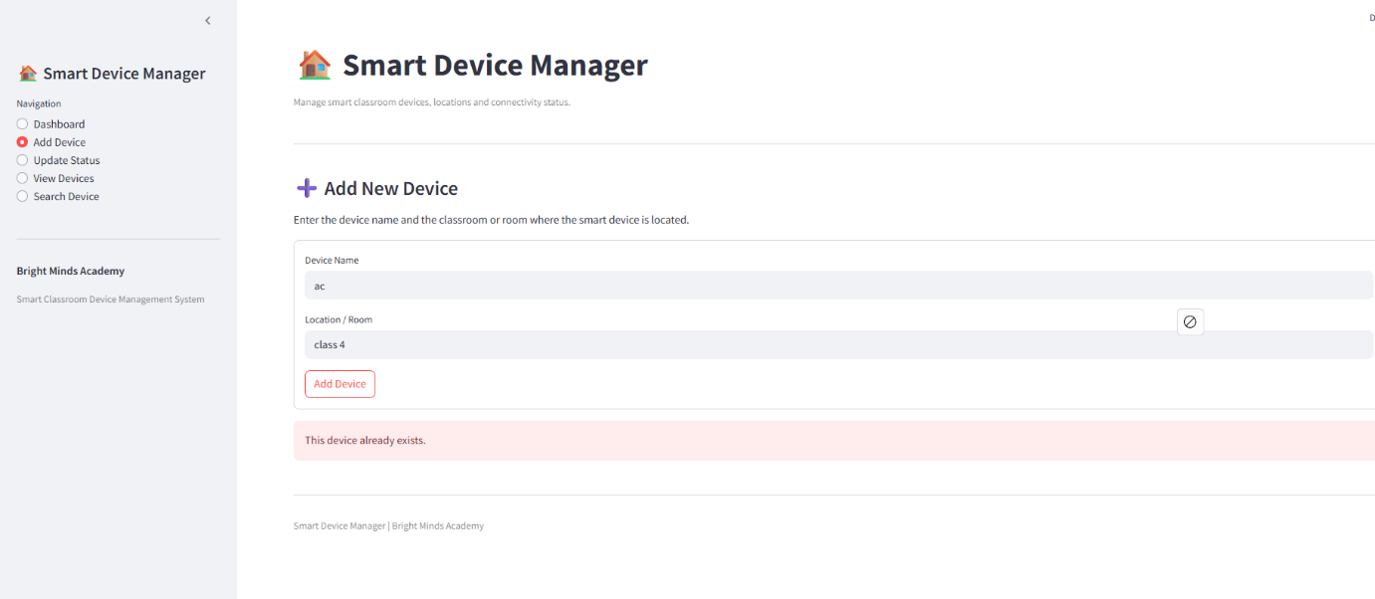
Figure 6. Duplicate-device validation
The result confirms that duplicate dictionary keys are prevented even if a different location is entered for the repeated device.

Empty Input Validation
Figures 7 and 8 show two important negative test cases.
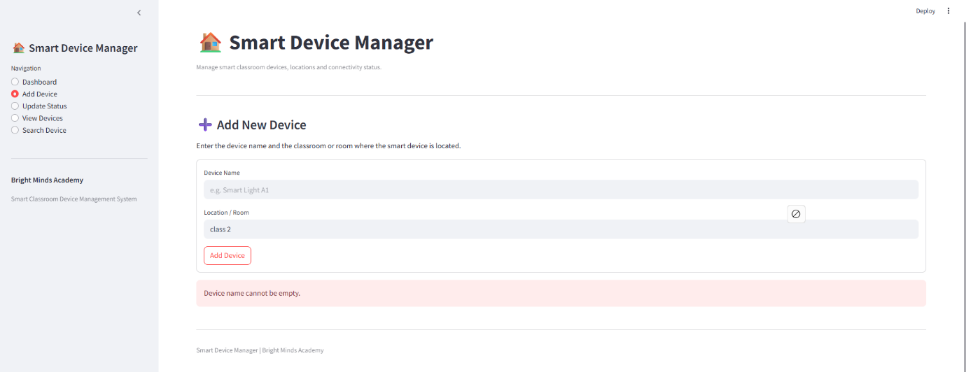
Figure 7. Validation of an empty device name
The application rejects the operation when no device name is supplied rather than creating an incomplete record.
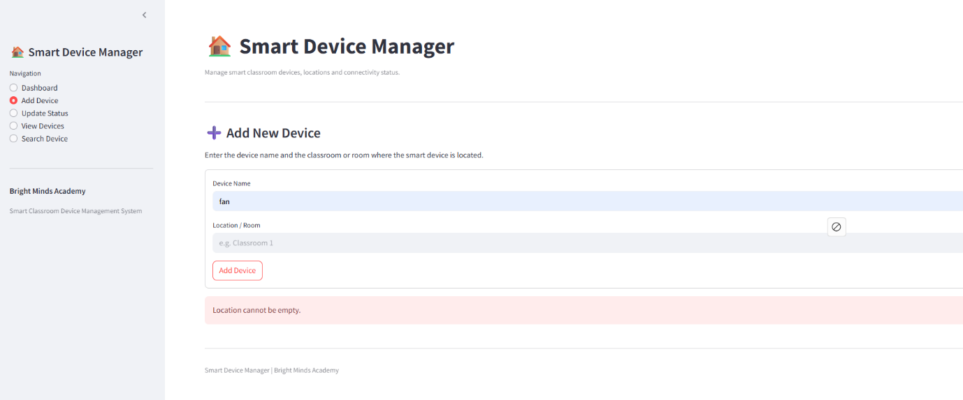
Figure 8. Validation of an empty device location
This test demonstrates that a device cannot be stored without its associated room or classroom location.

Viewing Registered Devices
Figure 9 shows the system after three valid devices were added.
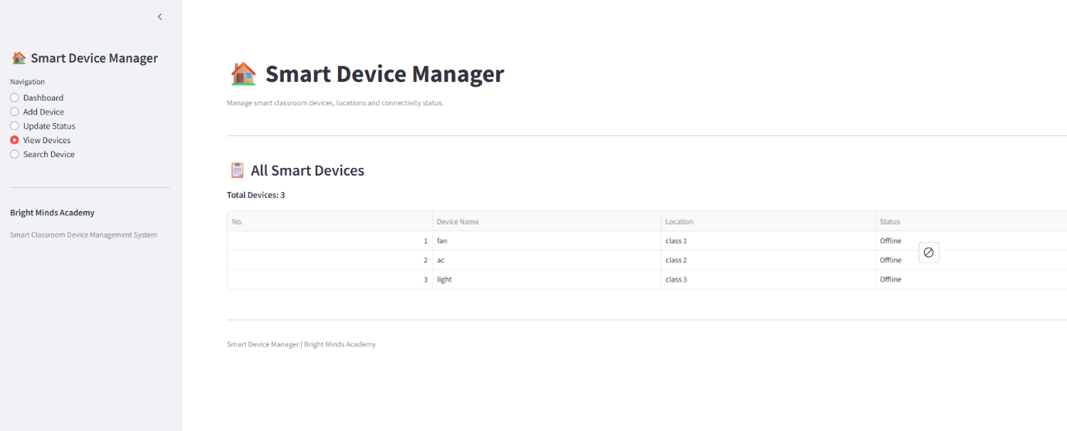
Figure 9. Display of all registered smart devices
The table correctly displays three records together with their names, locations and current statuses. At this stage, all three devices initially appear as Offline.

Updating Device Status
Figure 10 shows the successful implementation of the status change of the device named as “fan”
Figure 10. Updating a device to Under Maintenance
Figure 10 shows that the user can choose a registered device and switch it from Offline to Under Maintenance mode.
Figure 11 shows the status update of the second device named as “ac”.
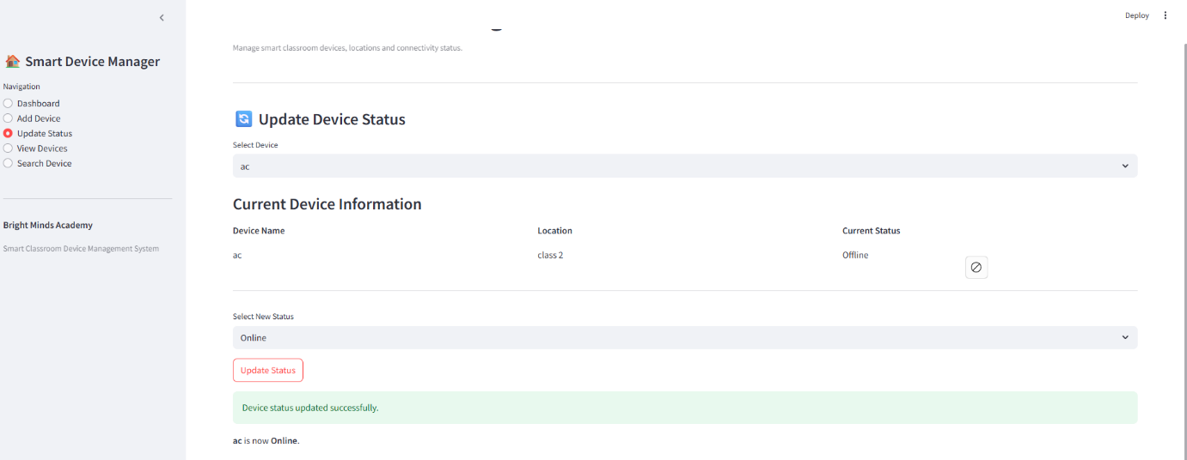
Figure 11. Updating a device status to Online
The ac record was successfully changed from Offline to Online. As seen in Figures 10 and 11, the application provides support for the required status categories.

Device Search
Figure 12 demonstrates a successful search for fan.
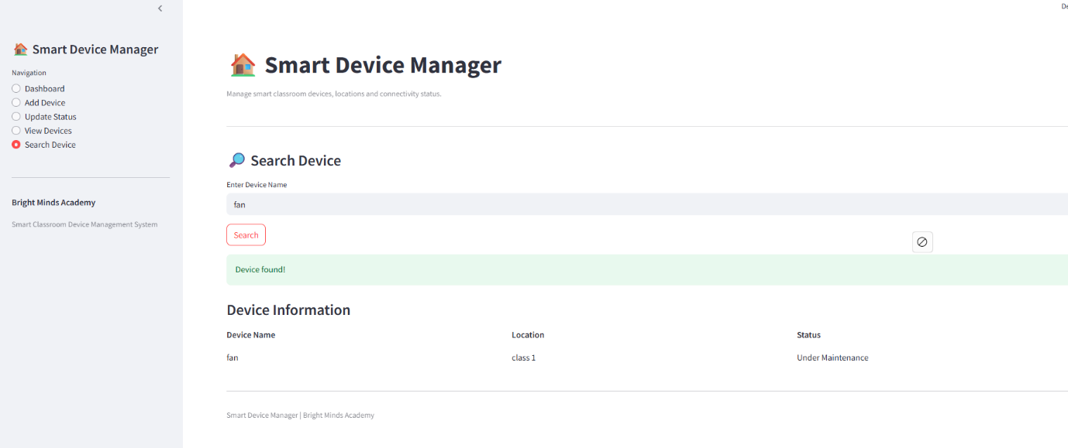
Figure 12. Successful device search
The returned information includes the correct location and the updated Under Maintenance status, demonstrating that the search function accesses the current stored record rather than the original value.
Figure 13 demonstrates the additional case-insensitive search test.
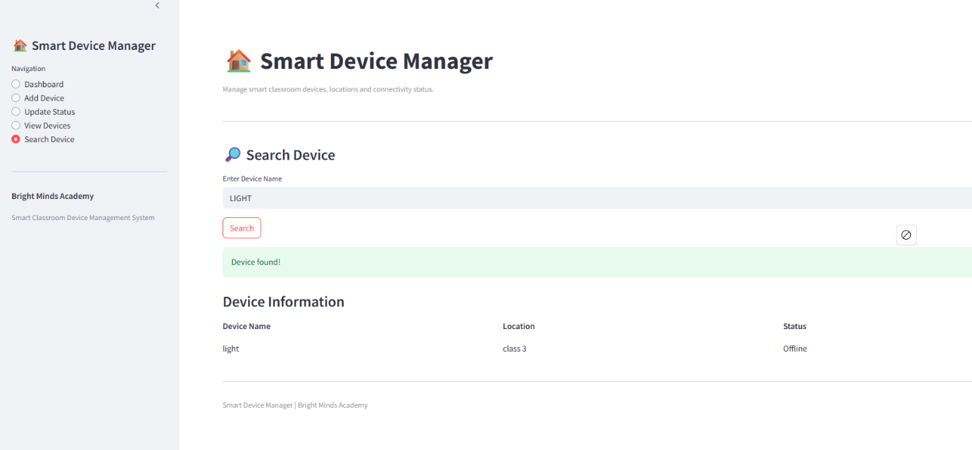
Figure 13. Case-insensitive device search
Although LIGHT was entered using uppercase characters, the stored light device was retrieved successfully. This confirms that device names are normalised before lookup..

Final System Verification
Figure 14 presents the final dashboard after all status-update tests were completed.
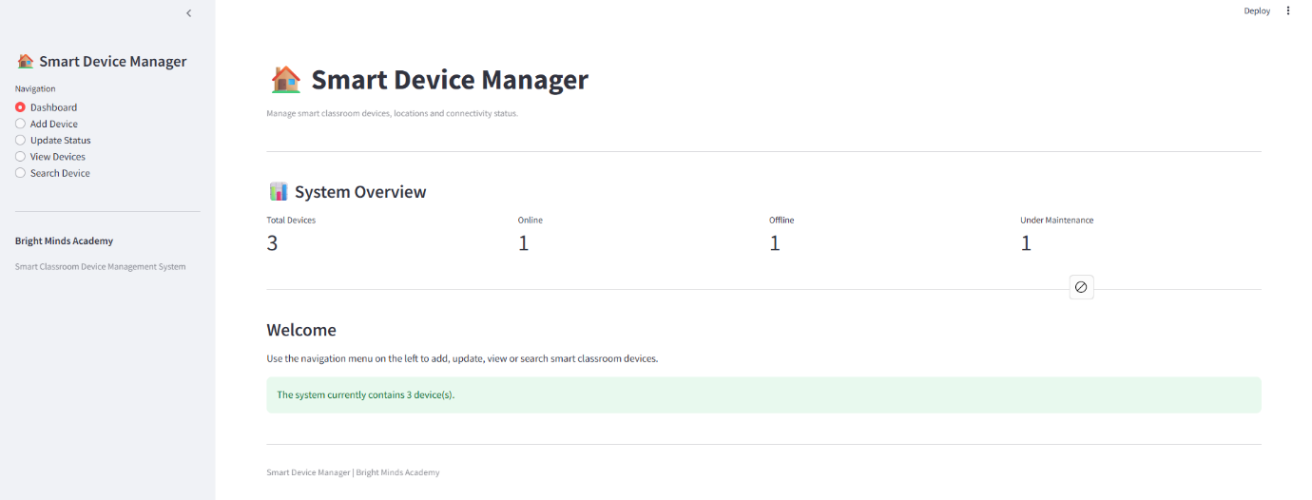
Figure 14. Final Smart Device Manager dashboard after testing
An end-to-end verification is an added advantage on the dashboard. There are three devices registered that are Online, Offline and Under Maintenance. The counters are thus matched correctly with the data that has been stored.
In general, the test outcomes show that the Smart Device Manager meets its primary functional needs and reacts correctly to improper and edge case inputs. Validation, clear error messages and systematic functional testing decrease the risk of incorrect device data being stored and/or displayed.

4. Evaluation
The project's primary goal of managing the smart classroom devices at Bright Minds Academy through a simple system was accomplished. The final solution allows users to add new devices, store their locations, update their operational status, view all registered devices and search for a particular device by name. In addition, the original command-line application was enhanced by a Streamlit interface, making it more user-friendly. The necessary functions were tested with valid and invalid values and were found to be correct. The development process also identified some difficulties and opportunities for improvement in the system in the future.

4.1 Challenges Faced
The most important problem was to design an appropriate structure that can store information about the device. These smart devices needed multiple different values: their name, location and status. A nested Python dictionary was chosen as the data structure, as the values could be collected into one record with the normalised device name being used as the unique key. Searching and updating in this structure were relatively easy. One challenge with this was that duplicate devices were not being entered in different capitalisations. For instance, Light, LIGHT and light might have been three distinct records. This has been addressed by changing the name of the device to lower case to use as a dictionary key.
Input validation was also a significant issue. Initial versions of the program had to be designed to prevent users from entering blank names and locations, and to prevent the program from ending abruptly after an invalid menu choice. So, a function was created that was reusable, and it asked for input as many times as necessary until the user provided a value that was not empty. A duplicate-device check, as well as predefined status options, were also added. This helped to get better data consistency and ensured data usability.
Careful handling was also necessary for the implementation of the status-management function. Only three statuses are allowed on a device: Online, Offline and Under Maintenance. It was then necessary to make sure that other values were not stored in the program. The same approach was taken for the command-line implementation, and if the user selected an invalid status, then they were prompted again.
Another hurdle was presented when the Streamlit UI library was released. The script would be rerun on every interaction with the widgets on the Streamlit interface, and a normal dictionary would lose its content in between. This was solved by storing the device dictionary in st.session_state to make the records available during the current browser session.
Also, a compatibility problem was observed in View Devices. The first time it was run, it had the attribute width="stretch" in the st.dataframe() function, but the version of Streamlit installed was unable to accept this argument and generated runtime error. The traceback was analysed to locate the offending statement, and the incompatible argument was deleted. After the change, the table displayed correctly. This experience proved the need to test applications in the actual software environment where they will run.
These challenges were helpful because they made it necessary to improve the program in stages, not just the simplest successful implementation.

4.2 Future Improvements
The system developed for this project meets the requirements for the project; however, there are some improvements that can be made for the system to be more practical in the real world.
The biggest restriction is that information about the devices is only kept in memory. For the command-line version, all records will be gone if the application closes. Information is only saved during the current session in the Streamlit version. Persistent storage (e.g. SQLite, MySQL or other DB system) could then be used for a future version. This would ensure that the device information is retained even after the system restarts and would enable more records to be held.
An additional improvement would be to assign unique device ID for each device. The current solution uses the device name as the identifier. Duplicate validation will minimize issues, but two devices in different classrooms may have the same or similar names. It would be better to have a unique ID for each physical device.
Other attributes of the device may also be stored. For instance, the following information can be included: Device Type, Device Maker, Install Date, Serial number, Last Used Date and Maintenance Notes. These fields would give staff a better whole-equipment management system, just as they would have a location and connection status field.
One potential enhancement is editing device information or deleting devices. The current application enables adding, searching, viewing and updating the status, but it does not offer any support functionality for renaming a device, changing the room location and deleting a device that has reached the end of its life.
Streamlit dashboard can also be enhanced with filtering and reporting capabilities. Staff could be able to filter by room, type or status and charts could be used to give a visual overview of the number of devices online, offline or under maintenance.
The system could eventually be connected to real IoT devices if a more advanced implementation is required. The software can read the live connectivity information from device APIs or an IoT platform instead of manually changing a device from Online to Offline. Automated alerts could then be generated when key classroom equipment is unavailable.
Lastly, rosters and authentication could be implemented if the system were to be utilized by multiple members of staff. For instance, normal users could see device information, and authorised administrators can add/remove/modify entries.

4.3 Self Reflection
This project helped to understand the concept of combining the concepts of basic programming to solve a practical problem. The complete application was split into smaller operations like adding device, searching, viewing, updating devices, etc. before development. This facilitated the overall development process and showed the effectiveness of problem decomposition.
The project helped to gain a deeper knowledge of using Python dictionaries in this project. It provides learning on how to use the 'dictionary' to store and manipulate structured data, and how the keys of a dictionary can be used to efficiently access and modify records. It also provided hands-on experience with if/elif/else statements, for/while loops, functions and input validation.
An important learning outcome was testing. Firstly, it was a simple matter to concentrate on whether valid input gave the required output. Duplicated devices, empty fields, non-existent search and empty system state tests however proved that bad inputs are equally critical in assessing the quality of software. The troubleshooting of the Streamlit dataframe error also helped building trust in reading error messages and finding the problem to a specific statement.
Creating the Streamlit application interface provides learning about developing a console application more user-friendly. It demonstrated the separation of application logic and interface design without losing the same data concepts.
In general, the project gave more confidence in the planning, coding, testing and evaluation of a python application. It also emphasized that the software development process is an iterative process with the possibility of improving the solution over time by means of validation, testing and reflection.

5. Conclusion
The “Smart Device Manager” project has achieved the main objectives of Bright Minds Academy and has proven to be a straightforward and easy-to-use solution in managing smart classroom devices. Staff can add new devices to the system, record the location of the devices, change the status of the devices, view all devices and search for devices as required. Python dictionaries were used to store device information to maintain the program structure and its reliability, and functions, conditional, loops, and validation techniques were used to keep the program organised. An interface designed using Streamlit was also created to render the system more user friendly and intuitive. The test demonstrated that it can receive valid data, invalid data, and edge cases like duplicate devices, empty fields and failed search. The project was also focused on the importance of Software Design, Software Validation, Software Testing and Debugging in Software Development. The existing architecture is appropriate to the project needs, but future versions could feature persistent database storage, user authentication, and more device information and real-time IoT connectivity. In general, the project offered a concrete illustration of the practical application of basic programming concepts to a real device-management problem for a software solution.

References
[1] V. Chanda, L. Hao, and H. Schulzrinne, “From Frustration to Function: A Study on Usability Challenges in Smart Home IoT Devices,” in 2024 IEEE 21st Consumer Communications & Networking Conference (CCNC), 2024, pp. 1–6, doi: 10.1109/CCNC51664.2024.10454634.
[2] D. Stanelytė, B. Rataitė, A. Andriušis, A. Narščius, G. Kučinskas, and J. Dikun, “Development of a Solution for Smart Home Management System Selection Based on User Needs,” Applied System Innovation, vol. 8, no. 5, Art. no. 139, 2025, doi: 10.3390/asi8050139.
[3] D. L. Parnas, “On the criteria to be used in decomposing systems into modules,” Communications of the ACM, vol. 15, no. 12, pp. 1053–1058, 1972, doi: 10.1145/361598.361623.
[4] Python Software Foundation, “The Python Tutorial: Data Structures and Control Flow Tools,” Python Documentation, 2026. [Online]. Available: https://docs.python.org/3/tutorial/. [Accessed: Aug. 11, 2026].
[5] Streamlit, “Session State,” Streamlit Documentation, 2026. [Online]. Available: https://docs.streamlit.io/develop/api-reference/caching-and-state/st.session_state. [Accessed: Aug. 11, 2026].
[6] V. R. Basili and R. W. Selby, “Comparing the effectiveness of software testing strategies,” IEEE Transactions on Software Engineering, vol. SE-13, no. 12, pp. 1278–1296, 1987, doi: 10.1109/TSE.1987.232881.
[7] A. Bertolino, “Software testing research: Achievements, challenges, dreams,” in Future of Software Engineering (FOSE ’07), 2007, pp. 85–103, doi: 10.1109/FOSE.2007.25.

Appendix A: Pseudocode
The following pseudocode describes the main algorithm and the core functions of the application.
Main Program
BEGIN
CREATE empty dictionary called devices
WHILE program is running
DISPLAY main menu:
1. Add New Device
2. Update Device Status
3. View All Devices
4. Search Device
5. Exit
INPUT user choice
IF choice = "1"
CALL AddDevice
ELSE IF choice = "2"
CALL UpdateDeviceStatus
ELSE IF choice = "3"
CALL ViewDevices
ELSE IF choice = "4"
CALL SearchDevice
ELSE IF choice = "5"
DISPLAY closing message
EXIT loop
ELSE
DISPLAY invalid menu choice message
END WHILE
END
Add Device
PROCEDURE AddDevice
INPUT device name
WHILE device name is empty
DISPLAY error message
INPUT device name again
END WHILE
CONVERT device name to lowercase key
IF device key already exists in devices
DISPLAY duplicate device error
RETURN
END IF
INPUT device location
WHILE location is empty
DISPLAY error message
INPUT location again
END WHILE
SET status = "Offline"
STORE:
original device name
location
status
IN devices dictionary using lowercase device key
DISPLAY success message
END PROCEDURE
Update Device Status
PROCEDURE UpdateDeviceStatus
IF devices dictionary is empty
DISPLAY "No devices available to update"
RETURN
END IF
INPUT device name
CONVERT device name to lowercase key
IF device key does not exist
DISPLAY "Device not found"
RETURN
END IF
DISPLAY current device information
REPEAT
DISPLAY:
1. Online
2. Offline
3. Under Maintenance
INPUT status choice
IF status choice = "1"
SET new status = "Online"
ELSE IF status choice = "2"
SET new status = "Offline"
ELSE IF status choice = "3"
SET new status = "Under Maintenance"
ELSE
DISPLAY invalid status message
UNTIL valid status has been selected
UPDATE device status
DISPLAY success message
END PROCEDURE
View Devices
PROCEDURE ViewDevices
IF devices dictionary is empty
DISPLAY "No devices are currently available"
RETURN
END IF
DISPLAY total number of devices
FOR EACH device IN devices
DISPLAY device number
DISPLAY device name
DISPLAY location
DISPLAY status
END FOR
END PROCEDURE
Search Device
PROCEDURE SearchDevice
IF devices dictionary is empty
DISPLAY "No devices are available to search"
RETURN
END IF
INPUT device name
WHILE device name is empty
DISPLAY error message
INPUT device name again
END WHILE
CONVERT device name to lowercase key
IF device key exists in devices
DISPLAY:
device name
location
status
ELSE
DISPLAY "Device not found"
END IF
END PROCEDURE

Appendix B: Main Code of Application
The following listing presents the main command-line implementation. Comments have been retained to explain the purpose of important sections and demonstrate the organisation of the program.
Listing 1: smart_device_manager.py
# Smart Home Device Manager
# Module: Scripting and Programming Concepts
# Module Code: ACCA5036
# =========================================================
# DATA STORAGE
# =========================================================
# Dictionary used to store all smart devices
devices = {}
# =========================================================
# INPUT VALIDATION
# =========================================================
def get_non_empty_input(prompt):
"""Ask for input until the user enters a non-empty value."""
while True:
value = input(prompt).strip()
if value:
return value
print("Error: Input cannot be empty. Please try again.")
# =========================================================
# MAIN MENU
# =========================================================
def display_menu():
"""Display the main menu."""
print("\n" + "=" * 50)
print(" SMART DEVICE MANAGER")
print("=" * 50)
print("1. Add New Device")
print("2. Update Device Status")
print("3. View All Devices")
print("4. Search Device")
print("5. Exit")
print("=" * 50)
# =========================================================
# ADD DEVICE
# =========================================================
def add_device():
"""Add a new smart device to the system."""
print("\n" + "-" * 50)
print("ADD NEW DEVICE")
print("-" * 50)
device_name = get_non_empty_input(
"Enter device name: "
)
# Lowercase key supports case-insensitive operations
device_key = device_name.lower()
# Prevent duplicate devices
if device_key in devices:
print("\nError: This device already exists.")
return
location = get_non_empty_input(
"Enter device location/room: "
)

# New devices are Offline by default
status = "Offline"
devices[device_key] = {
"name": device_name,
"location": location,
"status": status
}
print("\nDevice added successfully!")
print("-" * 50)
print(f"Device Name : {device_name}")
print(f"Location : {location}")
print(f"Status : {status}")
# =========================================================
# UPDATE DEVICE STATUS
# =========================================================
def update_device_status():
"""Update the status of an existing device."""
print("\n" + "-" * 50)
print("UPDATE DEVICE STATUS")
print("-" * 50)
if not devices:
print("No devices are currently available to update.")
return
device_name = get_non_empty_input(
"Enter device name to update: "
)
device_key = device_name.lower()
if device_key not in devices:
print("\nError: Device not found.")
return
device = devices[device_key]
print("\nDevice found.")
print(f"Device Name : {device['name']}")
print(f"Location : {device['location']}")
print(f"Current Status : {device['status']}")
while True:
print("\nSelect new status:")
print("1. Online")
print("2. Offline")
print("3. Under Maintenance")
status_choice = input(
"Enter your choice (1-3): "
).strip()
if status_choice == "1":
new_status = "Online"
break
elif status_choice == "2":
new_status = "Offline"
break
elif status_choice == "3":
new_status = "Under Maintenance"
break
else:
print(
"\nError: Invalid status choice. "
"Please enter 1, 2, or 3."
)

device["status"] = new_status
print("\nDevice status updated successfully!")
print("-" * 50)
print(f"Device Name : {device['name']}")
print(f"New Status : {device['status']}")
# =========================================================
# VIEW ALL DEVICES
# =========================================================
def view_devices():
"""Display every registered smart device."""
print("\n" + "-" * 50)
print("ALL SMART DEVICES")
print("-" * 50)
if not devices:
print("No devices are currently available.")
return
print(f"Total Devices: {len(devices)}")
print("-" * 50)
for number, device in enumerate(
devices.values(),
start=1
):
print(f"\nDevice #{number}")
print(f"Name : {device['name']}")
print(f"Location : {device['location']}")
print(f"Status : {device['status']}")
print("-" * 50)
# =========================================================
# SEARCH DEVICE
# =========================================================
def search_device():
"""Search for a smart device using its name."""
print("\n" + "-" * 50)
print("SEARCH DEVICE")
print("-" * 50)

if not devices:
print("No devices are currently available to search.")
return
search_name = get_non_empty_input(
"Enter device name to search: "
)
search_key = search_name.lower()
if search_key in devices:
device = devices[search_key]
print("\nDevice found!")
print("-" * 50)
print(f"Device Name : {device['name']}")
print(f"Location : {device['location']}")
print(f"Status : {device['status']}")
print("-" * 50)
else:
print("\nDevice not found.")
print(
"Please check the device name "
"and try again."
)

# =========================================================
# MAIN PROGRAM CONTROLLER
# =========================================================
def main():
"""Control the Smart Device Manager application."""
while True:
display_menu(
choice = input(
"Enter your choice (1-5): "
).strip()
if choice == "1":
add_device()
elif choice == "2":
update_device_status()
elif choice == "3":
view_devices()
elif choice == "4":
search_device()
elif choice == "5":
print("\n" + "=" * 50)
print("Thank you for using Smart Device Manager.")
print("Program closed.")
print("=" * 50)
break
else:
print(
"\nError: Invalid menu choice. "
"Please enter a number from 1 to 5."
)
# =========================================================
# PROGRAM START
# =========================================================
if __name__ == "__main__":
main()

Appendix C: Streamlit Interface Code
# Smart Home Device Manager - Streamlit UI
# Module: Scripting and Programming Concepts
# Module Code: ACCA5036
import streamlit as st
# =========================================================
# PAGE CONFIGURATION
# =========================================================
st.set_page_config(
page_title="Smart Device Manager",
page_icon="🏠",
layout="wide"
)
# =========================================================
# SESSION STORAGE
# =========================================================
# Streamlit reruns the script whenever the user interacts
# with a widget. Session state keeps device data available
# during the current application session.
if "devices" not in st.session_state:
st.session_state.devices = {}
devices = st.session_state.devices

# =========================================================
# HELPER FUNCTIONS
# =========================================================
def add_device(device_name, location):
"""Add a new smart device to the system."""

device_name = device_name.strip()
location = location.strip()

# Validate device name
if device_name == "":
return False, "Device name cannot be empty."
# Validate location
if location == "":
return False, "Location cannot be empty."
# Lowercase key allows case-insensitive operations
device_key = device_name.lower()
# Prevent duplicate devices
if device_key in devices:
return False, "This device already exists."
# Store new device
devices[device_key] = {
"name": device_name,
"location": location,
"status": "Offline"
}
return True, "Device added successfully."
def update_device_status(device_key, new_status):
"""Update the status of an existing smart device."""
if device_key not in devices:
return False, "Device not found."
devices[device_key]["status"] = new_status
return True, "Device status updated successfully."
def search_device(device_name):
"""Search for a device by its name."""
device_name = device_name.strip()
if device_name == "":
return None
device_key = device_name.lower()

return devices.get(device_key)
# =========================================================
# SIDEBAR
# =========================================================
st.sidebar.title("🏠 Smart Device Manager")
page = st.sidebar.radio(
"Navigation",
[
"Dashboard",
"Add Device",
"Update Status",
"View Devices",
"Search Device"
]
)
st.sidebar.divider()
st.sidebar.write("**Bright Minds Academy**")
st.sidebar.caption(
"Smart Classroom Device Management System"
)
# =========================================================
# MAIN HEADER
# =========================================================
st.title("🏠 Smart Device Manager")
st.caption(
"Manage smart classroom devices, locations and connectivity status."
)
st.divider()
# =========================================================
# DASHBOARD
# =========================================================

if page == "Dashboard":
st.subheader("📊 System Overview")
# Count total devices
total_devices = len(devices)
# Count online devices
online_devices = sum(
1
for device in devices.values()
if device["status"] == "Online"
)
# Count offline devices
offline_devices = sum(
1
for device in devices.values()
if device["status"] == "Offline"
)
# Count devices under maintenance
maintenance_devices = sum(
1
for device in devices.values()
if device["status"] == "Under Maintenance"
)
# Dashboard metric cards
col1, col2, col3, col4 = st.columns(4)
with col1:
st.metric(
"Total Devices",
total_devices
)
with col2:
st.metric(
"Online",
online_devices
)
with col3:
st.metric(
"Offline",
offline_devices
)
with col4:
st.metric(
"Under Maintenance",
maintenance_devices
)
st.divider()
st.subheader("Welcome")
st.write(
"Use the navigation menu on the left to add, update, "
"view or search smart classroom devices."
)
if not devices:
st.info(
"No devices have been added yet. "
"Select 'Add Device' from the sidebar to begin."
)
else:
st.success(
f"The system currently contains {len(devices)} device(s)."
)
# =========================================================
# ADD DEVICE
# =========================================================
elif page == "Add Device":

st.subheader("➕ Add New Device")
st.write(
"Enter the device name and the classroom or room "
"where the smart device is located."
)
with st.form("add_device_form"):
device_name = st.text_input(
"Device Name",
placeholder="e.g. Smart Light A1"
)
location = st.text_input(
"Location / Room",
placeholder="e.g. Classroom 1"
)
submitted = st.form_submit_button(
"Add Device"
)

if submitted:
success, message = add_device(
device_name,
location
)
if success:
st.success(message)
st.subheader("Device Details")
col1, col2, col3 = st.columns(3)
with col1:
st.write("**Device Name**")
st.write(device_name.strip())
with col2:
st.write("**Location**")
st.write(location.strip())
with col3:
st.write("**Initial Status**")
st.write("Offline")
else:
st.error(message)
# =========================================================
# UPDATE DEVICE STATUS
# =========================================================
elif page == "Update Status":
st.subheader("🔄 Update Device Status")
if not devices:
st.warning(
"No devices are available. "
"Please add a device first."
)
else:
# Map displayed device names to dictionary keys
device_options = {
device["name"]: key
for key, device in devices.items()
}
selected_name = st.selectbox(
"Select Device",
list(device_options.keys())
)
selected_key = device_options[selected_name]
current_device = devices[selected_key]
st.write("### Current Device Information")
info_col1, info_col2, info_col3 = st.columns(3)
with info_col1:
st.write("**Device Name**")
st.write(current_device["name"])
with info_col2:
st.write("**Location**")
st.write(current_device["location"])
with info_col3:
st.write("**Current Status**")
st.write(current_device["status"])
st.divider()
new_status = st.selectbox(
"Select New Status",
[
"Online",
"Offline",
"Under Maintenance"
]
)
if st.button("Update Status"):
success, message = update_device_status(
selected_key,
new_status
)
if success:
st.success(message)
st.write(
f"**{selected_name}** is now "
f"**{new_status}**."
)
else:
st.error(message)
# =========================================================
# VIEW ALL DEVICES
# =========================================================

elif page == "View Devices":
st.subheader("📋 All Smart Devices")
if not devices:
st.info(
"No devices are currently available."
)
else:
st.write(
f"**Total Devices: {len(devices)}**"
)
rows = []
for number, device in enumerate(
devices.values(),
start=1
):
rows.append(
{
"No.": number,
"Device Name": device["name"],
"Location": device["location"],
"Status": device["status"]
}
)
# Compatible dataframe display
# width="stretch" has intentionally not been used
st.dataframe(
rows,
hide_index=True
)
# =========================================================
# SEARCH DEVICE
# =========================================================
elif page == "Search Device":
st.subheader("🔎 Search Device")
if not devices:
st.warning(
"No devices are currently available to search."
)
else:
search_name = st.text_input(
"Enter Device Name",
placeholder="e.g. Projector B2"
)
if st.button("Search"):
# Validate blank input
if search_name.strip() == "":
st.error(
"Device name cannot be empty."
)
else:
device = search_device(search_name)
if device:
st.success("Device found!")
st.subheader("Device Information")
col1, col2, col3 = st.columns(3)
with col1:
st.write("**Device Name**")
st.write(device["name"])
with col2:
st.write("**Location**")
st.write(device["location"])
with col3:
st.write("**Status**")
st.write(device["status"])
else:
st.error(
"Device not found. "
"Please check the device name and try again."
)
# =========================================================
# FOOTER
# =========================================================
st.divider()
st.caption(
"Smart Device Manager | Bright Minds Academy"
)

