Results chapter
4.1 Introduction
The objectives of this chapter is to evaluate results of an online survey regarding Police Officers being more prone to mental health issues due to their roles as Police Officers. The survey was sent to current serving Gwent Police Officers within the Police Response Department. The survey was used to gain information and an understanding about their opinions regarding mental health issues within the police force. The survey was sent to 20 Police Officers and all 20 Police Officers completed the survey giving a completion rate of 100%. This was conducted over a 5-day period allowing the participants sufficient time to complete the survey. The average time for the 20 participants to complete the survey was 07:53 seconds.
The survey was sent to participants via their private work email address and each participant complete the survey. The survey results would remain anonymous and only I would be able to see the results of the survey to stay in line with the ethics and confidentiality of the participants involved. The survey had a total of 5 quantitative questions and 5 qualitative questions resulting in a 50-50 ratio.
4.2 Participants
The first question of the survey was to identify, How long have you been a serving police officer? The Reason for this question is because I wanted to identify the level of service the police officer had completing the survey as if they had more years of service had them been more prone to more mental health issues due to level of service. The three options was 1-3 years of service, 3-5 years of service and lastly 5+ years’ service. As you can see from the results below 45% of the participants was in their early years of service from 1-3 years. 30% of participants was 3-5 years in service and finally 25% of participants had 5+ years of being a service police officer.

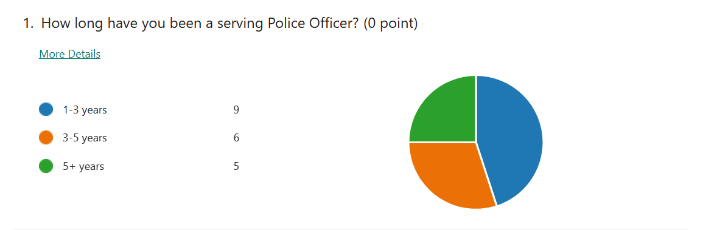

Question 2 of the survey , Since starting your role as a police officer have you noticed an increase in the number of officers suffering with mental health issues? This was a core question within the survey as it highlights the completing officers opinion on whether they have noticed an increase in mental health issues for officers and this can be compared to the research available regarding police officers suffering with mental health issues. Out of the 20 police officers completing the survey 17 officers which is 85% have said yes to noticing an increase in the number of officers suffering with mental health issues. 15% of participants said No.

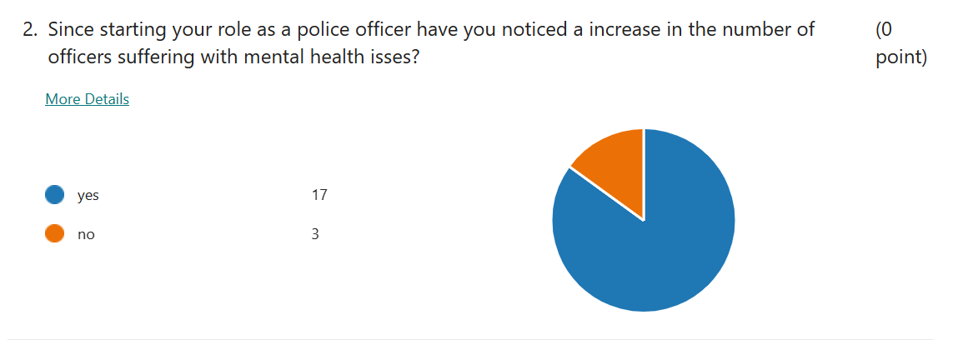

Question 3, Do you think police officers are more prone to suffering to mental health issues compared to other employees in other sectors? A massive 90% of officers completing the survey said Yes to the question. 0% answered no however 10% of participants was answered unsure.
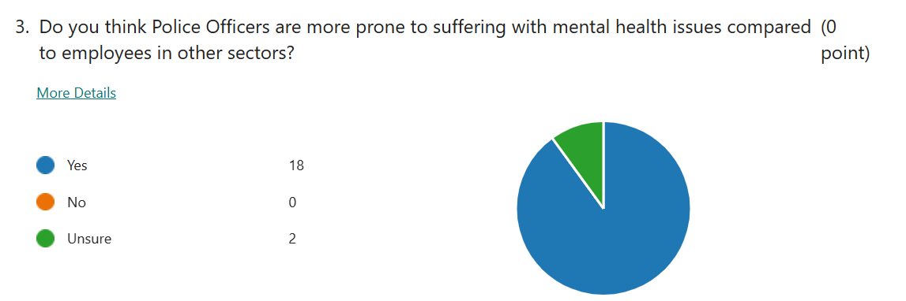
Question 4 was the first qualitative question of the survey, What is your opinion on mental health issues within the police service? The full 20 participants completed the questions giving some detailed answers to the question such as,
“high work demands”
“Levels of mental health issues have raised over recent years, as it is becoming less of a taboo subject. More still needs to be done to support those officers who ae struggling particularly after a difficult case”
“ Slight improvements in recent years but could still be improved upon”.

Question 5, Have you ever suffered from mental health issues whilst serving as a police officer? 15 out of 20 participants completed this question giving it a completion rate of 75%. Again there was answers relating to work related stressed causing mental health issues such as,
“Yes due to high work loads and jobs we attend”
“Yes, I was a laid back person before I joined. I now think of work 24/7. My rest days are ruined by the dread of coming back to 9 oclock jury emails from non emergency departments”
However, 6 of the 15 who completed the survey 40% said.
“No”

Question 6 relates to, How do you cope with keeping your mental health positive while working as a police office? The feedback to this was great with a full 20 participants completing giving it 100% competition rate stating things such as,
“Gym and family time”
“Engaging in activities which I enjoy socially”
These answers already backing the research which is already available relating to stress levels dropping through exercise.
“Exercise can provide stress relief for your body while imitating effects of stress, such as the flight or fight response, and helping your body and its systems practice working together through those effects. This can also lead to positive effects in your body — including your cardiovascular, digestive and immune systems — by helping protect your body from harmful effects of stress” (Mayo Clinic, 2020)

Question 7 was another quantitative questions relating to, Do you know where to go for support if you were to experience mental health issues?
As you can see below 100% completion of this question where 80% of participants would know where to go for support and 20% does not.
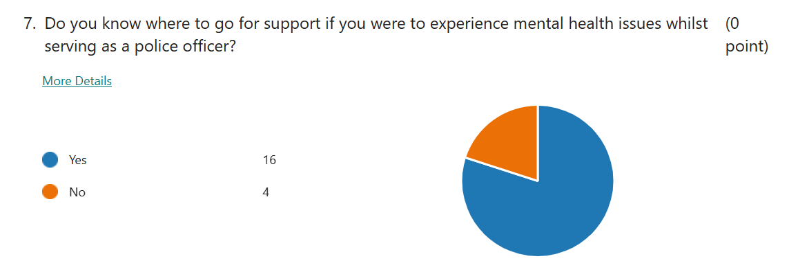

Question 8, Please rate how supportive you feel the police service is in supporting police officers with mental health issues? 1 being low support and 5 being very supported, as you can see form the results the average rating for this was 3.
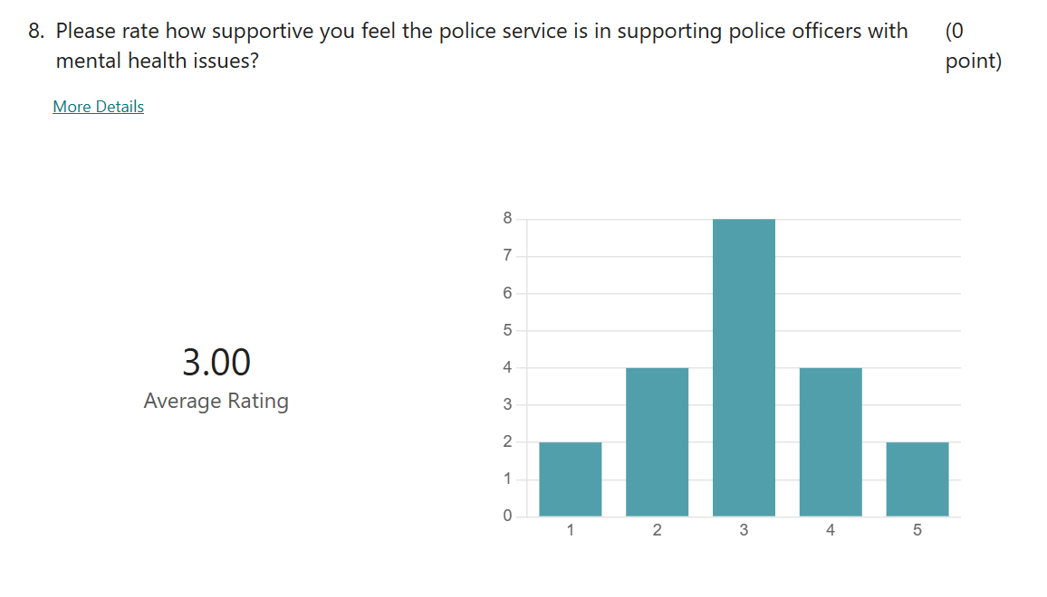
Questions 9 and 10 centred around, Do you believe there is a stigma in the police service that creates a barrier to seeking support for mental health issues? And If a colleague confided in you regarding suffering with mental health issues whilst in their role as a police officer, how would you support them? Regarding the stigma a number of participants still believe there is a stigma because,
“yes as police officers are supposed to be mentally tough and have the stigma just get on with it attitude”.
And in relation to helping colleagues with support for mental health issues response such as,
“guide them to where support is within the police service or speak to a supervisor”.

Conclusion 4.3
By looking at the feedback provided from the survey, the researcher was able to identify more in depth opinions on mental health issues with current serving police officers. The survey was only completed by Response officers however these results could be different if sent to other departments within the police service. During the next chapter a conclusion of the findings from the survey will be explored against the research already available to establish the aim of, Are police officers more prone to suffering with mental health issues due to the jobs they face.
Word count 1104.

References
Mayo Clinic (2020). Exercise and stress: Get moving to manage stress. [online] Mayo Clinic. Available at: https://www.mayoclinic.org/healthy-lifestyle/stress-management/in-depth/exercise-and-stress/art-20044469 [Accessed 25 Feb. 2023].

