University of Wales Trinity Saint David
Wales Institute of Science & Art

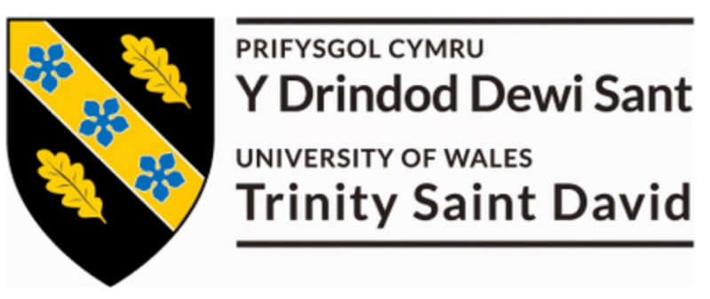

Coursework Title: Risk Assessment Report
Module Name & Code: Environmental Engineering and Sustainable Energy ACMA5012

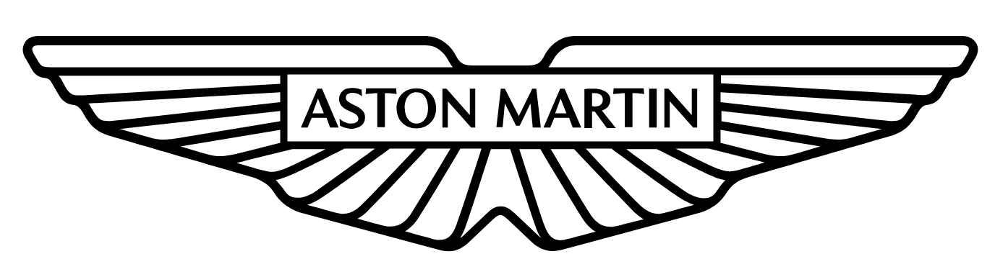
Name: Luke Huzzey-Evans (2205835)
Date: 17/11/2025

Abstract
This report presents a comprehensive environmental risk assessment for a proposed wind farm development in the North East of England, consisting of six 3.5 MW turbines on a 120-hectare site. The study evaluates potential environmental impacts across the construction, operational, and decommissioning phases, with particular attention to site-specific sensitivities including proximity to a Site of Special Scientific Interest (SSSI), local biodiversity, and hydrological systems. A structured risk assessment methodology, combining a qualitative likelihood consequence matrix with elements of environmental impact evaluation, is applied to prioritise risks. Key high-priority risks identified include habitat disturbance during construction, bird and bat mortality from turbine operation, and end-of-life disposal of composite turbine blades. Practical mitigation measures are proposed, including timing restrictions for construction, adaptive turbine shutdown protocols, and recycling or repurposing strategies for composite waste. The report highlights the balance between renewable energy benefits and environmental stewardship, concluding that with appropriate mitigation and monitoring, the project can align with sustainable development objectives while minimising adverse impacts.

Contents
1 Abstract ii
2 Introduction 1
2.1 Aims 1
2.2 Objectives 1
3 Methodology 2
4 Environmental Risk Identification 4
4.1 Construction Phase Risks 4
4.2 Operational Phase Risks 4
4.3 Decommissioning Phase Risks 5
5 Risk Assessment Matrix 6
6 Mitigation Measures 8
6.1 Habitat Loss and Fragmentation (Construction Phase) 8
6.2 Bird and Bat Collisions (Operational Phase) 8
6.3 Blade Waste Disposal (Decommissioning Phase) 9
7 Discussion & Recommendations 10
7.1 Evaluation of Mitigation Effectiveness 10
7.2 Adaptive Management and Continuous Improvement 11
7.3 Sustainability Alignment 12
7.4 Key Recommendations 12
8 Conclusion 13
9 References 14
10 Appendices 17
10.1 Appendix A - Risk Classification Framework 17
10.2 Appendix B - Bow Tie Analysis for Risk Management 18
10.3 Appendix C - Fault Tree Analysis (FTA) Guide 19
10.4 Appendix D - Triple Bottom Line 20

Table 1 - Comprehensive qualitative risk matrix for environmental impacts across project phases. 6
Table 2 - Application of the mitigation hierarchy. 10
Table 3 - Project alignment with UN Sustainable Development Goals (SDGs 7, 13 and 15). 12
Table 4 - Risk Classification Framework 17

Figure 1 - Project lifecycle stages and principal environmental risk categories. 2
Figure 2 - Adaptive-management cycle - ISO 14001 framework. 11
Figure 3 - Bow Tie Analysis (Watt, 2020) 18
Figure 4 - Fault Tree Analysis (Reliability.com, 2025) 19
Figure 5 - Triple Bottom Line (HBS Online, 2025) 20

Introduction
Wind energy is a vital part of the UK’s shift to a low-carbon economy, helping improve energy security and cut greenhouse gas emissions (Renewable UK, 2023). The proposed project by EcoWind Solutions Ltd. aims to build a medium-sized wind farm with six 3.5 MW turbines, totalling 21 MW, enough to power around 15,000 homes each year (BEIS (Department for Business, Energy & Industrial Strategy), 2022). While the advantages of renewable energy are well known, wind farm projects can pose environmental challenges due to their effects on ecosystems, landscapes, and local communities (Leung & Yang, 2012).
The chosen site for this development includes farmland, wetlands, and grasslands, and is next to a Site of Special Scientific Interest (SSSI). This area’s ecological importance demands a thorough environmental risk assessment to identify, assess, and reduce potential risks during the project’s lifecycle. Especially, the presence of protected species, migratory birds, and a nearby stream, increase the risk of significant environmental impacts if not properly managed (Drewitt & Langston, 2006).

Aims
The principal aim of this report is to conduct an environmental risk assessment of the proposed wind farm development, ensuring that potential adverse impacts are identified, prioritised, and mitigated in a manner consistent with sustainable development principles.

Objectives
- To identify potential environmental risks across the construction, operational, and decommissioning phases.
- To evaluate and prioritise these risks using a structured risk assessment matrix.
- To propose practical, site-specific mitigation measures for high-priority risks.
- To justify the methodology adopted and acknowledge limitations inherent to the assessment process.

Methodology
Environmental risk assessments provide a structured approach to identifying, analysing, and managing potential impacts associated with energy developments. For this project, a qualitative likelihood consequence matrix was selected as the primary assessment tool, consistent with best practice within UK environmental and risk-management frameworks (DEFRA, 2019). The method supports multidisciplinary decision-making and can be implemented where quantitative datasets are limited, as is typical during the planning phase of new wind-farm developments. This assessment follows the principles outlined in ISO 31000 Risk Management Guidelines (ISO 31000 Risk Management Guidelines, 2018) and the UK Environmental Impact Assessment (EIA) Regulations 2017 (GOV.UK, 2017), which emphasises a transparent and proportionate approach to identifying and prioritising environmental risks. The qualitative matrix method was selected because it provides clarity and accessibility for both technical and non-technical stakeholders. However, alternative semi-quantitative models, such as Bow-Tie Analysis (Watt, 2020) or Fault-Tree Analysis (Reliability.com, 2025), could deliver greater numerical precision where extensive baseline data are available. Recognising this limitation ensures that the adopted method remains appropriate to the project scope and available evidence.
As shown below in Figure 1 risks were grouped across the three main lifecycle phases: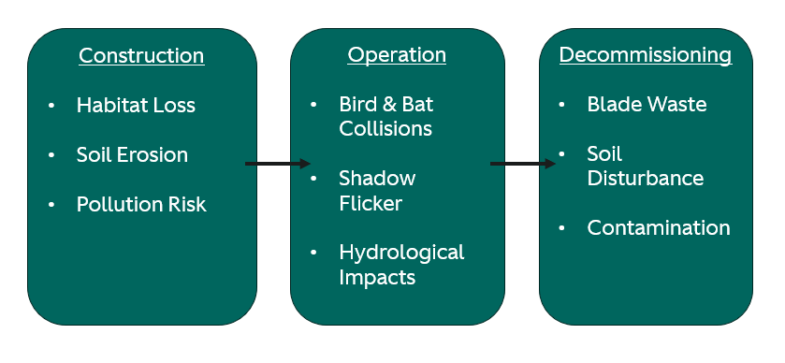
Figure 1 - Project lifecycle stages and principal environmental risk categories.
Each risk will be evaluated on a five-point Likelihood scale (1 = rare → 5 = almost certain) and a five-point Consequence scale (1 = minor → 5 = catastrophic). Multiplying these values produces an overall Risk Rating (L × C), enabling prioritisation into low, medium, or high. This ranking will guide the identification of mitigation measures presented in section 6.
Qualitative scoring inevitably involves a degree of subjectivity; future iterations could apply probabilistic modelling (ScienceDirect , 2025) or Monte Carlo simulation (Illuminating Probabilistic Risk in Renewable Energy with Monte Carlo Simulation in Excel. , 2024) to quantify uncertainty more precisely. The assessment also acknowledges that risk significance may vary over time as new environmental data becomes available. This approach aligns with the iterative, feedback-driven principles of adaptive environmental management (Holling, 1978), ensuring that monitoring results inform periodic reassessment of risks and mitigations. This methodology is therefore both systematic and flexible, allowing the integration and continual improvement to be consistent with ISO 14001 Environmental Management Systems.

Environmental Risk Identification

Construction Phase Risks
The construction of wind turbines, access roads, substations, and associated facilities poses several short-term but potentially significant risks to the local environment.
- Habitat loss and fragmentation caused by land clearance for turbine foundations and access roads may disrupt farmland, grassland, and wetland ecosystems, resulting in the displacement of species, including protected flora and fauna. (Fox, et al., 2006)
- Soil erosion and sedimentation caused by excavation and earthworks may elevate runoff into the nearby stream, impacting water quality and aquatic biodiversity. Wetland areas are especially vulnerable to sediment deposition. (Miller, et al., 2014)
- Noise and disturbance from construction activities, including pile driving, vehicle movements, and blasting, may affect breeding or migratory bird populations in the vicinity of the SSSI.
- Pollution risks can be identified through the use of fuels, lubricants, and construction materials, increasing the risk of accidental spills that could contaminate soils and nearby watercourses.

Operational Phase Risks
During operation, turbines pose long-term, ongoing risks that require careful management.
- Bird and bat collisions with rotor blades create collision risks, especially for migratory species, which can lead to mortality and long-term population effects. (Drewitt & Langston, 2006)
- Noise emissions from low-frequency turbine noises may affect nearby residents, although the nearest settlement is 2 km away, indicating relatively low human impact. However, noise could still disturb sensitive wildlife species. (Leung & Yang, 2012)
- Shadow flicker and visual impact caused by intermittent shadows cast by turbine blades may affect properties or recreation areas within a defined radius, while turbines will also alter the landscape character, potentially impacting tourism and local perceptions of the rural environment.
- Hydrological impacts from operational access roads may alter natural drainage patterns, increasing the risk of long-term soil compaction or surface runoff into the adjacent stream.

Decommissioning Phase Risks
At the end of the turbines’ operational life (typically 20–25 years), decommissioning activities can pose risks similar to those during construction, along with waste management challenges.
- Waste generation from obsolete turbine blades, composed of glass or carbon-fibre composites, presents recycling challenges due to their durability and resin composition (Liu & Barlow, 2017). Without appropriate disposal strategies, large volumes of waste may end up in a landfill.
- Soil and vegetation disturbance from dismantling foundations, roads, and substations may cause further soil disturbance, erosion, and habitat disruption.
- Residual contamination from oils, hydraulic fluids, and other operational residues in machinery could pose contamination risks if not managed responsibly during dismantling.

Risk Assessment Matrix
The following matrix evaluates potential environmental risks associated with the proposed wind farm across the construction, operational, and decommissioning phases. Risks are scored based on a qualitative assessment of their likelihood and consequence, with overall ratings and priority levels guiding mitigation planning. The classification of risk ratings in Table 1 is based on multiplying the Likelihood and Consequence scores (L×C), after which results are categorised as follows: 1–8 = Low, 9–12 = Medium, 13–16 = High, and 17–25 = Very High. This classification approach aligns with recognised best practice under ISO 31000 (ISO 31000 Risk Management Guidelines, 2018) and the DEFRA Environmental Risk Assessment and Management Framework (DEFRA, 2019) ensuring consistency and transparency in the evaluation of environmental significance.
Table 1 - Comprehensive qualitative risk matrix for environmental impacts across project phases.
Risk | Phase | Likelihood (1–5) | Consequence (1–5) | Risk Rating (LxC) | Priority Level  (RAG)
Habitat loss and fragmentation | Construction | 4 | 4 | 16 | High
Soil erosion and sedimentation | Construction | 3 | 4 | 12 | Medium
Noise and disturbance (wildlife) | Construction | 3 | 3 | 9 | Medium
Pollution from spills | Construction | 2 | 4 | 8 | Low
Bird and bat collisions | Operation | 4 | 5 | 20 | Very High
Noise emissions (wildlife/residents) | Operation | 2 | 3 | 6 | Low
Shadow flicker / visual impact | Operation | 3 | 3 | 9 | Medium
Hydrological impacts from access roads | Operation | 3 | 4 | 12 | Medium
Blade waste disposal (composites) | Decommissioning | 4 | 5 | 20 | Very High
Soil and vegetation disturbance | Decommissioning | 3 | 3 | 9 | Medium
Residual contamination (oils/fluids) | Decommissioning | 2 | 3 | 6 | Low

As shown in Table 1, the highest-priority environmental risks are concentrated within the operational and decommissioning phases of the project. The most significant issue is the potential for bird and bat collisions, classified as Very High, followed by habitat loss and fragmentation and blade-waste disposal.
Construction-phase impacts such as soil erosion and noise are moderate and can be effectively controlled through standard mitigation practices. These results indicate that long-term operational management and end-of-life planning represent the most critical focus areas for environmental control. Consequently, the mitigation strategies outlined in Section 6 were prioritised to target these high-risk categories, ensuring resources are directed where they will deliver the most significant environmental benefit.

Mitigation Measures
The mitigation strategies below address the three highest-priority environmental risks identified in Table 1: habitat loss and fragmentation, bird and bat collisions, and blade-waste disposal. Each set of measures is designed to be practical, site-specific, and aligned with UK environmental policy and best-practice standards.

Habitat Loss and Fragmentation (Construction Phase)
Risk Rating: 16 (High)
The establishment of turbine foundations, access roads, and the on-site substation will require vegetation clearance across farmland and wetland zones, with potential loss of ecological connectivity near the SSSI.
Mitigation Actions:
- Pre-construction ecological surveys: Conduct seasonal habitat and species surveys to identify sensitive areas. Establish 50 m buffer zones around any identified nesting or breeding sites (Natural England, 2020).
- Phased construction programme: Schedule groundworks outside key breeding and migration periods (March–August).
- Habitat compensation and enhancement: Replace unavoidable habitat loss with equivalent or improved ecological value, such as new hedgerows, wildflower margins, or wetland restoration.
- Soil-stabilisation measures: Apply silt fences and sediment traps near the adjacent stream to prevent runoff.
- Post-construction monitoring: Implement a two-year ecological monitoring plan to verify recovery and success of compensation areas.

Bird and Bat Collisions (Operational Phase)
Risk Rating: 20 (Very High)
The rotation of turbine blades presents a direct collision hazard to both local and migratory species recorded within the North East corridor.
Mitigation Actions:
- Turbine micro-siting: Position turbines at least 500 m from hedgerows, woodland edges, and known bat roosts to minimise intersecting flight paths (Drewitt & Langston, 2006).
- Operational curtailment: Introduce automated shutdowns during periods of high bat activity (low-wind summer evenings < 6 m/s) or peak bird migration.
- Blade-visibility enhancement: Apply high-contrast or UV-reflective markings to outer blade tips, reducing avian collisions by up to 70 % (May, 2020).
- Acoustic deterrents: Trial ultrasonic bat deterrent systems on turbines closest to woodland or wetland zones.
- Ongoing monitoring: Use radar and acoustic sensors to record flight activity, enabling adaptive management of curtailment schedules.

Blade Waste Disposal (Decommissioning Phase)
Risk Rating: 20 (Very High)
Wind-turbine blades are manufactured from fibre-reinforced composites that are difficult to recycle, leading to potential landfill impacts at the end of operational life.
Mitigation Actions:
- Recycling partnerships: Collaborate with UK and EU composite-recycling facilities capable of processing blades into secondary raw materials, such as cement additives (Liu & Barlow, 2017).
- Repurposing programmes: Explore the reuse of retired blades for structural applications, e.g., pedestrian bridges, acoustic barriers, or public furniture.
- Design-for-disassembly principles: Specify bolted rather than bonded joints in future procurement to facilitate dismantling and recycling.
- Circular-economy plan: Develop an end-of-life management strategy at project outset, incorporating dismantling logistics, waste-segregation procedures, and supply-chain commitments.
- Documentation and reporting: Record material flows during decommissioning to verify compliance with Waste Framework Directive (2008/98/EC) (GOV.UK, 2008; Waste Framework Directive (2008/98/EC), 2008).
These mitigation measures collectively aim to minimise ecological disturbance, enhance biodiversity, and ensure that project activities conform to both national and EU environmental obligations. Implementation should be managed through a formal Environmental Management Plan (EMP), supported by periodic audits and adaptive review (Rhoscrowther Wind Farm Limited, 2021).

Discussion & Recommendations
The environmental risk assessment confirms that the proposed EcoWind Solutions wind farm project offers significant renewable energy and carbon reduction benefits. Still, its overall sustainability depends on how effectively high-priority environmental risks are managed throughout the construction, operational, and decommissioning phases. The analysis shows that the most significant risks are habitat loss and fragmentation, bird and bat collisions, and composite-blade waste. All require an adaptive, evidence-based management approach rather than fixed one-off mitigations.

Evaluation of Mitigation Effectiveness
As shown in Table 2 below, the adopted mitigation hierarchy is avoid, minimise, restore, and offset. This aligns with both the UK Environmental Principles Policy Statement (HM Government (DEFRA), 2022) and Natural England’s Biodiversity Net Gain guidance (Natural England, 2020). Habitat protection measures, such as phased construction and ecological buffer zones, are expected to reduce short-term disturbance substantially. Their effectiveness, however, depends on strict contractor compliance and supervision. Embedding an ecological clerk-of-works role within the Environmental Management Plan (EMP) would provide continuous oversight and documentation (Chartered Institute of Ecology and Environmental Management (CIEEM), 2021).
Table 2 - Application of the mitigation hierarchy.
Stage | Example Action | Expected Outcome
Avoid | Turbine micro-siting outside SSSI boundary | No direct habitat loss
Minimise | Sediment-control barriers | Reduced downstream pollution
Restore | Wetland re-establishment | Habitat recovery
Offset | Compensatory habitat creation | Net biodiversity gain

In contrast, avian and bat-collision mitigation involves using on-demand shutdown systems, high-contrast blade markings, and ultrasonic deterrents. This balances ecological outcomes with operational efficiency. (May, 2020) demonstrated that high-contrast blade painting can reduce avian mortality by 60–70 %, while avoiding the energy-production losses associated with extended curtailment. This evidence supports prioritising visual-enhancement measures over excessive shutdown protocols.
For end-of-life management, the proposal to recycle or repurpose composite blades addresses a growing global challenge. Although (Liu & Barlow, 2017) note limited UK recycling capacity, early partnership with specialist processors and adoption of design-for-disassembly principles can align the project with circular-economy goals. Embedding these processes within an ISO 14001 Environmental Management System would formalise review procedures, provide auditable evidence of continual improvement, and strengthen regulatory compliance.

Adaptive Management and Continuous Improvement
Following the adaptive management model proposed by (Holling, 1978), Figure 2 outlines that monitoring data regarding bird-strike counts, acoustic readings, and habitat-recovery indicators should all feed into annual risk reviews. These reviews would update the qualitative matrix, refine mitigation measures, and inform operational decisions. Integrating this iterative process ensures that mitigation remains proportionate and responsive to real-world conditions.
Even though uncertainty is inherent in qualitative assessment methods, it can be mitigated through multidisciplinary evaluation and transparent documentation. Future phases could adopt probabilistic or Monte Carlo simulation techniques to quantify uncertainty more rigorously, providing a pathway toward semi-quantitative modelling once sufficient site data exist.

Figure 2 - Adaptive-management cycle - ISO 14001 framework.

Sustainability Alignment
As shown in Table 3, the mitigation plan supports key UN sustainable development goals (SDGs) (United Nations (UN), 2015):
Table 3 - Project alignment with UN Sustainable Development Goals (SDGs 7, 13 and 15).
SDG No. | Goal Title | Relevant Project Action | Expected Outcome
7 | Affordable & Clean Energy | Wind-farm provides 21 MW of renewable power | Reduced reliance on fossil fuels
13 | Climate Action | Circular-economy planning and ISO 14001 integration | Lower lifecycle CO₂ emissions
15 | Life on Land | Habitat compensation and biodiversity-net-gain measures | Protection of terrestrial ecosystems

Beyond environmental outcomes, the project also aligns with the triple-bottom-line (HBS Online, 2025) model by considering environmental integrity, social acceptance, and economic feasibility. Local employment during construction and community engagement during operation strengthen the project’s social licence to operate, while adaptive monitoring maintains long-term ecological resilience.

Key Recommendations
- Integrate Adaptive Environmental Management: Establish an annual monitoring and review programme to update risk rankings and mitigation actions in line with observed data.
- Formalise a Biodiversity-Net-Gain Strategy: Commit to measurable habitat-creation or restoration projects that deliver net ecological benefit beyond baseline conditions.
- Enhance Circular-Economy Planning: Secure long-term recycling and repurposing agreements for turbine components and encourage modular, recyclable design in procurement.
- Embed ISO 14001 Compliance: Use a certified Environmental Management System to ensure continual improvement, auditability, and transparent reporting.
- Strengthen Stakeholder Engagement: Maintain clear communication with local authorities, conservation bodies, and communities to reinforce transparency and trust.

Conclusion
This Environmental Risk Assessment has evaluated the potential impacts of the proposed 21 MW EcoWind Solutions wind farm in North East England using a qualitative likelihood consequence matrix. Key risks were identified across the construction, operational, and decommissioning phases, with habitat loss, bird and bat collisions, and composite-blade waste emerging as the highest-priority concerns. Mitigation measures were developed for each, including phased construction, targeted habitat compensation, adaptive turbine curtailment, and a circular economy approach for composite materials. These strategies demonstrate that the project can deliver renewable-energy benefits while minimising environmental harm.
Environmental performance should be treated as an ongoing improvement process. Integration into an ISO 14001 Environmental Management System would formalise continual monitoring, reporting, and evaluation. Likewise, applying an adaptive management approach allows mitigation measures to be refined as new ecological data becomes available. It also supports alignment with the UN Sustainable Development Goals, especially SDGs 7, 13, and 15. Whilst embedding biodiversity net gain and circular-economy principles, the project offers a practical and responsible model for sustainable wind-energy development.

References
BEIS (Department for Business, Energy & Industrial Strategy), 2022. UK Renewable Electricity Capacity and Generation Statistics.. [Online]
Available at: https://www.gov.uk/government/statistics/energy-trends-section-6-renewables
[Accessed November 2025].
Chartered Institute of Ecology and Environmental Management (CIEEM), 2021. Guidelines for Ecological Impact Assessment (EcIA) in the UK and Ireland.. [Online]
Available at: https://cieem.net/resource/guidelines-for-ecological-impact-assessment-ecia/
[Accessed October 2025].
DEFRA, 2019. Environmental Risk Assessment and Management Framework.. London: DEFRA.
Drewitt, A. L. & Langston, R. H. W., 2006. Assessing the impacts of wind farms on birds. Ibis, 148(1), p. 29–42.
Fox, A. D., Desholm, M. K. J., Christensen, T. K. & Petersen, I. K., 2006. Information needs to support environmental impact assessment of the effects of European offshore wind farms on birds. Ibis, 148(1), p. 129–144.
GOV.UK, 2008. Directive 2008/98/EC of the European Parliament and of the Council. [Online]
Available at: https://www.legislation.gov.uk/eudr/2008/98/contents
[Accessed 2025].
GOV.UK, 2017. Environmental Impact Assessment) Regulations 2017. [Online]
Available at: https://www.legislation.gov.uk/uksi/2017/571/contents
[Accessed 2025].
HBS Online, 2025. What is the Triple Bottom Line?. [Online]
Available at: https://online.hbs.edu/blog/post/what-is-the-triple-bottom-line
[Accessed November 2025].
HM Government (DEFRA), 2022. Environmental Principles Policy Statement.. [Online]
Available at: https://www.gov.uk/government/publications/environmental-principles-policy-statement
[Accessed November 2025].
Holling, C. S., 1978. Adaptive Environmental Assessment and Management.. London: Wiley.
Illuminating Probabilistic Risk in Renewable Energy with Monte Carlo Simulation in Excel. (2024) Lumivero.
ISO 31000 Risk Management Guidelines, 2018. Geneva: International Organization for Standardization.. [Online]
Available at: https://www.iso.org/standard/65694.html
[Accessed November 2025].
Leung, D. Y. C. & Yang, Y., 2012. Wind energy development and its environmental impact: A review. Renewable and Sustainable Energy Reviews, 16(1), p. 1031–1039. .
Liu, P. & Barlow, C. Y., 2017. Wind turbine blade waste in 2050.. Waste Management, Volume 62, p. 229–240. .
May, R., 2020. Paint it black: Efficacy of increased blade visibility to reduce avian fatalities at wind turbines.. Ecology and Evolution, 10(16), pp. 8927-8935.
Miller, A., Kroeker, J. & Lin, M., 2014. Sediment control and water-quality considerations during wind-farm construction.. Environmental Management, 54(3), p. 612–621..
Natural England, 2020. Biodiversity Net Gain: Good Practice Principles for Development.. [Online]
Available at: https://naturalengland.blog.gov.uk/2020/07/02/biodiversity-net-gain-good-practice-principles/
[Accessed November 2025].
Reliability.com, 2025. Fault Tree Analysis (FTA) Guide. [Online]
Available at: https://reliability.com/resources/articles/fault-tree-analysis-fta-guide/
[Accessed November 2025].
Renewable UK, 2023. Wind Energy in the UK – Facts and Figures. [Online]
Available at: https://www.renewableuk.com/page/WindEnergy
[Accessed November 2025].
Rhoscrowther Wind Farm Limited, 2021. Draft Construction Environmental Management Plan: Rhoscrowther Wind Farm.. Appendix 3.1 ed. Cardiff: Welsh Government..
ScienceDirect , 2025. Probabilistic Model – an overview. [Online]
Available at: https://www.sciencedirect.com/topics/materials-science/probabilistic-model
[Accessed November 2025].
United Nations (UN), 2015. Transforming our world: the 2030 Agenda for Sustainable Development. [Online]
Available at: https://sdgs.un.org/goals
[Accessed November 2025].
Waste Framework Directive (2008/98/EC), 2008. Directive of the European Parliament and of the Council on Waste and Repealing Certain Directives. Official Journal of the European Union, Volume 312, pp. 3-30.
Watt, J., 2020. 8 Steps to using Bow Tie Analysis for Risk Management. Many Caps Consulting Ltd..

Appendices

Appendix A - Risk Classification Framework
Table 4 - Risk Classification Framework
Score | Likelihood Descriptor | Description / Example
1 | Rare | May occur only in exceptional circumstances; no recorded incidents.
2 | Unlikely | Could occur at some time; limited historical evidence.
3 | Possible | Might occur at least once during the project; moderate likelihood.
4 | Likely | Expected to occur in most project cycles; regular occurrence.
5 | Almost Certain | Occurs frequently or continuously under current conditions.

Score | Consequence Descriptor | Description / Example
1 | Minor | Negligible or short-term local impact; easily reversible.
2 | Moderate | Noticeable but contained impact; limited restoration required.
3 | Major | Significant single-area effect; long-term recovery period.
4 | Severe | Widespread impact; potential regulatory breach or public concern.
5 | Catastrophic | Irreversible damage or major regulatory / reputational consequence.

Appendix B - Bow Tie Analysis for Risk Management
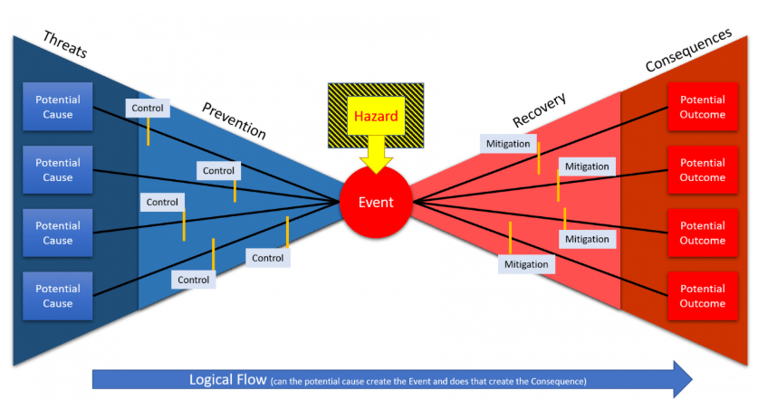
Figure 3 - Bow Tie Analysis (Watt, 2020)

Appendix C - Fault Tree Analysis (FTA) Guide
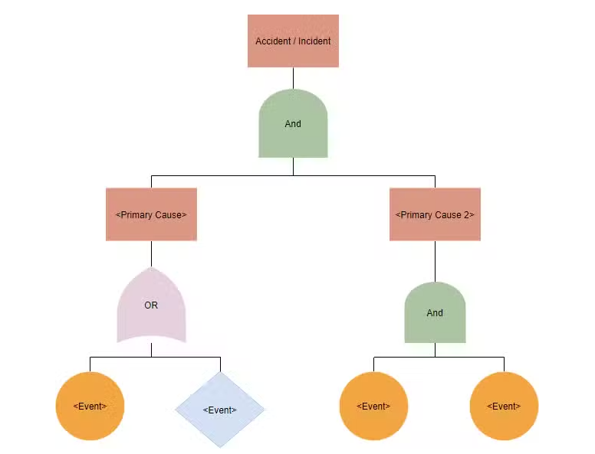
Figure 4 - Fault Tree Analysis (Reliability.com, 2025)

Appendix D - Triple Bottom Line
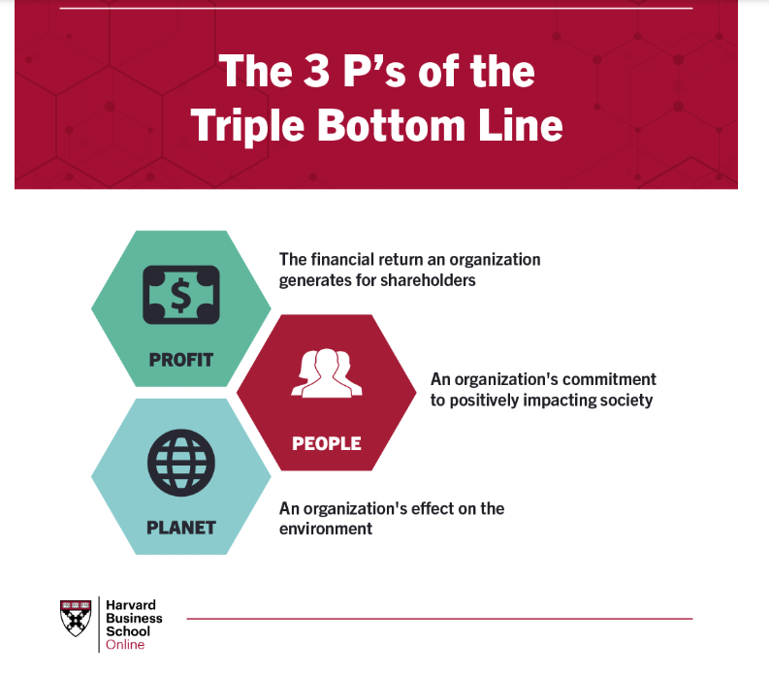
Figure 5 - Triple Bottom Line (HBS Online, 2025)

